Chapter 1:

Five Forces:
Buyer Power: When a consumer has many choices to where to buy their product from they have high buyer power. When they can only choose a few select they have low buyer power. Companies that want usually to get a competitive advantage in buyer power is by doing Loyalty Programs which rewards customers with the amount of business they do with them. These Loyalty Programs are made by IS systems.

Supplier Power: When you're the buyer and there is few choices, supplier power is high. However if there is many choices the supplier power is low. Companies that function as the supplier want to have high supplier power to distribute their products and low supplier power when they want to buy their supplies from other people

How IS can help: By doing a IS enabled private exchange(a special B2B marketplace where a buyer posts its needs and organizations can go make a bid). It could lead to a reverse auction that gives them the lowest price.

Threat of Substitute products or Services:
If there is many substitute to your product or service then the Threat is high, if there is only a few it is considered low. In these days it is hard to find a service that doesn't already have multiple alternatives. Therefore Companies try to use Switching Costs to gain competitive advantages. Switching costs are the consequences that a buyer makes by switching to another product or service. Ex: Amazon, Cellphone Companies, etc

Threat of new entrants: When it is easy for a someone to enter in that market it is considered high but when its tough to get in it is considered low. Low Threats usually have big entry barriers which is the typical things consumers tend to expect from a company of that industry.

Rivalry Among Existing Competitors: When companies are at each other, trying to up one the other. It is considered high. But when they are more lenient to each other, not caring that much it is considered low.

How IS Helps: IS helps create more efficiency in partnerships with companies and suppliers thus being able to reduce price to a point that gives them competitive advantage.

Generic Three Strategies
Organizations could follow Porter's three generic strategies when entering a new market. Broad cost leadership, Broad differentiation or Focused Strategy

Broad cost leadership: Focuses on lower costs but has different models to appeal to a bigger audience,

Broad Differentiation: Always trying to appeal to a larger audience but has a niche or something that differentiates from others.

Cost Leadership: Giving consumers the low-cost for their product and services

Focused Strategy: Appealing to a specific audience. Regardless of price

Value Creation:
Key Term, Business process: is a standardized set of activities that accomplish a specific task.

To check if an organization business process is efficient we use Michael Porter's value chain. When viewing an Organization as a Value Chain we see the organization as many processes. To get the competitive advantage a business must be able to create a unique value to their activities that other organizations don't have. Organizations have two types of activities in the Chain value Model. Primary activities (selling, buying supplies, etc.) and Support Activities (Firm infrastructure, HR, Technology, etc.)

How does IS get involved: We can use IS to improve not only support activities but the primary activities in an organization.

Combination:
It is recommended not only for an upcoming organization to use one of the models but, to combining both Five Forces and Value Chain for them to better analyze on the organization's status if there is needed a change in business strategy. Information Systems is key to this as it is the biggest way organizations can run more efficiently and give them the competitive advantage in this day and age
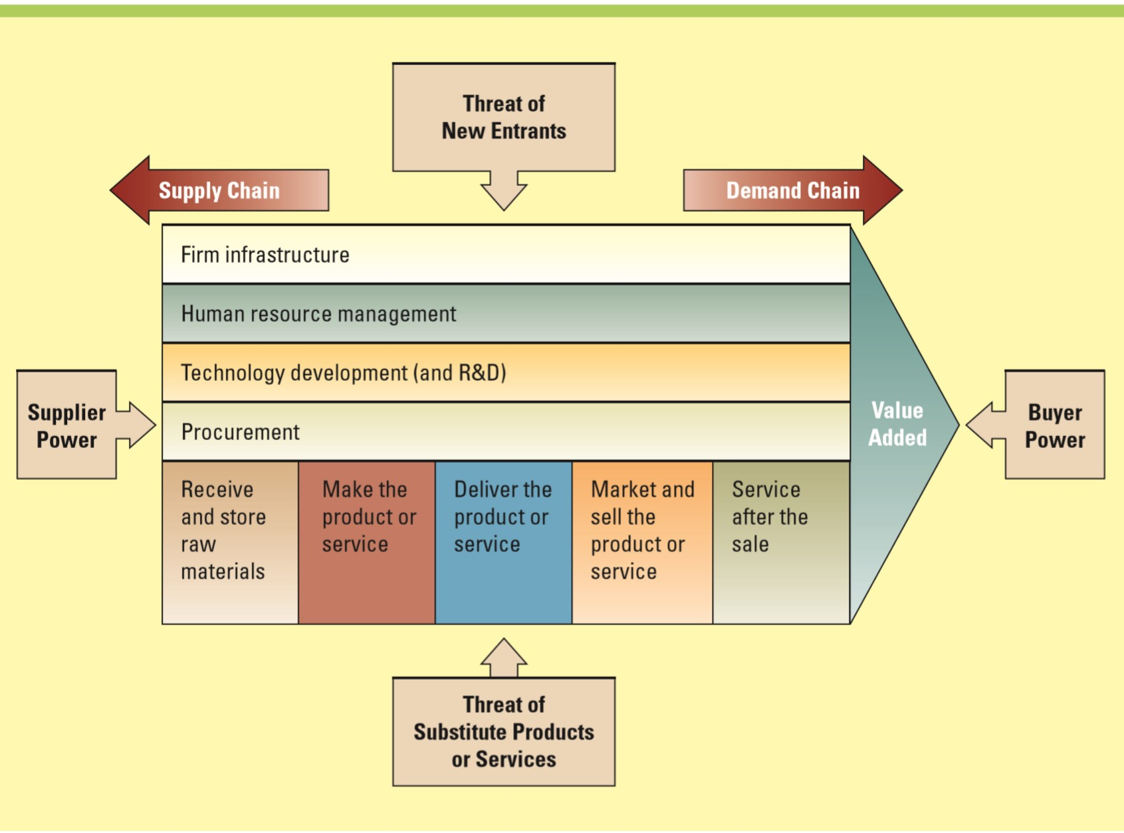

CHAPTER 2:

*Making Business Decisions -
Understanding the way people makes decisions is critical to embrace. They way people make decisions is going to affect your business and the culture that is created there. Exam question

Operational Decision Making -
Employee Type: lower management, analysts, staff
Focus: Internal, functional
Time Frame: Short term, day-to-day operations
Decision Types: Structured, recurring, repetitive
MIS Type: Information (summarized from raw data)
Metrics: Key performance indicators focus on efficiency
Examples:
- How many employees are out sick?
- How many products need to be made today?
- What are next week’s production requirements?
- How much inventory is in the warehouse?
- How many problems occurred when running payroll?
- Which employees are on vacation?
What are some examples of types of systems or activities at this level?
- Payroll
- Training & development
- Accounts payable & receivable
- Employee record keeping
- Scheduling
- Order processing
- Order tracking

Managerial Decision Making
Employee Type: Middle mgmt., managers, directors
Focus: Internal, cross-functional
Time Frame: Short term, daily, monthly, yearly
Decision Types: Semistructured, adhoc, reporting
MIS Type: Business Intelligence
Metrics: KPIs focusing on efficiency, and CSFs focusing on effectiveness
Examples:
- Who are our best customers by region, by sales representatives, by product?
- What are the sales forecasts for next month? How do they compare to actual sales for last year?
- What was the difference between expected sales and actual sales for each month?
- What was the impact of last month’s marketing campaign on sales?
- What types of ad hoc or unplanned reports might the company require next month?
What are some examples of types of systems or activities at this level?
- Sales management
- Pricing & profitability
- Contract analysis
- Production costs
- Sales analysis by region
- Inventory
- Audits

Strategic Decision Making
Employee Type: Senior management, presidents
Focus: external, industry, cross company
Time Frame: Long term, yearly, multi-year
Decision Types: Unstructured, nonrecurring, one time
MIS Type: Knowledge
Metrics: CSFs focusing on effectiveness
Examples:
- How will changes in employment levels over the next three years impact the company?
- What industry trends are worth analyzing?
- What new products and new markets does the company need to create competitive advantages?
- How will a recession over the next years impact business?
- What measures will the company need to prepare for due to new tax laws?
What are some examples of types of systems or activities at this level?
- Sales trend forecasting
- Budget forecasting
- Profit planning
- 5-year forecast planning

Metrics: Measurements that evaluate results to determine whether a project is meeting its goals ex: GPA for Students.

Benchmarks:
- Benchmarks help assess how an MIS project performs over time
- If a system held a benchmark for response time of 15 seconds, the manager would want to ensure response times did not deviate from this point – including increases or decreases.

FOCUS ON TPS AND DSS

DSS= Excel
'
The Way they Interact

- The TPS supplies transaction-based data to the DSS
- The DSS summarizes and aggregates the information from the many different TPS systems, which assists managers in making informed decisions.
- Canadian Pacific Railway (CPR) uses a DSS to analyze the movement of all its railcars and to track shipments against delivery commitments.
- Similar to the logistics and scheduling challenges faced by Grocery Gateway, CPR would have a difficult task of integrating and analyzing this transaction-based data without this tool.

Focus on Business Process and BPR
Business process re-engineering (BPR) – the analysis and redesign of workflow within and between enterprises
Example: insurance

Chapter 3:
Business and the Internet:

Metcafe Law: the net worth of a website is directly proportional to the amount of users

More and more celebrities and startups are using the internet to bolster their status or to gain status in this world.

E-business is the conducting of business on the Internet. So not only buying and selling, could be also customer service, etc.

Key point in E-Business website: innovative, add value and provide useful information

Disruptive Technology:

Most companies do decisions that hinder them in the long-term such as Polaroid's decision to keep with their same old technology, which is now just a niche product. Organizations inability to adapt to Consumer's new demands of an organization market is called Digital Darwinism.

Disruptive Technology: A new way of doing to things that initially does not meet needs of existing customers.

- Tend to open new markets and destroy old ones (eg. Media players)
- Usually start out as low end, budget technology.
- As Time and Revenue goes on, it is possible for evolution to a high-end product

Sustaining Technology: produces an product that's already been made, but improves it. (eg. A new car, new phone)

Ask Professor: For car companies such as General Motors is there such a need to put a focus on disruptive technology?

Evolution of the Internet:

- Internet started as an emergency military communications system operated by the Military
- As time grew on, the internet started passing to from US Military, Universities and Businesses
- The Internet is not controlled or operated by a single group, but there is protocols and set of standards.

Protocols: Standards that specify the format of data as well as Rules to be followed during transmission.

World Wide Web: global hypertext system that uses the internet as its transport mechanism.

(HTTP): Is the Internet standard that supports the exchange of information on the WWW. Which allows for hyperlinks.

Trivial Fact: Tim Berbers-Lee built the first Web site on August 6, 1991

Webpages over the course of years have improved exponentially, starting with only text-based websites to sounds, video files, etc.

With the internet we are able to do business in ways we thought it would not be possible.

Digital Divide: The advantage between those with the access of technology and those without.

WEB 2.0

WEB 2.0 is the trend of how we use the web in our days. It shows how developers have use the web platform in so many diverse and new ways. Business are trying to use now the web platform to get a First mover advantage in their markets.

Web Mashup: Website or Web application that uses content from more than one source to create a completely new service. Mashups are usually made by API's (application programming interface), which is a set of routines, protocols, and tools for building software applications. Most operating environments put an API so they write apps consistent with the operating environment.

Mashup Editors: provide a visual interface to build a Mashup, often allowing the user to drag and drop data points into a Web application.

WEB 3.0

People believe the next trend in the web platform is going to encompass 4 things

- Transforming the web Into a database
- Focus more on A.I (Artificial Intelligence)
- The realization of semantic Web and service-oriented architecture.
- Evolution toward 3D

Service-oriented architecture: A business-driven IS architectural approach that supports integrating a business as linked, repeatable tasks or services.

Semantic Web- Structuring data so web pages describe things in a way that computers can "understand" and thus, find, share and integrate ideas more effectively people.

Accessing Internet Information:

Organizations use the internet to share and access information, however large organizations tend to have communication problems because of it some include:

- Ongoing news and information was not communicated in a timely and consistent manner
- Business Objectives and priorities were not clearly communicated
- Too much reliance on email
- Information on the existing intranet was not current or relevant, was hard to find and required users to have technical skills to publish
- The existing intranet lacked a formal and comprehensive governance structure to manage intranet changes and to incorporate multiple stakeholder perspectives.

The Four common tools for accessing Internet information include:

Intranet: an internalized portion of the Internet, a network within the internet that protected from outside access only enabled by people working in that organization. It can host many company related information all in a centralized place.

Extranet: Extranet is the same as an intranet but allows for strategic allies (customers, suppliers,etc) to see company information. Companies could gain competitive advantage by allowing customers and suppliers view detailed product and inventory information which allows the customers and suppliers to see on how they will supply their goods or buy goods from the organization.

Portal: a website that offers a broad array of resources and services, such as e-mail, online discussion groups, search engines and online shopping malls. There are two major types of portals, general portals will offer many different types of services (Google, Microsoft, yahoo,etc) while niche portals will focus on a specific thing or market (garden.com)

Kiosk: a publicly accessible computer system that has been set up to allow interactive information browsing. Many companies use kiosk for customer service use, such as Chapters which use kiosks to show the books that are on sale and that are available within the store.

Three Common forms of serivce providers:

ISP: provides access to the internet
OSP: offers an extensive array of unique Web services
Application service provider: offers access over the internet to system and related services that would otherwise have to be located in organizational computers

They all use SLA's which define the specific responsibilities of the service provider and set the customers expectations

