Chapter 8: Application Cost of Taxation
How does a tax affext welfare?
- Impact on consumer surplus, producer surplus, and total surplus?
What is the deadweight loss of a tax?
- What is the loss of total surplus?
What factors determine size of the deadweight loss?
How does tax revenue affect the size of the deadweight loss?
The Effects of Tax
- With no tax, equilibrium price is P equilibrium and Quantity is Q equilibrium
- If government imposes a tax of $T per unit
- The tax generates revenue equal to $T x Qt.
- We will now measure the impact of tax on:
  - Consumer surplus (CS)
  - Producer Surplus (PS)
  - Tax Revenue (TR)
  - Total Surplus (TS)
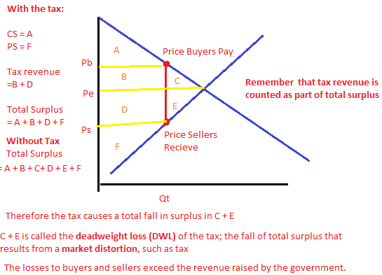
Why the deadweight loss? Because the tax, the units between Qt and Qe are not sold. The value of these units to buyers is greater than the cost of producing them, this is where there is a loss of efficiency. The demand curve shows the value to the buyers of the commodity and it exceeds the cost of production represented by the supply curve; however, since there is a tax some mutually beneficial trades have been prevented. The fall in total surplus is a loss in economic welfare.
What determines the size of the DWL?
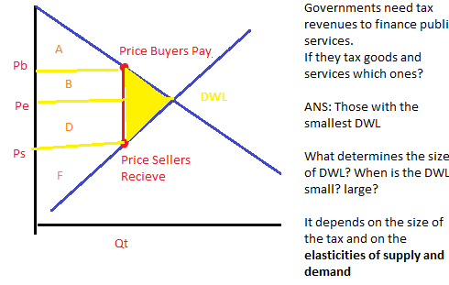
When supply is inelastic, the DWL of a tax is small. The more elastic the supply, the larger of the DWL of a tax. When demand is inelastic, the DWL is small. When the demand curve is elastic, the DWL is much larger.
Why is the deadweight loss larger when the demand and supply curves are more elastic?
- The more elastic the demand and supply curves, the greater the impact of a tax on quantity.
- The greater the impact on quantity bought and sold, the greater the deadweight loss.
- This is why the government taxes things like liquor, because they know that you will be willing to pay any price.
Chapter 8 Continued
What determines the size of the DWL? When is the DWL small or large? Remember in the basic diagram
the DWL is represented by sections C and E.
- Depends on the elasticities of the supply and demand
- The size of the tax
- Remember that the more inelastic the demand and supply curves, the smaller the deadweight loss.
Why is the DWL smaller when the demand and supply curves are more inelastic?
- The smaller the impact of the tax on quantity bought and sold, the smaller if the deadweight loss. (Since demand and supply is inelastic, the impact has very little impact on quantity bought and sold).
The Effects of Changing the Size of the Tax
- Policymakers often change the size of taxes
- Area of a triangle is a function of (size of triangle)²
  - Example: double size of tax (double size of triangle)
  - (2)² = you end up quadrupling the deadweight loss (area of the triangle)
  - If you triple the tax, the DWL increases by a factor of 9
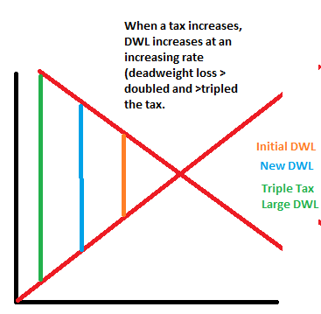
Revenue and the Size of the Tax
- The tax revenue us equal to T x Q
- It makes a rectangle shape
- When the tax is small it causes tax revenue to rise
- Yellow revenue shows the tax revenue initially
- What happens if we increase the tax further? Tax revenue falls. (pink area is smaller than yellow)
  - The tax increase causes quantity sold to fall offsetting
  - At some point, an increase in tax revenue due to a higher tax is offset by tax revenue lost due to lower quantity sold
  - The area for the first tax (yellow) is greater than the area in the second tax (pink), which is greater than the revenue received from the third tax (blue)
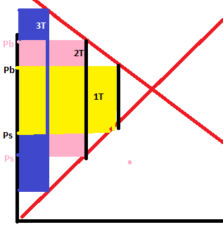
Note: Each colored area goes to the verticle edge, it is just impossible to make overlaps in paint.
The Laffer Curve shows the relationship between the size of the tax and the tax revenue
- Ex. Should the US increase or decrease taxes to reduce budget deficit?
- Conventional wisdom says that they should increase taxes to increase tax revenues
- SSE: taxes are already too high, they act as a disincentive to work, invest and spend
- Other economists say therefore, if government wants to stimulate economic growth and increase tax revenues, they should reduce the tax burden on individuals and corporations
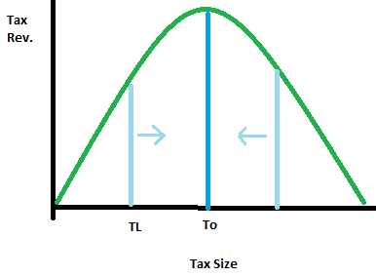
Conclusions:
- The more inelastic the demand and supply the smaller is the deadweight loss
- When a tax is increased DWL increases at an increasing rate
- When a tax is increased tax revenues initially rise
  - But at some point, increasing the tax further will lower tax revenues
  - (i.e. the offset by the loss of tax revenue due to lower quantity sold)
Chapter 9: Application : International Trade
Objectives
- What determines how much of a good a country will import or export?
- Who benefits from trade? Who does trade harm?
- If policy makers restrict imports who benefits and who is harmed?
- What are some common arguments for restricting trade? Do they have merit?
Recall from Chapter 3
- A country has a comparative advantage in a good if it produces the good at a lower opportunity cost than other countries
- Countries can gain from trade if each exports the goods in which it has a comparative advantage
- In this chapter, apply tools of welfare economics to asses where the gains from trade come from and who gets them.
Definitions
- P_{W} = the world price of a good, the price that prevails in world markets
- P_{D}= domestic price without trade
- If P_{D} < P_{W}
  - a country has comparative advantage in the good under free trade, country exports the good
- If P_{D}>P_{W}
  - a country does not have comparative advantage under free trade; country imports the good
The Small Economy Assumption
- A small economy is a price taker in world markets: its actions have no effect on world price (P_{w})
- This is not always true—especially for the U.S. and China—but this assumption simplifies the analysis without changing its lessons (conclusions)
- When a small economy engages in free trade the world price is the only relevant price
- No seller would accept less than P_{w} because seller could sell the good for P_{w} in world markets
- No buyer would pay more than P_{w} because the buyer could buy the good for P_{w} in world markets
The Determinants of Trade
- We will analyze the implications of international trade: who gains and who losses
- An example: we will analyze the steel industry before and after trade for three cases
  - 1. Exporting country where Pw > Pd
  - 2. Importing country where Pw < Pd
  - 3. Imposition of tariff
Case 1:
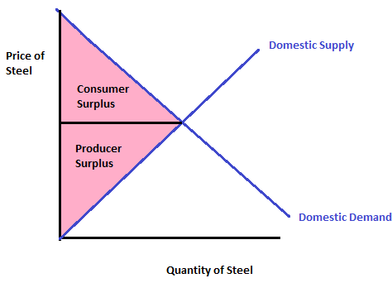

This is an example of a market if there is no trade. Therefore, the price is simply equilibrium price; there is no world price affecting the market.

Case 2:
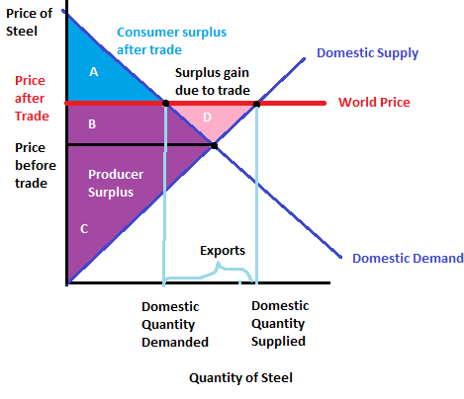
 | Before Trade | After Trade | Change
Consumer Surplus | A + B | A | -B
Producer Surplus | C | B + C + D | + (B + D)
Total Surplus | A + B + C | A + B + C + D | + D
After trade (exporting case)
(1) Consumer surplus fall
(2) Producer surplus increases
(3) Producers gain more than consumers lose
Note that the price has risen and producers’ output is more than without trade

Case 3:
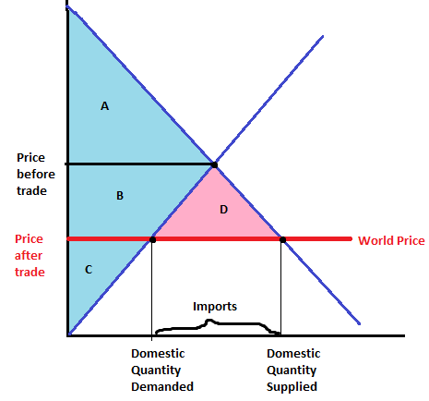
 | Before Trade | After Trade | Change
Consumer Surplus | A | A + B + D | + (B + D)
Producer Surplus | B + C | C | -B
Total Surplus | A + B + C | A + B + C + D | + D

After trade in importing case
(1) Consumers are better off
(2) Producers are worse off
(3) Consumers’ gain exceed producers’ loss
Comparison:
Exporting Country  Consumers are worse off  - Price rises  - Pw > Pd  Producers better off  - Price rises  - Domestic producer output higher  Gains of producers more than offsets losses of consumers | Importing Country  Consumers better off  - Price falls  - Pw < Pd  Producers worse off  - Price falls  - Domestic producer output lower (imports)  Gains of consumers more than offset losses of producers
The Effects of a Tariff
- A Tariff is a tax on goods produced abroad and sold domestically
(i.e. tax on imported goods)
- Raises the price of imported goods above the world price by the amount of the tariff
- Without tariff: relevant price is Pw
- With tariff: relevant price is Pw + tariff
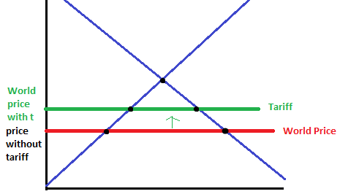

October 19 2011
Announcements:
In Class Exam: Surnames starting with A and up to W (Wilcox) write in SA Theatre B (classroom)
Surnames starting with W (Wilcox)-Z: Write in LA-A204: Loeb Building, Tower A, Room 204
- Much better to understand than to memorize the course material
- Helpful to do examples
- PASS-mock-up exam
- Past exams posted on Webct
- You need to be able to apply principles and concepts
- Not every question with numbers requires a mathematical calculation—think before calculating
Ch: 9 Applications of Trade:
The Determinants of Trade
- Discussing the gains from international trade and who gains, who loses
- Example: the steel industry before and after trade
  - Exporting country
  - Importing Country

Remember:
The Effects of a Tariff
- A Tariff is a tax on goods produced abroad and sold domestically
(i.e. tax on imported goods)
- Raises the price of imported goods above the world price by the amount of the tariff
- Without tariff: relevant price is Pw
- With tariff: relevant price is Pw + tariff
When a tax is introduced in this case, quantity supplied goes up (since the price does increase) while quantity demanded has decreased. The difference between the two is filled with imports from abroad.
The Impact: Domestic production is increased; domestic consumption decreases and imports are reduced
On the diagram above we have three prices:
- Domestic price without trade?
- World price?
- World price with tariff?
  - Which price is relevant? The world price with the tariff.
Remember: only one price can exist in a market for domestic and imported goods.
What happens to surplus/what is the impact of a tariff:
Outcome:
- Consumers lose
- Producers gain
- Government gains tax revenue
- There’s deadweight loss
Other Effects
- Price Rises
- Domestic Output Rises
This can be seen on the graph below:
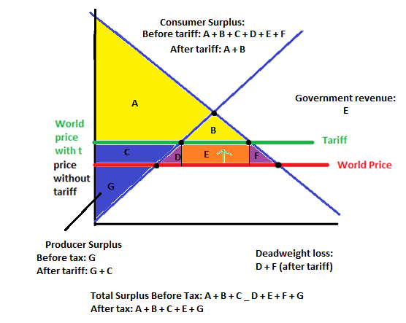
The Effects of an Import Quota:
- Import Quota: another way to restrict trade
- An import quota is a limit on the quantity of a good that can be imported
- Has roughly the same effects as a tariff
- Major Difference:
  - A tariff creates revenue for the government
  - A quota creates profits for the holder of the import license (though government could charge a fee for the import license of auction the license)
Arguments for Restricting Trade
Variety of arguments:
- Jobs
  - Protect domestic jobs
  - Trade destroys jobs in the industries that compete against imports
  - Economists’ response: Total unemployment does not rise as imports rise: job losses from imports are offset by job gains in export industries

- National Security
  - Safeguard security
  - Industry vital to national security: should be protected to prevent dependence on imports that could be disrupted during wartime (strategic industries).
  - Economists’ response: Fine…as long as we base policy on true security needs
    - Producers tend to exaggerate their own importance to national security
- Infant Industry Argument
  - Protect new start-up (emerging) industries
  - Provide temporary protection for new industry until it is mature and can compete with foreign firms
  - Economists Response: Difficult for government to determine which industries will eventually be able to compete (industrial policy)
    - Difficult to assess whether benefits of establishing these industries exceed cost to consumers of restricting imports
- Unfair Competition Argument
  - Foreign industries not subject to same labour and environmental standards
  - Producers often argue their competitors in another country have an unfair advantage, e.g. due to government subsidies, lax labour & environmental standards
  - Economists’ Response: Great! Then we can import extra-cheap products subsidized by the other country’s taxpayers
    - The gains to our consumers exceed the losses to our producers
    - Easier said than done! (Moral questions)
- Protection-as-a-Bargaining Chip
  - Use protection to bargain for future trade concessions
  - Bargaining strategy: (use protection to bargain for concessions—to remove restriction on your exports) if you remove your trade restriction, we will do likewirse
  - Retaliation (threaten to impose restriction because someone is restricting your exports) if you don’t remove your trade restrictions, we will impose our own restrictions on your exports
  - Economists’ Response: Suppose country refuses to remove prohibition. Then Canada must choose between two bad options:
    - Restrict imports from that country; which reduces welfare in Canada
    - Don’t restrict imports, lose face and suffer a loss of credibility
      - Usually, countries require reciprocity
Trade Agreements
A country can liberalize trade through:
- Unilateral reductions in trade restrictions
- Bilateral reductions with one other country
- Multilateral Agreements with a host of other nations
Examples of Trade Agreements:
- Trilateral Trade Agreement:
  - North American Free Trade Agreement (NAFTA)
  - Between Canada, US and Mexico
  - Three countries agreed to reduce tariff and other trade restrictions on a range of products
- Multilateral Agreement:
  - General Agreement on Tariffs and Trade (GATT)
    - Ongoing (successfully reduced the average tariff among member countries from about 40% after WWII to about 5% today on industrial products)
  - World Trade Organization (WTO) est. 1995
    - enforces trade agreements; houses GATT; resolves disputes
Question: International Trade
Using a supply and demand diagram, or otherwise, demonstrate the benefits to society of opening trade in a commodity for which, before trade, the domestic price was below the world price. Example: who wins and who losses from trade in this example? Illustrate using welfare analysis.
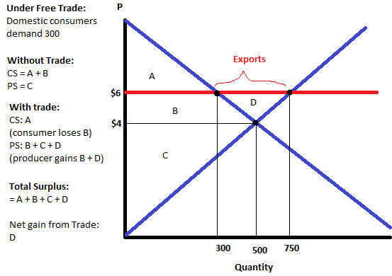
In this case, consumers lose and producers win.

Chapter 10: Externalities
Contents:
What is an externality?
- The uncompensated impact of one person’s actions on the well-being of a bystander
- Negative externality: the effect on bystanders is adverse
- Positive externality: the effect on bystanders is beneficial
When there are externalities, markets don’t allocate resources efficiently.
Governments can sometimes improve market outcomes.
Pollution: A Negative Externality
Example: Air pollution from a factory
- Firm does not bear the full cost of its production because it does not bear the cost of pollution
- It doesn’t take account of pollution costs in its decision making
- As a result the firm will produce more output than the socially efficient quantity.
- Governments may improve the market outcome:
  - By imposing a tax on the firm equal to the external cost of the pollution it generates
  - In this case, the firm will take into account the tax (i.e. pollution cost) in its decision making
Other examples of negative externalities:
- Dog barking next door
- Late-night stereo blasting in a student’s residence room
- Noise from a construction project
- Talking on cell phones while driving makes the roads less safe for others
- Health risk to others from second-hand smoke
Remember, negative externalities are when actions adversely affect bystanders
Positive Externalities:
Positive externalities have a beneficial effect on bystanders.
- Being vaccinated against contagious diseases protects not only you, but other people.
- R&D creates knowledge that others can also use.
- Renovating your house increasing neighbouring property values.
Prime Example: Education
- A more educated population benefits society:
  - Lower crime rates
  - Better government
  - Lower unemployment
  - Better competitiveness
  - Improved economic efficiency and productivity
- These external benefits are not taken into account when deciding how much education to “purchase”.
- Left to the market, provision of education would be too low.
Ch: 9 Applications of Trade:
The Determinants of Trade
- Discussing the gains from international trade and who gains, who loses
- Example: the steel industry before and after trade
  - Exporting country
  - Importing Country

Remember:
The Effects of a Tariff
- A Tariff is a tax on goods produced abroad and sold domestically
(i.e. tax on imported goods)
- Raises the price of imported goods above the world price by the amount of the tariff
- Without tariff: relevant price is Pw
- With tariff: relevant price is Pw + tariff
When a tax is introduced in this case, quantity supplied goes up (since the price does increase) while quantity demanded has decreased. The difference between the two is filled with imports from abroad.
The Impact: Domestic production is increased; domestic consumption decreases and imports are reduced
On the diagram above we have three prices:
- Domestic price without trade?
- World price?
- World price with tariff?
  - Which price is relevant? The world price with the tariff.
Remember: only one price can exist in a market for domestic and imported goods.
What happens to surplus/what is the impact of a tariff:
Outcome:
- Consumers lose
- Producers gain
- Government gains tax revenue
- There’s deadweight loss
Other Effects
- Price Rises
- Domestic Output Rises
This can be seen on the graph below:
The Effects of an Import Quota:
- Import Quota: another way to restrict trade
- An import quota is a limit on the quantity of a good that can be imported
- Has roughly the same effects as a tariff
- Major Difference:
  - A tariff creates revenue for the government
  - A quota creates profits for the holder of the import license (though government could charge a fee for the import license of auction the license)
Arguments for Restricting Trade
Variety of arguments:
- Jobs
  - Protect domestic jobs
  - Trade destroys jobs in the industries that compete against imports
  - Economists’ response: Total unemployment does not rise as imports rise: job losses from imports are offset by job gains in export industries

- National Security
  - Safeguard security
  - Industry vital to national security: should be protected to prevent dependence on imports that could be disrupted during wartime (strategic industries).
  - Economists’ response: Fine…as long as we base policy on true security needs
    - Producers tend to exaggerate their own importance to national security
- Infant Industry Argument
  - Protect new start-up (emerging) industries
  - Provide temporary protection for new industry until it is mature and can compete with foreign firms
  - Economists Response: Difficult for government to determine which industries will eventually be able to compete (industrial policy)
    - Difficult to assess whether benefits of establishing these industries exceed cost to consumers of restricting imports
- Unfair Competition Argument
  - Foreign industries not subject to same labour and environmental standards
  - Producers often argue their competitors in another country have an unfair advantage, e.g. due to government subsidies, lax labour & environmental standards
  - Economists’ Response: Great! Then we can import extra-cheap products subsidized by the other country’s taxpayers
    - The gains to our consumers exceed the losses to our producers
    - Easier said than done! (Moral questions)
- Protection-as-a-Bargaining Chip
  - Use protection to bargain for future trade concessions
  - Bargaining strategy: (use protection to bargain for concessions—to remove restriction on your exports) if you remove your trade restriction, we will do likewirse
  - Retaliation (threaten to impose restriction because someone is restricting your exports) if you don’t remove your trade restrictions, we will impose our own restrictions on your exports
  - Economists’ Response: Suppose country refuses to remove prohibition. Then Canada must choose between two bad options:
    - Restrict imports from that country; which reduces welfare in Canada
    - Don’t restrict imports, lose face and suffer a loss of credibility
      - Usually, countries require reciprocity
Trade Agreements
A country can liberalize trade through:
- Unilateral reductions in trade restrictions
- Bilateral reductions with one other country
- Multilateral Agreements with a host of other nations
Examples of Trade Agreements:
- Trilateral Trade Agreement:
  - North American Free Trade Agreement (NAFTA)
  - Between Canada, US and Mexico
  - Three countries agreed to reduce tariff and other trade restrictions on a range of products
- Multilateral Agreement:
  - General Agreement on Tariffs and Trade (GATT)
    - Ongoing (successfully reduced the average tariff among member countries from about 40% after WWII to about 5% today on industrial products)
  - World Trade Organization (WTO) est. 1995
    - enforces trade agreements; houses GATT; resolves disputes
Question: International Trade
Using a supply and demand diagram, or otherwise, demonstrate the benefits to society of opening trade in a commodity for which, before trade, the domestic price was below the world price. Example: who wins and who losses from trade in this example? Illustrate using welfare analysis.
In this case, consumers lose and producers win.

Chapter 10: Externalities
Contents:
What is an externality?
- The uncompensated impact of one person’s actions on the well-being of a bystander
- Negative externality: the effect on bystanders is adverse
- Positive externality: the effect on bystanders is beneficial
When there are externalities, markets don’t allocate resources efficiently.
Governments can sometimes improve market outcomes.
Pollution: A Negative Externality
Example: Air pollution from a factory
- Firm does not bear the full cost of its production because it does not bear the cost of pollution
- It doesn’t take account of pollution costs in its decision making
- As a result the firm will produce more output than the socially efficient quantity.
- Governments may improve the market outcome:
  - By imposing a tax on the firm equal to the external cost of the pollution it generates
  - In this case, the firm will take into account the tax (i.e. pollution cost) in its decision making
Other examples of negative externalities:
- Dog barking next door
- Late-night stereo blasting in a student’s residence room
- Noise from a construction project
- Talking on cell phones while driving makes the roads less safe for others
- Health risk to others from second-hand smoke
Remember, negative externalities are when actions adversely affect bystanders
Positive Externalities:
Positive externalities have a beneficial effect on bystanders.
- Being vaccinated against contagious diseases protects not only you, but other people.
- R&D creates knowledge that others can also use.
- Renovating your house increasing neighbouring property values.

Prime Example: Education
- A more educated population benefits society:
  - Lower crime rates
  - Better government
  - Lower unemployment
  - Better competitiveness
  - Improved economic efficiency and productivity
- These external benefits are not taken into account when deciding how much education to “purchase”.
- Left to the market, provision of education would be too low.
October 24th 2011
How do we analyze an externality?
Example:
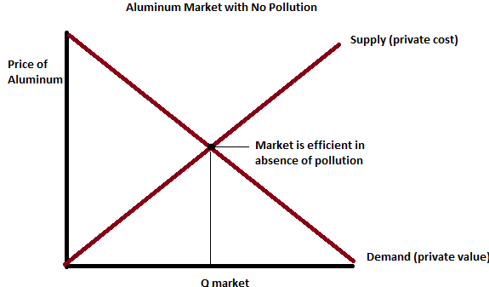
Negative Externalities:
In the presence of a negative externality the social cost of a good includes:
- Private cost: the direct cost to the sellers
- External cost: the cost of the negative impact on bystanders
Social cost = private cost + external cost
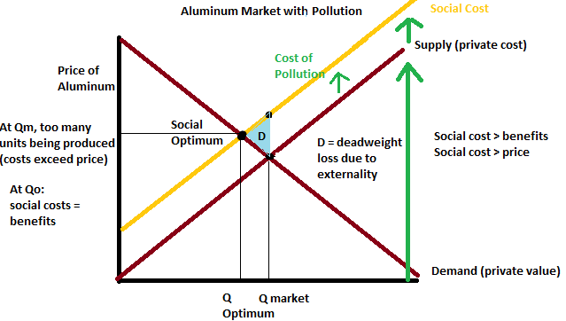
Important: At Qm, you have a deadweight loss of D. If you move from Qm to Qo, DWL is eliminated.
Hence, move from Qm to Qo increases total surplus by H.

Internalizing the Externality
What is meant by internalizing the externality:
Altering Incentives: so that people take account of the external effects of their actions on bystanders
- The government can internalize a negative externality by imposing a tax
- Such taxes are called Pigovian taxes after economist Arthur Pigou
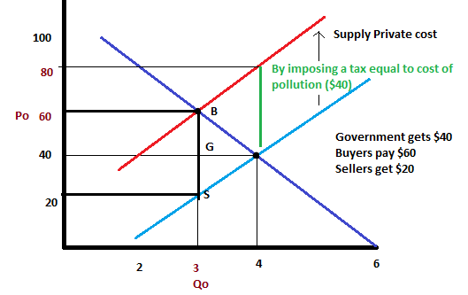
Positive Externalities
In the presence of a positive externality, the social value of a good includes:
- Private value—direct value to buyers
- External benefit—the value of the positive impact on bystanders
Social value = private value + external value
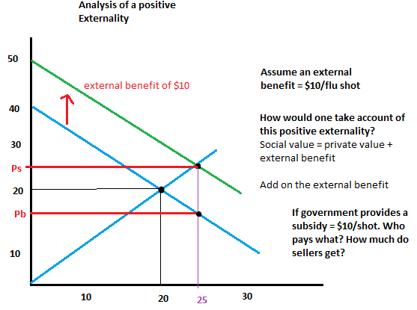
Private Solutions to Externalities
- Government action is not always needed to solve the problem of externalities
- There are private solutions which include
  - Moral codes and social sanctions
  - Charitable & non-profit organisations (e.g. Greenpeace)
- Integrating different types of businesses
  - Example : Apple orchard and bee hives
- Contracting between parties
  - People can bargain and compensate each other for externalities
The Coase Theorem
- The Coase Theorem:
  - The proposition that if private parties can bargain without costs (without transaction costs) over the allocation of resources, they can solve the problem of externalities on their own
- Transaction Costs:
  - costs that parties incur in the process of agreeing to and following through on a bargain
- Private Solutions Often Fail:
  - Because transaction costs can be very high so that private agreement is not possible
Public Policies towards Externalities
If private solutions are not possible, Government may attempt to solve the problem through…
- Command and control policies
  - Regulate behaviour directly
  - Examples:
    - Limits on quantity of pollution emitted
    - Requirements that firms adopts a particular technology to reduce emissions
- Market-based Policies
  - Provide incentives so that private decision-makers choose to solve the problem on their own
  - Examples:
    - Corrective taxes and subsidies
    - Tradable pollution permits

Economists Prefer
Market based to command and control policies.
Why market based preferred?
- Can achieve environmental goals at lower costs
- Producers and consumers have greater flexibility to find the cheapest way to meet goals
- Continuing incentive to develop and implement new technologies
Corrective Taxes vs. Regulations
Different firms have different costs of pollution abatement.
Efficient outcome:
- Firms with the lowest abatement costs reduce pollution the most.
A pollution tax is efficient:
- Firms with low abatement costs will reduce pollution to reduce their tax burden
- Firms with high abatement costs have greater willingness to pay the tax
Regulation
- Requiring all firms to reduce pollution by a specific amount not efficient.
Corrective Taxes:
- Gives firms incentive to continue reducing pollution as long as the cost of doing so is less than the tax
- If cleaner technology becomes available the tax gives firms an incentive to adopt it
Regulations:
- Firms have no incentive for further reduction beyond the level specified in a regulation
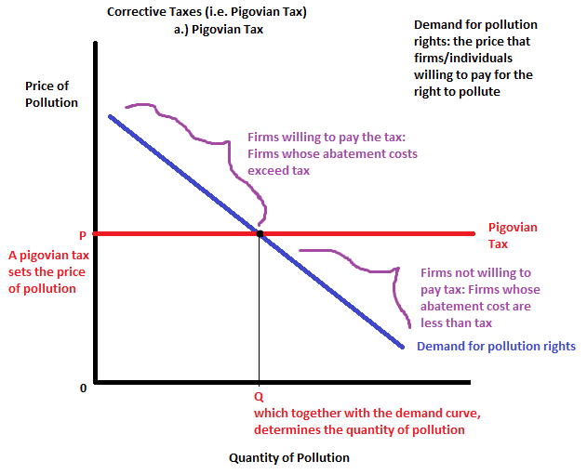
Tradeable Pollution Permits:
What is a pollution permit?
- The right to emit a certain quantity of pollution
Governments can:
- Sell the pollution rights, or
- Allocate these firms and let them trade among themselves (i.e. tradable pollution permit system)
A pollution permit system reduces pollution at lower costs than regulation
- Firms with low cost of reducing pollution will do so and not buy pollution rights
- Firms with high cost of reducing pollution will buy pollution rights
Public Goods and Common Resources Chapter 11
What are public goods and what are common resources?
What do markets generally fail to provide the efficient amounts of these goods?
How might the government improve market outcomes?
“The best things in life are free”
- We consume many goods without paying for them: parks, national defense, clean air and water
- When goods are free, market forces are absent
  - Therefore, market forces cannot allocate resources
- Furthermore, if market forces are absent, private markets will fail to provide socially efficient quantities
- Governments can potentially remedy the market failure
The Different Kinds of Goods
Useful to group goods according to two characteristics:
- Is the good excludable?
Can a person be excluded from its use?
  - Excludable: Big Mac, ice-cream
  - Not excludable: FM radio signals, TV signals, national defense
- Is the good rival in consumption?
Does one person’s use diminish other people’s use?
  - Rival: Big Mac, clothing
  - Not Rival: Fire protection, Cable TV
 | Rival? Yes | Rival? No
Excludable? Yes | Private Goods:  - Ice cream  - Clothing  - Congested toll roads | Natural Monopolies:  - Fire protection  - Cable TV  - Uncongested Toll Roads
Excludable? No | Common Resources:  - Fish in the ocean  - Natural environment  - Congested no toll roads | Public Goods:  - Tornado Siren  - National Defense  - Uncongested no toll roads
Private: “free” market can provide efficient quantities of private goods
Private Market: cannot provide efficient quantities of common resources or public goods.
Private market: can provide monopoly goods but not always in efficient quantities.
Public Goods: A Recap
Public goods:
- Not excludable: firms cannot prevent non-payers from consuming the good
- Not rival: one person’s use does not diminish other person’s use
- Examples: Tornado Siren, Basic Research, Fireworks
What is likely to happen?
The market cannot provide an efficient quantity
Public goods are difficult for private markets to provide because of the free-rider problem
Free-rider: a person who receives the benefit of a good but avoids paying for it
If good is not excludable, firms cannot prevent non-payers from consuming the good. Therefore, why pay for it if you can get it free if provided?
- The good will not be produced in sufficient quantities; even if buyers collectively value the good higher than the cost of providing it
- If you cannot exclude non-payers from consuming the good, not profitable for firms to provide efficient quantity
- Government usually has to provide public goods
Common Resources
Common Resources:
- Like public goods, they are not excludable
- Cannot prevent free riders from using them
- Therefore, little incentive for firms to provide
- But additional problem: rival in consumption
  - Each person’s use reduces others’ ability to use (unlike for public goods)
- Examples of common resources: Clean air, water, fish, whales and other wildlife
Two problems:
- Private markets cannot provide good (good is not excludable)
- But in addition, leads to over consumption or over use (good is rival in consumption)

What is the “Tragedy of the Commons?”
- Common resources are common to everyone
  - Can be used by everyone because not excludable
  - But rival in consumption each person’s use reduces others ability to use
- As much, common resources tend to be over used or over consumed
- Social and private incentives differ:
  - Private incentive: consume as much as possible
  - Social objective: consume sustainably
- Role for government: ensuring that they are not overused
Tragedy of the Commons Example:
Setting: a medieval town, where sheep grave surrounding public land, called the Town Common
Over time: population grows, so does the number of sheep
Outcome: since land is fixed, grass begins to disappear from overgrazing
Why?: Private incentives outweigh the social incentives
Moral: People can no longer raise sheep and feed themselves.
What caused the tragedy?
- The social and private incentives differ
- Private incentives: no family has an incentive to reduce the size of its flock
- Social incentive: use land carefully in a sustained way
- The tragedy due to an externality:
  - Allowing one’s flock to graze on the common land reduces its quality for other families
- People neglect this external cost when making decisions; causing overuse
What good the townspeople have done to prevent the tragedy?
- Regulate: the number of sheep per family
- Internalize the Externality: by use of market based policies:
  - Impose a tax on sheep
  - Sell/auction off a limited number of sheep-grazing permits
- Grant property rights: divide the land, sell lots to individual families. Convert the land to a “private good”
Why isn’t the Cow extinct?
- Private ownership and the profit motive
- Someone owns them! They have property rights over the cows.

The Importance of Property Rights
Public goods tend to be underprovided.
Common resources tend to be over-consumed.
Why?
- Markets fail to allocate resources efficiently because property rights are not well established
- Nobody owns the air, so no one can charge polluters; result is too much pollution
- Nobody can charge people who benefit from national defense; result is too little defense
- Nobody owns the fish in the oceans; result is fish over harvested/fished
Markets can only function well if property rights are well defined and legally protected.
In the absence of property rights, markets will fail.
But the government can potentially solve the problem:
- Regulate:
  - Restrict fishing and hunting seasons
  - Protect endangered species
- Use market based policies:
  - Tax pollution or sell pollution rights/permits
  - Sell licenses for commercial fishing
- Government can provide service
  - National defense
Chapter 13—Costs of Production
Starting a set of 5 chapters on Industrial Organization
How market structure affects firms’ decisions on price and quantity
- Chap 13: Cost of Production
- Chap 14: Competitive Markets
- Chap 15: Monopoly
- Chap 16: Monopolistic Competition
- Chap 17: Oligopoly
** If usually 3rd or 4th edition, instead of 5th edition, chapters 16 and 17 are switched
Objectives for Chapter 13
- What is a production function?
- What is marginal product?
- What are the various costs and how are they related to each other and to output?
- How are costs different in the short run vs. the long run?
- What are economies of scale?
Total Revenue, Total Cost and Profit
We assume that the firm’s goal is to maximize profit.
- Profit = Total revenue – Total Cost
Costs: Explicit vs. Implicit
- Explicit Costs: requires an outlay of money e.g. paying wages to workers
- Implicit Costs: do not require a cash outlay e.g. the opportunity cost of the owner’s time, the normal return on capital
- The cost of something is what you give up to get it
  - True whether the costs are explicit or implicit
  - Both matter for firms’ decisions
An example: Explicit vs. Implicit Costs
You need $100,000 to start your business. The interest rate is %5.
Case 1: you borrow $100,000
- Explicit cost = $5000 annual interest or loan (100,000 x 0.05 = $5000)
Case 2: Use $40,000 of your savings and borrow the other $60,000
- Explicit cost = $3000 interest on the loan
- Implicit Costs = $2000 foregone interest you could have earned on your $40,000 (you could have left it in the bank and gained 5% off your 40,000—which is $2000)
- In both cases, total (exp + imp) cost are $5000.
Economic Profit vs. Accounting
Accounting profit = total revenue – total (explicit) costs
Economic profit = total revenue – total (explicit + implicit) costs
- Explicit + Implicit is basically the opportunity cost
For an economist, normal rate of return is included in implicit costs. Economic profit is over and above the normal rate of return.
There is a table in your book that shows the difference between Economists and Accountants.
Chapter 13 Continued…
The Production Function
- Shows the relationsip between the quantity of inputs used to produce a good and the quantity of output of that good
- i.e. it relates quantity produced of the good to quantity of inputs used to produce the good
- It can be represented by a table, equation or graph
- Example:
  - Farmer Jack grows wheat
  - He has 5 acres of land
  - He can hire as many workers as he wants
L (no. of workers) | Q (bushels of wheat)
0 | 0
1 | 1000
2 | 1800
3 | 2400
4 | 2800
5 | 3000

Marginal Product
- Marginal product of any input: is the increase in output arising from an additional unit of that input, holding all other inputs constant
- If farmer Jack hires one more worker, his output rises by the marginal product of labour
  - Increase in output resulting from one additional worker
- Marginal product of labour (MPL) = change in Q/change in L
L (no. of workers) | Q (bushels of wheat) | MPL
0 | 0
1 | 1000 | 100
2 | 1800 | 800
3 | 2400 | 600
4 | 2800 | 400
5 | 3000 | 200

MPL equals the slope of the production function. Notice that MPL diminishes as L increases.
This explains why the production function gets flatter as you add more L.
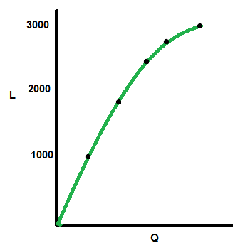
Why is MPL important?
- When Farmer Jack hires an extra worker, his output rises by MPL (i.e. increase in output due to 1 additional worker)
- What is the increase in total revenue attributable to the increase in output?
  - Increase in output = MPL
  - Price of bushel of wheat = P
  - Increase in TR = P x MPL
- To decide whether to hire an extra worker, Jack compares the increase in cost to the increase in total revenue
- His costs by the wage he pays the worker
  - Change in cost = wage (paid to extra worker)
  - His total revenue increases by TR = (P x MPL)
- Jack hires the worker if the increase in cost is less than the increase in total revenue
  - Change in cost < increase in total revenue
  - Wage < P X MPL
Why MPL Diminishes
- Diminishing marginal product: marginal product of an input declines as the quantity of the input increases (other things equal)
- Why?
  - If Jack increases workers but not land, the average worker has less land to work with, so will be less productive
  - As MPL diminishes as L rises whether the fixed input is land or capital (equipment, machines etc.)

Farmer Jack’s Production Costs
Example:
- Farmer Jack grows wheat
- He has 5 acres of land
- He can hire as many workers as he wants
- Fixed costs: 5 acres of land
  - Assume he pays $1000 per month for the land, regardless of how much wheat he grows
- Variable costs: function of how many workers he hires
  - Assume the market wage for a farm worker is $2000 a month
- Let’s relate Farmer Jack’s cost of production to how much wheat he produces…
  - Relate costs to output
L (# of workers) | Q (bushels of wheat) | Cost of land | Cost of labour | Total cost
0 | 0 | 1000 | 0 | 1000
1 | 10000 | 1000 | 2000 | 3000
2 | 1800 | 1000 | 4000 | 5000
3 | 2400 | 1000 | 6000 | 7000
4 | 2800 | 1000 | 8000 | 9000
5 | 3000 | 1000 | 10,000 | 11,000

Marginal Cost
- Marginal Cost (MC)—the increase in total cost from producing one more unit
  - MC = change in Total Cost / Change in Output
L (# of workers) | Total cost | Marginal Cost (MC)
0 | 1000
1 | 3000 | $2.00
2 | 5000 | $2.50
3 | 7000 | $3.33
4 | 9000 | $5.00
5 | 11,000 | $10.00

As you produce more and more units, each additional unit is costing more and more.
MC usually rises as quantity/output rises, as in this example. You can see this graphically if you plot quantity versus marginal cost.

Why is MC Important?
Jack is rational and wants to maximize his profit.
Question: To increase profit, should he produce more wheat or less?
To answer question: Jack needs to think at the margin
Must compare:
- Increase in cost to additional bushel of wheat to the increase in revenue from selling it
Profit maximizing rule:
- If the MC < TR
  - Then Jack’s profit rises if he produces more
General Rule:
- If MC < change in TR then produce the unit
- If MC > change in TR then do not produce unit
Fixed and Variable Costs
Fixed Costs (FC)
- Do not vary with the quantity of output produced
- For Farmer Jack, the F = $1000 for his land
- Other examples: equipment cost, loan payments, rent
Variable Costs (VC)
- Vary with the quantity produced
- For Farmer Jack, VC = wages he pays workers
- Other example: cost of materials
Total Costs (TC) = FC + VC
Generalized Examples of Various Cost Curves
Take a look at these shapes, most businesses will have one of these cost curves. These can be found on the slides or in the textbook (Sorry I cannot draw them fast enough before he changes the slides).
Average Fixed Costs:
- Is fixed costs divided by the quantity of output
- AFC = FC/Q
- Notice that average fixed costs fall as quantity rises
Average Variable Costs
- Is variable cost divided by the quantity of output:
- AVC = VC/Q
- As Q rises, AVC may fall initially. In most cases, AVC will eventually increase as output rises.
Average Total Cost
- Is total cost divided by the quantity of the output:
- ATC = TC/Q
- Also ATC = AFC + AVC
- Usually, the ATC curve is U-shaped.
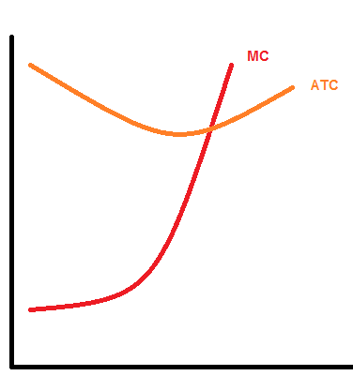
If there is anything you must remember from this lesson, it is that marginal costs increase and the curve for average total cost is U-shaped.
ATC = AFC + AVC
It is U-shaped because the AFC declines, while the AVC increases. At first the AFC declines faster than AVC increases, however, eventually the increase in AVC will be greater than the decrease of AFC, making the line go back up (making an overall U-shape).
When MC < ATC, ATC is falling.
When MC > ATC, ATC is rising.
The MC curve crosses the ATC curve at the ATC curves minimum.
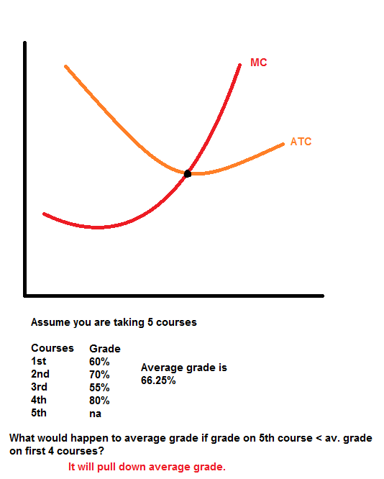
Three Important Properties of the Cost Curves
- Marginal cost (MC)
  - Eventually rises with the quantity of output
- Average Total cost curve (ATC)
  - Is u-shaped
- Marginal-cost curve
  - Crosses the average total cost curve at the minimum average total costs
Cost in the Short Run & Long Run
- Short run:
  - some inputs are fixed, such as factories, land etc.
  - some inputs are variable; such as labour, materials etc.
- Long run
  - All inputs are variable
    - (e.g. firms can build more factories, or sell existing ones)
- Illustrate the long run situation:
  - What happens when firms can build and sell existing plants?

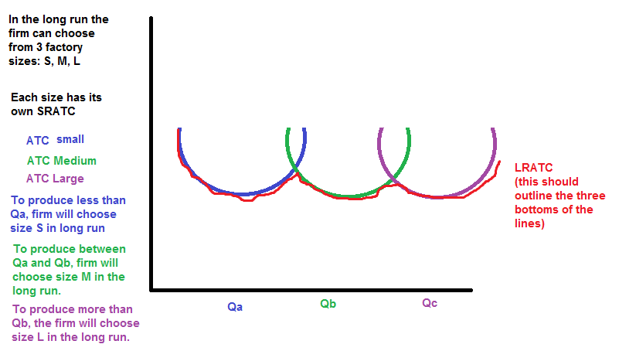
How ATC Changes as the Scale of Production Changes
Economies of Scale:
- Occur when increasing production allows greater specialization
- Workers are more efficient when focusing on a narrow task
- More common when Q is low
Diseconomies of Scale:
- Usually due to coordination problems in large organizations
- Management becomes stretched, can’t control costs
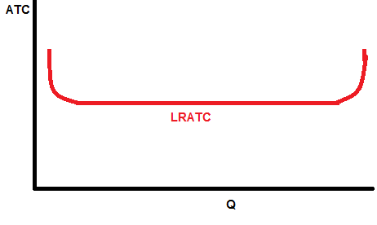
November 7th, 2011
Introduction: The Four Types of Market Structure
Monopoly: One firm producing all of the product (ex. Tap water, Cable TV)
Oligopoly: Few firms (Tennis balls, Crude oil)
Monopolistic Competition: Many firms producing differentiated products (ex. Novels, Movies)
Perfect Competition: Many firms producing identical products (ex. Wheat and Milk)
The fewer firms there are, the closer they behave like a monopoly.
We will examine the behavior of firms and how they set quantity and price in relation to their market structure.
Contents of Chapter 14
- Examine behavior of competitive firms
- How does a competitive firm determine the quantity that maximizes profits?
- When should the firm shut down in the short run?
  - Exit the market in the long run?
- What does the market supply curve look like
  - In the short run?
  - In the long run?
Characteristics of Perfect Competition
- Many buyers & many sellers
- The goods offered for sale are largely the same
- Firms can freely enter or exit the market
Because of 1 & 2, sellers are price takers.
Revenue of a Competitive Firm
Total Revenue: TR = P x Q
Average Revenue: AR = TR/Q = P
Marginal Revenue (The change in TR from selling one more unit): MR = change in TR/change in Q
Q | P | TR = P x Q | AR = TR/Q | MR = change in TR/change in Q
0 | $10 | $0 | n.a. | -----
1 | $10 | 10 | 10 | $10
2 | $10 | 20 | 10 | $10
3 | $10 | 30 | 10 | $10
4 | $10 | 40 | 10 | $10
5 | $10 | 50 | 10 | $10
Notice that when looking at the table, Marginal Revenue is equal to Price.
MR = P for a Competitive Firm
- A competitive firm can keep increasing its output without affectnig the market price
- So each one unit increase in Q caused revenue to rise by P, i.e. MR = P
- MR = P is only true for a competitive market
Profit Maximization
What quantity (Q) maximizes the firms profit?
- If Q is increased by one unit, revenue rises by MR, cost rises by MC.
General Rule:
- If marginal revenue is greater than Marginal cost, then raise quantity to raise profit.
- If marginal revenue is less than marginal cost, then reduce Q to raise profit
Q | TR | TC | Profit | MR | MC | Change in Profit = MR - MC
0 | 0 | 5 | -5
1 | 10 | 9 | 1 | 10 | 4 | 6
2 | 20 | 15 | 5 | 10 | 6 | 4
3 | 30 | 23 | 7 | 10 | 8 | 2
4 | 40 | 33 | 7 | 10 | 10 | 0
5 | 50 | 45 | 5 | 10 | 12 | -2

At any Q, with MR > MC, increasing Q raises profit.
At any Q, with MR < MC, reducing Q raises profit.
Therefore, profit is maximized where MR = MC.
MC and the Firm’s Supply Decision
MR = MC (generalized rule)
However, in a competitive situation MR = AR = P
Then, profit miximizing condition is where MR = MC = P for a competitive firm.
MR = MC = P only applies in competitive situation where firm is a price taker
MR = MC applies to all cases.
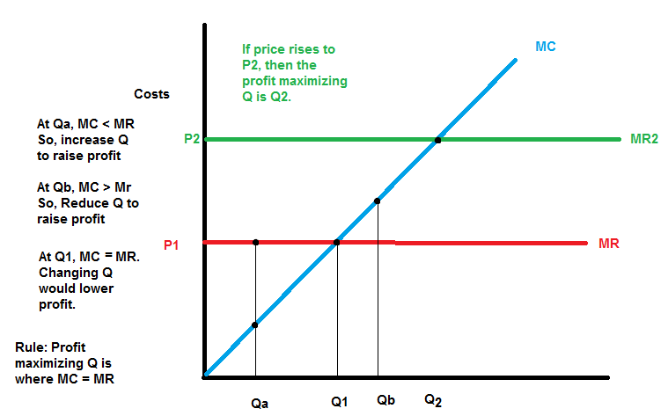
Firms in a Competitive Market
Definitions:
- Shutdown: a short run decision not to produce anything because of market conditions.
  - Temporary closure of production.
- Exit: A long run decision to leave the market
A key difference: If shut down is short run, must still pay fixed costs. If exit in long run, zero costs.
A Firm’s Short-Run Decision to Shutdown
Cost of shutting down: Revenue loss = TR
Benefit of shutting down: Cost savings = VC (firms must still pay FC).
So shut down if TR < VC.
Divide both sides by Q: TR/Q < VC/Q
So firms decision rule is: Shut down if P < AVC
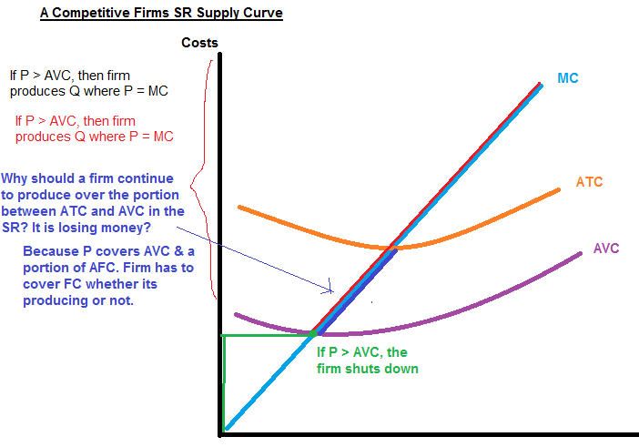
The Irrelevance of Sunk Costs
Sunk Costs:
- A cost that has already been committed and cannot to recovered
Sunk Costs should be irrelevant to decisions
- You must pay them regardless of your choice
Firms Long-Run Decision to Exit the Market
Cost of exiting the market: Revenue loss = TR
Benefit of exiting the market: Cost savings = TC (zero FC in the long run)
So firm exits if it expects that TR < TC
Exit if P < ATC
If the firm expects P < ATC in the long run then it should exit the market.
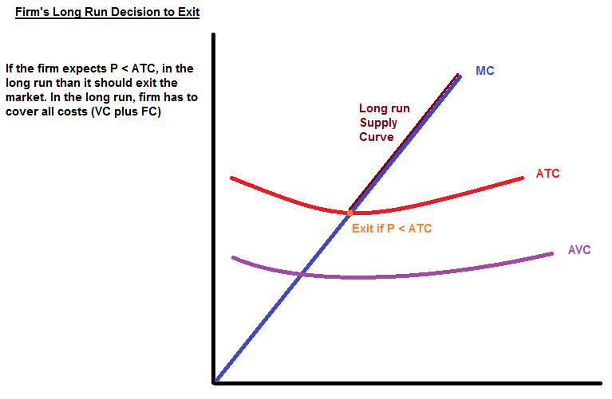
A New Firm’s Decision to Enter the Market
When should a firm enter the market?
In the long run, a new firm should enter the market if it is profitable to do so; that is, if it expects TR > TC in the long run. Or, stated in another way, if it expects P > ATC.
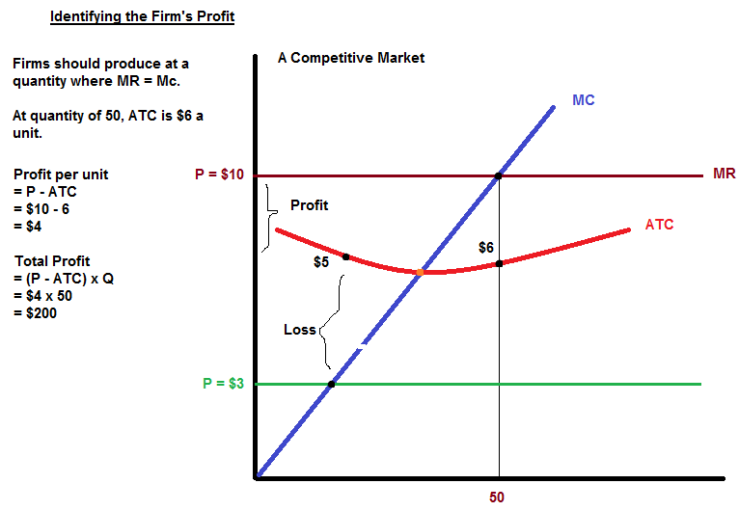
Market Supply Assumptions
Simplifying Assumptions
We have examined one firm’s supply, now we shall examine market supply.
- All exisiting firms & potential entrants have identicial costs
- Each firm’s cost do not change as other firms enter or exit the market
- The number of firms in the market is
  - Fixed in the short run (due to fixed costs)
  - Variable in the long run (due to free entry and exit)
The SR Market Supply Curve
- As long as P > AVC, each firm will produce its profit maximizing quantity where MR = MC.
- At each price, the market quantity supplied in the sum of the quantity supplied of the firm
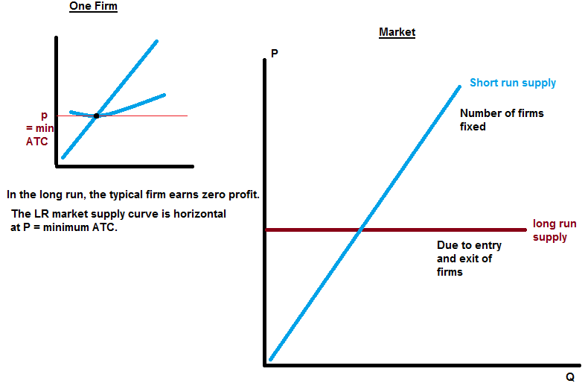

Entry and Exit in the Long Run
- In the long run, the number of firms can change
- If exising firms earn positive economic profit
  - New firms enter
  - SR market supply curve shifts right
  - P falls, reducing firms profit
  - Entry stops when firms’ economic profits have been driven to zero
- If existing firms incur losses
  - Firms exist until they cannot incur the losses
Firms of Competitive Markets Chapter 14 continued
Monday
- Covered the behavior of competitive firms in the short run
- Also initiated discussion of the long term
Entry and Exit in the Long Run
- In the short run, the number of firms is fixed
- In the long run, the number of firms can change due to entry and exit of firms
- If existing firms earn positive economic profit:
  - New firms enter
  - SR market supply shifts right
  - P falls, reducing profits and slowing entry
- If existing firms incur losses
  - Some firms exit
  - SR market suppy shifts left
  - P rises, reducing remaining firms losses

Long run equilibrium: When the process of entry or exit is complete—the remaining firms earn zero economic profit
- Zero economic profit occurs when P = ATC
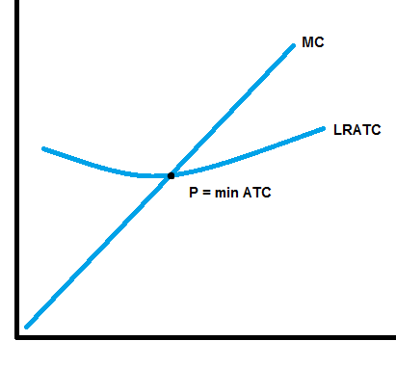
- Since firms produce where P = MR = MC the zero profit condition is P = MC = ATC
- Recall that MC intersects ATC at minimum ATC
- Hence, in the long run, P = minimum ATC
SR & LR Effects of An Increase in Demand
Typical long answer question:
- Assume that demand for sunflower oil increases
- What will happen to price and output in the market for sunflower oil?
- Consider both the short and the long run.
- Use diagrams to illustrate your answer.
A firm begins in long-run equilibrium.
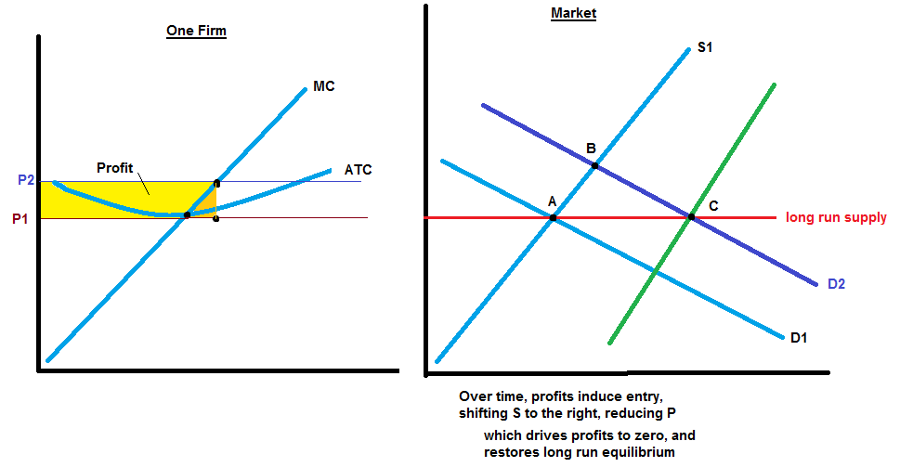

Question 2:
- Same question but with a DECREASE in demand
Outcome:
- Firms are back at LR eq-m
- Market quantity falls (from Q1 to Q2 to Q3)
- Price intitially falls but then moves back to P1
- Fewer firms in the market
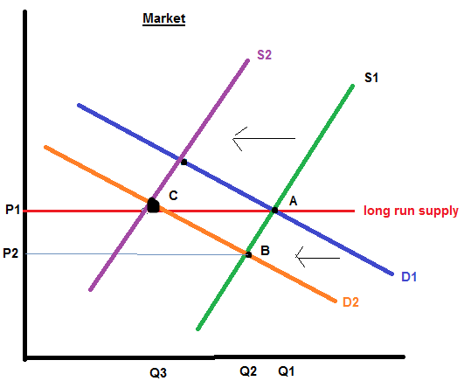
Why the LR Supply Curve Might Slope Upward
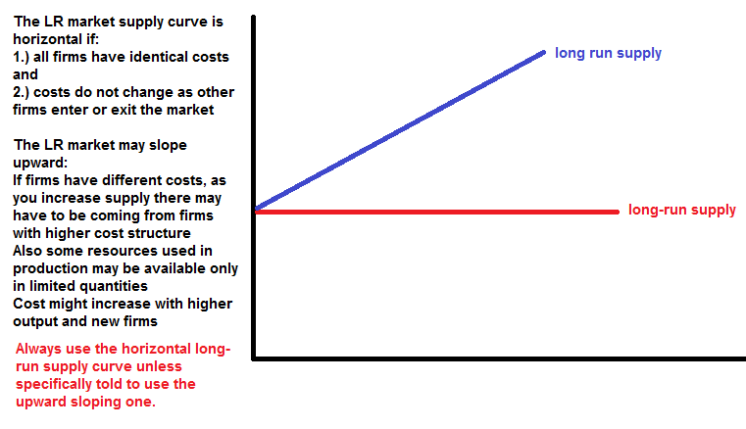

Chapter 15 – Monopoly
Contents
- What is a monopoly?
  - Why do they arise?
  - How do they choose their P and Q?
  - How do they affect society’s well being?
  - What can the government do about monopolies?
- What is price discrimination?
Monopoly and Market Power
Monopoly
- Firm that is the sole seller of a product without close subsitutes.
- A monopoly firm has market power: the ability to influence the market price of the product it sells
A competitive firm has no market power
- It is a price taker while a monopoly firm is a price maker
Why do Monopolies Arise?
The fundamental cause of monopoly is barriers to entry: when it is difficult for other firms to enter the market and compete.
There are three sources of these barriers:
(1) Ownership of a key resource
- E.g. DeBeers owns most of the world’s diamond mines
(2) The government gives a single firm the exclusive right to produce some good
- E.g. patents, copyright laws
(3) Natural Monopoly: A single firm can produce the entire market Q at lower cost than could several firms
- This can occur when a firm’s average total cost curve continously decliens over the relevent size of the market
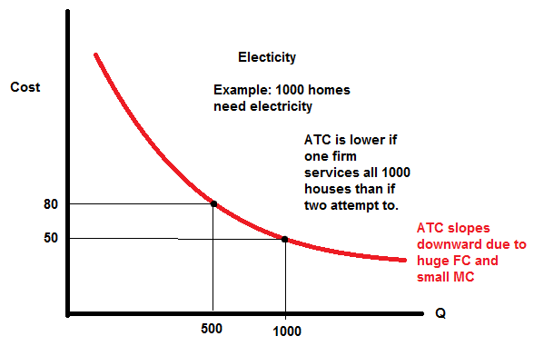
Monopoly vs. Competition: Demand Curves
- In a competitive market, the market demand curve slopes downward
  - But the demand curve for any individual’s firm;s product is horizontal at the market price
  - The firm can increase Q without lowering P
  - MR = P for the competitive firm
- A monopolist is the only seller, so it faces the market demand curve
  - To sell a larger Q, the firm must reduce P
  - Thus MR is NOT equal to price
Q | P | TR | AR | MR
0 | $4.50 | 0 | n.a.
1 | $4.00 | 4 | 4 | 4
2 | $3.50 | 7 | 3.50 | 3
3 | $3.00 | 9 | 3.00 | 2
4 | $2.50 | 10 | 2.50 | 1
5 | $2.00 | 10 | 2.00 | 0
6 | $1.50 | 9 | 1.50 | -1

Remember
TR = P x Q
AR = TR/Q
Here, P = AR, same as for a competitive firm
MR = change in TR/ change in Q
Here MR < P whereas in a competitive firm, MR = Price
Understanding the Monopolist’s MR
- A monopolist is the only seller so it faces the market demand curve
- To sell a larger Q, the firm must reduce P
- Increasing Q has two effects on revenue:
  - The output effect: more output is sold, which raises revenue
  - The price effect: the price falls, which lowers revenue
- To sell a larger Q, the monopolist must reduce the price on all the units it sells
  - MR < P
Profit Maximization
Like a competitive firm, a monoplist maximizes profit by producing the quantity (Q) where MR = MC
Once the monopolist identifies this quantity, it sets the highest price consumers are willing to pay for that quantity
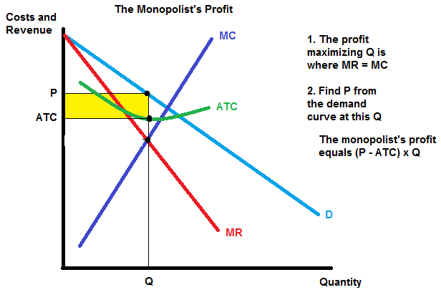

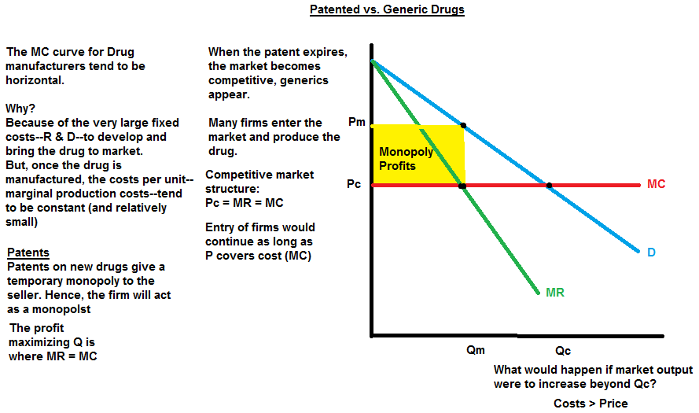

November 16, 2011
Monopolistic Competition Continued
Introduction: The Four Types of Market Structure
Many firms, identical product—perfect competition
Q at P = MR = MC
LR: P = min ATC
One firm producing the product—Monopoly
Q at P > MR = MC
LR: P > ATC > MC
Many times, differientiated products—Monopolistic competition
Q at P > MR = MC
LR: P = ATC > MC
Main features of Monopolistic Competition
Many sllers
- Competiting for the same group of customers
Product differentiation
- Products are similar but slightly differentiaited from those of other firms
Free entry and exit
- Firms can easily enter and exit industry.
A Monopolistically Competitive Firm Earning Profits in the Short Run
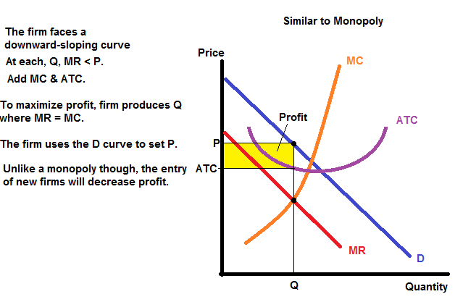
Firm is making economic profit. In the long run, new firms enter the industry, D curve and MR curve shift to left (fall).
Why? Because new firms take demand away from existing firms.
New output and price where MR 1 = MC
Economic profits are eliminated since P2 = ATC.
A Monopolistically Competitive Firm Lossing Profits in the Short Run.
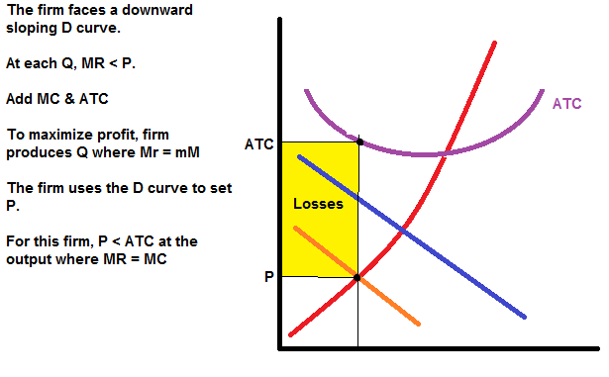
In the Long Run…
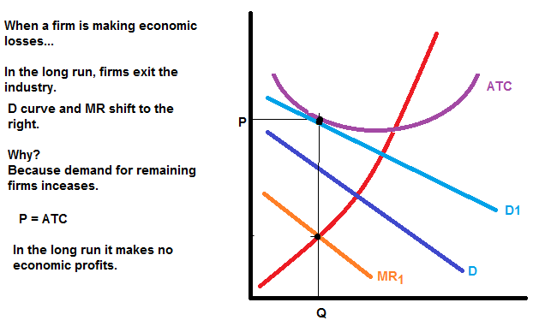

Recap:
Entry and exit occurs until P = ATC and profit = zero.
Notice that the firm charges a markup of price over marginal cost and does not produce at minimum ATC.
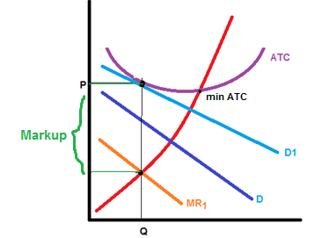

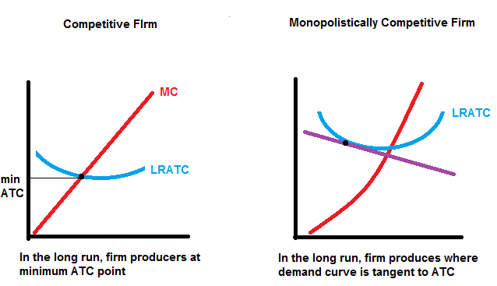
Why Monopolistic Competition is Less Efficient than Perfect Competition
There is a markup.
There is excess capacity.
- Monopolistic operates on downward sloping part of ATC, produces less than the cost-minimizing output.
- Under perfect competition, firms produce quantity that minimizes ATC.
Monopolistic Competition and Welfare
Monopolistically competitive markets do not have all the desirable welfare properties of perfectly competitive markets.
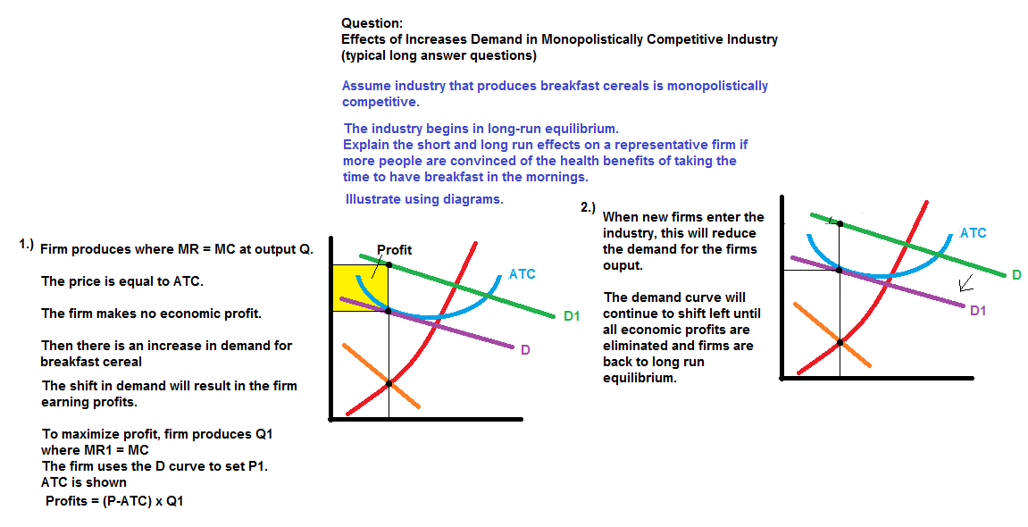
Advertising
In monopolistically competitive industries because of:
product differentiation, markup pricing (P > MC) and excess (idle) capacity.
Firms have an incentive to advertise in order to attract more buyers to its particular product.
- Try to shift the demand curve to the right
- By enticing customers to switch to their product
Economists disagree on the social value of advertising.
The Critique of Advertising
Critics of advertising believe:
- Society is wasting the resources it devotes to advertising (advertising spending about $20 billion)
- Firms advertise to manipulate peoples’ tastes
The Defense of Advertising
- Provides useful information to buyers
- Informed buyers can more easily find and exploit price differences
- Increases competition by offering a greater variety of products and prices
- The willingness of a firm to spend advertising and be a signal to consumers about the quality of the product being offered
  - Regardless of the content of ads
  - Ads may convince buyers to try a product once, but the product must be of high quality for people to become repeat buyers
  - The most expensive ads are not worthwhile unless they lead to repeat buyers
  - When consumers see expensive ads, they think the product must be good if the company is willing to spend so much on advertising
Brand Names
- In many markets, brand name products coexist with generic ones
  - Brand: Kellogg’s, Tide
  - Generic: No Name Products
- Firms with brand names usually spend more on advertising and charge higher prices for the products
- Critiques argue that:
  - Brand names cause consumers to perceive differences that do not really exist.
  - Consumers’ willingness to pay more for brand names is irrational, fostered by advertising.
- The Defenders of Band names:
  - Brand names provide information about quality to consumers.
  - Companies with brand names have incentive to maintain quality to protect the reputation of their brand names.
Chapter 17 - Oligopoly

What is an oligopoly and possible outcomes?
Why is it difficult for poligopoly firms to cooperate?
Learn about the prisoner's dilemma and how it applies to oligopoly and other issues
How the antitrust laws foster competition

Oligopoly: Between Competition and Monopoly

Two extremes:
- Competitive markets: many firms, identical products
- Monopoly: one firm in marketplace

In between these extremes:
- Monopolistic competition: many firms sell similar but not identical products
- Oligopoly: only a few sellers selling similar or identical products

Markets with only a few sellers

Because an oligopolistic market has only a few sellers, a key feature of oligopoly is the tension between cooperation and self interest
- Cooperation: Cooperating and acting like a monopolist
- Self-Interest: Caring about maximizing its own profit

Cell Phone Duopoly in Small Town
- Small town has 140 residents
- The good: cell phone service with unlimited anytime minutes and free phone
- Smalltown's demand schedule
P | Q | Revenue | Cost | Profit | TR = P x Q  Cost = 10 x Q  Profit = TR - Cost  Competitive Outcome:  P = MC = $10  Q = 120  Profit = 0 | The Monopoly Outcome:  P = $40  Q = 60  Profit = $1,800
0 | 140 | 0 | 1400 | -1,400 |  | The Monopoly Outcome:  P = $40  Q = 60  Profit = $1,800
5 | 130 | 650 | 1300 | -650 |  | The Monopoly Outcome:  P = $40  Q = 60  Profit = $1,800
10 | 120 | 1200 | 1200 | 0 |  | The Monopoly Outcome:  P = $40  Q = 60  Profit = $1,800
15 | 110 | 1650 | 1100 | 550 |  | The Monopoly Outcome:  P = $40  Q = 60  Profit = $1,800
20 | 100 | 2000 | 1000 | 1000 |  | The Monopoly Outcome:  P = $40  Q = 60  Profit = $1,800
25 | 90 | 2250 | 900 | 1350 |  | The Monopoly Outcome:  P = $40  Q = 60  Profit = $1,800
30 | 80 | 2400 | 800 | 1600 |  | The Monopoly Outcome:  P = $40  Q = 60  Profit = $1,800
35 | 70 | 2450 | 700 | 1750 |  | The Monopoly Outcome:  P = $40  Q = 60  Profit = $1,800
40 | 60 | 240 | 600 | 1800 |  | The Monopoly Outcome:  P = $40  Q = 60  Profit = $1,800
45 | 50 | 2250 | 500 | 1750 |  | The Monopoly Outcome:  P = $40  Q = 60  Profit = $1,800

- One possible duopoly outcome: collusion
- Collusion: an agreement among firms in a market about quantities to produce or prices to charge
- Bello and Telo could agree to produce half of the monopoly output
  - Each firm: Q = 30, P = $40, profits = $900
- Cartel: a group of firms acting in unison, e.g. Bello and Telo collude

Duopoly outcome with collusion:

P | Q | Each firm agrees to produce Q = 3-, P = 40, earns profit of 900  If Bello reneges on the agreement and produces Q = 40;  Market quantity = 70 (Bello 40, Telo 30) P = $35  Bello's profit = 40 x (35-10) = 1,000 $1000  Telo's profits will fall  Market quantity= 70; Telo's Q = 30, P = 35  Telo's profit = 30 x (35-10) = 750 $750  Hence Telo will increase output to 40 to increase profits  Therefore, total Q qill increase to 80 and P will fall to 30
0 | 140
5 | 130
10 | 120
15 | 110
20 | 100
25 | 90
30 | 80
35 | 70
40 | 60
45 | 50

If each firm produces Q = 40, then each firm's profit = $800.

Is it in Bello's interest to increase its output further to Q = 50?
- If Bello increases output to Q = 50
- Market quantity = 90, P = 25
- Bello's profit = 50 x (25-10) = 750
Bello's profits are higher at Q = 40 than at Q = 50. The same would be true for Telo as well.
There is no incentive for either firm to increase output any further.
This is known as the Nash equilibrium.

Collusion vs. Self Interest
- Both firms would be better off if both stick to the cartel agreement
- But each firm has incentive to renege on the agreement

The Equilibrium for an Oligopoly
- Nash Equilibrium: a situation in which economic participants interacting with one another each choose their best strategy given the strategies that all the others have chosen
- Our duopoly example has a Nash Equilibrium in which each firm produces Q = 40
Telo's best move is to produce Q = 40
- If Telo produces Q = 40, Bello's best move is to produce Q = 40

Oligopoly: Output & Price Effects
Increasing output has two effects on a firm's profits:
- Output effect: selling more output raises profits
- Price effect: raising production increases market quantity which reduces market price and reduces profits on all units sold
General rule:
- If output effect > price effect, the firm increases production
- If price effect > output effect, the firm reduces production
- This is how we got Nash equilibrium in duopoly case

The Size of the Oligopoly
- As the number of firms in the market increases,
  - The price effect becomes smaller (output effect becomes stronger)
  - Tendency to cheat and expand output is stronger
  - The oligopoly looks more and more like a competitive market
  - P approaches MC (competitive situation)
  - The market quantity (Q) approaches the socially efficient quantity

Game Theory
- Game Theory: the study of how people behave in strategic situations
- Dominant strategy: a strategy that is best for a player in a game regardless of the strategies chosen by the other players
- Prisoner's dilemma: a "game" between two captured criminals that illustrates why cooperation is difficult even if it is mutually beneficial

The Setting:
- The police caught Bonnie and Clyde, two suspected bank robbers, but only have enough evidence to imprison each for one year
- The police question each in separate rooms
The deals:
- Police offer each the following deal:
  - If you confess and implicate your partner you go free
  - If you do not confess, but your partner implicates you, you get 20 years in prison
  - If you both confess, each gets 8 years in prison

 |  | Bonnie's Decision | Bonnie's Decision
 |  | Confess | Remain Silent
Clyde's Decision | Confess | Bonnie gets 8 years  Clyde gets 8 years | Bonnie gets 20 years  Clyde goes free
Clyde's Decision | Remain Silent | Bonnie goes free  Clyde gets 20 years | Bonnie gets 1 year  Clyde gets 1 year

Dominant strategy:
Confessing Is the best strategy for both players, irrespective of the strategy of the other.
Moral of the story: Position yourself to minimize your loss irrespective of the strategies of others.

Oligopolies as a Prisoners' Dilemma
When oligopolies form a cartel in hopes of reaching the monopoly outcome, they become players in a prisoners' dilemma
Out earlier example:
- Bello and Telo, duopolist in Smalltown
- The cartel outcome maximizes profits: each firm agrees to serve Q = 30
- However, the logic of self interest takes over and they cheat on the agreement
- Here is the payoff…

 |  | Bello | Bello
 |  | Q = 30 | Q = 40
Telo | Q = 30 | Bello's profit = $900  Telo's profit = $900 | Bello's profit = $1000  Telo's profit = $750
Telo | Q = 40 | Bello's profits = $750  Telo's profit = $1000 | Bello's profit = $800  Telo's profit =$800

Why People (Firms) Sometimes Cooperate
When the game is repeated many times, cooperation may be possible
- Firms that care about future profits will cooperate in repeated games rather than cheat
- Why?
  - Because they learn from experience, its better to cooperate
  - OPEC countries have been successful at times in cooperating to set highger prices
  - But this requires everyone to play the game; it only takes one to break ranks for others to follow

Welfare Implications; Prisoner's Dilemma
The non-cooperative oligopoly equilibrium
- Bad for oligopoly firms: prevents them from achieving monopoly profits
The good for society
- Q is closer to the socially efficient output
- P is closer to MC

An aside: in other prisoner's dilemmas: the inability to cooperate may reduce social welfare
- e.g. arms race, nuclear weapons, overuse of common world resources

Public Policy Toward Oligopolies
For oligopolies: production is too low and prices are too high, relative to the social optimum
Role of policymakers: promote competition, prevent cooperation and cartels (illegal for firms to collute)
Canada's competition act: codifies what is against the public interest, identifies practices that restrain trade among competitors, provides for criminal and civil prosecuation

Controversies over Competition Policy
Most people agree that price-fixing agreements among competitors should be illegal.
However, there is a disagreement among economists what practicse constrain trade and competition.
Three examples:
- Resale price maintenance
- Predatory pricing
- Tying

Resale Price Maintenance ("Fair Trade")
- Occurs when a manufacturer imposes lower limits on the price retailers can charge
- Often opposed because it appears to reduce competition at the retail level.
- Yet, manufacturers do not gain from restricting competition at the retail level.
- The practice has a legitimate objective:
  - Preventing discount retailers from free-riding on the services provided by full-service retailers

Predatory Pricing
- Occurs when a firm cuts prices to prevent entry or to drive a competitor out of the market, so that it can charge monopoly prices later.
- Illegal under anticompetition laws, but hard for the courts to determine when a price cut is predatory and when it is competitive and beneficial to consumers
- Many economists doubt that predatory pricing is a rational strategy:
  - It involves selling at a loss, which is extremely costly for the firm

Tying
- Occurs when a manufacturer bundles two products together and sells them for one price (e.g. Microsoft including a browser with its operating system)
- Critics argue that tying gives firms to more market power by connecting weak products to strong ones
- Others counter that tying cannot change market power:
  - Buyers are not willing to pay more for two goods together than for the goods seperately
- Firms may use tying for price discrimination, which is not illegal, and which sometimes increase s economic efficiency

