ECOR 1010 – Introduction to Engineering

[Type Authors¹]
Assignment #1
Assignment Title: Relative Fuel Consumption and Carbon Dioxide Emissions
TO Marking TA:
Name: [Email]
Email:

Lab Section: A1
Room: ME2556 – Carleton University

FROM:
Email: [Email]
Student Number: [Email]

Number of Figures and Tables (Including handwritten ones): 11
Last Date and Time of Revision: 23/09/2014 @ 03:28 (AM

Introduction
Transportation plays a vital role in the production of greenhouse gases and due to this, steps must be taken to lessen the environmental impact that vehicles have. Vehicle manufacturers often skew information and data in their favour concerning environmental effects, and it is the duty of an engineer to investigate these claims. This is done through the estimation of fuel consumption and CO₂ production when travelling by aircraft, a 4-passenger sedan, and a 7-passenger minivan to ensure that the information that the companies produce is accurate.

Materials and Methods
Using the information given in the appendices (Table 1, Table 2, and Figure 1), the data was evaluated and calculations were made for the total fuel consumption and CO₂ emissions of various transportation vehicles. When taking into account measured values (E.x distance, mass, time, volume etc.) significant figure rules were followed. When taking into account exact values, it was assumed that values such as money, amount of people, and the conversion of pounds to kilograms (since 1 lb. is exactly 0.45359237 kg) were defined and therefore had no effect on significant figures.

Results
Calculations showed that the sedan and minivan consumes 1.64 L/100km/person and 1.22 L/100km/person respectively, while the plane consumes 3.1 L/100km/person. The plane produces 367 kg CO₂/person, the sedan produces 224 kg CO₂, and the minivan produces 167 kg CO₂/person. The cars are effectively more fuel efficient than the airplane while also producing fewer CO₂ emissions. More specifically, the results show that the minivan produces the least amount of CO₂ per person and consumes the lowest amount of fuel per person (Assuming full capacity).

Discussion
When comparing the fuel consumption per person in Table 3, the minivan consumed 1.22 L/100km/person, while the car consumed 1.64 L/100km/person which is approximately half of the fuel consumed by the aircraft which was 3.1 L/100km/person. Thus, the minivan is more fuel efficient per person (Assuming full capacity for all vehicles). The aircraft manufacturer can claim that it is more fuel efficient to fly (Assuming full capacity) than it is for a single person to drive since the fuel efficiency per person for the aircraft is 3.1 L/100km/person in comparison to a car and minivan which has fuel consumptions of 6.54 L/100km and 8.54 L/100km respectively (Appendices- Table 3). The CO₂ emissions produced by the aircraft was 91 700 kg while the car produced 1170 kg and the minivan produced 896 kg. Thus, the car produced the lowest amount of CO₂. The assumption that the maximum range of the airplane is the distance the plane can travel without using its reserve fuel can affect the validity of the results by effectively lowering the fuel consumption of the aircraft since the assumption states that the aircraft will only consume the minimal amount of fuel and it is unpredictable whether it is required that the aircraft uses the reserve fuel which in turn effects fuel consumption if it does.

Conclusions
The objective to calculate the fuel consumption and CO₂ emissions of vehicles and investigating the claims of the manufacturers was achieved. The minivan had consumed the least fuel per person, while the aircraft consumed the greatest amount. Also, the minivan produced the least CO2/person. Thus, it had the least environmental impact out of all three vehicles while being the most fuel efficient per person.

APPENDIces- Figures and Tables

Table 1: “BlueSky” model E-1010 airplane specifications.
Aircraft model | Max. no. of seats | Max. range* | Max. takeoff weight | Max fuel capacity** | Cruise speed @ 35,000 feet ***
E-1010 | 250 | (Km) | (Kg) | (kg) | (Km/h)
E-1010 | 250 | 4 655 | 67 775 | 32 389 | 894

Table 2: Useful Information
Automobile fuel price | 1.24 | $/L
Fuel density (aircraft and automobile) | 0.80 | kg/L
Aircraft reserve fuel | 10.40 | %
Automobile average speed | 84.00 | km/hr
Aircraft fuel price | 0.81 | $/L
Automobile CO2 emission | 2.35 | kg/L
Airplane CO2 emission | 3.16 | kg CO2/kg Fuel
Halifax to Vancouver distance by car | 5 831 | km
CO2 fixed by the average tree per year | 50.0 | lb CO2/tree/year

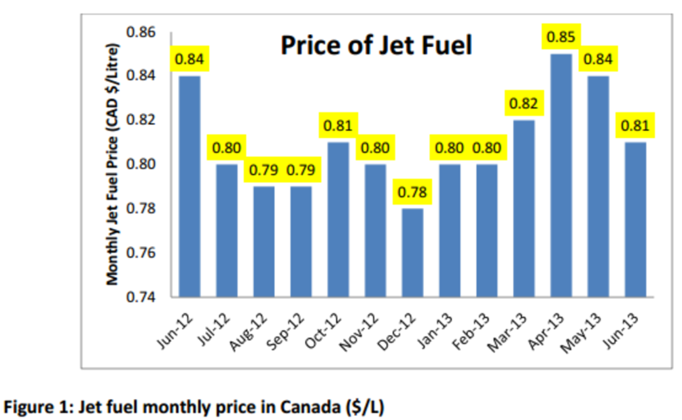

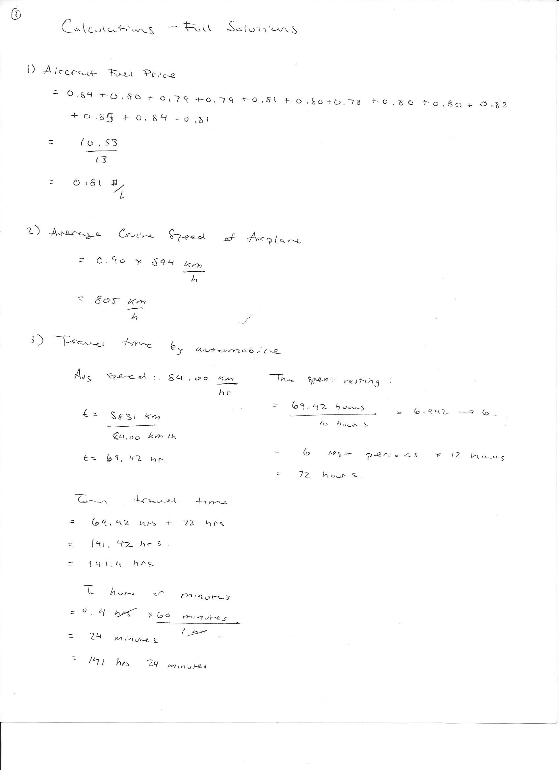
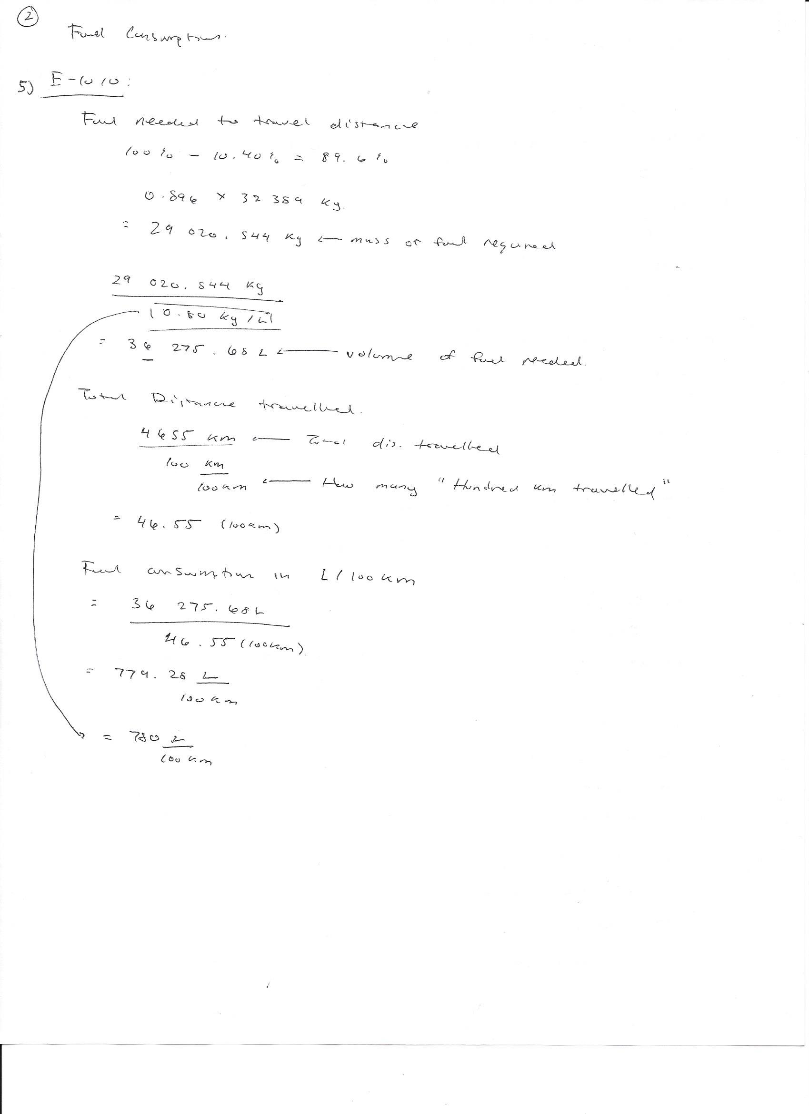
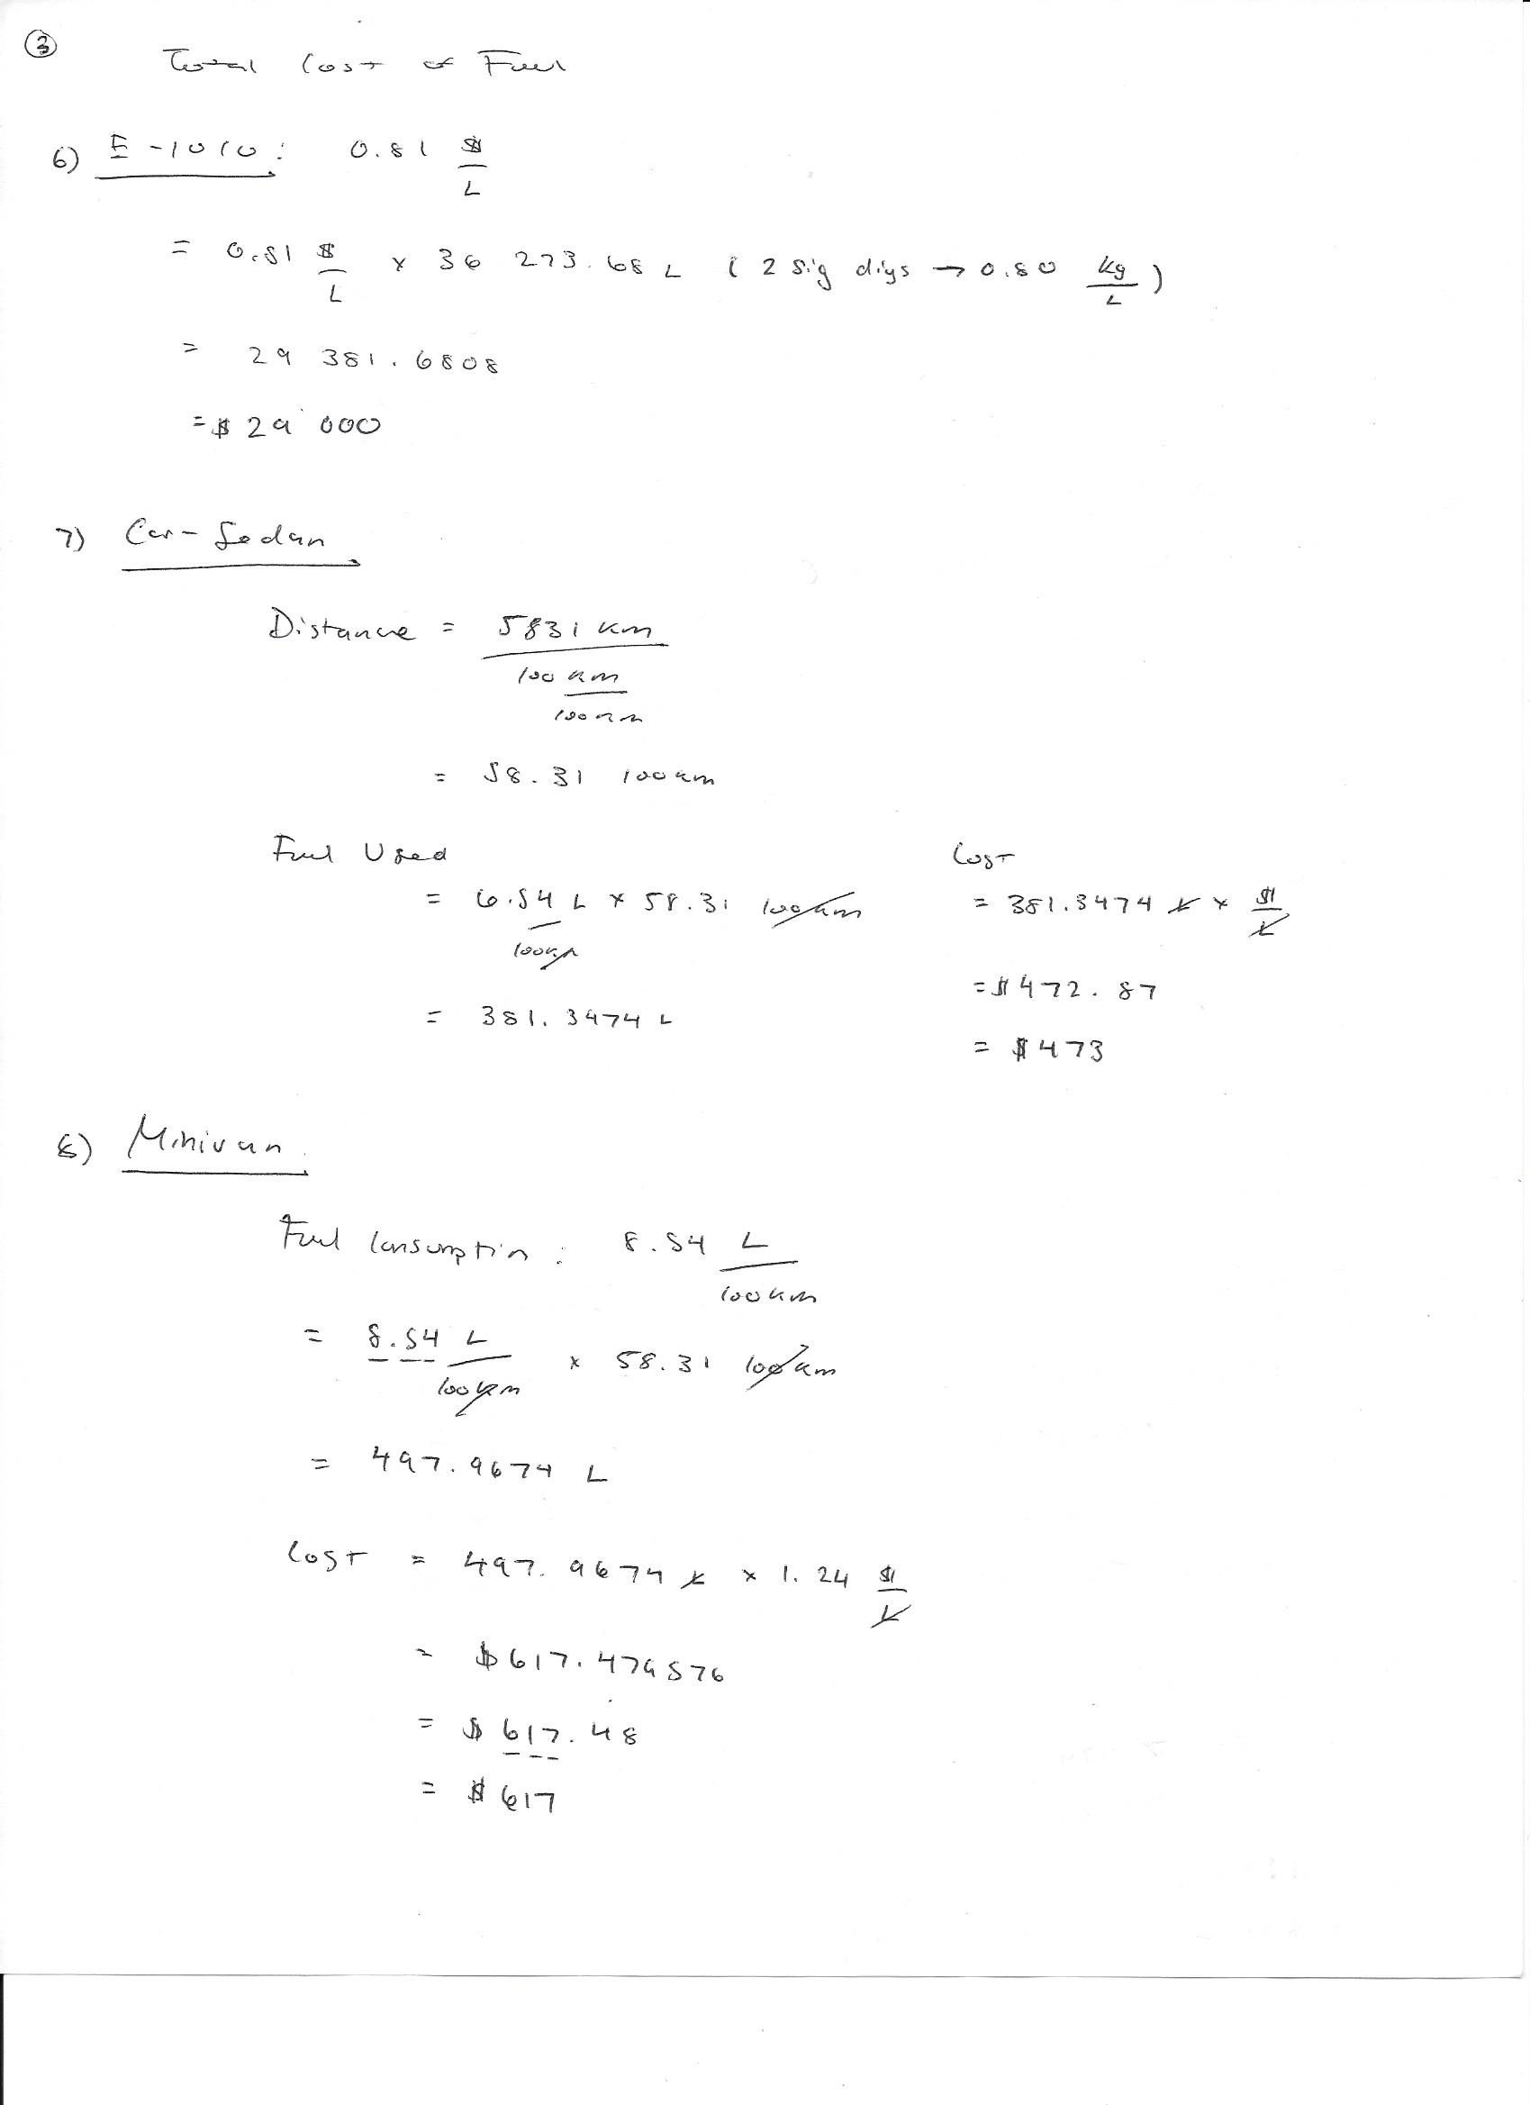
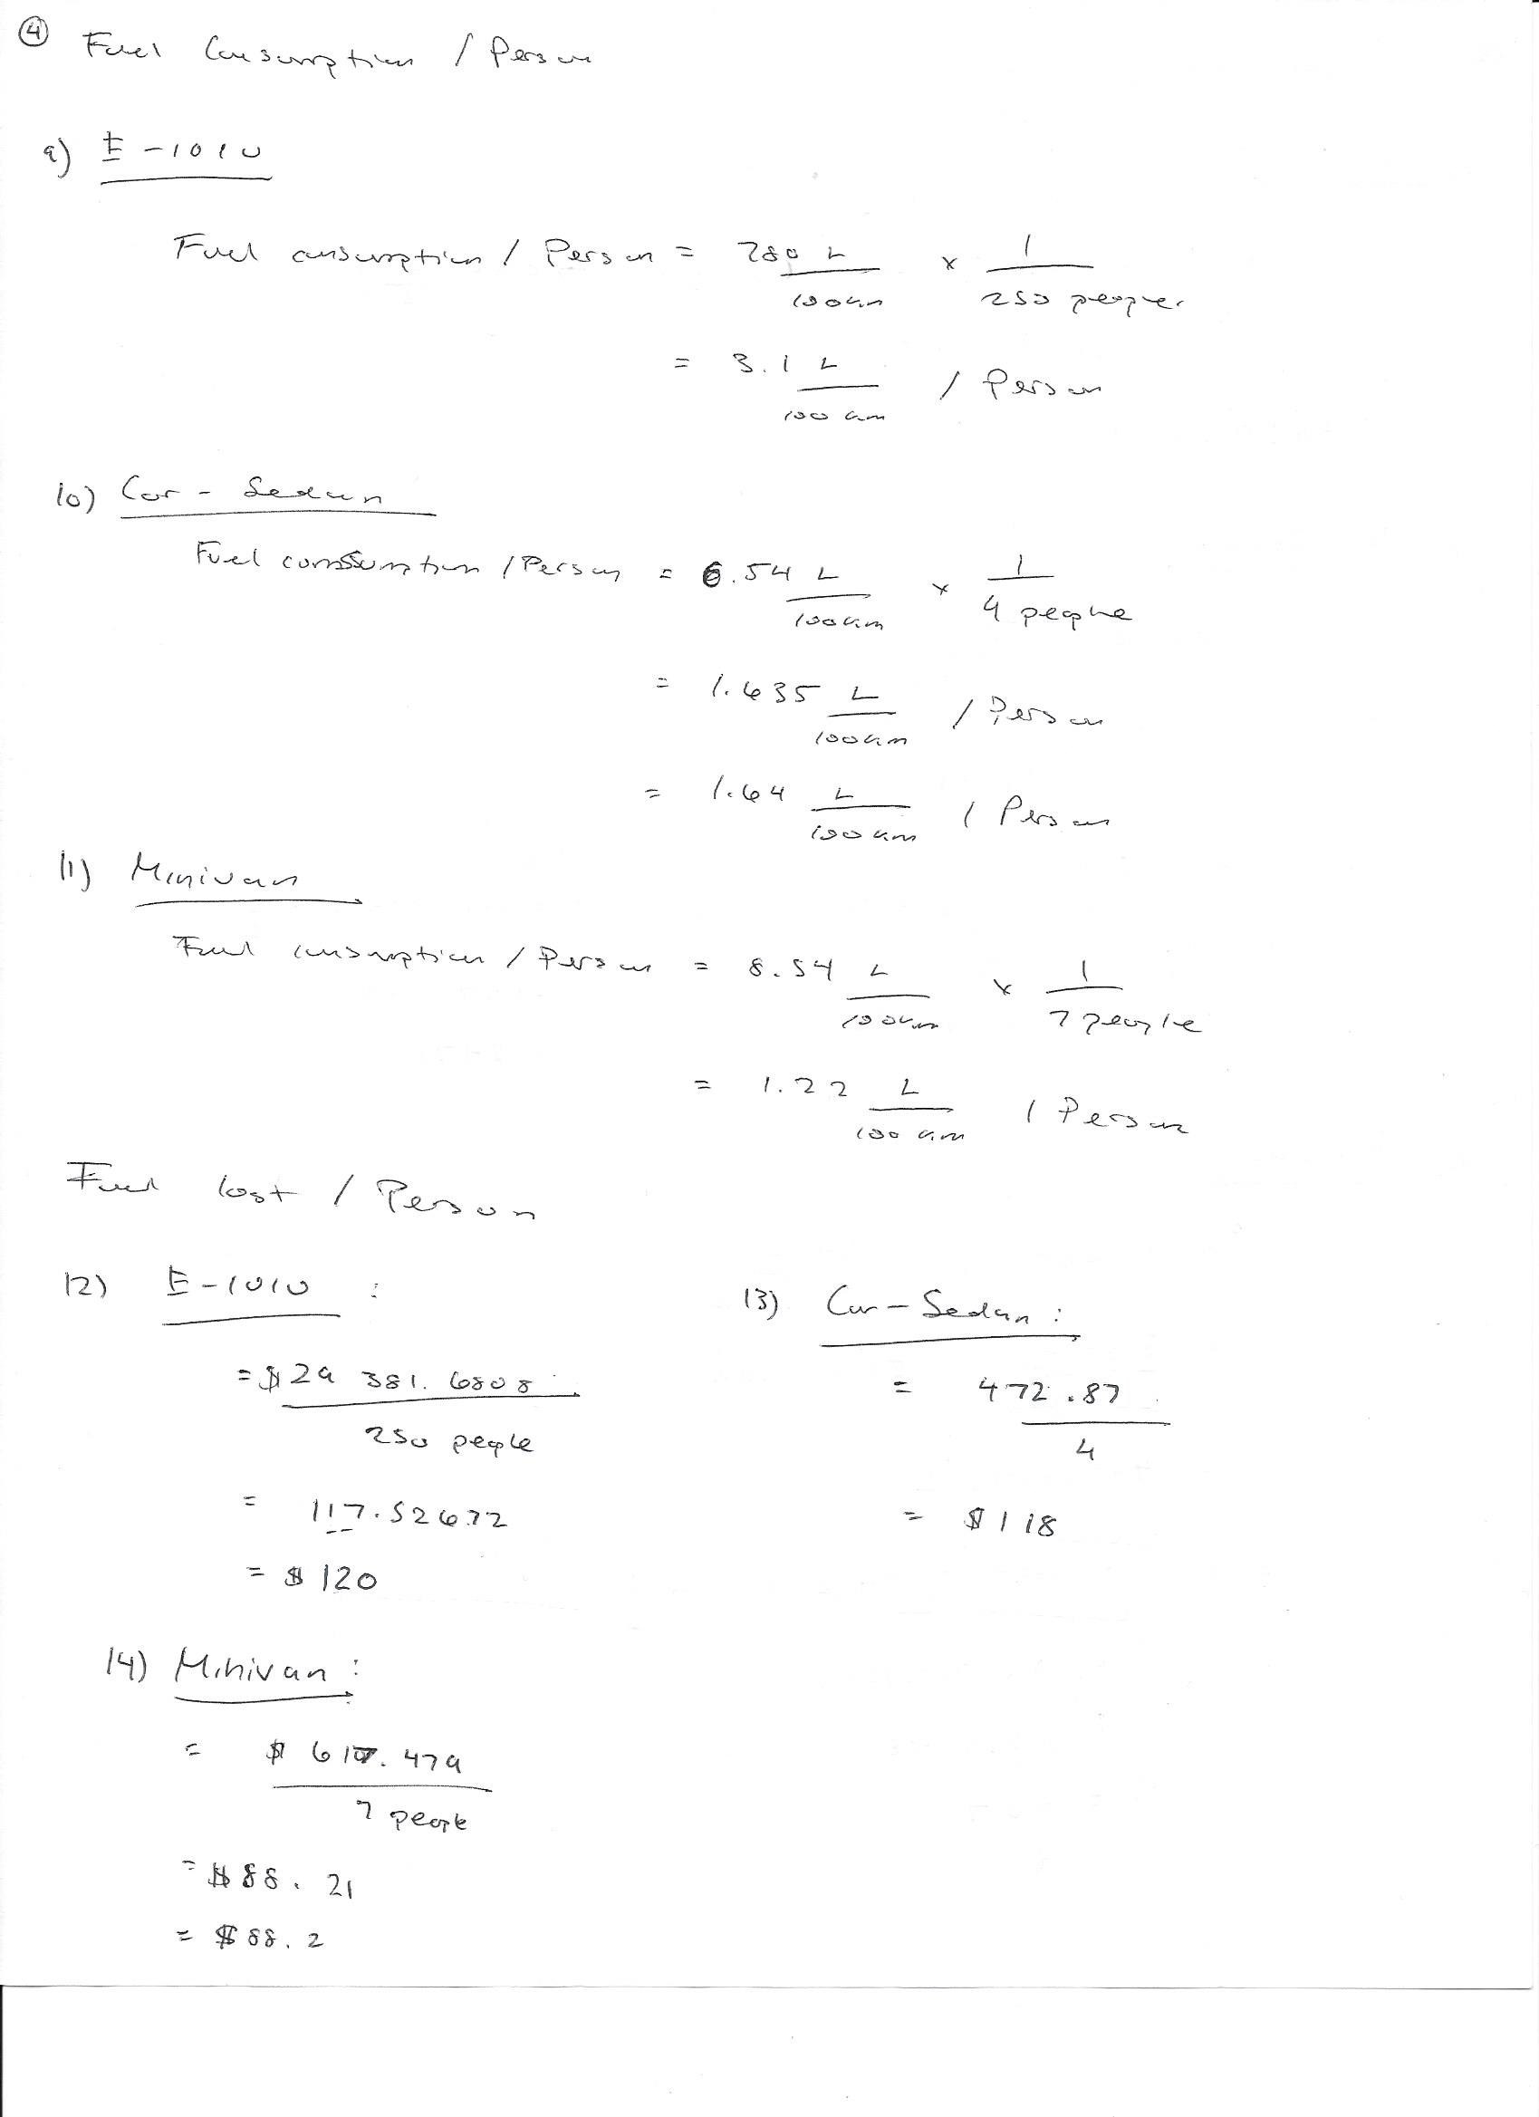
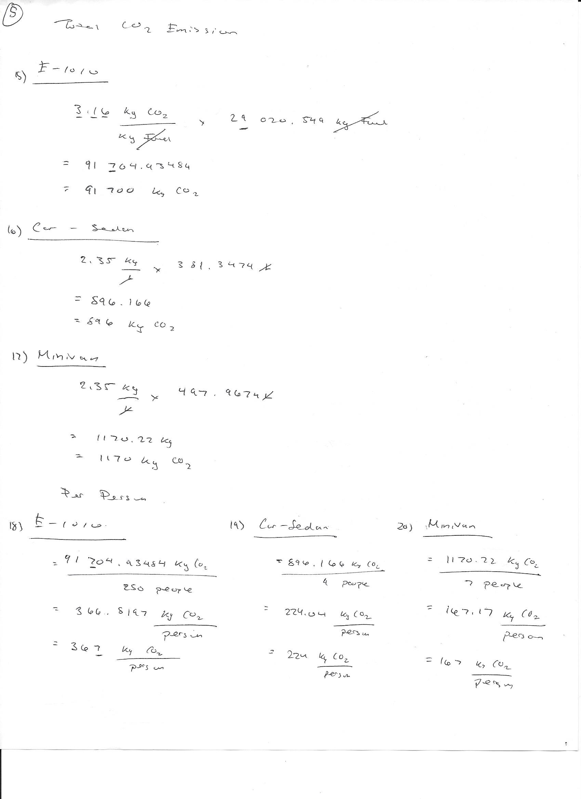
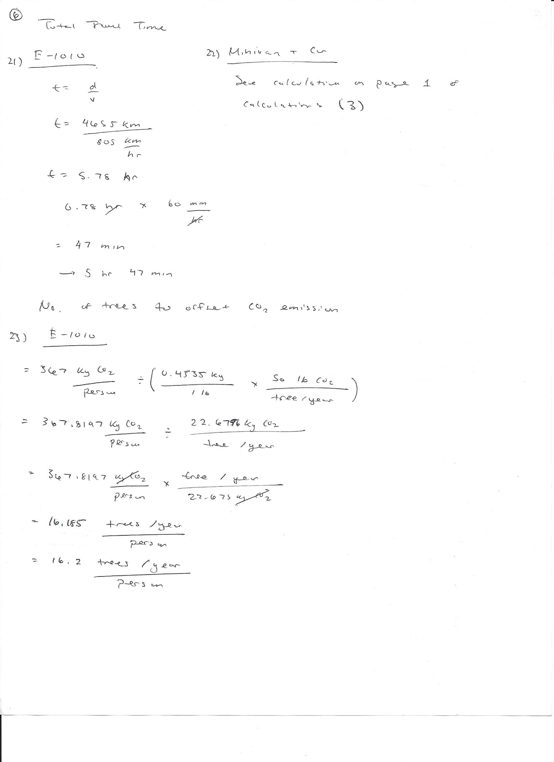
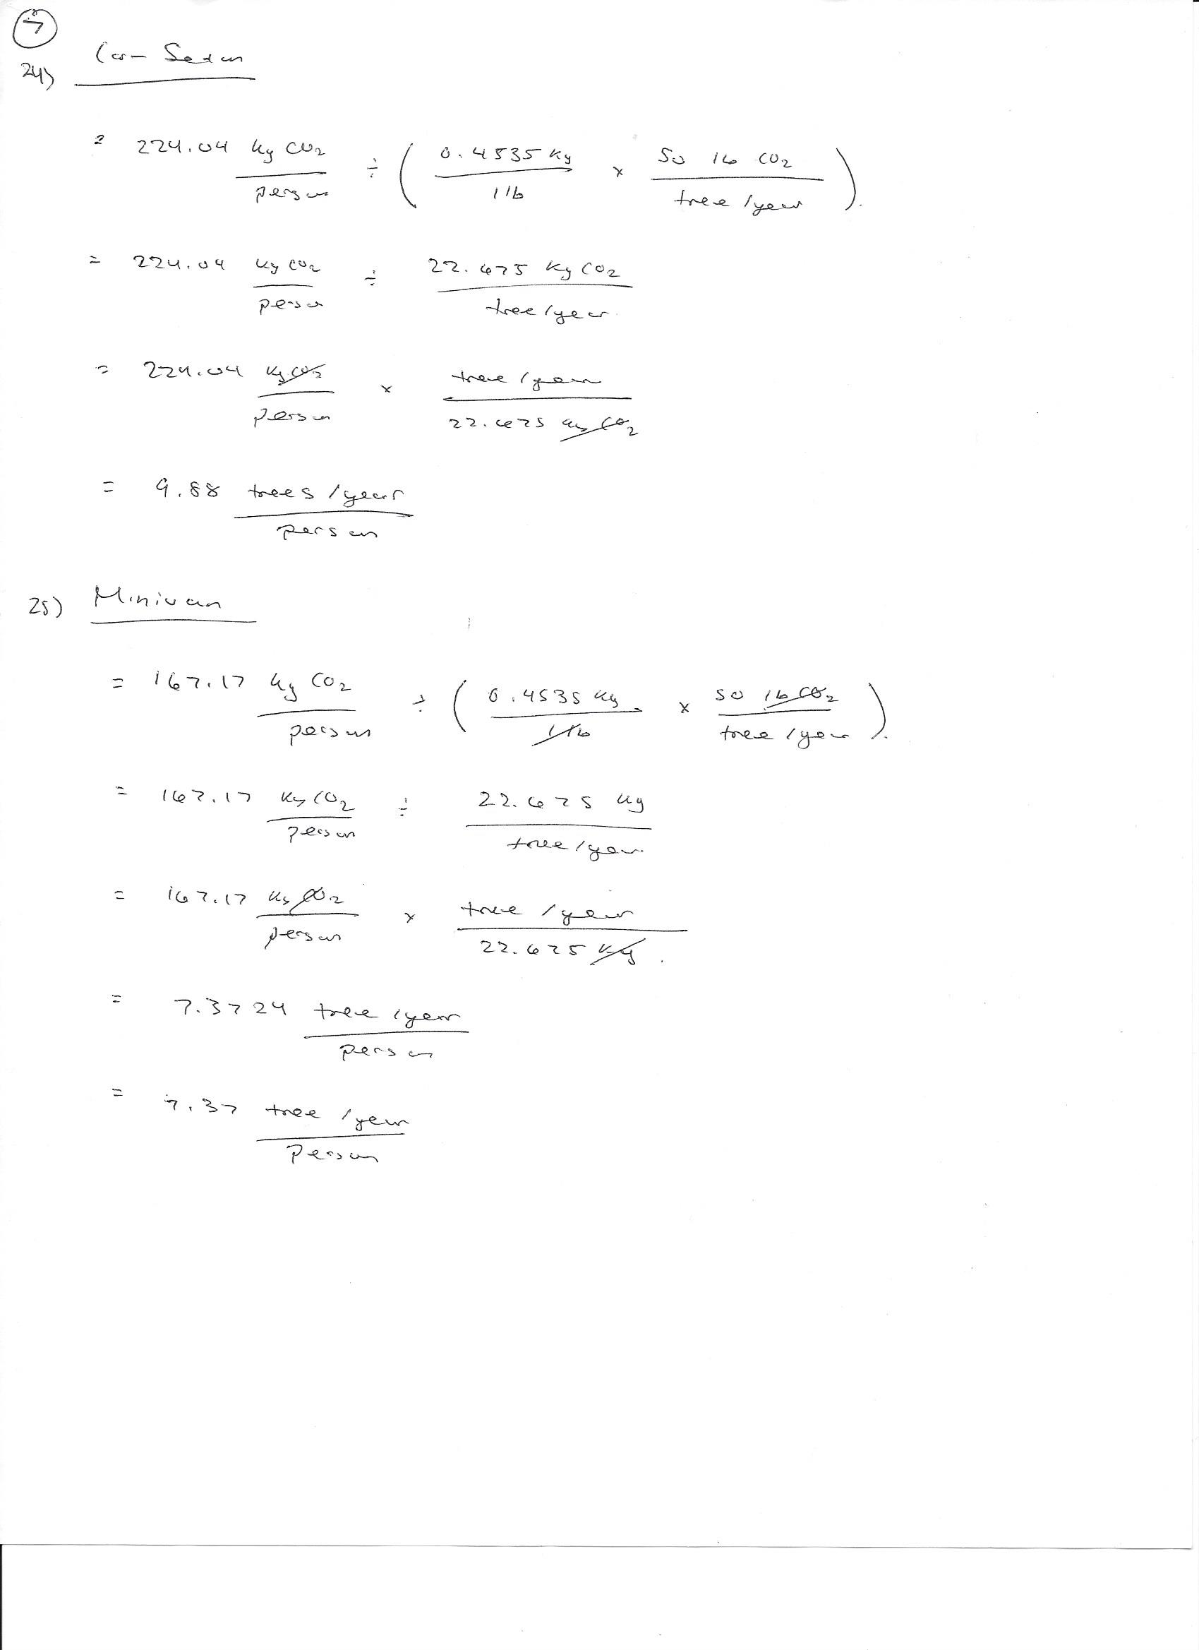

Table 3: Calculation Summary Table

 | Fuel Consumption L/100 km | Fuel Cost for the vehicle to travel the distance ($) | Fuel Consumption per person: 100% occupied seats L/100 km | Fuel Cost per person: 100% occupied seats ($) | CO2 Emission (kg) |  | Total Travel Time |  |  | No. of trees to offset CO2 emission /yr/person
 |  |  |  |  | Total | per person: 100% occupied seats |  | hr | min
E-1010  250 passengers | ⁽⁵⁾ 780 | ⁽⁶⁾ 29 000 | ⁽⁹⁾ 3.1 | ⁽¹²⁾ 120 | ⁽¹⁵⁾ 91 700 | ⁽¹⁸⁾ 367 | ⁽²¹⁾ 5.78 | 5 | 47 | ⁽²³⁾ 16.2
Car– Sedan 4 passengers | 6.54 | ⁽⁷⁾ 473 | ⁽¹⁰⁾ 1.22 | ⁽¹³⁾ 118 | ⁽¹⁶⁾ 896 | ⁽¹⁹⁾ 224 | ⁽³⁾ 141.4 | 141 | 24 | ⁽²⁴⁾ 9.88
Minivan 7 passengers | 8.54 | ⁽⁸⁾ 617 | ⁽¹¹⁾ 1.64 | ⁽¹⁴⁾ 88.2 | ⁽¹⁷⁾ 1170 | ⁽²⁰⁾ 167 | ⁽³⁾ 141.4 | 141 | 24 | ⁽²⁵⁾ 7.37

