Pharmacology : Scientific study of actions of drugs and their effects on a living organism (mostly based on plants)

Neuropharmacology: how drugs change the function of neurons. Its concerned with drug induced changes in the functioning of cells in the nervous system

Psychopharmacology: how the drug changes your mood, thinking and behavior

Neuro-psycho-pharmacology: Goal is to identify chemical substances that act upon the nervous system to alter behavior that is disturbed due to injury, disease, environment

- What is The difference between a drug action and a drug effect? Give an example

- Drug action is specific molecular changes produced by the drug when binds to particular target site or receptor. The action of the drug on the human body is called pharmacodynamics and what the body does with the drug is called pharmacokinetics.

- Drug affect: molecular changes lead to more widespread alterations in physiological or psychological functions

- The site of drug action might be different then site of drug affect.
- EX1: atropine is a drug used in ophthalmology to dilate the pupil of the eye before eye examinations. Atropine has a site of action which is the eye muscles of the iris which is close to the site of its effect being widening the pupil.

- EX2: morphine taken internally, the drugs action on the brain leads to pinpoint pupils. Clearly morphine the site of effect is far distant from the site of its initial action

- What is the difference between therapeutic effects and side effects?

- Therapeutic effect : a consequence of a medical treatment of any kind that results of which are judged to be desirable and beneficial (medicine). Meaning that the drug receptor interaction produces desired physical or bejavioural changes. All other effects or reffered to site effects

-

- side effect: some people take the drug for the desired side effect but can be very dangerous.
- -ex: Amphetamine like drugs produce alertness and insomnia, increased heart rate and decreased appetite. The drug may be used as a prescription diet control in weight reduction programs. In such cases insomnia and hyperactivity are frequently disturbing side effects thus therapeutic and side effects can change depending on the desired outcome

- what is the difference between specific and non specific effects?

- Specific effects are based on the physical and biochemical interactions of a drug with a target site in living tissue

- Nonspecific effects are not based on chemical activity but rather the unique characteristics of the individual such as experience, mood, expectations, attitude, perception of the drug taking situation, and other factors influence the outcome of drug use.
- Ex: placebo necessity of double blind experiment: when someone believes they are getting the drug so they behave the way they are expecting.
- STUDY:
- Two groups of patients with ulcers were given a placebo. First group the medication was provided by a physician who assured the patient that the drug would provide relief. Second group had the placebo administered by a nurse who described it as experimental in nature. In group 1, 70% found significant relief but in group 2 only 25% were helped by the “drug”

- Double blind experiment: neither the patient nor the observer know what treatment the patient has received.

Pharmacokinetic factors determining drug action

1)routes of administration: how and where drug is administered

2)absorbtion and distribution: drug must pass through variety of cell membrane and enter the blood plasma which transports the drug to virtually all of the cells in the body

3) binding: drug may binf to plasma proteins or may be sotred temporariy in bone or gat where it is inactive

4)inactivation : occurs as a result of metabolic processes in the liver

what are the different routes of administration ? and benefits/cons of each

- 1) Oral administration
- most popular route. Drug must dissolve in stomach fluids and pass through the stomach wall to reach blood capillaries and drub must be resistant to destruction by stomach acid and stomach enzymes

- benefits:

safe, self-administered, convenient and economical

disadvantage:
- vomit, stomach distress, hard to know how much is absorbed due to genetic differences and food in stomach and stomach acid destroys some drugs ex insulin can be destroyed by digestive process and for reason cannot be administered orally.

- First pass effect : before the blood goes to the rest of the body it passes through the liver which is the major organ that breaks down drugs.

- When drugs are orally administered, a certain amount of the drug will be inactivated or metabolized as it goes through the liver and less of the drug reaches the site of action.
- The reason why some medication come in high dosages

- ex: LSD, alcohol, amphetamines, ecstasy, caffeine

2) Injection (rectal administration)

- Intravenous (IV) (Usually suspended in a vehicle solution
  - Directly into the bloodstream
  - Benefits
    - Dosage can be extremely precise
    - FASTEST onset of pharmacological action
    - Drug reaches the brain almost insantly
  - Disadvantage:
    - The most DANGEROUS route
    - Easy to overdose
    - Cannot be removed from the stomach by stomach pumping
    - Toxic reactions
    - Lack of sterile injection equipment and aseptic technique can lead to infections such as HIV
    - Many drug abusers attempt to dissolve drus that have insoluble filler materials which when injected may become trapped in the small blood bessels in the lungs leading to reduced respiratory capacity or death

B) Intramuscular (IM)
  - Injected into skeletal muscle
  - Slower then intravenous (10-30 min)
  - Injection solution can be highly irritating, causing significant muscle discomfort

C) Subcutaneous (SC)
- Injected under the skin and absorption is slow and steady
- -usually for hormones, ex implanon and nexplanon
- -hormones are implanted through a small incision just under the skin of the upper arm

3) Epidural injections (not in the textbook)
  - the membrane that covers the spinal cord and nerve roots in the spine is called the dura
  - Space surrounding the dura is the epidural space
  - Nerves travel through the back epidural space to the back and into the legs (or neck and into the arms)

4) Inhalation

  - Lung tissues have a huge surface area and therefore this is a great way to get high allowing rapid absorption into the blood
  - Effect on the brain is very rapid because blood from the capillaries of the lungs travels only a short distance back to the heart before it is pumped quickly to the brain
  - Popular for tobacco, marijuana, cocaine and heroin
  - SOME drugs are faster than intravenous injection
  - DISADVANTAGES: irritation of the nasal passages and damage to the lungs caused by small particules that may be included in the inhaled material

5) Intranasal or sublingual
  - Absorbed through membranes in mouth or nose

Ex: heart patients nitroglycerine, snorting cocaine powder, nasal decongestants, nicotine gum

6) Transdermal
  - Patches that allow slow continuous absorption over hours or days minimizing side effects
  - Delivery of drug at a pre-programmed rate
  - Convenient because person doesn’t have to remember to take a pill and its painless without the need for injection
  - Advantage that is avoids the first pass effect

Ex: Nicotine, fentanyl (chronic pain), nitroglycerine, estrogen (hormone replacement theory)

Factors influencing drug absorption

-transport across membranes (phospholipids)

-Charged heads are in contacy with both the aqueous intracellular fluid and the aqueous extracellular fluid (prevents most molecules from passing through unless they are soluble in fat

lipid solubilty: drugs with high lipid solubility move through cell membranes by passive diffusion leaving the water in the blood or stomach and entering the lipid layers of membranes. The larger the concentration difference on each side of the membrane the more rapid the diffusion.

-lipid solubility increases the aborption of drug into the blood and determines how readily a drug will pass the lipid barriers to enter the brain

-example, heroin is more soluble in lipid that morphine and it penetrates into the brain tissue more readilty thus having a quickler onset of action and more potent reinforcing properties

IONIZED DRUGS(research more about it): depends on pH of the solution and an intrinsic property of the molecule

Distribution

- Chemical signaling: transmission occurs from the PRE-synaptic cell to the POST-synaptic cell

- Flow of information
- SynapseDendriteSomaAxonSynapse

- Neurotransmission in 4 steps

  - STEP 1 Synthesis and Storage
- a)Axon terminal: building blocks from food are pumped into cell via transporters

- b) Cell body: according to structions contained in the DNA and transported on microtubules to axon terminal.

  - STEP 2 Neurotransmitter release

- -at the terminal, the action potential opens voltage sensitive calcium channels (Ca+)
- -Ca+ enters the terminal and binds to the protein calmodulin forming a complex
- -Complex causes some vesicles to empty their contents into the synapse and others to get ready to empty their contents

  - What mechanisms control the rate of release ?
- 1) Rate of cell firing
- 2) Probability of transmitter release from terminal (sometimes Calcium channels open but do not release neurotransmitters
- 3)Autoreceptors: can be on either on terminal or somatodendritic
- -Terminal is located on axon terminals and inhibit further release
- -Somatodendritic is on soma or dendrites, with slow rate of cell firing causing less neurotransmitter release

  - STEP 3 Receptor Site Activation

- After being released, the NT diffuses across the synapse and activates receptors n the postsynaptic membrane.
- -Transmitter activated receptors : protein embedded in the membrane of a cell that has a binding site for a specific neurotransmitter

- Neurotransmitter can either :
- -depolarize the postsynaptic membrane causing excitatory action on the postsynaptic neuron

- -Hyperpolarize the postsynaptic membrane causing inhibitory action on the postsynaptic neuron

- -initiate other chemical reactions that modulate either the excitatory or inhibitory effect, or influence other functions of the receiving neuron (SECOND MESSENGER)

There are 2 broad categories for receptor types which are
- Ionotropic (AKA Ligand gated ion channel)

-Very fast and are made up of several proteins which form the complete receptor. The center of the subunits is the pore where ions flow through

-Posses one or more binding sites for NT

-pores are normally closed until NT binds to receptor

- Metabotropic

- Chapter 4 text book material

- Vivo measures : observed in the living organism

- Stereotaxic surgery:
- essential technique in neuroscience that permits a researcher to implant one of several devices into the brain of an anesthetized animal with significant precision.

- -brain sites coordinates are calculated using a brain atlas which is a collection of frontal sections of brain of appropriate species in which distance are measured from skull surface features

- -Accuracy of placement is determined histologically after the experiment is complete.

- Method 1) Lesioning and microinjection

- Uses a stereotaxic device to position a delicate electrode, insulated along its length except for the exposed tip, deep within the brain.

- Electrolytic lesion:-tissue at the tip is destroyed when a very high frequency radio current is passed through the electrode to heat the cells.

- -A neurotoxin which is a chemical that is damaging to the nerve cells can be injected via a cannula to destroy cells

- -Benefit: chemical lesions have the advantage of being significantly more specific because neurotoxic chemicals such as Kainac acid kill cell bodies in the vicinity of the cannula tip but spare the axons passing through the same area

- The lesioning techniques used are often specific for a neural pathway that uses a particular neurotransmitter. These specific neurotoxins most often are injected directly into the brain where they are taken up by the normal reuptake mechanism of neurons

- EX: intracerebro-ventricular administration of 6 hydroxy-dopamine (6-OHDA) produces nerve terminal degeneration in both noradrenergic and dopaminergic cells and profound neurotransmitter depletion.

- Method 2) Micro dialysis

- Measures NT released in specific brain region while subject engaged in behavior
- The technique requires a specialized cannula made of fine flexible tubing that is implanted stereotaxic ally

- -the cannula is sealed along its length except at the tip allowing investigators to collet material in extracellular fluid at nerve terminals at precise sites even deep within the brain

- -Artificial cerebrospinal fluid (CSF) is gently moved into the micro dialysis cannula by a pump

- -The CSF is gently moved into the mictrodialysis cannula by a pump

- -The CSF in the cannula and in the extracellular fluid are identical except for the material to be collected on the basis of
- -difference in concentration (chemicals of interest move across the membrane from the synaptic space into the cannula

- -Second pump removes the CSF from the cannula into a series of tubes to be analyzed by HPLC (High performance liquid chromatography

- EXAMPLE:
- evaluating the released neurochemicals during ongoing behaviors such as sleep and waking, feeding or operant tasks to obtain a window into the functioning CNS

- -Investigate the effects of drugs on extracellular concentrations os NS in selected brain areas

- In vivo v voltammetry
- Similar to micro-dialysis but the difference is that in vivo voltammetry measures changes in neurochemicals using implanted microelectrodes

- -microelectrodes can be used to activate cells at the tip while the change in animal behavior during stimulation is evaluated

- Electrophysiology (Implanted microelectrodes)

- -used to activate cells at the tip while the change in animal behavior during stimulation is evaluated (evaluate change of behavior)

- -Can also be used to record the summated electrical response of thousands of neurons in a specific brain region following drug treatment or other experimental manipulation in a freely moving animal ( Records population of neurons)

- -one would expect that stimulation of a given cell group should produce effects opposite those caused by a lesion at the same site

- -single unit recording: implanting a fine tipped electrode either into a single cell (intracellular) or into the extracellular fluid near a single cell to monitor the response of individual cells under various conditions

- -Intracellular recording must involve an anesthetized animal because the electrode must remain in a precise position to record the membrane potential of the cell

- -Extracellular recording: can be done in a mobile animal

- Patch clamp electrophysiology: used to study the function of individual ion channels which collectively are responsible for the membrane potential

- EXAMPLE: Parkinson’s disease
- Small pulses of electrical current applied to the thalamus cause te cells to fire and release neurotransmitter which redices the tremor on the opposite side of the body

- 2)Radio ligand binding
- - used to study the number of receptors in a given brain region and their affinity for drugs

- -brain is grinded up to make a homogenate
- -a ligand that is radioactively labeled is incubated with the tissue under conditions that optimize its binding

- -the amount of radio ligand bound to the tissue is then measure with a scintillation counter and reflects the number of receptors in the tissue

- -

- 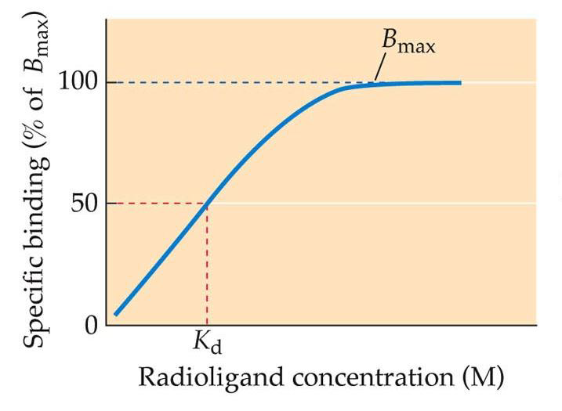

- B (Max) = all sites are filled
- K(d)= the ligand concentration at which 50% of the receptors are occupied

- Receptor Autoradiography

- Visualize the distribution of receptors within the brain
- -use a slide mounted tissue slices rather then ground up tissue
- -after the unbound radioactively labeled drug is washed away
- -slices are processed by autoradiography
- -slices put into cassettes with a specialized auto radiographic film is placed on top of the slides so that it is in physical contact with the tissue sections and cassettes are stored in the dark

- -Particles emitted from the radioactive material in the tissue expose the film and show not only the amount of radio ligand bound but also its location

- Immunocytochemistry
- - brain is fixed using a preservative. Tissue is then sliced and cut and incubated with the antibody in soltuon
- -aintibody attaches to the antigen wherever cells that contain that antigen are present

- -antibody is tagged so that the antigen containing cells can be visualized which is accomplished with a chemical reaction that creates a colored precipitate within the cells or with the use of a fluorescent dye that glows when exposed to light of a particular wavelength

- -researcher can then examine the tissue slices under a microscope to see which brain areas or neurons contain the antigen
- 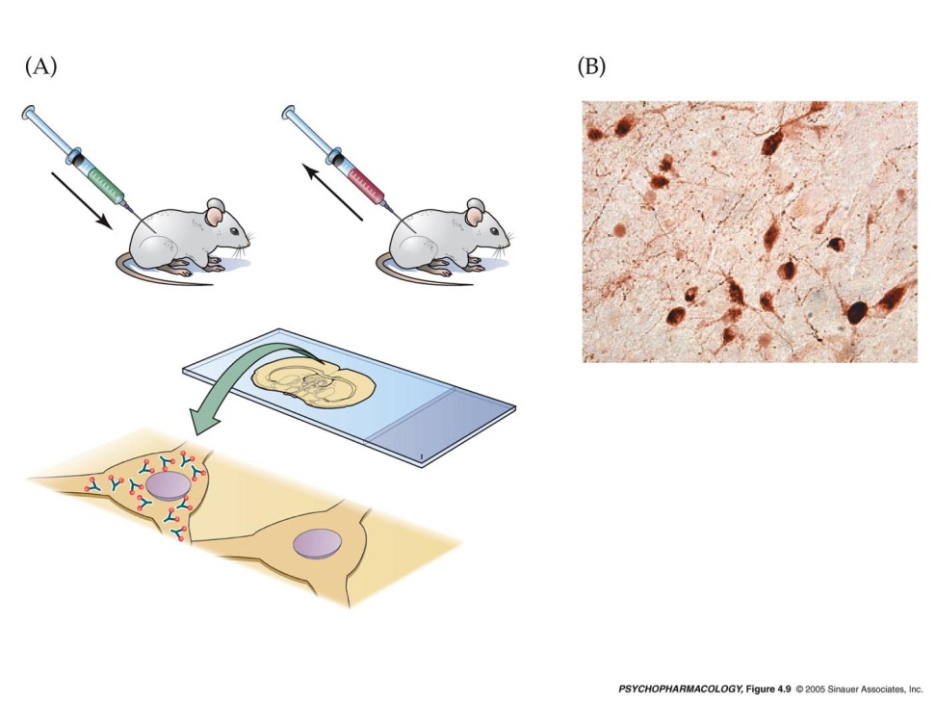
- steps 1) protein is injected into an animal who makes antibodies to the foreign material

‘

Acetycholine synthesis :

Neuromuscular junction:
  - Presynaptic neuron activated causes ACh to be released into synapse and opens ion channels

  - An action potential arrives at the presynaptic terminal causing voltage gated calcium ion channels to open, increasing the calcium ion permeability of the presynaptic terminal cell membrane

  - -Calcium ions enter the presynaptic terminal and cause vesicles to release their neurotransmitter acetylcholine (Ach) from the synaptic vesicle into the presynaptic cleft

  - Diffusion of acetylcholine across the synaptic cleft and binding of acetylcholine to acetylcholine receptors on the postsynaptic muscle fibre membrane cause an increase in the permeability of ligand gated sodium ion channels

  - -the movement of sodium ions into the muscle cell results in depolarization of the postsynaptic membrane. Once threshold has been reached, a postsynaptic action potential is generated and is propagated over the muscle cell membrane

  - Acetylcholine is rapidly broken down to acedic acid and choline in the synapse cleft by the enzyme acetycholinesterase
  - -the choline is reabsorbed by the presynaptic terminal and combined with acetic acid to form more acetylcholine which enters the synaptic vesicles

  - Ach is formed in a single step from two precursors

  - Choline (comes mainly from fat in our diet & also produced in liver)

-Synthesis of choline:

essential nutrient that is widely distributed in foods in the form of PHOSPHATIDYCHOLINE and as free choline

-foods richest in phosphatidycholine are beef liver, egg yolks and soya

-free choline: beef liver, iceberg lettuce, peanut butter, peanuts and cauliflower

  - Aceytl coenzyme A (Aceytl CoA) (generated within all cells by the metabolism of sugars and fats)

Synthesis :

-occurs in the matrix of the mitochondria

-produced during the second step of aerobic cellular respiration

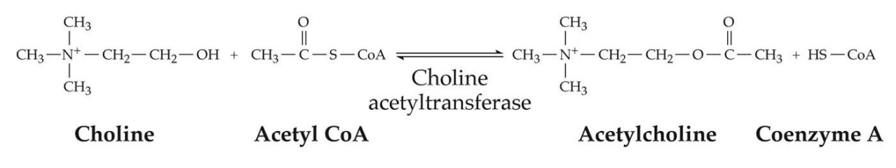
  - Acetycholine synthesis is catalyzed by the enzyme choline aceytltransferase (CHAT)
  - Choline aceytltransferase is present in the cytoplasm of the cell
  - Syntehsise of ChAT:

-synthesized within the cell body (rough ER)

-transferred to the nerve terminal via axoplasmic transport

The rate of Ach synthesis is controlled by

-Availability of its precursor

-rate of cell firing

RELEASE OF ACETYCHOLINE

  - The axon terminals of cholinergic neurons contain many small synaptic vesicles that store Ach for release
  - Vesicles are loaded with Ach by a transport protein in the vesicle membrane called Vesicular ACh transport (VAChT)

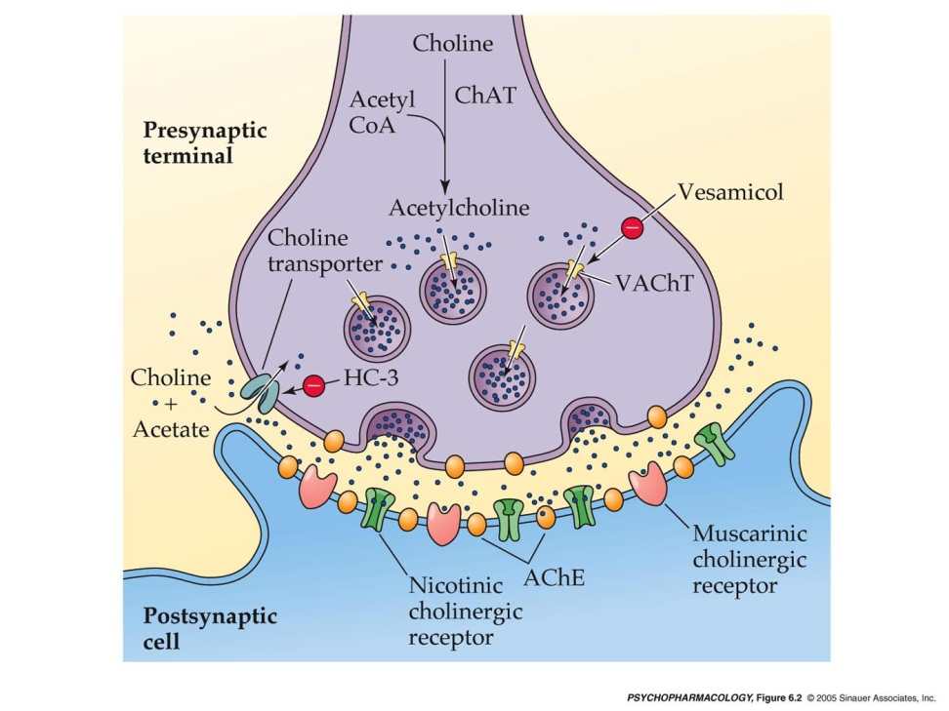

This protein can be BLOCKED by a drug called Vesamicol

-vesamicol treatment would decrease vesicular Ach but increase the level of Ach in the cytoplasm of the terminal

-vesamicol DOES NOT affect the rate of Ach synthesis, therefore ACh molecules that normally would have been transported into the vesicles remain in the cytoplasm of the terminal

-Because synaptic vesicles are the main source of ACh release, when the cholinergic neurons fire, such release is reduced in the presence of vesamicol

-cholinergic neurons are still present and continue to undergo exocytosis when the neurons are active but the amount of Ach available within the vesicle to be released is abnormally low

ACh Receptors
- 2 types of acetylcholine receptors (AChR) that bind acetylcholine and transmit its signal
  - nicotine receptors :
- nicotine receptors are highly concentrated on muscle cells at neuromuscular junctions, on ganglionic neurons of both the sympathetic and parasympathetic systems
- they are ionotripic receptors therefore they posses an ion channel
- When ACh binds to nicotine receptor, the channel opens very rapidly and sodium and calckum ions enter the neuron or muscle cell
- The flow of ions causes depolarization of the cell membrane and increases the excitability of the cell
- Nicotine receptors mediate fast excitatory responses in both the CNS and the PNS
- has 5 different subunits and 10 diff kinds of a subunits and 4 diff kinds of b subunits

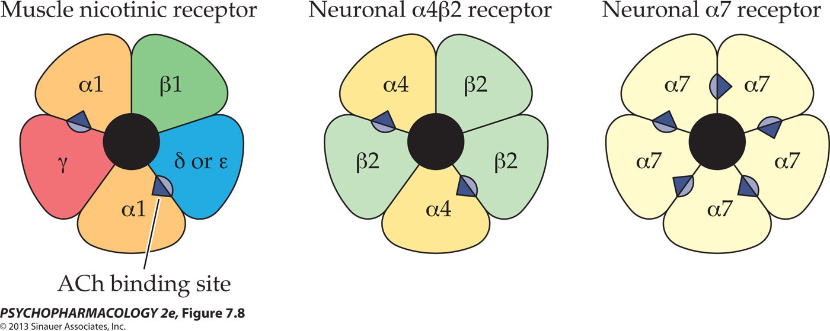

the nicotine receptors found in muscle cells have a different subunit composition than the receptors found in neurons

-all binding sites must be occupied to open the chanel

-When nicotine receptors are subjected to continuous agoinist exposure they become desensitized which means an altered state of the receptor in which the channel remains closed regardless of whether molecules of an agonist such as ACh or nicotine are bound to the receptor

-after a short while, desensitized receptors spontaneously resensitize and then are capable of responding again to a nicotinic agonist

even if cells are continuously exposed to nicotinic stimulation, not all of the receptors are desensitized. Those that remain active produce a persistent depolarization of the cell membrane. If this continues for very long, a process called depolarization block occurs in which the resting potential of the membrane is lost and the cell cannot be excited until the agonist is removed and the membrane repolarized

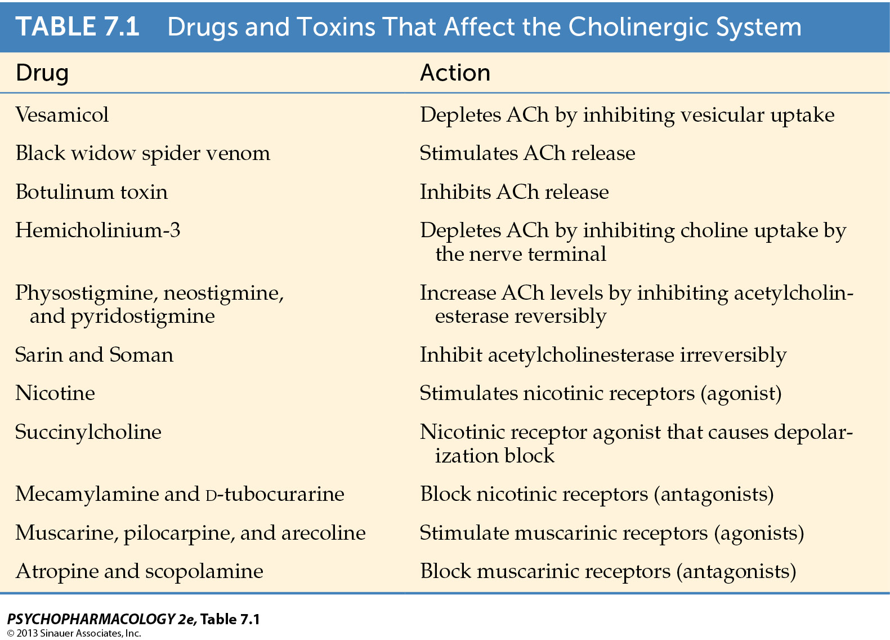

Antagonist

BLACK WIDOW SPIER
  - The release of Ach is dramatically affected by various animal and bacterial toxins
  - example, a toxin found in the venom of the black widow spider “Lactrodectus mactans” which leads to a massive release of Ach at synapses in the peripheral nervous system
  - over activity of the cholinergic system causes numerous symptoms, including muscle pain in the abdomen or chest, tremors, nausea and vomiting, salivation, and copious sweating.

BOTULINUM TOXIN (1Gram would kill 3 million people)

  - Taken up by cholinergic neurons and inhibits ACh release
  - Poisoning include blurred vision, difficulty speaking and swallowing, muscle weakness
  - Helpful in treating clinical disorders characterized by involuntary muscle contractions

-treatment of strabismus (crossed eyes)

-treatment of belepharo-spasm (spasm of the eyelid)

-treatment of hemi facial spasm (muscle spasm on just one side of the face)

BOTOX: cosmetic putposes I npatients with excessive frown lines, worry lines..etc
  - Results from chornic contraction of specific facial muscles and when injected locally into particular muscle or surrounding area, botox causes paralysis of that muscle as the result of blockade of ACh release from incoming motor nerve fibers

INACTIVATION

  - Enzymatic breakdown via acetyl cholinesterase . (AChE)
  - Levels of ACh are carefully controlled by an enzyme called acetyl cholinesterase which breaks down the transmitter into choline and ecitic acid

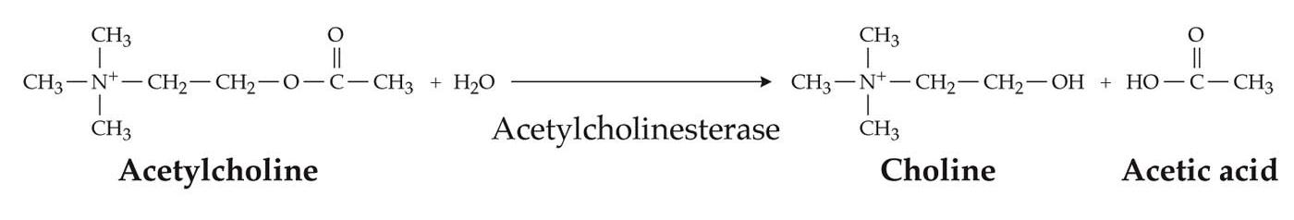
  - AChE is present at several locations
  - 1) found inside the presynaptic cell where it can metabolize excess of ACh that may have been synthesized

  - 2)present on the membrane of the post synaptic cell to break down molecules of ACh after their release into the synaptic cleft

-once ACh has been broken down within the synaptic cleft, a significant portion of choline is taken back up into the cholinergic nerve terminal by a choline transporter

-Choline transporter can be blocked by a drug called hemicholinium-3 (HC-3) resulting in a decrease in ACh production

-the cause of death in animals is lack of normal breathing due to failure to sustain ACh synthesis and release at the neuromuscular junction

( recycled choline plays a critical role in maintaining ongoing ACh synthesis)

  - 3)found at neuromuscular junctions which are specialized synapses between neurons and muscle cells where ACh is released by motor neurons

PHYSOSTIGMINE

  - Physostigmine is a drug that blocks AChE and prevents inactivation of ACh and therefore increasing the postsynaptic effects of the trasnimitter
  - A compound solated from calabar beans
  - –crosses the BBB and exerts its effects on the CNS
  - poising leads to slurred speech, mental confusion, hallucinations, loss of reflexes, coma, and death.

MYASTHENIA GRAVIS
  - Autoimmune disorder (a condition in which a part of the body is attacked by ones own immune system

  - Antibodies block muscle acetycholine receptors and eventually cause these receptors to be broken down by the muscle cells

  - Loss of receptor function causes the patients muscles to be less sensitive to ACh which leads to severe weakness and fatigue
  - Reversible AChE antagonist are used in the treatment
  - , ACh breakdown is restored after the drug dissociates from the enzyme

NERVE GASSES

  - Many nerve gasses such as Sarin and Soman are Irreversible AChE inhibitors
  - Sarin and soman are designed to be dispersed as a vapor cloud or spray which allows their entry into the blood through skin contact or by inhalation
  - The drug quickly penetrated into the bloodstream and is distributed to all organs including the brain
  - Symptoms of nerve gas poisoning: vomiting, loss of bladder and bowel control
  - Death occurs through asphyxiation due to paralysis of the muscle of the diaphragm
  - How can a reversible AChE inhibitor be an antidote against Sarin or Soman?
  - The temporary interaction of pyridostigmine bromine (PB pills) with the enzyme protects AChE from permanent inactivation by the nerve gases but requires that it be administered ahead of time before exposure to toxic agent

Anatomy of cholinergic pathways in the brain

  - Nerve cells in the stratum are internerous
  - –BASAL forebrain cholineirgic system (BFCS) : BFCS is the origin of a dense cholinergic innervation of the cerebral cortex as well as the hippocampus and other limbic system structues
  - –system plays a significant role in cognitive function

another set of important cholinergic cells is located in the dorsolateral pons within the laterodorsal and pedunculopontine tegmental nuclei (LDTg and PPTg)

LDTg ventral tegmental area VTA

PPTg substantia nigra

IN CONCLUSION

  - ACh is synthesized from choline and acetylc CoA in a single reaction catalyzed by the enzyme choline acetyltransferase. The rate of ACh synthesis is controlled by precursor availability and is increased by cell firing
  - ACh is loaded into synaptic vesicles by the specific vescular transporter VAChT
  - A variety of animal and bacterial toxins influence the cholinergic system either by stimulating or inhibiting ACh release
  - Following its release into the synapse or neuromuscular junction, ACh is rapidly degraded by the enzyme AChE
  - Much of the choline liberated from ACh breakdown is taken back up into the cholinergic nerve terminal by a choline transporter that plays a critical role in maintaining on going ACh synthesis
  - Drugs that block AChE cause prolongation of ACh action at the postsynaptic or muscular cholinergic receptors, reversible AChE antagonist are used in the treamtnet of the neuromuscular disorder myasthenia gravis whereas irreversible AChE inhibitors are the main ingredients of nerve gasses

- Synthesis:

- 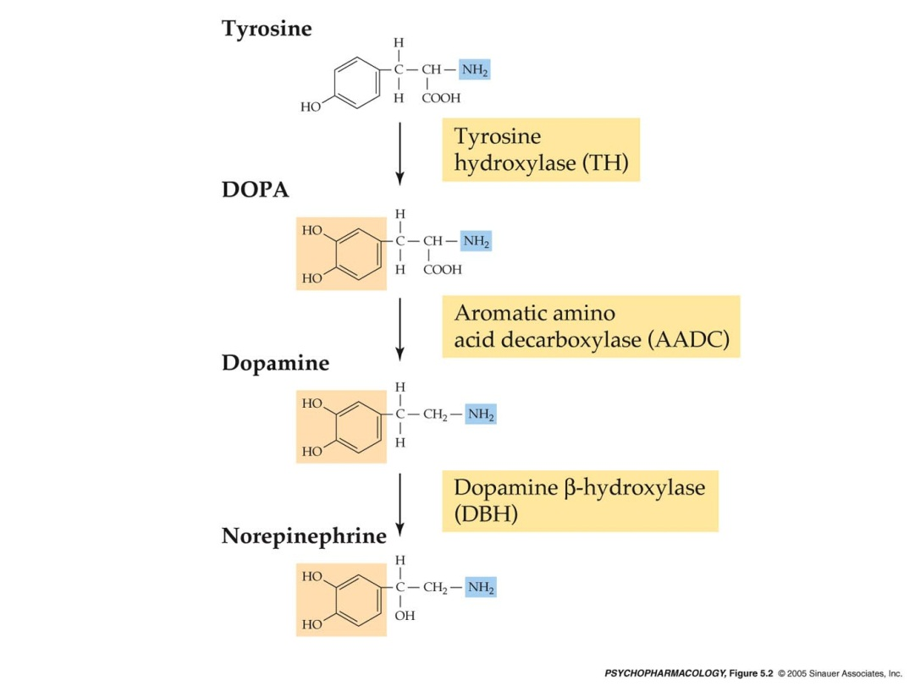
  - Catecholamines : all share core structure of catchol and nitrogen containing group called amine
  - –Dopamine, Norepinephrine, and epinephrine

Catecholamine SYNTHESIS

    - the level of catecholamine neurotransmission depends on a complex interplay between neurotransmitter synthesis, release and inactivation
    - the synthesis of catecholamine neurotransmitters occurs in several steps
    - 1) Biochemical pathway beings with the amino acid TYROSINE

-Obtained from dietary protein and is transported from the blood into the brain

Each steps in catecholamine formation depends on a specific enzyme that acts as a catalyst

Ex: Neurons that use Dopamine as their neurotransmitter only contain the first 2 enzymes called TYROSINE HYDROXYLASE (TH) and AROMATIC AMINO ACID DECARBOXYLASEYLASE (AADC)

However neurons that need to synthesis NE posses 3 enzymes with the third being DOPAMINE B-HYDROXYLASE (DBH)

    - The conversion of TYROSINE to DOPA (dihydroxyphenylalanine) by TH occurs at a slower rate then later reactions in the biochemical pathway
    - TH is the rate limiting enzyme in the pathway because it determines the overall rate of DA or NE formation
    - TH is regulated by

    - 1)how much DA and NE is present within the nerve terminal

high catecholamine levels =inhibits TH and synthesis is slowed

(negaitive feedback mechanism)

  - neurons are activated and fire at high rate : TH stimulated and synthesis accelerates to keep up with the increased demand

    - 2)Rate of cell firing because neuronal activity has a stimulatory effect on TH

AMPT a-methyl-para-tyrosine is a compound that BLOCKS TH and preventing overall catecholamine synthesis and causing a general depletion of these neurotransmitters

Catecholamine storage and release

    - once catecholamine’s have been synthesized they are transported into synaptic vesicles for later release
    - vesicular packaging is important not only because it provides a means of releasing a predetermined amount of neurotransmitter but also because it protects the neurotransmitter from degradation by enzymes within the nerve terminal

    - a specific protein in the vesicle membrane is responsible for vesicular catecholamine uptake called the vesicular monoamine transporter VMAT
    - VMAT can be blocked by a drug called reserpine
    - Blocking the vesicular transporter means that DA and NE are no longer protected from breakdown within the nerve terminal
    - Both transmitters drop to very low levels in the brain causing sedation in animals and depressive symptoms in humans
    - Arvid carlsson showed that the sedative effects of reserpine could be reversed by restoration of catecholamine’s with DOPA (the precursor of dopamine) 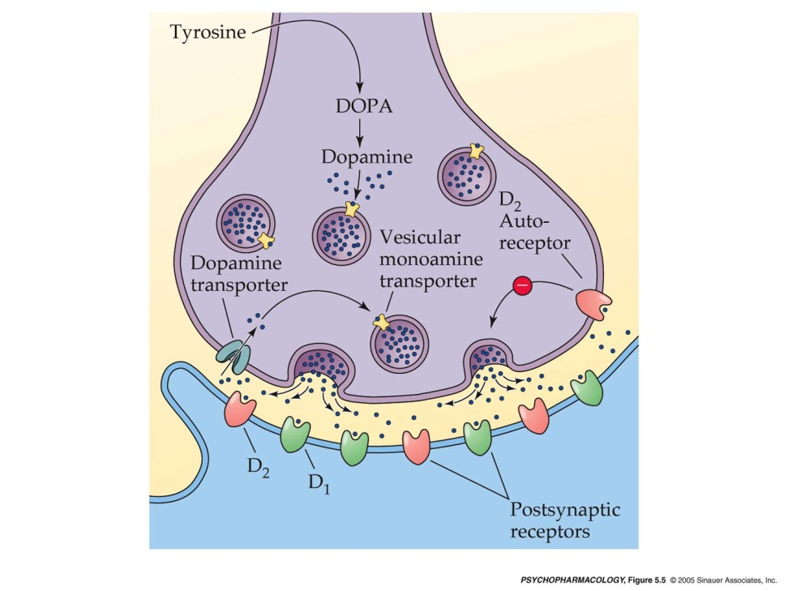
    - Catecholamine release is inhibited by autoreceptors located on the cell bodies, terminals, and dendrites of dopaminergic and noradrenergic neurons
    - Autoreceptors inhibit neurotransmitter release by enhancing the opening of a specific type of voltage gated K channel in the nere terminal
    - One possible mechanism for this efffect would be shortening the duration of action potentials entering the terminal thereby reducing CA influz and vesicle exocytosis

INACTIVATION Occurs through the combination of reuptake and metabolsim

Inactivation of catecholamines depends on reuptake
      - Much of the DA and NE that is released synaptically is taken up again into the nerve terminal by means of specific transporter proteins in the nerve cell membrane
      - Dopaminergic neurons contain a DA transporter and noradrenergic neurons contain a NE transporter
      - After the neurotransmitter molecules are returned into the terminal, some of them are repackaged into vesicles for re-release and the remaining are broken down and eliminted
      - Since the transporters are necessary for the rapid removal of catecholamines from the synaptic cleft, transporter blocking ddrugs enhance the synaptic transmission of DA or NE by increasing the amount of neurotransmitter in the synaptic cleft
      - Ex tricyclic antidepressants which inhibit the reuptake of both NE and serotonin
      - Or compounds in clinical use that more selectively inhibit NE uptake by blocking the NE transporter. These include reboxetine which is an antidepressent drug
      - Cocaine inhibits the reuptake of all three major monoamine transmitters DA NE and 5HT

Although reuptake can quickly treminate the synaptic actions of catecholamines, there must also be processes of metabolic breakdown to prevent excessive neuotransmitter accumulation

The breakdown of catecholamines primarily involves two enzymes COMT catechol-o-methyltransferase and MAO mono amine oxidase

