- ‘
- Acetycholine synthesis :

- Neuromuscular junction:
- Presynaptic neuron activated causes ACh to be released into synapse and opens ion channels

- An action potential arrives at the presynaptic terminal causing voltage gated calcium ion channels to open, increasing the calcium ion permeability of the presynaptic terminal cell membrane

- -Calcium ions enter the presynaptic terminal and cause vesicles to release their neurotransmitter acetylcholine (Ach) from the synaptic vesicle into the presynaptic cleft

- Diffusion of acetylcholine across the synaptic cleft and binding of acetylcholine to acetylcholine receptors on the postsynaptic muscle fibre membrane cause an increase in the permeability of ligand gated sodium ion channels

- -the movement of sodium ions into the muscle cell results in depolarization of the postsynaptic membrane. Once threshold has been reached, a postsynaptic action potential is generated and is propagated over the muscle cell membrane

- Acetylcholine is rapidly broken down to acedic acid and choline in the synapse cleft by the enzyme acetycholinesterase
- -the choline is reabsorbed by the presynaptic terminal and combined with acetic acid to form more acetylcholine which enters the synaptic vesicles

- Ach is formed in a single step from two precursors

- Choline (comes mainly from fat in our diet & also produced in liver)
- -Synthesis of choline:
- essential nutrient that is widely distributed in foods in the form of PHOSPHATIDYCHOLINE and as free choline
- -foods richest in phosphatidycholine are beef liver, egg yolks and soya
- -free choline: beef liver, iceberg lettuce, peanut butter, peanuts and cauliflower

- Aceytl coenzyme A (Aceytl CoA) (generated within all cells by the metabolism of sugars and fats)
- Synthesis :
- -occurs in the matrix of the mitochondria
- -produced during the second step of aerobic cellular respiration
- 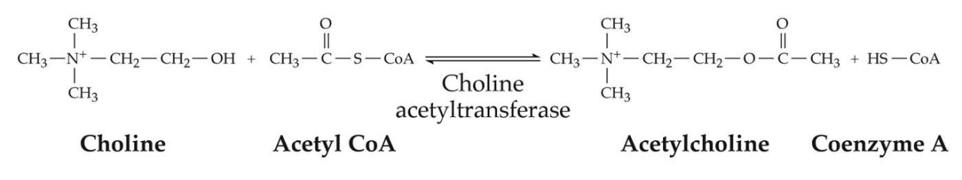
- Acetycholine synthesis is catalyzed by the enzyme choline aceytltransferase (CHAT)
- Choline aceytltransferase is present in the cytoplasm of the cell
- Syntehsise of ChAT:
- -synthesized within the cell body (rough ER)
- -transferred to the nerve terminal via axoplasmic transport

- The rate of Ach synthesis is controlled by
- -Availability of its precursor
- -rate of cell firing

- RELEASE OF ACETYCHOLINE

- The axon terminals of cholinergic neurons contain many small synaptic vesicles that store Ach for release
- Vesicles are loaded with Ach by a transport protein in the vesicle membrane called Vesicular ACh transport (VAChT)
- 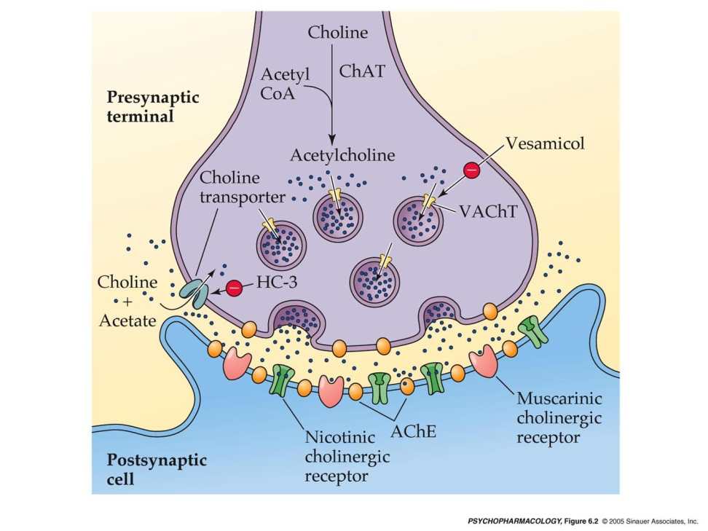
- This protein can be BLOCKED by a drug called Vesamicol
- -vesamicol treatment would decrease vesicular Ach but increase the level of Ach in the cytoplasm of the terminal
- -vesamicol DOES NOT affect the rate of Ach synthesis, therefore ACh molecules that normally would have been transported into the vesicles remain in the cytoplasm of the terminal

- -Because synaptic vesicles are the main source of ACh release, when the cholinergic neurons fire, such release is reduced in the presence of vesamicol

- -cholinergic neurons are still present and continue to undergo exocytosis when the neurons are active but the amount of Ach available within the vesicle to be released is abnormally low

- ACh Receptors
- 2 types of acetylcholine receptors (AChR) that bind acetylcholine and transmit its signal
- nicotine receptors :
- nicotine receptors are highly concentrated on muscle cells at neuromuscular junctions, on ganglionic neurons of both the sympathetic and parasympathetic systems
- they are ionotripic receptors therefore they posses an ion channel
- When ACh binds to nicotine receptor, the channel opens very rapidly and sodium and calckum ions enter the neuron or muscle cell
- The flow of ions causes depolarization of the cell membrane and increases the excitability of the cell
- Nicotine receptors mediate fast excitatory responses in both the CNS and the PNS
- has 5 different subunits and 10 diff kinds of a subunits and 4 diff kinds of b subunits
- 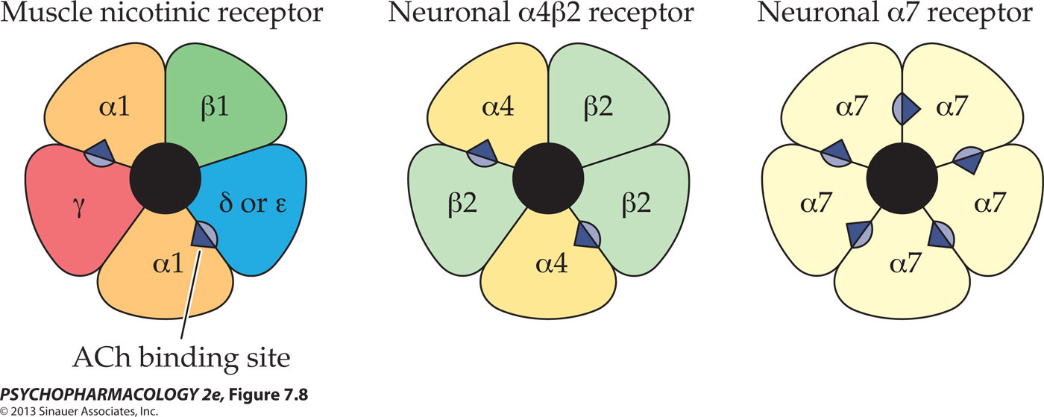
- the nicotine receptors found in muscle cells have a different subunit composition than the receptors found in neurons
- -all binding sites must be occupied to open the chanel

- -When nicotine receptors are subjected to continuous agoinist exposure they become desensitized which means an altered state of the receptor in which the channel remains closed regardless of whether molecules of an agonist such as ACh or nicotine are bound to the receptor

- -after a short while, desensitized receptors spontaneously resensitize and then are capable of responding again to a nicotinic agonist

- even if cells are continuously exposed to nicotinic stimulation, not all of the receptors are desensitized. Those that remain active produce a persistent depolarization of the cell membrane. If this continues for very long, a process called depolarization block occurs in which the resting potential of the membrane is lost and the cell cannot be excited until the agonist is removed and the membrane repolarized
- 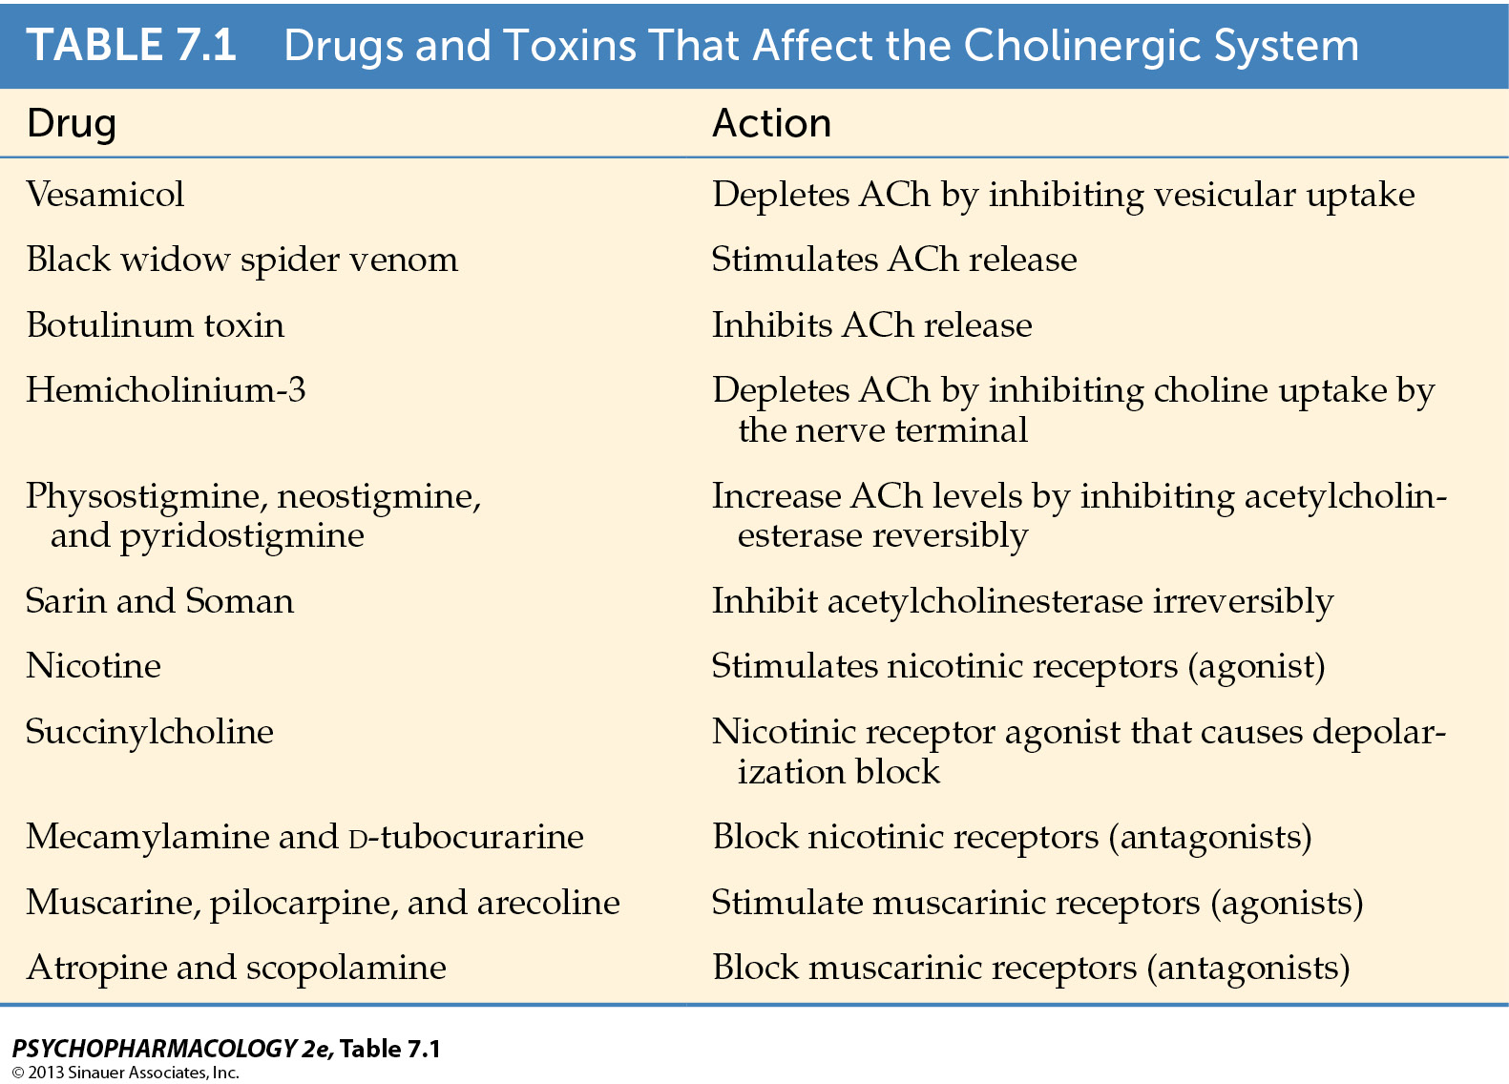
- Antagonist

- BLACK WIDOW SPIER
- The release of Ach is dramatically affected by various animal and bacterial toxins
- example, a toxin found in the venom of the black widow spider “Lactrodectus mactans” which leads to a massive release of Ach at synapses in the peripheral nervous system
- over activity of the cholinergic system causes numerous symptoms, including muscle pain in the abdomen or chest, tremors, nausea and vomiting, salivation, and copious sweating.

- BOTULINUM TOXIN (1Gram would kill 3 million people)

- Taken up by cholinergic neurons and inhibits ACh release
- Poisoning include blurred vision, difficulty speaking and swallowing, muscle weakness
- Helpful in treating clinical disorders characterized by involuntary muscle contractions
- -treatment of strabismus (crossed eyes)
- -treatment of belepharo-spasm (spasm of the eyelid)
- -treatment of hemi facial spasm (muscle spasm on just one side of the face)

- BOTOX: cosmetic putposes I npatients with excessive frown lines, worry lines..etc
- Results from chornic contraction of specific facial muscles and when injected locally into particular muscle or surrounding area, botox causes paralysis of that muscle as the result of blockade of ACh release from incoming motor nerve fibers

- INACTIVATION

- Enzymatic breakdown via acetyl cholinesterase . (AChE)
- Levels of ACh are carefully controlled by an enzyme called acetyl cholinesterase which breaks down the transmitter into choline and ecitic acid
- 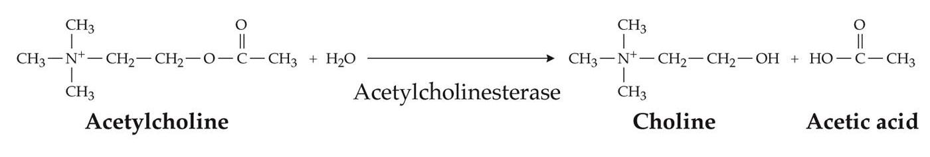
- AChE is present at several locations
- 1) found inside the presynaptic cell where it can metabolize excess of ACh that may have been synthesized

- 2)present on the membrane of the post synaptic cell to break down molecules of ACh after their release into the synaptic cleft

- -once ACh has been broken down within the synaptic cleft, a significant portion of choline is taken back up into the cholinergic nerve terminal by a choline transporter

- -Choline transporter can be blocked by a drug called hemicholinium-3 (HC-3) resulting in a decrease in ACh production

- -the cause of death in animals is lack of normal breathing due to failure to sustain ACh synthesis and release at the neuromuscular junction
- ( recycled choline plays a critical role in maintaining ongoing ACh synthesis)

- 3)found at neuromuscular junctions which are specialized synapses between neurons and muscle cells where ACh is released by motor neurons

- PHYSOSTIGMINE

- Physostigmine is a drug that blocks AChE and prevents inactivation of ACh and therefore increasing the postsynaptic effects of the trasnimitter
- A compound solated from calabar beans
- –crosses the BBB and exerts its effects on the CNS
- poising leads to slurred speech, mental confusion, hallucinations, loss of reflexes, coma, and death.

- MYASTHENIA GRAVIS
- Autoimmune disorder (a condition in which a part of the body is attacked by ones own immune system

- Antibodies block muscle acetycholine receptors and eventually cause these receptors to be broken down by the muscle cells

- Loss of receptor function causes the patients muscles to be less sensitive to ACh which leads to severe weakness and fatigue
- Reversible AChE antagonist are used in the treatment
- , ACh breakdown is restored after the drug dissociates from the enzyme

- NERVE GASSES

- Many nerve gasses such as Sarin and Soman are Irreversible AChE inhibitors
- Sarin and soman are designed to be dispersed as a vapor cloud or spray which allows their entry into the blood through skin contact or by inhalation
- The drug quickly penetrated into the bloodstream and is distributed to all organs including the brain
- Symptoms of nerve gas poisoning: vomiting, loss of bladder and bowel control
- Death occurs through asphyxiation due to paralysis of the muscle of the diaphragm
- How can a reversible AChE inhibitor be an antidote against Sarin or Soman?
- The temporary interaction of pyridostigmine bromine (PB pills) with the enzyme protects AChE from permanent inactivation by the nerve gases but requires that it be administered ahead of time before exposure to toxic agent

- Anatomy of cholinergic pathways in the brain

- Nerve cells in the stratum are internerous
- –BASAL forebrain cholineirgic system (BFCS) : BFCS is the origin of a dense cholinergic innervation of the cerebral cortex as well as the hippocampus and other limbic system structues
- –system plays a significant role in cognitive function

- another set of important cholinergic cells is located in the dorsolateral pons within the laterodorsal and pedunculopontine tegmental nuclei (LDTg and PPTg)

- LDTg ventral tegmental area VTA
- PPTg substantia nigra

- IN CONCLUSION

- ACh is synthesized from choline and acetylc CoA in a single reaction catalyzed by the enzyme choline acetyltransferase. The rate of ACh synthesis is controlled by precursor availability and is increased by cell firing
- ACh is loaded into synaptic vesicles by the specific vescular transporter VAChT
- A variety of animal and bacterial toxins influence the cholinergic system either by stimulating or inhibiting ACh release
- Following its release into the synapse or neuromuscular junction, ACh is rapidly degraded by the enzyme AChE
- Much of the choline liberated from ACh breakdown is taken back up into the cholinergic nerve terminal by a choline transporter that plays a critical role in maintaining on going ACh synthesis
- Drugs that block AChE cause prolongation of ACh action at the postsynaptic or muscular cholinergic receptors, reversible AChE antagonist are used in the treamtnet of the neuromuscular disorder myasthenia gravis whereas irreversible AChE inhibitors are the main ingredients of nerve gasses

