Internal Validity
- One of the 4 measures of quality, namely internal validity, relates to the control of extraneous variables
- Internal validity is a specific issue for experiments (e.g. causal claims)

- Researchers do their best to control everything, but this is not entirely possible
- There will always be a few things that vary
  - E.g. time of day, mood of experimenter, weather outside, testing environment, individual differences

Types of Extraneous Variables: Unsystematic vs. Systematic

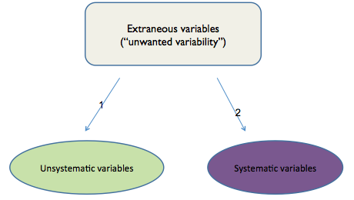

Unsystematic Variability
- extraneous variables are spread relatively evenly across all levels of the IV

Systematic Variability
- Called confounds
- Extra variable systematically “piggy backing” on levels of the IV and influencing the DV
- Provide alternative explanation for the results and threaten the quality of the claim

- Issues of internal validity (e.g. controlling for confounds) apply for both between-subjects and within-subjects experimental designs
- Some confounds that apply to both between-subjects and within-subjects designs
  - E.g. environmental variables
- Other confounds that are unique to each design
  - Between-subjects – individual differences
  - Within-subjects – situation differences

Environmental variables as confounds
- Some aspect of the environment that is not the independent variable, is systematically different for each level of the IV
  - Effects of caffeine on attention span study where the researcher mistakenly has everyone in the caffeine condition complete task in noisy coffee shop and everyone in the no caffeine condition complete in quiet library
  - As long as it’s the SAME across both levels, doesn’t matter if done in the noisy coffee shop or the quiet library
  - Want to make sure that it’s the same across both levels
  - Internal validity for study would be HIGH b/c making sure everything is the same for both levels
  - Unsystematic variables that affect the variables if you do the study in different environments
  - Confounds = systematic type!

- Environment is a potential concern for a between-subjects AND a within-subjects design
  - Make sure everything is consistent across all variables except for the IV
- E.g.
  - Researcher wants to examine the effects of happy mood on helping strangers with a sample of 100 people recruited through SONA
  - IV: mood (2 levels: happy / sad)
    - Hypothesis – happy mood leads to a happier condition
  - DV: helping stranger
  - After listening to songs (happy and/or sad depending on type of design) participants interact w/ a stranger and the researcher assesses how many people help the stranger
  - The researcher claims that sad mood causes increased helping

What do you think an alternative explanation for the results is (what are the confounds)?
- lyrics are really different
- primed w/ word helping, may want to help other people more

Internal Validity
- Internal validity concerns also differ based on the type of experiment design (e.g. confounds come in different forms)
  - Some confounds are unique to between-subject designs (e.g. selection factors)
  - Other confounds are unique to within-subjects designs

Threats to Internal Validity for Between-Subjects Designs
- 2 major sources of confounding
  - Environmental variables
    - Characteristics of the environment that may change from one treatment condition / level to another
  - Pre-exiting individual differences
    - Selection effects – occur when certain types of ppl w/ particular traits are systematically associated with levels of the IV
      - E.g. have all the shy people in one condition vs. extraverted people in another condition
    - Ways to increase chances of selection effects (BAD, DON’T WANT!)
      - Participants choose what level of the IV they want to be in
        - E.g. do you want to listen to a sad song vs. a happy song?
        - People could be picking which song based on their individual differences or their day or many other variables
      - Experimenter interview potential participant first and then decide what level of the IV that person should be in
        - Researcher may be biased by wanting their hypothesis to be true
    - Selection effects can be minimized through random assignment and matched-groups
      - E.g. confounds that relate to the environment and individual differences
      - Answer to assignment question!

Random Assignment
- Use of a random process to assign participants to treatment conditions helps to avoid selection effects
  - Doesn’t allow the participant decide which condition to be in
- Random assignment helps to increase chances that participant characteristics are distributed evenly across levels of the IV

Advantage
- Controls many variables simultaneously b/c doesn’t require special attention to each extraneous variable
  - Very time consuming to consider each one of those things and ensure that everything is equally spread
  - Use random assignment and hope that they spread out individual differences across the various levels
  - Sometimes researchers are just alright with the CHANCE of things being randomly distributed
Disadvantage
- Does not guarantee extraneous variables are controlled (uses chance)
- Need large sample

- Random sampling = rare, random assignment to condition = common ***** EXAM *****

Matching Across Treatment Conditions
- Matching levels of the variable across treatment conditions is another way to address selection effects
- Ensures that you have people w/ similar levels of an attribute in each level
- E.g. create pools of kids w/ hi, mod, low violent history; invite back to study and ensure that you sample equal amounts from each particular violent history into each level
- E.g. SONA

Matched Group Design
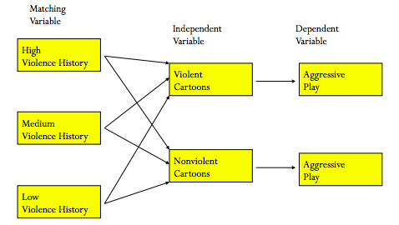

Matching
Advantage
- Useful for studies w/ small sample sizes
- E.g. small sample sizes increases chances that your sample may get lop-sided
Disadvantage
- Extra work to pre-measure and ensure equal amounts b/w different levels of the IV

Conclusion
- To deal w/ threats to Internal validity for between-subject designs
  - 1. Make the environment as similar as possible for all levels of the IV (IV manipulation will differ across levels)
  - 2. To deal w/ selection effects use random assignment and/or matching

Use this lecture for question 3 on the assignment!

