2 general types of experimental research design
- between-subjects
- within-subjects

Between-Subject Design
- Examine if differences in the DV exist b/w 2 or more levels of the IV
- Different group of people associated w/ each level of the IV
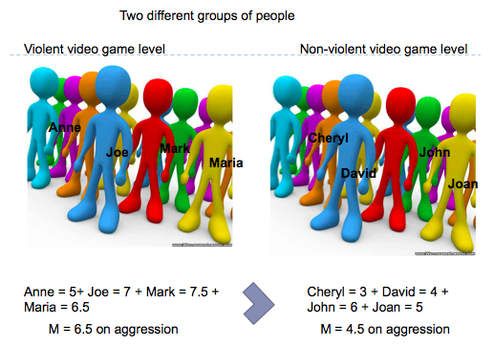

Advantages
- Each individual score is independent of other scores
  - Each participant enters the study fresh and naïve with respect to the procedures being tested

Disadvantages
- Requires relatively large number of participants
  - Pre-existing individual differences – characteristics that differ b/w participants at the beginning of the experiment (e.g. extraneous variable)

Within-Subject Design
- Examine if differences in the DV exist b/w 2 or more levels of the IV
- Same group of participants in all the levels of the IV
  - E.g. exposure time to objects and recognition ability
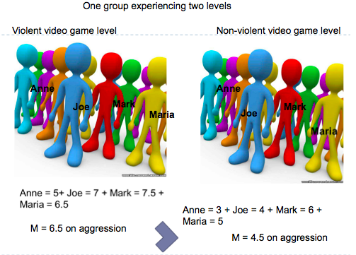

Advantages
- Need fewer participants
- Eliminates problems of individual differences (problems in between-subject designs)
  - No differences b/w groups in terms of individual differences b/c only one group of participants

Disadvantages
- Series of treatment conditions administered at different times
  - Order-related factors may influence score
    - Practice, fatigue, aftertaste
    - E.g. caffeine study – issue is an initial cup of caffeine may affect responses to decaf conditions

Between-Subject Design vs. Within-Subject Design

E.g. Between-Subject Design
- Does sugar lead to greater activity levels in children?
- Design Experiment
  - IV: Sugar given to participants, 3 levels: sweetener, 10g, 40g
  - DV: Activity level during dance video game
- What would a within-subjects experimental design look like?
  - n=50, expose the people to various levels, admin the study at the same time each experiment
- What would you be concerned about?
  - Confounds, etc.

External Validity
- Generalizability of the results
- Degree to which obtained results hold true outside the constraints of the study
  - E.g. populations, environments, measurements and times
- External validity is based on how participants are recruited and tested rather than how many of them were recruited

Threats to external validity
- Any factor that limits the generalizability of research results
- E.g.
  - Generalizing across participants or subjects
  - Generalizing to the real world
  - Generalizing across features of the study

1. Generalizing Across Participants or Subjects
- Do the findings generalize to the population of interest?

- Several issues when considering whether research claims generalize to the population of interest
  - Convenience samples
  - Volunteers
  - Cultural differences
  - Species differences
- Sampling procedure favours selection of some individuals over others

- Bias
  - 1- selection bias is the use of university / college students
    - Easily available
    - Characteristics limit generalizability to other adults – highly select group
      - Age
      - Education
      - Socioeconomic status
  - 2- volunteer bias
    - Individuals who choose to volunteer may be systematically different than those who didn’t volunteer
    - E.g. more educated, higher social class, more intelligent, more sociable

- Cultural Differences
  - E.g. research conducted w/ North American might not necessarily apply to people living in Japan

- Species Differences
  - Research conducted on non-human does not necessarily apply to humans
  - Need to consider similarities and differences between species

2. Generalizing to the real world

Ecological Validity
- extent to which study mimics the real world
- E.g. social exclusion, hot sauce paradigm, etc.

3. Generalizing Across Features of a Study

Features include: operational definitions / measures, time of measurement, experimenters

Generalizability Across Response Measures
- variables can be defined and measured in different ways
- limited by specific measurement
- may not generalize to other definitions or measures

Time of Measurement
- measurement at specific time after (during) treatment
- actual effect of treatment may decrease or increase with time
- results may differ depending on the time of measurement
  - E.g. extent of generalizability might only be a few seconds, minutes, a day, a week

Experimenter Characteristics
- to what extent can the results of the study be generalized to other experimenters?
- Results of study can be specific to an experimenter with certain set of characteristics
  - Demographic: age, race, gender
  - Personality: degree of friendliness, prestige, anxiety, hostility

