Question 1 - 10 marks (Net Present Value and Capital Budgeting)
NPV_{rent} = -218, 077 (2 marks); NPV_{purchase current machine}=-198,931 (3 marks) NPV_{purchase asdvancedmachine=} - 234,039 (3 marks)
Big Rock should purchase its current machine (2 marks)
Question 2 - 10 marks (Real Options)
- NPV_{good} = $23,595,041 (1 mark), NPV_{average} = $4,000,000 (1 mark), NPV_{bad} = -$16,000,00 (1 mark), Project NPV = $5,878,512 (1 mark)
- NPV_{good} = $21,450,037 (1/2 mark), NPV_{average} = $3,636,363 (1/2 mark), NPV_{bad} = $0 (1/2 mark), Project NPV = $8,253,193 (1/2 mark)
- NPV_{good} = $13,523,666 (1 mark), NPV_{average} = $0 (1 mark), NPV_{bad} = $0 (1/2 mark), Project NPV = $2,704,733 (1/2 mark) Do NOT wait - invest immediately (1 mark)
Question 3 - 10 marks (Net Present Value and Capital Budgeting)
incremental CAPEX = -100,000(1 mark) incremental EBITDA (Cash Flow) on a after-tax basis = $67,590 (4 marks); PVCCA (incremental capex) = $34,363.63 (2 marks); NPV (of incremental cash flows) =$1,953.87 (2 marks), replace machine (1 mark)
Question 4 - 10 marks (Leasing)
- K = 5.6% (1 mark), correct model (2 marks), payments valued as an annuity due (1 marks), NPV_{lease} = -$1818 – buy the dump truck (1 mark)
- Price = $102,270 (3 marks)
- Any two of those listed will do (1 mark each, 2 marks total)
Question 5 - 10 marks (Equity Options)
a) put options in the money by $10 (1 mark)
b) long stock =$1,105,000(1 marks); buy calls at $10 = $9,500 (2 marks) 0.5 marks each for benefit & drawback
c) put premium=$9.49
Question 6 - 10 marks (Project Evaluation)
- Big planes NPV = $199.63 million (2 marks), Big planes EANPV = $42.36 million (1 mark), Small planes NPV = $170.22 million (2 marks), no need to calculate EANPV small - go with the big planes (1 mark)
- big planes has the higher PI (2 marks) you can tell this from the priori information, no calculations required
- leftover pieces remain in the asset pool and are eventually accounted for (2 marks)

Question 2
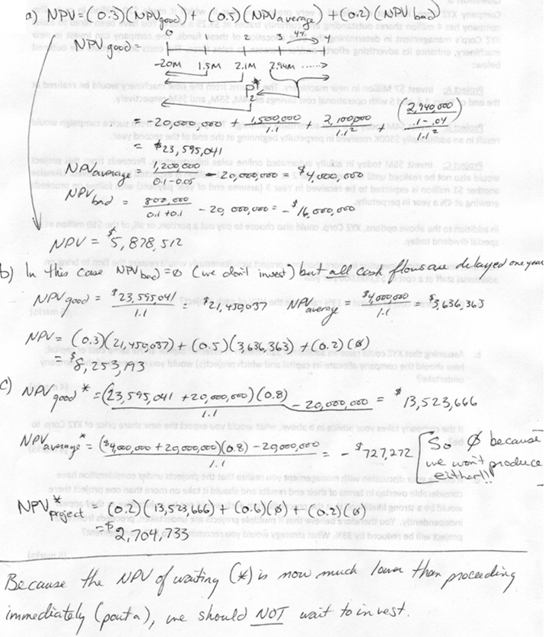
Question 3
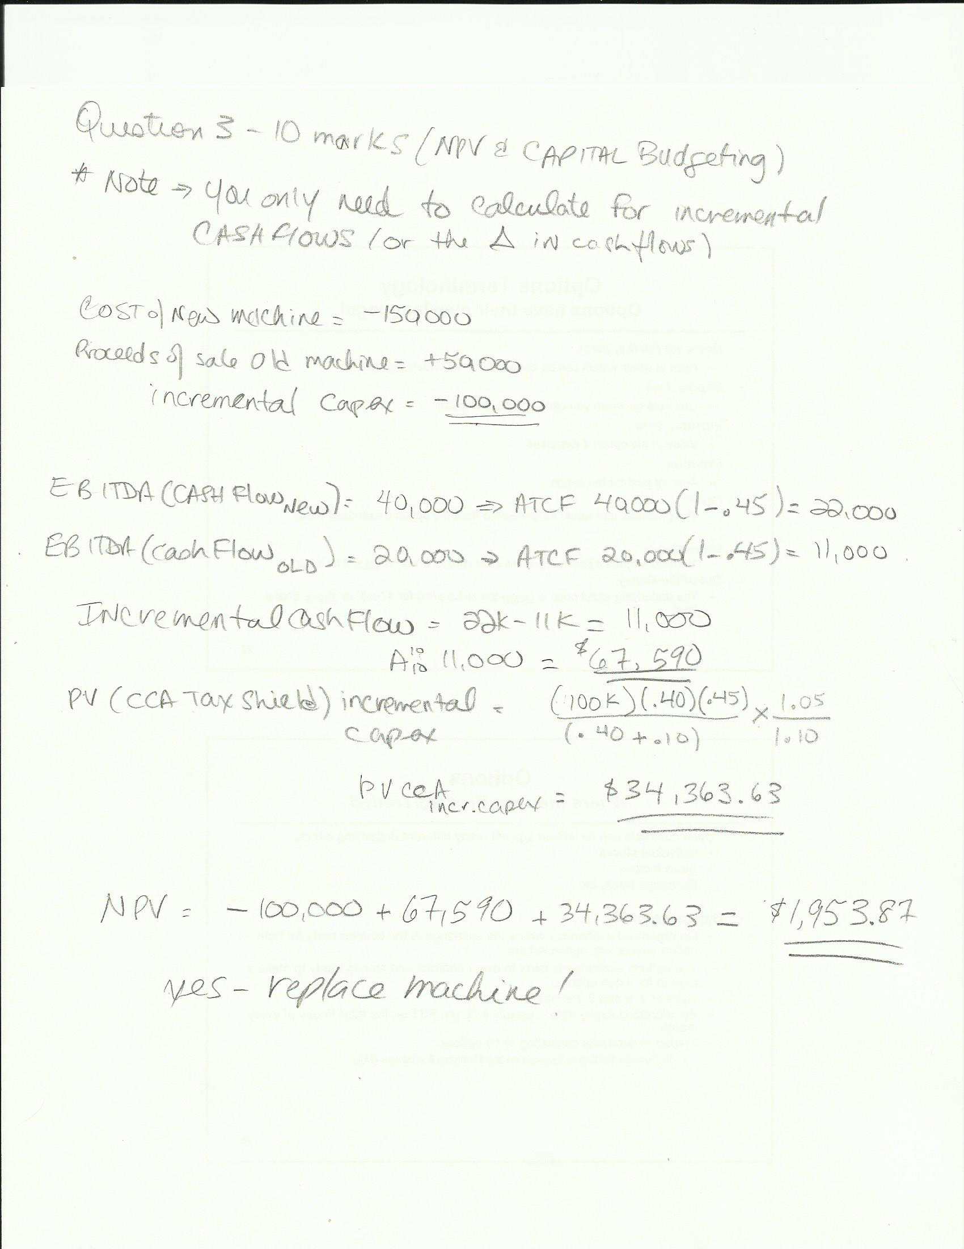

Question 4

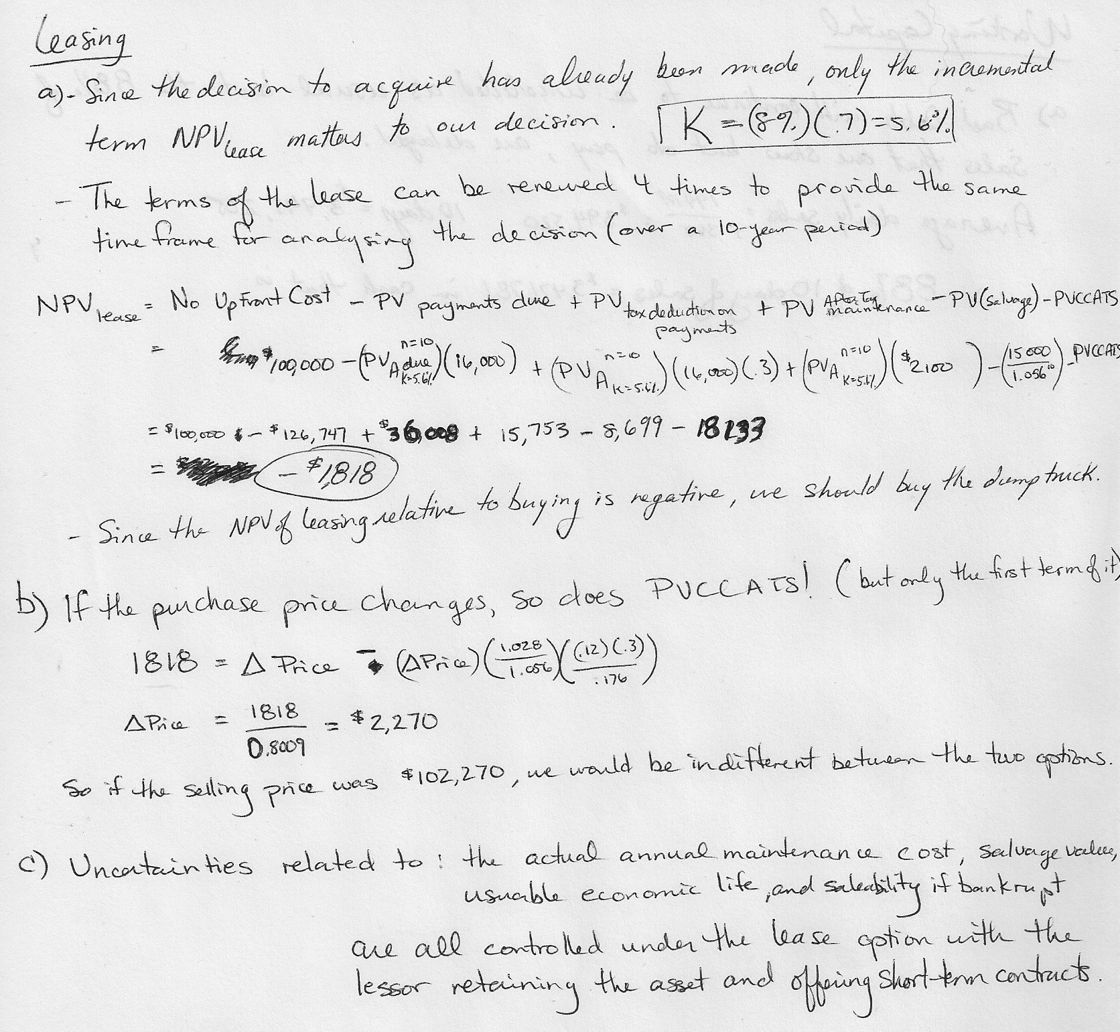

Question 5

a) | the put options are in the money as the stock is trading at 1,105 and the investor has the right to sell
 | the stock at a price of $1,115. The put option is 'in the money' by 1,115 - 1,105 = $10
b) | The investor can: a) go long the stock b) buy 10 Google call options
 | a) Cost of going long the stock: |  |  |  | 1,000 shares x $1,105 = $1,105,000
 | benefit: if the investor is wrong on his prediction for the earnings and subsequent increase in
 |  | the stock's price, it will not expire worthless - he can just hold the stock
 | draw back: | requires a very large cash investment (over $1,000,0000)
 | b) Cost of buying 10 call options: |  |  |  | 10 x 100x 9.50 = $9,500 USD
 | benefit: this a leveraged 'bet' and the cost to implement is very low
 |  | relative to purchasing the stock outright
 | drawback: |  | If the investor is 'wrong' in his prediction of the company's earnings and
 |  | subsequent increase in share price, the premium on the call option can go
 |  | to 'zero' since there is no time value (expiry is on Jan 18, 2014) and he can
 |  | lose the entire $9,500
c) | put call parity:
 | 1 month t bill rate is an annual yield - to calculate it for 1 month = 0.01/12=0.00005%
 |  | PV(X) = Xe^{-rt}
PV(1,105) = 1,105e^{-0.0000008333x1}

^{or} PV(1,105) = 1,105e^{-0.01%*17days/365days} - this is the correct way to do the calc. using the t-bill rate as it's an annual rate, no compounding

PV(1,105) = 1,105e^{-0.01%}

PV(1,105) = $1,104.99 or
PV(1,105) = $1,104.96 or
PV(1,105) = $1,104.89

Question 6


