ECN204- Personal Exam Notes

AE= C + I_{g} + G + X_{n}
Equilibrium: GDP = AE; Unplanned Inv= 0 AND Savings= Investments
Short-run Equilibrium: AE=45 degree line (GDP); here output=usage
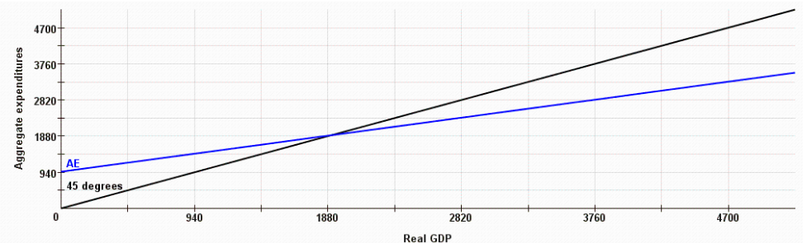
Consumption Function
C=C₀ + (mpc) Y (income); C (Consumption); C₀ (Autonomous Consumption); c (MPC= ΔC / ΔY =slope)
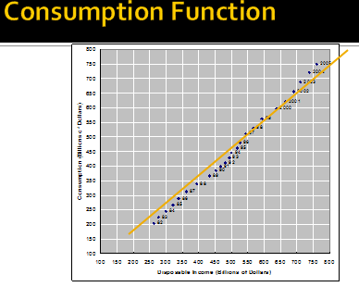
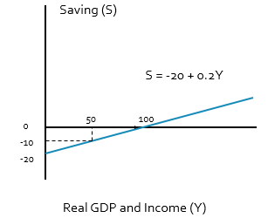

Savings Function
S= Y- C
S= Y- (C₀ + cY)

Interest Rate and Investment Relationship
- i: (real interest rate)= (nominal rate) – inflation
-Investment I= I_{g} It is a fnc of investment demand and not GDP
The Investment Demand Curve) and Investment Schedule
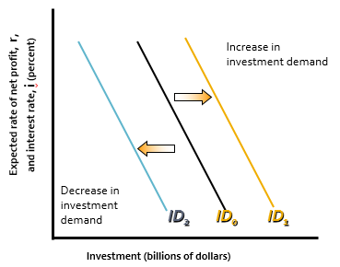
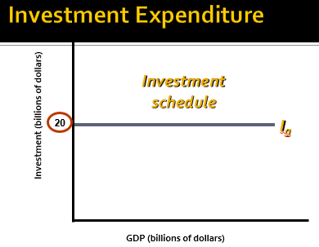
Determining Equilibrium Employment, Output and Income
- AE= C+ I
- Savings= GDP- Consumption aka Income-Consumption
- Unplanned inventories= GDP- AE
- Tendency: (-) Unplanned inventories then increase, (+) then decrease
- Equilibrium: GDP = AE; Unplanned Inv= 0 AND Savings= Investments
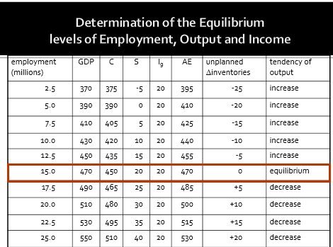
The Multiplier effect on changes in GDP
ΔGDP = (ΔAE)(Multiplier)
$$Multiplier=\frac{ΔYe}{ΔAE}$$
$$Multiplier=\frac{1}{1-MPC}=\frac{1}{MPS}$$
Change in spending Change in income Change in both savings and consumption

Complete AE/ Summary
Closed, Private Economy: AE= C+ I
AE= C + I + G + X_{n}
AE= C₀+ (mpc)Y + I + G + X_{n}
AE= C₀+ (mpc)Y + (Business Investment + Inventory) + G + X_{n}

AE= (mpc)Y + b
y= mx+ b [A linear Fnc]
b= (C₀) + (I_{g}) [Intercept]
Slope= MPC= ΔC/ΔY

1=MPC+MPS

Multiplier = 1/ (1-MPC) = 1/MPS

Reaching Eqm values: ΔGDP= ΔY= (ΔAE)(Multiplier)
ΔY_{e} = Δ(C₀ + I_{g})/(1-c)
New GDP= (Old GDP) + (ΔAE)(Multiplier)

The intercept of AE Fnc is given by Int= (C₀) + (I_{g}) and is called Autonomous expenditure
Average Propensity to Consume= Consumption/Income APS= Savings/Income

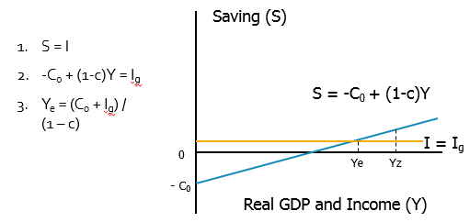
Chapter 6 Short Run Equilibrium and complete AE
- C = C₀ + c(Y-T), I = I_{g} and G
- AE = C + I + G+ NX
- AE = C₀ + c(Y-T) + I_{g} + G + NX
- Y = AE and I= S, NX=0 at equilibrium
- Y = C₀ + c(Y-T) + I_{g} + G +NX
- Y_{e} = (C₀ - cT+ I_{g} + G)/(1-c)

Below: Increases in public spending (G), or increases in I shifts AE upward higher equilibrium GDP(Y)
Investment decrease/ increases
- France has an MPC of 0.22 and a real GDP of $431 bil. Its investment spending decreases by $9 billion.
- Calculate new level of real GDP in the aggregate expenditures model.
- Changes in GDP = multiplier x initial change in spending
- Recall ΔY_{e} = Δ(C₀ + I_{g})/(1-c) ΔY_{e} = = $9/(1-0.22) = $11.54 billion
- New GDP = Old GDP + change in GDP (-) = $431 - $11.54 = $419.46 billion

Taxes and Government Spending Increases
-Generally, imposing taxes reduces GDP by that amount
(Eg. Suppose govt adds 40 bil purchases & suppose govt imposes 40 bil of lump-sum tax)
Given: GDP, T=40, G=40, C, I=20
-Consumption spending C_{a} Lowered; GDP(Y) income - 40bil lump/flat tax (T) = DI (Disposable Income)

DI= Y - T = C_{a} + S_{a} so: 1) calculate DI (Y-T) 2) calculate S (DI- C) 3) calculate NX=
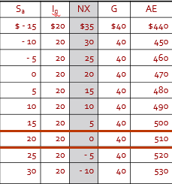
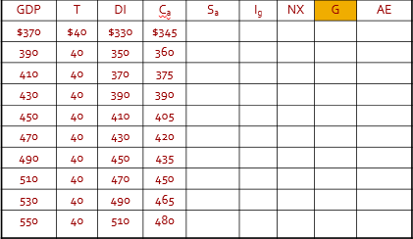

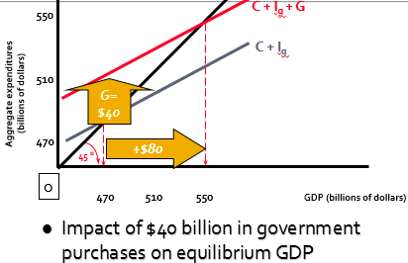
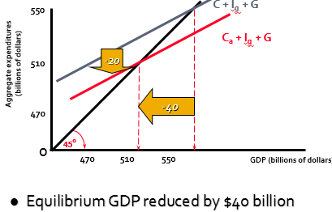
Taxes and EQP GDP

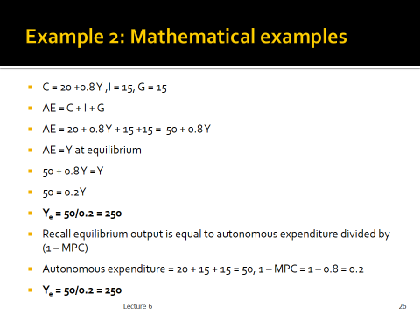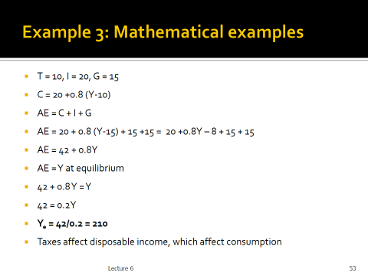

- Equilibrium GDP may or may not provide full employment
- Recessionary Expenditure Gap
- Increasing autonomous expenditure has a multiplier effect

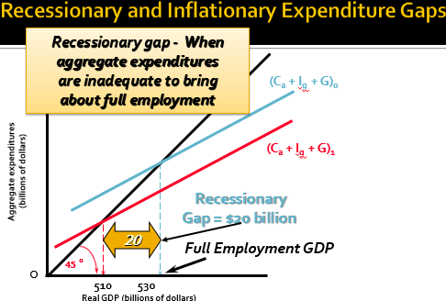

- France is falling 2.0% above its targeted income of $18,000 and has a marginal propensity to consume of 0.6.
- By using the multiplier model, what change in government expenditures would be needed to achieve this target?
- Recall, Multiplier = ΔY_{e}/ΔAE
- Multiplier = 1/(1-MPC) = 1/(1-0.6) = 2.5
- ΔY_{e}= 2%*$18,000 =$360
- ΔAE = $360 / 2.5 = $144
- Government must increase its expenditure by $144 to close the output gap.

- Taxes and transfer payment affect consumption
  - Lump sum tax, DI = Y - T
  - Net tax, NT = tY, t net tax rate
  - DI = Y – NT = (1-t)Y
- Lump Sum Tax
- Assume C = 20 + 0.8DI
- T = 10
- DI = Y-10
- So C = 20 + 0.8(Y-10)
C = 20 + 0.8Y – 8 = 12 + 0.8Y
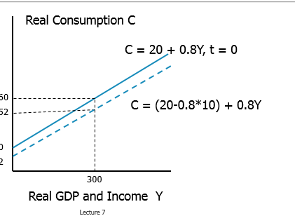
- Each dollar of lump sum tax reduces autonomous consumption by 0.8 dollar (80 cents)
Net Tax
- t = 10%
- DI = (1-t)Y
- So C = 20 + 0.8(1 – 0.10)Y
C = 20 + 0.72Y

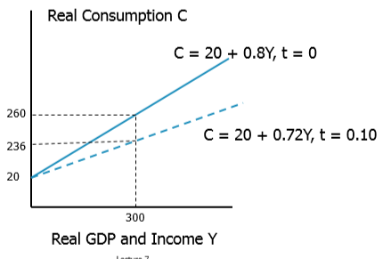
- Government spending (G) shift AE vertically
- Net tax (increasing tax rate) reduces DI, therefore lowers consumption, ro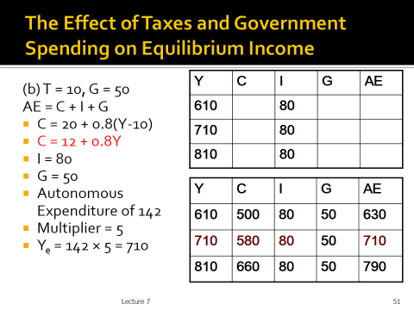tate AE to the right (slope of AE is reduced)
  - AE and C has the same slope MPC × (1-t)
- Multiplier effect is given by the combination of the two
- Multiplier = 1/(1-MPC x (1 –t))
The change of equilibrium GDP is given by G x multiplier.
- 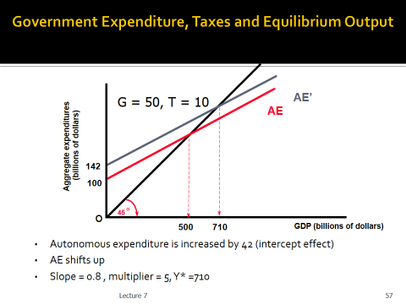
- 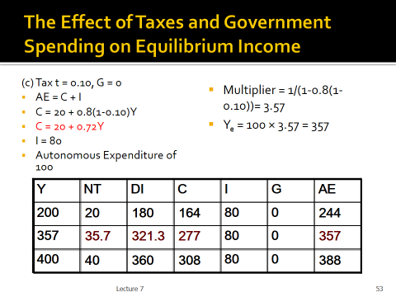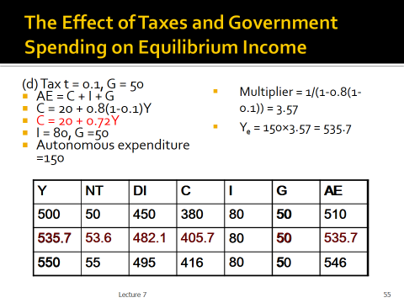Multiplier = 1/(1-MPC x (1 –t))
- 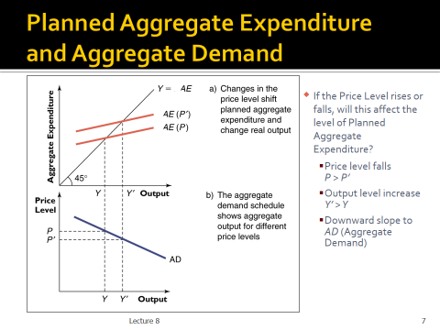Consumer Spending
- Investment Spending
- Government Spending
- Net Export Spending

Aggregate Supply
- The level of real domestic output that will be produced at each price level
- Production responses to price level changes differ in the long run & the short run
- 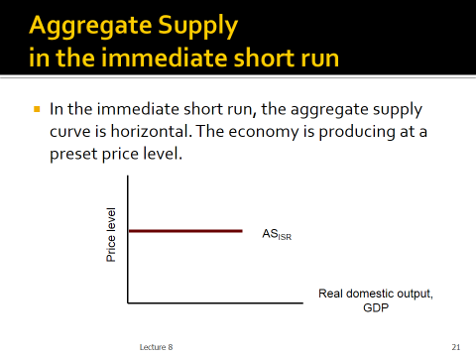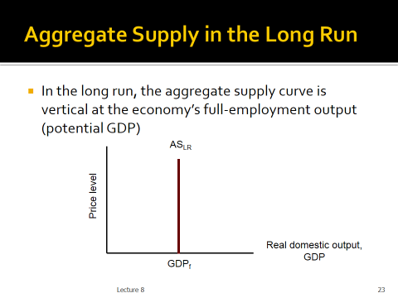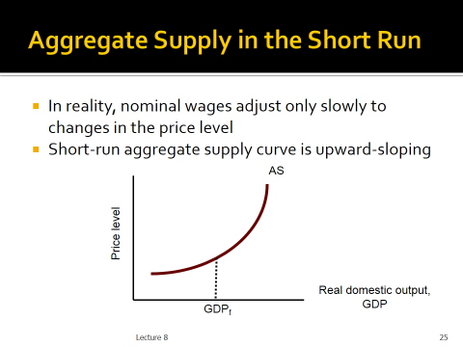
- Equilibrium occurs at the price level that equalizes the amount of real output demanded and supplied
A price level too low would mean AD>AS, putting upward pressure on prices across the economy
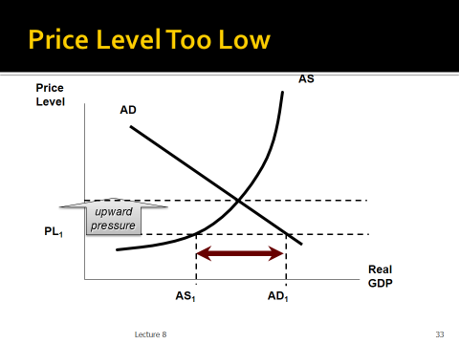

- Similarly, a price level too high would mean AD<AS, putting downward pressure on prices across the economy
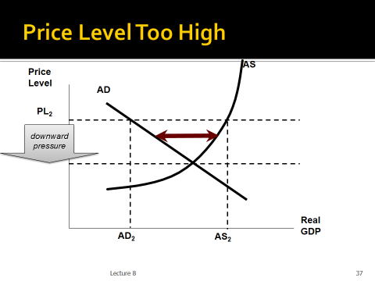

Demand Pull Inflation: increases in AD

- For any initial increase in aggregate demand, the resulting increase in real output will be smaller the greater is the increase in the price level
Demand-pull inflation
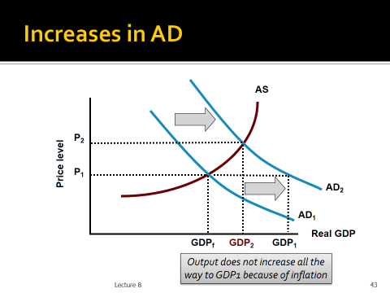
- Deflation is a rarity in the Canadian economy
- Real output takes the full brunt of the decline in AD because product prices are “sticky” in the short run. SO decreases in AD at P1, NO CHANGE in price levels, only GDP reduction

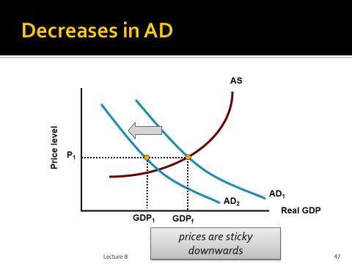

- Decreases in AS: Cost-Push Inflation
- Effects of a leftward shift in AS are doubly bad
  - output decreases
  - price level increases
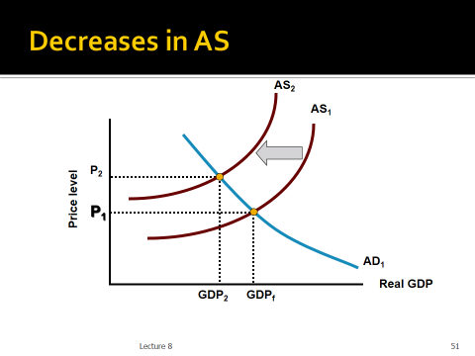
Increases in AS
- Full Employment with Price-Level Stability
- Increases in AD should normally lead to inflation
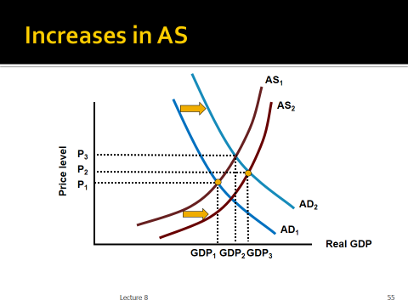
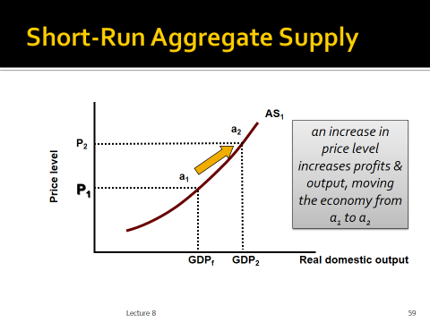
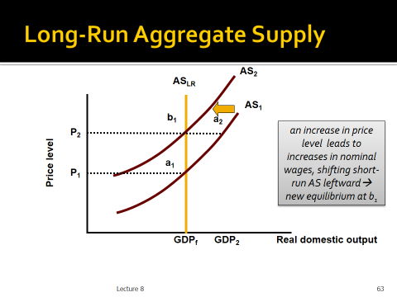
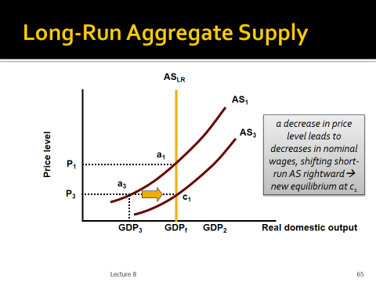
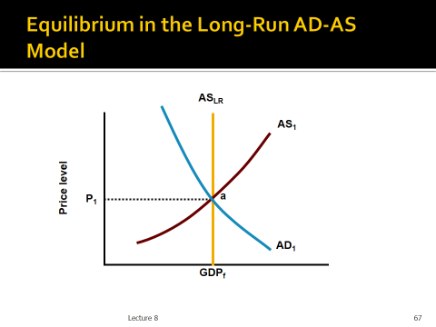
no guarantee, in the short run, that equilibrium GDP will be full-employment GDP

- A recessionary gap occurs when AD is too low, and equilibrium GDP is below potential GDP
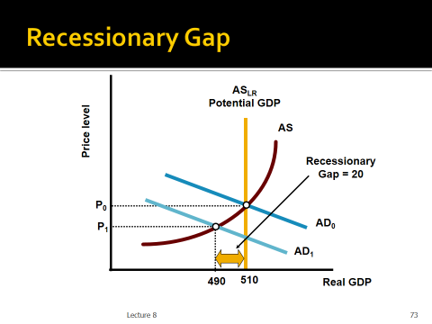

- An inflationary gap occurs when AD is too high, and equilibrium GDP is above potential GDP
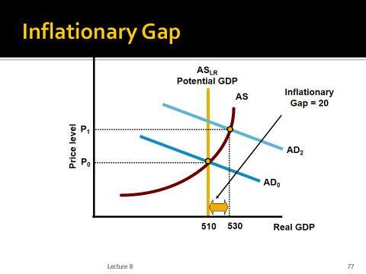

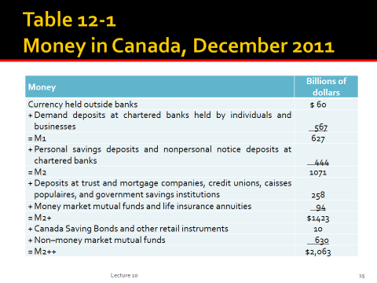
- Money and Prices
  - Purchasing Power of the Dollar
    - D = 1/P
    - If the price level is 1.0, then the value of the dollar is 1.
    - If the price level rises to, 1.20, D falls to 0.833;
  - Fractional reserve banking system
    - A banking system with a reserve ratio that is less than 100 percent of the deposit liabilities of a chartered bank
  - Making Loans
    - Prime rate
- Balance sheet
  - Assets = Liabilities + Net Worth
  - Both sides balance
- Necessary transactions
  - Create a bank
  - Accept deposits
  - Lend excess reserves

- Transaction #1 Vault cash: cash held by the bank
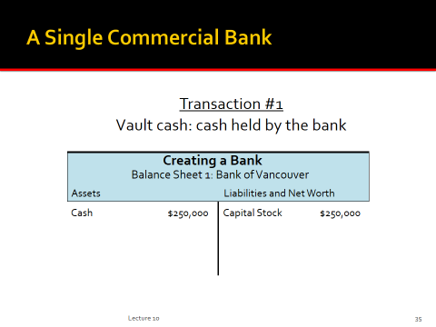
- Transaction #2 Acquiring property and equipment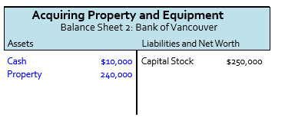
- Transaction #3 Chartered bank functionsAccepting deposits of $100,000
  - So demand deposits increase full amt. Cash increases by reserve
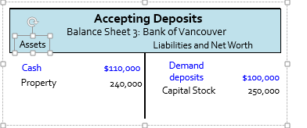
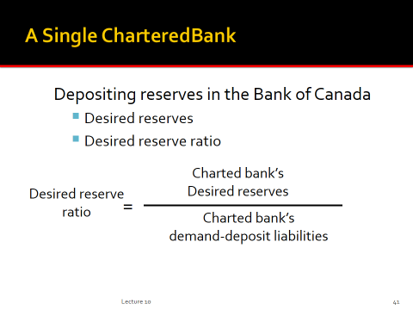
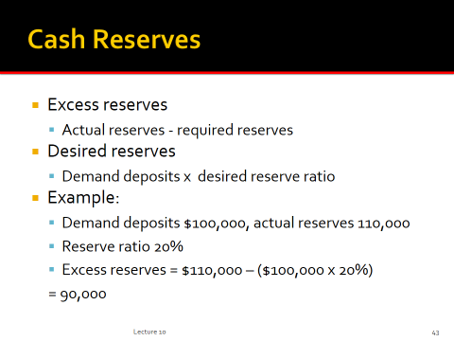
M1= actual reserves= cash+ demand deposits
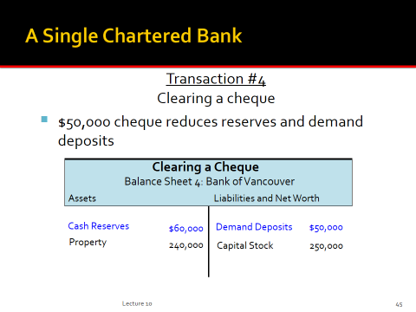
Only loans and demand deposits increase when a loan is deposited/granted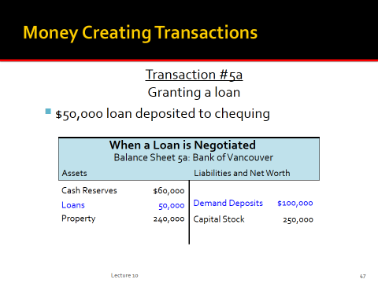
When the loan is cashed, demand deposits are reversed, but cloans remain and cash reserves are depleted. To an amount equal or less to its preloan excess reserves
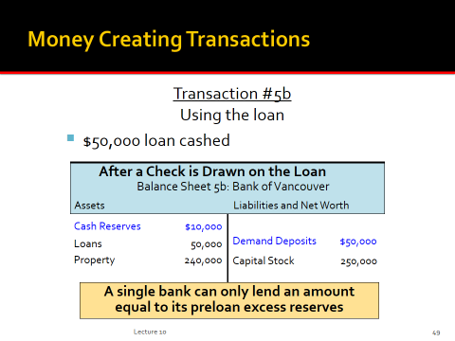
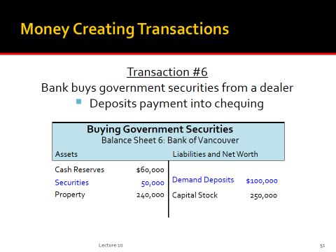
- Bond purchases from the public by the chartered banks increases the money supply
- Bond sales to the public decreases the money supply

- Multiple-deposit expansion
- Assumptions:
  - 20% required reserves
  - All banks “loaned up”
  - Banks lend all of their excess reserves
  - A $100 bill is found and deposited
  - Multiple deposits can be created
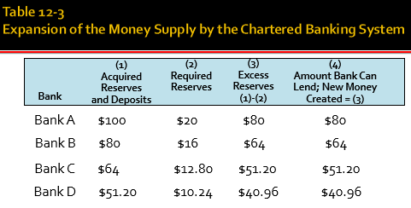
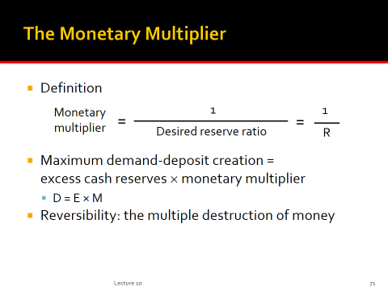
- Money supply = Currency held by the public + Bank deposits
- Money supply = Currency held by public + (Bank reserves /Desired reserve ratio)
- Example: the money supply at Christmas
  - Initially bank reserves are 500, the amount of currency held by the public is 500, and the desired reserve-deposit ratio in the banking system is 0.2.
  - Money supply = 500 + (500/0.2) = 3000
  - Because of Christmas shopping needs, the public increases its currency holdings to 600 by withdrawing 100 from commercial banks
  - Money supply = 600 +(400/0.2) = 2600
- When the public withdraws cash from the banks, the overall money supply declines significantly.
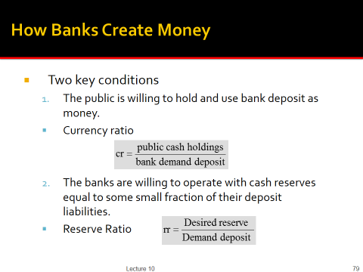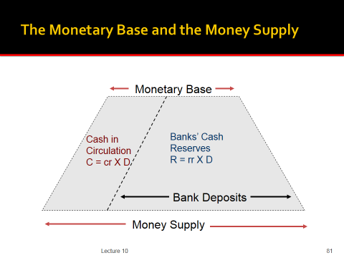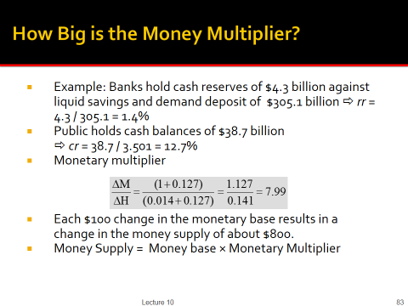

- Bank of Canada SELLS bonds to the public
  - Public pays bonds with cheque
  - Cheque is cleared in chartered bank
  - Chartered bank’s reserves decrease
- The Bank of Canada bond sales of $1000 to the chartered banking system reduce the system’s actual and excess reserves by $1000.
- But a $1000 bond sale to the public reduces excess reserves by $800
- The bank rate is the interest rate the Bank of Canada charges on the loans to the chartered banks
- Bank rate is set at the upper end of the Bank of Canada’s operating band for the overnight lending rate
- Bank has a publicized target for the overnight lending rate
- Overnight lending Rate
  - The interest rate charged by banks on overnight loans
- Bank of Canada conducts open market operations to achieve the target

- Expansionary monetary policy
  - Economy faces a recession
  - Lower target for overnight lending rate
  - Bank of Canada buys securities
  - Expanded money supply
  - Downward pressure on other interest rates

- Restrictive monetary policy
  - Periods of rising inflation
  - Increases target for overnight lending rate
  - Bank of Canada sells securities
  - Increases money supply
  - Increases other interest rates



