Midterm 1 Chapter 1-6 (slide 18) Notes
Chapter 1
Micro: Focused on individual industry, firm or household and price of specific products
Macro: Measures total output, tot employment, tot income, aggregate expenditure and general price lvl
PPC Tables and Curves
Optimal Product Mix: Any point on curve. Depends on society.
Productivity level = Outputs/Inputs
*Law of Increasing Opportunity Cost
Opportunity Cost: Amount of one product sacrificed for more of another. Measured in # of product.
- (Marginal) opportunity cost increases with more of a product produced. Causes concave PPC.
-Optimal allocation decided when MB=MC
-Marginal benefit: extra benefit of consuming 1 more unit
-Marginal cost extra opportunity cost of that unit
-Economic Rationale:
- Econ. Resources not fully adaptable to change in uses
- Eg. To make more pizza have to retrain workers who used to make robots
Calculating Opportunity Cost using Tables and Curves
If the economy was at point C, what is the opportunity cost of producing 8 more consumer goods?
-Note: move backwards from point C-B, so Opp. Cost= 24-16= 8 Capital goods
A technological change unique to capital goods means producing 50% more capital goods at each level
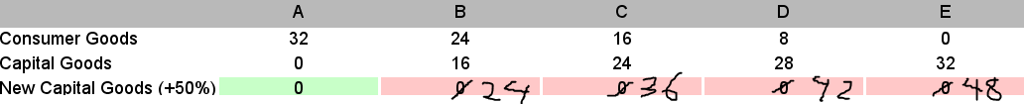
*Compared with the original combination "C", how many more capital and consumer goods can it now have as a result of the technological improvement?
-Capital: Increase= # new capital goods it can produce. Subtract original # from new. 36-24=12
-*Consumer: # of new consumer goods we can produce.
- Originally, economy operating at point C, producing 24 capital goods and 16 consumer goods.
-After tech change, can produce 24 capital goods at production point B. Keep prod of cap goods same, econ shifts to point B
-Increase in Con.Goods= Point C- Point= 24 - 16 = 8

Chapter 2
The Circular Flow Model (memorize)
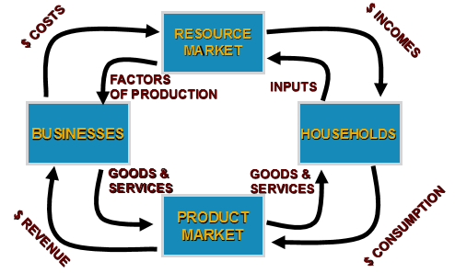
GDP: Real and Nominal
Final G&S: eg. Bread. Consumed by ultimate user. End products of production process.
Intermediate: eg. Wheat in flour, flour in brad. Used up in production of final. Not separately counted.
-So if stylist receives 20$ for ,cut, but pays assistant 4$ of that. GDP inclusion is still 20$
Value Added
  - Market value of G/S minus cost of inputs. Eg. Value added in bread production totals to the price of the final good (bread(
  - 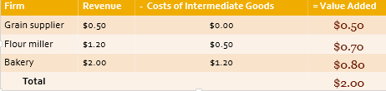

Calculating (nominal) Market Value GDP
- Total final G/S produced at current prices
GDP= (Qty Good)(Price Good)
-eg. 4 million apples, 6 million pears and 3 million pairs of shoes
-Price: $0.25 (apple), $0.50 (pear) and $20 (shoes)
-GDP = ($0.25×4) + ($0.50×6) + ($20×3) = 64 million
Suppose the total market value of all final goods and services produced in a particular country in 2000 is $600 billion and the total market value of final goods and services sold
is $525 billion. We can conclude that:
GDP in 2000 is $525 billion.
→ GDP in 2000 is $600 billion.
Nominal GDP
- Expenditure Approach
  - C: Consumer Expenditure
  - I_{g}: Gross Investment= Net Investment + Depreciation
= (Business investment + Inventory) +depreciation
  - G: Government spending (transfer payments)
  - Xn= Net Exports = Exports – Imports
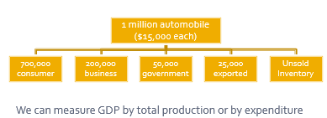
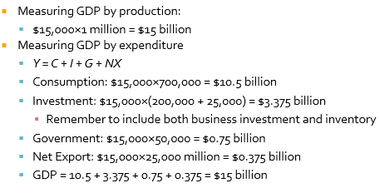
Real and Nominal GDP
Nominal: GDP at current prices
Real: GDP with prices of a base year
Note: Graphically, the real and nominal GDPS will intersect exactly at the base YR 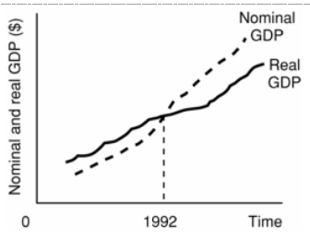
Calculating Price Index AKA GDP Deflator
OR $Price Index=\frac{Nominal GDP}{Real GDP}*100$
Note: Base yr always PI=100

Calculating Real GDP and GDP Deflator
$Real GDP=(Output Quantity)(Price Base Year$)
$GDP Deflator=\frac{Nominal GDP}{Real GDP}(100)$
a) Method 1: Get a price index, then adjust nominal GDP by dividing by price index (in hundredths)
b) Method 2: Get quantity of physical output and determine what it’d sell for in base year. Result is Real GDP. Implied GDP deflator= [Nominal GDP/Real GDP] x100 (for standard index form)
Chapter 3: Measuring Economic (GDP) Growth Rates
GDP Growth Rate and Per Capita
$GDP Growth=\frac{Real GDP Yr2-Real GDP Yr1}{Real GDP Yr1}*100\%$

Inflation/ Price Level / Consumer Price Level (CPI) Growth
$Inflation=\frac{CPI yr2-CPI yr1}{CPI yr1}*100\%$
Employment
-Employed: # of persons over 15 who are employed
-Labour Force: Employed and unemployed who are looking for work. Discouraged workers= gave up.

$Unemployment Rate=\frac{Labour Force-Unemployed}{Labour Force}*100\%$

$Participation Rate=\frac{Labour Force}{Population}*100\%$
Rule of 72
Idea of compound interest (interest paid on original deposit and previously accumulated interest)
$Years for Magnitude to Double=\frac{72}{Growth Rate}$
GDP Per Capita
$GDP Per Capita=\frac{GDP}{Population}$
Production or GDP is a function of: Technology, Physical Capital, Human Capital, Natural Resources

Chapter 4: Business cycles, potential output, unemployment/Okun’s law, Inflation
4 Phases of Business Cycles
-Cycle /=/ inevitable or regular econ fluctuations. Unemployment is key indicator of short-run fluctuations (cyclical unemployment). Inflation follows typical patters in recessions (falling) and expansions (rising)
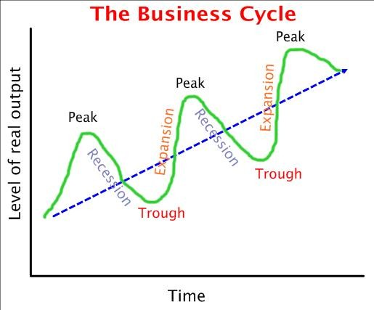
Peak: High point of GDP (Econ. Activity) before a downturn
Recession: Minimum 2 Consecutive quarters of declining GDP (or growth under normal rates)
Trough: Low point of GDP before a recovery
Expansion: Econ growing rate above normal, lasts longer than recession
Boom: expansion that is particularly drawn-out and strong

*Recent Recessions

Potential Output/Real GDP AKA Full Employment Output
Potential GDP (Y*): Real GDP an econ could produce if using resources at normal rates. Grows over time.

Output Gaps
Output Gap= Actual Real GDP (Y) – Potential Real GDP (Y*)
Recessionary Gap (Y<Y*): Negative gap. Unutilized capital/labour resources. High unemployment
Expansionary Gap (Y>Y*): Positive gap. Resources (labour) utilized at rate greater than normal. Low unemployment
Unemployment: Types of Unemployment and Examples
Frictional: those searching for jobs or waiting to take jobs soon; it is regarded as somewhat desirable, because it indicates that there is mobility as people change or seek jobs
Structural: Long-term chronic mismatch b/w workers’ skills and required job skills. Due to changes in the structure of demand for labour; e.g., when certain skills become obsolete or geographic distribution of jobs change
Seasonal: Predictable fluctuations in jobs due to weather/seasons (eg. Summer work, etc.)
Cyclical: Extra unemployment due to recession phase of business cycle (sometimes called deficient-demand unemployment). Eg.

Natural Unemployment Rate (u*) and Actual Employment Rate (u)
-u*= Frictional + Seasonal Unemployment
-Cyclical unemployment= 0
-Economy has no recessionary/expansionary gap
-Full-employment or non-accelerating inflation rate of unemployment (NAIRU)
-Cyclical Unemployment= (Actual employment rate) - (Natural rate)
-Cyclical Unemployment = U-U*
-Recession
-U > U* or U-U*> 0 [Positive cyclical unemployment gap]
-Expansion
-U< U* or U-U*< 0 [Negative cyclical unemployment]

Full Employment
-NOT unemployment= 0
-Unemployment rate= Natural Rate
-Equals frictional, structural and seasonal unemployment; Or all unemployment except Cyclical

Okun’s Law or Economic Cost of Unemployment Rates
-Relation b/w output gap and (cyclical) unemployment
-The percentage output gap is double the percentage-point gap between the actual unemployment rate and the natural rate.
-For every 1% actual unemployment exceeds natural rate, GDP gap of 2%
$$GDP \% Gap difference=2[\left(actual U rate\right)-\left(Natural U rate\right)]$$
$GDP \% Gap Difference=2\left[U-U*\right]=\% value$
$$GDP \$ Gap Difference=\left(\% Gap\right)\left(Potential GDP\right)=GDP Forgone in \$$$

Applying Okun’s Law
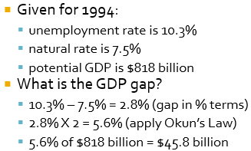

Assume that in a particular year the actual rate of unemployment is 9% and the natural rate of unemployment is 7%. Additionally, assume that the nominal GDP in this year is $411 billion.
- Using Okun's Law, calculate the size of the GDP gap in percentage-point terms
- Calculate how much output is foregone due to GDP gap
GDP gap = 2 × ([actual rate] - [natural rate])
Output Lost = [GDP gap %] × [Nominal GDP] / 100
Applying Okun’s Law Part 2 (lab 4 Q4)
Using Okun's Law, fill in the missing pieces of data from the following table. Please make sure your final answer(s) are accurate to the nearest whole number.
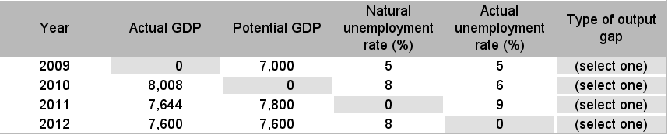
Difference = 100 × ([Actual GDP] - [Potential GDP]) ÷ [Potential GDP]
Okun’s law: ever 2% diff in GDP= 1% diff in unemployment rates
Gap difference = [Difference] ÷ 2
Actual unemployment = [Natural unemployment] - [Gap difference]
Type of Gap: Actual GDP or U>Potential: Positive gap, if equal no gap, Actual<Potential=Negative gap

Inflation/ Price Level / CPI
-CPI measures cost of standard basket of goods over a period of time, relative to a base year. Eg CPI in 2009= 125, so cost of living is 25% higher than in 2002 (base year)
$$CPI=\frac{Cost of Market Basket Current Yr}{Cost MB Base Yr}*100$$
$Inflation=\frac{CPI yr2-CPI yr1}{CPI yr1}*100\%$
Adjusting For Inflation CPI and GDP Deflator Methods
-Nominal: qty measured w/current $ value
-Real: Qty measured w/constant $ values
-Deflating: Dividing a nominal qty by Price Index and x100 to get Real qty
-Eg. 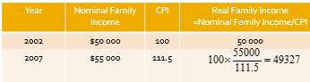
-Eg.Wage 2002=$16.67, Wage 2006= $18.02, CPI 2006=109.1. 2006 real wage=[100(18.02/109.1)]=16.52

Interest Rates: Nominal VS Real
Nominal Interest rate (i): Price paid per $ borrowed per year
Real Interest Rate (r): r=Nominal Interest rate- inflation OR $r=i-π$

Anticipated and Unanticipated Inflation and Debtors’ Outcomes
Anticipated: Inflation fits expectations, is normal and built into decisions.
Unanticipated: Debtors ($ borrowers) win when inflation>expected (Repay loan with lower $)
Debtors lose when Inflation<expected (pay loan w/higher $)
Fisher Effect: High inflation= high nominal interest rates. Lenders raise rates so real ROI unaffected
Low Inflation=1-3%/yr Moderate=3-6% High=>6% Hyper= >500%
Inflation types: Demand-Pull (Excess demand pulls prices up); Cost-Push (Unit production costs higher)

Chapters 5-6 (slide 18): Aggregate Expenditure (AE) Model
Short-run fluctuations & Key Keynesian Assumptions
Assumptions: In short-run, firms will meet product (output) demand at pre-set prices. Why?
Changing prices (rather than output quantity) to meet demand is costly. Therefore, economy’s spending changes are the cause of output gaps. Gaps persist= firms respond to eliminate. But V. slow process.
Aggregate Expenditure (AE)
- Total planned spending on final G/S
-4 Part: Consumer expenditure (C); Government S. (G); Investment (I_{g}); Net Exports (X_{n}=Imports-exports)
-AE= C + I_{g} + G + X_{n}
-**Private, Closed Economy (No G or NX): AE= C + I
-Income (Y) measured as Real GDP on X-axis of graph
-Short-run Equilibrium: AE=45 degree line (GDP); here output=usage

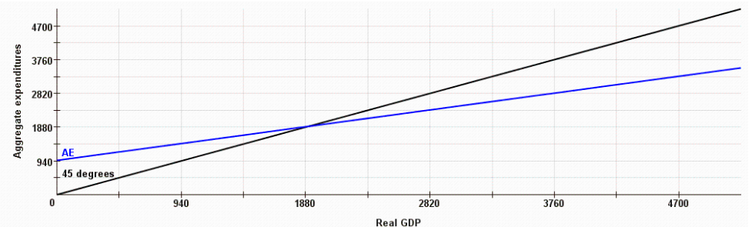
Consumption function: Relationship b/w real income and aggregative consumption spending
-C=C₀ + cY
-Consumption = Autonomous Consumption + MPC(Y)
-MPC= ΔC / ΔY= Slope of Consumption Fnc
-Y (income); C (Consumption); C₀ (Autonomous Consumption); c (marginal propensity to consume MPC)
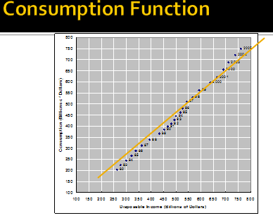
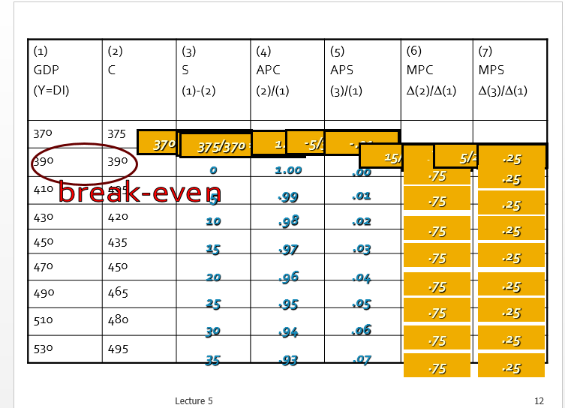

-Savings function: Savings= Real Income – Consumption
- S= Y- C
S= Y- (C₀ + cY)
S= S₀- sY (Autonomous Saving) + MPS(Y)
-s= MPS= marginal propensity to save
MPS= ΔS/ ΔY
- 1= MPC+ MPS

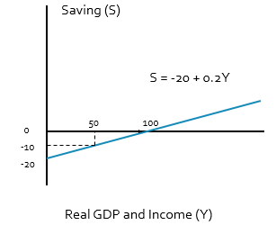
Interest-Rate and Investment Relationship
- r: expected rate of return
- i: (real interest rate)= (nominal rate) – inflation
-Investment I= I_{g} It is a fnc of investment demand and not GDP

The Investment Demand Curve (higher demand= lower interest rates) and Investment Schedule
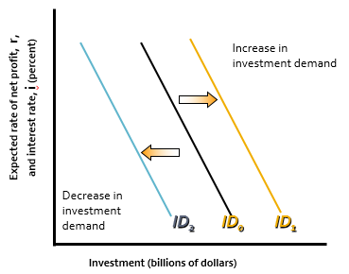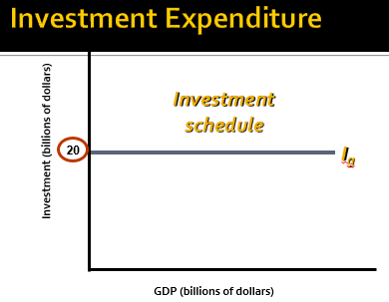

Determining Equilibrium Employment, Output and Income
- AE= C+ I
- Savings= GDP- Consumption aka Income-Consumption
- Unplanned inventories= GDP- AE
- Tendency: (-) Unplanned inventories then increase, (+) then decrease
- Equilibrium: GDP = AE; Unplanned Inv= 0 AND Savings= Investments
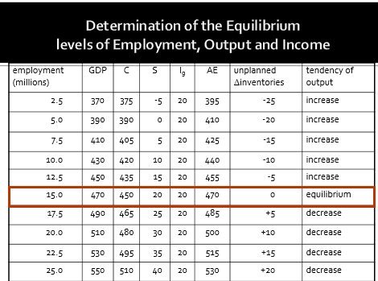
AE Function Example: Find the Equation

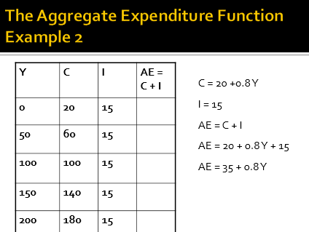

-AE= C+ I
-Consumption Fnc: C= C₀ +(mpc)Y
- Yint when Income(Y)=0, C₀=20 = autonomous consumption
-Slope= MPC= ΔC/ΔY = (60-20)/ (50-0) = 0.8
-So C= 0.8Y +20
-and AE= C+ I = 20+ 0.8Y +15
AE= 35 +0.8Y

The Multiplier effect on changes in GDP due to changes in Aggregate Expenditure

ΔGDP = (ΔAE)(Multiplier) but recall ΔGDP = ΔYe (eqm income)

So
$$Multiplier=\frac{ΔYe}{ΔAE}$$
$$Multiplier=\frac{1}{1-MPC}=\frac{1}{MPS}$$

Why does the multiplier effect happen and how does it propagate?
Why? Change in spending Change in income Change in both savings and consumption
Propagation:

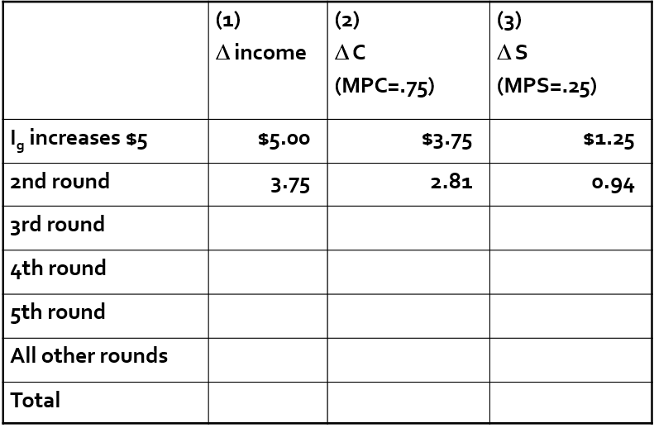
= ΔC Round1
= (ΔY)(MPS)
= (ΔY)(MPC)
Complete AE/ Summary

Closed, Private Economy: AE= C+ I
AE= C + I + G + X_{n}
AE= C₀+ (mpc)Y + I + G + X_{n}
AE= C₀+ (mpc)Y + (Business Investment + Inventory) + G + X_{n}

AE= (mpc)Y + b
y= mx+ b [A linear Fnc]
b= (C₀) + (I_{g}) [Intercept]
Slope= MPC= ΔC/ΔY

1=MPC+MPS

Multiplier = 1/ (1-MPC) = 1/MPS

Eqm values: ΔGDP= ΔY= (ΔAE)(Multiplier)
New GDP= (Old GDP) + (ΔAE)(Multiplier)

-The intercept of AE Fnc is given by Int= (C₀) + (I_{g}) and is called Autonomous expenditure

Note: Average Propensity to Consume= Consumption/Income
APS= Savings/Income

