ELEC 2607

SWITCHING CIRCUITS

Lab 3: The T-Bird Tail-Light Control
Using a CPLD

1. Introduction
In this laboratory, students were told to design a T-Bird Tail-Light control using a complex programmable logic device. The completed switch was to be able to successfully control the LED bulbs on the CPLD, allowing the light sequence of the bulbs to mimic the various turning and stopping signals of a car’s taillights. This laboratory explores more features in the Xilinx program, allowing us to download our switch design into the logic board and work the LED bulbs. Included in this report are the specifications and requirements of the circuit, the process and design of the circuit, the testing and implementation of our circuit, and the conclusion we arrived at after performing the laboratory.

2. Specifications

2.1 Design purpose
Students were required to design a T-Bird Tail-Light control in this laboratory. Three switches controlled the lights on the logic board: L, R, and B. The three inputs went through the circuit we designed and output the desired light patterns in the LED bulbs on the logic board as described in the requirements of the laboratory (the design of the circuit will be later discussed in the design section). The output sequences of the lights mimicked the sequences of the tail lights of a car, hence the name of the laboratory.

2.2 Design rules and requirements
- When the R switch is pressed, the LED bulbs on the right followed the sequence shown in figure 1.
Figure 1 Light sequence when switch R is pressed [1]
- When the L switch is pressed, the LED bulbs on the left followed the sequence shown in figure 2.
Figure 2 Light sequence when switch L is pressed [1]
- When the B switch was pressed while both L and R were off, all six LED bulbs were lit up.

- When both L and R switches were pressed without the B switch, all six lights flashed on for half-a-second and off for the next half-a-second. As long as the two switches were pushed, this flashing light pattern repeated.

- When either L or R were on with B, the tail lights on the side of the switch pressed with the B switch flashed to signal a turn while all the lights on the other side were lit to signal braking.

- When L, R, and B were pressed at the same time, all six LED bulbs were lit up.

2.3 Gates used and restrictions
Because the circuit was designed using a computer program, we were not limited to the number of gates available for the circuit design. For the counter, a flip flop, an OR gate, an XOR gate, an AND gate, and three inverters were used. As for the left and right switches, six AND gates, four OR gates and an inverter were used in each of the switches.

2.4 Theory and knowledge
The derivation of the representative equations for the counter block, left control box, and right control box will be present in the design section of this laboratory report. The purpose of the counter was to generate the waveforms for the outputs of Lite-1, Lite-2, Lite-3, and Emerg from the clock into the two control boxes. The purpose of the control boxes were to route these waveforms along with the user input left signal, brake, and right signal to the proper lights.

3.0 Design
As mentioned previously in the specifications sections, this group will attempt to construct and design a working a T-Bird Tail-Light control in this laboratory. To do so the circuit is split up into four different components, the clock divider, a counter, a left control box and a right control box. The clock divider will slow down the clock, as without it the clock would have a frequency too fast for a normal human to visually recognize. The clock divider will be already implemented into the lab.
All four of these components will carry a variety of logic gates and flip-flops. The following will demonstrate how each element of the circuit is connected to each other and how they interact with each other.

3.1 Counter
The counter, simply put will be the component to control the flashing of each specific light. The counter will output a frequency to either the left or right control box that will enable them to visually represent the flashing of the lights. The counter receives a input of clock (CLK) and will output four frequencies: Lite_1, Lite_2, Lite_3 and Emerg. Lite_1, Lite_2 and Lite_3 will give a frequency so that every half-second the next one turns on, as stated in specifications in figure 1 and figure 2. The fourth output is the Emerg, which will give a frequency so that both sets of left and right lights will be turned on and off periodically, representing the emergency lights, are outputted. An input of $Q_{0}$is needed. $Q_{0}$ represents the frequency of the clock divided by two. This second input will give a possible four states for the counter to go through. To do so, a D flip-flop (fig) will be used to make the circuit go through all four of these states.
To do so, a variety of flip-flops and logic gates will be used to make the circuit. Designing the counter is done through solving the trust table and obtaining an equation for each output. The truth table can be seen in figure .

$$Q_{0}$$ | $$CLK$$ | $$Lite_1$$ | $$Lite_2$$ | $$Lite_3$$ | $$Emerg$$
0 | 0 | 0 | 0 | 0 | 0
1 | 1 | 1 | 0 | 0 | 1
1 | 0 | 1 | 1 | 0 | 0
0 | 1 | 1 | 1 | 1 | 1

From the truth table the following equations can be derived for each output:
$$Lite_1= Q_{0}+CLK$$
$$Lite_2=Q_{0} ⊕CLK$$
$$Lite_3= \overline{Q_{0} }*CLK$$
$$Emerg=CLK$$
In which for each output a simple logic gate can be used to output the respective output frequency. For $Lite_1$ a simple OR Gate can be used to represent the output, while $Lite_2$ is represented as an X-OR gate. The $Lite_3$ is represented by an AND gate with a bubble (inverter) at its $Q_{0}$ input. Lastly, the $Emerg$ output is represented by a straight wire to the $CLK$ input (Note: in the design of the $Emerg$ output, a double inverter is present as the computer program used does not allow for a direct connection from input to output). Through all these equation a circuit can be achieved for the counter (fig). All four of the equations can be designed together as one circuit due them having the same inputs. 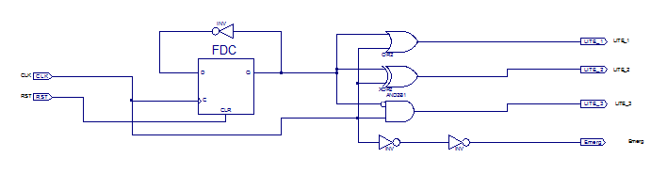

3.2 Left Control Box
The left control box will control all three lights on the left side of the car. It will also contain three inputs coming from three different switches, these inputs will be represented as $BLR$, where $B$ stands for brake, $L$ for left turn and $R$ for right turn. Depending if either the brake, left or right button are pressed, or a combination of the three, the left control box will output a flash turn (in this case a left turn), a steady brake light or an emergency flash to its 3 bulbs. A truth table is used to determine the equation for each possible output of the circuit, as seen in figure .

$$BLR$$ | Turn | Emergency | Brake
000 | 0 | 0 | 0
001 | 0 | 0 | 0
010 | 1 | 0 | 0
011 | 0 | 1 | 0
100 | 0 | 0 | 1
101 | 0 | 0 | 1
110 | 1 | 0 | 0
111 | 0 | 0 | 1
In which from the truth table, a K-map can be made to achieve an equation for each bulb that the left control box controls. These bulb outputs will be $Bulb_1$, $Bulb_2$ and $Bulb_3.$Where $Bulb_3$is the left-most bulb, $Bulb_2$ is the second left-most bulb and $Bulb_1$ is third left-most bulb.

$$LR\backslash B$$ | 0 | 1
00 |  | 1
01 |  | 1
11 | Emerg | 1
10 | Lite_X | Lite_X

In which, the users can group up various elements of the K-map together to form an equation. Lite_ represents all three Lite_ inputs that correlate with its corresponding bulb. The Following equations for each bulb can be obtained through the K-map:
$$Bulb_1=\left(Lite_1\right)L\overline{R}+\left(Emerg\right)\overline{B}LR+B\overline{L}+BR$$
$$Bulb_2=\left(Lite_2\right)L\overline{R}+\left(Emerg\right)\overline{B}LR+B\overline{L}+BR$$
$$Bulb_3=\left(Lite_3\right)L\overline{R}+\left(Emerg\right)\overline{B}LR+B\overline{L}+BR$$
Or it can be generalized as:
$$Bulb_X=\left(Lite_X\right)L\overline{R}+\left(Emerg\right)\overline{B}LR+B\overline{L}+BR$$
Where x represents the bulb number (one through three).

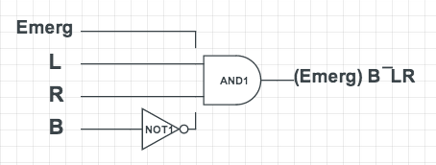
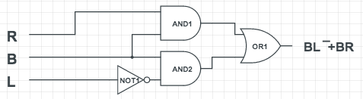
Now that the equation has been obtained, the circuit of the left control box can be obtained in figure . Due to this section $(Emerg)\overline{B}LR+B\overline{L}+BR$ of the equation (fig) remaining consistent throughout each bulb, all three bulbs will receive the same input, therefore eliminating the need to construct three different circuits. To simplify this construction of this circuit $\left(Emerg\right)\overline{B}LR$ and $B\overline{L}+BR$ were constructed using a variety of logic gates represented in figure and figure respectively.

To represent $\left(Lite_X\right)L\overline{R}$ a five inputs are need: $L, R, Lite_1, Lite_2 and Lite_3$
With the five inputs, a circumstantial circuit can be designed, as seen in figure .
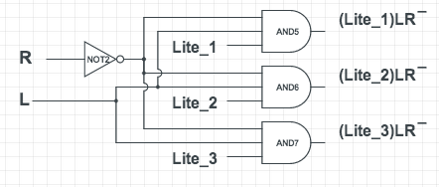

Now that the equation has been simplified into three different sections, a simplified version of the full left control box can be constructed with all three sections connected together through an OR gates going towards their respective output of either$Bulb_1$, $Bulb_2$, $Bulb_3$. This final design for the left turn box will look like figure .

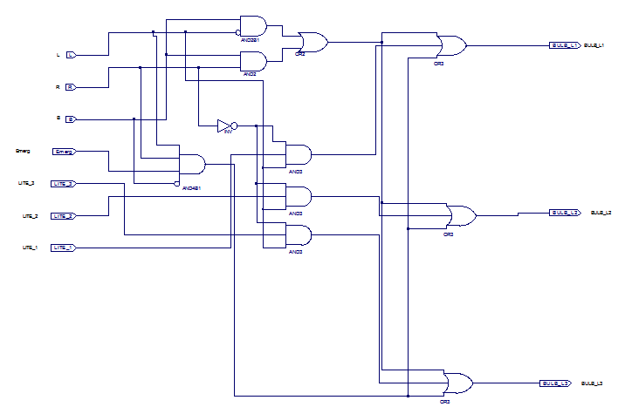

3.3 Right Control Box
The right control box is very similar to the left control box, except on the right side. It will control the three right bulbs. It will also have the some three switches, BLR

4. Testing and Implementation
During the prelab, each circuit of each component of the light control was derived and drawn separately. The first component we designed was the counter box. The second and third components we designed were the left and right control boxes. Using a truth table that included all the possible sets of inputs and outputs, we derived the equations for each of the outputs of the three components (truth tables deriving equations provided in section 3 of this report).
Once the wires and logic gates were connected in the Xilinx program for the counter box, the design for the counter box was downloaded onto the logic board in order to begin testing. We checked that the counter box was in working order before continuing with the control boxes because of two reasons. Firstly, if there were a mistake in our counter design, we’d catch it early and won’t have to deal with it later in case of any other mistakes. Secondly, if there were problems with the circuit later on, we would know it’s a problem with the control boxes, as we’ve eliminated the counter box as a suspect early on. Once the counter circuit was tested and concluded to have no errors, the left control box was added to the whole design and tested. Once we concluded that this section had no errors, the right control box was added to the whole design to complete the light control circuit.

4.1 Testing with physical logic board
Following the requirements described in section 2.2 of this report, each of the test scenarios were performed on the logic board. In each scenario, a button/ combination of button inputs were pressed and the output light sequence was observed and compared to those described in the laboratory requirements. One error was encountered, where a set of button were pressed and input into the circuit and the output observed was not expected (further elaborated in section 4.3). Once the error was corrected and the circuit was retested, each combination of inputs provided the desired outputs outlined by section 2.2 of this report. Therefore, we concluded that our circuit design was correct.

4.2 Testing with program simulation and waveforms
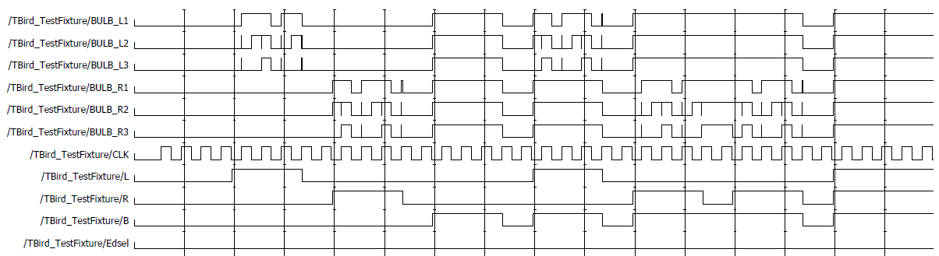
Figure 3 Simulated waveforms from test cases
Once all testing and verification were done on the logic board, we proceeded to test the light control through the simulation feature in the Xilinx program. Three test cases were missing from the test fixture file to be run by the simulation in order for all tests to be conducted and verified. Once the three test cases were written into the test fixture file, a simulation for the tail light control was performed and the waveforms in figure 3 were obtained. We expected the waveforms to be correct since everything worked perfectly on the logic board before the simulation was run. As expected, the waveforms output were correct in each scenario.
In order to verify the validity of figure 3, we checked the input combinations L, R, and B, along with the outputs corresponding to the inputs respective to their clock cycles. Each set of input-output combinations were matched to the desired input-output combinations described in section 2.2 of this report and verified. Every single combination matched perfectly; therefore we concluded that our circuit design was correct. For example, when the waveform for input L and B were both “1”, the waveforms for R1, R2, and R3 were expected to be “1” while the waveforms for L1, L2, and L3 were expected to alternate between “0” and “1” to indicated flashing. The expected result was shown in figure 3, indicating that that scenario was correct. All of the other scenarios described in section 2.2 were tested in this manner on the waveform graph of figure 3.

4.3 Debugging and limitations
Throughout the laboratory one mistake was caught through debugging. While testing each set of inputs and outputs, one set of inputs did not match our desired outputs. Here are the steps we used to debug our circuit:
- Noted down which set of inputs and outputs were incorrect (i.e. left control or right control and specifically which inputs provided the wrong outputs).
- Opened the circuit diagram in Xilinx for that specific component and followed the inputs through their respective paths and gates, verifying that paths are routed correctly and gates used corresponded to those derived in our design.
- Once the problem had been identified and fixed, the fixed design was reprogrammed onto the logic board and tested again.

In our case, one of the OR gates required was accidentally replaced with an XOR gate. Following the debugging steps, the problem was found, resolved and the circuit was in working order.

5. Conclusion
After thoroughly testing the circuit, it was proven that the specifications required were met. All eight variations of inputs were physically tested on the logic board and the output sequences and patterns of the lights in each test followed the requirements of the laboratory. All eight variations were also simulated through the Xilinx program on the computer and each of the output waveforms showed to be correct. Throughout the laboratory, we learned how to program the logic board and familiarized ourselves with new features within the Xilinx program. Our knowledge with constructing circuits with the software was reinforced after building several switches over the period of two laboratories. In the end we accomplished a fully functional T-Bird Tail-Light Control. If we were to revisit and improve this laboratory, we would double check our circuits before running simulations since simulations take a while to start and generate waveform outputs. If we could get all the gates and connections correct the first time then only a single simulation may need to be run so we wouldn’t have to wait for several simulations to compile before completing the laboratory. Different combinations of gates may be used the next time as well; perhaps a more simple circuit may be built, increasing efficiency and size of the circuit.

6.0 References
[1] J. Knight, “The T-Bird Tail-Light Control Using a CPLD”, Carleton
University, Department of Electronics, February 3, 2011.

