Week 10: Social control and Social learning
A. The social context of social control
1. Social Control Theories
- Downplay causative factors in criminal behaviour.
- Ask why people obey rules rather than break them.

- Albert Reiss
“may be viewed as a consequence of the failure of primary groups to provide the child with appropriate non-delinquent roles and to exercise social control over the child so these roles are accepted or submitted to in accordance with his needs” (Reiss, 1951).
- IVAN NYE
Direct control = punishment or restraints act as external forces.
Internalized control = individual regulates his/her own behaviour.
Indirect control = identification with and affection for parents and significant others.

- Walter Reckless
Family and other social bonds control delinquent behaviour.
Inner containment, e.g., self-control, good self-image, ability to tolerate frustration.
Outer containment, e.g., family values, institutional reinforcement, effective supervision.

- TRAVIS HIRSCHI
- PhD in sociology.
- Acknowledged influence of Durkheim, Albert Reiss, Nye and Reckless.
- Said that if individuals had strong social bond with society, they would be less likely to commit crimes.

Hirschi — Four components of the social bond:
  - Attachment: ties of affection and respect, with parents, school teachers.
  - Commitment: getting a good education, learning trade or profession, finding a good job.
  - Involvement: being involved in school, in recreation, with family.
Belief: shared values—it’s wrong to steal, people should respect the law.

- Gottfredson and Hirschi

Low self-control
- Low self-control advanced as main cause of crime in Gottfredson and Hirschi's 1990 book A General Theory of Crime.
- General theory meant to explain all crime, all of the time, at all ages, under all circumstances.
- Changed focus from external control to internal…
- Tautological

- Social process theories are so named because they emphasize the process of interaction between individuals and society.
- Criminality is not an innate human characteristic but rather is learned through interaction with others.

PROBLEMS WITH CONTROL THEORIES
- Gottfredson and Hirschi claim that all criminal acts provide "immediate, easy, and certain short-term pleasure", and that they "require little skill or planning".
- What about kidnapping for ransom, that often involves a high degree of planning (pre-selection of an unprotected, high value target), and protracted negotiations that can sometimes go on for months or years, with an uncertain outcome?

- Gottfredson and Hirschi say that like all other crimes, white collar crimes do not require any degree of specialization.
- They provide relatively quick and relatively certain benefit with minimal effort.
- White collar criminals are people with low self-control, inclined to follow momentary impulse without consideration of the long-term costs of such behavior.

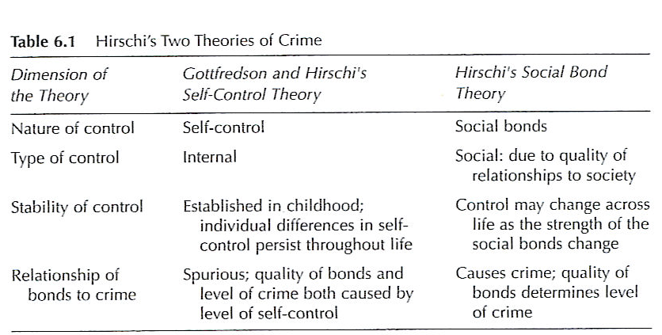

A) TITTLE

Control theory usually examines factors in the social environment that control or restrain individual behaviour.

Tittle argues that we should also examine the control that individuals have over their social environment (Lilly et al., 2011).
- Each individual is under a certain amount of control, but each individual also exercises a certain amount of control.
- Individuals want autonomy—they want to escape from control.
- The individual’s “control ratio” determines the likelihood of deviant behaviour (Tittle, 2001).
- When indivs exercise as much control as they are subjected to, they are more likely to conform.

- Social control theory popular because it conforms to public perceptions of why people become criminal.
- Also popular because it combines elements of anomie/social strain, social disorganization and differential association theory.

2. Social learning theories
- Criminal behaviour is a learned behaviour.

- Sykes and matza

- Sykes & Matza begin 1957 article by acknowledging Sutherland’s statement that criminal behaviour “is learned in the process of interaction.”
- Denial of responsibility
- Denial of injury
- Denial of the victim
- Condemning the condemners
- An appeal to higher loyalties

- AKERS
- Attempting to specify the mechanisms and processes through which criminal values are learned/transmitted.
- For Akers, the social environment was main source of reinforcement (influence of Sutherland and symbolic interactionism).
- Said that deviance was learned through social interaction, and that individuals learn definitions that become discriminating stimuli.

