Lecture Notes:
SOCIOLOGICAL EXPLANATIONS OF CRIMINAL AND DEVIANT BEHAVIOUR
Week 4: The Chicago School and social disorganization

Overview:
- track the origins of social ecological perspectives
- link social patterns to ecology patterns

- Identify relevance to today’s study of crime
- Pattern theory: Brantinghams
- Geographic profiling (Rossmo)
- Crime over-representation (Andresen etc.)

A.) THE CHICAGO SCHOOL

SOCIAL CONTEXT OF THE CHICAGO SCHOOL

- City grew through successive waves of immigrants.
- Poor wages, living in slums
- Subsequent immigrant groups would enter and replace the previous group

THE PROGRESSIVE MOVEMENT

- Rejected Social Darwinism’s notion that “the poor” were biologically inferior.

- Claimed that people were poor because of social environment.
- Argued that “The American Dream” did not reach the slums and the ghettos.

THE “ECOLOGICAL SCHOOL”

- Dominance

- Invasion

- Succession

BURGESS’ CONCENTRIC ZONE THEORY

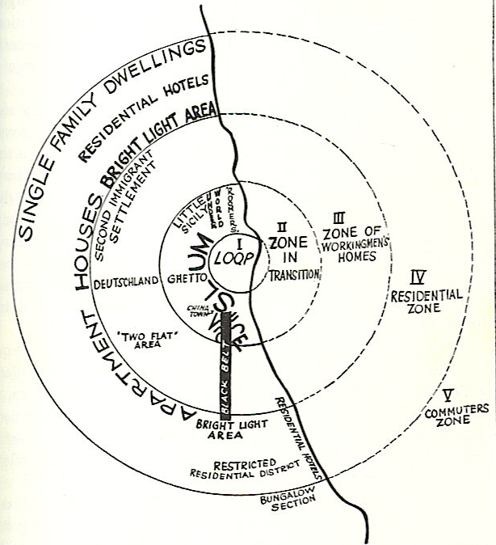

- Urban development is patterned socially.

- Stated that cities grow in concentric rings.

- Loop-central business district (close to transportation network).

- Residential zones on outskirts—away from crowding, noise, pollution.

ZONES IN TRANSITION

- As land values went up in city centre, landowners in transitional zone expected that their buildings would be torn down sooner or later, and didn’t bother to maintain them.

SHAW AND MCKAY

- Social disorganization

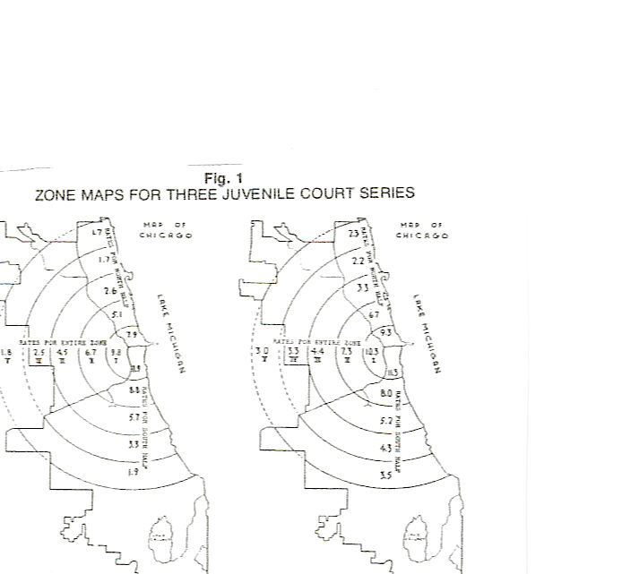

B) ENVIRONMENTAL CRIMINOLOGY

BRANTINGHAM & BRANTINGHAM

Crime Pattern Theory
- Complexity of the criminal event

- Crime is not random

- Criminal opportunities are not random

- Offenders and victims are not pathological in their use of time and space

CRIME OPPORTUNITIES AND EVENTS

- Routine Activities:
- Awareness space:
- Social Networks:
- Urban Structure:

Decisions: Crime Pattern Theory

Rule 1: As individuals move through a series of activities they make decisions. When activities are repeated frequently, the decision process becomes regularized. This regularization creates an abstract
guiding template. For decisions to commit a crime this is called a crime template.

Rule 2: Most people do not function as individuals, but have a network of family, friends and acquaintances. These linkages have varying attributes and influence the decisions of others in the network.

Rule 3: When individuals are making their decisions independently, individual decision processes and crime templates can be treated in a summative fashion, that is, average or typical patterns can be determined by combining the patterns of individuals.

Movement

Rule 4: Individuals or networks of individuals commit crimes when there is a triggering event and a process by which an individual can locate a target or a victim that fits within a crime template. Criminal actions change the bank of accumulated experience and alter future actions.

Rule 5: Individuals have a range of routine daily activities. Usually these occur in different nodes of activity such as home, work, school, shopping, entertainment or time with friends that are nodes of activity and along the normal pathways between these nodes.

Rule 6: People who commit crimes have normal spatio-temporal movement patterns like everyone else. The likely location for a crime is near this normal activity and awareness space.

Target and Victim Locations

Rule 7: Potential targets and victims have passive or active locations or activity spaces that intersect the activity spaces of potential offenders. The potential targets and victims become actual targets or victims when the potential offender’s willingness to commit a crime has been triggered and when the potential target or victim fits the offender’s crime template.

GEOGRAPHIC PROFILING (Rossmo)

“For any violent crime to occur there must have been an intersection in both time and place between the victim and offender” (Rossmo, 1996)
“The spatial relationship between the offender's home and his or her crimes is an underlying theme in much of this work. Is it possible to "invert" this research and use the locations of a series of crimes to suggest where an offender might reside?”

Profiling the signature

"geographic profiling" technique designed to map unsolved crimes and highlight any pattern or criminal "signature" overlooked by detectives assigned to individual cases”

May 1999 Rossmo reported an unusual concentration of disappearances in Downtown Eastside
Ignored and then punitively demoted

Inspector Gary Greer advised the press, "We’re in no way saying there is a serial murderer out there. We’re in no way saying that all these people missing are dead. We’re not saying any of that."

How does the technique work?

- Map boundaries delineating the offender's hunting area are first established using the locations of the crimes
- Manhattan distances from each point on the map to the crime location
- Distances are used as independent variable values in a formula where:
- if the point lies outside the buffer zone, becomes smaller the longer the distance, following some form of distance-decay; or
- if the point lies inside the buffer zone, becomes larger the longer the distance
- Numbers are multiplied together to produce a single score for each map point.

- three-dimensional surface, the "height" of which represents the relative probability that a given point is the residence or workplace of the offender

Crime location quotient: more than just crime rates
- Can show the representation of a particular type of offence in relation to the same type of offence within a larger geographical area
- Eg. Assault/Prince George compared to all assault in British Columbia
- Would expect a 1:1 ratio but not always the case.

