Chapter 8 & 9_ Bus 418

There are 3 main types of exposure to the foreign currency:
- Transaction exposure: It is the sensitivity of the domestic cash flows (receivables and payables) that are denominated in the foreign currency. It is basically a fixed price contract in a world where exchange rates are dynamically changing.
- Economic exposure: It is the extent to which the value of the firm will change in regards to unanticipated exchange rate changes. It can affect the firm’s position in the competitive market. (CH-9)
- Translation exposure: it states that the firm’s consolidated financial statements are also exposed the exchange rate. As the consolidated financial statement of the company’s subsidiaries have to converted into the $ value (home currency) there are accounting profits and gains related to it. (CH-10)

Transaction exposure example
Suppose a company in US sells its goods on credit to a company in Germany for 1 million euro. So, after the maturity of the contract (3-months) the US company have to convert 1million Euro to US $ at the prevailing market spot rate. There is a risk whether the favorable or unfavorable movement of the exchange rate might affect (or profit the transaction. (Plainly speculative)

Various operational and financial contracts are used to hedge the transactional exposure

Financial contracts:
- Forward market hedge
- Money market hedge
- Option market hedge
- Swap market hedge

Operational Techniques
- Choice of invoice currency
- Lead/lag strategy
- Exposure netting

FINANCIAL CONTRACTS
Currency forwards contracts: It is the simple and the most direct way to hedge against the transaction exposure

Example
Suppose Boeing supplies a jet to BA for 10 million pounds on credit terms of 1 year. Boeing is the exporter.

The U. S. interest rate: 6.10% per annum
The U. K. interest rate: 9.00% per annum
The spot exchange rate: $ 1.50/£
The forward exchange rate: $ 1.46/£ ( 1- year maturity).

Now to hedge the transaction by currency forward, Boeing can short (sell) forward it’s GBP receivable for a given amount of US dollars.
In this specific case, Boeing can sell 10 million pounds (receivables) for 1.46/GBP forward rate.
So, at the end of one year the company will get $14,600,000 regardless of the market spot rate. Also, the 10 million pounds the company will receive will in one year can simply pay it to the bank. Hence, there will be no GBP exposure.

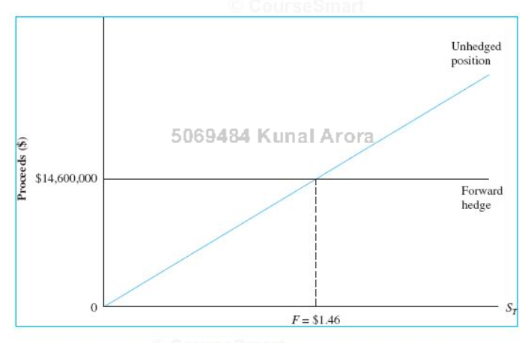

Gain: (F- St) x amount (for short position/exporter) if S(T)>F: loss or vice versa

Gain: (St- F) x amount (for long position/importer) S(T)<F: loss or vice versa

Note: exporter should short forward currency as it has to receive money
Importer should long forward currency as owes money

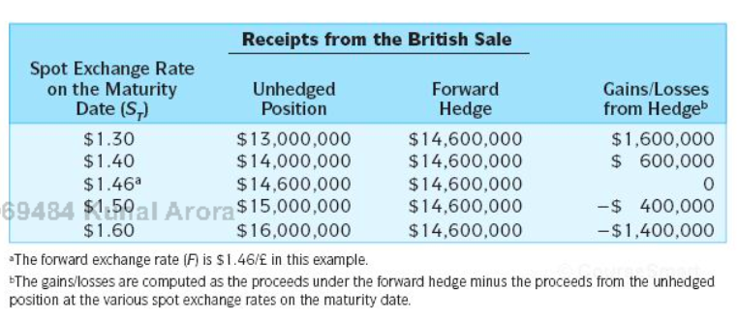

Illustrations of gains and losses from hedging
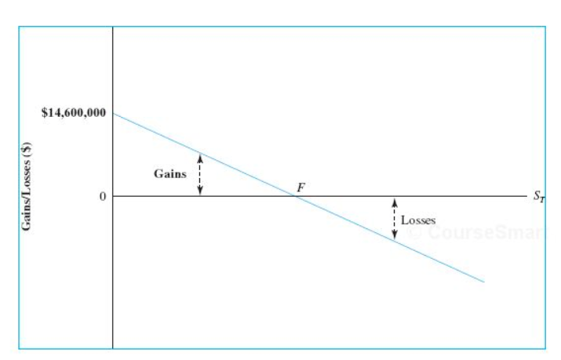

The more risk averse the firm is the more likely it is to hedge

Example 2: A U.S.-based importer of Italian shoes has just ordered next year’s inventory. Payment of €1M is due in one year. If the importer buys €1M at the forward exchange rate of $1.50/€, the cash flows at maturity look like this:
Importer should long currency forward
Transactions | CF at 0 | CF at 1
Imports shoes worth €1M | 0 | - €1M
Buys currency forward worth €1M at $1.50/€ | 0 | -$1.5M
Receives the currency forward | 0 | + €1M
Total | 0 | - $ 1.5 M

Hedged against the Euro exchange rate no matter what the Euro/$ is the company has to pay $1.5 to get €1M. As the importer has to pay, the graph is inverted.
Money market hedge: lending and borrowing in the foreign and the domestic money market can avoid Transaction exposure. The firm may borrow or lend in the foreign currency to hedge it’s foreign currency receivables or payables thereby matching it’s assets and liabilities in the same currency.

Receivables: short/sell/borrow
In this very example, Boeing can borrow GBP from British bank and convert it into US dollars and invest in USA to gain.
- How much foreign currency to borrow (GBP in this case)
The maturity value of the borrowing should be equal to the amount receivable. Therefore, the borrowing should be the PV of the amount receivable in 1 year. In this case it should be 1 GBP/1.09^1

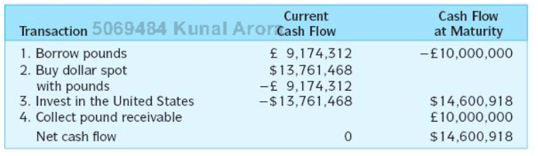

Step 1: Borrow £ 9,174,312. PV of GBP 10,000,000
Step 2: Convert £ 9,174,312 into $ 13,761,468 at the current spot exchange rate of $ 1.50/£.
Step 3: Invest $ 13,761,468 in the United States at 6.1%/annum
Step 4: Collect £ 10 million from British Airways and use it to repay the pound loan.
Step 5: Receive the maturity value of the dollar investment, that is, $ 14,600,918 5 ($ 13,761,468)(1.061), which is the guaranteed dollar proceeds from the British sale.

Money market is fully self-financing
IRP or the interest rate parity holds here

Importer: borrows from home bank and deposit it in the host bank
Exporter: borrows from the host bank and deposit it in the home bank.

One possible shortcoming of the money market and forward market hedge is that they completely eliminate exchange rate risk exposure

Option market hedge:
•If expecting a receivable in a foreign currency (an exporter), buy a put option to hedge your exposure.
Put option: right to sell
•If expecting to pay in a foreign currency (an importer), buy a call option to hedge your exposure.
Call option: right to buy

As an example,
Suppose the Boeing purchased in an OTC trade of a put option on about 10 million GBP with exercise price of $1.46/GBP.
T= 1 year
Premium at $0.02 per GBP
Boeing paid about 0.02 x 10,000,000 = $200,000 for the put option.
This transaction allows Boeing the right to sell at an X of about $1.46 regardless of the future spot rate
Since, the time value of money changes, Boeing paid about $212,200 (200,000 x 1.061)

It limits the downside risk, while preserving the upside potential

Cross currency hedging:
It involves hedging a position in one asset by taking a position in another asset

Effective ness depends upon how well the assets are correlated

For example
Your company is based in UK and have exported a bicycles worth 750,000 euros to an Italian retailer that is due in 6 months and you want to hedge the position in GBP.
Exporter: short forward
EUR/GBP
But only EUR/USD and GBP/USD futures are available
Therefore, we can short in EUR/USD and long in GBP/USD

- convert EUR into USD (sell Euro forward)
- USD into GBP (buy GBP forward)

Hedging contingent exposure

When future cash flow in uncertain hedging with a forward is big problem, it is better to use option hedging.

As an example:

–For example, GE bids for a C$100M construction contract in Canada and, thus, sells C$100M forward. But if it doesn’t win the contract, it has not C$ receivables and, turns out, has simply speculated against C$.
–A put option on C$100M solves this, because it is not an obligation to sell C$.
•If the spot rate declines, the put will be exercised.
–If the contract bid is accepted, the put is exercised as a hedge, compensating for the USD loss in the construction contract value.
–If the contract bid is rejected, the in-the-money put is exercised simply as a profitable financial market transaction.

If the spot increases, the put is out of the money and is not exercised.
–If the contract bid is accepted, GE exchanges C$100M into USD at the high spot rate.
- If the contract bid is rejected, all GE loses is the put option premium.

Exposure netting

If the firm has a natural hedge and deals in other currencies. It should only hedge its foreign currency.

Other hedging strategies:
- Hedging through the choice of invoice currency
- Hedging via Lead and Lag

hedging through the choice of invoice currency

Firms can shift, share, or diversify their FX risk
- •Shift exchange rate risk to the foreign client by invoicing foreign sales in the firm’s home currency
- •Share exchange rate risk with the foreign client by splitting the invoice amount between foreign and home currencies
- •Diversify exchange rate risk of a transaction by doing it in a market basket index currency (SDR, ECU)

Hedging via lead and lag

If a currency is appreciating, pay those bills denominated in that currency early (“lead”) - let customers in that country pay late as long as they are paying in that currency.

–If a currency is depreciating, give incentives to customers who owe you in that currency to pay early; pay your obligations denominated in that currency as late as your contracts will allow (“lag”)

–Difficult, because when you want to “lead”, your client wants to “lag”. So this works well only among branches of the same MNC.

There are several considerations that should be taken care of in order to make decision about to hedge or not to hedge
Hedging makes sense for entrepreneurs (individuals, a small firm) because
–Future forex rates are difficult, if not impossible, to predict
–An entrepreneur's wealth is concentrated in the firm and hard to diversify to avoid forex risk
–Hedging reduces the volatility of CFs
•This is desirable for a risk-averse individual (increases utility)

Merely reducing uncertainty is not a sufficient reason to hedge for corporations.

–Corporations are considered to be risk-neutral maximizers of firm value (for their shareholders)
–Hedging must increase the asset value of the firm or decrease the market value of debt to be worthwhile
•E=A-D = PV(CFs) + tax shields – cost of financial distress +… - D.

MM theory
Modigilani and Miller
They suggest that the hedging is irrelevant in the perfect capital market as the investors will hedge if the firm doesn’t
Also, they can undo the hedging the firm does
If it does not affect the systematic risk of the firm and expected value of cash flows unchanged, hedging will not affect the firm’s value

Following are the arguments against hedging:
See slides

