- Strategy: a company’s action plan for outperforming its competitors and achieving superior profitability
- Strategy is About Competing Differently
  - Strategy can only succeed when predicated on actions, business approaches, and competitive moves aimed at appealing to buyers in ways rivals can’t.
- Competitive Advantage
  - Giving buyers what they perceive as superior value compared to rivals. Sustainable c.a. means giving buyers lasting reasons to prefer you.
- Strategic Approaches
  - Low Cost, Differentiation, Value, Niche offering.

Strategy Evolves
  - Must be willing and ready to modify strategy in response to changing market conditions, advancing technology, shifting buyer needs, emerging market opportunities, and evidence existing strategy is not working.
- Strategy is Proactive (deliberate) & Reactive (emergent)
  - Realized Strategy: proactive & reactive elements, with certain elements abandoned due to obsoleteness.
- Business Model: Two propositions: Customer Value Proposition (greater value delivered (V) and lower the price (P), the better); Profit Formula (lower the costs (C), given the customer value proposition (V-P), greater the ability of the business model to be profitable.
- Winning Strategy Tests
  - The Fit Test: How well does strategy fit the company’s situation?
    - External Fit: in sync with prevailing market conditions
    - Internal Fit: tailored to company’s resources and capabilities supported by set of functional activities
    - Dynamic Fit: evolve over time with company’s situation even as external and internal conditions change
  - The Competitive Advantage Test: Can strategy help the company achieve a sustainable competitive advantage?
  - The Performance Test: Is the strategy producing good company performance? (Indicators)
- Good Strategy + Good Strategy Execution = Good Management

- Task 1: Developing a Vision, Mission Statement, & Set of Core Values
- Strategic Vision: describes management’s aspirations for the future and company’s strategic course and long-term direction
- Wording a Vision Statement
  - The Dos
    - Be forward-looking, directional, focused, feasible, and why the direction makes good business sense
  - The Don’ts
    - Don’t be: vague, dwell on the present, use broad language, state the vision in blandly
- Mission v. Vision
  - A mission statement focuses on current business activities - “who we are and what we do”
  - A strategic vision concerns a firm’s future business path - “where we are going”
- Mission Statement
  - Defines current business activities, highlighting boundaries of current business

Task 2: Setting Objectives

Objectives: an organization’s performance targets – the specific results management wants to achieve
- Stretch Objectives: performance targets that stretch an organization to perform at full potential and deliver best results
- Types of Objectives
  - Financial & Strategic Objectives [that include short/long-term (long takes precedence) objectives]
- Balanced Approach to Objective Setting
  - Balanced Scorecard: widely used method for combining the use of strategic and financial objectives, tracking achievement, and giving management a balanced view of how well an organization is performing.
- Setting Objectives For Every Organizational Level

- TASK 3: CRAFTING A STRATEGY
- Involves Managers at All Organizational Levels
- Strategy-Making Hierarchy
  - Corporate, Business (single-business) level, Functional Area, & Operating Strategy.

TASK 4: EXECUTING THE STRATEGY

Principle aspects:
    - Staffing organization, Developing strategy-supporting resources, Organizing work effort, Installing O/S, Motivating employees, work climate conductive to successful strategy, Leadership needed to propel implementation forward

- TASK 5: EVALUATING PERFORMANCE & INITIATING CORRECTIONS

Corporate Governance: The Role of The Board
- Every corporation should have a strong independent board of directors:

- Key Questions: Analyzing the Industry and Competitive Environment
  - What forces are driving changes in the industry, and what impact will these changes have?
    - REMOTE TO INDUSTRY: Political, economic
  - What kinds of competitive forces are industry members facing, and how strong is each force?
    - SPECIFIC TO INDUSTRY
- PESTEL Analysis – determine which factors represent are the most strategically relevant.
  - P – Political, E – Economic, S – Social, T – Technological, E – Environmental, & L – Legal Drivers

Assessing the Industry and Competitive Environment – craft a strategy that fits the company’s external situation
  - How strong are the industry’s competitive forces, driving forces, market positions, strategic moves, industry KSF, and what is industry outlook?

PORTER’s 5 Forces Model of Competition
  - Assess competition from:
    - Rival Sellers, Potential New Entrants, Producers of Substitute Products, Suppler Bargaining Power, Customer Bargaining Power

Competitive Pressures Created by the Rivalry among Competing Sellers
- Common “Weapons” for Competing with Rivals
  - Price discounting, clearance sales, advertising, innovative product performance/quality/features/customisation, Building a bigger/better dealer network, Improving warranties, offering low-interest financing.

Competitive Pressures Associated with the Threat of New Entrants (2 factors)
    - Expected reaction of incumbent firms to new entry
    - Barriers to entry – exist whenever it is hard for a newcomer to break into the market and/or the economics of the business put a potential entrant at a disadvantage
      - Cost advantages enjoyed by industry incumbents
      - Strong brand preferences and high degrees of customer loyalty
      - Strong “network effects” in customer demand (many other users)
      - High capital requirements
      - The difficulties of building network of distributors and securing space on retailers’ shelves
      - Restrictive government policies (regulations, tariffs, licenses)
- Competitive Pressures from the Sellers of Substitute Products
  - Identifying Substitutes: Determining industry boundaries. Which products address basic customer needs?
  - Other market indicators of the competitive strength of substitutes
    - Whether the sales of substitutes are growing faster than the sales of the industry being analyzed

Buyer Bargaining Power and Price Sensitivity

Profitability
  - Strong competitive pressures coming from all five directions drive industry profitability to very low levels
- Matching Company Strategy to Competitive Conditions
  - Pursuing avenues that shield the firm from as many of the different competitive pressures as possible.
  - Initiating actions to shift competitive forces in the company’s favour by altering factors driving the 5 forces
- Competitive factors most affecting every industry member’s ability to prosper:
  - Specific strategy elements, Product attributes, Resources, Competencies, Competitive capabilities
- KSFs spell the difference between
  - Profit and loss, Competitive success or failure
- Driving Forces: are the major underlying causes of change in industry and competitive conditions
- Identifying and Industry’s Driving Forces
  - Changes in: industry’s long-term growth, globalization, Emerging internet capabilities, Who buys the product and how they use it, Technology, Manufacturing/product innovation, cost/efficiency, uncertainty/risk, societal norms.
- Assessing the Impact of the Factors Driving Industry Change
  - Determine whether prevailing change drivers are making the industry environment more/less attractive
- Strategic Group Mapping: displays the different market or competitive positions that rival firms occupy in the industry
  - Strategic Group: a cluster of industry rivals that have similar competitive approaches and market positions
  - Procedure:
    - Identify the competitive characteristics that delineate strategic approaches used in the industry
      - Price/quality range, Geographic coverage, Product-line breadth (wide, narrow), Degree of diversification into other industries (none, some, considerable)
  - Guidelines:
    - Drawing the sizes of the circles on the map proportional to the combined sales of the firms in each strategic group allows the map to reflect the relative sizes of each strategic group
  - Value:
    - Reveal which companies are close competitors and which are distant competitors
- What Strategic Moves Are Rivals Likely to Make?
  - A firm’s best strategic moves are affected by: Current strategies of competitors, Future actions of competitors.
- Framework for Competitor Analysis (Porter) – indicators of a rival’s likely strategic moves and countermoves
  - Current Strategy, Objectives (financial & strategic), Capabilities, Assumptions
- Key Success Factors (KSFs) – Strategy elements, product/service attributes, operational approaches, resources, and
competitive capabilities essential to surviving and thriving in the industry.

Does the outlook for the industry present the company with sufficiently attractive prospects for profitability?

Is the industry outlook conductive to good profitability?

- Company Situation Analysis: The Key Questions

1: How well is the company’s present strategy working?
  - Start by identifying the company’s present strategy
    - What is the company’s basic competitive approach -
    - Over what geographic area does the company compete?
    - In what stages in industry’s production/distribution chain does the company operate?
    - What recent strategic moves has the company made
    - What functional strategies is the company using

Key Indicators of How Well the Strategy Is Working
  - Rising/falling: sales, market share, customers, profit margins, ROI, financial strength, stock price, image,
- Key Financial and Operating Statistics
  - Sales, Gross Profit, Direct Expenses, Contribution, Op Income, Equity, Net Income, No. of sales points
- Ratios
  - ROSales, ROE, R/salespoint ($000,000), Sales/salespoint ($000,000), Contribution/salespoint ($000,000), G&A/Sales, Direct/Sales

- 2: What is the company’s S.W.O.T.?
  - For a company’s strategy to be well-conceived, it must be: Matched to its resource strengths and weaknesses
- SWOT Analysis & Crafting a Better Strategy
  - Using the lists of strengths, weaknesses, opportunities, and threats

3. Analyzing Whether Company’s Prices/Costs Are Competitive
  - Assessing whether firm’s costs are competitive with those of rivals is crucial in sizing up a company’s situation
  - Key analytical tools: Value chain analysis & Benchmarking
- VRIN analysis (is it…?)
  - Valuable, Rare (What you do that competitors don’t), Inimitable, Non-substitutable

Value Chain Analysis

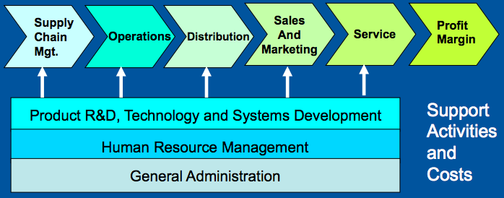

Benchmarking: A Tool for Comparing Costs of Key Value Chain Activities
  - Benchmarking involves gathering the data needed to make cross-company comparisons of how certain activities are performed, and costs associated with these activities

4. Is the company competitively stronger/weaker than key rivals?
  - List industry key success factors (KSF) from an internal resource perspective
    - KSF in industry: EX. Food Quality Internal: Our ability to acquire quality food
  - Based on strength ratings that determine if firm has a competitive advantage or disadvantage

What Do We Learn from a Competitive Strength Assessment?
  - Indicates whether firm has a net competitive advantage or disadvantage vis-à-vis each key rival
  - Identifies possible offensive/defensive actions (pit company strengths against rivals’ weaknesses or a need to correct competitive weaknesses)

5. What strategic issues merit front-burner managerial attention?
  - Based on results of both industry and competitive analysis and an evaluation of a company’s competitiveness, what items should be
on a company’s “worry list”?
  - Requires thinking strategically about
    - Pluses and minuses in the industry and competitive situation
    - Company’s resource strengths and weaknesses and attractiveness of its competitive position

- The Five Generic Competitive Strategies
  - Overall Low Cost , Broad Differentiation, Focused Low Cost, Focused Differentiation, and Best-Cost
- Strategy and Competitive Advantage
  - Competitive advantage exists when firm’s strategy gives an edge in: Attracting customers & Defending against competitive forces. Key to gaining a C.A. (Convince customers firm’s product/service offers superior value)
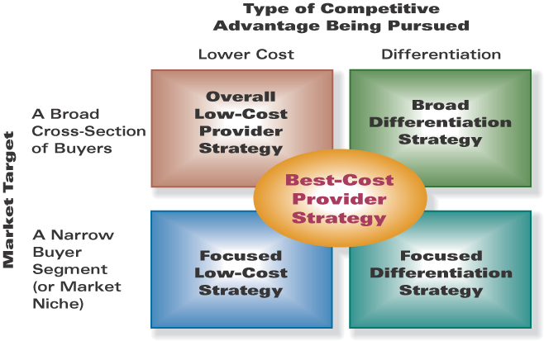
- The Five Generic Competitive Strategies

- 1. Cost-Efficient Management of Value Chain Activities
- Low Cost works best when
  - Price competition among rival sellers is vigorous. Products readily available from many sellers. Industry products are not easily differentiated. Most buyers use product the same ways. Buyers incur low costs. New entrants can use introductory low prices to build customer base
- Pitfalls of Low Cost
  - Smaller revenue, relying on cost advantages instead of raising them, becoming fixated on cost reduction to attract thus decreasing buyer appeal.
- 2. Broad Differentiating the Value Chain Activities
  - Linked to functional strategies
- When Differentiation Works Best
  - Diversity of buyer needs and uses for product. Many ways that differentiation can have value to buyers, Few rival firms follow a similar differentiation approach, Rapid change in technology and product features
- Pitfalls of Differentiation
  - Relying on product attributes easily copied by rivals. Introducing product attributes that don’t evoke enthusiastic buyer response. Overspending on efforts to differentiate firm’s product offering. Not opening up meaningful gaps in quality, service, or performance features vis-à-vis the products of rivals. Charging too high a price premium.
- 3. Focused differentiation approaches work best when:
  - The target market niche is big enough to be profitable and offers good growth potential. Industry leaders do not see that niche is crucial to their own success. It is costly or difficult for multi-segment competitors to meet the needs of target market niche buyers. The industry has many different niches/segments. Rivals have little or no interest in target segment. The “focuser” has a reservoir of buyer goodwill and long-term loyalty.
- 4. Overall Best Cost Provider Strategies
- Best Cost Works When:
  - Product differentiation is market norm. There are large number of value-conscious buyers preferring mid-range products. Competitive space near middle of market, for competitor to enter with medium-quality/below avg. price, OR, high quality/slightly higher price.
- The Big Squeeze
  - Fighting on two fronts: low-cost providers Best-cost provider strategy high-end differentiators.

Collaborative Strategies: Strategic Alliances and Partnerships
  - Companies sometimes use these to complement their own strategic initiatives and strengthen competitiveness.
- Merger and Acquisition Strategies
  - Merger – Involves a pooling of equals, with newly created firms often taking on a new name
  - Acquisition – One firm, the acquirer, purchases and absorbs operations of another.
- Vertical Integration Strategies
  - Extend a firm’s competitive scope within same industry, Backward into sources of supply, Forward toward end-users of final product, Can aim at either full or partial integration
- Outsourcing Strategies
  - Involves withdrawing from certain value chain activities and relying on outsiders to supply needed products, support services, or functional activities
- Offensive Strategies - Don’t’ have to do
  - Purposes of offensive strategies
    - Improve market position, Build competitive advantage or widen current, lower strong rival’s competitive advantage, Gain market share at expense of rivals despite their resource strengths and capabilities
- Defensive Strategies – have to do because in trouble
  - Purposes of defensive strategies
    - Lessen risk of being attacked, mitigate impact of any attack, Influence challengers to aim attacks at rivals, Defend firm’s competitive position/advantage, Protect valuable resources and capabilities from imitation
  - Types of defensive strategies
    - Block avenues open to challengers, Signal challengers vigorous retaliation is likely
- Web Strategies: Which One to Employ?
  - Approaches to using the Internet (what role should the website play in a competitive strategy?)
    - Solely as a vehicle to disseminate product information, Minor distribution channel, One of several important distribution channels, Primary distribution channel, Exclusive distribution channel
- CSR & Ethics
  - Sometimes ethical business practices present themselves as a significant issue deserving of managerial attention

- Ethical Universalism
  - What is ethical/unethical resonate with peoples of most societies regardless of Local tradition and Cultural norms
  - Thus, common ethical standards can be used by companies that operate in many markets/cultural circumstances
- Ethical Relativism
  - Honesty, Trustworthiness, Treating people with dignity/respect, Respecting other’s rights, Practicing the Golden Rule (reciprocity), Avoid unnecessary harm to Workers/Users of a company’s product, Respect the environment
- Integrative Social Contracts Theory
  - Draws on collective views of societies/cultures to place define Ethical/Unethical business behaviour
  - Wherever basic moral standards aren’t warped by local cultural beliefs, traditions, or religion, a MNE can apply code of ethics more or less can evenly apply across worldwide operations
- Concept of Ethical Relativism
  - Different societies/cultures. What is ethical or unethical? (judged despite local customs/social moves in country)
- Payment of Bribes and Kickbacks
  - Problem faced by MNEs multinational companies. Degree of cross-country bribes as part of business transactions
  - Companies forbidding payment of bribes face challenge in countries where payments are treated as local custom.

Ethical Relativism = Multiple Sets of Ethical Standards
  - Ethical relativism school maintains there are few ethical absolutes to judge company’s conduct in some countries
  - Ethical norms frequently contoured to fit: Local customs and traditions, beliefs and standards of “right”/“wrong”

Drawbacks of Ethical Relativism
  - Rule of “when in Rome, do as the Romans do” presents problems (shows non-specific ethical standards), dangerous for company personnel to assume local ethical standards are an adequate path to follow
  - From a global markets perspective, ethical relativism results in a maze of conflicting ethical standards for MNEs

Concept of Integrative Social Contracts Theory
  - Ethical standards should be upheld/governed by: Limited # of universal ethical principles that prescribe what is “ethically permissible”

Appeal of Integrative Social Contracts Theory
  - Commonly held views about morality/ethics (universal) combine to form a “social contract” with society (should include local norms) and second-order norms as well (which should not supersede universal norms!)
- Do Company Strategies Need to Be Ethical?
  - Depends on Manager: Company manager (ensure strategy is legal), moral senior executive (insists it is ethical), Amoral senior executives (use shady/borderline unethical tactics)
- What Are the Drivers of Unethical Strategies and Business Behaviour?
  - Large #s of amoral business people, personal greed, heavy pressures, profit over ethics organisations

- The Business Costs of Ethical Failures
- 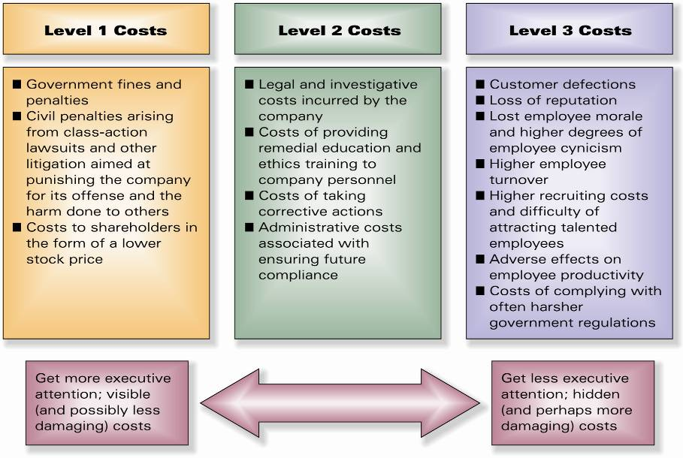
- Linking Strategy to Ethics and Values
- If ethical standards are to have more than a cosmetic role, senior officers must ask: “Is what we are proposing fully compliant with our code of ethics? (1) Is there anything that can be considered ethically questionable? (2) Is it apparent this proposed action is in harmony with our core values? Are there any conflicts?
- What Is Corporate Social Responsibility (CSR)?
  - Balance the interests of all stakeholders, applies to company’s duty to operate honourably and advocate better quality of life in the communities in which they operate/society at large. (recall my definition)
- What Is Socially Responsible Business Behaviour?
  - Benefit shareholders with no adverse affects on stakeholders. Be a corporate citizen. Socially responsible behaviours include: Corporate philanthropy(questionable)/Actions to earn trust/respect of stakeholders

- Key Elements from Chapters 10
  - Is the company performing the 10 basic managerial tasks of the strategy execution process?
    - Staffing the organization
    - Building the organizational capabilities
    - Creating a strategy-supportive organizational structure

Crafting vs. Executing Strategy
  - Crafting the Strategy
    - Market-driven activity, Successful strategy making depends on: Business vision, perception of market conditions, Attract/retain customers, beating rivals, Using resources/capabilities to forge a C.A.
  - Executing the Strategy
    - Operations-driven activity, Successful strategy execution depends on: Good organization-building and people management, Creating a strategy-supportive culture, Kaizen, Delivering good results

Executing the Strategy
  - Task involving management’s ability to: Direct organizational change, Achieve Kaizen in operations/business processes, Create/nurture strategy-supportive culture, Consistently meet/beat performance targets
- What Are the Goals of the Strategy Implementation Process?
  - Unite organisation behind strategy, Ensure activities are done conducive to first-rate strategy execution (match organisational structure to strategy), Generate commitment so enthusiastic crusade (proper staffing) carries out strategy. Fit how organisation conducts operations to requirements of strategy (building core competencies)

Building Core Competencies and Competitive Capabilities
  - Identifying desired competencies/capabilities to build into the strategy; putting them in place, modifying them to help achieve competitive advantage

Strategically-Relevant Competencies
  - Best avenue to industry leadership is to out-compete rivals with superior strategy execution!
  - Building competencies and capabilities rivals can’t match is one of the best ways to out-compete them!
- Why Structure Follows Strategy
  - Changes in strategy typically require a new/modified organization structure, how it is structured is a means to an end (not the end in itself!)
- Structuring the Work Effort to Promote Successful Strategy Execution
- Staff with people who “fit” in, integrate strategy cross-functional division, visibly involve/reward all employees,
don’t reward non-compliant employees

- Allocating Resources to Support Strategy Execution
  - Fund strategic initiatives related to strategy implementation, to strengthen competencies and capabilities, and shifting of resources.

Instituting Best Practices and Continuous Improvement
  - Identifying and adopting best practices, Benchmarking is the backbone of the process of identifying, studying, and implementing best practices, Kaizen, 6-sigma, Business Process Reengineering, TQM.

Characteristics of Best Practices
  - To be valuable and transferable, a best practice must
    - Demonstrate success over time
    - Deliver quantifiable and highly positive results
    - Be repeatable
- From Benchmarking and Best-Practice Implementation to Operating Excellence
- Business Process Re-engineering: A Contributor to Operating Excellence
  - When there is several functional departments there are inefficiencies, and lack of accountability. Solution is to create cross-functional work groups.

What Is Total Quality Management (TQM)?
  - Emphasizes Kaizen, 100% accuracy in performance, empowering employees at all levels, Customer satisfaction
- What is Six Sigma?
  - Statistics-based system aimed at having less than 3.4 defects per million for a business practice
  - Two approaches:
    - DMAIC process (Design, Measure, Analyze, Improve, Control)
      - Improvement system for existing processes falling below specification that need improvement
    - DMADV process (Define, Measure, Analyze, Design, Verify) or DFSS (Design for Six Sigma)
      - Used to develop new processes or products at Six Sigma quality levels
- Installing Strategy-Supportive Information and Operating Systems
  - Good information and operating systems are essential for first-rate strategy execution

Gaining Commitment: Components of an Effective Reward System
  - Monetary Incentives & Non-Monetary Incentives
- Designing an Effective Compensation System
  - Payoff must be a major piece of total compensation package, Incentive plan for all employees, Administer with fairness, incentives to achieving performance targets, Targets person expected to achieve must involve outcomes that can be personally affected, , Don’t reward non-performers

- Defining Characteristics of Corporate Culture
  - Core values, beliefs, and business principles, Ethical standards, Operating practices, Approach to people management, work environment, Stories illustrating: Company’s values, Business practices, Traditions

What to Look for in Identifying Corporate Culture
  - A company’s culture is manifested in . . . Values, beliefs, and business principles mgmt preaches and practices
- Where Does Corporate Culture Come From?
  - Same as “Defining Characteristics”

How Is a Company’s Culture Perpetuated?
  - Selecting new employees who will “fit” in, their indoctrination, and Senior management efforts to reinforce culture, Honouring employees who display cultural ideals, Visibly rewarding those who follow culture.
- Forces and Factors Causing Culture to Evolve
  - New challenges in marketplace, New tech, Shifting internal conditions, Internal crisis, Turnover of top executives, Diversification, Expansion, Rapid growth involving adding new employees, M&A
- Culture: Ally or Obstacle to Strategy Execution?
- Can contribute to (or hinder) successful strategy execution valuable if promotes well-suited attitudes and execution, and embraces attitudes that impede good strategy execution is a huge obstacle to be overcome
- Optimal Outcome of a Tight Culture-Strategy Fit
  - Promotes can-do attitudes, acceptance of change, peer pressure for strategy-supportive behaviours, dedicated effort to achieve company objectives
  - Closely aligning corporate culture with requirements for proficient strategy execution merits the full attention of senior executives!
- Perils of Strategy-Culture Conflict
  - Conflict between culturally-approved behaviours and behaviours needed for good strategy execution send mixed signals. Culture should not be changed hastily, or else it cannot be managed

Types of Corporate Cultures
  - Strong vs. Weak Cultures, Unhealthy Cultures, Adaptive Cultures
- Characteristics of Strong Culture Companies
  - Conduct business according to a clear, widely-understood philosophy that is reinforced.
- How Does a Culture Come to Be Strong?
  - Leaders establish values and behaviours, enforce it, be genuine with stakeholders
- Characteristics of Weak Culture Companies
  - Opposite of above.
- Characteristics of Unhealthy Cultures
  - Highly politicized internal environment, No change, “Not-invented-here” mindset.
- Hallmarks of Adaptive Cultures
  - Willingness to accept change and embrace challenge of introducing new strategies
- Dominant Traits of Adaptive Cultures
  - Any changes in practices that don’t compromise core values and don’t satisfy legitimate interests of stakeholders

