ECON1002-MACROECONOMICS
Chapter 5
Microeconomics: how individual households and firms make decisions and how they interact with one another in markets.
Macroeconomics: studying the economy as a whole. To explain the economic changes that are affecting households, firms and markets all together.
GDP (Gross Domestic Product): the market value of all final goods and services produced within a country in a given period of time. It is the most watched economic statistic because it is thought to be the best single measure of a society’s economic well-being.
- Measures two things:
- The total income of everyone in the economy
- The total expenditure on the economy’s output of goods and services.
- For an economy, income must equal expenditure. Every transaction has two parties: a buyer and a seller.
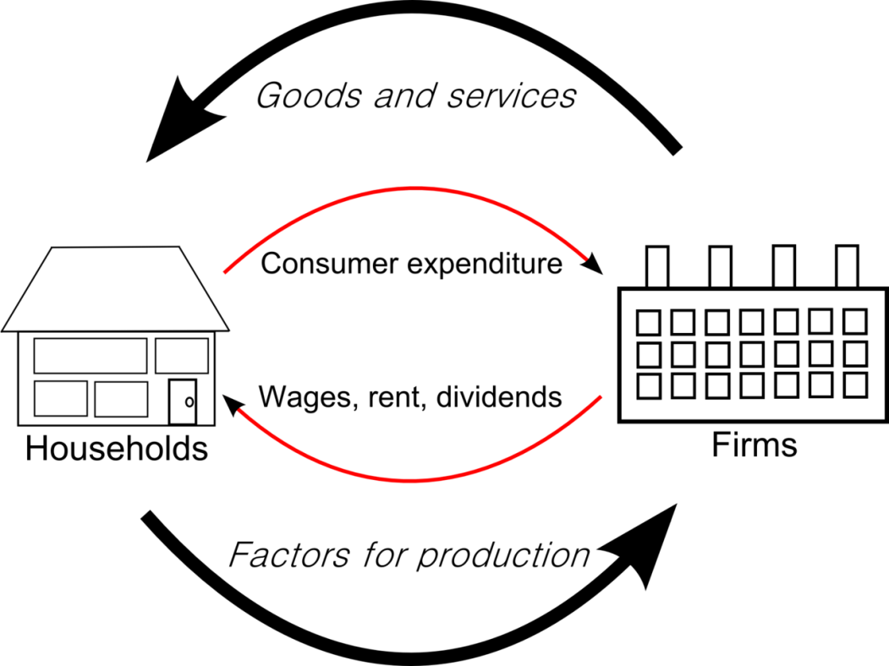’
This diagram explains how income=expenditure. However, in the actual economy households don’t spend all of their income. They pay some in taxes, save some for the future, etc. Some goods are bought by governments and some are bought by firms planning to use them in the future. However there is always a buyer+ seller therefore expenditure=income always.
Factor of 2’s
Two Markets: Factor markets (inputs), and goods and services markets (output)
Two Actors: Households and Producers (firms and businesses)
Two types of economic activity (flows): Income from services rendered, and expenditure flows from goods and services produced

Structure of the Model:
On the Bottom (Input Market): Households are the sellers (sell their time and effort), while firms are the buyers (pay for their wages)
On the top (Output Market): Households are the buyers (buy products), while firms are the sellers (sell their g & s to households)

- GDP uses market prices to measure the amount people are willing to pay for different goods.
- GDP includes all items produced in the economy and sold legally in markets. It also includes the market value for rental housing provided by the economy’s stock of housing. The rent equals both the expenditure and the landlord’s income. However many people own the place they live and do not pay rent. The government includes this owner- occupied housing in GDP by estimating it’s rental value. GDP is based on the assumption that the owner pays rent to himself, so the rent is included both in his expenditure and his income.
- Excludes products sold illegally, most items produced and consumed at home because they never enter the marketplace.
- Iffy situations, for example if Karen paid Doug to mow her lawn that would be a part of GDP. But if they married and Doug did it for free, Doug’s service wouldn’t be in the market so GDP would fall.
- GDP only counts Final goods as opposed to intermediate goods. Adding the market value of the paper to the market value of the card made would be counting the paper twice. An exception would be when an intermediate good is produced and added to a firm’s inventory to be used or sold at a later date. Then it is taken to be a final good.
- Is only for goods currently produced, not produced in the past. Meaning if someone sells an older used car to another person, the value isn’t added to the GDP.
- Within a country means within a geographic region.
- usually GDP is measured in a quarter (three months)
GDP is divided into four components:
- Consumption (C)
- Investment (I)
- Government Purchases (G)
- Net Exports (NX)
Therefore: $y= C+I+G+NX$
Consumption: The spending by households on goods and services.
Investment: the purchase of goods that will be used in the future to produce more goods and services.
- Capital equipment, inventories and structures.
- Buying a new house is a form of investment, not consumption
- If IBM produces a computer but doesn’t sell it and instead adds it to it’s inventory. IBM is assumed to have purchased the computer from themselves.
Government Purchases: spending on goods and services by local, territorial, provincial and federal governments.
- Salaries of government workers, spending on public works.
- Things like pension plan aren’t government purchases but are transfer payment because they aren’t receiving any service or good for their spending
Net Exports: the purchases of domestically produced goods by foreigners (exports) minus the domestic purchases of foreign goods (imports). Imports are subtracted from exports.
Real GDP Versus Nominal GDP
If total spending increases either one of these are true:
- The economy is producing larger output of goods and services
- Goods and services are being sold at higher prices.
Real GDP: shows how the economy’s overall production of goods and services changes over time by evaluating current production using fixed prices at past levels. This means it is not affected by changes in price. (example on page 107)
Nominal GDP: the production of goods and services valued at current prices.
GDP Deflator: the prices of goods and services but not the quantities produced.
GPD Deflator $=\frac{nominal GDP}{real GDP}*100$
- Measures the current level of prices compared to the prices of the base year.
- Has to do with inflation. The inflation rate is calculated as follows:
- $Inflation Rate in Year 2=\frac{GDP Deflator in year 2-GDP Deflator in Year 1}{GDP Deflator in Year 1}*100$

Chapter 6- Measuring the Cost of Living
Consumer Price Index: the overall measure of goods and services bought by a typical consumer.
Steps to finding the Consumer Price Index:
- Determine the basket- which prices are most important, weighing which items are more important than others.
- Find the Prices`
- Compute the Basket’s Cost- calculate the cost of the basket of goods and services at different times.
- Choose a base year and compute the index- designate one year as the base year
$$CPI=\frac{\left(Price of basket of goods and services in current year\right)}{price of basket in base year}*100$$
- Compute the Inflation Rate: the percentage change in the price index from the preceding period.
$$Inflation Rate in Year 2=\frac{CPI in year 2-CPI in year 1}{CPI in Year 1}*100$$
Core inflation: thought to be useful in predicting the underlying trend of changes in the consumer price index.
Problems with the Consumer Price Index
- Commodity substitution bias: when prices change from one year to the next, they don’t change proportionately. Consumers buy goods more or less based on if the price rises or falls. The CPI ignores the possibility of consumer substitution and overstates the increase in the cost of living from one year to the next. The CPI assumes consumers still buy items that have risen in price.
- Introduction of New Goods: when a new good is introduced, consumers have more variety from which to choose. Greater variety makes each dollar more valuable so consumers need fewer dollars to maintain any given standard of living.
- Unmeasured quality change: if the quality of a good changes from one year to the next, the value of the dollar falls even if the value of the good remains the same. If the quality raises the dollar raises.
These measurements tend to cause the Canadian CPI to overstate increases in their standard of living by about 0.6%. This is a problem as Old Age security and the Canada Pension Plan, personal income tax deductions and some government social payments are all adjusted upwards using the CPI. Adjustments to wages, pensions and social payments may be larger than necessary to maintain the purchasing power of these wages and benefits.
The GDP Deflator versus the Consumer Price Index
GDP deflator: the ratio of nominal GDP to real GDP. It reflects the current level of prices relative to the level of prices in the base year.
- Economists monitor both the GDP deflator and the CPI to gauge how quickly prices are rising.
Differences between GDP Deflator and CPI:
- GDP deflator reflects the prices of all goods and services produced domestically while the consumer price index reflects prices of all goods and services bought by consumers.
- The consumer price index compares the price of a fixed basket of goods and services to the price of the basket in the base year. The GDP deflator compares the price of currently produced goods and services to the price of the same goods and services in the base year
Figure 6.2 page 127
Dollar Figures from Different Times
How much of the rise in the price of a product is simply a reflection of the general rise in prices? In other words, how much of the rise of the price in gasoline is due to a fall in the value of money? We would need to inflate the price of the earlier price to the newer price.
Example:
Inflate the 1957 price of gas from 9.5 cents/litre to 2009 dollars.
Statistics Canada gives a CPI of 14.8 for 1957 and 114.3 for the year 2009. (The base year is 2002). The overall level of prices rose by a factor of 7.72.
1957 gas price in 2009 dollars=1957 gas price x (CPI in 2009/CPI 1957)
=9.5 cents x (114.3/14.8)
=73.4 cents
The 1957 price of gasoline is equivalent to a price of 73.4 cents per litre in 2009. Therefore after adjusting for inflation the 2009 gas price of 95 cents per litre is still considerably higher than 52 years earlier.
Indexed: when a dollar amount is automatically corrected by for inflation by law or contract.
Chapter 7-Production and Growth
The large variations in living standards around the world depends on productivity
-Productivity: the quantity of goods and services a worker can produce for each hour of work
For example in a simple economy (stranded on an island) whatever you produce (fish, cook, make clothes) the better you live.
GDP measures the total income earned by everyone in the economy and the total expenditure on the economy’s output of goods and services- they must be equal.
Therefore, the economy’s income must = the economy’s output
How Productivity is Determined
- Physical Capital/Worker: the tools workers have make them more productive. Equipment and structures that are used to produce goods and services.
- Human Capital: knowledge and skills that workers acquire through education, training and experience. Teachers, libraries, etc are the inputs.
- Natural Resources Per Worker: inputs into production that are provided by nature. Take 2 forms: renewable and non-renewable. Some countries like Saudi Arabia and Kuwait are rich because they are on top of plenty of Natural Resources.
- Technological Knowledge: the understanding of the best ways to produce goods and services. Many people used to work on farms but an increase in technology meant more output, now the labour can be used for other goods and services.

Economic Growth and Public Policy
What can government policy do to raise productivity and living standards?
Saving and Investment
- One way to raise future productivity is to invest more current resources in the production of capital
- We face trade offs, devoting fewer resources to producing capital requires devoting fewer resources to producing goods and services for current consumption.
- For society to invest more in capital it must consume less and save more of it’s current income.

Diminishing Returns and the Catch-Up Effect
- Diminishing Returns: as the stock of capital rises, the extra output produced from an additional unit of capital falls.

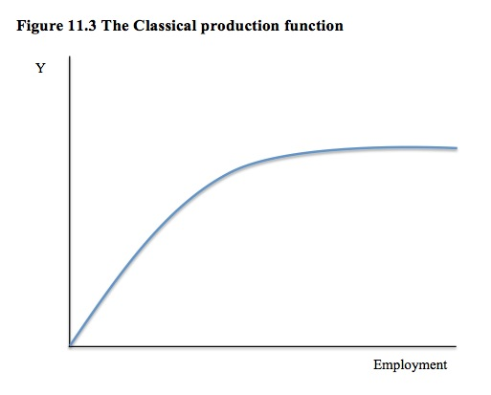
y=output per worker
- An increase in saving rate leads to higher growth only for a while
It is easier for poorer countries to grow faster. Poor countries have low productivity, so increase in capital can raise productivity substantially which is called the catch up effect
Since capital/worker is already high in rich countries, additional capital investment has a small effect on productivity.
Investment from Abroad
Investment by foreigners can raise economic growth
- Foreign Direct Investment: capital investment that is owned and operated by a foreign entity.
- Foreign Portfolio Investment: investment financed with foreign money but operated by domestic residents.
- Example: a Canadian can buy stock in an Irish company, that company uses the investment to build a new factory.
- Canadian saving is being used to finance Irish Investment. Foreign Investors expect to earn a profit. If Bombardier opens an assembly plant in Ireland, it increases Ireland’s productivity and GDP. Some of the income doesn’t apply to people who do live in Ireland. Therefore the GNP>GDP in this sense.
- Foreign Investment leads to poorer countries raising productivity.
- The World Bank and International Monetary Fund lets richer countries give loans to poorer ones, and gives them advice on how to manage money.
Education
- Raises productivity
- But the opportunity cost means students forgo wages they could have earned
- In poorer countries students drop out earlier to help support their families.
- Human capital is good for economic growth because it conveys positive externalities
- Externalities: effect of one person’s actions on the well being of a bystander.
- Brain Drain: most poor countries have their smartest people emigrating.
Health and Nutrition
- Healthier workers are more productive
- Poor countries are poor because their workers are malnourished, but malnourished because they are poor.
Property Rights and Political Stability
- Policymakers can foster economic growth by protecting property rights and promoting political stability
- Market prices are made to balance supply and demand.
- Made by the invisible hand
- Property Rights: the ability for people to exercise authority over the resources they own
- Poorer countries lack property rights, and political instability can lead to a threat of Property rights.
Free Trade
- Inward Oriented Policies: trying to raise productivity by limiting interaction with the rest of the world. This is for protection from foreign competition.
- Outward Oriented Policies: integrate these countries into the world economy.
Research and Development
- Research to improve the ability to produce goods and services.
- Public good: other people can freely use
- Tax breaks are given to firms that engage in Research and Development.
Population Growth
- A large population means more workers but less consumers
- Doesn’t mean higher standard of living
Thomas Robert Malthus
- An ever increasing population will continually strain society’s resources
- As population grows, each person can use less capital so the GDP per worker lowers.
- If there are more people, there is more knowledge to increase technology and capital leading to an increased GDP.
Chapter 8- Saving Investment and the Financial System
Financial System
- Institutions in the economy that help to match one person’s saving with another person’s investment.
- Can be grouped in two categories:
- Financial Markets
- Financial Intermediaries
Financial Markets
- Institutions through which a person who wants to save can directly supply funds to a person who wants to borrow.
- Bond Market: a bond is an IOU. It identifies a date of maturity (when it will be resold), the rate of interest paid: principal. The Bond buyer can keep the bond until maturity or sell it.
- Perpetuity is a bond that doesn’t expire
- Credit Risk is the risk the borrower won’t repay which is called default. Companies can default on their loan by filing bankruptcy.

- Provincial government bond issues are less stable than federal government because their tax revenues can change quickly.
- Newer companies issue junk bonds because they offer high interest.
- The Stock Market: selling and buying of ownership in a firm and is a claim to the profit a firm makes
- Selling a stock to raise money is called equity finance selling bonds is called debt finance.
- Shareholders enjoy the benefits but bondholders only get the interest.
- Stock index is an average of a group of stock prices.
Financial Intermediate
- Financial institutions through which savers can indirectly provide funds to borrowers.
- Two of the most important types:
- Banks
- Mutual Funds
- Banks: take deposits from people who want to save money and use the deposits to make loans to people who want to borrow. They pay depositors interest and charge borrowers slightly higher interest.
- Mutual Funds: an institution that sells shares to the public and uses the proceeds to buy a selection or portfolio of various types of stocks, bonds or both.
- The company operating the mutual fund charges a shareholder’s fee, usually between 0.5 and 3.0 percent of assets each year.
- The people handling the funds buy profitable stocks and sell less profitable.
- Index Funds: buy all the stocks in a given stock index. They keep costs low by buying and selling rarely, and not having to pay the salaries of the professional money managers.
Saving and Investment in the National Income Accounts
- Identity: an equation that must be true because of the way the variables in the equation are defined.
Important Identites:
- GDP: Y=C+I+G+NX…..C=Consumption, I=Investment, G=Government Purchases, NX=Net exports
- Closed Economy: one that doesn’t interact with other economies. Doesn’t engage in international anything
- Open Economies: interact with other economies around the world.
- in a closed economy we may write: Y=C+I+G because there are no exports.
Y-C-G=I is called national saving
Sub “S” for Y-C-G and we get S=I saving equals investment
- Let T= the amount the government collects from households in taxes minus the amount it pays back in transfer payments.
We can write national savings in two ways:
S=Y-C-G or S=(Y-T-C)+(T-G)
- (Y-T-C) is private savings and (T-G) is public savings.
- Private Saving: amount of income that households have left after paying their taxes and paying for their consumption. Houses receive income of Y, pay taxes of T and spend C on consumption.
- Public Saving: amount of tax revenue the government has left after paying for it’s spending. Receives T in tax revenue but spends G on goods + services
- There is a Budget Surplus if T exceeds G
- A Budget Deficit is when they are spending more money than the government is receiving in Tax Revenue. T-G= Negative Number
Market for Loanable Funds
Assume the economy has only one financial market called the market for loanable funds
- Loanable Funds: all income people have chosen to save and lend out. Only one Interest rate, return to saving and the cost of borrowing.
- Supply= people with extra income they want to save and lend out.
- Demand=households and firms who wish to borrow to make investments.
- The interest rate is the price of a loan.

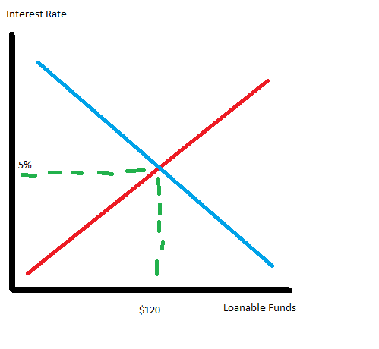
- Low interest rate=less supplied, high interest rate= encourage saving and increase the quantity of loanable funds supplied and discourage borrowing.
- If higher than the equilibrium, the quantity of loanable funds supplied would be higher than demanded and interest rates would be driven down.
- Nominal Interest Rate: the interest rate as usually reported. The return to savings and cost of borrowing.
- Real interest Rate: nominal interest rate corrected for inflation. =Nominal Interest rate- Inflation rate
Saving Incentives
- People are discouraged to save because the government keeps taxing their incomes. To solve these economists have tried implementing different things, such as the GST which is on consumption.
- RRSP’s allow people to save for the future without being taxed. Also TFSA (Tax Free Savings Accounts)
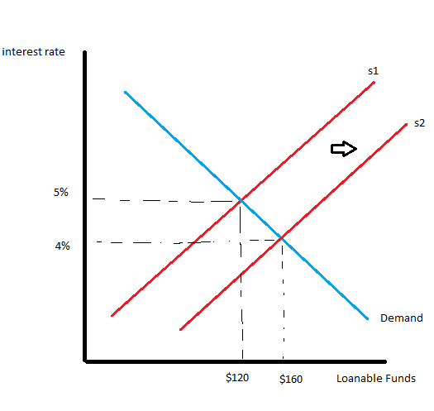
Change in tax laws encouraging saving would shift the supply of loanable funds. Equilibrium interest rate would fall, the lower interest rate would stimulate investment.
Affects the supply because it affects the amount of quantity of loanable funds supplied.

Investment Incentives
- investment tax credit: gives a tax advantage to any firm building a new factory or buying new equipment.
- would affect demand because it is rewarding the firms that borrow and invest in new capital. Demand would increase because there is more incentive to increase investment and the quantity of loanable funds would increase.
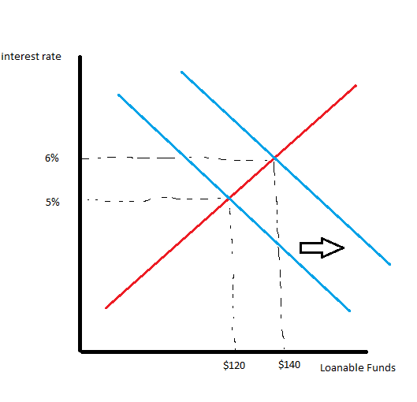
Higher interest rate would stimulate saving and equilibrium interest rate would rise.
Government Budget Deficit and Surpluses
- Government Debt: the sum of all past budget deficits – the sum of all past budget surpluses.
- It changes the supply of loanable funds because national saving is the supply of loanable funds. It is composed of public saving and private saving, and the government budget is public saving. Shifts supply to the left. The fall of investment due to government borrowing is called crowding out.
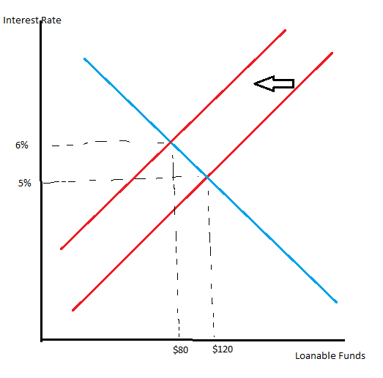
Chapter 9- Unemployment and It’s Natural Rate
People who would like to work but can’t find jobs don’t contribute production of goods and services, and GDP is lower.
- Natural rate of unemployment: normal amount of unemployment an economy experiences
- Cyclical Unemployment: year to year fluctuations in unemployment.
How is unemployment measured?
Three categories:
- Employed
- Unemployed
- Not in the labour force
Labour force
=sum of employed and unemployed
=number of employed +number of unemployed
Unemployment rate $=\frac{number of unemployed}{labour force}*100$
Labour force participation: measures the percentage of the total adult population of Canada that is in the labour force.
Labour force participation rate= $\frac{labour force}{adult population}*100$
- The economy returns to the natural rate of unemployment in the long run
- Estimate for Canada is 6% to 8%.
- The difference between the observed unemployment rate and the natural unemployment rate is the cyclical unemployment rate.
- Frictional unemployment: the unemployment that results from the process of matching workers and jobs.
- Structural unemployment: quantity of labour supplied exceeds quantity demanded. Occurs when wages are set above the level of equilibrium.
Government programs try to facilitate job search in many different ways. Employment agencies, public training programs, etc.
- Employment insurance: providing income for the unemployed. Some believe that this may increase the unemployment rate to be higher than normal. May increase the amount of frictional unemployment without intending on doing so. In places with low unemployment rates, more hours of work are needed to be eligible for EI.
Minimum-Wage Laws
- When a minimum-wage law forces the wage to remain above the level that balances supply and demand (equilibrium), it raises the quantity of labour supplied and reduces the quantity of labour demanded compared to equilibrium level. Because there are more workers willing to work than there are jobs.
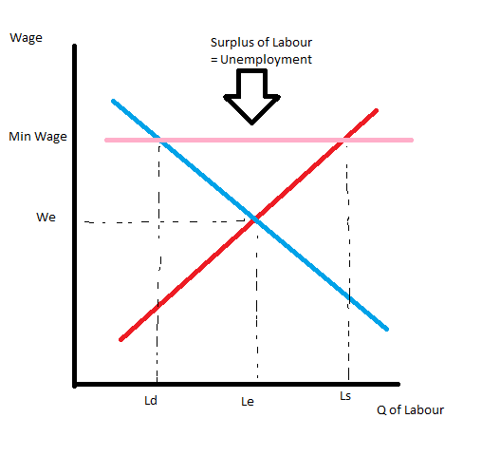
- Union: a worker association that bargains with employers over wages and working conditions.
- High union wages reduce the quantity of labour demanded and cause some workers to be unemployed and reduce the wages in the rest of the economy.
- Efficiency wages: theory that firms operate more efficiently when wages are above the equilibrium level.
- Health: better paid workers eat more nutritious and are more healthier and productive.
- Firms can reduce turnovers (workers leaving) by paying them high wages.
- Working effort: people work harder when paid more.
- Worker Quality: higher wages attract more experienced workers.

Chapter 10- The Monetary System
- Double Coincidence of Wants: the unlikely occurrence that two people have goods/services each other wants.
- Money: set of assets people use to buy goods and services
The Functions of Money
- Medium of Exchange: an item that buyers give to sellers when they purchase goods and services.
- Unit of Account: standard monetary unit of measurement ($)
- Store of Value: item people can use to transfer purchasing power from the present to the future. You can hold the money and become a buyer of another good or service at another time. A recognized form of exchange.
- Liquidity: the ease that an asset can be changed into a medium of exchange (money). Stocks and bonds can be sold easily with small cost so they are relatively liquid. Selling a house requires more time and effort so this is less liquid.
The Kinds of Money
- Commodity money: when money has value if it weren’t used as money. Example: gold is used as currency, also to make jewellery.
- Fiat Money: established as money by the government. (Canadian dollars)
The Bank of Canada measures the money stock defined as M1+ and M2.
The Bank of Canada
- Central Bank: an institution designed to control the quantity of money in the economy. Owned by the government and hand over profits to the government. Primary responsibility is to act in national interest.
- Commercial Bank: owned by their shareholders. Primary responsibility is to maximize the profits they earn on behalf of their shareholders.
Bank of Canada Jobs:
- Issue Currency
- Act as a banker to commercial banks
- Act as a banker to the Canadian government
- Control the quantity of money made available to the economy (money supply). Decisions concerning the money supply constitute monetary policy.

Commercial Banks and The Money Supply
- Reserves: deposits that banks have received but haven’t lent out.
- Each deposit in the bank reduces currency and raises demand deposits by exactly the same amount, leaving the money supply unchanged.
- If the flow of new deposits is roughly the same as the flow of withdrawals, the bank only needs to keep a fraction of it’s deposits in reserve. They adopt a system called fractional-reserve banking
- Reserve Ratio: fraction of total deposits that a bank holds. If you have a 10% reserve ratio and you hold $100 in demand deposits, you need $10 in reserves and can loan $90.
- Banks have a legal requirement of reserves called a reserve requirement so they don’t run out.
- When banks make loans, the money supply increases. When a bank holds only a fraction of deposits in reserve, banks create money. The borrowers are taking on debts, so the loans don’t make them any richer. At the end of this process of money creation the economy is more liquid because there is more medium of exchange but the economy is no wealthier than before.
- The amount of money the banking system generates with each dollar of reserves is called the money multiplier. (Page 230 and 231 read this and understand it)
- $Money Supply=Currency+Demand Deposits$
- The higher the reserve ratio, the less of each deposit banks loan out and the smaller the money multiplier.
Changing the Overnight Rate
- Bank Rate: rate of interest central banks charge commercial banks for these loans (overdrafts).
- Overnight rate: rate of interest on very short-term loans between commercial banks.
- Will always be around a quarter of a percent below the bank rate.
- A higher overnight rate discourages banks from borrowing reserves from the Bank of Canada

Chapter 11- Money Growth and Inflation
Prices rise when the government prints too much money.
The Level of Prices and the Value of Money
- Money used to buy something can become less valuable.
- Inflation concerns the value of the economy’s medium of exchange
- If P is the price of a good, the amount that can be bought with $1 is $\frac{1}{P}$
Money Supply, Money Demand and Monetary Equilibrium
Supply and demand for money determines the price of money
- The demand of money depends on liquidity preference, how much money people want to hold.
- How much money they hold depends on prices
In the long run, the overall level of prices adjusts to the level at which the demand for money equals the supply
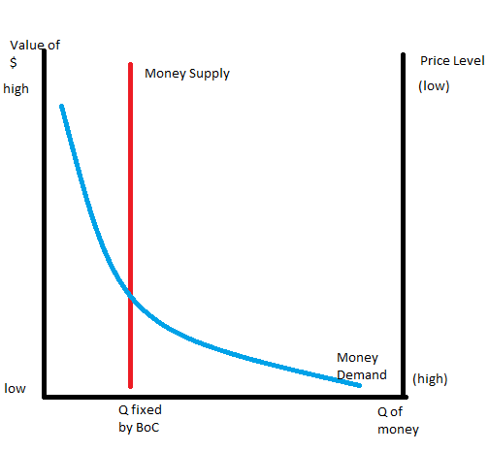
People want to hold a larger quantity of money when each dollar buys less.
- When the value of money is high, the price level is low
- When the value of money is low, people demand a larger quantity of it to buy goods and services
- Equilibrium of money supply and money demand determines the value of money and the price level
The Effects of a Monetary Injection
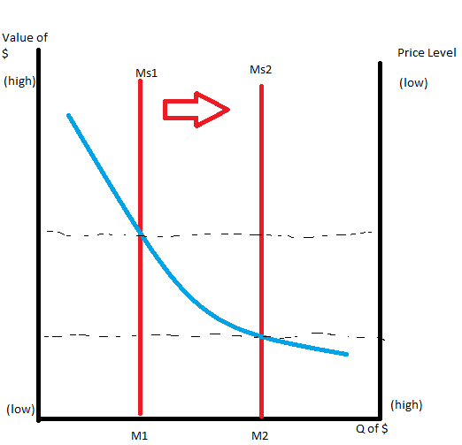
- Value of money decreases and the equilibrium price level increases
- Each dollar is less valuable when there is an increase in money supply
- Quantity Theory of Money: quantity of money available in the economy determines the value of money and growth in quantity is the cause of inflation
The Classical Dichotomy and Monetary Neutrality
All Economic variables should be divided into two groups
- Nominal Variables: variables measured in monetary units
- Real Variables: variables measured in physical units. (Real wage and real interest rate)
The separation of these groups is called classical dichotomy
Relative Prices: measuring the value of something with the quantity of another.
Changes in the supply of money affect nominal variables but not real variables.
- Monetary Neutrality: irrelevance of monetary changes for real variables in the long run.
- Real variables are things such as production, employment, real wages, etc.

Velocity and the Quantity Equation
- Velocity of Money: speed the typical dollar travels from wallet to wallet
- Divide the nominal value of output (nominal GDP is P*Y) by the quantity of money. If P is the price level (GDP deflator), Y is the quantity of output (Real GDP), M is the quantity of money, velocity is:
$$V=\frac{\left(P*Y\right)}{M}$$
Can also be written:
$M*V=P*Y$ which is called the quantity equation
- Relates the quantity of money(M) to the nominal value of output (P*Y)
- The quantity equation shows that increasing the money supply should only be because of price level rising, the quantity of output rising or the velocity of money falling.
- Since Y is determined by factory supplies and technology, when the central bank alters the money supply (M), the changes are reflected in changes in the price. Therefore when the Central Bank increases the money supply, the result is a high rate of inflation.
The Inflation Tax
Governments print money to fund different projects if they don’t have enough tax revenue.
- When the government raises revenue by printing money, it is said to levy an inflation tax.
- Inflation tax: when the government prints money, the price level rises and the dollars in your pocket are less valuable. Inflation tax is like a tax on everyone who holds money.
The Fisher Effect
$$Real Interest Rate=Nominal Interest Rate-Inflation Rate$$
$$Nominal Interest Rate=Real Interest Rate+Inflation Rate$$
- Fisher Effect: When the Bank of Canada increases the rate of money growth, the result is both a higher inflation rate and a higher nominal Interest rate.
The Inflation Fallacy
- People aren’t losing money with inflation, as incomes inflate as well.

Shoeleather Costs
- Shoeleather cost: the cost of reducing your money holdings. (Called shoeleather because it erodes your shoes walking to the bank so often)
- you can avoid inflation tax by going to the bank more often, holding less money on you. Keep your wealth in interest- bearing savings account and less in your wallet.
Inflation-Induced Tax Distortions
Taxes distort incentives
- Capital Gains: the profits made by selling an asset for more than it’s purchase price. You have to include this on your income and be taxed. Inflation could have been greater, and you could have been taxed on a greater gain. Inflation exaggerates the size of capital gains and inadvertently increases the tax burden on this type of income.
Chapter 12- Open-Economy Macroeconomics: Basic Concepts
- $Net exports=\left(Value of Exports\right)-(Value of Imports)$
- Also called the trade balance
- $Net Capital Flow=\left(purchase of foreign assets by domestic residents\right)-(the purchase of domestic assets by foreigners)$
- Net Capital Outflow must be equal to Net Exports
$$NCO=NX$$
- When NX>0, there is a trade surplus. Is it selling more goods and services to foreigners than it is buying from them. However the foreign currency it is using is buying foreign assets, and NCO>0 too.
- When a nation has a trade deficit, capital is flowing out of the country NX<0, but the foreigners must be buying our domestic assets, so capital is flowing into the country. NCO<0
- National Saving is written as $\left(Y-C-G\right)=I+NX, S=I$but because net exports (NX) also equals (NCO), we can write the equation
$$S=I+NCO$$

Country with a Trade Surplus
Income (Y=C+I+G+NX) must be greater than domestic spending (C+I+G), but if Y is greater than C+I+G than Y-C-G must be greater than I. (S=Y-C-G) must be greater than investment. Net capital outflow must be greater than zero.

Country with a Trade Deficit
Income (Y=C+I+G+NX) must be less than domestic spending (C+I+G), meaning (Y-C-G) is less than I. Net Capital Outflow is negative.

Nominal Exchange Rate
- The rate at which a person can trade the currency of one country for the currency of another.
- Appreciation: the dollar buys more foreign currency
- Depreciation: the dollar buys less foreign currency.
Real Exchange Rate
- The rate at which a person can trade the goods and services of one country for the goods and services of another.
- Express it as units of a foreign item per units of domestic items.
$$Real Exchange Rate=\frac{Nominal exchange rate*Domestic price}{Foreign Price}$$
- Macroeconomists use CPI and prices of foreign baskets to measure an economy as a whole. Canadian basket (P), price index for a foreign basket (P*) and the nominal exchange rate between the Canadian dollar and foreign currencies (e)
$$Real Exchange rate \left(overall\right)=\frac{e*P}{P*}$$
- Measures the price of a basket of goods and services available domestically relative to a basket of goods and services available abroad.
- A cheaper domestic real exchange rate means consumers will buy more from us, but a more expensive one means we will buy from others and other wont buy from us.
Purchasing-Power Parity
- A unit of any given currency should be able to buy the same quantity of goods in all countries.
- If one good is cheaper in another country, people will buy it and sell it to other countries, driving up the price in the once cheap country, and lowering it in the other. Bringing it to near equal.
- For the purchasing power of a dollar to be the same in two countries, it must be the case that $\frac{1}{P}=\frac{e}{P*}$ rearranged to $1=\frac{eP}{P*}$
- The left-hand side of this equation is a constant, and the right side is the real exchange rate. Thus if the purchasing power of the dollar is always the same at home and abroad, then the real exchange rate cannot change.
- Nominal Exchange rate:$e=\frac{\left(P*\right)}{P}$, the nominal exchange rate must be equal to the different price levels in those countries.
- When a country prints money, the value of it’s currency depreciates.
Perfect Capital Mobility
- Meaning we have full access to international markets, and our market is available internationally.
- Real Interest rate, must equal the world Real Interest rate. $r=r^{w}$
- If higher, Canadians would prefer to buy internationally instead of domestically, and vice-versa.
- The theory that Canadian interest rates should be equal to the rest of the world’s is interest rate parity.

Chapter 13- A Macroeconomic Theory of the Open Economy
- When a country is buying foreign assets, their savings are going abroad to purchase foreign assets.
- To understand the forces in an open economy, we look at the market for loanable funds and the market for foreign-currency exchange
The Market for Loanable Funds
$$Saving \left(S\right)=Domestic Investment \left(I\right)+Net Capital Outflow \left(NCO\right)$$
- If a nation’s savings exceed its amount to purchase domestic capital, the amount left over can be used to purchase foreign assets (NCO Positive). (S>I)
- If national saving is insufficient to purchase domestic capital, the shortfall can be met by the savings of foreigners (NCO is negative). (S<I)
- If we ignore tax treatments and default risk, Canadian interest rate will equal the world interest rate. This is because borrows or savers can borrow or lend to either domestic or foreign residents if there is a higher or lower interest rate.
- Canadians would have to lend their savings at the World Interest Rate if its lower

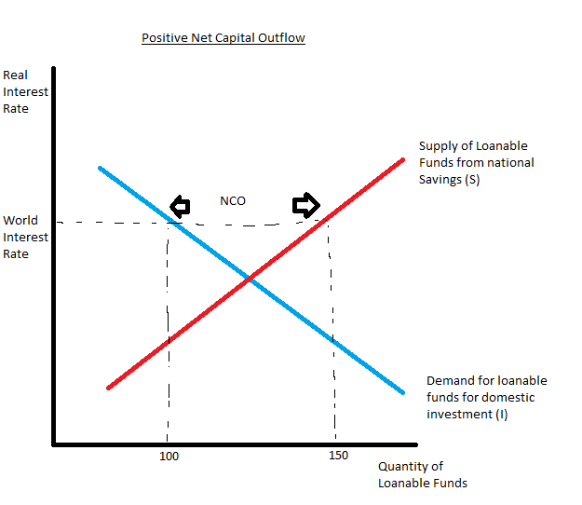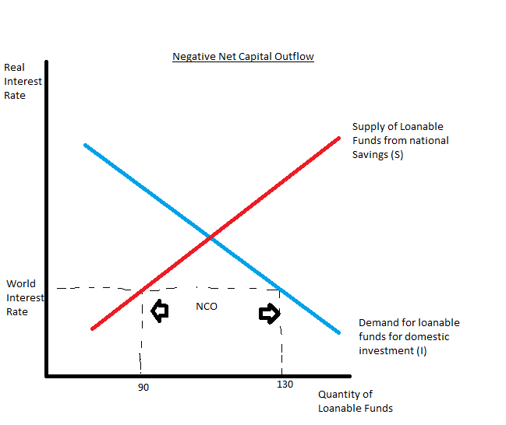

- In an economy with perfect capital mobility, the supply curve represents only a fraction of the loanable funds supplied.
- The supply curve shows the amount of national savings.
- A higher interest rate increases the available supply of Loanable funds to Canadians
- NCO is the difference between the supply of loanable funds due to national saving (S) and the demand for loanable funds (I)
$$NCO=NX (Net Exports)$$
The Market for Foreign-Currency Exchange
It exists because people want to trade goods, services and financial assets with other countries, but want to be paid in our own currency.
- In order for a Canadian to trade internationally, they must purchase another country’s currency.
$$Saving \left(S\right)-Domestic Investment \left(I\right)=Net Exports (NX)$$

- The difference between national saving and domestic investment represents NCO.
- Represents the quantity of money supplied in the market for foreign-currency exchange for the purpose of buying foreign assets.
- When Canadians want to buy a foreign asset they supply dollars in the market for foreign-currency exchange.
- NX represents the quantity of $ demanded in that market
- When a foreign entity wants something Canadian, they demand dollars in the market for foreign currency exchange.
- Real exchange rate is the price that balances supply and demand in the market for foreign currency exchange.
- When Canada’s Real exchange rate appreciates, Canadian goods are more expensive relative to foreign goods, meaning exports fall and imports rise.
-reduces the quantity of money demanded in the market for foreign currency exchange.

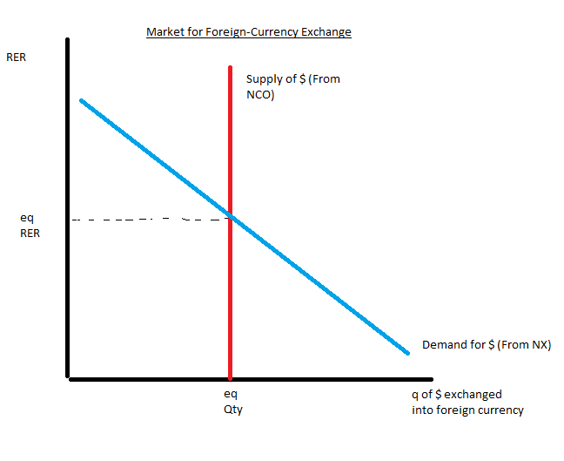
- The supply curve is vertical because neither domestic savings nor domestic investment depends on real exchange rate.
- Net exports is the source of demand for $
- NCO is the source of the Supply
Net Capital Outflow: The link Between the Two Markets
$$S=I+NCO$$
$$NCO=NX$$
- In the market for loanable funds, NCO is the difference between domestic investment and national saving at the world interest rate.
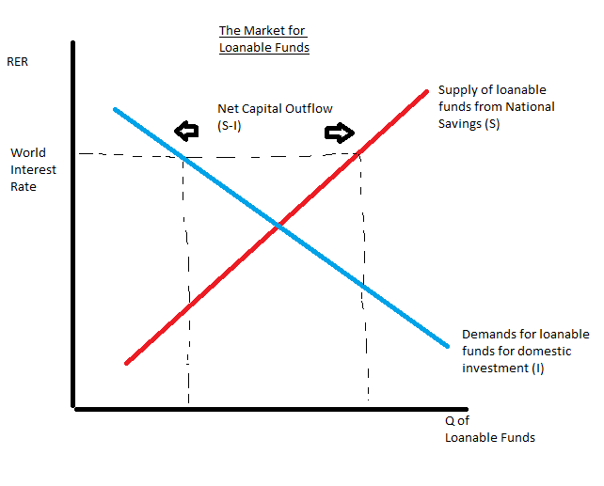
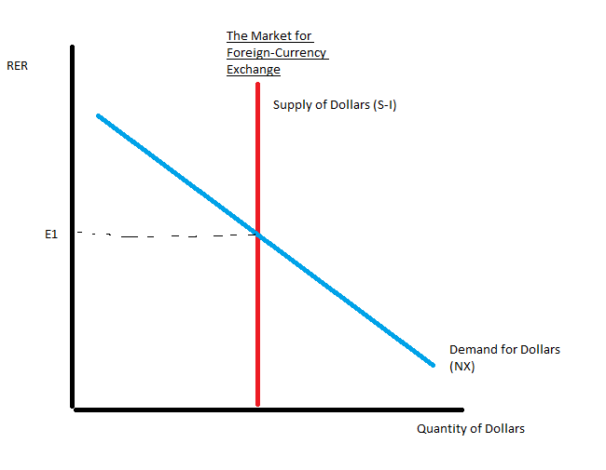

Increase in World Interest Rates
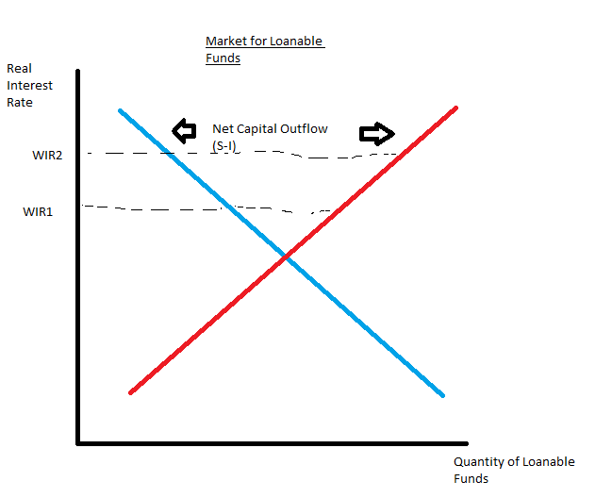
When the world interest rate increases, it increases the supply of loanable funds made available by Canadians and reduces the quantity of loanable funds demanded for domestic investment. NCO increases.
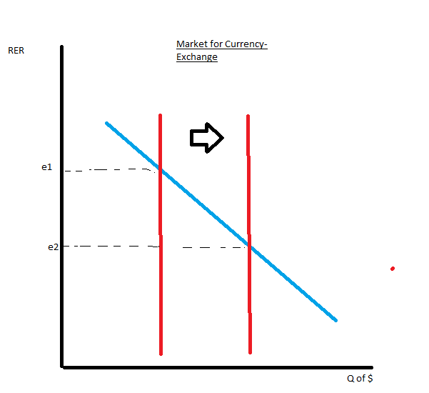
Increase in the supply of dollars in the market for foreign-currency exchange causes the CDN $ to depreciate. This causes net exports to rise.
In a small open economy with perfect capital mobility, an increase in world interest rate crowds out domestic investment causes the dollar to depreciate and net exports to rise.

How Policies Effect an Open Economy
Government Budget Deficits and Surpluses
- A budget deficit is a negative public savings, meaning it reduces the supply of loanable funds, drives up the interest rate and crowds out investment.
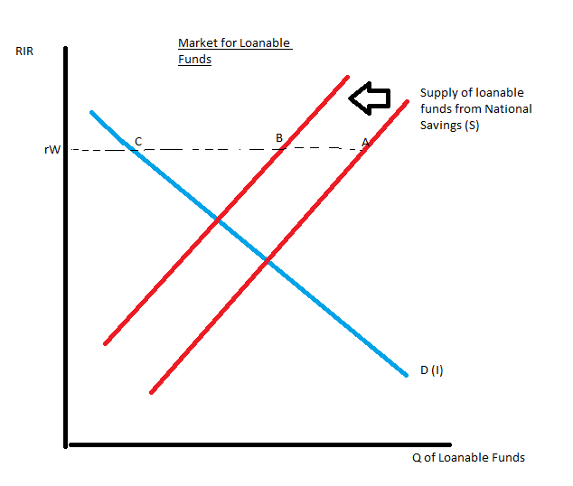
With a government budget deficit supply curve shifts to the left, NCO decreases from A to C, to B to C.
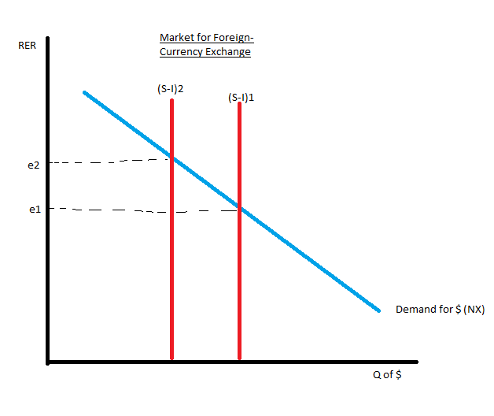
The decrease in supply of dollars causes the supply curve to shift to the left, and causes the Real exchange rate to appreciate from E1 to E2. The appreciation of the exchange rate causes net exports to fall.
Therefore, in a small open economy with perfect capital mobility, an increase in government budget deficits causes the dollar to appreciate and causes net exports to fall.
Reversing the implications, in a small open economy with perfect capital mobility, a decrease in government budget deficits causes the dollar to depreciate and net exports to rise.
Trade Policy
- Tariff: a tax on imported goods
- import quota: a limit on the quantity of a good that can be produced and sold domestically.
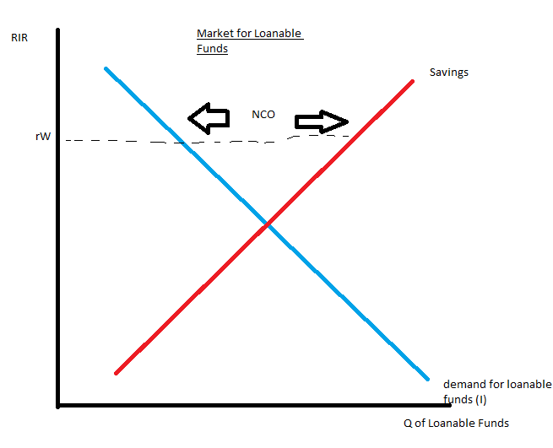
When the government imposes a quota, nothing happens to loanable funds. The only effect is a rise in net exports for any given exchange rate. The demand for dollars in the market for foreign-currency exchange rises. The dollar appreciates from E1 to E2, which reduces net exports, offsetting the direct effect of the import quota on the trade balance.
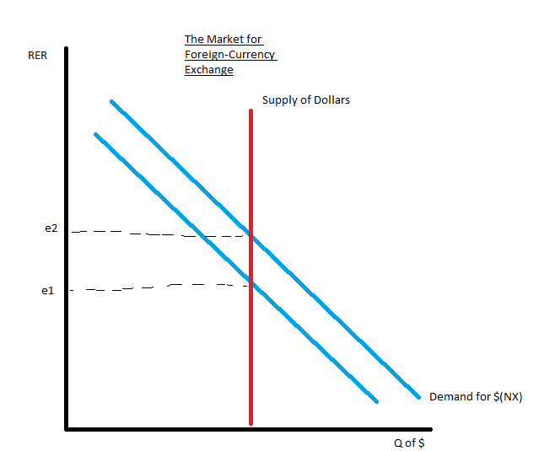
Net exports stay the same while imports fall. This is because when the dollar appreciates in value in the market for foreign-currency exchange, domestic goods are more expensive relative to foreign goods. This means there is more imports and less exports, meaning both of these changes work to offset the direct increase in net exports due to the import quota. In the end an import quota reduces both imports and exports, but net exports is unchanged.
Shouldn’t imports rise?******
Therefore trade policies do not affect the trade balance.
$$NX=NCO=S-I$$
Trade policies don’t alter the trade balance because they don’t affect Savings or investment.
Political Instability and Capital Flight
- Capital Flight: pulling assets out of a country because of political instability.
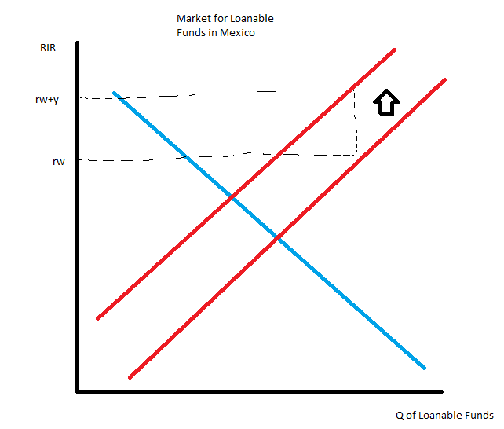
If Mexico is judged to be an unsafe place to keep savings, savers will demand a risk premium. This increases the interest rate by an amount of “y”, this makes the quantity of loanable funds demanded for domestic investment reduces. This increases the NCO of Mexico.
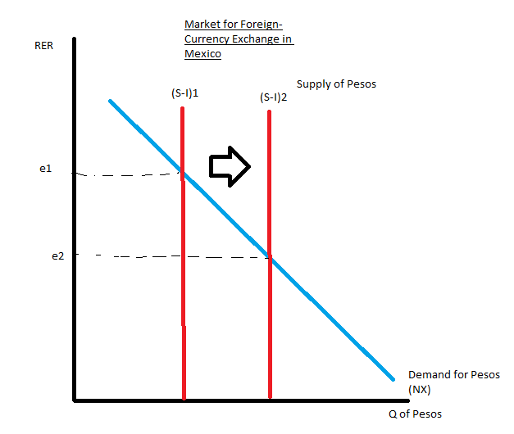
The increase in NCO means the supply of Pesos in the market for foreign-currency exchange increases. This causes the peso to depreciate, so the peso becomes less valuable compared with other currencies.
The capital flight from Mexico increases Mexico interest rates and decreases the value of the Mexican peso in the market for foreign-currency exchange.

Chapter 14- Aggregate Demand and Aggregate Supply
- Recession: falling incomes, rising unemployment.
- A depression is more severe.
- Most economists use aggregate demand and aggregate supply to model short-run fluctuations in the economy.
Economic Fluctuations are irregular and Unpredictable
- Fluctuations are called the business cycle.
- When Real GDP grows, business is good.
Most Macroeconomic Quantities Fluctuate Together
- Real GDP is used to monitor changes in the economy. It measures the value of all final goods and services produced within a given period of time. Also measures the total income (adjusted for inflation) for everyone in the economy.
- Macroeconomic variables fluctuate together. In a recession, everything lowers, unemployment rises.
- Declines in investment account for a large portion of the decline in GDP. Much of the decline is attributable to reductions in spending.
As Output Falls, Unemployment Rises
- When firms choose to produce less goods, they lay off workers. Real GDP lowers, Unemployment rises.
Explaining Short- Run Economics Fluctuations
The Assumptions of Classical Economics
- Changes in the money supply affect nominal variables not real variables
- Classical Economic World
The Reality of Short-Run Fluctuations
- Most economists believe that classical theory describes the world in the long run not in the short run.
- Changes in the money supply don’t affect real GDP, unemployment and other real variables.
- In the short run, when the money supply rises, it takes time for prices to rise so the economy enjoys more employment and production.
The Model of Aggregate Demand and Aggregate Supply
Focuses on two variables:
1) Economy’s output of goods (Real GDP)
2) Overall price level (CPI or GDP Def)
- Output is a real variable, price is nominal.

We analyze fluctuations with the model of aggregate demand and supply
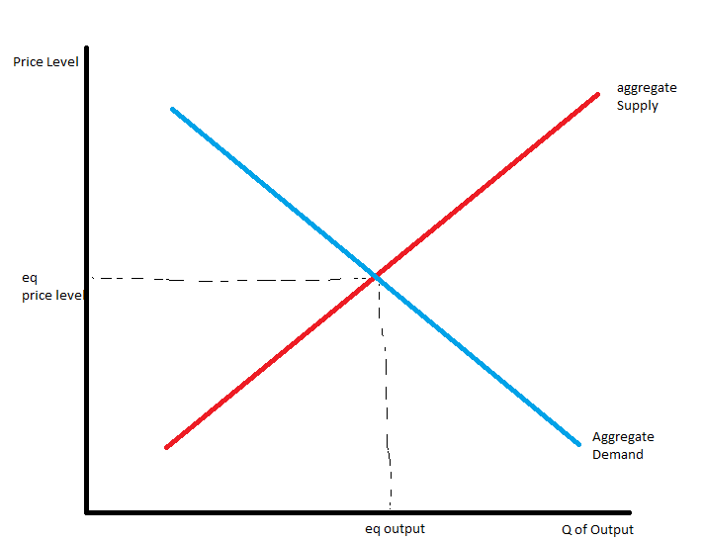
Aggregate demand curve shows the quantity of goods households, firms and the government want to buy at a given price.
Aggregate supply curve shows the quantity that firms produce and sell at a given price.

The Aggregate Demand Curve
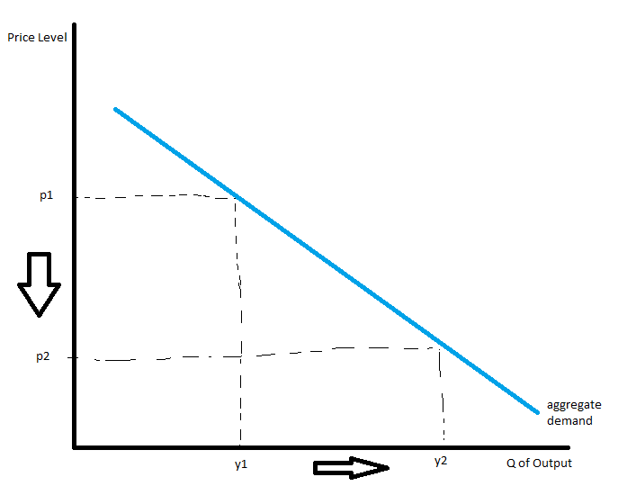
- as price falls, real wealth rises, interest rates fall and the exchange rate depreciates.
Why the aggregate demand curve slopes downward.
$$y=C+I+G+NX$$

Price Level and Consumption: The Wealth Effect
- The nominal value of money is fixed, but the real value isn’t.
- when prices fall, the dollar is more valuable because you can buy more goods. This increase in consumer spending means there is a larger quantity of goods and services demanded.
Price Level and Investment: The Interest Rate Effect
- Price level is the determinant of quantity of money demanded. The lower the price level, the less money households need to hold.
- When price level falls, households try to reduce their holdings of money by lending some of it out. They may buy things like interest-bearing bonds, or deposit it into an interest-bearing savings account, so the bank would use these funds to make more loans.
- When households try to convert some of their money into interest-bearing assets, they drive down the interest rates.
- Interest rates affect spending. Lower interest rates makes borrowing less expensive, so it encourages firms to borrow more to invest. Lower interest rates increase the quantity of goods and services demanded.
The Price Level and Net Exports: The Real Exchange-Rate Effect
$$Real Exchange Rate=\frac{\left(e*P\right)}{P*}$$
$$e=nominal exchange rate between the Canadian dollar and foreign currencies. \\ p=price index for a Canadian basket of goods \\ p*=price index for a foreign basket of goods$$
- Lower price level means a lower real exchange rate. We can buy less foreign objects relative to Canadian, so everyone wants Canadian produced goods and services. This increases net exports, and the quantity of goods and services demanded.
Three Reasons why a Lower Price Level increases quantity demanded of goods and services
- Consumers are wealthier, which increases demand for consumption goods.
- Interest rates fall, which increases the demand for investment goods.
- Exchange rate depreciates, which increases demand for Net exports.
This is when we assume money supply is fixed. When there is a change in money supply, the aggregate-demand curve shifts.

Why the Aggregate-Demand Curve Might Shift
- A fall in the price level raises the overall quantity of goods and services de manded.
Shifts Arising from Changes in Consumption
- Any event that changes how much people want to consume at a given price level will shift the aggregate-demand curve. Example: when the government cuts taxes, people will spend more, the demand curve shifts right. When they raise taxes it shifts left.
Shifts Arising from Changes in Investment
- Any event that changes how much firms want to invest at a given price level shifts the aggregate-demand curve. If a new item is released and firms want it, demand goes up (Shifts right)
- Investment tax credit: a tax rebated tied to a firm’s investment spending (can increase the demand for investment, shift right).
- Money supply can affect the aggregate demand. Increasing the money supply lowers the interest rate, meaning borrowing is less costly which shifts the demand curve to the right. Also the opposite.
Shifts Arising from Changes in Government Purchases
- If governments spend less or more, the aggregate demand curve shifts.
Shifts Arising from Changes in Net Exports
- Any event that changes net exports also shifts aggregate demand. When another country is in a recession and doesn’t import anything from Canada, our net exports is lower and the aggregate demand for the Canadian economy shifts to the left. An appreciation in the real exchange rate shifts the demand curve to the left, depreciation to the right.
The Aggregate-Supply Curve
Tells us the total quantity of goods and services that firms produce and sell at a given price level. In the long run, the aggregate-supply curve is vertical but in the short run it is upward sloping.
Why the Aggregate Supply Curve is Vertical in the Long Run
- In the long run, an economy’s production depends on its supplies of labour, capital and natural resources and technology.
- Price level doesn’t affect long-run determinants of real GDP, so the supply curve is vertical. The inputs to factors of production are the same regardless of what the price level is.
Why the Long-Run Aggregate-Supply Curve Might Shift
- Natural Rate of Output: the normal rate of output, shows the production when the economy gravitates in the long run.
- A change in the natural rate of output shifts the aggregate-supply curve.
Shifts Arising from Changes in Labour
- A greater number of workers means the goods and services supplied would increase (shift to the right). This could be from immigration. If people left, it would shift to the left.
- Depends on the natural rate of unemployment. If minimum wage rose, the natural rate of unemployment would rise and the supply curve would shift to the left. If EI encouraged people to get jobs, natural rate of unemployment would lower and the supply curve would shift to the left.
Shifts Arising from Changes in Capital
- Increasing an economy’s capital stock increases productivity and thereby the quantity of goods and services supplied. Shifts the supply to the right.
Shifts Arising from Changes in Natural Resources
- More natural resources shifts supply to the right, harsher weather conditions to the left.
Shifts Arising from Changes in Technological Knowledge
- A new computer that helps productivity could shift it to the right, a new law preventing pollution would be to the left.
Using Aggregate Demand and Aggregate Supply to Depict Long-Run Growth and Inflation
- Two most important policies that govern the long-run economy are technology and monetary policy.
- New technology shifts the supply curve to the right
- If the Bank of Canada increases the money supply the aggregate- demand curve shifts to the right.
- Graph on p.341

Why the Aggregate-Supply Curve Slopes Upward in the Short Run
In the short run, the price level does affect the economy’s output.
- An increase in the overall level of price increases supply, a decrease in price decreases supply.
Sticky-Wage Theory
- Nominal wages are slow to adjust to changing economic conditions. Nominal wages are based on expected prices, and do not respond immediately when the actual price level turns out to be different than what was expected.
Sticky-Price Theory
- Prices of some goods and services adjust sluggishly in response to changing economic conditions.
- Menu Costs: the cost of printing and distributing catalogues and the time required to change price tags. Firms may temporarily lag behind in reducing or raising costs due to an economic change.
The Misperceptions Theory
Changes in the overall price level can temporarily mislead suppliers about what is happening in the individual markets in which they sell their output. Suppliers respond to changes in the level of prices, and this response leads to an upward-sloping aggregate-supply curve.

$$Quantity of Output Supplied=Natural Rate of Output+a(Actual Price level-Expected Price Level)$$
“a” is a number that determines how much output responds to unexpected changes in the price level.
In the long run, the mathematical statement becomes:
$$Quantity of Output supplied=Natural Level of Output$$

Why the Short-Run Aggregate Supply Curve Might Shift
The important new variable that affects the position of the short-run aggregate-supply curve is the price level that people expected to prevail.
- When people change their expectations of the price level, the short-run aggregate supply curve shifts.
- Example: if workers expect the price level to be high, they are more likely to negotiate high nominal wages. This raises the firm’s costs, and reduces the quantity of goods supplied. Meaning the aggregate-supply curve shifts to the left.
- An increase in the expected price level reduces the quantity of goods and services supplied and shifts the short-run aggregate supply curve to the left. A decrease in the expected price level shifts it to the right.
- Table 14.2 on page 347 helps.
Two Causes of Economic Fluctuations
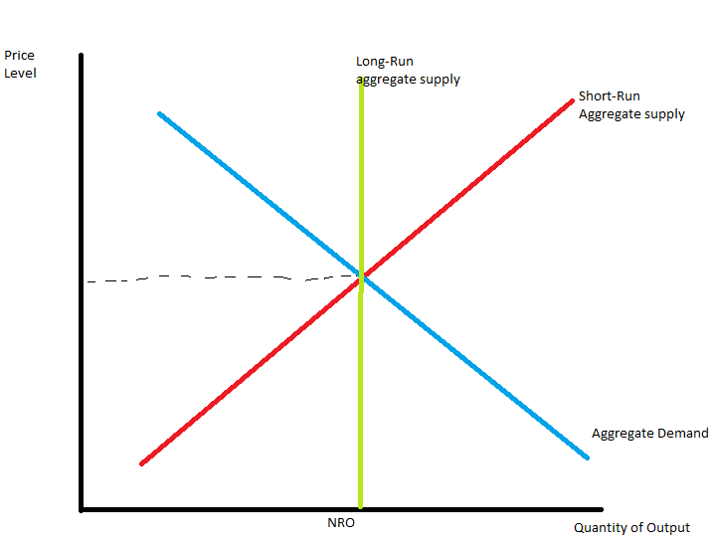
In this equilibrium, wages, prices and perceptions will have adjusted so that the short-run aggregate-supply curve crosses this point as well.
The Effects of a Shift in Aggregate Demand
- Assume a wave of pessimism takes over, people lose confidence in the future. It affects the aggregate demand curve because people don’t want to spend. Since households and firms want to buy a smaller quantity of goods, the aggregate demand reduces. This shifts it to the left.
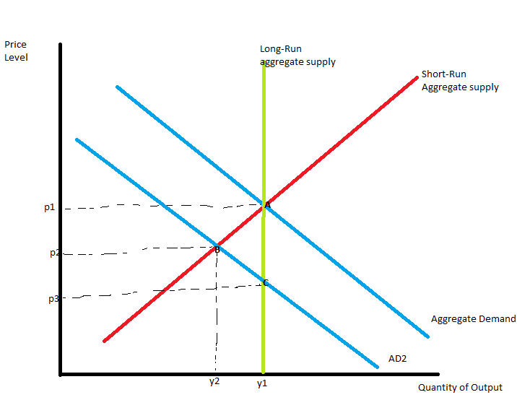
- Output falls from y1 to y2 and the price falls from p1 to p2.
- The falling level of output indicates the economy is in a recession. Firms would respond to lower sales and production by reducing employment.
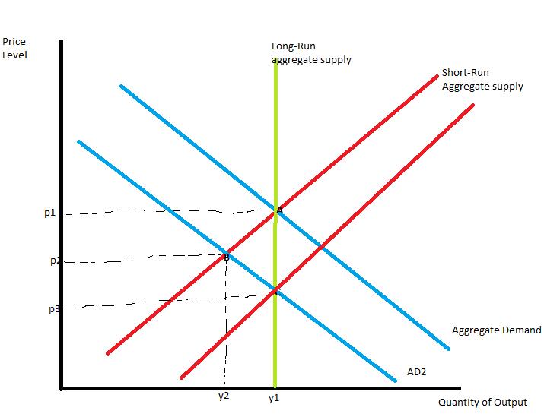
- In the long-run equilibrium, the price level is now lower than people had come to expect. There is a fall in expected price level which alters wages, prices and perceptions which will influence the position of the short-run aggregate supply curve.
- Once workers and firms come to expect a lower level of prices, the firms begin to bargain for lower nominal wages, a reduction in labour costs encourage firms to hire more workers and expands production at any given level of prices. Thus the fall in expected price level shifts the short-run aggregate supply curve to the right, and allows the economy to approach point C where the new aggregate demand curve crosses the long-run aggregate supply curve. Price level has fallen to p3. Thus in the long run, the shift in aggregate demand is reflected in price level.
The Effects of a Shift in Aggregate Supply
- Suppose that suddenly some firms experience an increase in their costs of production. Changes in production cost affect the aggregate-supply curve. Higher costs means less production, supply curve shifts to the left. The output of the economy falls and the price level rises. Because the economy is experiencing stagnation( falling output) and inflation (rising prices), it can be called stagflation.
- According to the sticky-wage theory, firms and workers may respond to the higher level of prices by raising their expectations of the price level and setting higher nominal wages. This means firm’s prices will rise and the aggregate-supply curve will shift farther to the left.
- The level of output and employment will be put downward. Workers will have less bargaining power since unemployment is high and nominal wages will fall, meaning producing goods and services will become more profitable so the aggregate supply curve shifts to the right.
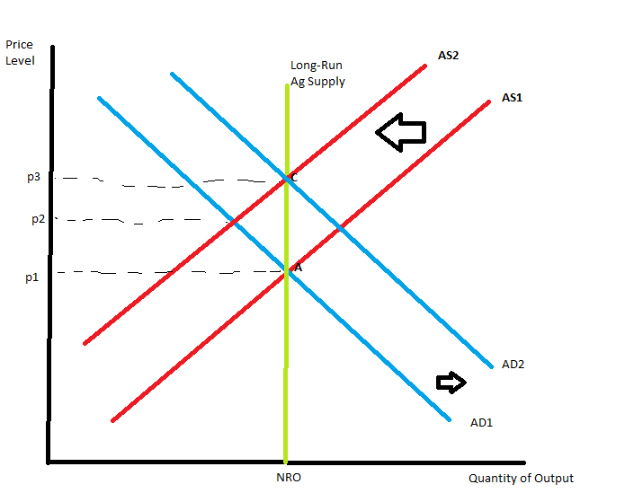
- The transition back to the initial equilibrium assumes that aggregate demand is held constant throughout the process. But this may not be the case in the real world
- In our diagram, changes in policy shift the aggregate-demand curve to the right, to prevent the shift in aggregate supply from affecting output. The economy moves from Point A to point C, Price rises from p1 to p3.
Chapter 15- The Influence of Monetary and Fiscal Policy on Aggregate Demand
How Monetary Policy Influences Aggregate Demand
The aggregate demand curve slopes down because:
- The wealth effect
- The interest-rate effect
- The real exchange-rate effect
In a closed economy, the interest-rate effect is the most important reason for the downward sloping aggregate demand curve.
Theory of Liquidity Preference
Explains what causes short-run economic fluctuations and what policymakers can do about them.
- The interest rate adjusts to balance the supply and demand for money.
- When borrowers and lenders expect prices to rise over the course of a loan, they agree to a nominal interest rate that exceeds the real interest rate by the expected rate of inflation. The higher nominal interest rate compensates for the fact that they expect the loan to be repaid in less valuable dollars.
- We hold constant the expected rate of inflation for the economy in the short run, because it is typically stable over a short period of time. When the nominal interest rate rises or falls, the real interest rate that people expect to earn rises or falls as well.
Money Supply
The bank of Canada can alter the money supply using two methods:
Open-Market Operations:
- Changing the quantity of reserves in the banking system
- When the Bank of Canada buys government bonds, the dollars it pays are deposited in banks and they are added to bank reserves. When the Bank of Canada sells them, the dollars it receives for the bonds are withdrawn from the banking system and the reserves fall.
- The change in reserves leads to changes in the bank’s ability to make loans and create money.
- Bank of Canada buying and selling foreign currencies in the market for foreign-currency exchange.
- If the Bank of Canada sells foreign currency from it’s foreign exchange reserves, it receives Canadian dollars in exchange. Those Canadian dollars are withdrawn from circulation, so the Canadian money supply is reduced.
Changing the Bank Rate:
- Bank rate is the interest rate on loans that the Bank of Canada makes to commercial banks. Commercial banks may borrow from the Bank of Canada if they find that their reserves are inadequate.
- Increasing the bank rate makes loans more expensive and discourages commercial banks from borrowing reserves which in turn reduces the money supply.
- A decrease in the bank rate makes it less expensive for banks to borrow from the Bank of Canada, increasing the quantity of reserves in the banking system, increasing the money supply.
The Bank of Canada’s decision on whether or not to buy and sell dollars in the market for foreign-currency exchange has important implications for the effect of monetary and fiscal policy on aggregate demand.
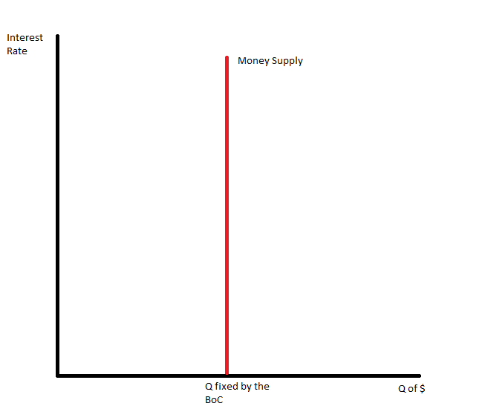
The supply of money in an economy (Canada) is fixed by the central bank (Bank of Canada). The Bank of Canada controls the money supply directly. Because the quantity of money supplied doesn’t depend on the interest rate, the supply curve is vertical.

Money Demand
- Money is the most liquid asset available. People choose to hold money instead of other assets that offer higher rates of return because money can be used to buy goods and services.
- The factors emphasized by the theory of liquidity preference is the interest rate. The interest rate is the opportunity cost of holding money.
- When you hold cash in your wallet instead of in an interest-bearing bond, you lose the interest you could have earned. An increase in the interest rate raises the cost of holding money, reducing the quantity of money demanded.
- A decrease in the interest rate reduces the cost of holding money and raises the quantity demanded.
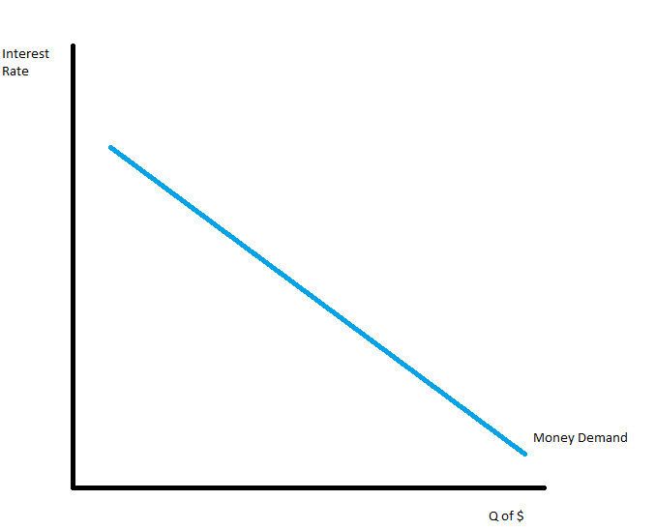
For these reasons, the demand curve is sloping down.

Another key determinant of the quantity of money demanded is the fact that money is used to buy goods and services.
- When either the quantity or the price of goods and services increases, people need to hold more of their assets in the form of money.
- The quantity of goods and services that people buy is real GDP
- The price of goods and services is represented by the CPI or the GDP Deflator
- For any given interest-rate an increase in the dollar value of transactions causes the demand for money to increase (move to the right). A decrease in the dollar value of transactions causes it decrease (move to the left).
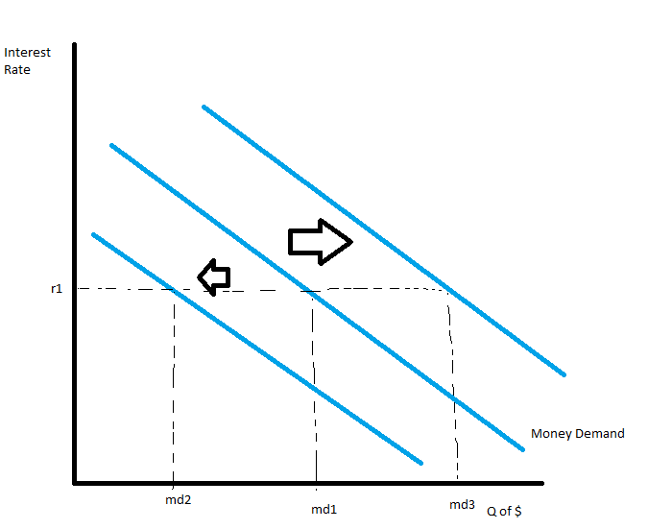

Equilibrium in the Money Market
- Equilibrium interest rate is the quantity of money demanded that exactly balances the quantity of money supplied.
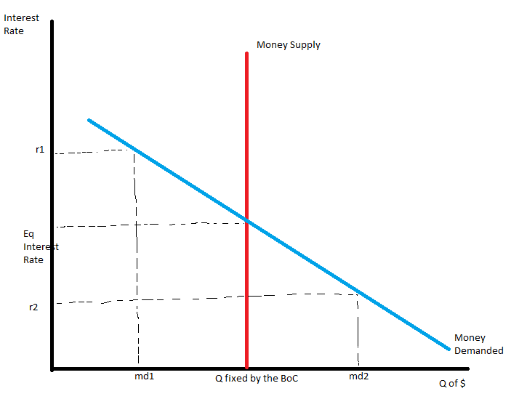
If the interest rate is above the eq level (r1) the quantity of money that people want to hold (md1) is less than the quantity of money the BoC has supplied. The people who are holding the surplus of money will try to get rid of it by buying interest-bearing bonds, or by depositing it in an interest- bearing bank account. Bond issuers and banks want to pay lower interest rates, they respond to this surplus by lowering the interest rates they offer. As the interest rates fall, people want to hold more money until the equilibrium interest rate is reached.
If the interest rate is below the equilibrium level (r2) the quantity of money people want to hold (md2) is greater than the quantity of money that the BoC has supplied. People try to increase their holdings of money by reducing their holdings of bonds and other interest-bearing assets. When people cut back the issuers have to offer higher interest rates to attract buyers, so the interest rate reaches equilibrium level

The Downward Slope of the Aggregate Demand Curve
- With a fixed money supply, the interest rate must rise to balance money supply and money demand. The higher price level has increased the amount of money people want to hold and has shifted the money demand curve to the right. However the quantity of money supplied is unchanged so the interest rate must rise to discourage the additional demand.
The analysis of the Interest-rate effect can be analysed in three steps:
- The higher price level raises money demand
- Higher money demand leads to a higher-interest rate
- A higher interest rate reduces the quantity of goods and services demanded.
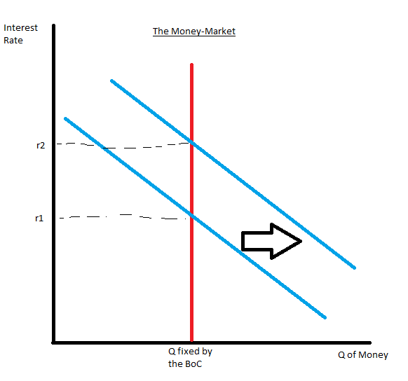
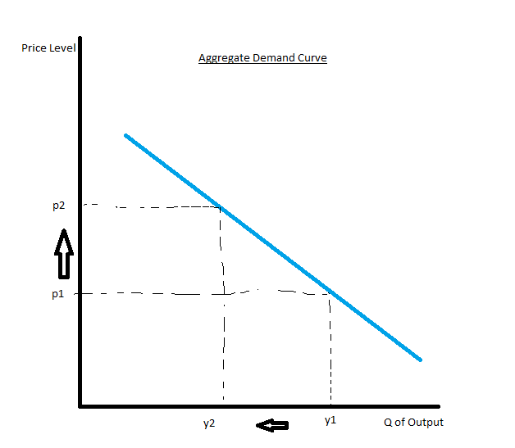
There is a negative relationship between the price level and the quantity of goods and services demanded.
- Another important influence in an open economy is the real exchange-rate effect. An increase in the price level causes the real exchange rate to increase, and net exports fall. In a small open economy, an increase in the price level causes the quantity of Canadian-produced goods and services demanded to fall.
Changes in the Money Supply
- how the economy responds to changes in the quantity of goods and services demanded depends on whether or not the economy is closed or open.
- when the money supply is increased (shifts to the right), the interest rate must fall to induce people to hold the additional money the BoC created. This lower interest rate increases the quantity of goods and services demanded at any given price, so the aggregate demand curve shifts to the right because people are consuming more.
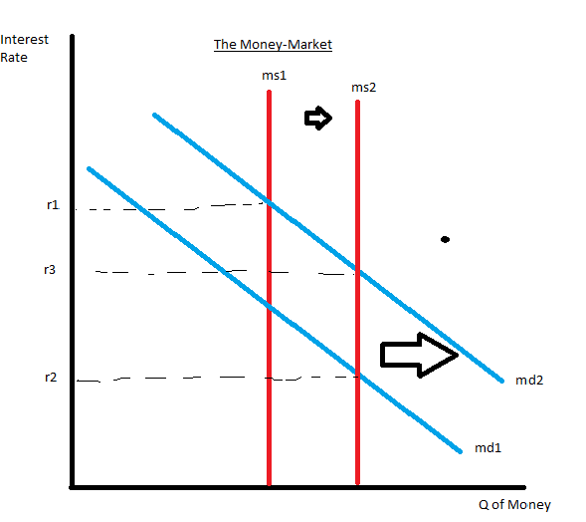
Interest rate falls from r1 to r2 to balance money supply and demand, since the interest rate lowers money demand increases to make the equilibrium at r3.
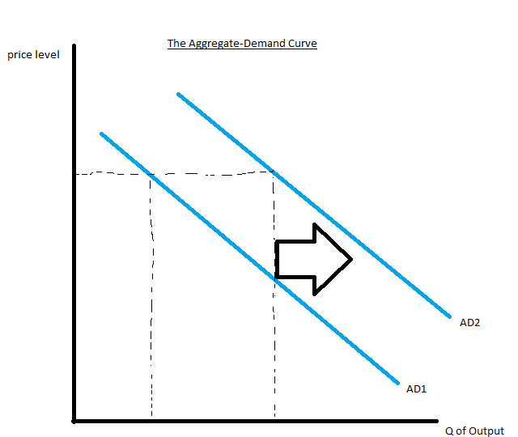
The lowering of the interest rate means an increase in quantity of goods and services demanded at the given price level.
Open-Economy Considerations
We know that in a small open economy with perfect capital mobility, our interest rate moves up and down with the world’s. It only differs in the tax treatment of financial capital and differences in default risk in Canada versus other countries.
- Everything happens the same as a closed economy, except the MD Curve and AD Curve will shift a second time to the right to bring the Interest rate back up to the World Interest rate. (Graphs page 376)
- This is because when the interest rate falls below the world interest rate, Canadian and foreign savers don’t want Canadian assets because they pay less than the world interest rate. So they sell Canadian assets and buy foreign assets. People want to be paid in their own currency, so there is a sale of Canadian dollars to purchase foreign currencies. In the market for foreign currencies, this causes the Canadian dollar to depreciate in vakue and real exchange rate to fall. This increases Net exports and increases the AD curve (shifts to the right) because people want more goods and services at a certain price level. The increase in output shifts Money Demanded to the right one more time, increasing the interest rate to meet the world interest rate.
- In this we assume the BoC allows the exchange rate to change.

How Fiscal policy Influences Aggregate Demand
Changes in Government Purchases
How much does a $5 billion government expenditure shift the aggregate-demand curve?
The Multiplier Effect suggests that the shift could be larger than $5 billion.
The Crowding-Out Effect suggests that the shift could be smaller than $5 billion.
The Multiplier Effect
- If the government spends $5 billion on construction work, for a given price level the immediate impact of the higher demand from raising employments and profits and construction firms isn’t the only impact on demand. It is also the workers seeing higher earnings and firms owners seeing higher profits, therefore increasing their consuming. He firms that produce these consumer goods hire more people and experience higher profits, which stimulate consumer spending again and so on. The total impact on the quantity of goods and services demanded can be much larger than the initial impulse from the higher government spending.
- Because each dollar spent by the government can raise the aggregate demand for goods and services by more than a dollar, it is called the multiplier effect.
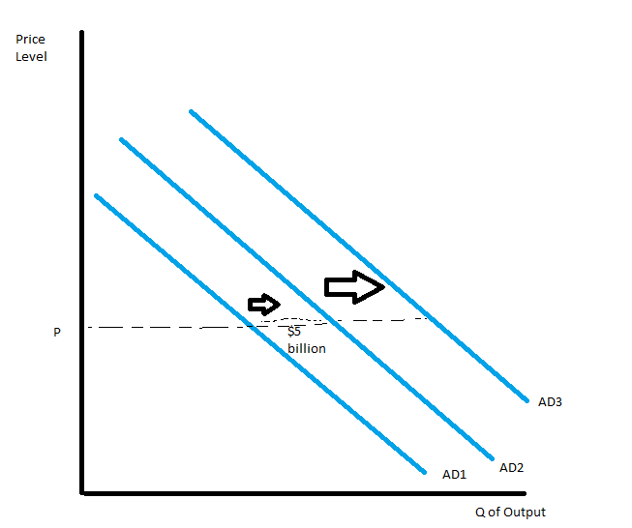

A Formula for the Spending Multiplier
- Marginal propensity to Consume (MPC): the fraction of extra income that a household consumes rather than saves.
- if mpc is $\frac{3}{4}$, this means that for every extra dollar a household earns, it spend $0.75 and spends $0.25.
- the first impact on the aggregate demand is the initial $5 billion. The second is the $MPC*\$5 billion$. The third is $MPC*(MPC*\$5Billion)$ and so on.
The total impact:
$$Change in Government Purchases=\$5billion \\ First Change in Consumption=MPC*\$5Billion \\ Second Change in Consumption=MPC^{2}*\$5Billion \\ And so on…. \\ Total Change in Demand=\left(1+MPC+MPC^{2}+MPC^{3}+….\right)*\$5billion$$So the multiplier is:
$$Multiplier=1+MPC+MPC^{2}+MPC^{3}….$$
This tells us the demand for goods and services that each dollar of government purchases generates.
To simplify: $x=MPC$
$$Multiplier=\frac{1}{1-MPC}$$
The multiplier tells us the demand for Canadian Produced goods and services. If there was a fraction that a household spent on imported goods, it would be the Marginal Propensity to Import (MPI).
$$Multiplier=\frac{1}{1-MPC-MPI}$$
The multiplier is much smaller in an open economy than a closed.

Other Applications of the Multiplier Effect
Page 384
The Crowding-Out Effect on Investment
An increase in government purchases also causes the interest rate to rise, which reduces investment spending and chokes off aggregate demand. Called the crowding-out effect on investment.
- With the multiplier effect, incomes and spending of firms and households increase, which means they will hold more of their wealth in liquid form. So an increase in income caused by the fiscal expansion will raise the demand for money. The money supply stays the same because the BoC didn’t change it, but the money demand shifts to the right. The interest rate must rise to keep the supply and demand in balance.
- The increase in interest rate reduces the q of goods and services demanded because borrowing is more expensive. So an increase in government purchases increases the demand for goods and services but may crowd out investment. This partially offsets the impact of the government purchases and the crowding out shifts the AD curve back to the left a bit. (Graph on page 385)
Open-Economy Considerations
Canada’s interest rate must equal the world’s interest rate.
- The multiplier effect shifts the Money Demand curve to the right which increases the demand for money, and the interest rate rises. By increasing the cost of borrowing, the higher interest rates reduces the demand for investment, and the q of goods and services demanded at the given price level falls.
- This is exactly what happens in a closed economy, but the interest rate would still be above the world interest rate.
Flexible Exchange Rate
- Since the interest rate is higher, Canadian and foreign saveers will find Canadian assets more attractive than the ones that pay the world interest rates. They sell foreign assets and buy Canadian assets. The demand for Canadian currency increases, appreciating the real exchange rate so Canadian exports decrease. This is called the crowding-out effect on net exports.
- Lower net exports means the quantity of Canadian produced goods and services demanded at a certain price decreases, meaning there is a fall in the demand for money. This causes the Canadian interest rate to fall back to the world interest rate. (FOLLOW THE GRAPHS ON PAGE 387)
Fixed Exchange Rate
- The bank of Canada can choose to prevent changes in the value of the exchange rate. They can influence the value of the exchange rate by buying and selling foreign currencies. It does this by buying Canadian dollars and selling foreign currencies.
- Instead of letting the higher interest rate crowd out business, the BoC can buy foreign currencies, increasing the money supply and set the interest rate back to the world’s interest rate by themselves (Page 389). This eliminates the crowding- out effect of government expenditures on net exports.
- If the Bank of Canada chooses to prevent any change in the exchange rate, expansionary fiscal policy will have no-crowding out effects and will therefore cause a very large increase in the demand for goods and services.
Changes in Taxes
When the government cuts taxes and stimulates consumer spending, earnings and profits rise which further stimulates consumer spending. This is the multiplier effect.
Higher income leads to higher money demand which raises interest rates, making borrowing more costly which reduces investment spending. This is the crowding-out effect.
The shift in aggregate demand could be larger or smaller than the tax change that causes it.
In a small open economy, whether or not the change in position lasts depends on the Bank of Canada’s decision of whether or not to let the Real Exchange Rate change.
Deficit Reduction
- Some government’s rely on tax increase, some reduce expenditures.
- Some believe these methods shouldn’t be used because they reduce aggregate demand, but if the Bank of Canada lets the Real exchange rate be free, they should return to the original aggregate demand.
Using Policy to Stabilize the Economy
Should policymakers use these tools to stabilize and control aggregate demand?
The Case for Active Stabilization Policy
- Unexpected expansions and contractions in the economy impose costs on people and firms as unemployment, inflation and uncertainty.
- Keynes thought the government should stimulate aggregate demand when it was insufficient to maintain production at full-employment.

The Case Against Active Stabilization Policy
- People believe monetary and fiscal policy should only be used for long-term goals
- Policies affect the economy with a long lag.
- Monetary
Automatic Stabilizers: Changes in fiscal policy that stimulate aggregate demand without policymakers having to take any deliberate action when the economy goes into a recession.
- Most important is the tax system
- When the economy is in a recession, tax revenue falls.
- Tax cut will stimulate aggregate demand and reduce the magnitude of economic fluctuations.
- Employment insurance, social assistance and a tax system
A Flexible Exchange Rate as an Automatic Stabilizer
- If the Bank of Canada lets the Exchange rate be flexible
- A fall in net exports makes incomes fall, reducing money demanded. Interest rate will fall below the world interest rate. Canadian and foreigners sell Canadian assets in favour of foreign assets, increasing the supply of Canadian dollars making the exchange rate lower, net exports higher, and moving the aggregate demand curve to the right.
- But flexible exchange rate can damage a firm hoping to produce goods for export if its unsure how much Canadian dollars it will get. People believe we should adopt the USD to avoid this uncertainty.


