Lecture 8 – Introduction to Endocrine Diseases
- Principal (major) endocrine glands
  - Hypothalamus brain
  - Pituitary gland brain, under hypothalamus
  - Thyroid and parathyroid glands esophagus, thyroid is anterior
  - Adrenal glands atop kidneys
  - Pancreas stomach
  - Ovaries end of fallopian tubes
  - Testes testicles
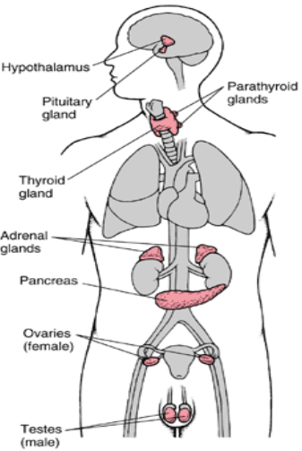
- Releasing hormones stimulate the release of hormones, have no inherent effects
  - Growth hormone-releasing hormone (GHRH)
    - GH also known as somatotropin
  - Thyrotrophin-releasing hormone (TRH)
  - Corticotrophin-releasing hormone (CRH)
  - Gonadotrophin-releasing hormone (GnRH)
- Inhibiting hormones inhibit the release of hormones, have no inherent effects
  - Somatostatin (SS)
  - Dopamine Prolactin-inhibiting factor
- Anterior pituitary hormones
  - Growth hormone (GH)
  - Thyroid-stimulating hormone (TSH)
  - Adreno-corticotrophic hormone (ACTH)
  - Luteinizing hormone (LH)
  - Follicle-stimulating hormone (FSH)
  - Prolactin (PRL/PROL)
- Posterior pituitary hormones
  - Antidiuretic hormone aka vasopressin (ADH)
  - Oxytocin
- Thyroid hormone precursors
  - Thyroxine (T4)
  - Triiodothyronine (T3)
  - Calcitonin
- Adrenal gland hormones
  - Cortex (outer)
    - Mineralcorticoids Aldosterone
    - Glucocorticoids Cortisol
    - Androgens DHEA, andro, DHT
  - Medulla (inner)
    - Catecholeamines
    - Epinephrine and norepinephrine
- Pancreatic hormones
  - α cells Glucagon
  - β cells Insulin
  - δ cells Somatostatin
- Parathyroid gland Parathyroid hormone (PTH)
- Hormones are biochemical regulators and have differential effect ranges
  - Endocrine secreted into blood vessels and carried to distant target cells
    - Ex. ACTH secreted into blood and acts on adrenal glands
  - Paracrine (para: beside, by) secreted locally to act on nearby cells
    - Ex. Glucagon acts on pancreatic β cells to inhibit insulin secretion
  - Autocrine (auto: self) secreted locally to act on the cell that secreted it
    - Ex. 1,25(OH)₂VitD secreted from prostate & pancreas acts on itself
  - Neuroendocrine/transmitter (neural: neurons) secreted from neural axon terminals
    - Ex. Epinephrine & dopamine
- The endocrine system is controlled by feedback loops and receptor regulation
  - The majority of feedback loops are negative

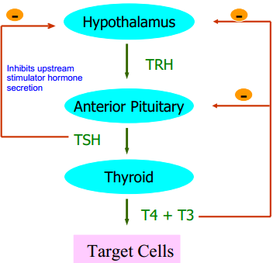
  - Ex. TRH acts on the anterior pituitary to stimulate TSH release TSH inhibits TRH secretion from the hypothalamus. Similarly, TSH stimulates T4 and T3 release from the thyroid gland T4/T3 inhibits both the anterior pituitary and hypothalamus
- Receptor regulation the interactions of hormones with their receptors is reversible and specific
  - H + R ↔ HR… allows termination of signalling
  - Hormone receptors can be downregulated and are limited to expression on particular tissues
  - Cell surface receptors have intracellular signalling pathways
    - Usually used by protein & peptide hormones due to their large size
    - Rapid response
  - Intracellular (cytosolic & nuclear) receptors act as transcription factors
    - Steroid hormones like T4 and 1,25(OH)₂VitD can diffuse through cell membranes
    - Slower response
- Hypothalamo-pituitary regulatory system
  - Hormones are often synthesized in the hypothalamus then travel to the pituitary glands via hypophyseal artery to the portal veins
    - Ex. ADH & oxytocin
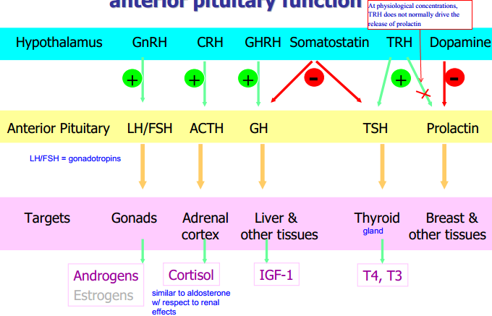
- Hormone concentration in blood varies episodic, stress, circadian
  - A single blood hormone measurement has no clinical value
- Dynamic (provocative) tests are used instead assess blood hormone concentration after stimulation or inhibition
  - Demonstrate normal or abnormal hormonal response
  - Ex. Dexamethasone suppression (Cushing’s), Synacthen (synthetic ACTH, Addison’s) test, OGTT (Diabetes, acromegaly)
- Acromegaly increased GH secretion in adults
  - Most probable cause is pituitary adenoma inducing high GH secretion
  - Clinical features coarse facial features, spade-like hands, prognathism, impaired glucose tolerance/diabetes
- Growth hormone (somatotrophin)
  - Reduced glucose transport & metabolism can be through reduction in liver insulin receptor expression
    - Counter regulatory hormone to insulin
  - Increased lipolysis increases FFA substrate to provide energy for muscles
  - Increased amino acid transport into muscle, liver, adipose tissue
  - Increased protein synthesis increases transcription and translation of proteins in the liver
  - Increased IGF-1 production indirectly promotes growth via IGF secretion in both, soft tissue, gonads
- Regulation of GH secretion
  - GH secretion is stimulated by GHRH and inhibited by SS
  - Also varies with sleep, amino acid content, exercise, and stress
  - High levels of glucose suppress GH secretion whereas low levels of glucose increase it
  - GH (like most endocrine hormones) also suppresses its own release
- GH levels are measured by immunoassay
  - Dynamic testing since GH levels vary
    - Insulin-induced hypoglycemia test for GH deficiency By introducing insulin it should cause a decrease in glucose… response is to increase GH levels (low glucose)… lack of GH stimulation indicates GH deficiency
      - Hypoglycemia induces a stress response
    - Glucose tolerance test for acromegaly Glucose should cause a reduction in GH levels... lack of GH suppression indicates acromegaly
  - IGF-1 (somatomedin C) synthesis depends on GH and is predominantly in the liver as an endocrine hormone
    - Useful marker for GH status
- Treatment of acromegaly surgery, medical, radiotherapy
  - Effective drugs
    - Somatostatin analogue increase GH suppression (octreotide)
    - Dopamine analogue can lower GH and IGF-1??
      - GH-secreting adenomas can express dopamine receptors and become inhibited by binding of dopamine to this receptor (?)
    - Growth hormone antagonist block effects of GH on body
- Treatment of GH deficiency GH supplementation
Lecture 9 – Thyroid diseases
- Goiter enlarged thyroid gland
  - Is not necessarily associated with increased thyroid function
  - Can be caused by high iodine environment
- Thyroid gland and thyroid hormone
  - Thyroid gland secretes mostly T₄ then peripheral tissues (liver and kidney) deiodinate T₄ to generate 2/3 of circulating T₃
    - Only the thyroid gland uptakes iodine
  - Thyroid hormones bind to their receptor T₃ has higher biological activity than T₄ but is at a lower concentration
  - Reverse T₃ (RT₃) is an inactive form of T₃ metabolised from T₄ local thyroid status can be modulated by balancing production of T₃and RT₃
  - Thyroid hormones are essential for normal maturation and metabolism of all tissues
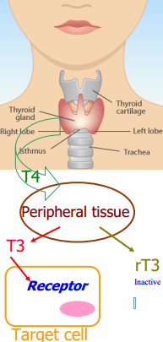
- Thyroxine and triiodothyronine are both generated initially from tyrosine
  - Tyr addition of two iodine to generate 3,5-diiodotyrosine (DIT or T₂)
  - Two DIT molecules can be coupled generates T₄ (T₂+T₂)
  - T₄ can be deiodinated at the 5’ position to generate T₃
  - OR T4 can also be deiodinated at the 5 position to generate rT₃
  - Don’t know what dehydroalanine (DHA) is for??
- As mentioned in lecture 8, there is feedback from thyroid hormones and derivatives on the tissue secretors
  - Short-loop feedback one step? TSH inhibits its own release from the hypothalamus
  - Long-loop feedback T4 and T3 inhibit secretion of TSH and TRH from the anterior pituitary and hypothalamus, respectively
- T₄ can exist in a bound and free form
  - T₄-binding globulin (TBG) can bind T₄ as well as albumin
  - Only a small fraction of T₄ is unbound and can therefore exert biological activity
  - Alterations in the concentration and/or affinity of binding proteins may
  - There is approximately 10 times more free T₃ than T₄
- Changes in TBG affects total levels but not necessarily free
  - Estrogen/oral contraceptive increases TBG increases the total bound hormone… more T4/T3 is synthesized which keeps free levels constant, but increases total levels
  - Androgens/glucocorticoids decreases TBG decreases total bound hormone.. less T4/T3 synthesis to keep free levels constant
  - Salicylates inhibit binding of T₄ and T₃ to TBG decreases ability to bind to TBG so more free levels… in response the production decreases and subsequently free levels decrease
- Hypothyroidism symptoms mostly hypometabolic
  - Weight gain
  - Easily fatigued less metabolism
  - Myxedema dry & waxy swelling of skin due to abnormal deposits of glucosaminoglycans (unbranched polysaccharides)
  - High cholesterol less LDL receptors which decrease LDL clearance
  - Bradycardia less thyroid hormone to promote heartbeat and metabolism
  - Constipation reduced intestinal movements
  - Polymenorrhia
- Causes of hypothyroidism
  - Primary
    - Hashimoto’s disease autoantibodies produced which destroys thyroid gland
    - Radioiodine or surgical treatment of hyperthyroidism maybe incorrect dx, so now it causes hypothyroidism
    - Congenital defects in biosynthesis and action
    - Transient hypothyroidism due to antithyroid drugs
  - Secondary pituitary diseases that result in reduced TSH production
  - Tertiary hypothalamic diseases which reduce production of TRH
- Diagnostic strategy for suspected hypothyroidism first check TSH and fT₄ levels
  - High/normal TSH with high fT₄ not hypothyroid
  - High TSH with low fT₄ primary hypothyroidism because anterior pituitary response is correct
  - High TSH with normal fT₄ “subclinical” hypothyroidism… the high TSH suggests that the normal TSH level is insufficient to keep fT₄ levels constant
    - Patients may regress to normal or progress to clinical hypothyroidism
  - Low TSH with low fT₄ secondary hypothyroidism as the low TSH is causing low total T₄ and fT₄
- Complications of hypothyroidism vary with age
  - Pregnancy irreversible fetal malformation, growth retardation, and neurological deficits
  - Infancy & early childhood decreased linear growth, inadequate brain maturation, low IQ and psychomotor development, cretinism
  - Adult myxedema coma from longstanding severe hypothyroidism + precipitating factor (infection, MI, sedation)
    - Presents with severe hypothermia and loss of consciousness
- Cretinism aka congenital hypothyroidism (that has been left untreated)
  - May occur due to the absence of the thyroid gland (primary) or (secondary) to defect of thyroid hormone synthesis
  - Cretinism causes mental retardation, short stature, deafness
  - Can be treated if diagnosed and treated with thyroid hormone (T₄ and T₃ itself because of primary hypothyroidism, cannot give TSH or TRH)
  - TSH screening test included in the newborn screening program
  - Other symptoms periorbital edema, flattened bridge of nose, large & protruding tongue, hoarse cry, somnolence (drowsy/sleepiness)… although the majority do not present
- Treatment of primary hypothyroidism primarily through replacement therapy of synthetic T₄ and T₃
  - Need to monitor for 4 to 8 weeks after therapy since there is pituitary lag serum TSH values do not immediately reach a new steady state
    - Need to measure other markers (TSH, TRH) since you are giving synthetic T₄ and T₃
- Hypermetabolic syndrome symptoms
  - Causes low cholesterol from high LDL production
  - Glucose intolerance because insulin is cleared quickly
  - Tachycardia from excess thyroid hormone promoting heart beat
  - Muscle tremors
  - Fatigue
  - Heat intolerance
  - Weight loss
  - Goiter
  - Diarrhea
  - Oligomenorrhea
- Causes of hyperthyroidism
  - Graves’ disease (diffuse toxic hyperplasia)
  - Plummer’s disease (toxic multinodular goiter)
  - Hyperfunctioning thyroid carcinoma
  - Thyroiditis
  - TSH secreting pituitary tumour (secondary hyperthyroidism)
  - HCG secreting trophoblastic tumor
    - HCG and TSH share an α unit (β unit is unique) so HCG can bind and stimulate the TSH receptor leading to thyroid hormone production
  - Iodine or iodine-containing drugs increased substrate automatically leads to increased
  - Excessive T₄ and T₃ ingestion through drugs
- Graves’ diseases most common cause of hyperthyroidism
  - Autoantibodies to TSH receptor bind and induce TSH action
  - Pituitary TSH secretion inhibited by high circulating T₄ and T₃
  - TSH is low since anterior pituitary response is to reduce secretion
  - fT₄ is high due to stimulation of TSH receptors (on liver and kidney)
  - Diagnosis anti-TSH receptor antibodies, radionuclide uptake & scan
  - Treatment antithyroid drugs (block iodide uptake, inhibit T4 synthesis and T4 to T3 conversion), radioiodine (Na¹³¹I uptake by thyroid which destroys it), surgery
  - Monitor recurrence or developing hypothyroidism
- Diagnostic strategy for suspected hyperthyroidism
  - Normal thyrotoxicosis ruled out
  - TSH normal or increased, fT₄ increased TSH-secreting pituitary adenoma or thyroid hormone resistance syndrome
  - TSH decreased , fT₄ normal fT₃
    - Normal fT₃ subclinical thyrotoxicosis
    - High fT₃ T₃ toxicosis primary hyperthyoridism
  - TSH low, fT₄ high primary hyperthyroidism
- TRH stimulation test secondary/tertiary hypothyroidism
  - Give TRH if TSH and T4/T3 goes up, diagnose tertiary
  - If TSH does not change, secondary hypothyroidism
Lecture 10 – Adrenal Diseases
- Adrenal glands sit atop the kidney
- Adrenal glands can be further divided
  - Cortex
    - Zona glomerulosa (outer) aldosterone
    - Zona fasciculata and reticularis (inner) cortisol, androgens, estrogens
  - Medulla (part of sympathetic nervous system) epinephrine, norepinephrine, dopamine
- Biosynthesis of steroid hormones
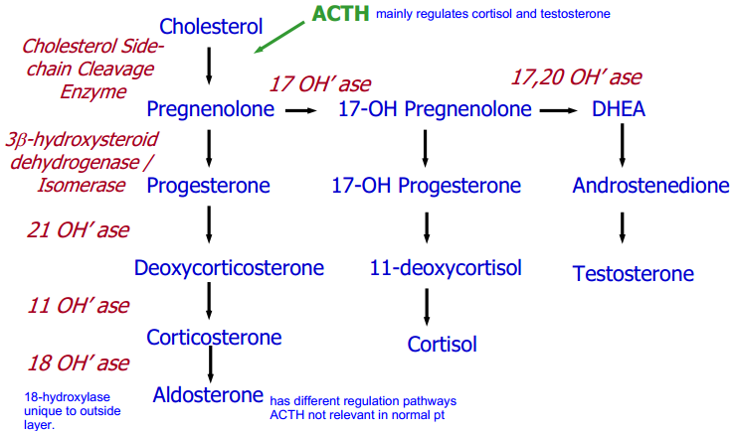
- Cholesterol (liver) + ACTH + cholesterol side-chain cleavage enzyme Pregnenolone
- Pregnenolone + 17 OH’ase 17-OH pregnenolone + 17,20 OH’ase DHEA
- If add 3β-hydroxysteroid dehydrogenase/isomerase generate
  - Pregnenolone progesterone
    - Progesterone + 21 OH’ase deoxycorticosterone
    - Deoxycorticosterone + 11 OH’ase corticosterone
    - Corticosterone + 18 OH’ase aldosterone
  - 17-OH pregnenolone 17-OH progesterone
    - 17-OH progesterone + 21
  - DHEA androstenedione
  - Ok not going to bother writing rest, look @ diagram
Lecture 10 – Adrenal Diseases
- Cortisol physiology
  - Effects on metabolism
    - Carbohydrate promotion of gluconeogenesis in liver
    - Protein increase of muscle proteolysis
    - Fat activation of lipolysis and release of FFAs
  - Excess glucocorticoids causes central distribution of fat on face, neck, trunk
  - Circulating forms 90 – 98% cortisol is bound to cortisol-binding protein (CBG) and albumin (minor)
    - CBG increased in pregnancy and estrogen treatment
  - Cortisol is cleared through liver conjugation and excretion
- Stress and sleep/wake cycle stimulation: hypothalamus
  - Hypothalamus CRH; acts on anterior pituitary
  - Anterior pituitary ACTH; acts on adrenal cortex
  - Adrenal cortex cortisol; acts on target cells
    - Only cortisol forms a negative feedback loop with the hypothalamus and anterior pituitary known as the hypothalamic-pituitary-adrenocortical (HPA) axis
- Cushing’s syndrome prolonged excessive exposure of body tissue to cortisol or other glucocorticoids
  - Causes
    - Pituitary ACTH-producing tumor Cushing’s disease
    - Ectopic ACTH ACTH produced by cells other than pituitary
      - Ex. Small cell carcinoma in lung can secrete ACTH, stimulating cortisol axis
    - Adrenal cortisol-producing tumor (adenoma or carcinoma)
    - Exogenous glucocorticoids (taken orally, inhaled, or applied topically)
- Clinical features of Cushing’s syndrome
  - Baldness
  - Bufalo hump
  - Increased abdominal fat
  - Osteoporosis
  - Abdominal striae fat accumulation under skin stretches it, exposing blood vessels
  - Muscle weakness from proteolysis
- Diagnosis of Cushing’s syndrome
  - Screening test 24 hrs urinary free cortisol
    - Excess cortisol which is not bound by CBG (exceeds its capacity) is excreted in the urine elevated in Cushing’s but confounded by obesity and stress. Need to further confirm
  - Plasma cortisol measured at 8 am and 22 pm
    - Normal ACTH circadian rhythm (high peak in morning) is not apparent in Cushing’s
  - Low dose (1 mg) dexamethasone (cortisol analogue) test suppresses cortisol production in normal subject (>50% reduction from baseline) but not in Cushing’s
  - High dose (4mg) dexamethasone test suppresses cortisol production in Cushing’s (50% reduction from baseline) but not if caused by adrenal adenoma or carcinoma, ectopic production of ACTH
  - Plasma ACTH low in adrenal tumours (since anterior pituitary resp. is normal) but very high in ectopic ACTH secreting tumors
- Case ex. of Cushing’s
  - Clinical presentation glucose intolerance (cortisol promotes gluconeogenesis), abdominal striae (accumulation of fat stretches skin), wasting of muscles (increased proteolysis)
  - Screening plasma cortisol measured at 8 am and 22 pm but remained the same
  - Confirmation
    - Low dose Dex no reduction in cortisol production, therefore confirms Cushing’s
  - DDx of cause
    - High dose Dex test no reduction in cortisol production (if reduction, dx is Cushing’s disease from pituitary ACTH-producing tumor)
      - Suggests Cushing’s is from adrenal adenoma/carcinoma or ectopic production of ACTH
    - Plasma ACTH very elevated, suggest ectopic ACTH secreting tumor
- Aldosterone physiology produced by zona glomerulosa which has 18-hydroxylase and 18-hydroxysteroid dehydrogenase
  - Regulated through RAS system as well as ACTH and K+
  - Biological effects Na, H₂O retention coupled with K+ and H+ secretion
    - Activates Na/K channels... pumps Na into the blood from the cell and K into the cell creates gradient so Na goes from tubule lumen into cell (reabsorption)
    - H+ secreted through Na/H+ exchanger which brings Na into the tubular cell in exchange for H+ secreted into the lumen
    - One of the main functions of aldosterone is to raise BP (since part of RAS) reabsorbing water increases blood volume which increases pressure
    - Stimulates secretion of K+ into the tubular lumen
  - Cushing’s syndrome therefore promotes hypertension as all cortisol precursors (21-hydroxylated steroids) have aldosterone-like effects to varying degrees
- Renin-angiotensin-aldosterone system
  - Renin is released from the kidney (JG cells) in response to
    - Low tubular Na+
    - Low renal arteriolar BP
    - Sympathetic stimulation
    - Increased K+
    - At physiological concentrations, ACTH does not contribute to renin secreton
- Aldosterone excess
  - Hypertension from excess H₂O reabsorption (??)
  - Neuromuscular abnormalities weakness, paresthesia, tetany
    - Caused by K+ depletion due to high K+ secretion into lumen, K+ required for muscular repolarization
  - Polyuria caused by ADH resistance so lose water in urine
    - This causes polydipsia
  - Hypokalemia causes renal tubule ADH resistance nephrotic diabetes insipidus
    - NOT NORMAL DIABETES
    - Central diabetes insipidus cannot produce ADH
  - Conn’s syndrome low-renin hyperaldosteronism, primary due to adrenal tumors
    - Excess aldosterone even when low renin… suggests primary cause of adrenal zona glomerulosa secreting too much aldosterone
  - Secondary hyperaldosteronism caused by high renin associated with renal, heart, or liver disease. Ex. renal artery stenosis, reduces renal blood pressure triggering high renin secretion
- Main difference between primary and secondary hyperaldosteronism is in renin secretion in primary, renin secretion is low because an adrenal adenoma is making large amounts of aldosterone
  - In secondary, renin secretion is high because it is the precipitating factor causing high aldosterone
  - Both cases of course have high aldosterone High Na retention and K+ loss.. high BP, etc.
- Aldosterone excess diagnosis
  - Serum K+ low and urine K+ elevated
  - High serum aldosterone
  - Differential renin concentrations High for secondary, low for primary
  - Metabolic alkalosis low K+ levels triggers H+ into cells from the blood, also there is H+ secretion at the level of the tubule (Na/H exchanger)
- Hypoadrenalism adrenal insufficiency
  - Addison’s disease Autoantibodies against adrenal tissue which destroys adrenal glands
  - Gland destruction caused by tuberculosis, bacterial/fungal infection, metastatic carcinoma
  - Secondary or tertiary causes ACTH deficiency from pituitary or hypothalamic diseases so adrenal gland fails to produce cortisol
  - Long-term corticosteroid therapy suppression & impairment of HPA axis since weakens the natural homeostatic response system
- HPA axis in primary and secondary adrenocortical insufficiency
  - Primary: hypothalamus CRH increased ACTH adrenal unresponsive so no suppression of CRH and ACTH since low cortisol
  - Secondary: hypothalamus CRH anterior pituitary unresponsive low cortisol no HPA axis suppression
- Hypoadrenalism clinical features
  - Lethargy (low Na, high K+), anorexia, weight loss
  - Primary Hypoadrenalism (Addison’s) causes increased pigmentation due to melanocyte-stimulating hormone (MSH) secreted with ACTH from common peptide precursor, pro-opiomelanocortin (POMC)
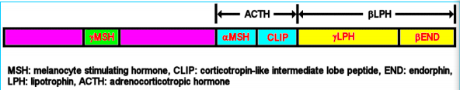
  - Lack of negative feedback causes large ACTH production… causes high MSH production because MSH is a part of the POMC peptide precursor
    - Low MSH would be seen in secondary Hypoadrenalism since ACTH levels are low therefore low POMC and low MSH
  - Acute crisis dehydration, hypotension, nausea & vomiting
- Hypoadrenalism biochemical features:
  - Hyponatremia (low Na retention), hyperkalemia (high K+ retention from low excretion), mild metabolic acidosis (K+ shift into cells causes H+ shift into blood)
  - Hyperuremia (low GFR?) and hypoglycemia (low cortisol secretion)
  - Increased plasma ACTH if primary adrenal failure
- Hypoadrenalism diagnosis serum aldosterone or cortisol assay not useful
  - Use a short Synacthen (1-24 ACTH analogue) test (ACTH stimulation test) measure baseline serum cortisol, then measure after synacthen bolus
    - Normal pt increase from baseline b/c ACTH stimulates cortisol production
    - Addison’s disease no increase since adrenal glands destroyed
    - Adrenal atrophy slight rise… adrenals are less responsive
- Case 2 Hypoadrenalism
  - Muscle weakness change in Na/K profile
  - Pigmentation high MSH
  - Hypotensive cannot retain water, low renin, AT-II
  - Lab tests results
    - Low Na cannot absorb and retain
    - High K+ cannot excrete, high K+ is coupled with low Na usually
    - Slightly lowered Cl
    - Low HCO3 mild metabolic acidosis
    - High urea hyperuremia from low blood pressure/GFR
    - High creatinine low water content
      - Urea should increase more than creatinine because it is not renal failure Why?
  - Short Synacthen test low serum cortisol before & after… improper response of adrenal gland to ACTH
  - Suggests Addison’s serum ACTH should be high since primary issue
- RAS antihypertensive agents
  - ACE inhibitor, AT-II antagonist, diuretic, aldosterone receptor antagonist, renin receptor antagonist
- Exercise 2 looks obese, moon face, buffalo hump
  - Hyperadrenalism associated with Cushing’s
Lecture 11 – Infertility
- Infertility defined as failure to conceive after 1 year of regular & unprotected intercourse
  - Therefore if < 1 yr, recommendation is to ‘just keep trying’
  - Causes of infertility are 40% male factors, 50% female factors, and 10% unknown
  - Endocrine abnormalities are more common in women (1/3) than men (very rare)
- Sex steroid hormones
  - Sources gonads (testes and ovaries) as well as peripheral conversion (in adrenal & adipose tissues)
  - Testosterone and androgens in women, approximately 50% of production is from the ovaries, with the other 50% from peripheral conversion of dehydroepiandrosterone (DHEA) and DHEA-sulphate (DHEAS) secreted from the adrenal cortex
    - DHEAS is a useful marker in the ddx of the source of excessive androgen production in women since it is only made in the adrenal cortex
      - Elevated DHEAS suggests adrenal cortex is producing many androgens
    - Testosterone and androstenedione are the major male sex hormones but are present in low amounts in women as well
  - Estradiol and estrogen major in women… men also has some low estradiol concentrations
- Sex hormone-binding globulin (SHBG)
  - Affinity for testosterone > estradiol
  - Estradiol stimulates SHBG synthesis in liver; testosterone decreases its synthesis
  - Plasma concentration of SHBG in females is twice as high as males
  - Factors which alter SHBG concentration alter ratio of unbound testosterone to unbound estradiol since SHBG binds testosterone with greater affinity, expect increased SHBG to reduce free testosterone more than estradiol
- Hypothalamus produces GnRH in an oscillatory manner targets anterior pituitary to increase both FSH and LH levels
  - FSH promotes spermatogenesis while LH promotes testosterone production
  - Testosterone converted to Dihydrotestosterone important for development of male sex characteristics (virilisation)
    - Also has negative feedback on both hypothalamus and anterior pituitary
  - Gonads secrete inhibin and activin which inhibit and stimulate the anterior pituitary, respectively
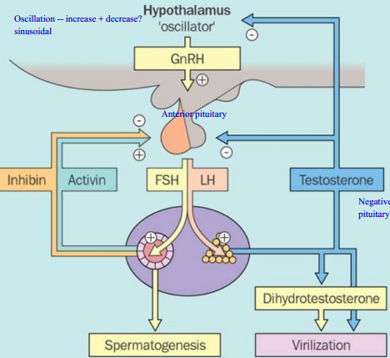
- Testosterone can be converted to DHT with 5α-reductase, or estradiol through aromatase
  - Deficiencies in DHT therefore can be attributed to deficiencies in 5α-reductase
  - Testosterone and DHT differ by the reduction of the double bond and addition of hydrogen
  - Estradiol differs from testosterone by the addition of a OH grp in place of the carbonyl
- Disorders of male sex hormones hypogonadism
  - Primary: Hypergonadotropic hypogonadism high GnRH with low testosterone
    - Suggests primary issue as gonads are not responsive to stimulatory effects of FSH/LH
  - Secondary/tertiary: hypogonadotropic hypogonadism low GnRH with low testosterone
    - Suggests secondary or tertiary issue because the upstream issue leads to low testosterone
    - Pituitary tumor (2ndary) or hypothalamic disorder (tertiary) both cause either failure of FSH/LH production, or GnRH production (Kallmann’s)
    - Can be determined through GnRH stimulation test
  - Defects in androgen action
    - Testicular feminization syndrome androgen receptors cannot receive androgen stimulation
      - Can detect high testosterone levels even though presents with feminine features
- Hyperprolactinemia can cause infertility in both men and women by inhibiting ovulation
    - 5α-reductase deficiency causes a DHT deficiency so testes cannot develop and pts appear with a female appearance
    - 5α-reductase deficiency is exclusive to males
- Hypothalamic-pituitary-ovarian axis
  - Main stimulus is GnRH pulse frequency from the hypothalamus
    - Slow pulses stimulate FSH secretion
    - Fast pulses stimulate LH secretion
  - FSH causes follicle growth generates inhibin B which inhibits FSH
  - LH causes ovulation and generation of the corpus luteum generates inhibin A, estradiol, progesterone, and testosterone
    - Estradiol can positively feedback on LH to cause a surge
    - Progesterone and testosterone negatively feedback on the anterior pituitary and hypothalamus
Lecture 12 – Calcium, Vitamin D, & Parathyroid Diseases
- Rickets softening of bones
  - Common causes: malnutrition, lack of sun exposure, breast-fed infants
  - Vitamin D deficiency, Low Ca
- Calcium fluxes
  - Net gain 150 mg/d in intestines
  - Net loss 150 mg/d in kidney (no reabsorption)
  - No net difference in bone (500 mg/d formed and resorbed)
- Parathyroid gland synthesizes parathyroid hormone
  - PreProPTH ProPTH PTH
- PTH is secreted in response to low Ca and functions to
  - Increase bone resorption
  - Increase Ca2+ reabsorption (kidney)
  - Decrease phosphate reabsorption (kidney)
    - Phosphate levels are usually inversely proportional to Ca as there needs to be charge balance?
  - Increase 1-hydroxylase and 1,25(OH)₂VitD
- Vitamin D and its metabolites
  - 7-dehydrocholesterol (Provitamin D₃) + UV on skin Vitamin D₃
  - Vitamin D₃ + 25-hydroxylase in liver 25-OH-VitD₃
  - 25-OH-VitD₃ + 1α-hydroxylase in kidney) 1,25-(OH)₂VitD₃
  - **If add 24-hydroxylase it deactivates it
  - provitD3 UV vitD3 25 OHase 25VitD3 1α-hydroxylase 1,25OHase
- Can get vitamin D3 from milk, salmon goes to liver for 25OHase goes to kidney for 1αOHase
  - Has paracrine and autocrine functions
- 1,25-(OH)₂VitD₃ hormonal effects
  - Intestine increases Ca and P absorption
  - Bone causes bone resorption
  - Parathyroid gland decreases PTH synthesis and secretion
  - Inhibits is own synthesis directly as well as promotes its metabolism if there is too much active VitD it will decrease 1αOHase and increase 24OHase to convert it to inactive form
  - Is a steroid hormone, which is bound to a vitamin D-binding protein
  - In the cell, complexes with a nuclear vitamin D receptor to act as a transcription factor
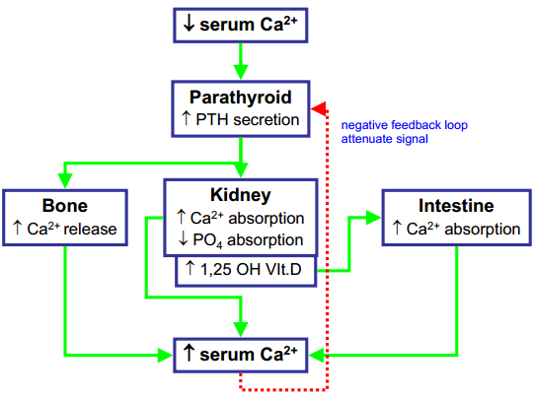
- Calcitonin
  - 32-amino acid peptide secreted by parafollicular C cells of the thyroid gland
  - Stimulated by high Ca2+ and GI hormones
  - Decreases serum Ca and PO
    - Not typically significant in calcium homeostasis
  - Inhibits bone resorption by osteoclast
    - Treatment for osteoporosis
  - Tumor marker for medullary thyroid carcinoma (C cell tumor)
- Clinical significance of Calcium
  - Hypocalcemia causes neuromuscular hyperexcitability (tetany), Trousseau’s sign (arm looks like duck)
  - Hypercalcemia reduced neuromuscular excitability, fatigue, weakness
    - May induce mild nephrogenic diabetes insipidus (ADH resistance) causing polydipsia and polyuria
    - Renal stones from chronic hypercalcemia and hypercalcuria
- Causes of hypocalcemia
  - Hypoparathyroidism idiopathic or postsurgical; inability to produce PTH
  - Pseudohypoparathyroidism deficiency in PTH receptors… feedback increases [PTH] but will still be hypocalcemic
  - Magnesium deficiency normal PTH secretion utilizes Mg so Mg deficiency reduced PTH secretion
  - Renal failure phosphate retention and 1,25(OH)₂VitD₃ deficiency.. unable to reabsorb Ca
    - Phosphate combines with calcium to form calcium phosphate deposits reduction in plasma calcium
    - Kidney converts vitamin D to active form which improves Ca absorption from intestine so reduced Ca absorption when kidney failure
  - Vitamin D deficiency dietary, lack of sun exposure, malabsorption, chronic liver & renal disease
- What are the Ca and PTH levels in renal failure and VitD deficiency
  - Renal failure & VitD deficiency high PTH, and low Ca
    - These are causes of secondary hyperparathyroidism since the response by the parathyroid gland is normal (increase PTH)
- Causes of hypercalcemia
  - Mechanisms
    - Increased intestinal absorption (Vit D intoxication)
    - Enhanced renal retention of Ca
    - Increased bone resorption (osteoclasts)
  - Primary hyperparathyroidisms
    - Malignancies cancer with or without bone metastases which secrete PTHrP
    - Milk-alkali syndrome self medication antacids (CaHCO3) causing alkalosis (ingestion of Ca)
    - Diseases with increased 1α-hydroxylase activity Sarcoidosis
    - Familial hypocalciuric hypercalcemia (FHH) mutations of Ca-sensing receptor… body senses Ca is low (even when in reality it is high) and produces PTH in response
      - Often misdiagnosed as hyperparathyroidism
      - Symptoms hypocalciuria with high PTH and high blood Ca
      - Adaptation to higher than normal blood Ca levels
- Primary hyperparathyroidism excessive secretion of PTH most common due to parathyroid adenoma
  - Most often seen in postmenopausal women
  - Biochemical profile
    - High PTH (causes the issue)
    - High Ca from high PTH
    - 1,25(OH)2VitD normal or increased can be increased from PTH, but high Ca also inhibits it… so VitD3 levels NOT necessarily useful for ddx
    - Low PO4 high PTH causes decreased PO4 reabsorption in kidneys… “more phosphate is excreted through the urine”
- Parathyroid hormone related peptide (PTHrP) similar to PTH, but derived from Chr 12 instead of Chr 11
  - N-terminal end similar to PTH… rest dissimilar
  - Is able to bind to PTH receptor thereby mimicking the effects of PTH and can also bind to other receptors
  - Expressed in normal tissue of fetuses and adults, particularly in breast milk
  - Commonly produced by pituitary tumors causing humoral hypercalcemia of malignancy (HHM)
    - Biochemical profile
      - High Ca, Low PO4
      - 1,25OHVitD low or normal cannot increase expression of 1α-hydroxylase in kidney
- Bone diseases
  - Note: hypercalcemia or hypocalcemia DOES NOT IMPLY that there are necessarily any changes to bone structure
  - Osteomalacia, rickets, Paget’s osteoporosis
- Bone metabolism
  - Osteoclasts bone resorption
  - Osteoblasts bone formation
- Bone markers
  - Bone resorption deoxypyridinoline (collagen degradation product)
  - Bone formation alkaline phosphatase (bone specific isoenzyme required to build new bones) and osteocalcin (synthesized by osteoblasts)
  - Follow up markers PTH, Mg, Ca (serum/urine), 25(OH)VitD
- Osteomalacia defective bone mineralization
- Rickets defective bone & cartilage mineralize in children
  - Causes (most common) Vitamin D deficiency from malnutrion, lack of sun exposure, or breast-feeding (does NOT supply Vitamin D)
  - Vitamin D dependent rickets type I inherited defect in 1α-hydroxylase causing impaired formation of active Vitamin D
    - Biochemical profile high PTH, low Ca, low 1,25(OH)₂ Vit D
  - Vit D dependent rickets type II vitamin D receptor defect, high serum 1,25(OH)₂ Vit D, low Ca, High PTH
- Paget’s disease increased osteoclast AND osteoblast activity… but new bone is laid down improperly
  - Presentation severe bone pain
  - Biochemical markers normal serum Ca, serum alkaline phosphatase increased
- Case example
  - Medical history severe bone pain which suggest large amount of bone remodelling
  - X ray pagetic lesions
  - Normal total Ca, vit D metabolites, and PTH
  - High alkaline phosphatase diagnose Paget’s disease
  - Treatment bisphosphonate drug (triggers apoptosis of osteoclasts) or calcitonin (inhibits osteoclasts)
- Osteoporosis reduction in bone mass per unit volume with normal composition
  - Common in elderly, causes morbidity & moratlity
  - Primary osteoporosis postmenopausal women; unknown etiology
  - Secondary osteoporosis iommobilization, Cushing’s (high cortisol increases osteoclast activity), gonadal failure
    - Lack of exercise increases osteoclast activity & inhibits osteoblast activity common in astronauts
- Types of Vitamin D supplements
  - Parent (native) Vitamin D same structure as normal (pre-liver precursor)
  - Vitamin D metabolite 25(OH)VitD (liver precursor)
  - Vitamin D metabolite 2 1,25(OH)₂VitD (active form, after kidney precursor)
- Which one should be used? always use the LEAST processed form, if possible
- Vitamin D deficiency caused by malnutrition, lack of sun exposure, or exclusive breast-feeding use native VitD since there is no inherent defect in VitD processing or diseases… but can also use metabolites (depends on severity, increasing severity want to skip the processing give them the good stuff)
- Vitamin D caused by chronic liver disease give 25(OH)VitD which can still be processed by kidney to form active
- Vitamin D caused by renal disease give 1,25(OH)VitD since cannot create (no 1α-hydroxylase)
- Vitamin D dependent rickets type I (issue with 1-hydroxylase production) 1,25(OH)VitD.. .same as kidney disease
- Vitamin D dependent rickets type II Cannot treat with VitD, give Ca?

Lecture 13 – Diabeetus
- Prevalence 2.4 million Canadians
  - T2DM 570,000
  - Pre-diabetes / at risk for development 6 million
- Large economic impact ($17 bill)
- Diabetes mellitus
  - Common endocrine disorders
  - Characterized by hyperglycemia
  - Causes lack of insulin secretion or action or both
- Glucose metabolism
  - Insulin binds to insulin receptor on cell
  - Causes intracellular protein activation cascade
  - GLUT-4 receptors translocated to cell membrane
  - GLUT-4 receptors transport glucose from extracellular to intracellular
  - Glycogen is synthesized & stored
  - Upon drop in blood glucose glycolysis
  - Fatty acid synthesis
- Glucose homeostasis in fed and fasting states
  - Fed state
    - Liver removes 70% of glucose ingested
    - Glucose is oxidized and converted to glycogen
    - Excess glucose is converted to VLDL in liver and transported to adipose tissue
  - Fasting state
    - Glycogen breakdown occurs
    - Gluconeogenesis occurs glycerol, lactate, pyruvate, amino acids
- Glucose homeostasis hormonal regulations
  - Increase glucose
    - Glucagon from pancreas α-cells
    - Growth hormone
    - Adrenaline
    - Cortisol
  - Decrease glucose
    - Insulin from pancreas β-cells
- Insulin
  - Synthesized in islet of Langerhans β-cells
  - MW = 5808 kDa
  - Composed of two amino acid chains connected through disulfide links
  - Synthesized are insulin-preProHormone (MW = 11,500 kDa) cleaved to prosinulin (MW = 9000) further cleaved into insulin
    - Cleavage also creates C-peptide
- Insulin and glucose metabolism
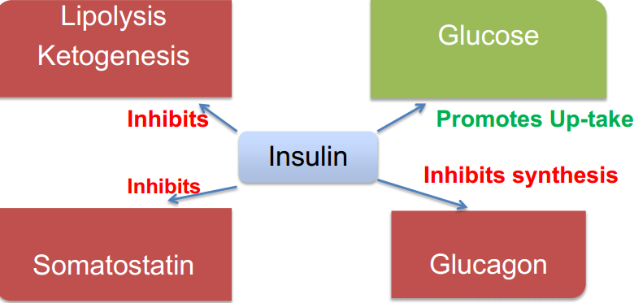
- Metabolic effects of insulin deficiency
  - Decreased:
    - Glucose uptake in muscle & liver
    - Synthesis of glycogen in liver
    - Glycolysis conversion of glucose to pyruvate
    - Synthesis of proteins amino acids used as substrate to create glucose and therefore there is reduced substrate for protein synthesis
    - Uptake of K+ and PO4 (kidney?)
  - Increased:
    - Gluconeogenesis (restricted to liver) glucose synthesis from amino acids, pyruvate, and lactate
    - Glycogenolysis breakdown of glycogen
    - Lipolysis breakdown of fats
    - Ketogenesis generation of ketone bodies
    - Proteolysis breakdown of proteins (generate AA substrates)
- Classifications of DM
  - Type 1 autoimmune destruction of pancreatic β-cells causing insulin deficiency
    - Accounts for 10-15% of diabetics and is common in children
  - Type 2 resistance of peripheral tissues to effects of insulin
    - See high/normal levels of insulin onset of disease has higher insulin, but pancreas ability to produce it decreases… so levels may decrease to normal or low
    - 85%% of diabetics (more than type 1)
    - Common in older people
  - Gestational glucose intolerance during pregnancy
  - Other (similar to type 1, but different pathogenesis) genetic diseases leading to defective β-cells or other issues
    - Hemochromatosis, Cushing’s, Pheochromocytoma
- Complications of DM
  - Microangiopathy destruction of small blood vessels
  - Retinopathy
  - Nephropathy
  - Neuropathy
  - Macroangiopathy destruction of large vessels
- Diagnosis of DM
  - Blood glucose testing what criteria for DM dx?
    - Fasting plasma glucose (FPG) ≥ 7.0 mmol/L
      - 8 – 10 hours fasting, or directly in the morning before meal
    - Random plasma glucose (PG) ≥ 11.1 mmol/L
      - Must also present with: polydipsia, polyuria, and weight loss
    - Oral glucose tolerance test (OGTT) 11.1 mmol/L
      - Deliver 75 g glucose bolus measure PG 2 hours later
        - Confirm with repeat testing on another day
- Diagnostic criteria of DM
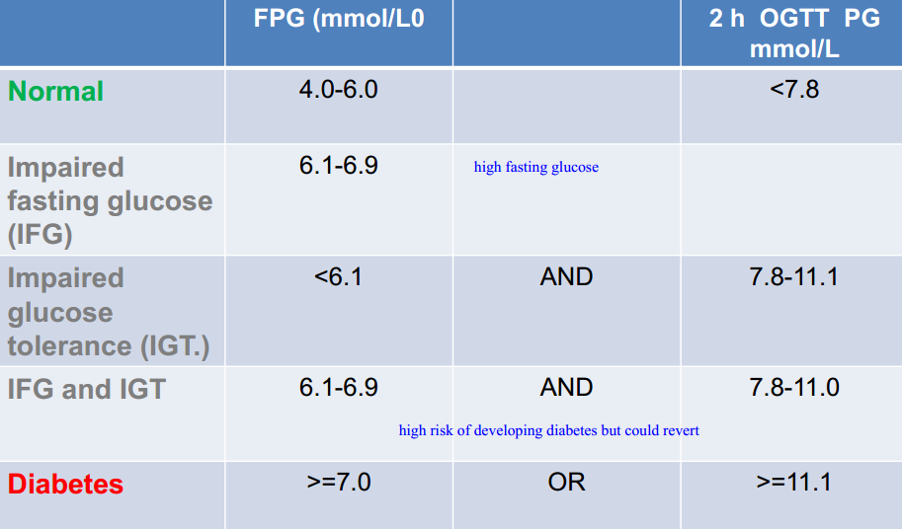
  - Impaired fasting glucose (IFG) fasting glucose is too high (6.1 – 6.9)
  - Impaired glucose tolerance (IGT) OGTT test is too high (7.8 – 11.1)
  - IFG + IGT combine both… IFG is 6.1 – 6.9 and OGTT is 7.1 – 11.0
- Significance of IFG and IGT
  - Individuals with IFG/IGT have increased risk of T2DM
  - Some individuals could also revert to normal (normoglycemia)
  - DM can be prevented or delayed with appropriate interventions … so detection is valuable
  - DM is correlated with also having CHD, HT, and dyslipidemia… screening should occur if suspected DM
- Methods to monitor DM
  - Self-monitoring of blood glucose point of care testing (personal glucometer) which uses whole blood
  - Microalbuminuria small amounts of albumin in urine
    - Leakage of albumin suggests nephropathy can be used as a marker to test progression
  - Mean glycemia use glycated hemoglobin (HbA_{1c}) which is representative of mean glycemia over a preceding period of 3 months
    - Personal glucometers only measure HbA_{1c}
- Glycated hemoglobin HbA_{1c}
  - In hyperglycemia, Hb becomes glycated glucose attached to valine residue at the N terminus of HbA
  - Represents the blood glucose concentration and the life span of RBCs (3 months)
- Criteria for interventions
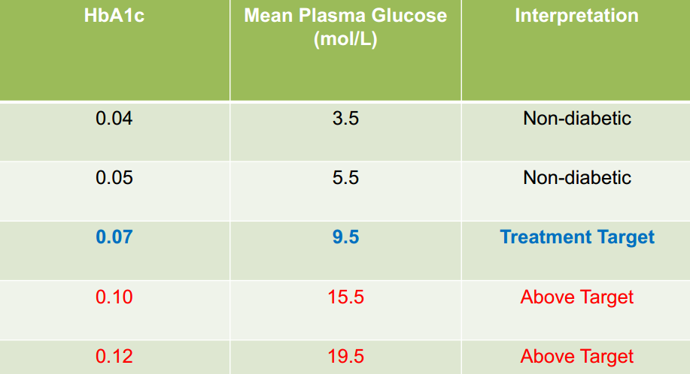
  - If HbA_{1c} < 0.05 and mean PG is < 5.5 non diabetic
  - If HbA_{1c} 0.07 and mean PG is 9.5 should begin intervention
  - If HbA_{1c} > 0.10 and mean PG is > 15.5 above target
- Management of diabetes
  - Lifestyle management
  - Antihyperglycemic agents
    - Metformin increases insulin sensitivity
    - Sulfonylureas increase insulin secretion (not useful for T1DM)
    - α-glucosidase inhibitor slow rate of carbohydrate absorption & digestion
    - Insulin last resort
- Diabetic ketoacidosis (DKA) occurs in T1DM
  - Presentation dehydration, vomiting, hyperventilation
    - Test for ketones
  - Ketoacidosis lipolysis increases FFA levels which are converted into ketones… ketones are negatively charged and decrease the pH of blood
  - Dehydration caused by osmotic diuresis (glucose pulls water into urine) as well as ketoacidosis-mediated vomiting
  - Treatment & management of DKA
    - Insulin
    - Fluids to restore water balance
    - K+ to prevent hypokalemia from insulin treatment
      - Insulin increases Na/K activity increases uptake of K+ into cells, thereby causing hypokalemia
    - Sodium bicarbonate NaHCO3
- Hyperosmolar non-ketotic coma occurs in T2DM (complication)
  - Lack of ketosis
  - Presentation High plasma glucose, osmotic diuresis, severe dehydration, and impaired consciousness
  - Develops over days
  - Residual insulin is able to prevent ketosis (increase lipogenesis, reduce lipolysis, etc.) but is unable to prevent the hyperglycemia
  - Treatment slow rehydration (prevent cerebral edema) and insulin
- Hypoglycemia clinical emergency with high mortality
  - Presentation sweating, shaking, tachycardia, weakness, nausea, confusion, coma
  - Biochemistry Low glucose ( < 2.2 mmol/L)
  - Treatable via glucose administration
  - Causes
    - Excess insulin (from treatment, take too much drugs)
    - Insufficient carbohydrate ingestion need to properly match insulin dosage with food ingestion
    - Exercise blood glucose utilizes by exercise… need to properly eat or avoid insulin usage
- Risk factors for developing DM
  - Hypertension
  - Dyslipidemia
  - Obesity
  - Schizophrenia, PCOS
  - Family history relatives with diabetes
  - History of IGT and/or IFG
  - Vascular diseases
  - History of gestational DM
  - History of macrosomic (larger body & weight) infant
  - Ethnicity (high risk groups) aboriginals, Hispanics, Asian, south Asian, African
  - Metabolic syndrome X
- Metabolic syndrome X criteria
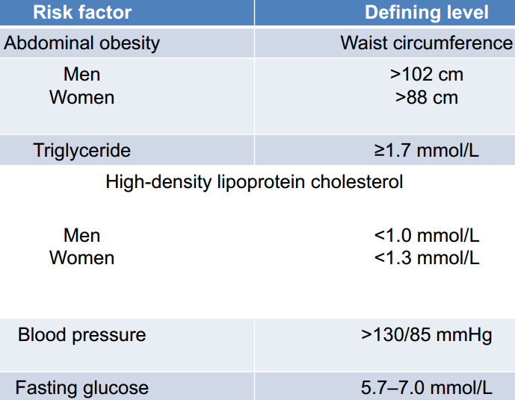
- Case example
  - 14 year old boy found drowsy and uncooperative
  - Thirsty for last 1-2 months, weight loss, abdominal pain & discomfort
  - Biochemical panel
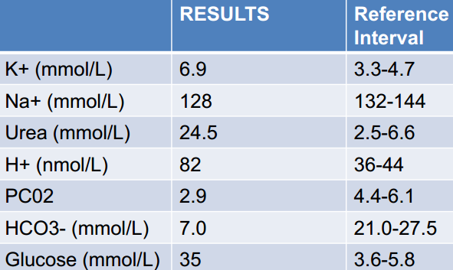
- High K+ suggests low concentration of insulin or deficient function; reduced Na/K activation causes K+ buildup in blood
- Slightly lower Na same principle, since Na/K pump is 3 Na out 2 K in there is less Na being pumped out and subsequently lower blood Na
- High urea some kidney failure or sissues?
- High H+ (low blood pH) K+ shift into cells causing H+ to be displaced into blood
- Low pCO2 hyperventilation in order to shift blood buffer equilibrium away from H+ (to the right)
- Low HCO in response to above, also a lot of it being converted to H2CO3 from the high H+
- High glucose insulin resistance so GLUT-4 not expressed, no glucose transport into tissues
- Breath smell acetone like; suggests ketoacidosis from buildup of β-hydroxybutyrate and acetoacetate

