- Dr. Christopher Fredette

- Metaphor: It’s Role in Organization Theory
- Metaphors are often at the heart of organization theories, for example:

- Organizations as machines (Bureaucratic views)

- Organizations as communities (Network views)

- Organizations as ecologies (Open Systems views)

- Organizations as prisons (Radical Critical views)

Seeing these early in the learning process will help you understand what each theory implies and how it contributes to our thinking

Org Theory: What is it? Where does it fit? What does it do?

- Organization Theory (OT) is the bridge between Organization behaviour (OB) and strategic management (SM)
- 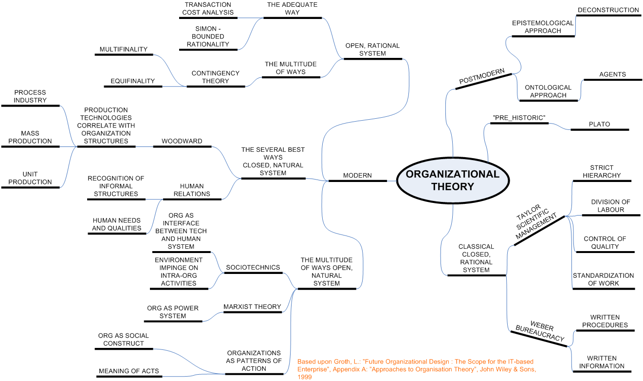

- Organization Theory (OT) is composed of a collection of theories aimed at understanding:
- - Why organizations exist
- - Why organizations look the way they do
- - What factors make them look similar and different
- - The relationships between characteristics of organizations and their implications for things like organization effectiveness

- Why do we organize? For what benefit?
- - Increased specialization (divide and specialize)
- - Scale up, Scope up (Economies of size)
- - Manage environmental complexity (multi-tasking)
- - smooth out rough spots (stabilize transaction costs)
- - Improve power and control (strength in numbers)
- Why should we study Organizational Theory?
- - organization theory focuses on structure, culture, and socio-political aspects of organizations to explain performance and value creation
- 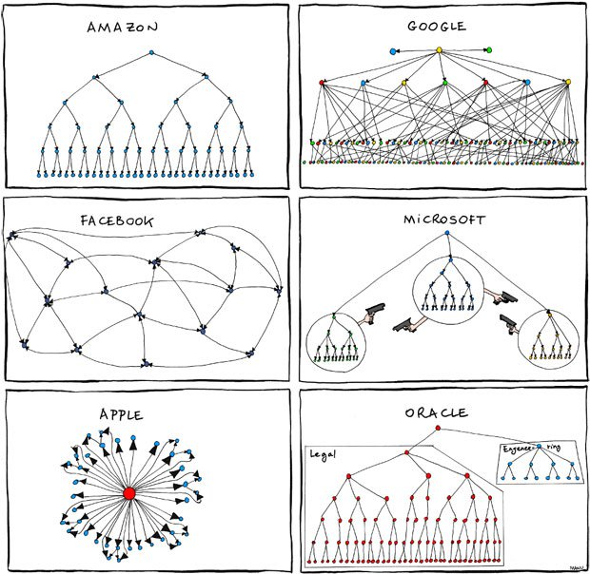

- Organizational Theory is “like the sociology of organizations”…
- - it focuses on the structure, culture, and political climate of organizations
- - it explains how organizations systematically influence the behaviour of organization members
- - creates clusters around purpose (organizes people)
- - creates patterns for performance (organizes activity)
- - creates order about intentions (organizes resources)

- - this systematic influence is not new.. and neither is the way that structure, culture, and politics collide in organizations
- - although the content may have changed, the intersection of work and life remains

- Implicit Biases in the Text: Things for your generation to consider
- - Assumes there is “one best way” to design: positivist orientation to design and structure
- - Assumes “Bigger is always better”: natural leaning toward growth and size
- - Assumes “Built right, does right”: perfect action-design relationship
- - Assumes “Top down approach”: often assumes perfect management by fiat

- *Economy video - Story of Stuff (waste)
- - resources are limited
- - its not a matter of choosing green or profit, but rather looking for the areas that we can do both
- - Ray Anderson, Interface Carpet (not a charity), it is a corporation = sustainability
- - Ray didn’t have answers to environmental questions and felt disturbed because of that
- - “the death of birth” = epiphany experience for him
- - every piece of waste can be turned into carpet
- - they have moved away from standard dyes and treatments to standard chemistry

- What is an org?
- - Orgs are not unique to business, but in business we think of these as tools used to accomplish goals
- Why do we create organizations?
- - To do things that would be difficult or not economical for people to do alone
- What is special about organizations?
- - Everything! They are all unique, and have many unique ways to contribute value to society
- Why do we study OT?
- - OT helps explain why orgs exist, how they change, and why some survive and others don’t

- Basic Building Blocks of OT
- What is the purpose of an org?
- - To create value (or benefit) for its stakeholders
- How does it create value for its stakeholders?
- - By accessing, transforming, and releasing resources

- Input Convert Output
- 1. Input: Obtain resources:
- - raw materials
- - components
- - money/capital
- - employees
- - knowledge
- 2. Convert: Transform input and add value:
- - build
- - combine
- - produce
- - enhance
- 3. Output: Provide output to environment:
- - products
- - services
- - dividends
- - stakeholder value

- An organization is a collection of:
- - Structures: by structure we mean formal patterns of relationships that give organizations their shape
- - Cultures: by culture we mean norms, values, and traditions that give organizations their character
- - Capabilities: by capabilities we mean the processes, skills and abilities to create value
- - Politics: by politics we mean power and how it is used in/by the organization

- What is Structure? Why does it Matter?
- Organizational structure is..
- - the formal system of task and authority relationships that control how people are to cooperate and use resources to achieve organizational goals
- It matters because it…
- - controls coordination and motivation
- - shapes behaviour of people and the organization
- - can be managed/changed to improve performance
- “We shape our organizations, and thereafter they shape us.”

- What is Culture? Why does it Matter?
- Organizational culture is..
- - the set of shared values and norms that control organizational member interactions with people inside and outside the organization
- It matters because it..
- - controls coordination and motivation
- - shapes behaviour of people and he organization
- - can be managed/changed to improve performance

- Organizational Effectiveness: Measuring Org Success
- *We measure the impact of Structure, Culture, Capabilities, and Politics with Organizational Effectiveness
- - External Resource Approach
- how effectively do we manage our resources?
- - Internal Systems Approach
- how effectively do we keep pace with our competitors?
- - Technical Fitness Approach
- how effective are we at efficiently creating value?

- **PROJECT – Basic Questions to consider
- - Are you able to define the purpose of your org?
- - Are you able to understand and explain its structure?
- - Can you explain how it creates value and for whom?
- - Can you make judgments about its effectiveness in meeting its goals?

- Fundamentals of Organizational Growth: An example of how we got to where we are – Organization Growth

- What is happening to the org? What do the lines linking people represent? Where is value being created? By line roles or staff roles?
- - more complex
- - more layers
- - boss is removed from day-to-day operations
- - more product = more profit
- - more resources required

- Organizational Growth:

- Can you characterize the org structures here? What is happening to the org as it grows?

- Fundamentals of Org Growth
- Org Growth – leads to changes in org structure and hierarchy
- - leads to increasing role differentiation and specialization
- - increases the need for resources
- But, Growth also – separates owners from day-to-day operations as complexity increases
- - increases complexity of operations requiring professional managers
- - results in a separation of ownership-management
- *These issues are at the heart of the Agency Problem because they make organizations less transparent.

- Staff Job: HR and Accounting (In)
- Line Job: Most income and resources, Production and sales (Out, earning living)

- AGENCY THEORY: At the Heart of the Agency Problem
- How do we deal with the conflicting interests that result from the separation of Management and Ownership?
- Sources of conflict:
- - information asymmetry
- - lack of transparency
- - divergent goals
- How to address this conflict:
- - monitoring executive action
- - oversight and governance
- - incentivize desired behaviour

- = gap between owners and managers

- Organizational Stakeholders: Beyond Just Shareholder Responsibility
- - Considering stakeholders is relatively new, and until recently we focused almost exclusively on shareholders
- - In general, we can divide stakeholders in two groups
- 1. Inside stakeholders
- 2. Outside stakeholders
- *Stakeholder perspectives offer a different view on the environment.

Organizations and Ethics: Consider Issues, Weigh Decisions, Take Actions

Where do ethics come from?

- societal values, organizational codes, professional standards, and individual beliefs

What is the big issue with ethics?

- the issue with ethics in business isn’t the ethics, it’s the “ethical violations” that kill organizations

- when activities conflict with stakeholder values the results can be volatile

- shareholder activism brought down Hollinger

- Internal whistle-blowing devastated the FBI and Enron

- Investigations into Madoff have generated interest in reform

**PROJECT: Consider

- Which stakeholders are most important to your org? why?

- How do they affect your org? In what ways?

- What are their interests relative to your org?

*Stakeholders need to be considered carefully because they can have a powerful effect on organizational health

Organizational Environment: Expanding outward to include forces

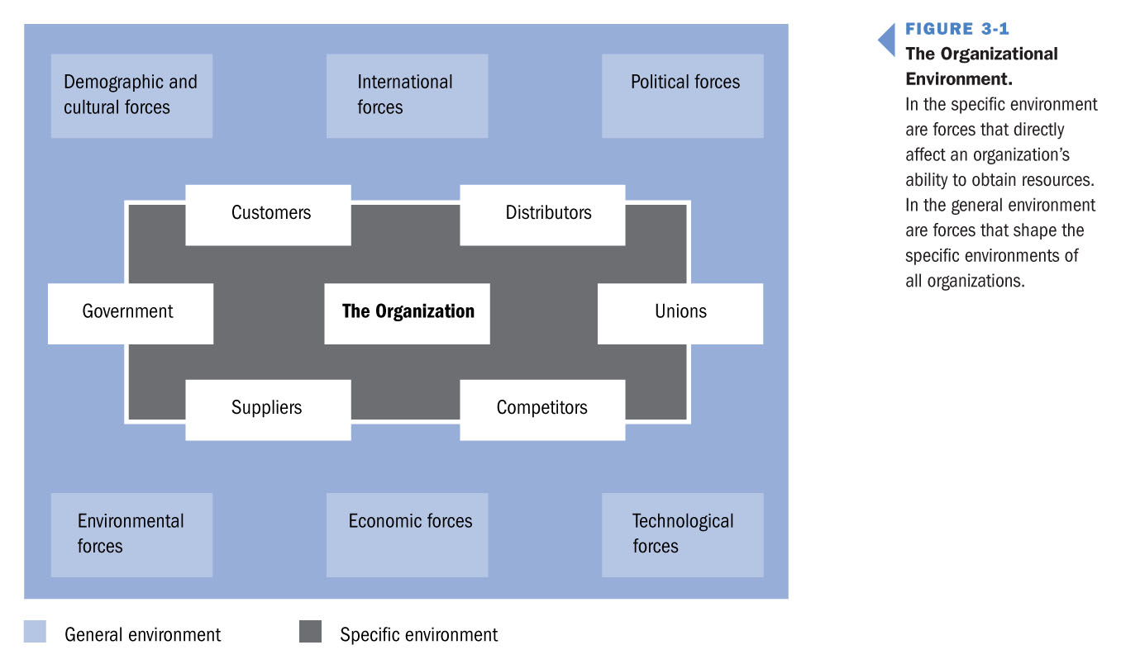

Expanding Outward to include Forces

The “general environment” includes forces that shape the specific environment and affect the ability of all organizations in a particular environment to obtain resources

Forces that shape the General Environment:

1. Technological Forces – Research and Development, Information Processing Equipment, and Computerized manufacturing

2. Political and Environmental forces – Tariffs, Changing Regulations and Pressures from Environmental Groups

3. Demographic, Cultural and Social forces – Affects tastes and needs of consumers, and are an important source of uncertainty

Environmental Uncertainty: Org Environments are Always Uncertain

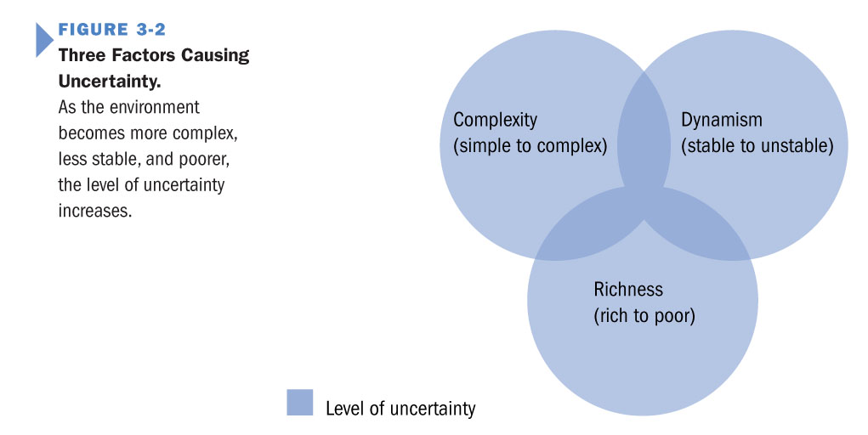

Think about answering these 3 simple environment questions:

1. How complex is it? Which parts are complex?

2. How dynamic is it? What is the relative pace of change?

3. Are resources scarce? Can you get what you need?

* These will get you on your way to an environmental analysis.

Resource Dependence Theory

Tools for Managing Environmental Uncertainty

How should we manage relationships with other firms to ensure access to resources without loss of control?

*Resource Dependence Theory (RDP) assumes…

- resources are scared and firms compete for them

- resource flows are unpredictable

- organizations want access, but don’t want to be dependent on others (i.e. no loss of control)

*An organization must simultaneously manage two aspects of its resource dependence:

1. Exert influence over other organizations to obtain resources

2. Respond to the needs of other organizations in its environment

Resource Dependence Theory

Managing symbiotic Interdependencies

- Cooperative and complementary relationships

- Generally exist between organizations and their suppliers and distributors

Resource Dependence Theory

Managing Competitive Interdependencies

- conflicting and clashing relationships among competitors for resources

- generally exist between organizations and their competitors

Strategic Alliances in RDP

Modes of Allying with Increasing Control

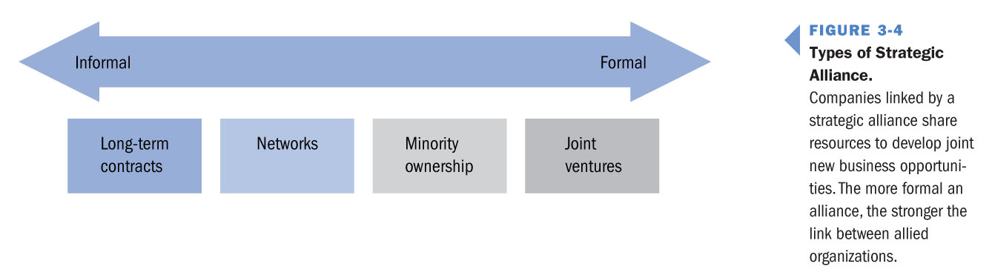

Long-term contracts: reduces costs by sharing resources

Networks: clusters of different firms who coordinate by contracts

Minority Ownership: groups of firms which hold minority position in other firms (for example, Keiretsu)

Joint Venture: strategic alliance between two or more firms that agree to establish a new business

Resource Dependence Theory

Takeaways and Conclusions from RDP

- Organizations have a number of options available for securing resource access

- Each option comes with a cost to independence, autonomy, and control

- Managers need to weigh the costs and benefits of each approach before taking action

*There are no bonus points for overkill

*It is easier to start informally and increase formality over time if needed

*Powerful partners should be approached with care

Transaction Cost Theory

Approaches to Address Resource Concerns

How should we set organizational boundaries? Should organizations make or buy?

Transaction costs are…

- costs of negotiating, monitoring, and governing exchanges between firms

- the same as bureaucratic costs when done inside the organization

Transaction Cost Theory says to minimize the transaction and bureaucratic costs…

- if TC > BC then make the product in house

- if TC < BV then buy the good from the market

What drives Transaction Costs up?

- Environmental Uncertainty linked to Bounded Rationality of Managers

*Complexity, Dynamism, and Resource Scarcity make planning very difficult (can’t know everything)

- Opportunism linked to Small Numbers Bargaining

*Limited numbers of resource suppliers make it more likely you will be taken advantage of

- Risk linked to Specific Asset Requirement

*The more specific the assets required for production, the greater the risk involved

TCs are low when:

- firms exchange non-specific goods/services

- uncertainty is low

- there are many likely exchange partners

consider LESS FORMAL linkages to the market

TCs increase when:

- firms exchange more specific goods and services

- uncertainty increases

- the number of possible exchange partners falls

consider MORE FORMAL linkages to the market

*Formal mechanisms minimize the transaction costs associated with reducing uncertainty, opportunism and risk

- Last week we discussed 4 major ideas dealing with the organization and its external environment:
- 1. The nature and importance of organizational stakeholders
- 2. Agency Theory and its contribution to OT
- 3. The sources and impact of environmental uncertainty
- 4. How resource dependence and transaction cost theories help managers respond to the organization’s environment

- Challenges of Organization Design
- Balancing the Trade-offs of Stability and Change
- 4 Universal Challenges:
- 1. Determining the level of differentiation
- 2. Deciding how to coordinate activities
- 3. Determining who will make decisions
- 4. Deciding how tightly the organization will control employee activities

- Organizational Terms and Functions
- - Managerial Function: coordinate and control activities within and among departments
- - Support Function: facilitates a firms relations with its environment and stakeholders
- - Production Function: manage and improve the efficiency of an organization’s “conversion” processes
- - Maintenance Function: enables an organization to keep its departments in operation
- - Adaptive Function: allows an organization to adjust to changes in the environment
- *In many cases these may be pieces of one person’s job!

- Fundamentals of Organizational Design
- Returning to our example of growth:
- _______________________________________________>>>

- Organizational Differentiation
- How should we divide up the organization’s labour force?

- Differentiation is the process of dividing tasks and authority.

- Organizational Challenges
- How should we “control” our “coordination”?
- Challenge #1: Taking on new design challenges as they arise, it’s not clear who’s responsible for what or who reports to whom. It’s difficult to coordinate work as a team.
- How do we differentiate? – Vertically or Horizontally?
- How do we choose how much to differentiate? – Subunits? Based on what? Authority concentrated?
- *These decision are about value creation!
- - Balance the costs and benefits of:
- control and predictability (vertical differentiation)
- coordination and specialization (horizontal differentiation)
- - If there are no advantages to increased differentiation…
- reevaluate past decisions, consider alternatives
- strip out excessive differentiation, delayer and de-specialize
- We differentiate to bring order and control.. but use caution!

- How should we “integrate” after “differentiating”?
- Challenge #2: People don’t coordinate or communicate. Not only does specifying tasks and roles not help, but it builds barriers between people and functions.
- Why do we integrate?: Subunit orientation? Lack of coordination? Value creation becomes unstable and unpredictable
- How do we integrate?: Build connections among subunits? Based on what?
- We can improve integration by using these mechanisms:
- - Hierarchies of Authority: specify reporting relationships
- - Direct Contact: regular management meetings
- - Liaison Roles: designate a cross-functional coordinator
- - Task Forces: temporary cross-functional committees
- - Teams: permanent cross-functional coordinating groups
- - Integrating Roles: often senior managers that boundary span
- - Integrating Departments: create new department to link functions or other divisions
- We integrate to improve coordination.. but use caution!

- How should we “integrate” after “differentiating”?
- 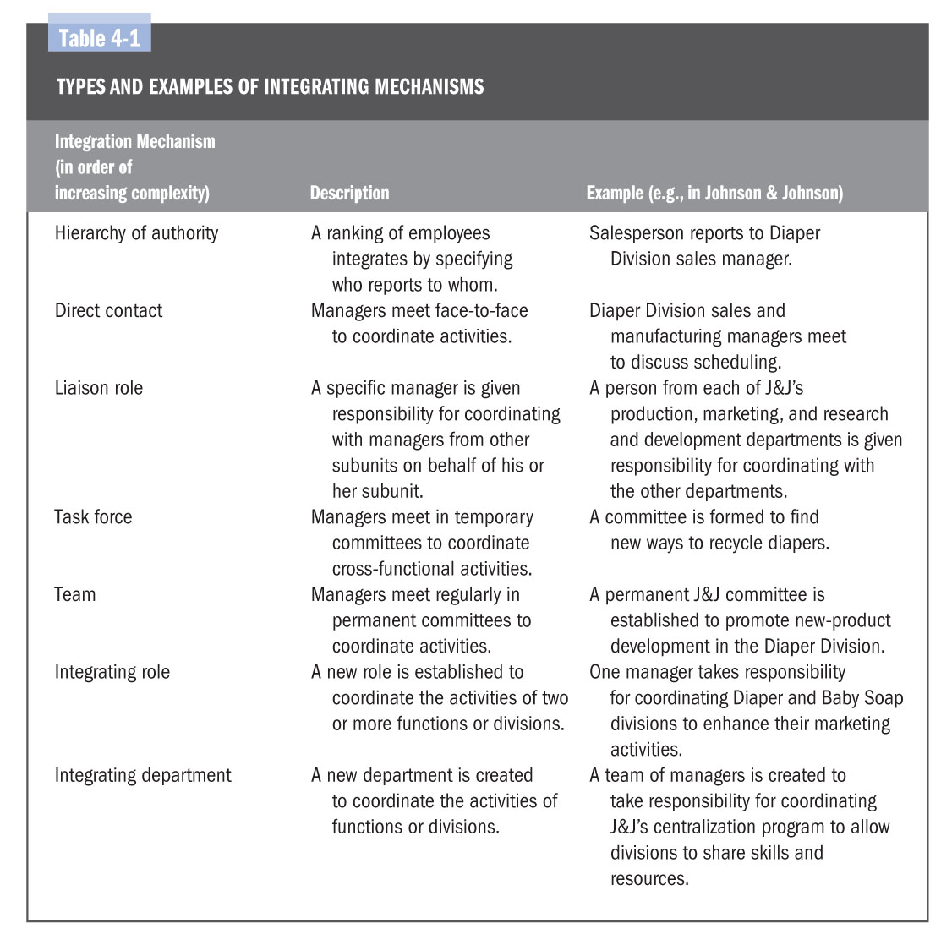

- How should we “control” who “decides”?
- Challenge #3: People don’t take risks or responsibility. They always look to the boss for direction and supervision. Decisions are slow and they miss opportunities.
- How should we make decisions? – Centralized control? Decentralized control? Value creation becomes inhibited by inaction
- What are we trying to gain? – Stability and predictability? Change and adaptability?
- Stop for a minute to consider benefits and costs of:
- - centralizing authority and decision-making
- - decentralizing authority and decision-making
- What is the organization trying to achieve?
- - would Stability and Predictability enhance value creation?
- - would Change and Adaptability enhance value creation?
- We centralize to improve control, but it comes with big costs!

- How “flexible” should our “designs” be?
- Challenge #4: People are too rules oriented. Since no one is willing to bend the rules, unusual customer requests or quick service questions are not satisfied.
- Where does standardization come from? – Formalization (Rules, Policies and Standardized Operations), Socialization (Norms, Values and Understanding)
- What are we trying to gain? – Stability and Predictability? Change and Adaptability?

Where and when does Standardization work well?

- Highly formal organizations with strongly centralized controls (Specialized, Centralized, Formalized)

Firms that need stability and predictability to create value!

Where and when does Mutual Adjustment work well?

- Loosely formalized organizations with decentralized decision making systems (Undifferentiating, Decentralized, Flexible)
- Firms that need variation and adaptability to create value!
- We standardize to improve control, but now we can’t change!

- Balance Organization Design
- Characterizing Organizations into Two Types
- 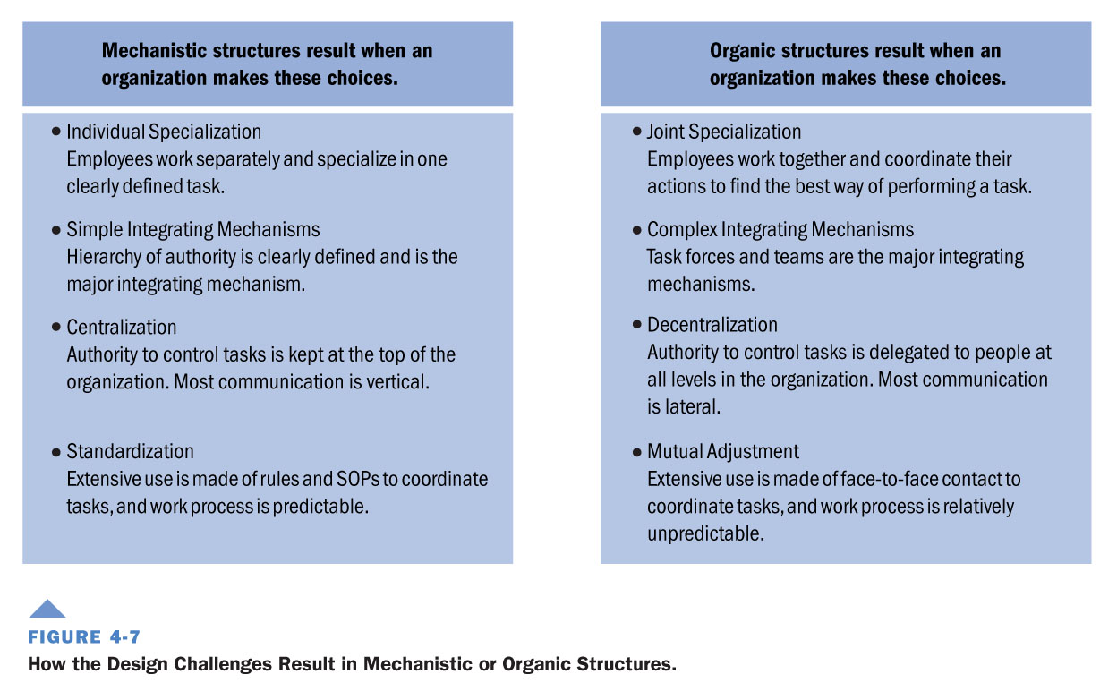

- Mechanistic Structures
- - designed to induce people to behave in predictable, accountable ways
- - hierarchy is the principal integrating mechanism
- - tasks and roles are coordinated through standardization
- This structure is best suited to stable unchanging environments

- Organic Structures
- - promotes flexibility, and quick adaptation to changing conditions
- - they are decentralized, roles are loosely defined and a high level of coordination is required
- This structure is best suited for unstable or highly uncertain environments

- Contingency Theory: A Question of Fit
- The “IT DEPENDS” Approach to Organizations
- How should we organize the structure and design of the organization to best create value? IT DEPENDS!!
- 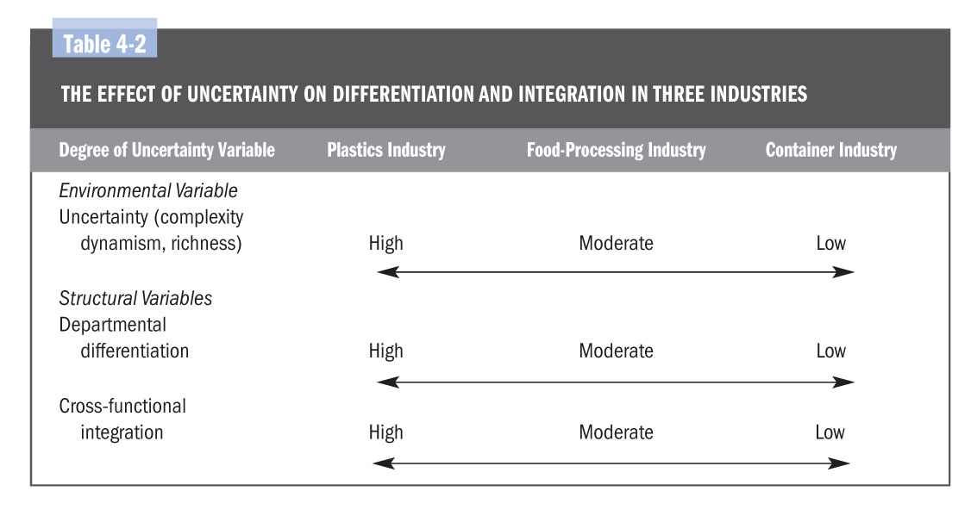
- Contingency theory says look to the environment for indicators like uncertainty and try to fit in!
- - Organizations must be designed and structured to best fit their external environment
- 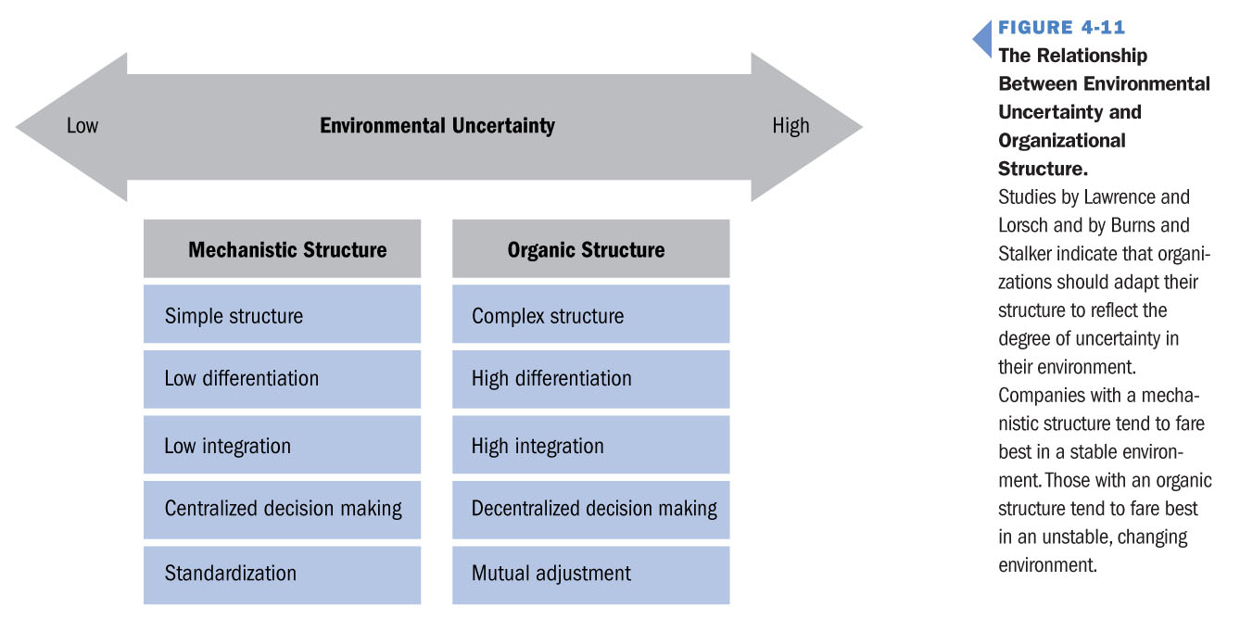
- Should we focus on stability or adaptability? IT DEPENDS!

- Lawrence & Lorsch (1967)
- - investigated how companies in different industries differentiate and integrate their structures to fit the industry characteristics
- - they found when environment is unstable, organizations are more effective when less formalized, more decentralized, and highly differentiated and integrated
- Under environmental uncertainty go Organic for faster response!

- Burns & Stalker (1965)
- - organizations need different kinds of structures when adapting or responding to changes in the environment
- - companies with organic structures were more effective in unstable environments
- - the reverse is true of stable environments
- Under environmental uncertainty you need to have authority to make decisions quickly

- Last week we discussed 4 major design challenges facing organizations:
- 1. Determining the level of differentiation
- How should we “control” and “coordinate”?
- 2. Deciding how to coordinate activities
- How should we “integrate” after “differentiating”?
- 3. Determining who will make decisions
- How should we “control” who “decides”?
- 4. Deciding how tightly the organization will control employee activities
- How “flexible” should our “design” be?

- Balancing Organization Design
- Characterizing Organizations into Two Types
- Mechanistic Structures:
- - designed to induce people to behave in predictable, accountable ways
- - hierarchy is the principal integrating mechanism
- - tasks and roles are coordinated through standardization
- This structure is best suited to stable unchanging environments

- Organic Structures:
- - promotes flexibility, and quick adaptation to changing conditions
- - they are decentralized, roles are loosely defined and a high level of coordination is required
- This structure is best suited to unstable or highly uncertain environments

- Fundamentals of Organizational Design
- Returning to our example of Growth

- Why does a hierarchy emerge?
- What are the control benefits of hierarchies?
- What is the span of control on our sales manager?

- - Gaining control as we grow is critical to organizational success
- - But how much is enough and how much is too much?
- 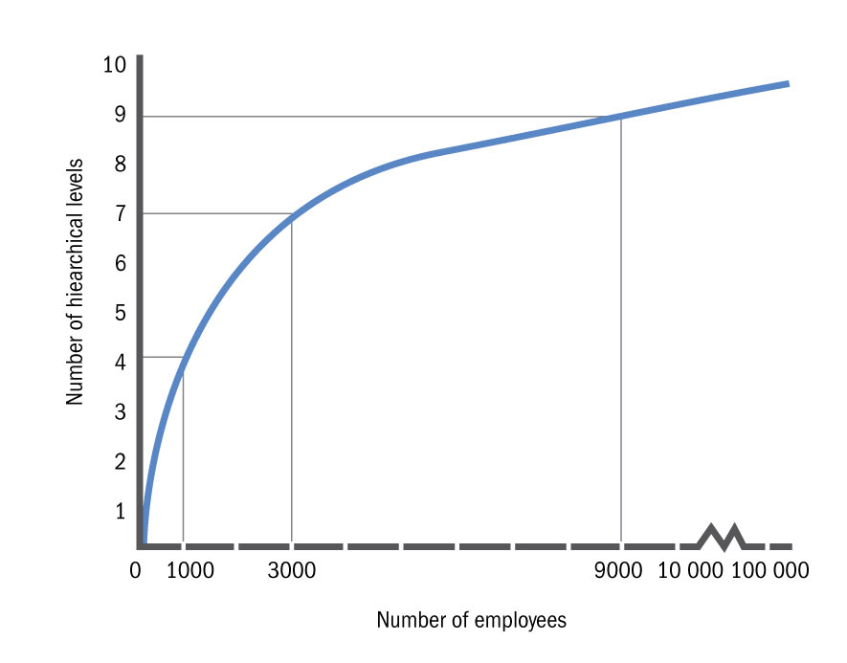
- 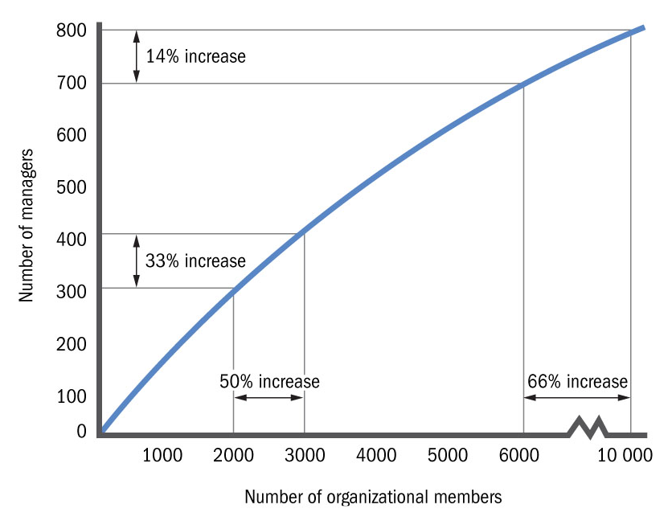

- Problems with Tall Org Structures
- Important problems with increasing hierarchy:
- - Communication Problems
- Communication takes too long, becomes distorted across levels, information is selectively passed down
- - Motivation Problems
- As levels increase, the relative difference in the authority possessed by managers at each level decreases, as does area of responsibility
- - Bureaucratic Costs
- The more managers, the less cost effective an organization as payroll cost increase

- Factors Driving the Shape of the Hierarchy
- 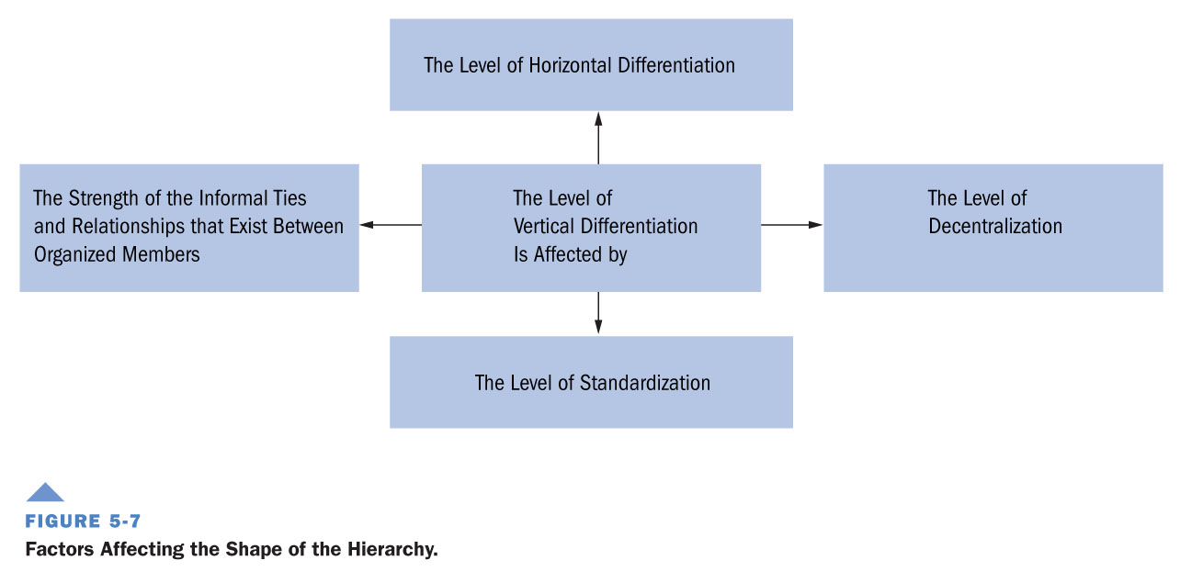

- Parkinson’s Principle of Minimum Chain of Command
- Parkinson’s Law: Growth in number of managers and hierarchical levels is controlled by two principles:
- 1. Managers want to multiply subordinates not rivals
- 2. Managers make work for one another
- - If Parkinson is right that “work expands so as to fill the time available”
- - Then a Principle of Minimum Chain of Command must be chosen
- The minimum number of hierarchal levels consistent with organization goals and the environment in which it operates
- Choose fewer levels of hierarchy, subject to the environment
- How would Parkinson advise us to organize?

Choose fewer levels, but are roles complex or interrelated?

Max Weber’s Contribution

The Principles of Bureaucracy

Weber introduced a set of principles for a typical bureaucracy

- Bureaucracy is a form of organizing, giving us…

- meritocracy

- rational-authority

- chains of command

- codified management

Principle #1: A bureaucracy is founded on the concept of rational-legal authority

Rational-legal authority: authority a person has relative to her/his position in the organization

Weber’s position: an organization’s hierarchy should be based on the needs of the task, not on the person performing the task

It’s the rank or position that matters, not the person!

Principle #2: Organizational roles are held on the basis of technical competence

Role-based competence: decisions should be made based on meritocracy only

Weber’s position: these two principles establish the organizational role, as the basic component of bureaucratic structure

It’s my knowledge, skills, and abilities that got me the job!

Principle #3: A role’s task and decision-making authority and its relationship to others should be clearly specified

Role Conflict and Ambiguity: differing views of what another person should do, placing conflicting demands on them

Weber’s position: clear and consistent pattern of vertical and horizontal differentiation is a source of organizational effectiveness

Everyone knows their role, and how they are related!

Principle #4: Roles in a bureaucracy are such that each lower office is under the control of a higher one

Chain of command: each person should be able to recognize the chain of command

Weber’s position: an organization’s hierarchy should ensure that each employee has only one supervisor to report to

We have one boss, and our boss has only one boss too!

Principle #5: Rules and norms should be used to control behaviour and the relationships among roles in a firm

Standardized Rules and Norms: Rules, SOPs, and norms clarify expectations and prevent misunderstandings

Weber’s position: differentiation breaks the firm into distinct roles that must be coordinated and integrated to accomplish organizational goals

Rules and norms help standardize the way we do things!

Principle #6: Administrative acts, decisions, and rules should be formulated and put in writing

Codified Rules and Standards: a bureaucratic structure provides organizations with memory and a history of prior actions

Weber’s position: written records ensure that organization history cannot be altered and that people be held accountable for their decisions

Having clear rules and standards avoids favoritism!

Advancements based on Principles of Bureaucracy

- Clearly specifies authority and task relationships leaving no question about each person’s role

clarifies roles, relationships, and patterns of authority

- It fosters differentiation, increasing organizations’ core competencies and improves ability to compete for resources

Bureaucracy separates the position from the person

- Care must be taken to avoid bureaucracies which pursue power and status, to operating efficiently

Standards, rules and norms should enhance the firm

Weber notes the need for control, coordination and communication!

Management By Objectives

Alternatives to Authoritative Control

MBO: A system of evaluating subordinates on their ability to achieve specific organization goals or performance standards and to meet operating budgets

3 Step Process to creating an MBO organization:

1. Specific goal and objectives are developed by levels

2. Managers and subordinates determine subordinate’s goals

3. Managers and subordinates cyclically review subordinate’s progress

Shared goals lead people to perform toward those goals!

Work in a Flatter Organization

Alternatives to Authoritative Control

- Empowerment: the process of giving employees the authority to make decisions and be responsible for them

- Self-managed teams: work groups lead themselves are responsible for ensuring team goals are met

- Cross-functional teams: work groups across an organization functions empowered to direct and coordinate the value creation activities which complete different projects

- Contingent workers: temporary employees of an organization who receive no indirect benefits like health care

Functional Structure

The evolution of the Functional Structure

Functional Structure: grouping people on the basis of common expertise or experience or because they use the same resources

- its basis is the bedrock of horizontal differentiation

- organizing tasks into functions, it increases effectiveness of achieving its principal goal: providing customers high-quality service at reasonable prices

Functional structures have been a traditional starting place!

Shortcomings in a Functional Structure

- all organizations are initially organized into functions as this allows them to manage specialization and division of labour

- as an organization produces a wider variety of goods/services, it is increasingly difficult to provide good service or perceived customer value

- as product types increase, or geographic diversity is improved, or increased competition is faced, the ability to coordinate activities is compromised

Control Problems in a Functional Structure

Functional structures have their limitations..

- Communication problems: increasing differentiation leads to communication difficulty

- Measurement problems: hard to differentiate contributions of each area of organization

- Location problems: geographic diversity

- Customer problems: increased product offerings increases customer demands

- Strategic problems: too complex to manage and plan at the same time

Increasing organizational complexity demands change!

Beyond Functional Designs

Moving to a more complex structure

The move is based on 3 design choices:

1. Increasing Vertical Differentiation including:

a – increasing number of levels in the hierarchy

b – how much decision-making authority to place at the top

c – increase in rules, SOPs and norms to exert control

2. Increasing Horizontal Differentiation by overlaying functional groupings with subunits

3. Increasing Integration – the greater differentiation, the more complex the integrating mechanisms

Moving to a Divisional Structure

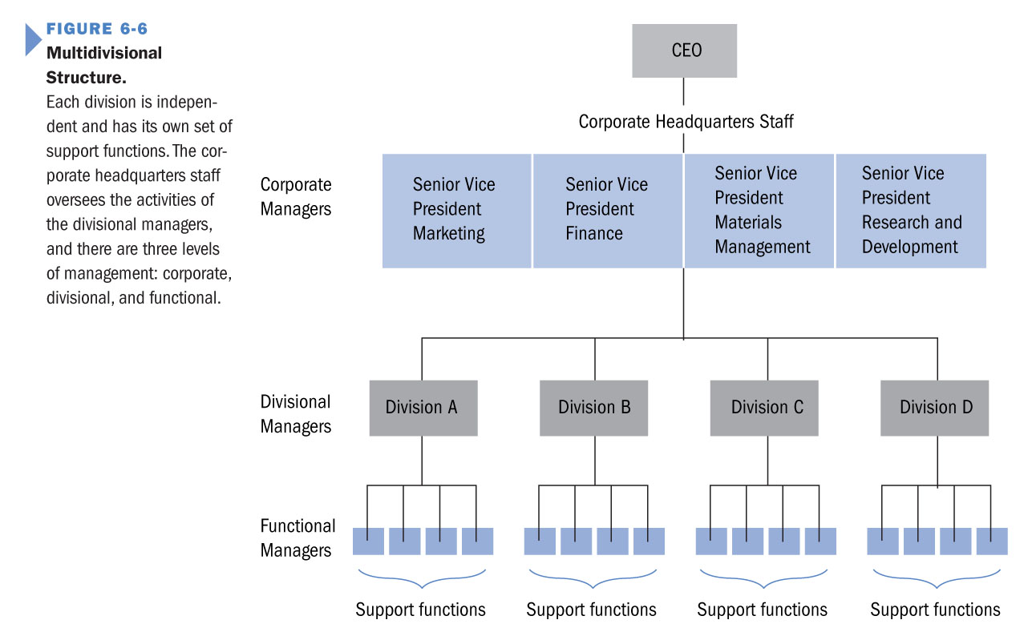

How do these choices impact control?

What about coordination or communication?

Divisional Structure: a structure in which functions are grouped according to the specific demands of products, markets or customers

- the purpose is to create smaller, more manageable subunits within an organization

3 Divisional Structures –

1. Product Structures: organize around products

2. Geographic Structures: organize around locations/areas

3. Market Structures: organize around marketing functions

Advantages of a Multidivisional Structure

A large organization is provided with several advantages when a multidivisional structure is managed effectively:

- Increased org effectiveness: clear division of labour between divisional and corporate managers

- Increased control: corporate managers monitor activities of divisional ones, curbing staff enlargement

- Profitable growth: each division is its own profit center and individual profitability is identifiable

- Internal labor market: Promotion occurs from within

Division structures rescale the size and scope of the firm!

Disadvantages of a Multidivisional Structure

Not all problems can be controlled by a good structure!

- Managing corporate-divisional relationships: centralization and decentralization need to be managed continuously

- Coordination problems between divisions: divisions may compete for resources and rival divisions prevent cooperation

- Transfer pricing: the price at which one division sells a product to another division – too high and it penalizes others

- Bureaucratic costs: multidivisional structures are expensive to operate – extensive duplication of activities are inherent

Good management is essential to solve these issues!

Adding Further Complexity with a Matrix

Matrix Structure: design groups resources and people two ways, simultaneously by function and by product

- matrix structures use teams to coordinate activities

- they juggle conflicting demands from product and functional dimensions

- in matrix structure team membership is not fixed

- matrix structure is more flexible than product team

- matrix structure forces integration on its members

- team members have two bosses: product and functional

Matrices are particularly good in very complex firms!

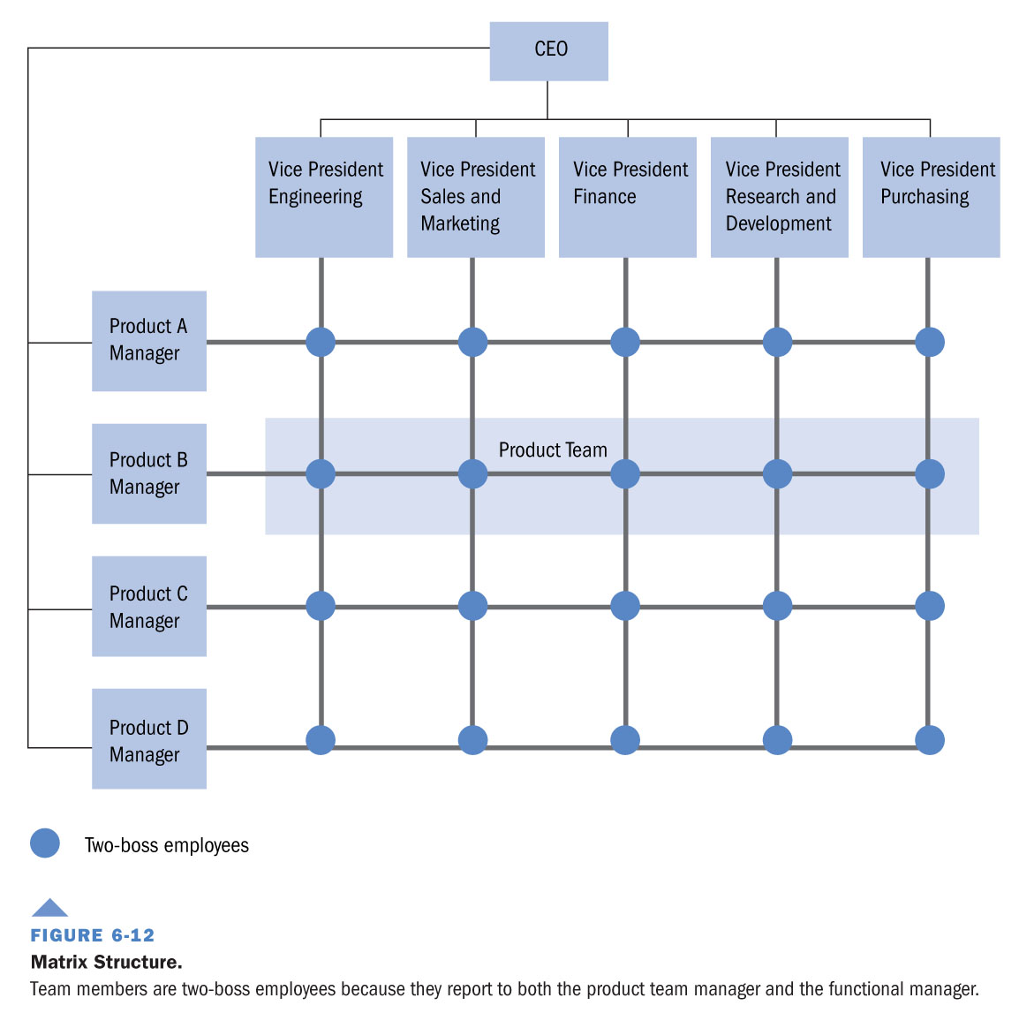

- A matrix is a rectangular grid, showing a vertical flow of functional responsibility and a horizontal flow of product responsibility

- Rows and columns can be adjusted to suit organizational needs

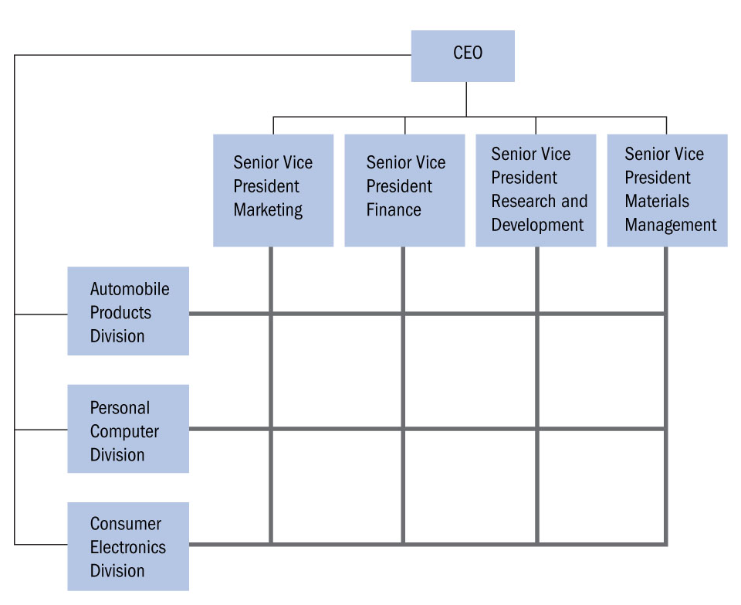

Advantages of a Matrix Structure:

4 Significant advantages over traditional structures:

1. Cross-functional teams lower functional barriers

a – integration becomes easier to achieve

b – team structure facilitates learning and adaptation

c – matrix makes the firm flexible and able to respond quickly

2. Matrix opens learning and communications among functions

3. Matrix enables organizations maximum use of skilled professionals

4. Dual functional and product focus promotes concern for both cost and quality

Disadvantages of a Matrix Structure

- problems arise from theory to practice when a matrix structure is implemented

- matrix lacks advantages of a bureaucratic structure

- people don’t like role conflict and role ambiguity

- lack of a clearly defined hierarchy leads to conflict between functions and product teams over resources

- power struggles emerge between functional and product managers and politicking emerges

Boundary-less Organizations

An Evolution in Organizational Design

Advantages:

- production costs reduced when firms find partner who can perform functions at a lower cost

- bureaucratic costs are avoided in operating a complex structure

- a network structure allows an organic profile, providing a quick response to change

- if partners fail to respond to an organization’s standards, they can be replaced

Disadvantages:

- not all businesses are suited to network structures (e.g. a computer firm has to be very responsive to adapt, trying to outperform competitors while ensuring proprietary hardware and software is maintained

- the more complex the value creation process, the more problems associated with a network structure

Networks may be the next big thing, or just another way…

- What is Org Culture?
- Org culture reflects the set of shared values, norms, and beliefs that guide the behaviours and activities of organization members
- culture facilitates mutual adjustment within an organization’s structure
- - We can thing of values as instrumental or terminal
- Instrumental values: those that reflect a desire mode of behaviour (i.e. the way we should act)
- Terminal values: those that reflect an ideal, goal or desired outcome (i.e. what we hope to accomplish)

- How do we communicate an organization’s culture to members and nonmembers?
- Socialization: process of induction into organization and it’s culture
- Ceremonies, Rites, and Rituals: local customs
- Stories and Histories: building myth and lore
- Special codes and Languages: think SBSS or DT
- *Using these things in combination we can shape behavior toward a more or less individualized orientation

- Cultural Transmission by Socialization
- Van Mannen and Schein’s Characterization
- Tactics that lead to Institutionalized Orientation
- Collective: Common/shared experience
- Formal: trained by lesson
- Sequential: fixed progressive instruction
- Fixed: known program of study
- Serial: mentorship and role modeling
- Divestiture: membership is earned over time

- Tactics that lead to Individualized Orientation
- Individual: unique experience by context
- Informal: training by need (on job training)
- Random: tactics based on newcomer needs
- Variable: dependent program of study
- Disjunctive: self-guided adjustment to culture
- Investiture: membership is immediate

- Sources of Org Culture
- Where does an org’s culture come from?

- Sources of Org Culture
- Where does Wal-marts culture come from?
- Characteristics of people inside the org…
- - people are often attracted to organization’s based on their culture, and whether an organization’s values match their own
- - over time, people who do not fit in tend to leave
- - thus, people inside the organization tend to become more and more similar
- *Social Homophile: birds of a feather flock together

- Organizational decisions about property rights..
- - these are rights that an organization gives to its members to receive and use resources
- - in general…
- - managers receive stronger rights because they are unlikely to be motivated to work hard solely on behalf of the organization and its stakeholders (agency issues)
- - worker receive weaker rights, with their rights to use organizational resources linked to their level of control over tasks (limited to legitimate authority)

- Organizational ethics and values…
- - many cultural values derive from the personality and/or beliefs of the organization founder and its top managers
- - an organization can purposefully develop some cultural values to control how its member’s behave and interrelate

- Decisions about the organization’s structure..
- - Recall that structure deals with the formal system of task and authority relationships that coordinate and control organizational activities
- - Organizational structure affects cultural values that guide organizational members as they perform their activities

- Decisions about the organization’s structure also..
- Degree of centralization results in different cultural values
- - decentralizing motivates creativity or innovation
- - centralizing favors obedience and accountability
- Competitive advantage relies on the ability to generate and sustain a good fit between the design of structures and management of culture
- - When there is a poor fit, problems begin to occur

- Corporate Social Responsibility
- When Organization Culture leads People Off Track
- Corporate Social Responsibility (CSR) reflects a manager’s duty or obligation to make decisions that nurture, protect, enhance and promote the welfare and well-being of stakeholders and society as a whole
- - This extends the discussion of ethical principles and systems in Chapter 2 by looking at the value of their application
- For example, using ‘Triple Bottom Line” thinking like..
- - balancing the interests of “People, Planet, Profit”
- - judging value creation by “Economics, Ethics, Environment”

- The strength of an organization’s commitment to social responsibility ranges from low to high
- 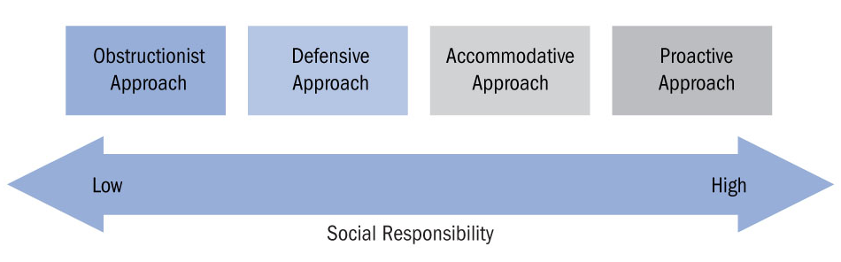
- Obstructionist Approach
- - Managers choose to behave in a non-socially responsible way. They behave unethically or illegally and try to prevent knowledge of their behavior from reaching others

- Defensive Approach
- - Managers stay within the law and abide strictly to legal issues. When making ethical choices, they put the claims of shareholders first, above other stakeholders

- Accommodative Approach
- - Acknowledges the need to support social responsibility. Managers make choices that are reasonable in society’s eyes and do the right thing when called on to do so

- Proactive Approach
- - Managers embrace behaving in socially responsible ways. They go out of their way to learn about the needs of different stakeholders and to promote these interests

