Question 1

BBB-rated Company
Bond | Credit Spread | Maturity
5 Year Bond | 1.25% | Feb 13th, 2018
7 Year Bond | 1.75% | Feb 13th, 2020

Benchmark for 5 Year Bond
Line | Bond | Yield
58 | CAN 1 ¹₂ 09/01/17 | 1.319%
59 | CAN 4 ¹₄ 06/01/18 | 1.379%

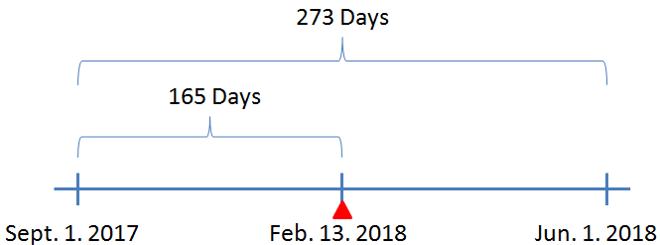

$Interpolation: \left(1.379-1.139\right)×\frac{165}{273}≈0.036263736$
$∴5 Year Coupon: 1.319+1.25+0.036263736≈2.60526\%$

Benchmark for 7 Year Bond
Line | Bond | Yield
60 | CAN 3 ³₄ 06/01/19 | 1.471%
63 | CAN 3 ¹₄ 06/01/21 | 1.644%

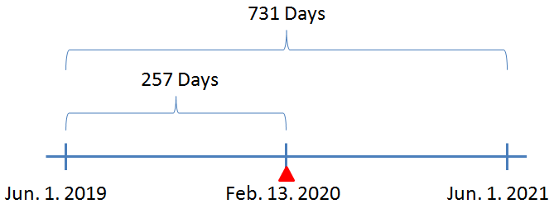

$Interpolation: \left(1.644-1.471\right)×\frac{257}{731}≈0.060822161$
$∴7 Year Coupon: 1.471+1.75+0.060822161≈3.28182\%$

For the 5 Year Bond, we used bond “CAN 1 ¹₂ 09/01/17” and “CAN 4 ¹₄ 06/01/18”; for the 7 Year Bond, we used bond “CAN 3 ³₄ 06/01/19” and “CAN 3 ¹₄ 06/01/21”.

This is because these Canadian Government bonds are the most recently auctioned government bonds, and they are the closest “on-the-run” government bonds to the 5 Year Bond and the 7 Year Bond issued by the BBB-rated Company respectively; therefore, they are used for interpolation calculation.

Question 2

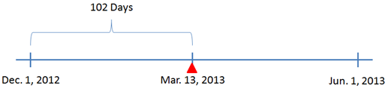

$$Inflation Compensation=1000000×\frac{121.2387}{115.60}-1000000≈\$48777.68$$
$$Coupon Payment=\frac{1.5\%}{2}×(1000000+48777.68)≈\$7865.83$$
$$Days Accrued=102 Days$$
$$Total Days=\frac{365}{2}=182.5 Days (based on {Actual}/{365} Day Count Convention)$$
$$Accrued Interest=7865.83×\frac{102}{182.5}≈\$4396.25$$

- $Reference CPI = 121.2387$
$$Base CPI = 115.6$$
$$Face Value = \$1000$$
$$Inflation Compensation on Principal=1000×\frac{121.2387}{115.6}-1000≈\$48.78$$

- $\frac{Coupon}{2}= \frac{1.5\%}{2}=0.0075$
$$Inflation Compensation on Coupon=0.0075×48.78≈\$0.37$$
Question 3

Information of the Deferred Coupon Bond
Principal | $1000
Coupon | 12%
Coupon/2 (semi-annual basis) | 6%
YTM | 12%
YTM/2 (semi-annual basis) | 6%
Day Count Convention | Actual/365

Timeline
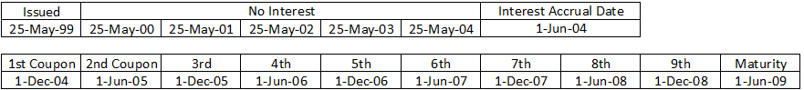

Calculation
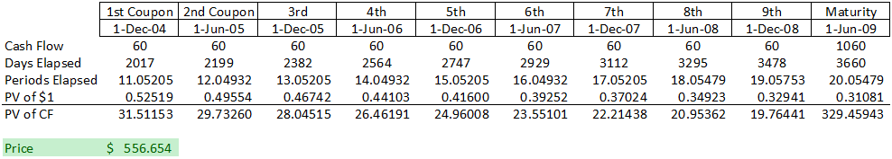
Question 4

(Note: 1/3/2011, 2/21/2011, 4/22/2011, 5/23/2011, 7/1/2011, 8/1/2011, 9/5/2011, 10/10/2011, 11/11/2011, 12/26/2011, 12/27/2011, 1/2/2012, 2/20/2012, 4/6/2012, 5/21/2012, 7/2/2012, 8/6/2012, 9/3/2012, 10/8/2012, 11/12/2012, 12/25/2012, 12/26/2012, 1/1/2013 are banking holidays.)

- The yield curve as of January 31, 2013 is a normal, upward sloping curve, with spreads of both 2/10s and 2/30s being positive, and the spread increases as the term to maturity increases. Although it is a normal curve, it is relatively flatter in comparison to the yield curve back in around September of 2011.

The steepness is decreasing for both of the 2/10s and 2/30s, this means that the yield curve is flattening. As we know, the market moves faster than the central bank, and a flattening yield curve means that the market anticipates lower inflationary pressure in the future.

- Bank of Canada signaling that it would begin to hike interest rates by mid-year indicates that there is inflationary pressure and the Central Bank intends to control it to prevent economy overheat. This implies, to the investors, that a small recession would begin, and expect the long term bond yields to decrease. Demand for long term bonds will increase to lock in the high yield. Supply for short term bonds/bills will increase to take advantage of high prices, and also because of corporations issuing more short term papers to take advantage of lower short term rates. In aggregate, the yield curve will flatten.
Question 5

Year | Par Yield
1 | 6.25%
2 | 6.01%
3 | 5.77%
4 | 5.53%
5 | 5.30%
6 | 5.07%
7 | 4.84%
8 | 4.62%
9 | 4.39%
10 | 4.16%

$$y_{1}=r_{1} \\ 1000=\frac{1000×y_{2}}{1+r_{1}}+\frac{1000×y_{2}}{{\left(1+r_{2}\right)}^{2}}+\frac{1000}{{\left(1+r_{2}\right)}^{2}} \\ 1000=\frac{1000×y_{3}}{1+r_{1}}+\frac{1000×y_{3}}{{\left(1+r_{2}\right)}^{2}}+\frac{1000×y_{3}}{{\left(1+r_{3}\right)}^{3}}+\frac{1000}{{\left(1+r_{3}\right)}^{3}} \\ ⋮ \\ 1000=\frac{1000×y_{10}}{1+r_{1}}+\frac{1000×y_{10}}{{\left(1+r_{2}\right)}^{2}}+…+\frac{1000×y_{10}}{{\left(1+r_{10}\right)}^{10}}+\frac{1000}{{\left(1+r_{10}\right)}^{10}}$$

Year | Forward Yield
2 | 5.75%
3 | 5.25%
4 | 4.75%
5 | 4.26%
6 | 3.76%
7 | 3.26%
8 | 2.77%
9 | 2.27%
10 | 1.78%

$$Forward Yield=\frac{{\left(1+r_{t+1}\right)}^{t+1}}{{\left(1+r_{t}\right)}^{t}}-1$$

Question 6

- Timeline
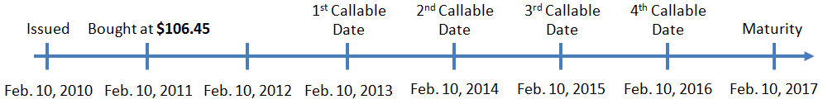

Yield to Call for 2013 |  |  |  |  |  | Yield to Call for 2014
Coupon |  |  |  | 7.25 |  | Coupon |  | 7.25
Redemption |  |  |  | 103.625 |  | Redemption |  | 101.813
Period | Time |  |  | Cash Flow |  | Period | Time | Cash Flow
0 | 10-Feb-11 |  |  | -106.45 |  | 0 | 10-Feb-11 | -106.45
1 | 10-Aug-11 |  |  | 3.625 |  | 1 | 10-Aug-11 | 3.625
2 | 10-Feb-12 |  |  | 3.625 |  | 2 | 10-Feb-12 | 3.625
3 | 10-Aug-12 |  |  | 3.625 |  | 3 | 10-Aug-12 | 3.625
4 | 10-Feb-13 |  |  | 107.25 |  | 4 | 10-Feb-13 | 3.625
 |  |  |  |  |  | 5 | 10-Aug-13 | 3.625
1st Call IRR |  |  |  | 2.76883% |  | 6 | 10-Feb-14 | 105.438
1st Call BEY |  |  |  | 5.53765%
 |  |  |  |  |  | 2nd Call IRR |  | 2.72730%
 |  |  |  |  |  | 2nd Call BEY |  | 5.45459%
Yield to Call for 2015
Coupon |  |  | 7.25
Redemption |  |  | 101.208
Period |  | Time | Cash Flow
0 |  | 10-Feb-11 | -106.45
1 |  | 10-Aug-11 | 3.625
2 |  | 10-Feb-12 | 3.625
3 |  | 10-Aug-12 | 3.625
4 |  | 10-Feb-13 | 3.625
5 |  | 10-Aug-13 | 3.625
6 |  | 10-Feb-14 | 3.625
7 |  | 10-Aug-14 | 3.625
8 |  | 10-Feb-15 | 104.833
3rd Call IRR |  |  | 2.84859%
3rd Call BEY |  |  | 5.69719%

- The yield to worst for the bond is the yield to call for 2014, which is 2.72730%.

- Face amount to be paid by Corus would be 101% of the face value of the bond; therefore:
$$Face amount to be paid=101\%×500M=505M$$

- Corus will call the bond early if the company's credit rating has improved to a higher credit rating, which in turn decreases the company's credit spread, therefore the company can issue new bonds at a lower yield than the current yield.

