Final Exam
Sleep and dream
Origins of Biological Rhythms
- Biorthythm: Inhert timing mechanism that controls or initiates various biological processes
  - Linked to the cycle of days and seasons produced by the Earth’s roation around the sun
  - Animals living near the poles of the Earth are more effected by sesonal changes then animals livin in equatorial regions
  - Human behavior is governed more by daly cycles than by seasonal cycles
- Biological Clocks
  - Nerual systems that times behavoir
  - Allows animals to anticipate events before they happen. (birds migrate before they get cold)
- Behavoir is not simply divern by external cues from the environment
- Rhythms are endogenous (control comes from within)
- Biological Rhythms:
- Period: time reqired to complete a cycle of activity
- Circannual Rhythms: Yearly cycle
- Infradian Rhythm: Les than a year cycle
- Circadian Rhythm: Daily cycle (eg sleep)
- Ultradian rhythm: less than a day (eating cycle)
- Free-Running Rhythms: Rhythm of the body’s own devising in the absence of all external cues.
  - Without input from external cues, our bodies have their own rhyths with periods of 25-27 hours. (sleep to wake cycle shift everyday)
  - Animals expand and contract their sleep periods as the sleep-related lighting period expands or contracts.
- Zeitgebers: environmnental event that entrains biological rhythms; a “time giver” Example: light resets the biological clock.
- Entrainment: Determination or modication of the period of a biorhythm
- Jet lag: Fatigue and disorientation from rapid travel through time zones an exposure to change light-dark cycle
Neural Basis of the Biological Clock
- Suprachiasmatic Nucleus: Main pacemakes of cicadian rhythms located just above the optic chiasm
- Retinohypothalamic Pathway: Nural route from a subset of cone recepots in the retina to the suprachiasmatic nucleus of the hypothalamus; allows light to entrain the rhythmic activity of the SCN
- Other pacemakes exist is the retina and pineal gland, but the SCN is the main one.
- Immortal time: endogenous rhythm is not learned
- Martian and colleagues: transplation studies in hamsters
  - After lesions to the SCN eat and sleep a normal amount but the rhythmic nautre of these behaviors disappears
  - If SCN cells from embryos are transplanted into the lesioned animals, they will reestablish circadian rhythms.
- At least half a dozen genes and the proteins they make seem to produces the circadian rhythm of the SCN cells in mammals
- Mechanism is not fully understood
- Timing System:
  - Light entrains the SCN pacemakes
  - SCN pacemaker drives a number of “slave oscillators” each of which controls the rhythmic occurrence of one behavior (eg body temperature

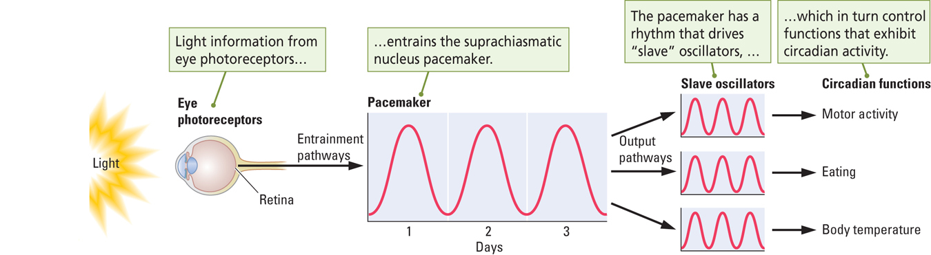

- Melatonin: hormone secreted by the pineal gland during the dark phase of the day-night cycle; influences daily and seasonal biorhythms
- Hamsters: in winter melatonin levles increase, gonads shrink, testosterone levels decrease, and sexual behavior decreases. In summer melatonin levels decrease, gonads grow, testosterone levels increases and sexual behavior increases.
Sleep and dreaming
- Measures how long we sleep
- There is a considerable variation in people’s sleep-waking behavior
- People sleep more when they are young
- Most people sleep 7-8 hours per night
- Some sleep much more or less
- Measuring sleep:
  - A polygraph is used to measure the electrical activity of the brain and body
  - EEG: records brain wave activity
  - EMG: records muscle activity
  - EOG: records eye movment
- Beta Rhythm (Waking State): fast brain-wave activity. 15-30HZ. Pattern associated with a waking EEG.
- Alpha Rhythm (Drowsy State): Large, extremely regualt brain waves. 7-11Hz. Associated with drowsiness
- Delta Rhythm (sleeping state): slow brain wave activity 1-3 Hz. Pattern associated with deep sleep (NREM sleep)
- REM Sleep (dreaming state): fast brain-wave pattern displayed by the neocortical EEG record during sleep

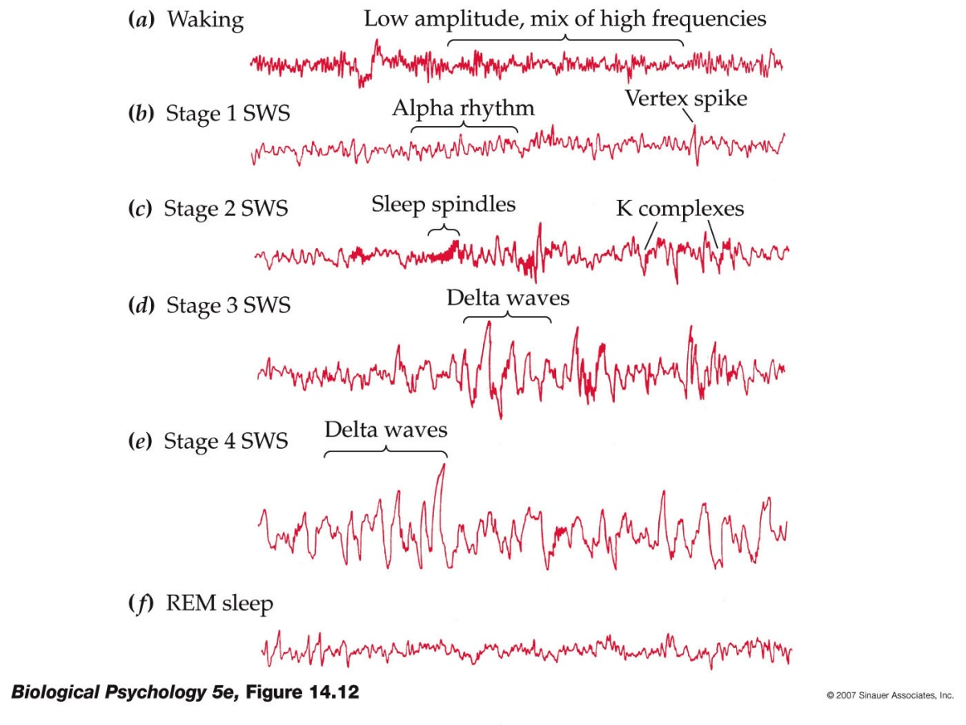

- A typical night’s sleep: 4 stages of Non-REM or slow wave sleep
  - Stage one most shallow
  - Stage 2
  - Stage 3
  - Stage 4: most deap
- REM: deep sleep, 5th stage, dominant in hours 4-7 of sleep
- NREM sleep: large range of activities take place
  - Decrease in body temperature, increase in growth hormone release
  - Dreams occur but are not as vivid
  - Sleeptalking
  - Sleepwalking
  - Night terrors
  - NREM sleep is not a quiet, inactive period
- REM sleep:
  - Atonia: no tone; condition of complete muscle inactivity produced by the inhibituon of motor neurons
  - Mechanisms that regulate body temperature stop working
  - Vivd dreams occur: everyone dreams!!
  - Dreams take place in real time, dream sessions get longer throughout sleep session
Pychoanalytic Theories of Dreaming:
- Sigmund Freud: Dreams are the symbolic fulfillment of unconscious wishes
  - Manifest Content: Loosely connected series of bizarre images and actions
  - Latent Content: true meaning of the dream.
- Carl Jung: dreams are expressions of our collective unconscious (history of the human race)
- J. Allan Hobson: Activation-Synthesis Theory:
  - The cortex is bombarded with signlas from the brainstem, producing the waking of EEG
  - In response, the cortex generates images, actions and emotions of personal memory stores
  - Dreams are personal but they have no meaning.

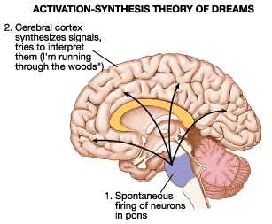
Evolutionary Hypothesis:
- Anttio Revonsuo: dreams are highly organized and biased toward threatening images.
- Dreams are biologically important because they lead to enhanced performance in dealing with threatening life events (adaptive function)
- Dreams are a coping strategy.
What does sleep accopmplish?
- Early explanation: sleep is a passive process that takes place as a result of a decrease in senory stimulation
- Does not account for the complexity of sleep
- No direct evidence:
  - Sensory deprivation research has shown that people actually sleep less, not more when placed in isolated environements
- Biological Adaptation:
- Sleep is an engergy-conserving strategy:
  - Gather food at optimal times and sleep to conserve engergy the rest of of the time
  - Nocturnal or diurnal animals will sleep during those times in which they cannont travel easily
- Animals with nutrient-rich diets spend less time foraging for food and more time sleeping
- Animals that are predators sleep more than animals that are prey.
- Basic rest-activity cycle:
  - Recurring cycle of temporal packets, about 90 minute periods in humans, during which an animal’s level of arousal waxes and wanes:
  - Examples: school classes, work periods, meal times, snacks, REM cycles
  - So fundamental that it cannont be turned off even at night, so the body is paralyzed during REM sleep to prevent interruptions thoughout sleep.
Sleep as a Restoritive Process:
- Chemical events that provide energy to cells may be reduced during waking and are replenished during sleep
- Fatigue and altertness may simply be aspects of the circadian rhythms and have nothing to do with wear and tear on the body.
Sleeep Deprivation:
- Recuperative theories make specific predictions about sleep deprivation
- Long periods of wakfulness will produced physiological and behavioural disturbances
- Disturbances will grow steadily worse as deprivation continues
- After a period of deprevation has ended, much of missed sleep will be regained
- Randy Gardner: 1965 Science fair project, stayed awake for 264 hours 11 days.
  - Only thing proved wrong was that sleep will be regained.
- Stress causes sleep deprivation
- Shift workers or jet lag changes circadian rhythm
- Studies: meausres sleepiness, mood, cognition, motor performance, physiological function
- Complete depreavtion: 3-4 days max, negative effects on mood, congnitive and perceptual motor task
- Microsleeps: 2-3 sec eyelids droop, less responsive to external stimuli
- Partial deprivation or sleep restriction (sleep only 3-4 hours/night)
  - Increased sleepiness,
  - Disturbances in mood
  - Perform poorly on tests of vigilance, impaired attention, reaction time, coordination and decision making
  - Worse if subjects performing long lasting, difficult monotonous tasks.
REM sleep deprivation:
- Little effect on daytime functioning
- Two consistent effects:
  - With each successive night of depivation, greater tendancy to initate REM seequences; 17 v 67 times
  - Rebound effect: following REM depreavion, have more than usual amount of REM for 2-3 nights
  - Similar effects with SWS (slow wave sleep): Suggests amount of REM and SWS is regualted separately
- Appear to be no adverse effects of REM sleep deprevation
- Antidepressants reduce the amount of REM sleep with no evidence of adverse consequences
- Recent paper suggests tha REM sleep supression following antidepressant administration impairs hippocampus-dependent learning
Sleep and memory storage
- Sleep plays a role in solidifying and organizing events in meory:
- Wilson and McNaughton: groups of place cells that fired during a food-searching task also fired during the subsequenct sleep period
- Importance of NREM for memory storage
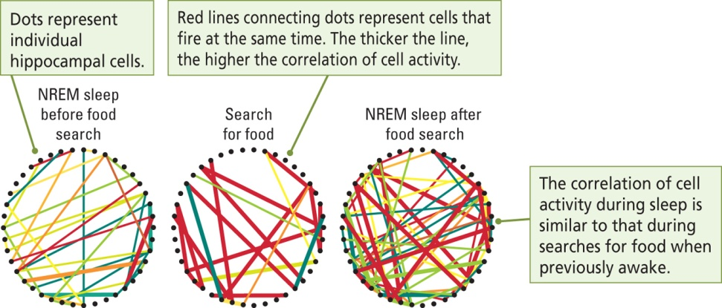
- Maquet and colleagues: used PET imaging to record brain activity while human subjects performed a serial reaction task
  - PET imaging during subsequent sleep revealed that the same brain regions that were active during the task were also active during Rem sleep
  - Subjects were dreaming about their learning experience
  - REM sleep strengthened the memory of the task
Recticular Activating System and Sleep
- Large recticulum (mixture of cell nuclei and nerve fibers) that runs through the cernter of the brainstem
- Associated with sleep-wake behavior and behavioral around
- Stimulation of the RAS produces waking EEG; dmage to it produces a slow wave EEG. (normally, RAS leads to desynchronized EEG)
Neural Basis of EEG changes associated with Waking:
- Two brainstem systems influence waking:
- Basal Forebrain: contains cholinergic cells that secrete actylcholine onto neocortical neurons that stimulate a waking EEG (beta rhythm)
  - Animal is still but alert
- Median Raphe Nucleus (midbrain): contains serotonin neurons that project diffusely to the neocortex; also stimulate beta rhythms
  - Animal is altert and moving
Neural Basis of REM sleep:
- Perbrachial Area:
  - Cholinergic nucleus in the dorsal brainstem have a role in REM sleep behaviours: projects to the medial pontine reticulum
  - Initiates REM sleep
- Medial Pontine Reticular Formation
  - Nucleus in the pons particpating in REM sleep
  - Projects to several other brain stem areas that produce REM-related bahaviors (example prduces atonia)

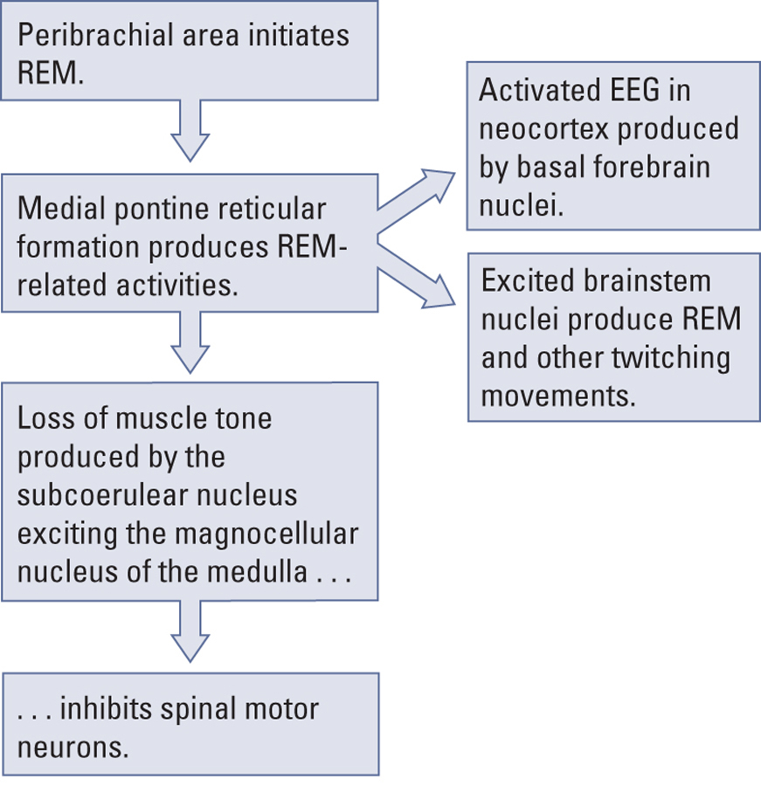

Disorders of Non-REM sleep:
- Insomnia: disorder of slow-wave sleep resulting in prolonged inability to sleep. Has multiple causes
- Drug-Dependency Insomina: condition resulting from continuous of sleeping pills; drug tolerance also results in deprivation of either REM or NREM sleep leading the user to increase the drug dosage
- Narcolepsy: slow wave sleep disorder in which a person uncontrollanly falls asleep at inappropriate times.
  - May be due to mutations in the gene that produces hypocretin/orexin peptides
- Sleep Apnea: Inability to breathe during sleep; person has to wak up to breathe
- Sleep Paralysis: inability to move during deep sleep owing to the brain’s inhibiton of motor neurons
- Catteplexy: form of narcolepsy linked to strong emotinal stimulation in which an animal loses all muscle activity of tone as if in REM sleep while awake
- Hypnogogic Halluncination: deamlike event at the beginning of sleep or while a person is in a state of cataplexy
What does sleep tell us about consciousness:
- Consciousness is not a unitary condition, but rather there are states of consciousness
- Studing sleep may also help us to understand some psychiatirc and drug-incuced conditions
- Examples: are halluncinations related to dream events that occur during Rem sleep?

Learning and Memory
- Learning: a change in an organism’s behavior as a result of experience
- Memory: the ability to recall or recognize previous experience.
  - The persistence of learning (animals)
  - Memory Trace: a mental representation of a previous experience
  - Presumed to corresponnd to some phyciscal change in the brain
Classical conditioning:
- Learing procedure whereby a neutral stimulus comes to elicit a response because of its repeated pairing with some event
- Unconditioned stimulus: stimulus that evokes an uncondtioned response without previous conditioning (food)
- Unconditon response: unleared reaction to the unconditioned stimulus, that occurs without learning (salivation)
- Conditioned Stimulus: previously a neurtal stimulus and now elicits the response
- Conditioned response: learned reaction to a conditioned stimulus that occurs because of conditioning
- Eye blinking conditioning: experimental technique in which subjects learn to pair a formerly neurtral stimulus to a defensive response. Example: puff of air and a tone makes you blink
Neural Basis of Classical Conditioning:
- A training stage activates a pathway involving the cerebellum (superordinate curcuit) that makes the subject blink.
- After the training stage the conditioned stimulus alone activates the superordinate circuit.
- Neuroplasticity allows for the strengthening of synapses. If a tone is the conditioned stimulus, the synapse between a neuron in the auditory system will strenthen with the motor neuron of that particular action.
Fear conditioning:
- Learned association, a conditioned emotional response, between a neutral stimulus and a noxious event such as a shock.
- Involves the amygdala
- Remember better when you have a high adrenline dose in your system.
Instrumental Conditioning:
- Learning procedure in which the consequences (such as obtaining a reward) of a particular behaviour (such as pressing a bar) increase or decrease the probability of the behavior occurring again.
- Thorndike’s Puzle Box: a hungry cat will eventually learn that pressing a lever will open the door so that it can reach some food.
Prinicples of Reinforcement:
- Fundamental principle: organisms tend to repreat responses that are followed by fourable consequences
- There behaviours are reinforced: when an event following a response increases and orgainsm’s tendency to make that response.
- Positive reinforcement: adding a reward or a consqence.
- Negative reinforcement: removal of a reward or a consequence
Independent Memory Systems:
- Short term memory: sensory, motor, cognitive
- Longterm:
- explicit (concious)
  - Also known as declarative
  - Episodic: personal, autobiographical, events pegged to specific place time contexts
    - Episodic amnesisa: inability to recall any personally experiened events
    - Associated with frontal lobe injuries or reduced blood flow to the frontal lobes
    - Frontal lobes may allow us to menally travel through our past
  - Semantic: factsm knowledge.
  - Subjects can retrieve an item and indicate that they knw that the retrieved item is the correct item
- Implicit (unconsious): skills, habits, priming, conditioning
  - Also known as Procedural
  - Subjects can demonstrate knowledge such as a skill, a conditioned response or recalling events on prompting, but cannon explicitly retreive the information.
- Emotional ( both): attraction, avoidance, fear.
Differences between explicit and Implicit:
- Encoding memories::
  - Implicit information is processed in a “botton-up” or data-driven mammer
  - Information is encoded in the same way as it was perceived
  - From the sensory systems to the contex
  - Explicit information is prcessed in a top-down or ceptually-driven manner
  - The subject reorganized the information before it is encoded.
- In implicit tasks the person has a passive role; whereas in explicit tasks the person has an active role
- Priming: using a stimulus to sensitize the nervous system to a later presentaion of the same or a similar stimulus; often used to mesure implicit memory: gollin figure test (lines making an object… what is the object)
Neurobiology of Memory
- Karl Lashley
- There is no single place in the nervous system that can be indentified as the location of memory or learning (cortex works as a whole)
- Does not depend on connections across cortex
- Information from each sensory modality is processed and stored in differnet neural areas.
- Marin and colleagues:
  - Participants shown black and white line drawings of objects
  - Asked to generate words denoting either colours or actions or objects
  - Recall of colours activated a region in the ventral temportal lobe
  - Recall of action words activated a region the in the middle temporal gyrus
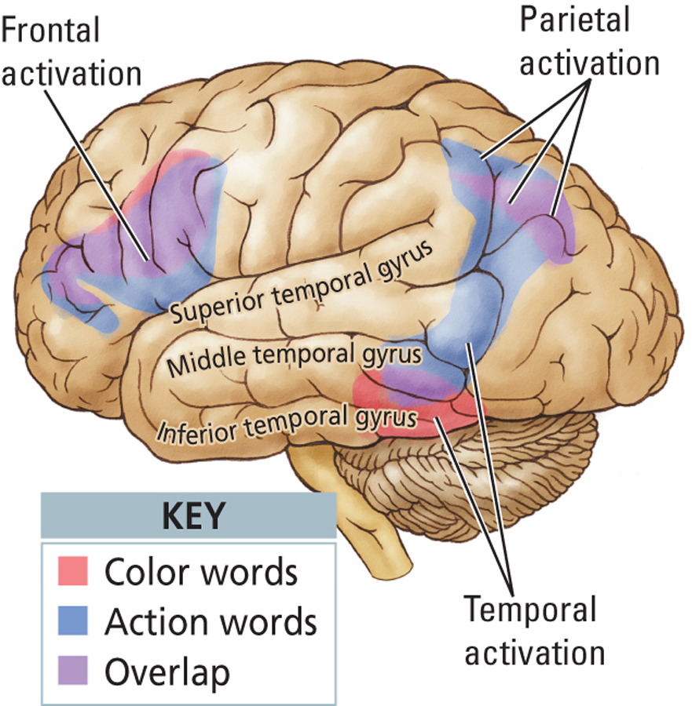

- Different types of memory involve distinct brain regions:
- Short term: prefrontal cortex, sensory association areas
- Longterm:
  - Delarative: medial temporal and frontal lobes
  - Procedural: basal ganglia, motor association areas, cerebellum
  - Episodic: frontal lobe
  - Emotional: amygdala
- In 195h William Scoville preformed a bilateral medial-temporal lobe resection on HM for relief of severe epilepsy (hippocampla formation, amygdala, adjacent cortices in medial temporal lobe)
  - Could not recall anything that had happened after the surgery (no explicit memory
  - Performed well on perceptual tests and could still recall his childhood
  - Implicit memory left intact
- Retrograde amnesisa: cannot remember past
- Anterograde: cannot form new memories
- People with amnesia can perform normally on tests of implicit memory but not explicit memory
- Patient JK: imparied implicit memory with intact explicit memory
  - Developed parkinson’s disease in his mid 70s and started to have memory problems at 78 years of age
  - Damamge to basal ganglia
  - Impaired ability to perform tasks that he had done all his life (turning of a radio)
  - Could still recall events
Neural circuits for Explicit memories
- Medial temporal region: hippocampus, amygdala, entorhinal cortex (intergrative role, Alzheimer’s)
  - parahippocampal cortex: cortex located along the dorsal medial surface of the temporal lobe.
    - Receives connections from parietal cortex; involved in visuospatial processing
  - perirhinal cortex: cortex lying next to the rhinal fissure on the base of the brain
    - receives connections from the visual regions of the ventral stream; visual object memory
- Frontal cortex
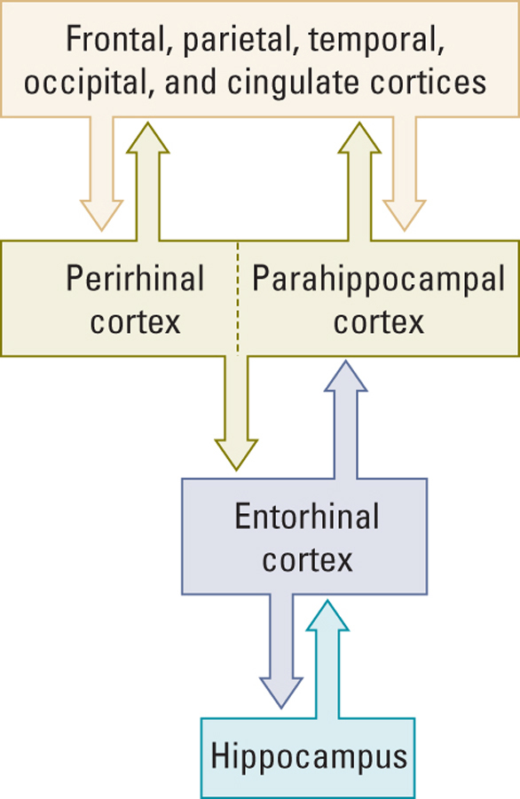

Hippocmpus and Spatial Memory:
- Visuospatial Memory
- Using visual information to identify an object’s location in space
- Monkeys with hippocampal lesions have difficulties with visuospatial learning
- Perirhinal lesions impaire in taks B
- Hippocampal lesions impaired in task C

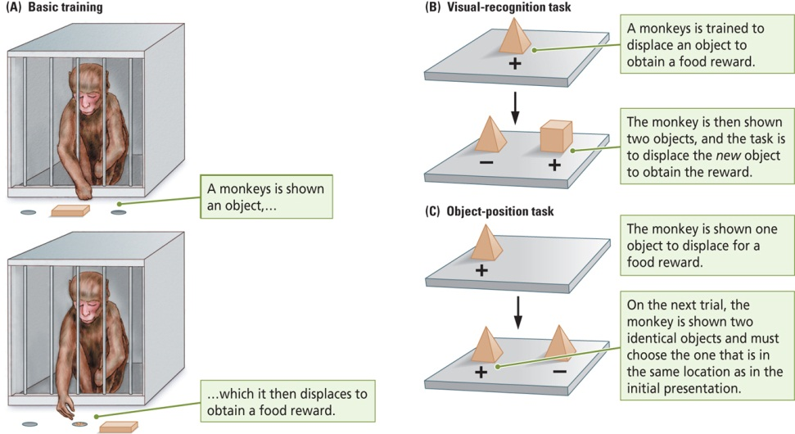

Frontal Lobe and Short Term Memory
- All sensory systems project to the frontal lobes
- During tasks in which monkey keep information in short-trm memory over a delay certain cells in the frontal cortex will fired throughout the delay
- Animals that have not learned the task show no such cell activity
- Delayed response task: must chose the same location
- Delayed alternation task: must chose other position
- Matching to sample: must chose same coloured light
Reciprocoal Connections for Explicit Memory:
- The neocortex projects to the entorhinal cortex which projects back to the neocortex:
- Signals from the medial temportal regions back to the cortical sensory regions keep the sensory eperience alive in the brain: the neural record outlasts the actual experience
- Pathway back to the neocortex means it is kept apprised of the information being processed in medial temportal regions
Neural Circuit for Explicit Memory:
- Mishkin and colleagues
- Temporal Lobe structures
- Frontal Lobe: frontal cortext importan for short-term memory and oder of explicit events
- Basal Forebrain activating systems: keeps activity in forebrain high
- Temporal lobe=LTM
- Sensory areas to the medial temportal regions to medial thalamus and prefrontal cortex
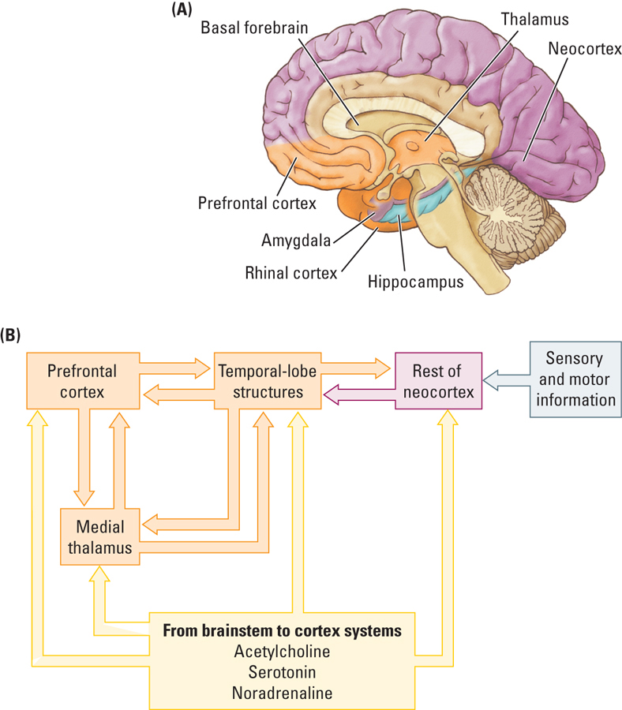

Proposed circuit for Implicit Memory:
- Mishkin and colleagues
- Basal Ganglia
- Ventral Thalamus
- Substantia Nigra
- Premotor Cortex
- Unconcious nature of implicit memory: connection bewteen the basal ganglia and cortex are unidirectional
  - Basal ganglia receives information from the cortex but does not project back to the cortex
  - For memories to be consious there must be feedback to the cortex
  - Medial temporal lobe projects back to the cortex SO explicit memories are conscious
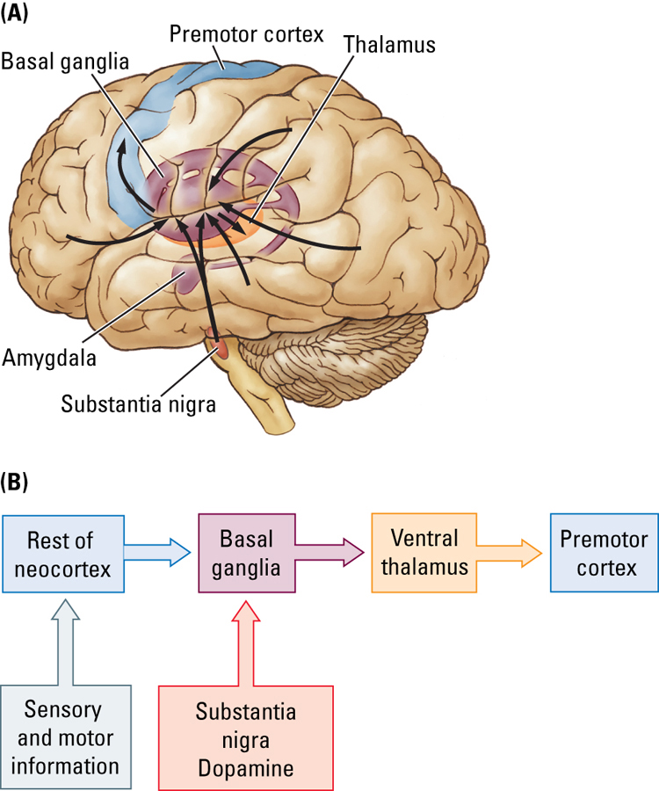

Neural Circuit for Emotional Memories
- Affective properties of stimuli or events
- Amygdala is critical
- Medial temporal cortext if the memory is explicit
- Brianstem (autonomic arousal
- Hypothalamus (hormones)
- Periaquaductal Grey matter (pain
Basal Ganglia is th e memory is implicit
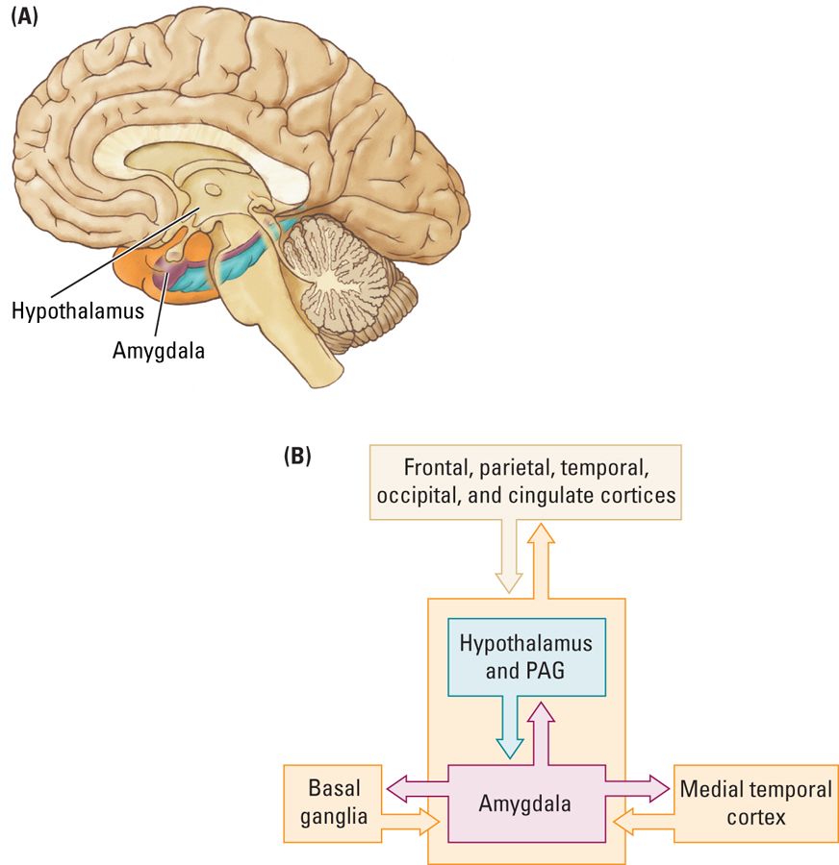

Korsakoff’s Syndrome:
- Indirect cause of chronic alcohol consumption; direct cause of malnutrition
- Poor diet: lack of vitamin B1 (thiamine)
- Chronic alcoholism compromises thiamine absorption from GI tract, impairs thiamine storage
- May also result from dietary deficiencies, prolonged vomiting or eating disorders
- Results in both types of amnesia
- Confabulation
Mammillary Body Atrophy
- Also have damage to medial thalamus and frontal lobes
- Acute WKS: mammillary body hemorrhages
- Old WKS: mammillary body atrophy
- Involed in explicit memory?
Structural Basis of Brain Plasticity
- All brain regions can be modified by experience
- At the neural level, memory is associated with changes that take place at the synapse
- Two research approaches
  - Synaptic changes in the nervous system of “simple” organisms
  - Synaptic changes in the mammalian brain
- Measuring Synaptic Change:
  - Modifying existing circuits
  - Neurons change their structure in response to their changing experiences
  - Changes in the number of dendrites canbe used to infer synaptic changes
  - More dendrites= more connectections= change in synaptic organization
  - New synapses can form between neurons that are already connected or between neurons that were not previously connected
  - Formation of new synapses from new axon terminals
  - Formation of new synapses from original terminals
- Creating Novel Circuits:
  - Predominate view prior to the mid-1990s: the mammalian brain does not make new neurons in adulthood
  - There is now evidence that neurogenesis does occur in the mammalian brain
- Enriched Experience and Plasticity
  - Increased brain weight
  - More dendrites
  - More astrocyctes
  - More blood capillaries
  - More synapses per neuron
  - Increased mitochondrial volume (marker of greater metabolic activity)
- Sensory or Motor Training and Plasticity:
  - Chang and Greenough:
    - Placed patches over one eye of each rat so that the contralteral hemisphere was deprived of visual input
    - Trained rats on a maze
    - The visual cortex of the “trained hemisphere” (received info from eye without the patch) had more extensive dendrites
  - Nudo and Colleagues (1997)
    - Had monkeys retrieve food from small or large food wells
    - Small wells required dexterous movements of one or two fingers ( more difficult task required the learing of a fine motor skill whereas the monkeys could put their entire hand in the large wells
    - The digit representation on the motor cortex was larger for animals hat had to retrieve food from the smaller wells
  - Ramachanran (1993)
    - Indirectly measured the cortical maps in individuals with limb aputations
    - When the face was stroked softly with a cotton swab, amputees reported sensation of being touched in the amputated hand
    - “phantom limb”
    - Neurons of the face area of the motor cortex has expanded to occypy the missing limb portion
    - But the brain circuitry still responds to the activity of this cortex as representing input from the limb.
- Experience dependent changes in the brain:
- Is there a replationship between neuronal structre and education
  - Whereicke’s area more dendritic branching with more education
- Scheibel and collegues:
  - Relationship between the complexityof dendritic branding and the nature of the computational tasks performed by a brain area
  - Neurons receiving input from the fingers will be larger versus the chest wall
  - Life experience alters dendritic morphology
  - Career word processors have greater differences between finger and truck neurons than salespersons
Molecular Basis of Memory:
- The preeated and persistent stimulation of the post synaptic neuron by the presynaptic neuron leads to an increase in the synaptic efficacy (increase strength of the PSP)
- The disuse of a sunaptic pathway leads to a decrease in synaptic efficacy (decrease in the strength of the PSP)
- Hebbian Learning
- Cell assembly: interlinking neurons capable of action as a closed system.
- Concept of reverberating circuits: interneurons could be used to feed excitation back into a given neural circuit, keeping that circuit active long after the original source of exciatiion has been removed
- Long-term potentiation: increase in synaptic strength following high frequency stimulation of neuralpthway that remains even after the stimulus has been removed
  - A long term increase in the magnitude of EPSPs in the postsynaptic neurons
  - Rapid rate of stimulation required

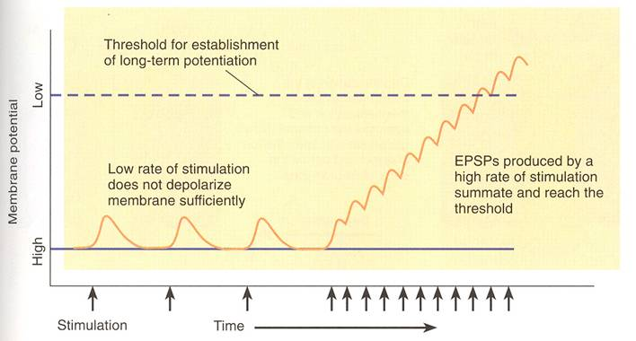

- Gradual increase in EPSPs size over days
- LTP involves activation of synapses and depolarization of the postsynaptic membrane
- LTP involes activation of NMDA and non NMDA receptors (Glutamate)
- The NMDA receptor controls a calcium channel which is blocked by Mg2+ ions
- Mg2+ ions are ejected from the calcium chnnel when the membrane is depolarized though the activation of AMPA receptors
- Opening the calcium channel requires via activation of NMDA receptors requires the presence of glutamate and a depolarize membrane
- Drugs that block NMDA receptor block the formation of LTP
- 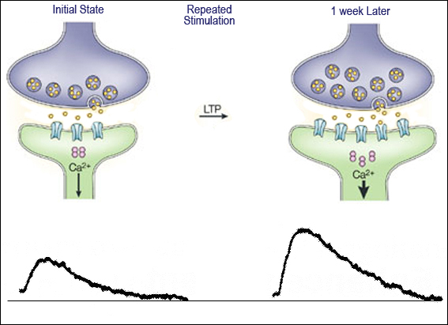
- Beacuase the NMDA receptor pore is blocked by a magnesium ion, release of glutamate by a weak electrical stimulation activates only the AMPA receptor
- A strong electrical stimulation can depolarize the postsynaptic membrane sufficiently that the magnesium ion is removed from the NMDA receptor pore.
- Now glutamate, released by weak stimulation, can activate the NMDA receptor to allow an influx of calcium, which through a second messsenger, increasses the function the function or number of AMPA receptors or both.
- Inhibition of protein synthesis effects learning
- 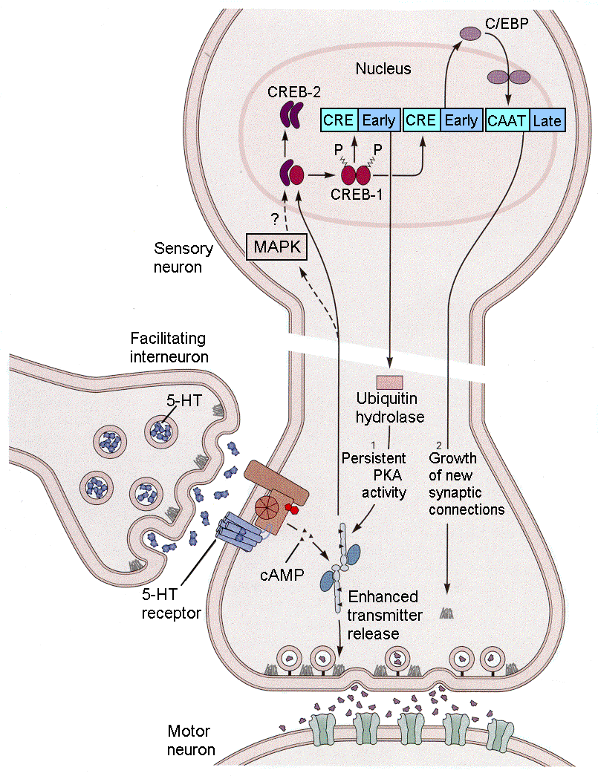
Long term Depression
- A long term decrese in the excitability of a neuron to a particular synaptic input caused by the stimulation of the terminal button while the postsynaptic memnrain eis hyperpolarized
- Low frequency stimulation decreasing the streghth of synaptic connections >10Hz
- May allow for reversal of learned patterns in response to changes in th environment.
Hormones and Plasticity
- High levels of estrogen: more dendritic spines in the hippocampus
- Low levels of estrogen: more dendritic spines in the neocortex but fewer spine in the hippocampus
- Estrogen related to memory decline in middle-aged females?
- Low levels of testosterone: more dendritic spines in neocortex (related to decrease in spatial ability?)
- Glucorticoids:
  - Released from the adrenal cortex in times of stress
  - Assist in the metabolism of proteins and carbohydrates and the control of sugar levels in the blood and cells
  - Steady levls of glucocorticoids that are seen with prolonged stress may be neurotoxic.
  - Stress kills hippocampal cells.
Neurotrophic Factors and Plasticity:
- Nerve growth Factor: stimulaates neurons to grow dendrites and synapses and in some cases, promotes the survival of neurons
- Brain-Derived neurotrophic Factor: may enhance plastic changes such as the growth of dendrites and synapses
- Increased levels when animals learn to solve problems.
Psychoactive Drugs and Plasticity:
- Drug induced bhavioral sensitization:
  - Escalating bejavioral response to the repeated administration of a psychomotor stimulant, such as amphetamine, cocaine, or nicotine, also called behavioral sensitization
  - Sensitization is associated with an increased number of receptors, synapses and ddendrites
  - Theres changes were localized to regions that receive a large dompanine projection (prefrontal cortex, nucleus accumbens)
  - The sensitization induced by repeated exposure to amphetamine changes the stucture of neurons in certain brain area.
Recovery from Brain Injury
- Learn new ways to solve problems
- Reorganize the brain to do more withless
- Gernerate new neurons to produce new circuits
- Compensate by changing behaviour (three legged cat)
- New circuit solution: in response to injury the brain can form new connections and do more with less
  - Behavioral Therapy (speech, physiothereapy)
  - Pharamcological Therapy (nerve growth factor, amphetamine)
  - Nerve growth factor stimulates dendritic growth and incrased spine density in both normal and injured brain, these neuronal changes are correlated with improved motor function after a stroke.
- Lost Neuron replacement solution
  - Fetal tissue implantation: limited success to date, only when small number of cells are needed (dopamine cells in Snigra for Parkinson’s)
  - Replaced lost cells: neurotrophic factor that stimulates the subventricular zone to genrate cells that migrate into the striatum eventually differentiate into neurons and glia
Cognition
The Nature of thought
- Thinking is an activity of complex neural cirucits, not some region of the brain
- Cell Assembly
  - Hypothetical group of neurons that become functionally connected because they receive the same sensory inputs
  - Hebb propised that cell assemblies were the basis of perception memory and thought
- Thinking is due to the activity of many different systems which, in the mammalian brain are located in the cortex
- Difficult to study as these are not observable
- Psychological constructs: idea resulting fron a set of impresions that some mental ability exists as an entitiy, difficult to localize in the brain
- Cognition: act or process of knowing or coming to know, the processes of thought
Characterisitics of Human thought:
- Verbal
- Language gives the edge on thinking
  - Categorize information
  - Organizing time
- Synatx:
  - Allows humans to have a language that moved beyond the concrete world of ther here and now.
Neural Unit of thought:
- Newsome and Colleagues:
  - Trained monkeys on an apparent motion paradigm and performed single cell recordings
  - Found that the perception of apparent moton was influenced by individual neurons, not by the summed activity of many neurons.
- Neurons are the foundation of thought and congitive process
- Multiple neurons converge to form cell assemblies to represent complex thought
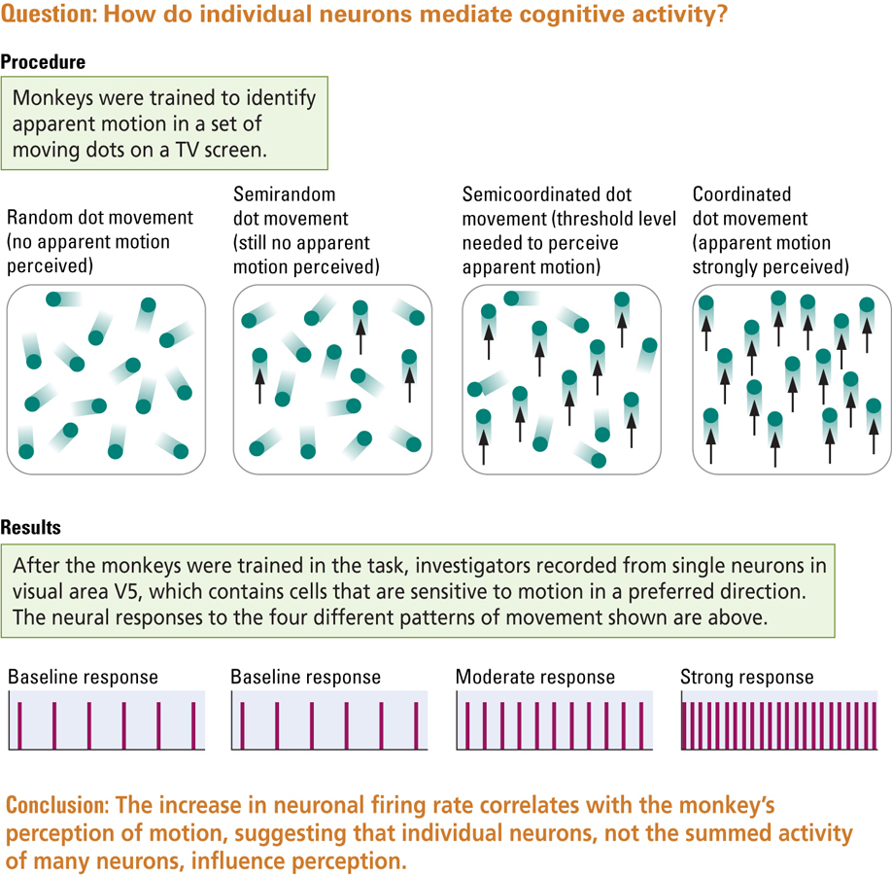

Key cortical areas:

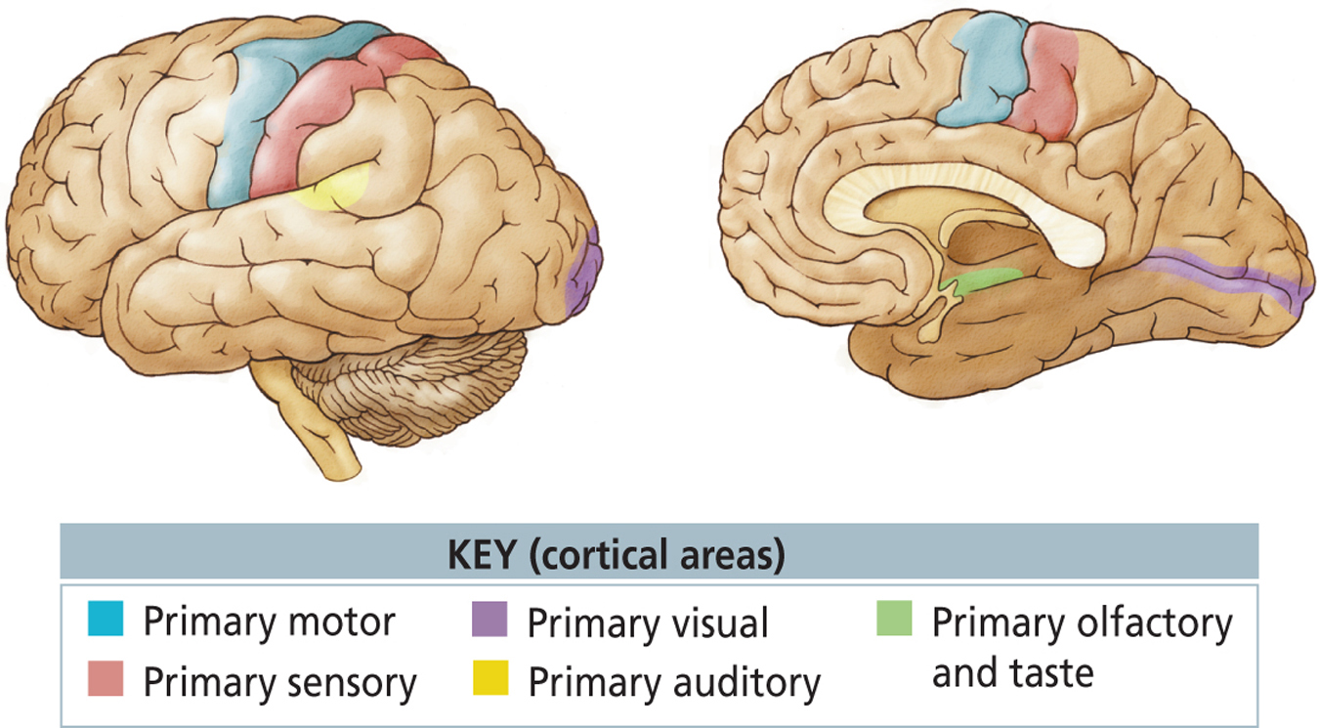

- All areas that is not a primary cortex is the association cortex
Association Cortex and Cogniton
- One of the key differences between association cortex and the primary sensory and motor corticies is the pattern of connection
- The association cortex reieves information that is more highly processed than informaton recived by the primary corticies
- Detailed knowledge about the external world and the interal world
Forms of conitive behaviour linked to parts of the association cortex:
- Knowledge about objects: Temporal association cortex, ventral visual stream
  - If the temportal association cortex is damaged: visual agnosia (what they are are what they are used for)
  - Apperceptive Visual Agnosias: failure to perceive objects
    - Can still recognize by touch
    - Cannot draw objects or copy drawings
    - Deficit in perception

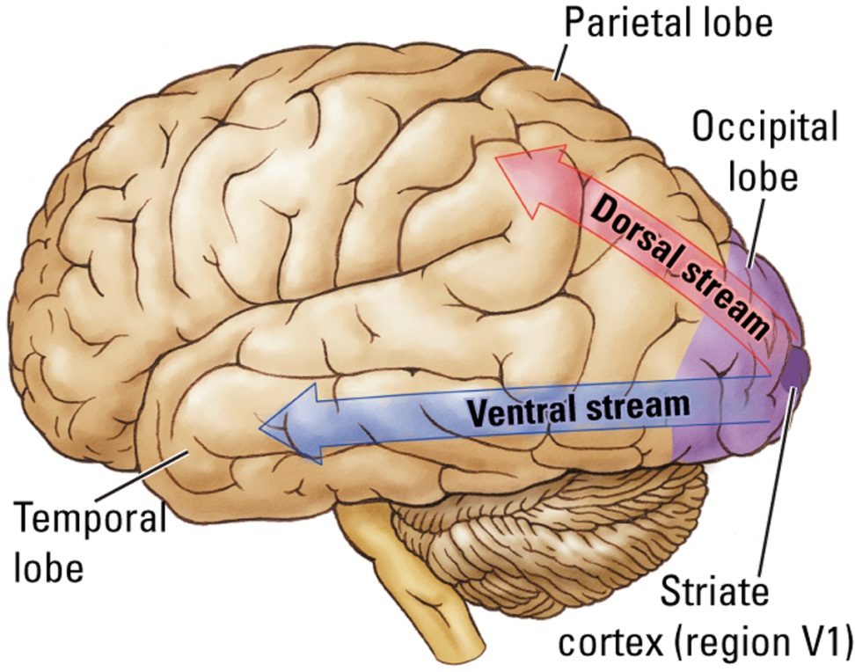

- Multisensory Intergration: Binding problem
  - How the brain ties single and varied sensory and motor events together into a unifed perception or behavior
  - Regions of the association cortex are multimodal
  - These neurons respond to informaton from more than one sensory modality.
- Spatial Cognition: range of metal functions, raning from the ability to navigate from point A to point B to the representation of complex visual arrays
  - The ability to mentally manipulate thinkgs likely evolved in parallel with out ability to navigate in space
  - The dorsal visulat stream the parietal lobes is important in spatial cognition
- Attention: selective narrowing or focusing of awareness to part of the sensory environment or to a class of stimuli
  - Morgan and Desimone:
  - Neurons is area V4 could be trained to respond selectively to information in their receptive field.
  - Respond tostimuli in one location but not the other.
- Deficits of Attention:
- Frontal association cortex: Damage can lead to focusing excessively on external stimuli and difficulty shifting attention
- Parietal Association Cortex: damage can produce contraleral neglect
  - Ignoring a part of the body or world on the side opposite that of the brain injury
  - Extinction: neglect of information on one side of the body when it is presented simultaneously with similar information on the other side of the boyd
  - Patients with contralateral neglect exhibit this symptom as they begin to recover
  - The same objects: paitent sees only one
  - Different objects the paitent sees both
- Planning: Frontal lobes act like a conductor
  - People with frontal lobe injuries are unable to orgnize their behaior
  - Card sorting test
- Imitation and Understanding: for successful communication, sender and receiver must have a common understanding of what counts
  - Mirror neurons
  - Cells in the primate premotor cortex that fire when an individaul observes a specific action taken by another individual
  - Rizzolatti: The human capacity to communicate with words may have resulted from the progressive evolution of mirror-neuron system
Cerebral Asymmetry in thinkinkg/ Anatomical Asymmetry
- Gross anatomical differences between hemispheres
- Left hemisphere: language
- Primary Auditory cortex: larger on the right than on the left
- Secondary Auditory Cortex: larger on the left than on the right
- Sensory Motor Cortex representing the face: larger on the left than on the right
Fuctional Asymmetry
- Case GH: damage to right parietal lobe: difficulties copying drawings, assembling puzzels, navigating familiar places
- Case MM: Left Parietal damage: dificulties with language, copying movements, reading, math, generating names of objects or animals
- Right Hemisphere: spatial skills, left hemisphere in language, reading, writing math
Normal Brain:
- Dichotic Listening:
  - Experimental procedure for simultaneously presenting a different auditory input to each ear through earphones
  - Right ear advantage for verbal information
  - Left ear advantage for musical information
- Visual System:
  - Right for language realted information
  - Left for non verbal spatial information
  - Example: right sees name, left sees face
Split Brain:
- Surgical disconnection of the two hemispheres in which the corpus callosum is cut
- Language Abilities:
  - When objects are presented in the right visulat field information goes to left brain, patients can easily name them
  - When objects are presneted to the right hemisphere, patients cannot name them but may be able to make nonverbal resposonses: used their left hand to select the object that matches the one that was presented.
  - The two hemispheres can act independently
  - When each hemisphere is shown a different object the two hangs will each slect different objects as being the correct one.
  - In additon to supporting the role of the left hemisphere in language reseach with split brain individuals also confirms the role of the right hemisphere in spatial tasks
  - When asked to perform a visuoconstruction task the individuals perform better with their left hand than with their right hand
  - Left hand superiority increases as the task becomes more difficult
Explaining Cerebral Asymmetry:
- Why is the left hemisphere specialized for language?
  - LH plays are role in the control of fine movements and fine movements are necessary for the production of language
- RH for spatial abilities?
  - RH plays are role in the control of actual movements in space and in mental imagery of such movements (elaboration of the functions of the dorsal stream)
Left Hemisphere, Language and Thought
- Gazzaniga (1992)
- Unlike other animals the speaking left hemisphere in humans acts as an interpreter: it is able to infer relationships among stimuli
- Example: present images to both hemispheres then another image that completes the sequence must be selected. (present match and log, then selcet fire)
- Right hemisphere cannont make the selction
Sex differences in Cognitive Organization;
- On average females are better than males on short term memory tye tasks and verbal fluency type tasks
- On average males are better on spatial realation type tasks and mental rotation tasks.
Neural Basis of Sex differences:
- Gonadal hormones influence the structures of neurons on the rat prefrontal cortex
- Neurons in male rats have larger dendritic fields in the medial frontal cortex
- Neurons in female rats have larger dendritic fields in the orbitofrontal cortex
- These differences are not seen when the rats have had their gonads or ovaries removed
- Rowntree (2009):
  - Tested girls at age 16 and under
  - Girls who began menstruating early (12 or younger) were better on tests of verbal fluency than girls who began menstruating later
  - Grils who began menstruating later were better at tests of spatial ability
  - The age at which gonadal hormones affect the brain may be an important factor in congitive development
- Kimura (1999) does brain damage affect females and males differnently?
  - Females were more likely to be aphasic and aparaxic after lesions to the left frontal cortex
  - Males were more likely to be aphasic and apraxic after lesions to the left posterior cortex
  - These results sugggest a sex differnce in intrahemispheric oganization.
Evolution of sex related differences
- Males have better spatial skills because during evolution males had to tend over larger territories than females
- Females have better language skills because during evolution femles engaged more in social interaction
- Also females may have been selcted for fine motor skills which are related to language
Handedness and Cognitive organization
- Most right handed people have language localized in their left hemisphere
- The opposite is not true of left handed people:
  - Assessed using sodium amobarbital test
  - 70% also have language in their left hemisphere
  - 15% have language in their right
  - 15% hanve bilateral representation of language
- Witelson and Goldsmith found that the cross-sectional area of the corpus callosum was 11% greater in left-handed or ambidextrous individuals
- Synesthesia: Ability to perceive a stimulus of one sense as the senation of a different sense such as when sound procuces the sensation of colour.
  - 1 in 23 people
  - runs in families
  - one direction only (colour doesn’t elicit sound)
- Hypotheses regarding the neural basis of Synesthesia:
  - Extraordiary neural conections between different sensory regions
  - Increased activity in multimodal ares of the frontal lobes that receive input from more than one sensory area
  - Unusual patterns of cerebral activation n response to particular sensory inputs
Intelligence:
- General intelligence “g” factor (Spearman 1920s)
- Hard to locatlize general intelligence in the brain
- Enstein’s Brain: average size and weight. Investigations imply that cerebral connectivity and high glia to neuron ration may play importan roles in intelligence
  - Greater glia to neuron ration in the inferior parietal cortex, involved in mathematical reasoning.
- Multiple Intelligences (Gardner 1983)
- Neuropsychologist that examined the effects that brain injury had on behavior
- Proposed 7 types of intelligence
  - Linguistic
  - Musical
  - Logical-mathematical
  - Spatial
  - Bodily-kinesthetic
  - Intrapersonal
  - Interpersonal
Convergent Intelligence:
- Form of thinking that searches for a single answer to a question
- Measured in tradition intelligence tests
- People with temporal and parietal lobe lesons perform poorly
Divergent Thinking
- Form of thinking that searches for multiple solutions to a problem
- Frontal lobe lesions perform poorly on these tests.
Intelligence, Heredity, Environment and the Synapse:
- Intelligence A: Hebb’s term for innate intellectual potential, which is highly heritable and connot be measured directly
- Intelligence B: Hebb’s term for observed intelligence, which is influenced by experience as well as other factors in the course of development and is measured by intelligence tests
- Experience may influence interlligence by incresing the number of synapses and the number og glial cells.
Conciousness:
- Level of responsiveness of the mind to impressions made by the senses
- One reason why we are conscious may be because it provided an adaptive advange
- Jeannerod and Colleagues (1991)
  - Dissociation between motor behavior and cncious awareness
  - Subjects made movments before they were actually aware of them
Neural basis on Conciousness:
- There are conditons in which people can process information without being aware of that information
  - Blindsight from agnosia, visual neglect, amnesia
  - OCD keep checking even though have already checked
- There are condtions in which people have conscious awareness of events that are not actually present:
  - Phantom limbs, hallucinations
- The representaion of a visualt object is likely distributed over many parts of the brain and part of this neural circuit must produce awareness
- Neural circuits rather than individual neurons: the greater degree of complexity the greater the degree of consciousness
- Product of all cortical areas, their connections and their cognitive operations.
Deciding Advantageosly Before Knowing the Advantageous Strategy:
- Nonconcious bisases guide behavior before conscious knowlede does.
- Overt knowledge may be insufficent to ensure advantageous behavior
- With prefrontal damage continued to chose disadvantageously even after they knew the correct stratey
- Anticipatory skin conductance responses when pondering a choice that is risky before they knew it was a risky choice
- Prefrontal damage never creates SCR

Neurobehavioural Disorders
Causes of Abnormal Behvaiour
- Evidence for brain abnormalities in organic-neurological disorders is strightforward, and the causes are generally known.
  - Genetic errors (Huntington’s disease)
  - Progressive cell death (Alzheimer’s disease)
  - Rapid cell death (stroke)
  - Loss of neural connections (MS)
- Far less is known about the causes of behavioral psychiatric diorders but there must be some abnormality in brain structure or activity
- Micro-Macro
Identifying and Classifying Mental Disorders
- Epidemiology: the study of the distribution and causes of diseases in human polulations
- DSM: diagnostic and Statistical Manual of Mental Disorders, classification system for psychiatric disorders
- Psychiatric disorders are to some extent arbitrary and depend on prevailing cultural views
- Challenges: It is difficult to diagnose behavioral disorders
- People are seldome objective observers of their own behavior or that of a loved one
  - The patient and their loved ones may be selective in what their notice
- People are seldom specific in identifying symptoms (memory deficits)
- Evaluators have their own conceptual biases, which may influence the questions that they ask and the information that they gather.
Treatments for Disorders
- The long-term prospects for curing organic or behavioral disorders on the macro level depend on the ability to treat structural and biochemical abnormalities at the mirco level
- Ultimate clinical problem:
  - Apply knowledge of behavioral neuroscience to genrate treatments that can restore a disordered brain to the range of normalcy
  - Nosology preceds etiology: how do we treat a disorder when we don’t know what causes it?
Traumatic Brain Injury
- Head injuries are the most common form of brain damage in people younger than 40
- Children more likely
- Males between 15 and 30 are more likely to suffer head injuries especially from automobile and motorcycle accidents
- Truma can disrupt the brain’s blood supply, induce bleeding, cause swelling, expose the brain to infection and scar brain tissue
- Two behavioural effects
  - Specific impairments may be the result of the coup and countercoup lesion
  - More genralized impairments may be due to widespread damage throughout the brain.
- Often misdiagnosed no abnormal MRI or CT scan
- Most congitive recovery occurs within the first 6-9 months
- Congitive abnormalities tend to make a good recovery, but social skills and normal personality typically do not show significant change
Stroke
- Interuption of blood flow eithr from the blockage of a blood vessel or from bleeding of a vessel
- Ischemia: lack of blood to the brain as a result of stroke
  - Sets off a cascade of cellular events that cause the read damage to the initial site and surrounding areas
- Diaschisis: Neural shock that follows brain damage in which areas connected to the site of damage show temporary arrest of function
- Administer anti-clot drugs in three hours
- Neuroprotectant: drug used to try to block the cascase of poststroke neural events. No good ones are available yet
- Therapies are ofter used to facilitate plastic chnages in the brain following a stroke
Epilepsy
- Symptomatic Seizure: indentified with a specific cause such as infection, trauma, tumor, or other neurological disorders
- Idiopathic Seizure: appears spontaneously and in the absence of other diseases of the central nervous system. Due to a variety of factors
- Three common symptoms
  - An aura or warning of impending seizure- a sensation, odor, noise, feeling
  - Loss of consciousness often followed by a period of amnesia that can include the seizure itself
  - A motor compnent that can vary from shaking to automatic movements such as hang-rubbing or chewing.
- Two types of Epileptic Seizures
  - Focal Seizure: Catefory that begins locally (at a focus) and then spreads out to adjacent areas (Jacksonian March)
    - Complex Partial Seizure: type of focal seizure, that originate mostly in the temporal lobe. Subjective experiences that presage the attack, automatisms or repetitive stereotyped movements, postural changes
  - Generalized Seizures: lack focal onset; occur on both sudes of the body
    - Grand mal: characterized by loss of consciousness and setereotyped motor activity. Tonic stage: body stiffens and breathing stops. Clonic stage: rhythmic skaing, Posticatal depression: postseizure state of confusion
    - Petit Mal Seizure: of brief duration, characterized by loss of awareness with no motor activity expect for blinking, turing the head or rolling the eyes
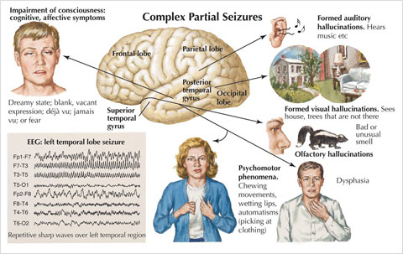

Treatment:
- Anticonvulsant mediacation: stabilizing the neuronal membrane especially inhibitory neuros
- Surgical removal of the abnormal tissue that is the focus of the seizures is sometimes performed in severe cases
Multiple Sclerosis
- Disease characterized by a loss of myelin, largely in the motor tracts but also sensory nerves
- Replaases and remissions are common
- Brain imaging reveals discrete lesions
- Cause is unknown, but proposed causes include: backterial infection, a virus, environmental factors, and an immune response of the central nervous system
Dementia
- Acquired and persistent syndrome of intellectual impairment
- Diagnostic Features:
  - Memory and other congitive deficits
  - Impairment in social and occupational functioning
- Nondegenerative dementias are a heterogeneous group of disorders with diverse etiologies (vascular, Korsakoff’s)
- Degenerative demetias are presumed to have a degree of genetic transmission (Alzheimer’s; Hintington’s, Parkinson’s)
Parkinson’s Disease
- Related to the degeneration of the substantia nigra and to the loss of the neurotransmitter dopamine
  - May be caused by diseases such as encephalitis, syphilis, drugs, or unknown causes
  - Environmental toxins (increase in people over 40)
- Despite a common site of damage, symptoms vary enormously amoung people
- Many symptoms resemble the changes in motor activity that take place as a normal consequence of aging
- Postitive Symptoms: something gained
  - Tremor at rest
  - Muscular rigidity
  - Involuntary movements
  - Akathesia: small, involuntary movements or changes in posture; motor restlessness
  - Occulogyric Crisis: involuntary turns of the head and eyes to one side
- Negative Symptoms: something lost
  - Posture diosrders
  - Disoders of righting (standing up)
  - Disordering od locomotion: festination: tendency to engage in a behavior such as walking at faster and faster speeds
  - Speech disturbances (loss of prosody)
  - Akinesia (slowness of movement)
- Also congititive disturbances (impoverishment of feeling, motive, attention, cognitive slowing.
- Treatment:
  - Behavioral: physical therapy
  - Pharmacological: increase levels of domapine.
  - Suppress the activity of structures that show heightened activity in the absene of adequate dopamine action.
  - Surgical: Electical stimulation or lesionsing of the internal global pallidus reduces rigidity and tremor
  - Deep Brain Stimulation: Neurosurgery in which an electrodes implanted in the brain stimulate a targated area with a low-voltage electrical current to facilitate behavior
  - Transplantation: embryonic dopamine producing cells or multipotential stem cells into basal ganglia (experimental)
Alzheimer’s Disease:
- Approximatelty 65% of dementia cases
- Cause is unknown but proposed cuases include:
  - Genetic predisopsition
  - Environmental toxins
  - Autoimmune response
  - Reduced blood flow to the hemispheres
Alzheimer’s Anatomical Correlates:
- Neuritic (amyloid) plaques:
  - Located mostly in the cerebral cortex
  - Also found in non-A dementia
- Neurofibrillary tangles:
  - Paired helical filaments found in the cerebral cortex and hippocampus
  - Also found in patients with Downs, Parkinson’s and other dementias
- Cortical Degeneration:
  - Most affected areas are the limbic cortex, inferior termporal cortex and the posterior parietal cortex
  - The entorhinal cortex (link between neo and hippocampus) shows clearest evidence for cell loss which may explain why memory problems occur early
  - The primary sensory and motor areas are spared
- Cerebral atrophy may be due in large part to the loss of dendritic arborization and loss of neurotransmitters
  - Acetycholine
  - Noradrenaline
  - Dopaime
  - Seratonin
  - NMDA, AMPA glutamate receptors
Understanding and Treating Psychiatric Disorders
- Wide range in DSM
- Psychotic 1%
- Mood 10%
- Anxiety (most popular)
Schizophrenia
- Delusions, hallucinations, disorganized speech, disorganized behavior, catatonic behavior, negative symptoms (blunted emotions)
- Type one:
  - Positive symptoms (halluncinations, agitated movements)
  - Dompaminergic dysfunction
  - Acute onset, good prognosis, good response to neuroleptics
- Type two
  - Negative symptoms
  - Englarged ventricles and cortical atrophy in frontal cortex
  - Associatied with chronic affiction, poor prognosis, poor response to neuroleptics, cognitive impairments
- 20-30% of patitents show mixed
Neuroanatomical Correlates:
- memory defiits: large ventricles and thinner cortex in the medial temporal regions and abnormal dendritic fields in the dorsal prefrontal area, hippocampus, ad entorhinal cortex
- Deficits in executive functioning: abnormal blood flow in the dorsolateral prefrontal cortex
- Auditory hallucinations: abnormalities in the auditory regions of the temporal lobes
- Thought disorders: Wericke’s area
- Dopamine Hypothesis of Schizophrenia: too much dopamine!
  - Antipsychotic drugs block d2 receptors
  - Amphetamine promotes release of dopamine and can also produce symptoms similar to schizophrenia
  - There is still no conclusive evidence of d-related differences in the brains of patients
  - Neuropletics are dopamine agonistis
  - Too simple: many other neurochemical abnormalities are associated with schizophrenia
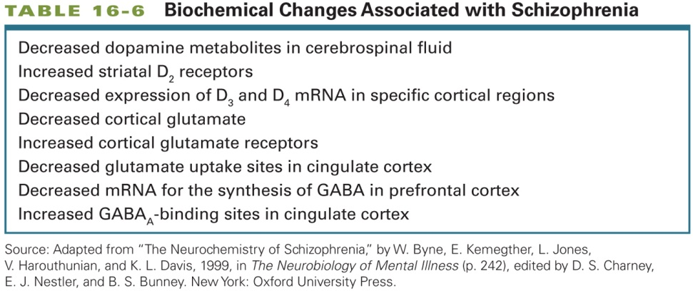
- Treatment:
  - Antipsychotics
  - Some have negative side effects
  - Tardive Dyskinesia: inability to stop the tongue from moving, can last long after person stops taking the drug
Mood Disorders:
Depression:
- Low levels of serotonin and norepinephrine (antidepressants increase these levels)
- There is little evidence that low levels of these neurotranmitters cause depresion
  - Lowering levels in normal people does not produce depression
  - Medications alter the levels witin days but it takes weeks for the drugs to start working
- Duman (2004)
  - Depression may envolve low levels of neurotrophic factors
  - Brain-derived neurotrophic factor is down regulated by stress and up rated by meds
  - Meds increase levels of BDNF via altering intracellular signalling
- Relationship between mod and reactivity to sress:
  - Hypothalamic-pituitary adrenal circuit that controls the production and relases of hormones related to stress
  - Chronic stress can lead to oversecreation of cortisol associated with depression in adult hood (shut down of cortisol fails)
  - 45% of adults with depression lasting more than 2 years experience abuse, neglet or parental loss as children.
Treaments:
- SSRIs, Tricyclics, MAO-Is
- The best treatment need no be direct biological intervention (cognitive behavioral therapy)
- Electroconvulsive Therapy:
  - Using electrical current to produce seizures as a treatment for severe depresion
  - Stimulates the production of neurotrophic factors
  - Need to medicate person to avoid the caused by the electrical stimulation
  - ECT leads to memory loss
- Transcranial Magnetic Stimulation
  - Alternative to ECT
  - Less drastic
  - Fewer side effects than ECT because the magnetic stimulation can be applied narrowlu to a focal area rather than diffusely as in ECT
- Other mood disorders: Mania, Bipolar
Anxiety Disorders:
- GAD
- Panic
- PTSD
- Social Phobia
- Specific Phobia
- OCD
- Table 15-9
Neural Correlates:
- Increased activation in the cingulate cortex and parahippocampal gyrus
- Enchanced response to anxiety provoking stimuli in the amygdala and prefrontal cortex
- Excessive excitatory neurotransmission in enhance anxiety: GABAergic drugs are effective meds
- Anxiety disorders may be caused by stressful experiences in early life
Treatment:
- Pharmacological: Benzodiazepines were once the primary treatment for anxiety disorders, but SSRIs are now commonly used treatments
- Congnitive Behavior Therapy: challenging the reality

Is Misbehavior always bad?

Miller and colleagues:
- Loss of function in one brain area sometimes release new functions elsewhere
- Neurocognitive enhancemnt:
  - Brain-function enhancement is pharmacoloical physiological or surgical manipulation
  - raises a number of moral and ethical issues.

