Midterm Review

Resting membrane potential:
Factors:
-Diffusive Forces (lots of Na+ on the outside, Lots of K+ and proteins (-) on the inside)
-Active Transport (sodium potassium pump, pumps out 3 Na+ ions for every 2 K+ ions pumped in)
-Electrostatic pressure
-Permeability of ion channels

Post-Synaptic Potentials
IPSP: Inhibitory signal (reduces likelihood of action potential). Eflux of K+ and influx of Cl-
EPSP: Excitatory signal (increases likelihood of action potential). Influx of sodium ions.

Summation
Temporal Summation: PSPs that fire at the same time
Spatial Summation: PSPs fire close together, or close to axon hillock

Action potential
Action potential: A reversal in polarity. Cell “fires”, do or do not, there is no try. Lasts about 1ms.

Depolarization (Na+ gates open, floods in), Repolarization (K+ gates open, flood out), Hyperpolarize (too much K+ leaves, gates close, balance restored by pump)

Absolute refractory period: Can’t fire again after an AP
Relative refractory period: Can fire again, but only if very stimulated.

Neurotransmission

AP makes it to terminal button, it opens Calcium Channels. Calcium bind with calmodulin. This complex activates neurotransmission.

Ionotropic receptors: Connected to a channel/pore. Transmitter binds to receptor on channel, causes channel to open.

Metabatropic receptors: No pore, transmitter binds to receptor, alpha part of g-protein detaches, and attaches to nearby ion channel.
OR
Alpha detaches, attaches to enzyme, which releases “second messengers” which either open a channel, or activates DNA (long term changes)

Activating Systems!

Neural pathways that are driven by a single neurotransmitter.
Cholinergic:
Nuclei located in brainstem: midbrain nuclei, basal forebrain nuclei.
-Maintaining memory
-Maintain waking EEG pattern (wakefulness)

Dopaminergic:
-Ventral tegmentum nuclei,
Reward
Substantia niagra,
-important in movement

Noradrenegric:
Locus Coeruleus (brain stem)
-emotional tone
-depression vs mania

Serotonergic system:
Raphe nuclei
Maintains wakefulness
Mood/depression

Neurobiology of motivation

Key Structures in motivation
Hypothalamus/pituitary gland:
Feedback loops: controls amount of hormone released
Neural regulation: other brain regions
Experience
Limbic System:
Frontal Lobe:

Neurobiology of Emotion
3 major components
Autonomic response (hypothalamus)
Ex. Increased heart rate
Subjective feelings (amygdala)
Ex. Fear
Cognitive response (cerebral cortex)
Ex. Thoughts about emotion

Critical in homeostasis

Chapter 6 - Measuring brain and behavior

Neuropsychology: The study of the relation between brain function and human behavior. Originated with Paul Broca (discovered the link between left hemisphere damage and language impairment)

Behavioral Neuroscience: The study of the biological basis of behavior. Attempts to develop methods of studying both normal and abnormal behavior.

Methods to manipulate and measure brain-behavior interaction

Lesion: The ablation (removal/destruction) of tissue in brain.

Brain Stimulation: Stimulates a certain section of the brain, has has the opposite effect as a lesion of the same area (usually enhances neural functioning).

Stereotaxic apparatus: Surgical apparatus that permits researcher to target a specific part of the brain.

Bregma: Intersection of sultures on skull

Measuring electrical Activity in the Brain

Transcranial Magnetic Stimulation (TMS): Non-invasive procedure using magnetic coil over skull to stimulate brain.

Electroencephalography (EEG): Measures the summed graded potentials from many thousands of neurons, revealing features of the brain’s electrical activity. (simplified: measures electrical activity in the brain)

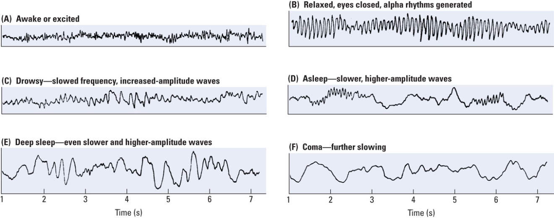
EEG waveforms associated with different states of consciousness. Know these.

Event-related potentials (ERPs): Complex electroencephalographic waveforms related in time to a specific sensory event.

Magneto-encephalography: Measures electrical potentials in brain using magnetic detectors outside the skull. Higher resolution than ERP, but far more expensive.

Static imaging techniques

Computerized Tomography (CT Scan): X-ray beam projected through head. Series of photo taken at each axis, creating 3-d representation of the brain.

Magnetic Resonance Imaging (MRI): Passes strong magnetic field through brain, followed by a radio wave, and then measures radiation produced by hydrogen atoms. Produces static 3-d image of brain, very high spatial resolution.

fMRI (functional): MRI that measures changes in the brain when performing specific behaviors. Essentially an MRI that provides functional information as well as spatial.

Positron emission tomography (PET scan): Measures blood flow in the brain. Very good temporal resolution.

Measuring Brain Chemistry

Microdialysis: Technique used to determine the chemical makeup of extracellular fluid.

Cellular voltammetry: Technique to measure the concentration of different chemicals in the brain as animals behave freely.

Genes and behavior

Variations in gene sequence influence brain development.

Epigenetics: Changes in gene expression related to experience.
Example: Fraga et al. study: determined that have nearly identical gene expression at early age, but very different by age 50.

Chapter 7 – How does the Nervous System Develop and Adapt?

3 perspectives of brain development:

Structural: Studying physiological development of the brain and correlating it to behaviors.

Behavioral: Analyzing behavioral development and predicting what underlying circuitry is emerging (the opposite of structural perspective).

Other: Covers anything else that influences behavioral or structural development of the brain. (Example: hormones, genes, experiences etc.)

Gross Development of the Nervous System

The 3 prenatal stages:

Zygote (Fertilization to 2 weeks) Embryo (2 to 8 weeks) Fetus (9 wks to birth)

Neural Plate: Thickened region of the ectodermal layer that forms the neural tube.

Neural Tube: A structure in the early stage of brain development from which the brain and spinal cord develop.

“Major Events”
Day 49: Embryo begins to resemble a little person

Day 60: Sexual differentiation

Day 100: Brain looks distinctly human

7 months: Gyri and Sulci begin to form (grooves in brain)

9 months: looks like adult brain

Neurotrophic Factors: A chemical compound that acts to support growth and differentiate in developing neurons. It may also help keep neurons alive throughout life.
***Examples:

(EGF) Epidermal Growth Factor supports Stem Cells release a progenitor cell.
(bFGF) Basic Fibroblast Growth Factor supports progenitor cells achieve a Neuroblast.

Development of Neurons and Glial Cells
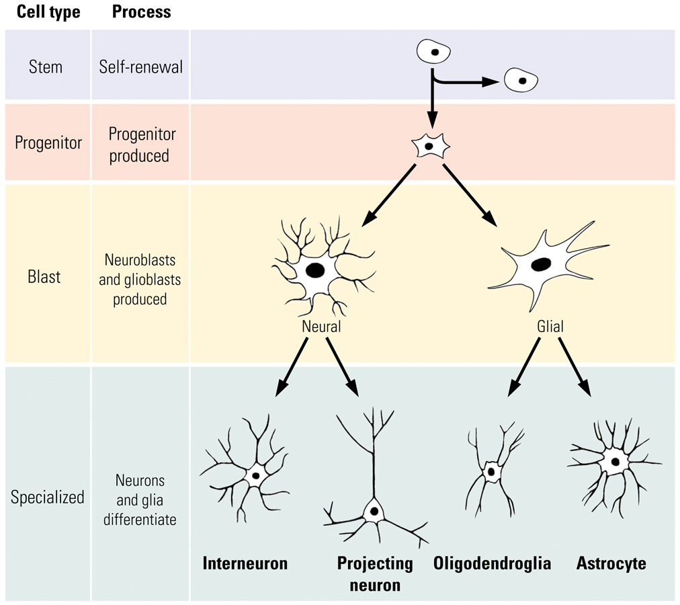

- Stages of Nurodevelopment

- Cell Birth: neurogenesis; gliogenesis
- Cell Migration: cells move to establish distinct populations
Radial Glial cells: pathway cells followed by a migrating neuron
- Cell Differentiation: cells become distinctive neurons or glial cells
- Cell Maturation: dendrite and axon growth
Dendritic Growth + Axonal Growth
Growth cone: one extended/growing part of an axon
Filopod: one tip of a growth cone

- Synaptogenesis: formation of synaptic connections

- Cell Death and Synaptic Pruning: selective death of some nerve cells; fine-tuning (Neural Darwinism)
- Myelogenesis: formation of myelin

Correlating Behavior with the development of the Nervous System

Should also note that myelination in the brain corresponds with improvements in motor function.

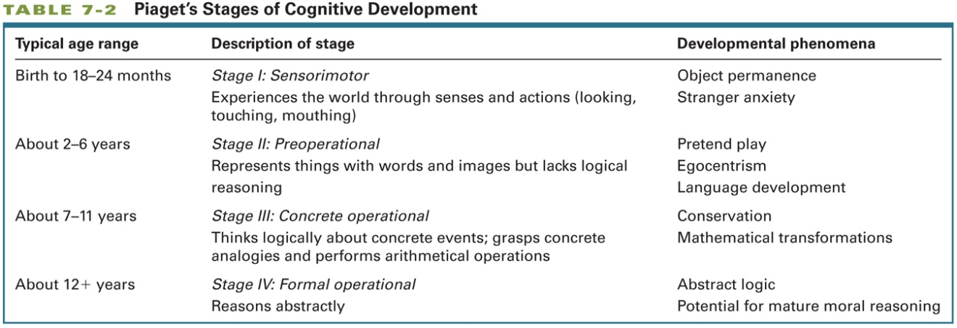
Growth Spurts: Sporadic period of sudden growth that lasts for a finite time.
Epstein identified 5 growth spurts during development:
First 4 correspond with Piaget’s 4 stages, last one occurred around age 14-16 years.

Brain Development and the Environment

Hebb Experiment (1947): Tested home rats vs. lab rats. Home rats better at maze, shows effect of environment on neurodevelopment. Larger/more synapses, and mor astrocytes developed in house rats.

Effects on neural connectivity:

Prenatally, Chemoaffinity Hypothesis: Neurons or their axons/dendrites are drawn towards a signalling chemical that indicates the correct neural pathway.

Postnatally: The fine tuning of connections made in prenatal stage is fine-tuned through activities/experience. (What fires together wires together)

Critical periods: A developmental window in which some event has a long-lasting effect on development (also known as sensitive periods)

Abnormal Experience and Brain Development

- Early deprivation of sensory experience (e.g., being placed in dark) has the opposite effect of cognitively stimulating environments: atrophy (certain places not working) of dendrites
- Early deprivation of social experience (e.g., raised without maternal contact) has a profoundly negative effect on later intellectual and social behaviors

- Human Cases: If deprivation is relatively short (e.g., less than a few months), the child may be able be to overcome some of the negative effects
- Stress in early life has been associated with:
  - Increase in size of amygdala
  - Decrease in size of hippocampus
  - Later development of depression and anxiety disorders, addictions

Hormones and Brain Development
- Testosterone (Androgens)
  - Stimulates development of male reproductive organs and the later development of male secondary sexual characteristics (e.g., facial hair) during puberty
  - Activational effect
- Masculinization
  - Process by which exposure androgens (male hormones) alters the brain, rendering it identifiably male
  - Organizational effect

The presence of testosterone and estrogen both affect the development of the brain
  - Can alter:
    - Number of neurons
    - Dendritic branching
    - Synaptic growth
  - Not just areas of brain related to sexual behavior: These hormones can affect “higher functions” such as cognition

Hormones and Brain Development

Bachevalier and colleagues: Postnatal Effects

Monkeys
-Object reversal task & concurrent discrimination task
-Male an
d females showed different patterns of performance on tests at 2.5 months old
-Males better at object reversal; females at concurrent task
-Males that had testes removed at birth performed more like females
Humans
-Similarly, males and females showed different patterns of performance around 15 to 30 months of age
-Males better at object reversal; females at concurrent task
-Sex differences disappeared at 32 to 55 months of age (the difference disappears)
-Rate of maturation differs between sexes; at later age, brain has completely matured in both sexes

Juraska (1990): Postnatal Effects (estrogens, antogens)

Rats Reared in Complex Environments
-Males showed more dendritic growth in the visual cortex than females
-Females showed more dendritic growth in frontal lobes than males
Summary:
-Sex differences in brain structure exist throughout development

Injury & Brain Development
In Humans
- Worst time for brain injury:
Last half of intrauterine period and the first few months after birth
- “Better” time for brain injury:
First few years after birth
More resilient to deficits (e.g., language impairments) than when damage occurs in adults

Drugs & Brain Development

Precise effects of drugs on prenatal brain development are poorly understood
There is some evidence that:
-Prenatal exposure to psychoactive drugs may increase the chance of later drug use
-Prenatal exposure to drugs such as nicotine and caffeine increase the chance of learning disabilities and hyperactivity

Genetic Abnormalities
Spina bifida
-Spinal cord abnormality due to the failure of the neural tube to close completely
Associated with serious motor problems
Anencephaly
-Front end of the neural tube does not close
Failure of the forebrain to develop
Infants typically die soon after birth

Other Kinds of Abnormal Brain Development

Abnormal Cell Migration and Differentiation
-Faulty connections may produce a range of problems
-Example: Schizophrenia (Disorganized pyramidal neurons in the hippocampus)
-Too many synapses (failure of pruning) can also produce neural dysfunction
- Behavioral effects of brain damage to a certain area are often not seen until the time at which that particular area matures
Example:
-The frontal lobes continue to develop into adulthood, therefore, the behavioral effects of frontal lobe damage may not be seen until adolescence

Developmental Disability: Impaired cognitive functioning due to abnormal brain development.
Many causes:
-Genetic abnormalities (e.g., Down syndrome)
-Prenatal exposure to infections (e.g., rubella) or toxins such as alcohol (e.g., fetal alcohol syndrome)
-Birth trauma, such as anoxia (e.g., cerebral palsy)
-Malnutrition
-Environmental abnormality, such as sensory deprivation (e.g., Romanian orphans)

Purpura (1974)
-Examined children with developmental disabilities who died from accidents or diseases unrelated to the nervous system
-Compared with normal children, dendritic growth was reduced in children with various forms of mental retardation
-Suggests that there were fewer connections in the brain

-Brain has a substantial capacity to repair minor abnormalities that may occur during development (plasticity)
-There is a “range of normality” with respect to brain development
-Most of us develop a brain that falls within a certain range of normality
-Plasticity occurs into older adulthood

Chapter 8 – DRUGS!!!

Pharmacology: The scientific study of how drugs affect the nervous system and behavior.
Drugs: Chemical compounds administered to produce a desired changed in the body.
Psychoactive drug: Substances that influence normal cell firing in the nervous system (for better or worse). Can affect mood, thought, behavior etc.

Different drug routes into the nervous system:
Oral administration = safest/easiest, and most complex (more barriers, takes longer to enter bloodstream).
Other methods: inhalation, injection, produce much faster effects.

The blood brain barrier
-A way for the brain to protect itself from toxins
-Brain had a very high blood flow, and therefore increased risk of toxic danger
-“Pasta strainer vs Flour sifter” Tight junctions between cells in blood vessels of brain
-Capillaries in brain don’t allow drugs to pass ass easily as capillaries in the rest of the body

3 “Barrier free” sites

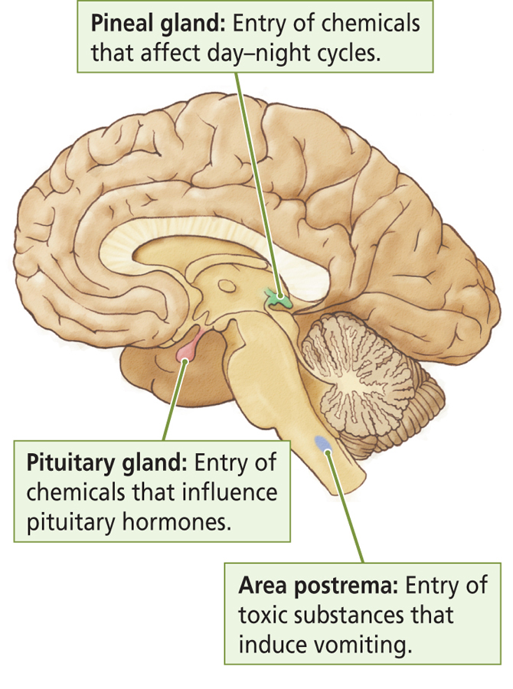

Metabolism and Elimination of drugs in the system

Broken down in kidneys/liver/intestines
Excreted in urine/sweat/exhaled air/breast milk
Substances that aren’t removed can build up in body and become toxic

A drug is psychoactive because it influences the effect of normal cell firing!
Two main types of psychoactive drugs: Agonist and Antagonist
Agonist: Substance that increases the effectiveness of neurotransmitters
Antagonist: Substance that decreases the effectiveness of neurotransmitters

Drugs can alter chemical processes in 7 different stages of synaptic transmission:
-Synthesis
-Storage
-Release
-Receptor Interaction
-Inactivation
-Reuptake
-Degradation

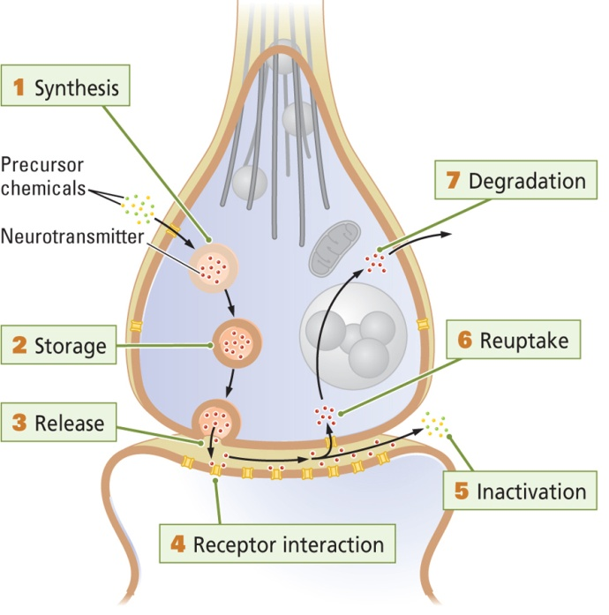

Principles of Psychopharmacology

Tolerance: Decrease in response to a drug with the passage of time
-Metabolic tolerance: increase the number on enzymes used to breakdown substance
-Cellular tolerance: Activities of brain cells adjust to minimize effects of the substance
-Learned Tolerance: Classical and operant conditioning

Sensitization: Increased responsiveness to successive equal doses of a drug.

Classifications of Psychoactive Drugs (by most pronounced effect)

- Anxiety Agents and Sedative Hypnotics
-Barbiturates: Produce sedation and sleep…or anesthesia, comas, and death if you take too much.. (example: alcohol)
-Benzodiazepines: Minor tranquilizers and anxiety reducing drugs (ex Valium).
-Also includes dissociative anestehtics, which produce altered states and hallucinations (ex. Rohypnol or “date rape” drug)

- Antipsychotic Agents
Major tranquilizers(Neuroleptics):
-drugs that block the D2 Dopamine receptor
-Used mainly for the treatment of SCHIZOPHRENIA.
-Immediate reduction in motor activity, after short period of use, decrease in symptoms of schizophrenia.

- Antidepressants
-Used primarily for treatment of major depression
-Common in around 6% of the adult population (twice as common in women)

Classes of Antidepressants:
Monoamine Oxidase (MAO) Inhibitors: Block MAO enzyme from degrading dopamine, noradrenaline and serotonin.
Tricyclic antidepressants: “First generation”, chem. Structure characterized by 3 rings. Block serotonin reuptake transporters.
Second-generation antidepressants: Similar to “first generation”, but more selective in its action on the serotonin reuptake (SSRIs).

4) Mood stabilizers (Lithium, Valproate)
Used to treat bi-polar disorder
-Mutes the intensity of one pole of the disorder, thus making the other pole less -likely to recur
-Not well understood.

- Opioid Analgesics (Opioids like Codeine and morphine)
-Drugs with sleep-inducing/pain-relieving properties.
-Heroin is synthesized from morphine (acts like opiate)
-Opiates mimic the effects of Epinephrine
-Acts on 3 opoid receptor classes: Mu, Delta, Kappa (Mu is critical for effects on pain and addictive properties)

- Psychomotor stimulants
Drugs that elicit and increase in motor behavior and elevate a person’s mood/level of alertness
Cocaine: blocks dopamine reuptake. Many derivatives.
Amphetamine: Dopamine Agonist. Releases dopamine and blocks reuptake.

- Psychedelic Drugs
Alters sensory perception and cognitive processes. Can also produce hallucinations

Substance abuse = use of a drug for the changes that it produces outside of therapeutic effects.
Addiction = -“syndrome at the centre of which is a loss of control over a reward-seeking behavior” (compulsive behavior)

Drug Withdrawal: Behavioral and physiological symptoms that occur upon cessation of drug use. Produces opposite of the acute effects of the drug taken because your body has tried to compensate for the drug being in the system.

Relapse: Reappearance of drug problem after a period of remission. Different than just a lapse. A return to cycle of abuse.

Sex Difference in Addiction

-women are affected twice as much by drugs as guys are. (body size and hormonal differences)
-women are slightly less likely to become addicted, but “telescoping effect”
Telescoping effect: women tend to become dependent on drugs more quickly than men.

Intro to hormones

Discovered first by Berthold (1849): Chopped the balls off some chickens and they stopped crowing/being aggressive. The behaviors returned after re-implantation of balls.

Hierarchal control of hormones:
Hypothalamus Pituitary Gland (aka. “master gland” Target Endocrine Glands Target Organs and Tissues

Classification of Hormones

By Function:
- Homeostatic hormones
  - Maintain a state of internal metabolic balance and regulation of physiological systems
- Gonadal (sex) hormones
  - Control reproductive functions; sexual development and behavior
- Glucocorticoids
  - Secreted in times of stress; important in protein and carbohydrate metabolism

By Structure:
- Steroid Hormones
  - Fat-soluble chemical messenger synthesized from cholesterol
    - Examples: gonadal (sex) hormones, thyroid
- Peptide Hormones
  - Chemical messenger synthesized by cellular DNA that acts to affect the target cell’s physiology
    - Examples: insulin, growth hormone

Stress Hormones:

Stressor: A stimulus that challenges the body’s homeostasis/triggers arousal. Illicits a stress response.

Two sequences of response: Fast-acting (fight or flight) or slow-acting (rest/digest)

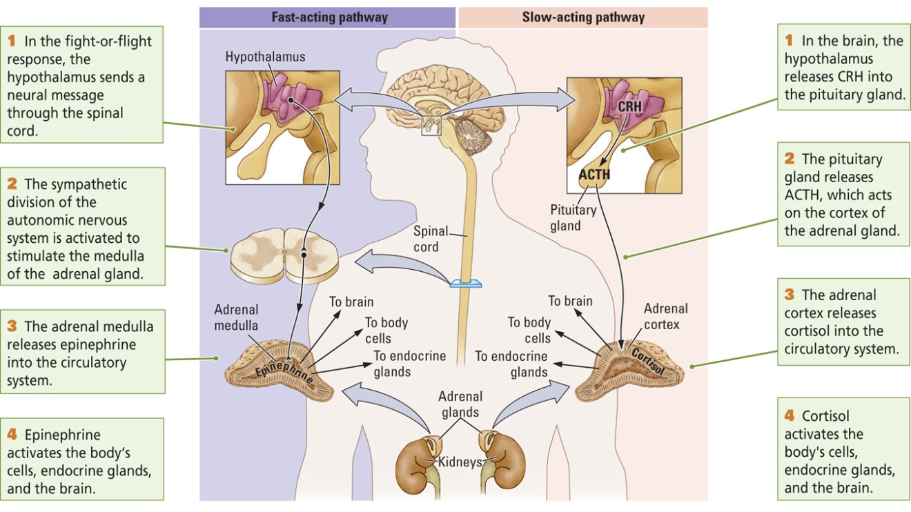

-Normally stress responses are brief
-Stress responses are turned on and off in the brain

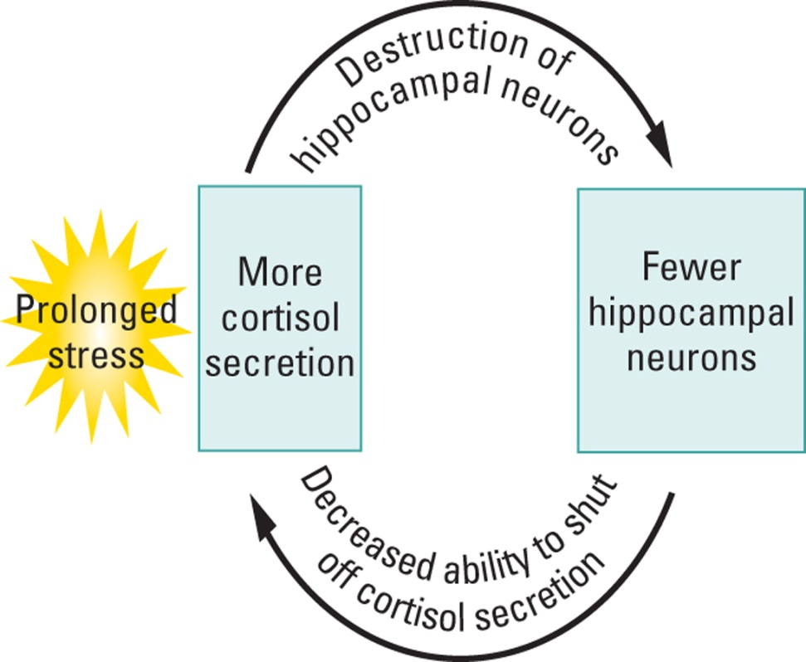

Chapter 9 – Sensation and Perception

Basics of sensory processing

Sensory transduction: Sensory cells convert stimulus into an electrical signal.

Receptor density:
Important to determine sensitivity to particular sense. Example: fingertips more sensitive to touch than arm. Differences in receptor density are important in determining special abilities of animals (ex dogs with smell.)

Each sensory system has a distinct pathway.. most of which pass through the thalamus and terminate in the cortex.

Sensory receptors Thalamic relay nuclei Primary sensory cortex Secondary sensory cortex Association cortex (which gets inputs from more than one sense).

Action potentials code different sensations by firing down different along different nerve pathways (optic olfactory etc), and as such stimulating a different area of the cortex.

Topographic map – spatially organized neural representation of external world on our brains. Example: tonotropic representation on cortex

Sensation: The registration of physical stimuli by senses.

Perception: Subjective interpretation of sensation by brain.

Basically we all sense the same world, but perceive that world differently, because our brains are all different.

Sight!

Light: A wave, a stream of photons, tiny particles that each consist of one quantum of energy. (The stimulus for vision)

Visible spectrum: Waves of electromagnetic energy between 380 and 760 nanometers of length.

Light Properties:
Wavelength: Color (length from peak to peak or trough to trough)
Short=blue, medium = green, long = red

Amplitude: Brightness (Height of the wave) higher = brighter

Purity: Saturation

Anatomy of the eye:
Cornea: The transparent “window” into the eye. Changes the angle of the light wave as it enters the eye.
Iris: Colored part of the eye – regulates light entering the eye by expanding or contracting
Pupil: Where light enters the eye (as it cannot get through the iris)
Lens: Lens inside the eye that allows change in focus.

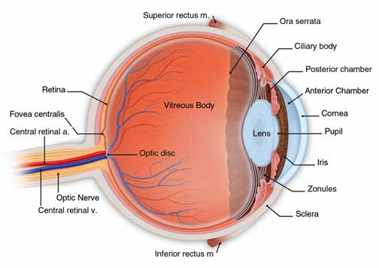
Retina: A light sensitive membrane in the back of the eye that contain “rods (more numerous and sensitive to low light)” and “cones (good at color and high acuity, 3 types of pigment, ALL in fovea)”. These change the light energy entering the eye into a neural signal.
5 layers:
Photoreceptors: Rods and Cones
Horizontal cells: Link Photoreceptors and bipolar cells
Bipolar cells: One side contacts photoreceptors, and the other contacts retinal ganglion
Amacrine cells: Links with bipolar cells and retinal ganglion cells
Retinal Ganglion Cells: First place there’s an action potential. Axons of these compose the optic nerve.

Fovea: Center of the retina, specialized for high acuity/spatial resolution. (higher concentration of cones than the peripheries.

Optic disk: where the optic nerve leaves the eye (optic nerve)

This is for all senses!

Sensory receptors Thalamic Relay Nuclei Primary Sensory cortex

Secondary Sensory Cortex Association Cortex

Visual Streams

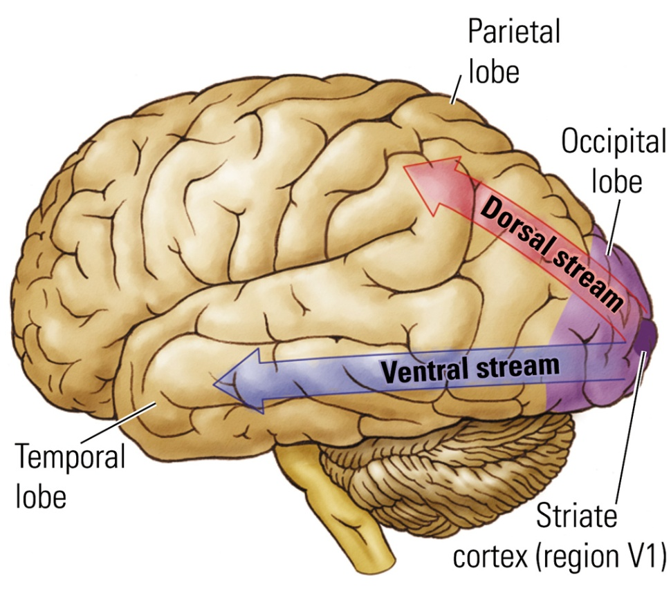
Dorsal Stream: Originates in occipital cortex, projects to parietal cortex. “How” stream
Ventral Stream: Goes from occipital cortex to temporal cortex “What” stream

Hearing!

Stimulus for sounds = vibration
-Vibration of an object causes molecules in the object’s surrounding medium (usually the air) to vibrate
Vibration is sensed, and then interpreted/percieved as sound

Properties of Sound quite similar to properties of Light
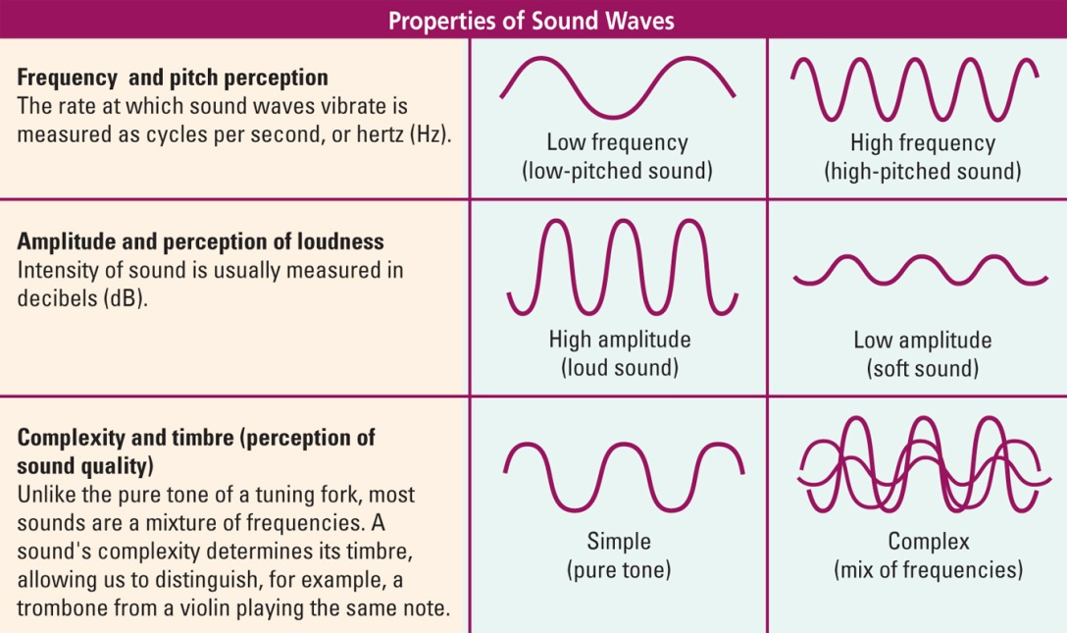
Frequency: we can hear between 20 -20,000 hertz

Structures of the Human Ear
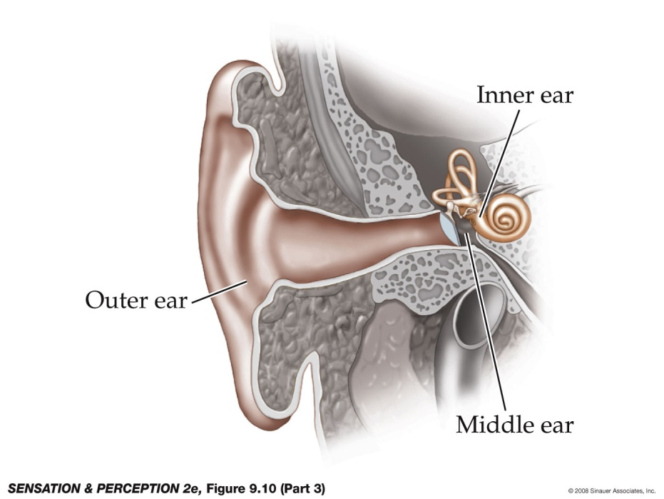

Outer Ear
Where sounds are first collected (by the pinnae ear canal)

Earn canal: main purpose is to insulate the structure at the end of it: The Eardrum

Tympanic Membrane: “eardrum”, a thin sheet of skin at the end of the outer ear. Vibrates in response to sounds.

Middle Ear
Consists of three tiny bones called the ossicles: Malleus, incus, and stapes
Function of Inner Ear: Amplify and transmit sounds to the inner ear

Inner Ear
Functions much like the retina in the eye. Changes in sound pressure are transduced into neural signals in the inner ear.

Consists of:
Cochlea, cochlear canals and membranes

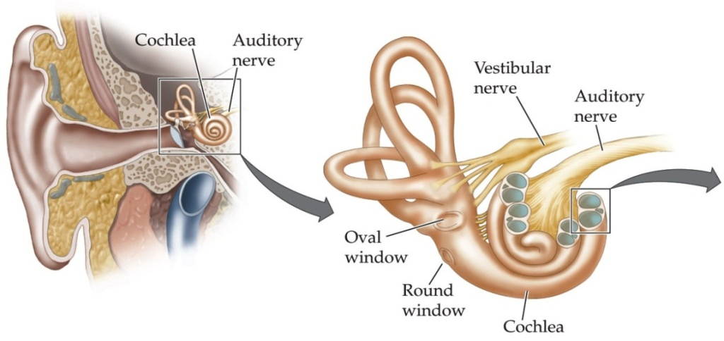
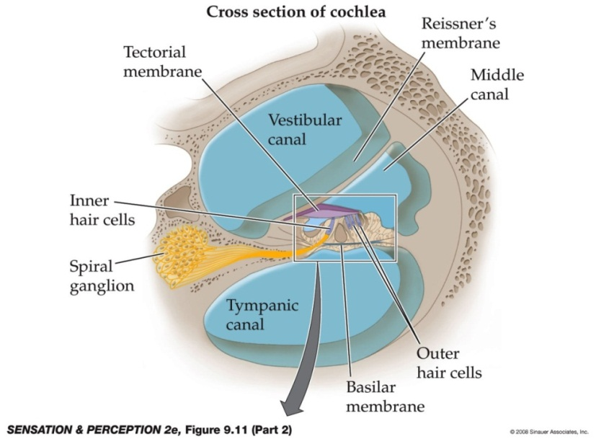

The Organ of Corti:
A structure on the basilar membrane of the cochlea that is composed of hair cells and dendrites of auditory nerve fibers
Two types of hair cells
  - Inner hair cells: Where transduction is done. Convey almost all information about sound waves to the brain. The axons of these cells bundle and form the auditory nerve.
  - Outer hair cells: Convey information from the brain (using efferent fibers)
    - Elaborate feedback system

- Tectorial Membrane: A gelatinous membrane that floats over the organ of corti. Vibrations cause displacement of the tectorial membrane, which bends the inner hair cell’s stereocilia (small hair-like fibres that come out of the hair cells)
This is where transduction occurs!!!

Lateralization: the process by which processes become localized to one side of the brain
Left side of our brain = Language
Right side of our brain = Music

Localization of language in the brain

Broca’s Area: Anterior speech area in the left hemisphere. Functions in concert with the motor cortex to create speech.

Wernicke’s Area: Posterior speech area on the left temporal lobe. Relates to language comprehension.

Aphasia: An inability to speak or comprehend language despite the presence of the proper hardware/mechanisms to do so.

The Chemical Senses!

The chemical sense play a significant role in motivated and emotional behavior.
Smell mark territories and ID group members
Taste identify foods (and poisons!)

Olfaction
Cause: Odorants (volatile chemicals)

- Receptor Surface: Olfactory epithelium (retina of the nose)
  - Contains receptor cells (olfactory sensory neurons) and support cells
  - Receptor cells send cilia into the olfactory mucosa
- Airborne chemicals dissolve in the olfactory mucosa and interact with the cilia

- Olfactory cells project to the olfactory bulb, ending in tufts of dendrites called glomeruli
- In the olfactory bulbs, synapses are formed with mitral cells, which then project to several areas of the forebrain

Olfactory nerve travels up to connect with various forebrain structures.

- Note: no connection through thalamus for amygdala and pyriform cortex!
Only sense that doesn’t pass through the thalamus

- Pheromone
  - Odorant biochemical released by one animal that acts as a chemosignal and can affect the physiology or behavior of another animal
- Vomeronasal Organ
  - Special olfactory receptor, made up of small group of receptors that are connected by a duct to the nasal passage and detect pheromones; projects to the amygdala and hypothalamus (humans don’t have this)

We have 5 different taste receptors in our tastebuds.
Taste buds connect to cranial nerves 7 (facial), 9 (glossopharyngeal), 10 (vegas)
- Gustatory stimuli interact with microvilli, located on the tips of receptors, to open ion channels and alter the membrane potential

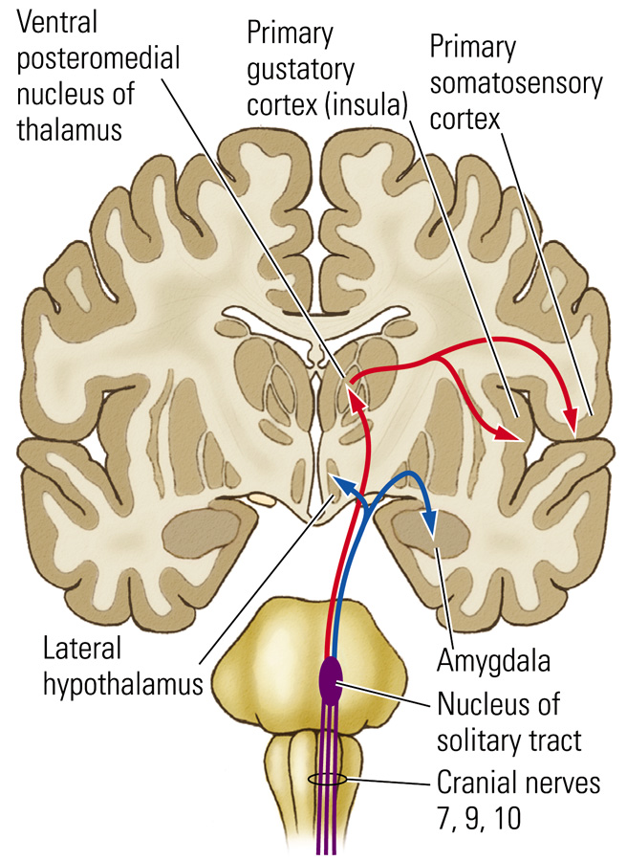

Gustatory Pathway
- Cranial nerves 7, 9, and 10 form the main gustatory nerve, the solitary tract, from which two paths emerge
  - Through posterior medulla to ventroposterior medial nucleus of the thalamus
    - Splits at the thalamus and projects to the primary somatosensory cortex and the gustatory cortex of the insula (which then projects to the orbital cortex)
    - Perception of flavor
  - Second pathway from gustatory nerve projects through pons to hypothalamus and amygdala
    - Feeding behavior

Chapter 12: Motivation and Emotion

Emotion: A cognitive interpretation of subjective feelings (anger, sadness, fear). They can occur unconsciously.

Motivation: Goal directed behavior. Subjective.

Causes of behavior
Possible explanations

- Brain requires stimulation (supported by Hebb sensory deprivation experiment)
Hebb and Heron (1950)
-Subjects allowed limited sensory deprivation, became very distressed after a short time. Some even experienced hallucinations.

Drives: Hypothetical state of arousal that motivates an organism to engage in a certain behavior.
Led to drive theories of motivation (basically a certain behavior builds up, and then is all released in response to a stimulus). Later proven wrong

Changes in behavior have been linked conclusively to changes in neuronal activity as opposed to drives. (example: stimulation of certain brain cells leads to massive increase in sexual behavior).

Evolutionary influences on behavior

IRM (Innate Realeasing Mechanisms) responses that are triggered by certain stimuli which are pre-wired into our genome. (example: babies ability to respond to facial expressions).
Though IRMs are pre-wired, they can be altered with experience (example: sexual stimuli)

Evolutionary Psychology: A discipline that seeks to explain behavior through the principles of natural selection. Argues that certain behaviors exist because their neural circuits were favored by natural selection during our evolution.
Example: Homicide – is exists today because aggression and killing are part of our past adaptive behaviors.

Environmental influences on behavior

B.F. Skinner suggested the strong role of learning in the shaping of our behavior. Argued most of our behavior is a result of pairing certain stimuli with rewards (positive reinforcement encourages a behavior and vice versa).

Learned taste aversion: acquired association between taste/order and illness
Garcia: Poisoned sheep carcass, made attacking coyotes ill. Most coyotes stopped attacking sheep

Preparedness: people are predisposed to respond to some stimulus a certain way (likely to be phobic of snakes, or blood)

The Neuroanatomy of Motivated Behavior

Critical Structures:
-Hypothalamus and associated pituitary gland (sends info to rest of brainstem)
-Limbic System
-Frontal Lobes
“Funnel Model” Limbic system/frontal lobes feed into hypothalamus
Critical in maintaining homeostasis (maintenance of critical body functions within a certain range)

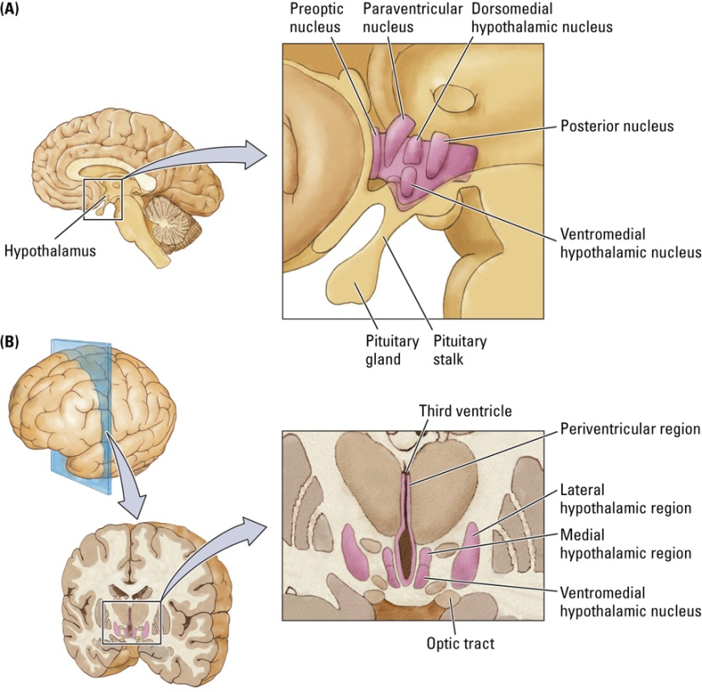

Lateral Hypothalamus
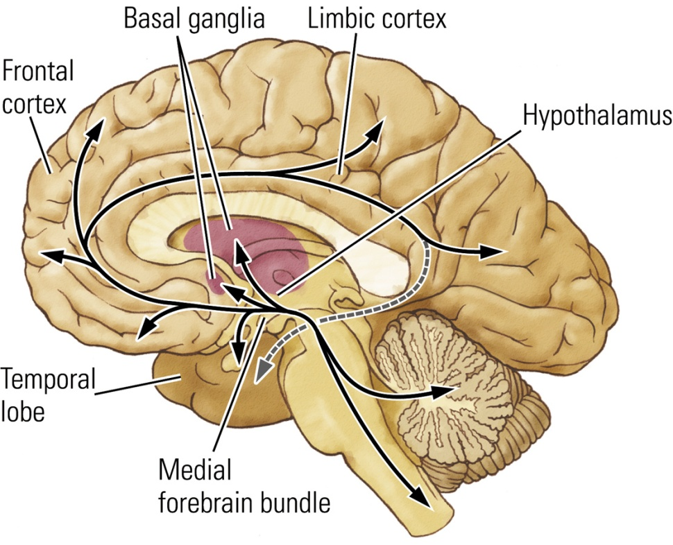

Regulatory Behavior
-Behavior motivated to meet the survival needs of the animal
-Controlled by homeostatic mechanisms, which involve the hypothalamus
Examples: Body Temperatures, eating/drinking, waste etc.

Non-regulatory behavior
Not necessary to meet basic animal needs
Occurs largely in frontal cortex (most recently evolved)
Strongly influenced by external stimuli
Examples: Food preference, reading, sexual behavior

Regulatory Functions of Hypothalamic Circuit
Maintains homeostasis by acting on the endocrine system and autonomic nervous system.
-Main purpose: control pituitary gland (an endocrine gland attached to the bottom of the hypothalamus), controls bio-rhythms.

Medial forebrain bundle: Tract that connects the brainstem with various parts of limbic system.

The pituitary Gland (Master Gland)

Posterior: Neural tissue, continuation of hypothalamus. Where peptides are released/enter bloodtream.

Anterior: glandular tissue. Controlled by releasing hormones (from posterior of hypothalamus)

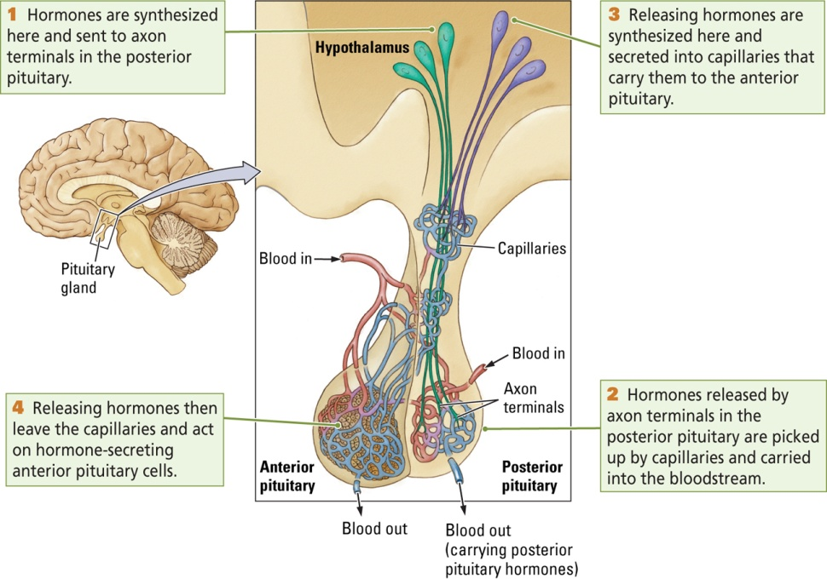

Releasing Hormones: Peptides released from the hypothalamus, travel through capillaries, and act upon the anterior pituitary to influence hormone release.

Factors in regulating hypothalamic hormone activity

Feedback loop: Controls the release of hormones in the brain. Hormones in bloodstream make their way back to the hypothalamus, acting on releasing hormones (shut ‘er down)
Neural regulation: other brain regions that influence hormone release (e.g. limbic system and frontal lobe)
Experiential Responses: Experience can alter the structure and function of hypothalamic neurons

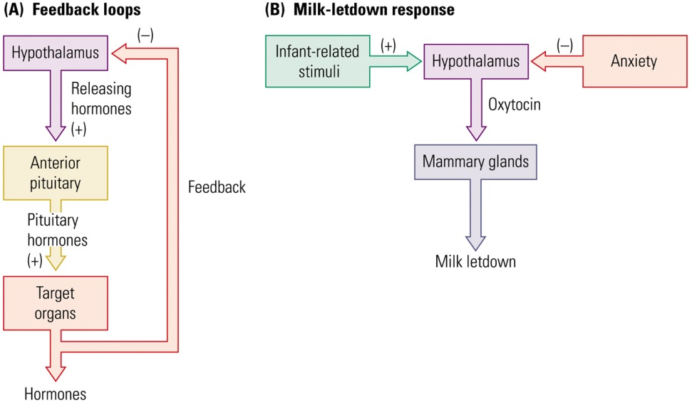

Limbic Circuit – Organizing Function

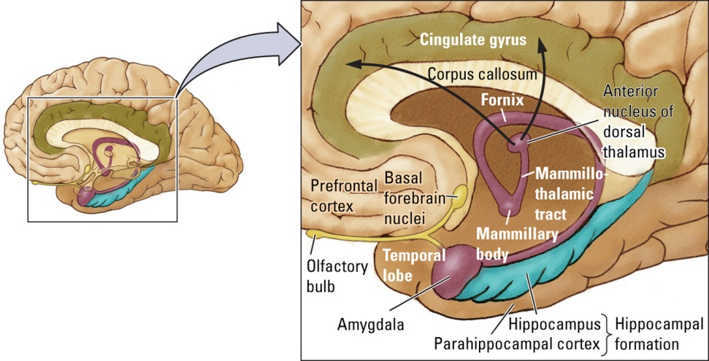
Hippocampal formation
Primitive Limbic Process
Hippocampus: Memory, spatial, species-specific behavior. Vulnerable to stress.
Parahippocampal Cortex: Cortex below hippocampus

Papez Circuit
Hippocampus, amygdala and prefrontal cortex all connect with the hypothalamus, and then they end up back there. All connected.

Amygdala: (almond, we have 2, one for each side of the brain). Has a huge role in emotional behavior: particularly fear. Important in “flashbulb memories”
-many neurons in amygdala respond to more than one sense (multimodal)
-sends projections to the hippocampus and brain stem.

Frontal Lobe
Three main regions:
Motor Cortex Fine movements
Premotor cortex: Selects appropriate movement sequences
Prefrontal cortex Involved in specifying goals toward which movement should be made (most recently evolved)

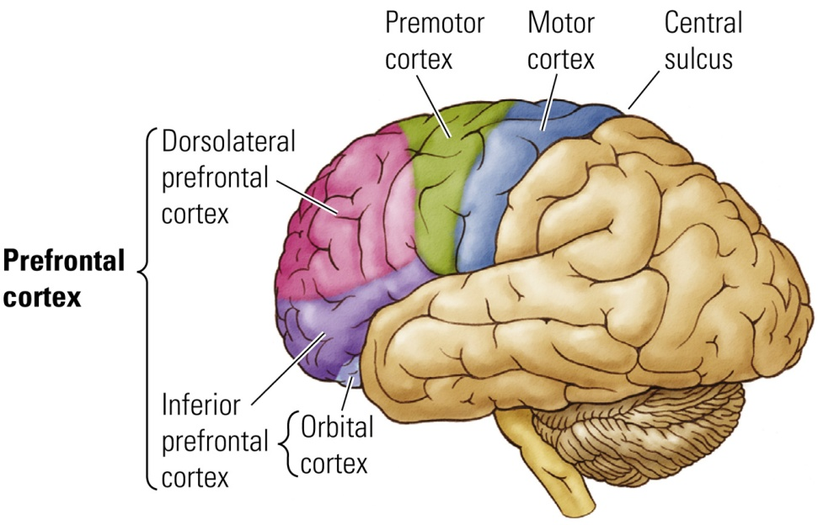

Prefrontal cortex:
Receives connections from:
-the amygdala,
-dorsomedial thalamus
-the posterior parietal (sensory association) cortex
-dopaminergic cells of the ventral tegmental area.

Projects to:
Inferior region amygdala and hypothalamus (autonomic NS)

Dorsolateral region posterior parietal cortex, the cingulate cortex, the basal ganglia, and the premotor cortex (Influences movement and memory)

See Diagram on next page

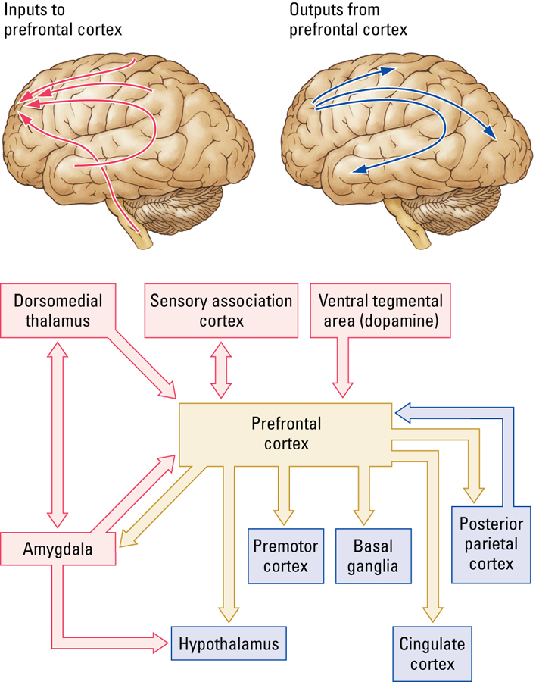

What is Emotion?

What’s emotion? No easy answer.

Three components:
Autonomic response: Hypothalamus and associated structures (physical)
Subjective feelings: Amygdala and frontal lobes (emotional)
Cognition: Cerebral cortex (thought)

Amygdala in emotion:
-Involved in species specific behavior
-influences autonomic and hormonal responses to stuff
-involved in conscious awareness of consequences (ex, public speaking)
-key for innate and learned fear response
-Learning to avoid (opposite of reward system)

Kluver Bucy Syndrome:
-lesion to amygdala
-hypersexuality

Prefrontal Cortex
-Damage to prefrontal cortex = severe emotional deficits (flattened affect, disorganization)
-Example: Phineas gage (railroad spike)

Control of Regulatory Behaviors

Anorexia Nervosa: Most severe mental health disorder (exaggerated concern with being thin).
Bulimia Nervosa: Similar to anorexia, binge followed by purge.
Binge eating: same as bulimia, without purge (equal representation)

Digestive System:
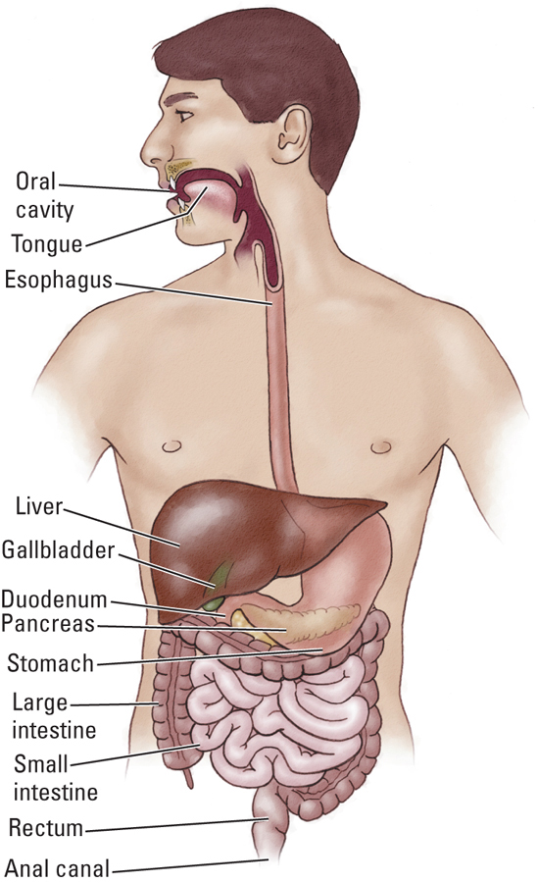

Mouth, Stomach, Gall Bladder, Pancreas, Anus
3 Nutrients: Lipids, Amino Acids, Glucose

Hypothalamus in eating behavior
Lesion of lateral region = aphagia (won’t eat)

Lesion of ventromedial/paraventricular region = hyperphagia

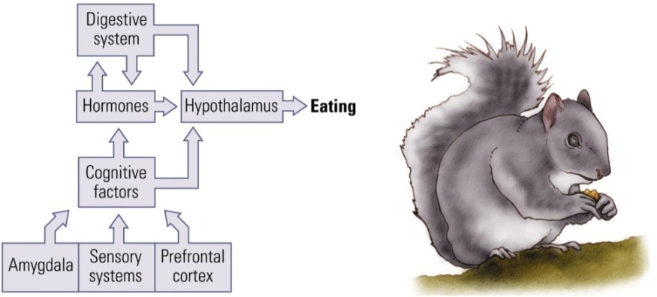
Cognitive Factors: thinking of food can lead to food seeking behavior even when no hunger. (amygdala and prefrontal cortex).

Osmotic thirst: -increased concentration of chemicals known as solutes, in body fluids.
- hypothalamus detect changes
-drink water to restore concentrations
Hypovolemic Thirst
- Produced by loss of overall fluid volume from body
- Drink fluids
-Different hypothalamic circuit

Control of Non-regulatory behavior

Sex hormones affect organization of brain development
-Sexual dimorphism:
Estradiol masculinizes the male brain
Aromatase converts testosterone to estradiol in both males and females
In females: Enzyme alpha fetoprotein prevents estrogen from entering neurons

Sex hormones also have activating effects
Example: different place in estrous cycles in females results in changes in sexual behavior.

Brain parts involved in sexual behavior
Ventromedial Hypothalamus
-controls female mating posture
-controls hormones
Preoptic area of Medial Hypothalamus
-controls copulaltory behavior in males, but not sexual motivation
Amygdala:
-controls sexual motivation in males and maybe in females

Sexual orientation: A person’s sexual attraction to either opposite/same/both sex.
Sexual Identity: A person’s feeling either male or female

Note: There are differences in the hypothalamus between sexes, also, a difference in homosexual men, suggesting a possible 3rd sex (as far as hypothalamic structure)

Motivation and Reward
-Reward mechanism: a mechanism that helped to increase adaptive fitness of species/individuals (maintain contact with good stuff, not bad)

Mesolimbic Pathway of the dopamine system CRITICAL in reward behavior.

Reward = 2 independent processes
-Wanting (incentive) and liking (evaluation of pleasure)
-Often occur together, but not always

SLEEP & DREAMING

Biorhythm: endogenous timing mechanism that control or initiates various biological processes

biological clock: Neural system that times behavior; allows animals to anticipate events before they happen (e.g., birds migrate before it gets cold)

period: Time required to complete a cycle of activity.
  - Circannual rhythms: yearly (migratory cycle of birds)
  - Infradian rhythms: less than a year (human menstrual cycle)
  - Circadian rhythm: daily (human sleep cycle)
  - Ultradian rhythm: less than a day (eating behavior)
free-running rhythms: Rhythm of the body’s own designing in the absence of all external cues (example, human body runs on a 25-27 hour rhythm naturally)

zeitgebers: Environmental event that entrains biological rhythms (e.g., light resets the biological clock)

Entrainment: determination or modification of the period of a biorhythm
(SCN) Suprachiasmatic nucleus: located just above the optic chiasm, maintains human circadian rhythm
Retinohypothalamic Pathway: neural route from a subset of cone receptors in the retina to the suprachiasmatic nucleus; allows light to entrain the rhythmic activity of the SCN

What Drives Circadian Timing
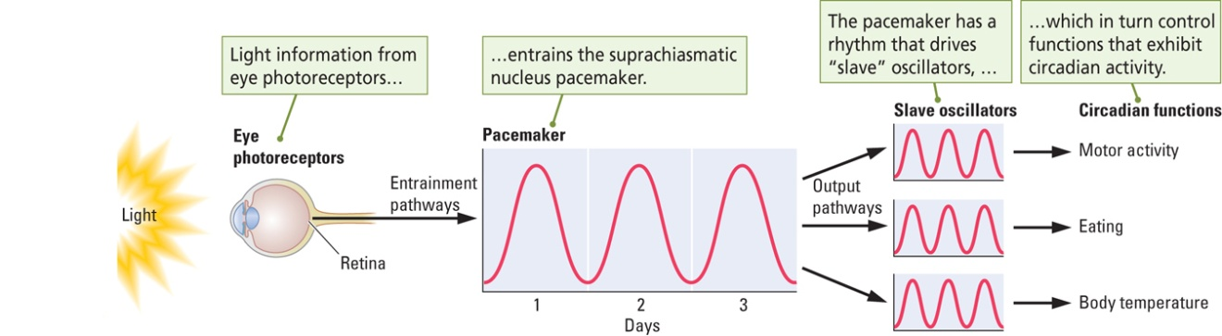

Melatonin: hormone secreted by the pineal gland during the dark phase of the day-night cycle; influences daily and seasonal biorhythms
four tools for measuring sleep:
  - Polygraph used to measure the electrical activity of the brain and body
  - EEG: record of brain-wave activity
  - Electromyogram (EMG): record of muscle activity
  - Electrooculogram (EOG): record of eye movement

Stages of Sleep and Waking:
Beta Rhythm (Waking State)
Alpha Rhythm (Drowsy State)
Delta Rhythm (Sleeping)
REM (Dreaming)
5 stages of sleep: 1-4 = NREM, stage 5 = REM

properties of NREM sleep
- Decrease in body temperature
- Increase in growth hormone release (critical in maintaining normal cellular function)
- Dreaming does occur in NREM but dreams are not as vivid

REM sleep
- Atonia: loss of muscle tone; condition of complete muscle inactivity produced by the inhibition of motor neurons
- Mechanisms that regulate body temperature stop working
- Vivid dreams occur during REM sleep
  - Everyone dreams a number of times each night; appear to take place in real time; sessions get longer throughout a sleep session
theories on dreaming

Psychoanalytic theories (Freud): dreams are the symbolic fulfillment of unconscious wishes
Collective unconscious (Jung): A history of the human race encoded in us.
Activation-Synthesis Theory (Hobson): Cortex is bombarded with signals from the brainstem, in response cortex creates vivid images from person memories.
evolutionary hypothesis (Revonsuo): Highly organized and biased towards threatening images. Teach us how to deal with threatening situations.
Theories of “why we sleep”
Early explanation: sleep is a passive process that takes place as a result of a decrease in sensory stimulation
Sleep is a biological adaptation for energy conservation
Sleep as a restorative process: Chemical events that provide energy to cells may be reduced during waking and are replenished during sleep
  - Fatigue and alertness may simply be aspects of the circadian rhythms and have nothing to do with wear and tear on the body

Sleep Deprivation has profound effects on mood. Will create psychological and behavioral disturbances that deteriorate the longer you are awake.

rebound effect: following deprivation, have more than usual amount of REM for 2-3 nights.

Place cells: hippocampal cell that fires when a rat is in a particular location in an environment. Place cells also fired during NREM sleep. Suggests a role of sleep in memory.
reticular activating system: large reticulum (mixture of cell nuclei and nerve fibers that runs through the center of the brainstem) associated with sleep-wake behavior and behavioral arousal
Two brainstem systems that influence waking
Basal Forebrain: Animal is “still” but alert.

Median Raphe Nucleus (Midbrain):Contains serotonin neurons. Animal is alert and moving.

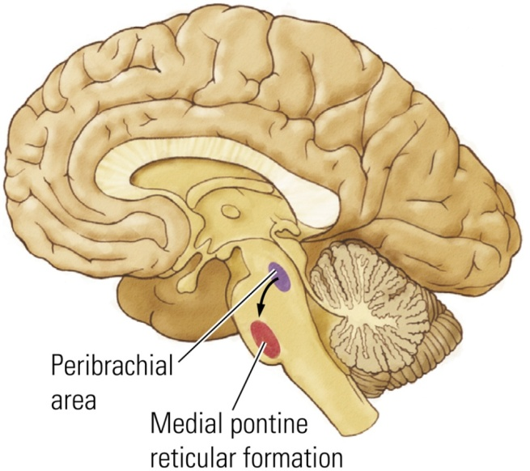

Peribrachial Area: Cholinergic nuclei, initiates REM sleep

Medial Pontine Formation: also plays a role in REM sleep, particularly atonia.

Describe the four non-REM sleep disorders
- Insomnia: disorder of slow-wave sleep resulting in prolonged inability to sleep
- Drug-dependency insomnia: condition resulting from continuous use of “sleeping pills”
- Narcolepsy: slow-wave sleep disorder in which a person uncontrollably falls asleep at inappropriate times
- Sleep apnea: inability to breathe during sleep (person must wake to breathe)
Describe the three REM sleep disorders
- Sleep paralysis: inability to move during deep sleep owing to the brain’s inhibition of motor neurons

- Cataplexy: form of narcolepsy linked to strong emotional stimulation in which an animal loses all muscle activity or tone, as if in REM sleep, while awake

- Hypnogogic hallucination: dreamlike event at the beginning of sleep or while a person is in a state of cataplexy

NEUROLOGICAL DISORDERS

Causes of Abnormal Behavior
  - Genetic errors (e.g., Huntington’s disease)
  - Progressive cell death (e.g., Alzheimer’s disease)
  - Rapid cell death (e.g., stroke)
  - Loss of neural connections (e.g., multiple sclerosis)

Epidemiology: study of the distribution and causes of diseases in human populations
Behavioral disorders are very difficult to diagnose:
  - People are seldom objective observers of their own behavior
  - People are seldom specific in identifying symptoms
  - Evaluators have their own conceptual biases

Ultimate clinical problem: apply the knowledge of behavioral neuroscience to generate treatments that can restore a disordered brain (and mind) to the range of normalcy
What are the most common form of brain damage in people younger than 40?
Head injuries. Children/Older adults, as well as young men are at higher risk.
Coup: site of impact
Countercoup: opposite side

Most cognitive recovery occurs within what time frame?
- The first 6-9 months: cognitive abilities tend to make a good recovery
- Repeated brain injury: takes longer to recover from with each successive injury (logarithmic relationship)
Stroke: Interruption of blood flow from the blockage of a blood vessel or from bleeding of a vessel.
Ischemia: lack of blood to the brain as a result of stroke
Diaschisis: neural shock that follows brain damage in which areas connected to the site of damage show temporary arrest of function

Treatment of stroke:
administration of anti-clot drugs (must be administered within 3 hours of stroke)
Neuroprotectant: drug used to block the cascade of post-stroke neural events
Therapies: speech or physical; often used to facilitate plastic changes in the brain following stroke (should continue beyond two weeks)

Epilepsy: Characterized by recurrent seizures accompanied by loss of consciousness
Symptomatic seizure: identified with a specific cause, such as infection, trauma, tumor, neurological disorder, etc.
Idiopathic seizure: appears spontaneously and in the absence of other diseases of the CNS (auras, loss of consciousness, shaking)

Focal Seizure: begins locally (at a focus) and then spreads out to adjacent areas (“Jacksonian march”)
Complex Partial Seizure: type of focal seizure, originate mostly in the temporal lobe

Generalized seizures: Lack of foal onset, occurs on both sides of the body
  - Grand Mal seizure: loss of consciousness and stereotyped motor activity; 3 stages
    - Tonic stage: body stiffens and breathing stops
    - Clonic stage: rhythmic shaking
    - Postictal depression: post-seizure state of confusion/amnesia for the seizure
Treatment: Meds, most common: Dilantin.
-In severe cases, removal of tissue.

multiple sclerosis: Disease characterized by a loss of myelin, body thinks it is a threat to be dealt with. Causes unknown. Can be chronic or relapsing/remitting.

Dementia: Acquired and persistent syndrome of intellectual impairment that occurs generally as we age.

Two broad categories:
Nondegenerative dementias: (vascular dementia, Korsakoff’s).
Degenerative dementias: Diseases (alzheimers)

Parkinson’s: Characterized by degeneration of substantia niagra, as well as inhibited dopamine transmission. Huge range of symptoms despite common cause.
Positive Symptoms (tremors at rest, muscle rigidity and involuntary movement)
Negative Symptoms (Posture disorder, trouble standing/balance, speech disturbance)

Possible treatments: Behavioral, drugs, Surgical, DBS or transplantation of stem cells.

Alzheimer’s

65% of dementia cases = Alzheimers
Proposed causes: Genetic predisposition, environmental toxins, slow acting virus, autoimmune response, reduced blood flow in brain

High risk populations: Women, Those living in colder climates, Lower education
What are the neurological findings in Alzheimer’s patients?
-Neuritic (amyloid) amyloid plaques
-Neurofibrillary tangles
-Cortical degeneration
-loss of dendritic arborisation

What are the symptoms of schizophrenia?
- Symptoms:
  - Delusions
  - Hallucinations (often auditory)
  - Disorganized speech (thought disorders manifest as speech problems)
  - Disorganized behavior (lack of planning)
  - Negative symptoms (blunted affect)
  - Catatonic behavior
Describe the two types of schizophrenia
- Type I: Positive symptoms: hallucinations & agitated movements, generally responds well to treatment.

- Type II: Negative symptoms: catatonia & negative affect. poor prognosis, poor response to neuroleptics, cognitive impairments. 20-30% of population shows a mix of both types.
3 main types of psychiatric disorder:
Psychotic Disorders
Mood Disorders
Anxiety Disorders

Neurological Symptoms
Memory Deficits
Deficits in executive functioning
Auditory hallucinations
Though Disorders

Dopamine first implicated in cause of schizophrenia, but widely regarded now as “too simple”

What are the three mood disorders?
- depression, mania, bipolar disorder
Depression
-low levels of serotonin and norepinephrine

HPA axis: hypothalamic-pituitary-adrenal circuit that controls the production and release of hormones related to stress (releases cortisol).
Chronic stress = over-release of cortisol, associated with depression.

Describe four forms of treatment for mood depression
- Pharmacotherapy (SSRIs, tricyclics, MAO-Is)
- Cognitive-behavioral therapy: problem-focused, action-oriented, structured treatment for eliminating dysfunctional thoughts and maladaptive behavior
- Electroconvulsive therapy for intractable depression: Using electrical current to produce seizures as a treatment for severe depression
- Transcranial magnetic stimulation: alternative to ECTWhat are the six different

Anxiety disorders
  - Generalized anxiety disorder
  - Panic disorder
  - Post-Traumatic Stress Disorder
  - Social Phobia
  - Specific Phobias
  - Obsessive-Compulsive Disorder
What have brain imaging studies revealed regarding anxiety disorders? What about neurotransmitters?
- Increased activation in the cingulate cortex and parahippocampal gyrus
- Enhanced response to anxiety-provoking stimuli in the amygdala and prefrontal cortex
- Excessive excitatory neurotransmission may enhance anxiety
  - GABAergic drugs are effective at reducing anxiety
- May be caused by stressful experiences in early life
Describe the two forms of treatment for anxiety disorders
- Pharmacological treatment: benzodiazepines once the primary treatment, but SSRIs are now commonly used
- Cognitive-Behavior Therapy: challenging the reality of patients’ obsessions and the behavioral necessity for their compulsions. As effective a pharmacological.

