Economics Chapter 5

Income and Expenditure
Gross Domestic Product (GDP)- measured in income or expenditures
*****INCOME = EXPENDITURE *****
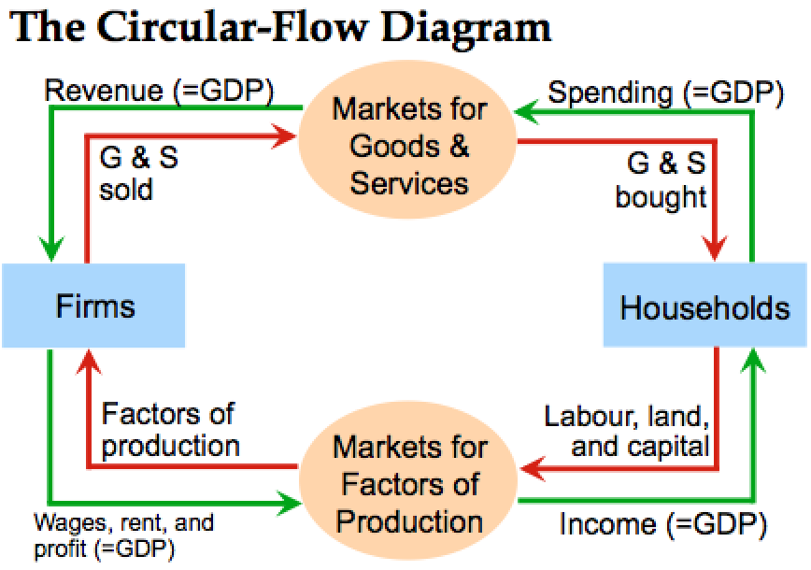
Circular Flow Diagram
Green =nominal Money
Red = real goods
Factors of production- land (rent), labour (wages), capital (interest), entrepreneurship (profits) *****
Factor payments- payments to factors of production (rent, wages, interest, profits)
Households)- own the factors of production- sell/rent to firms for income, buy and consume goods and services (SELLER AND BUYER: prostitutes)
Firms- buy/hire factors of production- use to produce g & s, sells g & s
(SELLER AND BUYER)
NOT included in diagram:
Government- collects taxes and buys g & s, makes transfers, give out/take back money
Financial system- matches savers’ supply of funds with borrowers’ demand for loans
Foreign sector- trades g & s, financial assets, and currencies with the country’s residents
Gross Domestic Product (GDP)- the market value of all final goods and services produced within a country in a given time period *****
- goods valued at market prices so goods are measured in the same units (CAD) and things that don’t have a market value are excluded (housework you do for yourself, or black market)
- Final goods- good or commodities that is sold ONLY included in GDP because you *** want to avoid double counting by not including intermediate goods***
- Intermediate goods- used as components or ingredients in the production of other goods
- Includes CURRENTLY produced goods, not goods produced in the past *****
- Usually a year or a quarter (3 months)
GDP components (4)
(C)onsumption- total spending by households on g & s
- renters: consumption includes rent payments
- home owners: consumption includes the rental value of the house, but not the purchase price or mortgage payments
(I)nvestment- total spending on goods that will be used in the future to produce more goods (capital equipment: machines/tools, structures, inventories) , NOT the purchase of financial assets like stocks and bonds
(G)overnment Purchases- includes salaries of government workers and public works, or any other spendings by governments that ARE NOT purchases of g & s
- EXCLUDES transfer payments- Canada pension plan benefit to an elderly or employment insurance benefits
(NX)Net eXports= exports – imports
- Imports- C I G
***** GDP(Y) = C + I + G + NX ***** Anything goes up, GDP goes up
EXEPT Exports increase GDP but imports decrease GDP
Real vs. Nominal GDP
Nominal- values output using current prices, it is not corrected for inflation (measured using the ‘then’ current prices) Dollar terms
- change in nominal GDP reflects both prices and quantities
Real GDP- values output using the prices of a base year, real GDP is corrected for inflation (measured using constant prices from base year) terms of goods
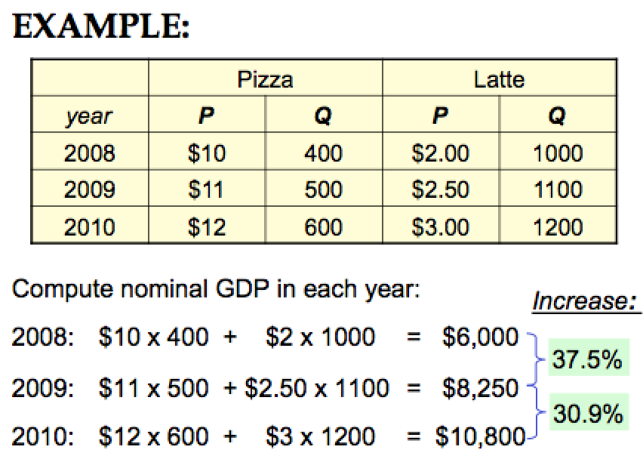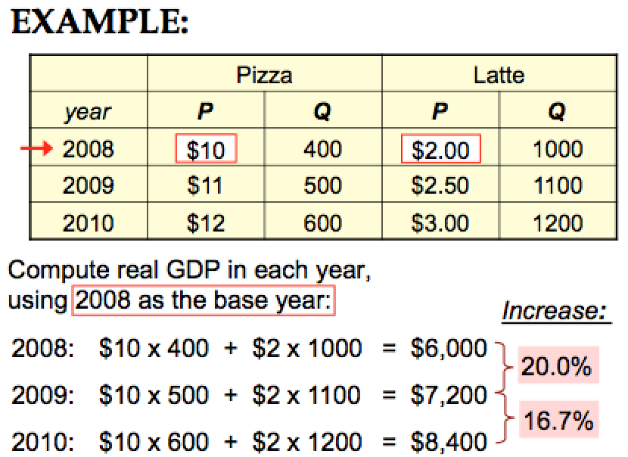

real measures purchasing powder (quantity terms)
nominal is price terms

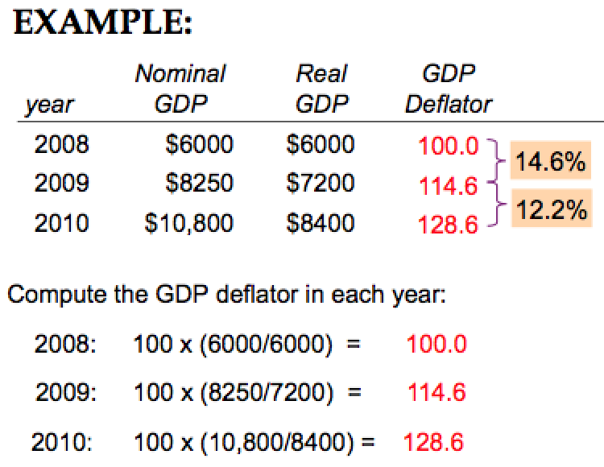
GDP Deflator- a measure of the overall level of prices
GDP Deflator = 100 x $\frac{nominal GDP}{real GDP}$ *****
- one way to measure the economy’s inflation rate is to compute the percentage increase in the GDP deflator from one year to the next

GDP and Economic Well-being
GDP per Capita- main indicator of the average person’s standard of living (not perfect measure)
DOES NOT VALUE: quality of environment, leisure time, non-market activity (child care parent provides at home for child), an equitable distribution of income, black market (NEGATIVE EXTERNALITIES)
WHY GDP IS IMPORTANT: large GDP enables country to afford better schools, cleaner environment, health care, etc.
Economics Chapter 6: Measuring the Cost of Living

Consumer Price Index (CPI)- measures the typical consumer’s cost of living (basis of cost of living adjustments (COLAs) in many contracts and in social security)
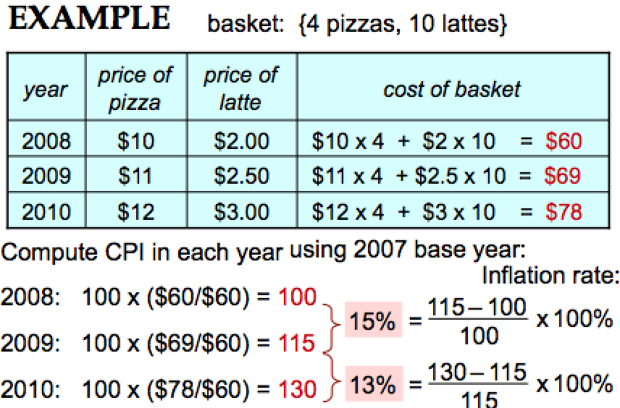
How it is calculated
- determine the ‘basket’
- find the prices
- compute the basket’s cost
- choose a base year to compute the index
CPI = 100 x $\frac{cost of basket in current year}{cost of basket in base year}$ *****
- compute the inflation rate- the percentage change in the CPI from the preceding period
inflation rate = $\frac{CPI this year-CPI last year}{CPI last year}$ x 100 %
Problems with CPI:
ALL CAUSES CPI TO OVERSTATE COST OF LIVING INCREASES
Commodity Substitution Bias
- some prices rise faster than others
- consumers substitute toward goods that become relatively cheaper
- the CPI misses this substitution because it uses a fixed basket of goods
Introduction of New Goods
- intro of new goods increases variety, allows consumers to find products that more closely meet their needs
- dollars become more valuable
- CPI misses this effect because it uses a fixed basket of goods
Unmeasured Quality Change
- improvements in quality of goods in the basket increases value of each dollar
- quality is hard to measure
The GDP Deflator vs. the CPI
- economists and policy makers monitor both the GDP deflator and consumer price index to gauge how quickly prices are rising
- GDP- reflects prices of all g & s produced domestically
  - Compares the price of currently produced g & s to the price of the same g & s in the base year
- CPI- reflects the prices of all g & s bought by consumers
  - Compares the price of a fixed basket of g & s to the price of the basket in the base year
 | CPI | GDP
Imported consumer goods | Included | Excluded
Capital goods | Excluded | Included
Basket (matters if different prices are changing by diff amounts) | Uses a fixed basket | Uses basket of currently produced goods & services
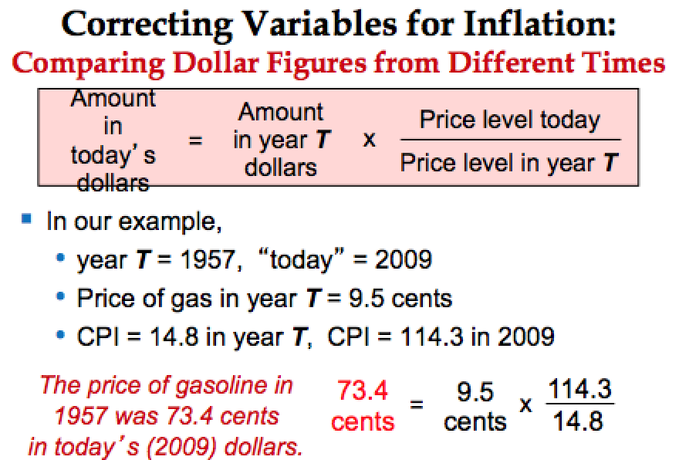
Correcting Variables for Inflation:
Comparing Dollar Figures from Different Times
Amount in Today’s Dollars = Amount in year T dollars x $\frac{Price level today}{Price level in year T}$

Real Vs. Nominal Interest Rates
Nominal Interest Rate | Real Interest Rate
- interest rate NOT corrected for inflation  - the rate of growth in the DOLLAR VALUE of a deposit or debt | - interest rate corrected for inflation  - the rate of growth in the PURCHASING POWER of a deposit or debt
Real interest rate = (nominal interest rate) – (inflation rate)

Economics Chapter 7: Production and Growth

Productivity- the average quantity of g&s produced from each hour of a worker’s time *
Y = real GDP = quantity of output produced
L = quantity of labour
Productivity (output per worker) = $\frac{Y}{L}$
Physical Capital
Physical capital (K)- the stock of equipment and structures used to produce g&s
Capital per worker = $\frac{K}{L}$
- Nominal Terms: Increase in K causes increase in Y
- Real Terms: Increase in K/L causes an increase in Y/L
Human Capital per Worker (H)- knowledge and skills workers acquire through education, training, and experience
Average worker’s human capital = $\frac{H}{L}$
- Nominal Terms: increase in H causes an increase in Y
- Real Terms: Increase in H/L causes an increases Y/L
Natural resources (N)- the inputs into production that nature provides (land, mineral deposits)
- Nominal Terms: increase in N causes an Increases Y
- Real Terms: Increase N/L causes an increases Y/L
The Production Function- a graph or equation showing the relation between output and inputs
Y = A x F(L, K, H, N)
F- a function that shows how inputs are combined to produce output
- level of technology
- A multiplied the function F- so improvements in technology (increases A) allow more output (Y) to be produced from any given combination of inputs
Change in Y over change in LKH or N is positive
LKHN increase at a decreasing rate
Constant returns to scale- changing all inputs by the same percentage causes output to change by that percentage
- if you increase input, it increase output
- (e.g. increasing all inputs 10% (multiplying by 1.1) increases output by 10%
- but do not multiply the A variable
Saving and Investment
Increase in productivity- increase in K (investment)
Producing more capital- producing fewer consumption goods
Reducing consumption- increase saving
The Production Function & Diminishing Returns
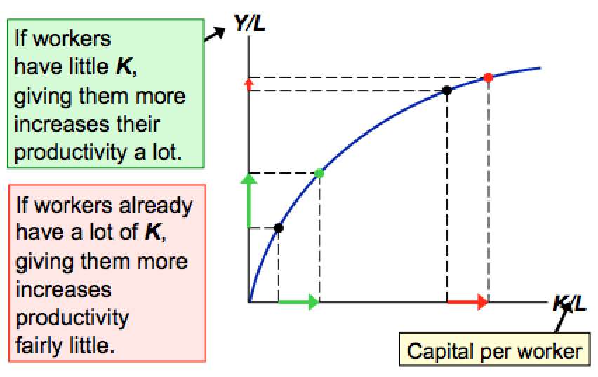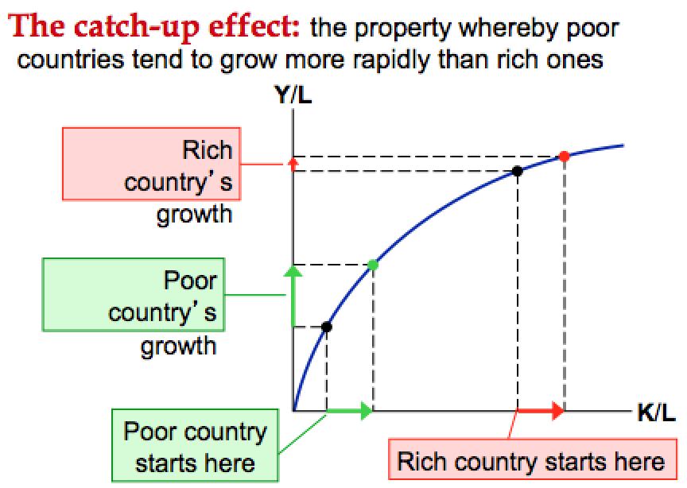
Catch up Effect- The property whereby poor countries tend to grow more rapidly than rich ones
Investment from Abroad
To rise K/L, govt can encourage:
Foreign direct investment (FDI)- a capital investment (factory) that is owned & operated by a foreign entity [Real Variable] own your company
Foreign Portfolio Investment- a capital investment finances with foreign money but operated by domestic residents [Monetary] own your money
Education- investment in (H) to increase productivity by promoting education
Health and Nutrition
*Property Rights- the ability of people to exercise authority over the resources they own
Free Trade
Inward- Oriented Policies- aim to raise living standards by avoiding interaction with other countries (e.g. tariffs, limits on investments from abroad) Generally Failed
Outward- Oriented Policies- promote integration with the world economy(e.g. the elimination of restrictions on trade or foreign investment) Generally Succeeded
Research and Development
- knowledge is a public good- ideas can be shared freely, increasing the productivity of many

Population Growth- may affect living standards in 3 diff ways
- Malthus argues pop growth would strain the society’s ability to provide for itself
- World population increased, but Malthus wrong, living standards have risen, not fallen
- Malthus failed to account for technical progress and productivity growth
Diluting the Capital Stock
H/L, N/L, K/L, increases L but decreases, H/L, N/L, K/L, decreases Y/L
Promoting Tech Progress
- more people = more scientists, inventors, engineers, etc
- growth rate increase, world population increase
Economics Chapter 9: Unemployment and its Natural Rate
Labour force statistics
Employed- a person is considered employed if he/she has spent most of the previous week working at a paid job
Unemployed- is he or she is on temporary lay off, is looking for a job, or is waiting for the start date of a new job
Not in labour force- everyone else
*Labour force = employed + unemployed
*Unemployment rate( u- rate) = 100 x $\frac{number of unemployed}{labour force}$
*Labour force participation rate = 100 x $\frac{labour force}{adult population}$
*Working Limitations
Discouraged worker hypothesis- would like to work but has given up on looking for jobs, “not in labour force” falling u rate gives impression that the labour market is improving but its not
Unemployment rate rises- you know what this is. Duh.
Unemployment unchanged- sam goes from full time salary to part time
*unemployment rate ignores what we call underemployment where we want to work more but have a job already
Natural rate of unemployment
- rate of unemployment in which the economy tends to return in the long run
- always some unemployment though u- rate fluctuates from yr to yr
- Canada’s natural unemployment rate is 6-8%
Types of Unemployment
Cyclical- deviation between natural and actual rate
Frictional- occurs when workers spend time searching for jobs that best suit their skills and tastes in the short term
Structural-fewer jobs than workers usually long term
Job Search- process of matching workers with appropriate jobs
Sectorial shifts- changed in the composition of demand across industries or regions of the country
- some people must move for new jobs to suit tastes
- some frictional unemployment is inevitable
Employment insurance- protects employees when unemployed

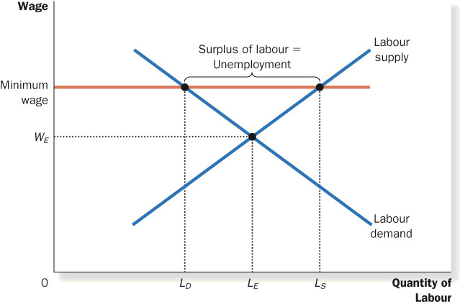

Minimum wage laws-may exceed equilibrium wage for the least skilled or experienced workers, causing structural unemployment
- when wage is above equilibrium level, quantity of labour exceed quantity of labour demanded. People unemployed because they are waiting for jobs to open up
Union- a worker association that bargains with employers over wages, benefits, and working conditions
- union worker earns 20% more wages and gets more benefits than non union worker for the same type of work
Collective bargaining- process which unions and firms agree on terms of employment
Strike- refers to when the union organizes a withdrawal of labour from the firm. Will be organized is firm and union do not reach an agreement.
- when unions raise wage above equilibrium, quantity of labour demanded falls and unemployment results
- insiders- workers who remain employed are better off
- outsiders- workers who lose their jobs are worse off
- Some outsiders go to non-unionized labour markets which increased labour supply and reduces wages in those markets

Efficiency wages- firms voluntarily pay above equilibrium wages to boost worker productivity
- worker health- better health, better work
- worker turnover- more pay, more incentives to stay, less turnover
- worker quality- higher wages better applicants
- worker effort- slackers are fired, work harder to stay

Chapter 10: The Monetary System

Barter- the exchange of one good or service for another
Double coincidence of wants- the unlikely occurrence that two people each have a good the other wants
Money- the set of assets that people regularly use to buy g&s from other people
3 Functions of Money
Medium of exchange- an item buyers give to sellers when they want to purchase g&s
Unit of account- the yardstick people use to post prices and record debts
Store of value- an item people can use to transfer purchasing power from the present to the future
Two kinds of money
Commodity money- takes the form of a commodity with intrinsic (natural) value (eg. Gold coins, cigarettes in POW camps)
Fiat money- money without intrinsic value, used as money because of gov’t decree (e.g. the Canadian dollar)
Money in the Canadian Economy
Money supply (money stock)– the quantity of money available in the economy, decisions are done by the monetary policy
Currency- the paper bills and coins in the hands of the (non- bank) public
Demand deposits- balances in bank accounts that depositors can access on demand by writing a cheque or using a debit card
The Bank of Canada
Central bank- an institution designed to regulate the money supply in the economy
Bank of Canada- the central bank of Canada
- issue currency
- act as a banker to commercial banks
- act as a banker to the Canadian government
- control the money supply

commercial banks- can influence the quantity of demand deposits in the economy and the money supply (e.g. credit unions, caisses populaires, trust companies)
Commercial Banks and the Money Supply
Fractional reserve baking system- banks keep a fraction of deposits as reserves and use the rest to make loans
- banks may hold more than this minimum amount if they choose
- creates money, not wealth
- Reserve ratio (R)= the fraction of deposits that banks hold as reserves = total reserved as a percentage of total deposits
Bank T- Account
T account- a simplified accounting statement that shows a bank’s assets and liabilities (liabilities: deposits, assets: loans and reserves)
The Money Multiplier
Money multiplier- the amount of money the banking system generates with each dollar of reserves
= 1 / R
Bank of Canada’s Tools of Monetary Control
Open market operations- conducts when buying government bonds from or sells government bonds to the public
- buying bonds causes money supply to increase
- selling bonds causes money supply to decrease
Changing the overnight rate-
- Bank rate- interest rate changed by the bank of Canada on loans to the commercial banks
- Overnight rate- interest rate on very short term loans between commercial banks
Foreign Exchange Market Operations- conducts when it buys or sells foreign currencies
- money increases when buys foreign currency within Canadian currency
- money decreases when sells foreign currency
Problems in Controlling the Money supply
- The Bank of Canada’s control of the money supply is not precise.
- The Bank of Canada must wrestle with two problems that arise due to fractional-reserve banking.
- The Bank of Canada does not control the amount of money that
  - households choose to hold as deposits in banks.
  - commercial bankers choose to lend.

Chapter 11

The quantity theory of money

Inflation is when aggregate demand exceeds aggregate supply

The Classical Theory of Inflation
The quantity theory of money is used to explain the long-run determinants of the price level and the inflation rate

Purchasing power = M/P
M increases PP increases

The Value of Money

Economics Chapter 11: Money Growth and Inflation

Quantity theory of money- prices rise when the govt prints too much money, good for explaining the long run behaviour of inflation
Classical Theory of Inflation
- inflation is an increase in the overall level of prices
- Hyperinflation is an extraordinarily high rate of inflation
Quantity theory of money- is used to explain the long-run determinants of the price level and the inflation rate (when overall price level rises, the value of money falls)
The Value of Money
P= the price level = the price of a basket of goods, measured in money
1/P- is the value of $1 measured in goods
- e.g. if P = $2, the value of $1 is ½ candy bar
- inflation drives up prices and drives down the value of money
Money Supply (MS)
Vertical on a graph
*Money supply is independent of the price level and money supply*
Money Demand (MD)- refers to how much wealth people want to hold in liquid form.
- *depends on P, an increase in P reduces the value of money, so more money is required to buy g&s
- M/P = purchasing power = real balances
- *quantity of money demanded is negatively related to the value of money and positively related to P, other things (real income, interest rates, availability of ATMS) equal
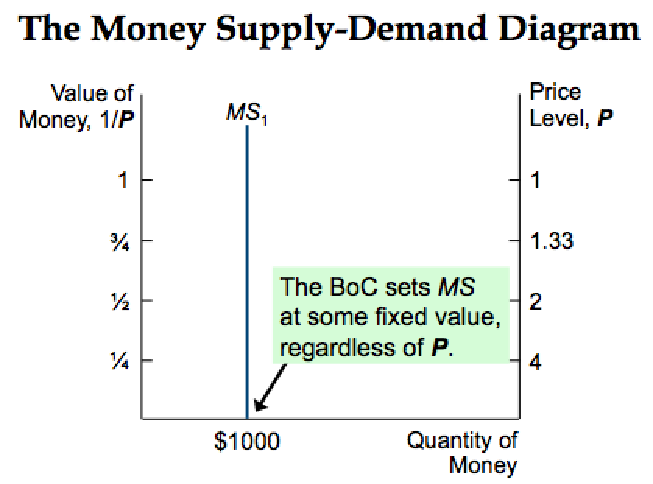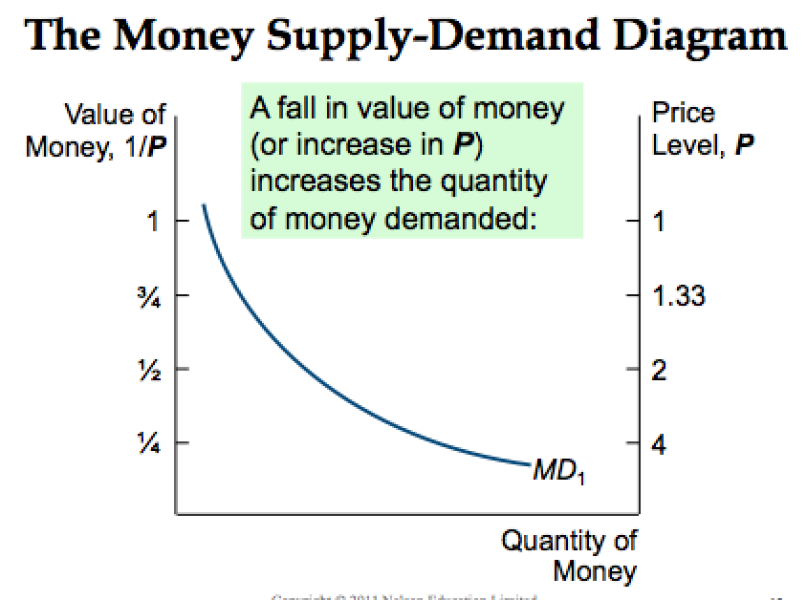
REFER TO DIAGRAM ON THE RIGHT.
Put a P beside MD b/c a change in P causes a shift, and R is along
Price goes up, MD shifts up || Price goes down, MD shifts down
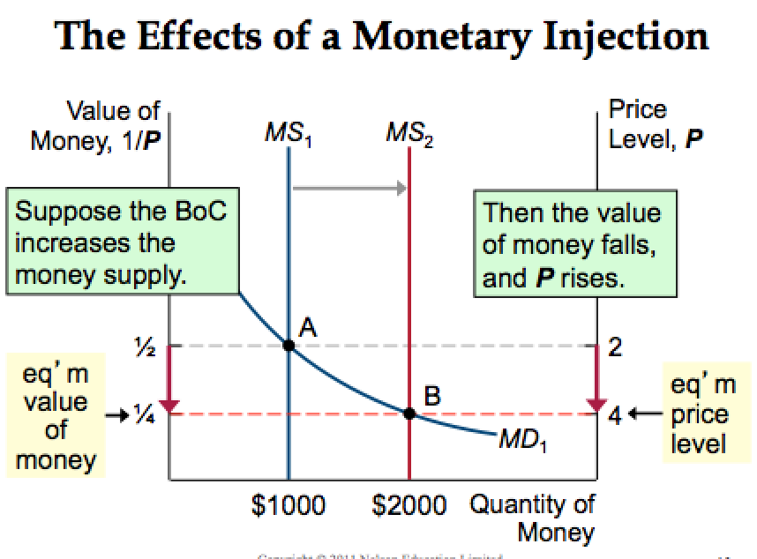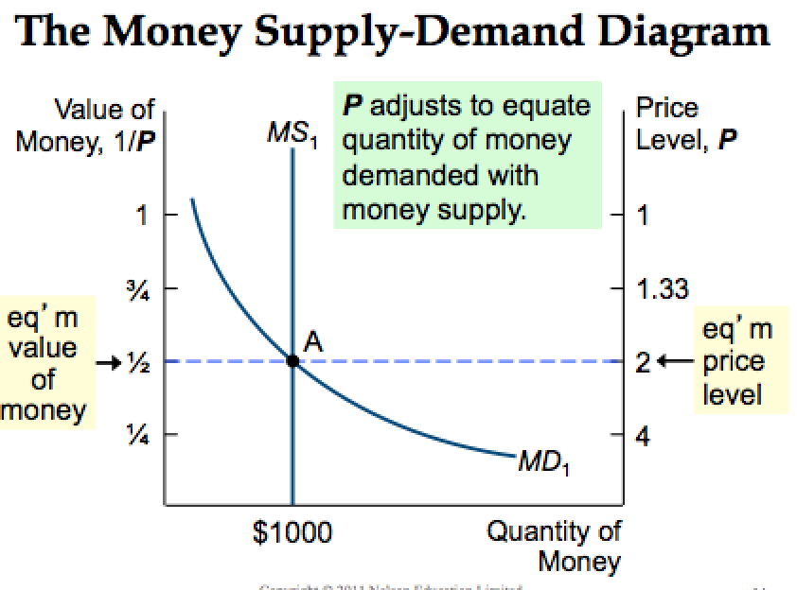
REFER TO DIAGRAM ON LEFT
BoC = bank of Canada example
REFER TO DIAGRAM ON THE RIGHT
*Money supply unrelated to P and R
*Money demand, downward sloping in R, shifts because of P
Adjustment Process
WHY DOES THE MONEY IN A SENSE GO DOWN- skill testing question
Inject money into economy, more money, excess supply of money, 1/P (value of money) falls, P (price of money) goes up
*M & P are positively related*
Real vs. Nominal Variables
Nominal variables- measured in monetary units (nominal GDP (Y), nominal interest rate (I), nominal wage (W) anything with one letter)
*Measured on dollars*
Real variables- measured in physical units (Real GDP (Y/P), real interest rate, real wage (W/P) and (M/P)) Does your money purchase more? Are you better off?
*Measured on g&S, purchasing power*
Relative price= $\frac{Price of one good}{Price of another good}$ = # good1 per good2
the price of one good relative( divided by) another. Measured in physical units, so they are real variables
- using nominal to calculate real
W = nominal wage = price of labour (eg. $15/hour)
P = price level in nominal terms = price of g&s (e.g. $5/ unit of output)
Real wage = $\frac{W}{P}$ = $\frac{\$15/ hour}{\frac{\$5}{}unit of output}$ = 3 units output per hour
Nominal divided by nominal is real, similarly to math where negative times negative is positive
Classical dichotomy- All nominal variables will double if you double money but real prices aren’t touched (MONETARY ECONOMY HAS NO EFFECT ON REAL ECONOMY) long run economy description
- monetary changes have no real changes. If you change the money supply, you do not change real balances. If you change the wage rate, you don’t change the real wages.
$$\frac{2M}{2P}= \frac{M}{P}$$
Think of it as nominal M and real M have a wall that you can’t penetrate
Neutrality of Money
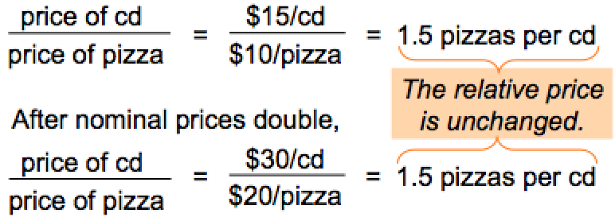
Monetary neutrality- the proposition that changes in the money supply do not affect the real real variables. Real terms are constant (money doesn’t matter)
- doubling the money supply causes all nominal prices to double
If 10W/10P = W/P (real wage) =no change in: labour demand, supply, employment, real GDP (called money illusion) Dichotomy says everyone suffers from money illusion
Velocity of Money- the rate at which money changes hands, how many times money has been touched and moved (transactions)
$Velocity (V)= \frac{P x Y}{M}$
P x Y = price level x real GDP = nominal GDP
M = money supply || V = velocity
Quantity Equation = (M x V = P x Y) Assume V is stable
It is another way of describing the classical dichotomy
Change in M no change in Y
Fisher Effect
Nominal interest rate= inflation rate + real interest rate
- real interest rate is determines by saving & investment in loanable funds market
- money supply growth determines inflation rate
- long run, money is neutral
- * a change in the money growth rate affects the inflation rate but not the real interest rate
Hyprinflation- inflation exceeding 50% per month
Inflation Tax- tax revenue is inadequate and ability to borrow is limited, govt may print money to pay for its spending
* nominal does up to an equal proportion to inflation rate for real interest rate is fixed
Costs of Inflation
Shoe leather costs- the resources wasted when inflation encourages people to reduce their money holdings (includes the time and transactions osts of more frequent bank withdrawals)
- as inflation goes up, you have to hold more money, so you have to go to the bank more often, so you wear out more shoe leather going to the bank
Menu costs- the costs of changing prices (printing new menus, mailing new catalogues, etc)
- As prices go up, you have to reprint your menus as a restaurant
Misallocation of resources from relative-price variability- firms don’t all raise prices at the same time, so relative prices can vary which distorts the allocation of resources
- every time the inflation goes up, there is a misallocation of resources, b/c they get used to the price level of resources and make choices based on it when they should change it
Confusion and inconvenience- inflation changed the yardstick we use to measure transactions. Complicates long-range planning and the comparison of dollar amounts over time
- in kam’s terms, it’s a pain in the ass b/c we always have to adjust to price changes
Tax distortions- inflation makes nominal income grow faster than real income. Inflation causes people to pay more taxes even when their real incomes don’t increase

Economics Chapter 14: Aggregate Demand and Aggregate Supply

Classical Dichnotomy- separation of variables into two groups, Real (quantities) and Nominal (measured in terms of money)
Neutrality of money- changes in the money supply affect nominal but not real variables
- short run, changed in nominal values like money supply or P can affect real variables like Y or u-rate
GDP Fluctuation Trends
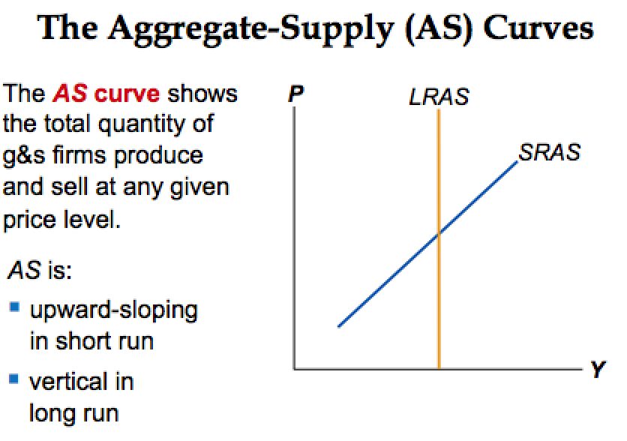
Recessions- periods of falling real incomes and rising unemployment
Depressions- severe recessions (very rare)
Business cycles- short economic fluctuations
Facts about Economics Fluctuations
*he doesn’t care and doesn’t want us to know these*
- economic fluctuations are irregular and unpredictable
- Most macroeconomic quantities fluctuate together
- As output falls, unemployment rises
In summary, as something changes, so does something else
Classical Economics Recap
- fluctuations have short come effects in the economy, but not long run
- change in nominal variables (money supply or P) can affect real variables (like Y or u-rate)
- SHORT RUN = money not neutral (dichotomy is violated)
- LONG RUN = money neutral (dichotomy holds)
Basic Model of Aggregate Demand and Aggregate Supply
- used to explain short-run fluctuations in economic activity around the long-run trend
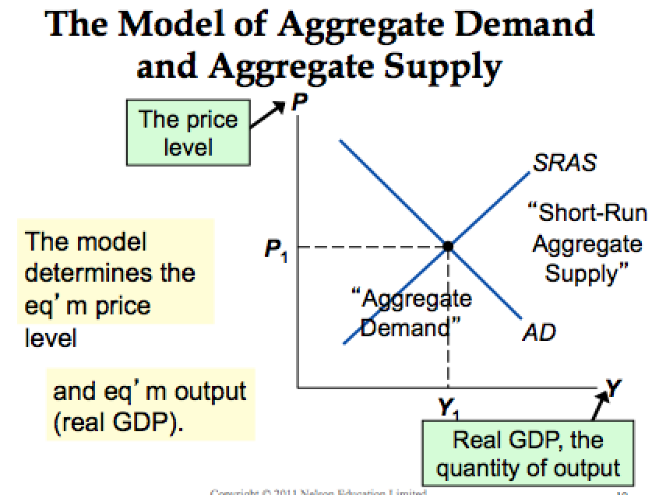
Aggregate demand curve- shows the quantity of goods and services that households, firms, and the government want to buy at each price level (basket of goods, not A good)
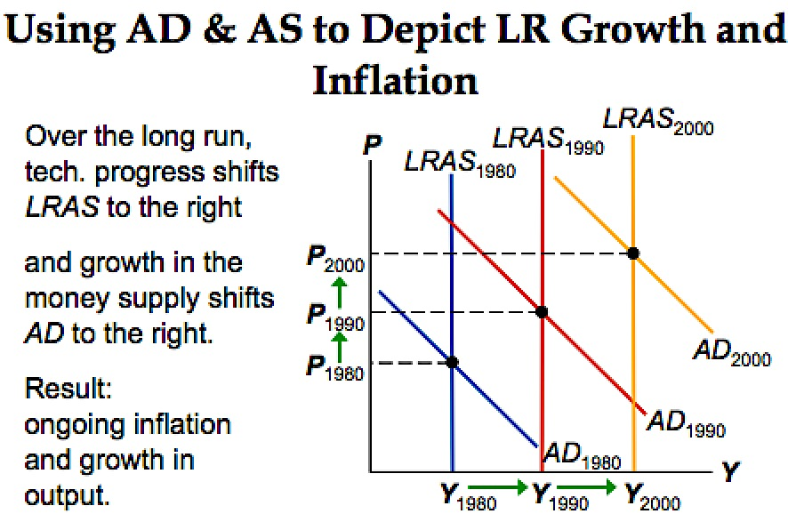
Aggregate supply curve- shows the quantity of goods and services that firms choose to produce and sell at each price level (a price, not a price level)
*ASAD short run if there is SRAS
* aggregate demand is the intersection
change in price level = movement along AD curve
Why AD curve slopes downward
Y = C + I + G + NX
1. Wealth Effect
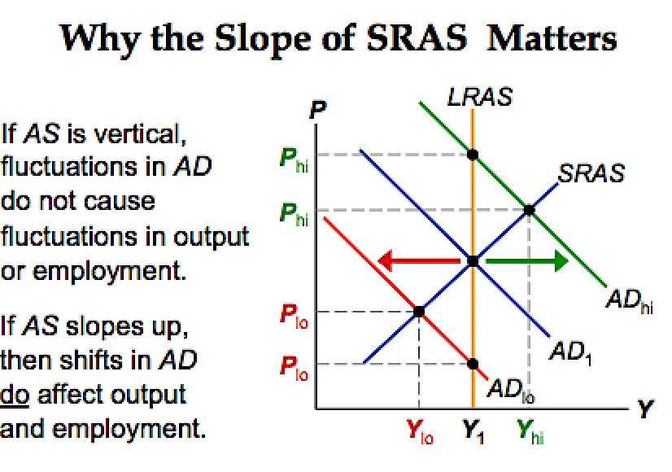
Suppose P rises, the dollars people hold buy fewer g&s, so the real wealth is lower, people feel poorer, C falls
- (P rises), M/P goes down, purchasing power goes down, people consume less (C goes down)
2. Interest- Rate Effect
Suppose P rises, buying g&s requires more dollars, to get these dollars, people sell bonds or other assets, this drives up interest rates, Investment(I) falls
- (P rises), M/P falls, people sell bonds, interest rates go up, investment falls (I falls)
- b/c when the price of money goes up, you demand less money
3. Exchange- Rate Effect (P and NX)
Canadian interest rates rise (interest rate effect), foreign investors desire more Canadian bonds, higher demand for $ in foreign Canadian bonds, Canadian exchange rate appreciates, Canadian exports more expensive to people abroad, imports cheaper to Canadian residents, NX falls
- (P rises), interest rates rise, demand increases for Canadian dollars, money becomes more expensive (stronger), imports rise, NX down.

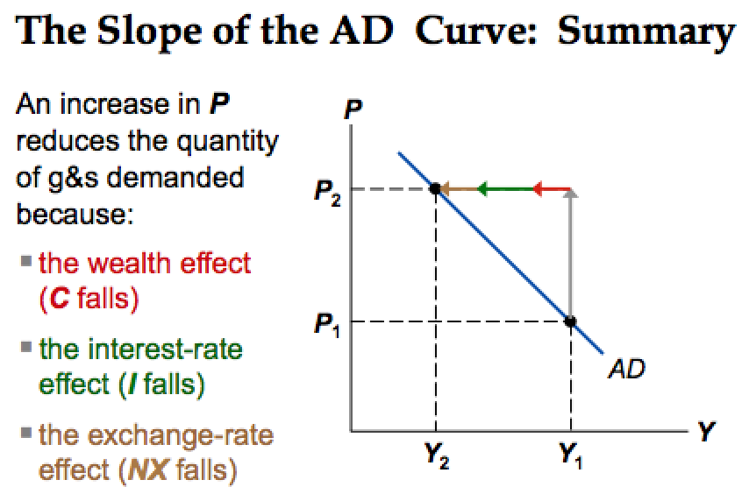
Why AD is a downward sloping

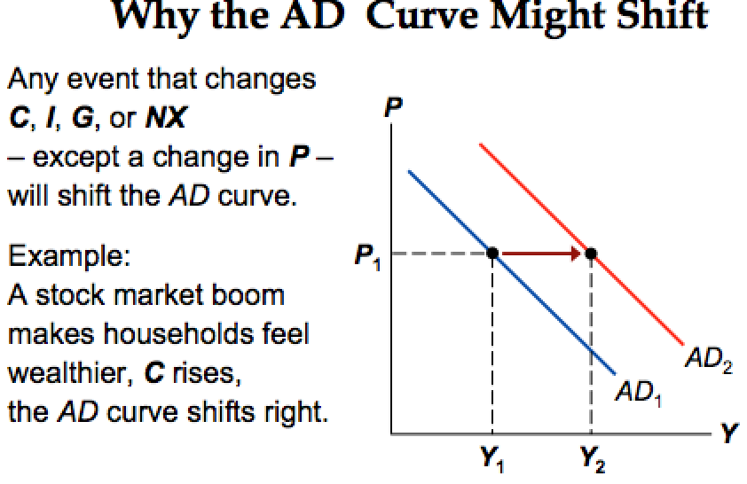

*Why the AD Curve Might Shift all increase AD (C, I, G, NX)
Changes in C- stock market boom/ crash, tax hikes/ cuts
Changes in I- firms buy new computers, equipment, factories, expectations, optimism, pessimism, interest rates, monetary policy, investment tax credit or other tax incentives
Changes in G- federal spending (defense), provincial and municipal spending (roads, schools)
Changes in NX- rooms/ recessions in countries that buy out exports, appreciation/ depreciation resulting from international speculation in foreign exchange market
Short run- P up, Y up (positive relationship)
Long Run- P down, Y up (negative relationship)

Natural rate of output- is the amount of output the economy produces when unemployment is at its natural rate (LRAS)
(Yn) aka potential output, full- employment output
*insensitive to changes in P
Why LRAS is vertical ** TEST QUESTION
Increase in P = Increase in M
Increase in P = Increase in W
W/P = no change ]
M/P no change ] Therefore no change in Y
* Prices and nominal variables adjust proportionately and instantly
*Why the LRAS Curve Might Shift
Supply side variables shift the LRAS (K, H, L, A)
Changes in L- immigration, baby boomers retire, govt policies reduce natural U rate
Change in K or H- investment in factories, equipment, more people get college degrees, factories destroyed by a hurricane
Changes in natural resources- discovery of new mineral deposits, reduction in supply of imported oil, changing weather patterns that affect agricultural production
Changes in technology- productivity improvement from technological progress

Why is SRAS upward sloping
P goes up, W or M stays same, so there is a change in Y because W/P, M/P

We have two equilibriums now
Short run: SRAS = AD
Long run: SRAS = AD = LRAS
You are always in short run equilibrium where SRAS = AD
Three Theories of SRAS
There is a market imperfection where there is an accident
Price level Doesn’t equal the Price level that occurs
Sticky Wage Theory- nominal wages are sticky in the short run, adjust sluggishly (labour contracts, social norms)
- firms and workers set the nominal wage in advance based on Price expected (Pe)
- P > Pe revenue is higher, but Labour cost is not. Production is more profitable so firms increase output and employment
- P causes higher Y, so SRAS CURVE SLOPES UPWARD
- W/P doesn’t instantly adjust
Sticky Price Theory- prices sticky in short run due to menu costs, to adjust prices
- firms set sticky prices in advance based on Pe
- P goes up, Y goes up, SRAS CURVE SLOPES UPWARD
Misperceptions Theory- firms may confuse changes in P with changes in relative price of the products they sell
- if prices rises above Pe, a firm sees its price rise before realizing all prices are rising.
- P goes up, Y goes up, SRAS CURVE SLOPES UPWARD

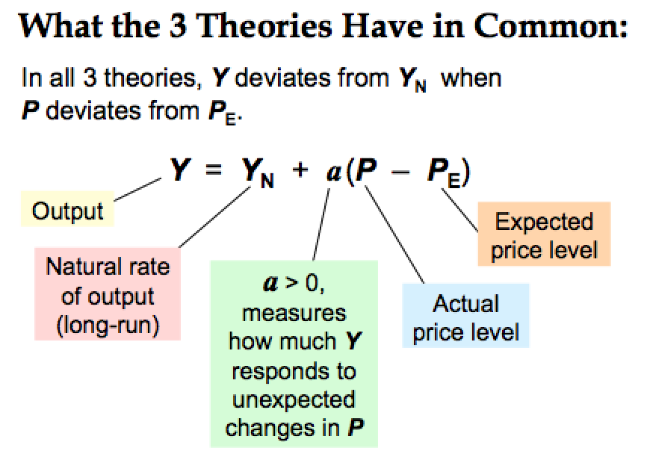
*If P = Pe, Y = Yn
d
If P not equal Pe, Y not equal Yn, but it adjusts at a speed of ‘a’
D

In the Long Run
Pe = P , AS curve is verticle

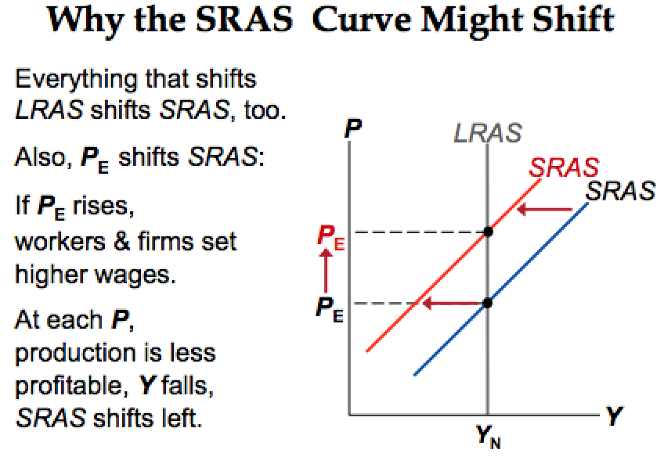
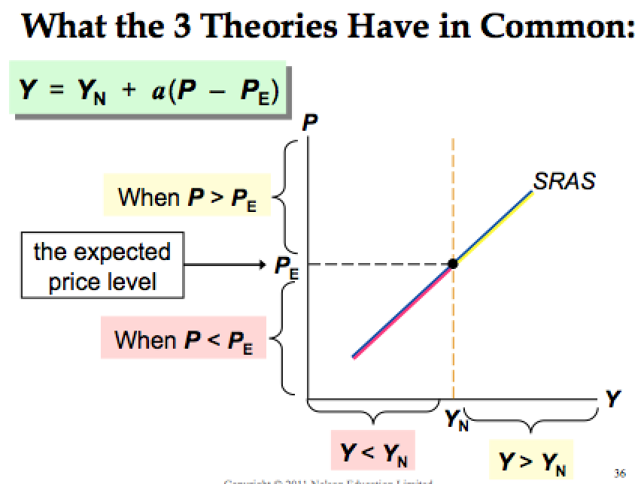
f

Why the SRAS Curve might shift ** EXAM
Change in LRAS -> Change in SRAS (left)
Change in Pe Change in SRAS alone (right)
SRAS = AD
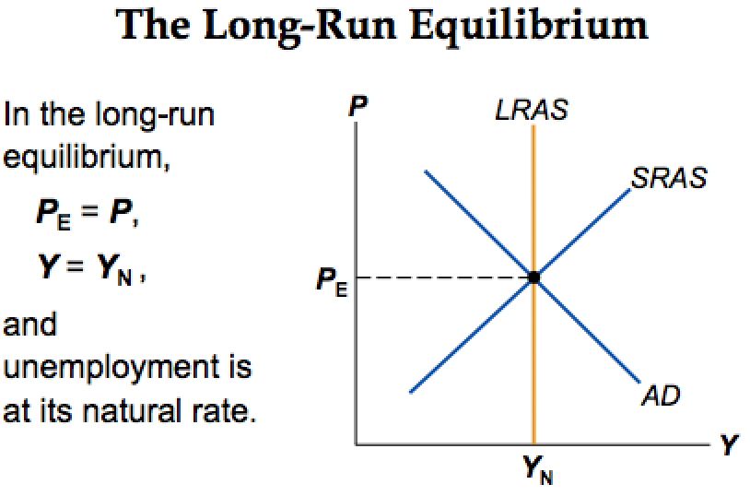
d
LRAS = SRAS = AD
Economic Fluctuations
- determine whether the event shifts AD or AS
- Determine whether curve shifts left or right
- Use AD-AS diagram to see how the shift changes Y and P in the short run
- Use the AD- AS diagram to see how economy moves from new SR eq’ m to new LR eq’m
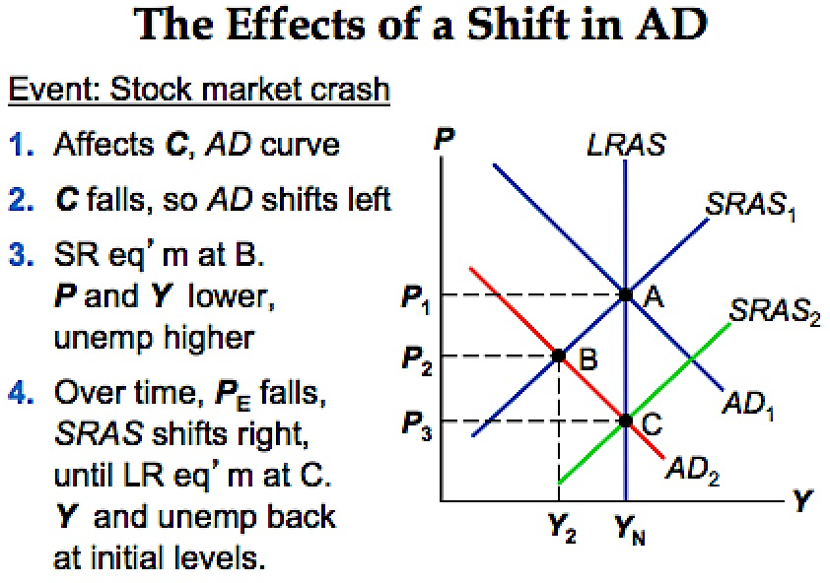
Y down, turns Yn to Y2

Y2 < Yn recession
= Prices fall

BAC Triangle = recessionary gap, prices fall

Short run: A B = Prices fall (Pe – P2), Y fall, Y1 – Y2)

Long Run: P down P2- P3
Y up Y2 – Yn
No change in Y & P fell
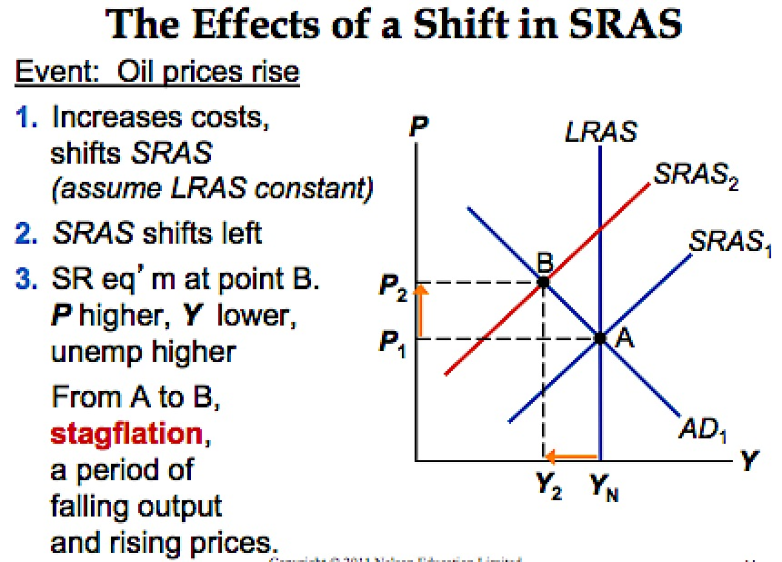
Chapter 15: The Influence of Monetary and Fiscal Policy on Aggregate Demand

Theory of Liquidity Preference- Interest rate(r) adjusts to balance supply and demand for money
Money Demand- reflect how much wealth people want to hold in liquid form, endogenous, negative function of interest rate
Money supply- assume fixed by central bank, does not depend on interest rate (exogenous)
Household Wealth- two assets
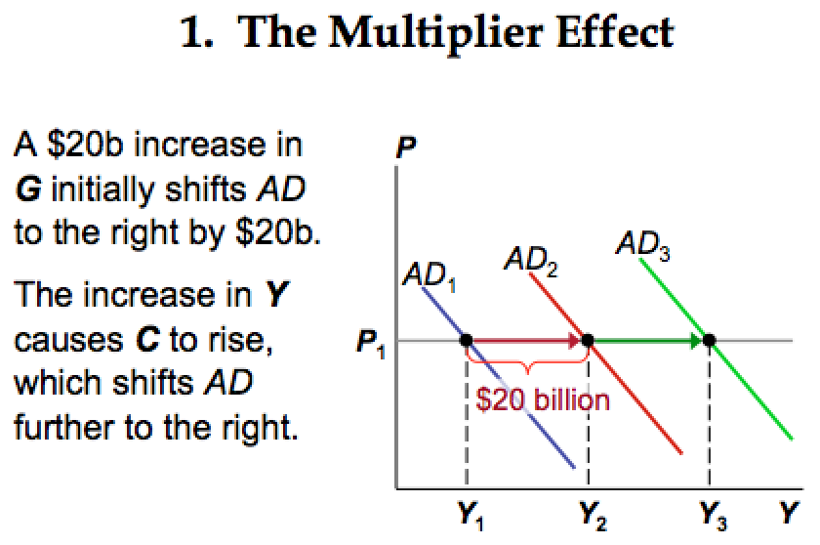
Money- liquid, r = 0
Bonds- not as liquid, r =/= 0
Md influences = f (P, Y, r)
= f (positive, positive, negative)
**If Y rises- real GDP goes up, money demand goes up, others equal
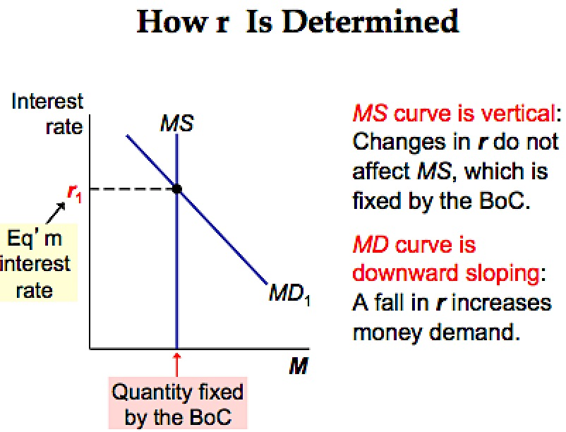
- households want to buy more g&s so they need more money. To get this money, they attempt to sell some of their bonds
MONEY SUPPLY IS GIVEN BY THE CENTRAL BANK

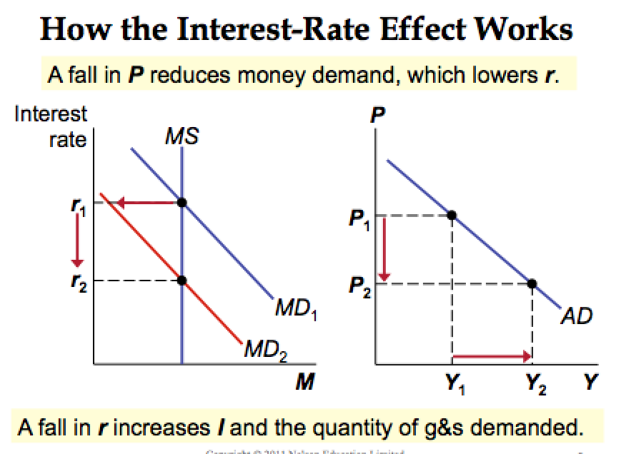

Md depends on price level +(shift)
R and I negative relationship
I and Y negative relationship
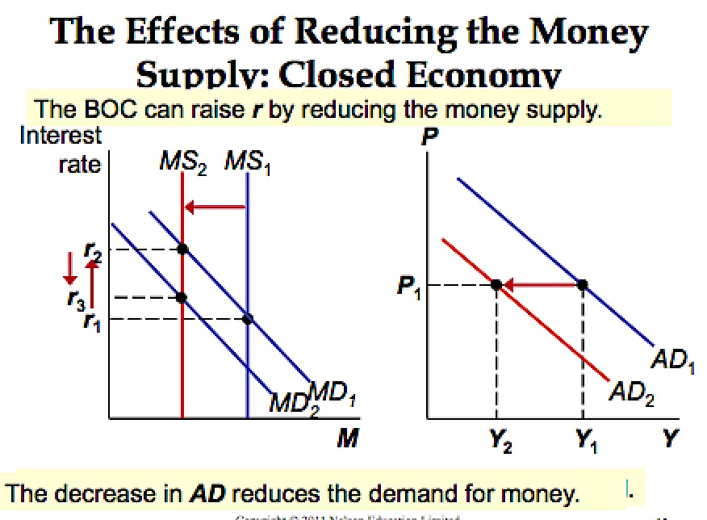
Monetary Policy and Aggregate Demand
Monetary policy- stimulates AD

Bank of Canada can change money supply by buying and selling gov’t bonds by conducting open market operations = changes rate and shifts AD curve

R goes up, Investment falls, Real GDP falls, Shifts AD1 to AD2, shifts MD1 to MD2, so decreases R2 to R3
**** KNOW HOW TO REVERSE THE STORY OF ANY GRAPHS ****
r goes up, P goes down, what
Ms down, r up
R up, I down
I down, Y down
I down, AD down
AD down, MD down
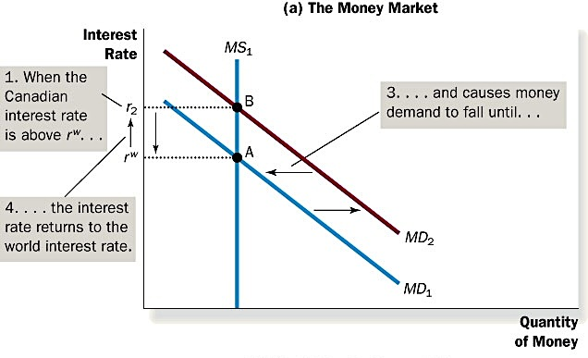
MD down, r down steps
Open Economy Considerations
Ms up, dollar value down, net exports rise, Y up
- Y goes up, increases AD, shifts to the right
- R2 > r of world, Md up, Md1 to Md2, A to B
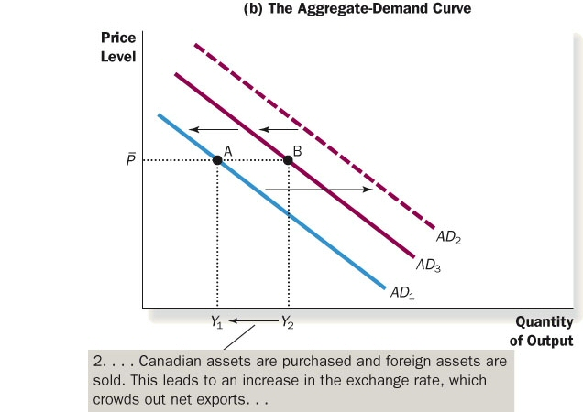

Crowding out effect- AD2 to AD3, causes Money demand to fall
AD down, MD down, r down, until r Canada = r world
Fiscal Policy and Aggregate Demand
Fiscal policy- the setting of the level of govt spending and taxation by govt policymakers
Expansionary Fiscal Policy- an increase in G and/or decrease in T shifts AD right
Contractionary Fiscal Policy- a decrease in G and/or increase in T shifts AD left
Fiscal Policy Effects on AD
1. Multiplier Effect- the additional shifts in AD that result when fiscal policy increases income and thereby increases consumer spending
- happens b/c of feedback effects, increase consumption, increase AD, Y up, AD up, Y up…. etc
- spend a dollar, change GDP and something greater than a dollar
Marginal propensity to consume (MPC)- the fraction of extra income that households consume rather than save *** EXAM LOTS OF QUESTIONS***
e.g. is MPC = 0.8 and income rises $100, C rises $80
MPC = Change in C / Change in Y
Change in Y = $\frac{1}{1-MPC}$ (Change in G)
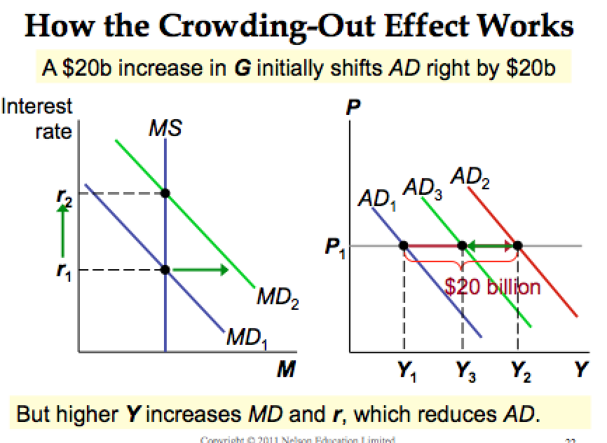
MPC up, Multiplier up
2. The Crowding- Out Effect- CLOSED ECONOMY, fiscal expansion raises r, reduces investment, reduces the net increase in AD, size of AD shift may be smaller than the initial fiscal expansion

- C up, AD up, Y up MD up, R up, I down, Y down **

AD1 AD2 initial increase = (G up), AD up, Y up
AD2 AD3 Second around = Y up, Md up, (R up), I down, AD down,
Hope AD1 to AD2 > AD2 to AD3
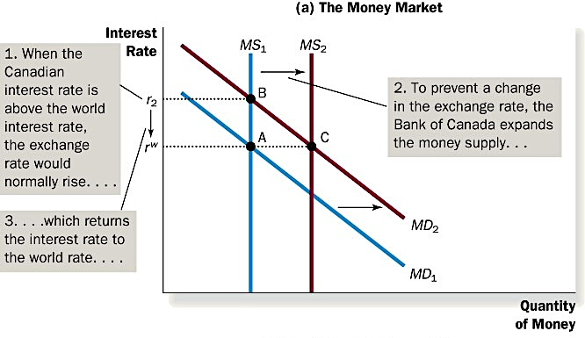
Open Economy Crowding Out Effect- flexible exchange rates reduces the demand for Canadian produced g&s

R up, e up NX down, Y down

