Country Analysis of Turkey

[Aderemi Lawal]

[100912110]

[BUSI 2701A]

[Daniel Gulanowski]

[May 20th, 2014]

TABLE OF CONTENT

EXECUTIVE SUMMARY 2
TURKEY’S MACRO ENVIRONMENT 3
  - Overview of the country……………………………………………………………………………………..........................3
Economic ties with EU …………………………………………………………………………………….................................................3
Level of corruption……………………………………………………………………………………………………………3
Political scenario of Turkey………………………………………………………………………………………………….4
Legislation affecting foreign investment…………………………………………………………………………………………………...4
Environmental concern………………………………………………………………………………………………………..5
FACTORS OF ENDOWMENT 5
Analysis.....................................................................................................................................................5-6
Recommendation & Conclusion..................................................................................................................6
APPENDIXES…………………………………………………………………………………………………………………………………………...6
appendixe A…………………………………………………………………………………………………………………………………………7
appendixe B………………………………………………………………………………………………………………………………………..8
BIBLIOGRAPHY………………………….…………………………………………………………………………………………………………...9

Country Analysis

Executive Summary
A thorough analysis was carried out to gain more knowledge and understanding about Turkey’s environmental, demographic and socioeconomic factors in order to determine whether or not they should undertake the decision for global expansion. Based upon some observation and factual information, the findings indicate that Turkey is a favorable market for foreign investors irrespective of the obvious risks that may impede the new entrants from exploring the market. Turkey has flexible laws pertaining to entry and exist barriers making it easier for the foreign market to enter Turkey’s business market. After having collaborated with European Union, there has been a rapid growth and stability of the country which attracts business prospects into the country. Some of the key challenges highlighted in the study included uncontrollable corruption, political unrest, cultural differences and the rising pollution which makes Turkey’s market a risky venture. However, some major steps have been taken in order to lessen the challenges and increase opportunities that foreign countries can offer in order to increase foreign exchange remove the underlying problem of trade deficit. After having conducted a thorough analysis, the conclusion was that the Canadian company should consider expanding its foreign operations in Turkey in order to reap numerous benefits, including favorable climatic conditions, young and diligent workforce, liberal policies and various growth opportunities.

Turkey’s Macro Environment
Overview of the country
Turkey is one of the most attractive locations in a global business field. Unlike other countries Turkey facilitates a liberal trade environment whereby an open trade system is fostered. The country has a strong financial sector giving it a competitive edge over of other countries. In general the country offers favorable business dynamics and a robust framework for starting a business in the midst of contemporary environmental laws. In the year 2010, several endeavors were directed towards making Turkey a more democratic state which will endorse openness of culture. (Turkey: Country Profile
Economic ties with EU
With the influx of globalization, Turkey seems to be steering towards an economic growth trend. The establishment of negotiation between Turkey and European Union has paved pay for prosperity and growth. There has been a rapid growth in Turkey’s equity market particularly resulting from the restructuring of the banking sector. The changing business dynamics and established interaction with entities such as the European Union has made the battle ground easier for Turkey allowing foreign investors to trade with the country. Example of multinational companies based in turkey is Microsoft, Hitli.
Level of corruption
There is a significant level of corruption in the country which is one of the implications which holds back foreign entry into the market. According to the corruption index in 2010, Turkey ranked fifty third among one hundred and seventy eight countries which is an alarming rate for a corruption level in the country striving to sustain and create a global competitive environment for itself. A large number of people in government sector are involved in corruption which often goes unnoticed. However, the people whose unlawful activities are exposed face serious consequences including detention and permanent suspension from the post. (See Appendix A)
Political scenario of Turkey
Turkey faces a tremendous political disruption due to the level of corruption in the country. The members of Erdogon were censured to have been involved in a number of illicit activities pertaining to corruption. This led to an outbreak of conflicts and political unrest in the country. Although the corporate governance in the country relies primarily on democratic representation, there is always a friction between prime minister and the preceding government
Legislation affecting foreign investment
The increase in the level of exports has a direct correlation with a favorable balance of trade and a positive foreign investment index. As a result, per capita income of people in Turkey has remarkably increased. As compared to other countries, Turkey does not levy entry and exit barriers allowing a seamless flow of trade and a favorable balance of trade. (See Appendix c)
Cultural issues
Turkey is a country situated on one side in Asia and on another side in Europe, doing business differ has you move within the country. When doing business in Turkey initial meetings should always concentrate on relationship building. In most business environment most women and men would shake hands with you but that is not the case in eastern or rural turkey where people are more conservative. Turks enjoy relaxing environment and good food while engaging in business activity. Turkey is a culturally based society built on Islamic values. Business in turkey is solely defined by your ability to build effective personal relationship. (Business in turkey, 2014)

Factor Endowments
Endowed with innumerable resources, a relatively younger workforce, favorable climatic conditions and cultural diversity, Turkey provides various opportunities for foreign business looking out to venture into global business. Located in the mist of prominent continents of Europe and Asia, Turkey provides a great platform for the foreign markets to set their base in this ideal location. The increment of exports after forming a relationship with EU, has further improvised the desirability of the country for a myriad of business opportunities. The influence of EU and compliance with an array of rules and has turned the tables around for Turkey making it an attractive market for foreigners. Yet another contributing factor which presents foreign business with a myriad of benefits is the modernity of ideology. This suggests that the country the country exists in a modern environment and can adapt to new business dynamics without much reluctance

Analysis
Some of the underlying benefits of venturing into this modern country include a favorable location amidst east and the west which provides an entryway into both the continents, favorable climatic conditions which makes Turkey a great place for expatriates, liberal policies pertaining to entry and exit barriers which makes it very easy for new entrants to set up their base in the country, innumerable resources unlike other country and a diverse pool of young workforce who are diligent and hardworking.
On the contrary some of the challenges and risks pertaining to Turkey include an overriding problem of pollution which is hazardous to health, a high degree of corruption in the government which impedes equity of access, political upheaval resulting in conflicts between parties and cultural disparity.
However, irrespective of these challenges, Turkey remains an attractive market for foreign investors anticipating to set up their base in a secure environment where they can grow and prosper. The young and thriving human resource is one of the greatest assets of the country which a foreign country can benefit from. As far as the environmental implications are concerned, the government anticipates mitigating the problem by complying with the European Union laws and condemning the disposal of toxic contents in the water according to vision 2023. Cultural disparity can be controlled up to a greater degree by familiarizing the people with culture, language and core values which defines the people of both countries

Recommendation & Conclusion
According to the above analysis it is quite evident that the Canadian company should go ahead with the global expansion in Turkey in order to reap innumerable advantages. There is a dire need for the managers to induct training to the employees about the cultural dynamics of the country in order to establish rapport and work seamlessly in a diverse business setting and strengthen business ties with the people in Turkey.
The presence of European Union has made Turkey a very secure place for Canadian investment. In sum, it is a pragmatic decision to go ahead with the expansion in the country irrespective of a volatile political environment after considering the key implications pertaining to the culture. It is vital for the managers to conduct various training programs for all employees in order to create awareness about the working dynamics of the country.
Appendixes A

Corruption index map world

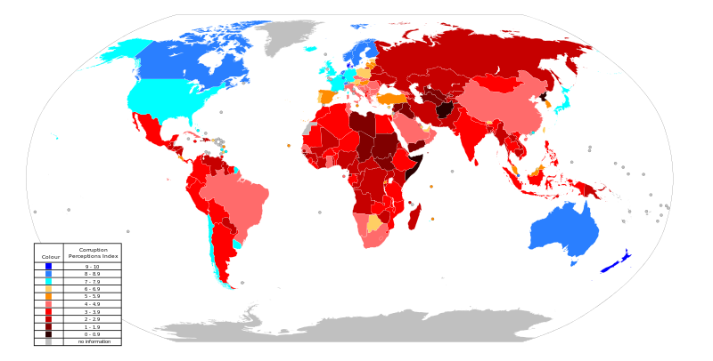
(Wikipedia 2014)

Appendices B

Foreign Direct Investment Flow
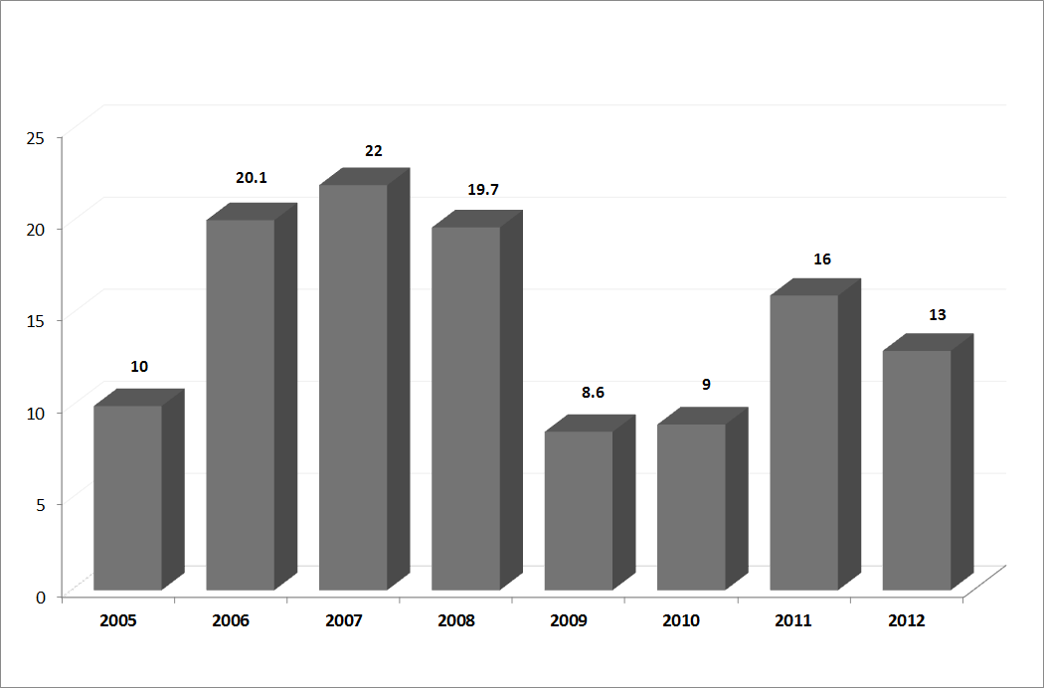

(Investor 2014)

Bibliography

2004. "Turkish equity market: still promising." Euromoney 35, no. 424: 8-9. Business Source Complete, EBSCOhost.
http://web.b.ebscohost.com/bsi/detail?vid=3&sid=4ff3daf8-36e1-4322-806c-13b6607db7ea%40sessionmgr111&hid=117&bdata=JnNpdGU9YnNpLWxpdmU%3d#db=bth&AN=14693507
2013. "POLITICAL LANDSCAPE." Turkey Country Profile 35-42. Hospitality & Tourism Complete, EBSCOhost (accessed May 15, 2014). http://web.b.ebscohost.com/bsi/detail?vid=11&sid=4ff3daf8-36e1-4322-806c-13b6607db7ea%40sessionmgr111&hid=117&bdata=JnNpdGU9YnNpLWxpdmU%3d#db=bth&AN=36428245
2012. "Turkey: Country Profile." Turkey Country Profile 1-76. Hospitality & Tourism Complete, EBSCOhost (accessed May 15, 2014).
http://web.b.ebscohost.com/bsi/detail?vid=13&sid=4ff3daf8-36e1-4322-806c13b6607db7ea%40sessionmgr111&hid=117&bdata=JnNpdGU9YnNpLWxpdmU%3d#db=bth&AN=94508365
Onder, Gokhan, and Zeynep Karal. "DETERMINANTS OF FOREIGN DIRECT INVESTMENTS OUTFLOW FROM A DEVELOPING COUNTRY: THE CASE OF TURKEY." Business, Management & Education / Verslas, Vadyba Ir Studijos 11, no. 2 (July 2013): 241-255. Business Source Complete, EBSCOhost,
http://connection.ebscohost.com/c/articles/5885717/locational-determinants-foreign-direct investment-emerging-market-economy-evidence from-turkey
Abercrombie, Katherine1, kabercrombie@student.clayton.edu, and Michael2, MichaelDeis@clayton.edu Deis. 2011. "The Cultural Aspects of Doing Business in Turkey." Global Education Journal no. 2: 124-135. Education Source, EBSCOhost
http://connection.ebscohost.com/c/articles/73151081/cultural-aspects-doing-business-turkey

Doing Business in Turkey, 2014, Kwintessential, Doing business In Turkey.
http://www.kwintessential.co.uk/etiquette/doing-business-turkey.html

2012. "Turkey: Country Profile." Turkey Country Profile 1-76. Hospitality & Tourism Complete, EBSCOhost
2004. "Turkish equity market: still promising." Euromoney 35, no. 424: 8-9. Business Source Complete, EBSCOhost
Ibid 1
2013. "POLITICAL LANDSCAPE." Turkey Country Profile 35-42. Hospitality & Tourism Complete, EBSCOhost
Onder, Gokhan, and Zeynep Karal. "DETERMINANTS OF FOREIGN DIRECT INVESTMENTS OUTFLOW FROM A DEVELOPING COUNTRY: THE CASE OF TURKEY." Business, Management & Education / Verslas, Vadyba Ir Studijos 11, no. 2 (July 2013): 241-255. Business Source Complete, EBSCOhost
Abercrombie, Katherine1, kabercrombie@student.clayton.edu, and Michael2, MichaelDeis@clayton.edu Deis. 2011. "The Cultural Aspects of Doing Business in Turkey." Global Education Journal no. 2: 124-135. Education Source, EBSCOhost

