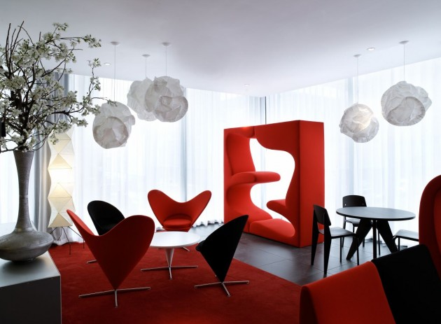
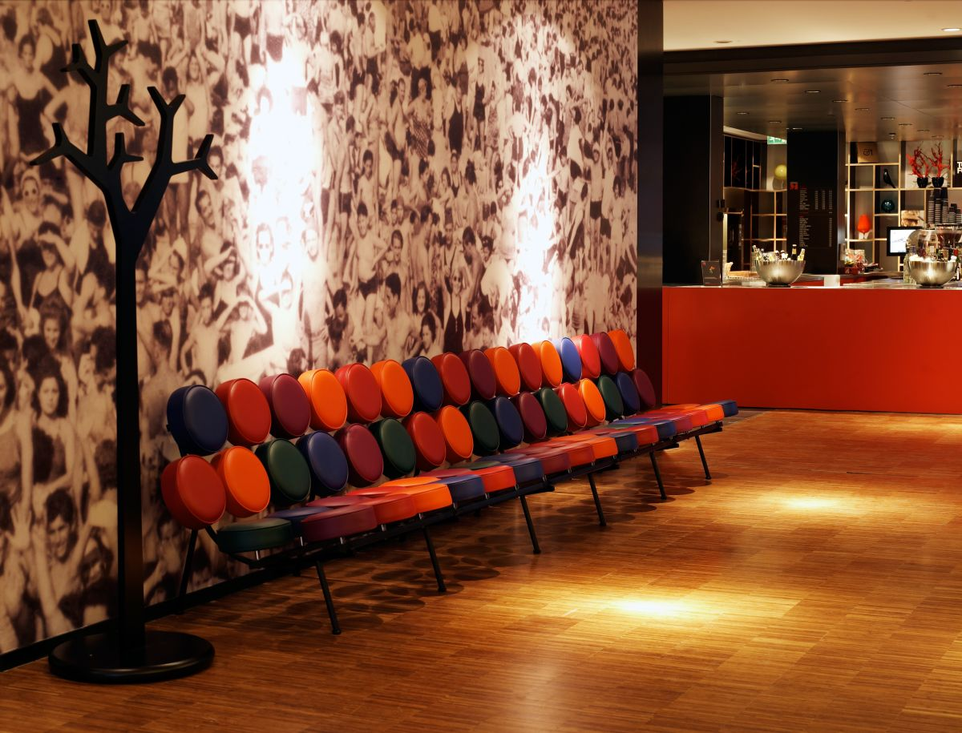
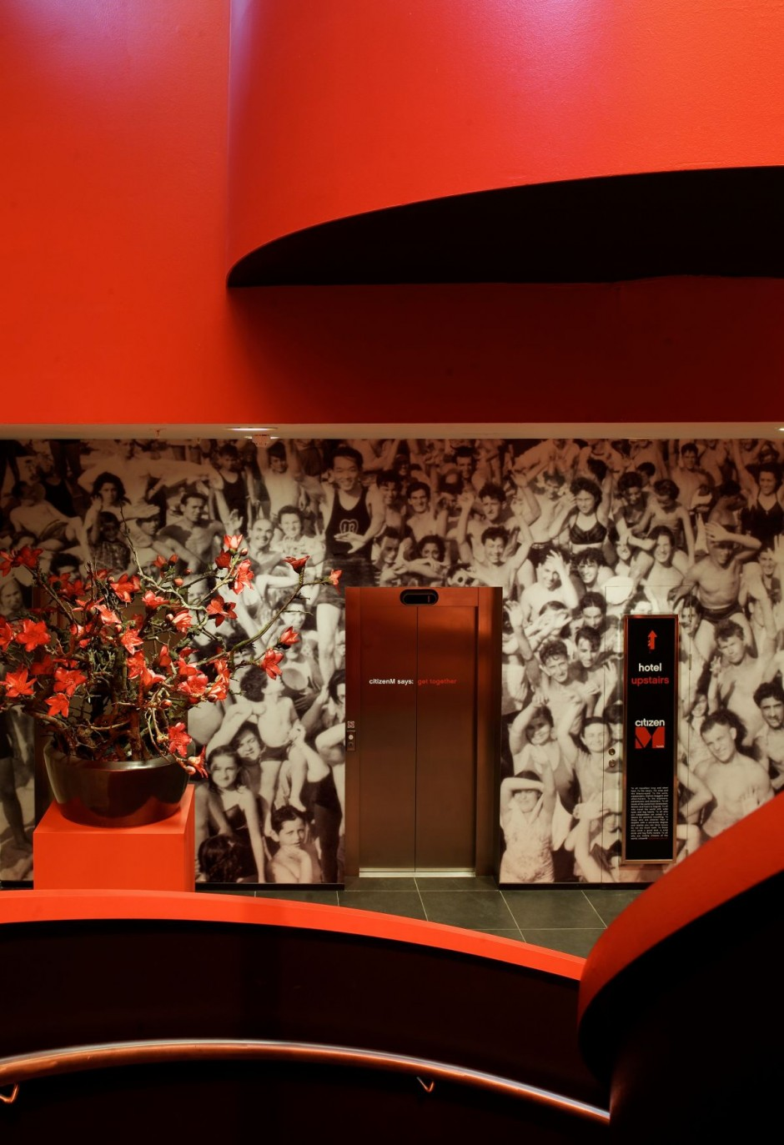
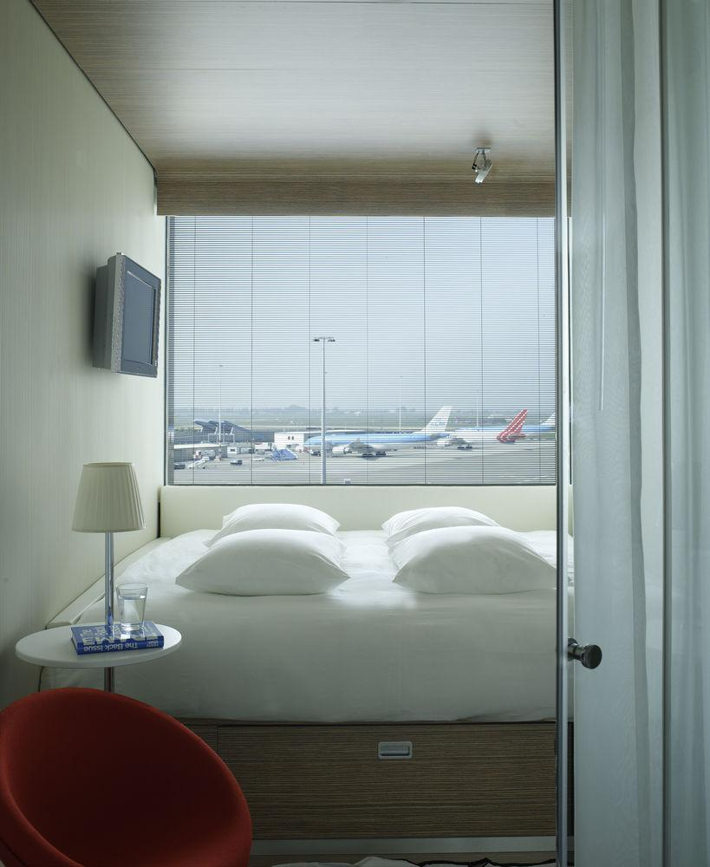
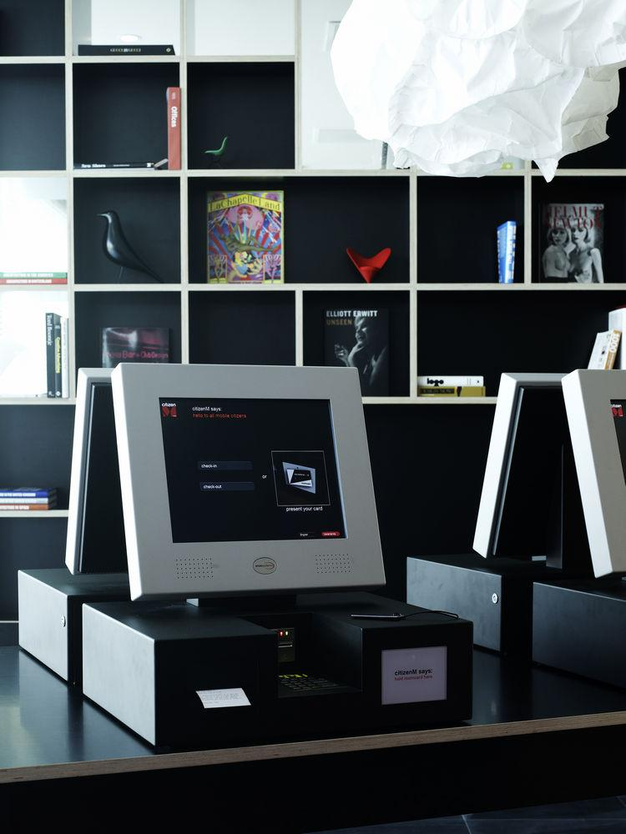
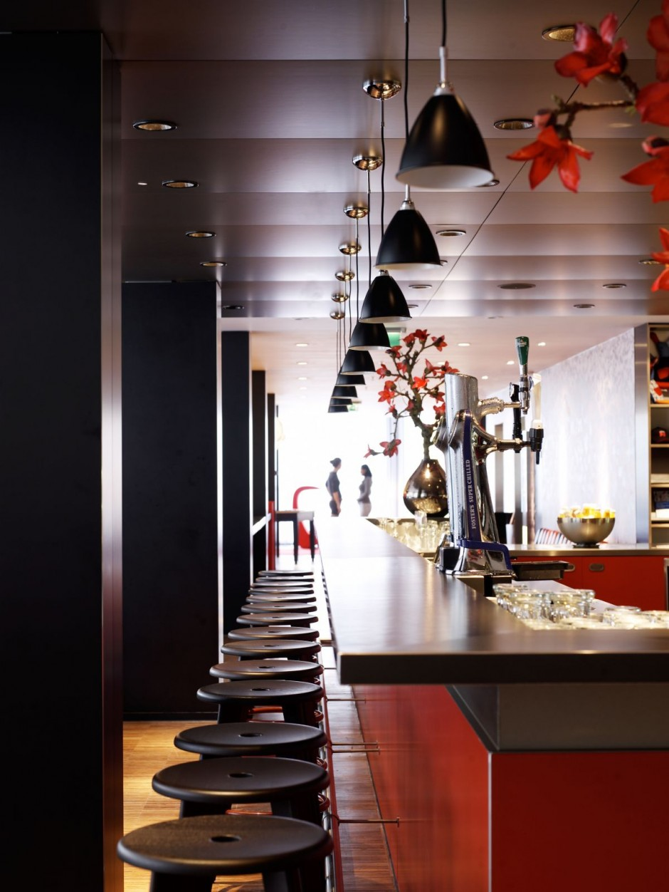
Critical Analysis of CitizenM Schiphol Airport Project Amsterdam
 | Table of Contents
Sr. No. |  | Page No.
1 | Introduction | 3
2 | CitizenM Project | 3
3 | CitizenM Project Stakeholders | 3
4 | CitizenM Project Scope | 4
5 | CitizenM Project Critical Review | 5
6 | Conclusion and Recommendations | 6
7 | Appendix | 7
8 | Referencing | 9

Introduction: - The Concept of ‘Smart Hotel’ or ‘room in a Box’ was introduced and developed by the Dutch Company called CitizenM in 2007 and it came into reality when they opened their first CitizenM hotel in 2008 at Amsterdam Schiphol Airport. The objective of the company is to provide affordable luxury to the people and it’s also reflected in their mission statement “Creating a luxury contemporary hotel for the cost conscious travellers”. The concept of the CitizenM hotel is to provide luxury at the budgeted price by cutting off all the hidden costs and by removing all the unnecessary items. The CitizenM hotel project had 230 rooms’ property with lounge/ living area and ‘CanteenM’ food and beverage outlet. The project also included self-check in terminals, free Wi-Fi, mood lighting, wall size windows, king size bed, heavy rain shower and mood pad to control all the features in the room. This paper reviews the first CitizenM hotel project as a management prospective. Project management is very challenging in the hospitality industry as the nature of the business is changing very constantly and technique and trends are shifting very rapidly. Lock (1988) noted that the versatile nature of the hospitality project gives the possibilities of changing and replanning of the procedures and practices in various stages of the project life cycle. Projects are very précised in other industries but in hospitality the final outcome could very from the initial stages prediction as various stakeholders, internal and external environment plays a vital role in any hospitality project planning.
CitizenM Project: - According to Portny et al. “The project management is the procedure of administrating the project from its beginning through its execution to its closure”. The CitizenM project was to build an airport hotel in 6000-m2 total gross areas consisting of 230 box type rooms of 14 m2 each with high-end Information technology solutions and user-friendly common area (Swisscom Hospitality 2008). The time frame to build the first hotel was of 12 months and definite end date of the project was 31st July 2008.
CitizenM Project Stakeholders: - The alliance partners embraced of the Dutch parent company CitizenM Pvt Ltd and construction firm ‘Concrete’ to conceptualize the project and to plan the interior and exterior of the hotel including common lounge/living areas. Philips provided the technology and equipment for the smart hotel concept including smart LCD televisions and mood pads, which controls all the features in the room. Swisscom hospitality was accountable for all the information technology specification of the hotel operations including hotel reservation system, self-check in terminals; cloud based sharing, system integration and network management. ReviewPro was the media partners to build the band image, communication strategies. The Figure 2 shows the other suppliers and advisors of the projects and the main stakeholders were the cost conscious mobile customers, who wants basic facilities inside the room and more casual common living / lounge space with high-end technologies (The tower hamlets, ‘design and access statement’ 2013). The other stakeholders were the top airport hotels in Schiphol, who compete with the prices, facilities and the common public who share the economical and environment effects of the operations.

Figure 1 CitizenM Hotel alliance partners

CitizenM Project Scope: - The scope of the project gives us the various deliverables and the end result of the project (Thomsett 2002). The CitizenM made alliances with technology partners, construction and concept developer, hospitality infrastructure providers and outsourcing the media representative. The scope included constructing a budgeted hotel of similar size rooms, which were prefabricated in company’s own factory and transported to the hotel location and saving 40% to 50% onsite construction cost and by removing all unnecessary items from the hotel (Cleaver hotel organisation 2014). Technology alliance with Philips and Swisscom provided the hardware and software infrastructure with network solutions to feed the demand of the potential targeted consumers and to compete in the throat cut market (The Tower Hamlets 2014). The figure 3 includes some of the deliverables finalised by the alliance partners and the parent company.
CitizenM Project Critical Review: -
The CitizenM Hotel project resulted in success as it met with all the pre-defined objectives and deliverables, the core concept of providing luxury at a budgeted price was initialized as the onsite constructing cost was reduced by 40% to 50% by applying off-site construction strategy of ‘Industrial Flexible Demountable’ rooms in company’s owned factory (ReviewPro case study, 2011, ‘A case study of CitizenM hotel’ 2014). The off-site factory safeguarded that the prefabricated rooms were of high standards and with quality products and technologies. The integrated system united the functionality with luxury and design. The initiating process of the project included the concept of a boutique luxury hotel with modern technologies at a very competitive price to lure the target market segment was clear in the mind of the four founders, who were from hotel and fashion industries (Cleaver hotel organisation,’ special hotel concept 2009). The planning process included the brainstorming of the venue options and different parameters were developed to maintain high quality standards and alliance with top industries specialist were made to get the desired outcome (Maylor 2010). Scope of the project with different deliverables was finalized with various stakeholders and key personals were assigned for accountability of the end results (Kerzner 2009). The work breakdown structures were made to set the deliverable by each stakeholder and to calculate the cost and time frame required by each process and work (Thomsett 2002). The execution process involved completion of the work with various processes and specifications to meet the scope of the project (Wysocki 2007). The monitoring and controlling process defined the key issues involved with the ongoing processes and the desired end results to match shareholders expectations (Lock 1988). Any limitations or issues were evaluated and monitored by following strict guidelines and Work Breakdown Structures, replanning were conducted to change the scope to get the desired outcome (Wysocki 2007). The closing process of the CitizenM hotel project included with the compliance of the desired outcomes of each alliance partners and regulating future technological and network support by Swisscom Hospitality and marketing campaign by ReviewPro. The construction and concept development firm Concrete made all the assumptions on time and built the hotel as per the specifications of the parent company. The hotel project was completed on time with the desired outcome and new benchmark was set for affordable luxury seekers.
Conclusion and recommendations: - The first property opening project of CitizenM hotels in Amsterdam shows the industrial experience of the parent company and alliance specialised nature, which provides the fantastic end results. The concept of creating modular rooms in off site factory outlet and later assembling them on site reduced the construction time to 70% and leads to 15 days assembly time to build the entire hotel structure. Versatile staffing was done to reduce the staff costing and by taking 70% of online reservation to reduce the costing and by providing the self check ins koisk and self service food and beverage counters they saved lots of money (Cleaverhotel organisation,’ special hotel concept 2012). Lower construction and running cost showed the 130% revenue in first 2 years and up to 90% occupancy through out the seasons. The CitizrenM hotel has opened 2 more properties in The Netherlands, one in London and Glasgow and is planning to open properties in New York and Paris in the year 2014 and with expansion planning of 20 countries in the year 2015, which clearly pointed out the success story of the company’s core concept of ‘Room in Box’or ‘Smart Hotel’ (Swisscom hospitality management 2010).

Appendix: -
Figure 2 CitizenM Stakeholders
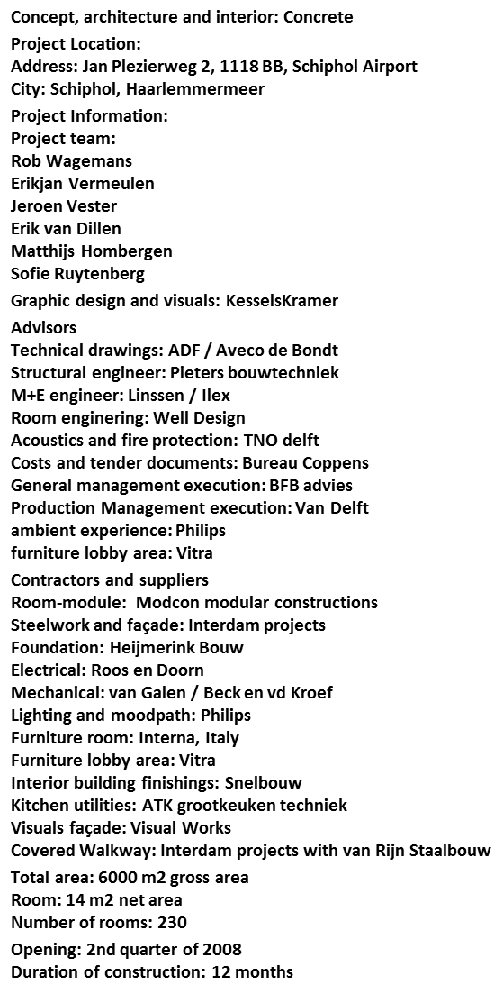
Figure 3 CitizenM Deliverables
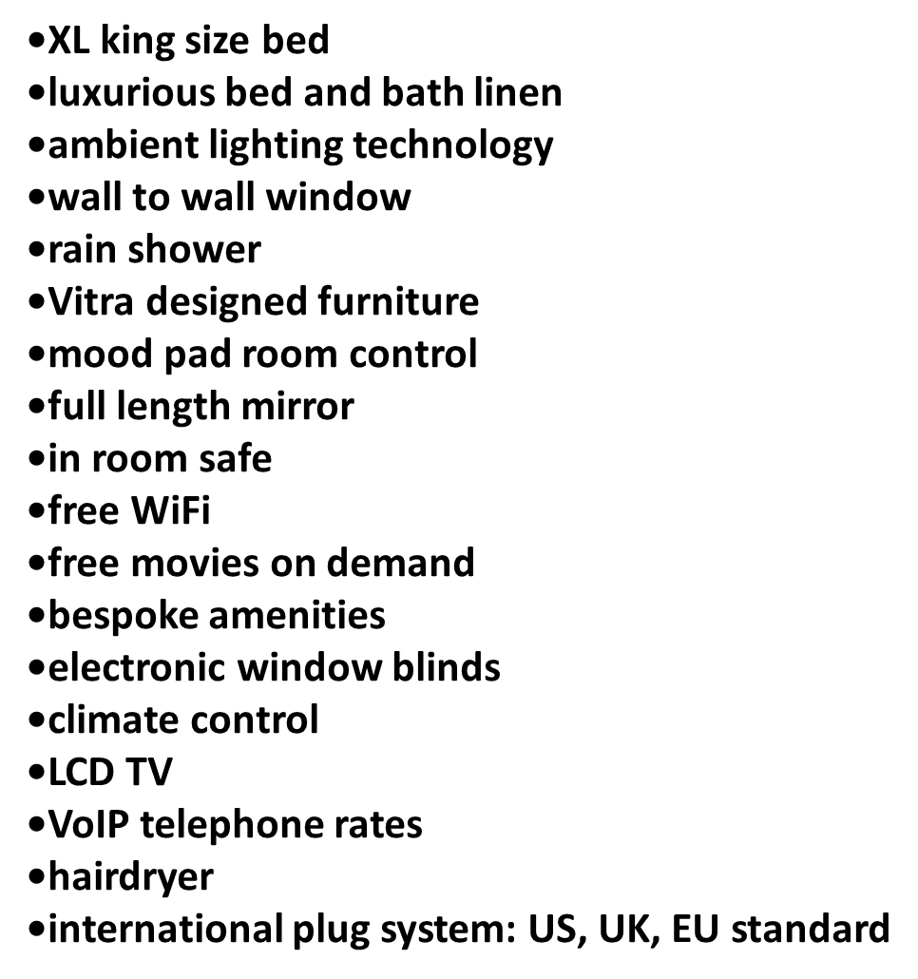

Referencing: -
Cleaverhotel organisation,’ special hotel concept, viewed 10th February 2014,<http://www.cleverhotel.org/sites/default/files/special_dossier_files/8th-annual-international-hotel-technology-forum-ihtf-2011/ihtf2011itoutsourcing.pdf
Kerzner, H 2009, Project management : case studies, Wiley, Hoboken, N.J.
Lock, D 1988, Project management, Gower, Aldershot, Hants., England ; Brookfield, Vt., U.S.A.
Maylor, H 2010, Project management, Financial Times Prentice Hall, Harlow, England ; New York.
Pinto, JK 2010, Project management : achieving competitive advantage, Prentice Hall, Upper Saddle River, N.J.
Portny, SE & Kramer, BE 2008, Project management, Wiley, Hoboken, N.J.
ReviewPro case study, 2011, ‘A case stufy of citizenM hotel’, viewed 08th February 2014,<http://c1c35c868abedd24e8f5-97d19343b07df5b518fd90f90b8c9dd9.r81.cf2.rackcdn.com/wp-content/uploads/2011/06/ReviewPro-Case-Study-citizenM.pdf
Swisscom hospitality management, 2010,’ A master class overview’, viewed 08th February 2014,<http://uhof.com.ua/docs/user/day-1-master-class-swisscom.pdf
The case centre, ’citizenM smart hotel concept’, viewed 11th February 2014,< http://www.thecasecentre.org/includes/sandbox/citizenm/
The case centre, 2010, ’citizenM hotel case study’viewed 11th Februry 2014,,http://www.thecasecentre.org/includes/sandbox/citizenm/
The hotel news now,’CitizenM establishing global footprints’ viewed 10th February 2014,<http://www.hotelnewsnow.com/Article/12415/CitizenM-establishing-global-footprint
The tower hamlets, ‘design and access statement’, viewed 10th February 2014,< http://planreg.towerhamlets.gov.uk/WAM/doc/Design%20&%20Access%20Statement-608081.pdf?extension=.pdf&id=608081&appid&location=VOLUME5&contentType=application/pdf&pageCount=1
Thomsett, R 2002, Define scope, objectives and stakeholderss
Wysocki, RK 2007, Effective project management : traditional, adaptive, extreme, Wiley, Indianapolis, IN.

