Lecture 10: Skulls I
Skull:
- skeletal structure of the head, minus the lower jaw
- Made of a complex fusion of:
  - Dermal elements
  - Endoskeletal elements (including visceral and somatic elements)

Braincase: Supportive and protective box surrounding brain, sense organs
- Posterior to anterior:
  - occipital region, surrounds foramen magnum, include occipital condyle
  - Occipital region widens into paired otic capsules (encloses the middle ear)
  - Narrows into orbital (aka. interorbital, sphenoidal) region
  - Expands into ethmoid region; contains nasal capsules
    - Ventrally, braincase articulates with palatoquadrate
In sharks, braincase is formed of separate cartilaginous centres.

In other bony vertebrates, ossification makes distinct bones; vertebrate bony skull is composed of:
- Braincase: mostly somatic endochondral, some dermal. Not all bones paired
  - Dermal
    - Parasphenoid:
      - Forms skin on roof of oral cavity
      - Ventral part of braincase
      - Narrow anteriorly, wide posteriorly
  - Somatic endrochondral:
    - Occiput (4 bones, surround foramen magnum)
      - Supraoccipital –dorsal to foramen magnum-
      - Basioccipital –ventral to foramen magnum-
      - Paired exoccipitals –one on each side of foramen magnum-
    - Paired bones associated with otic regions (contain sacs & canals of inner ear)
      - Opithotic- posterior
      - Prootic
    - Basisphenoid
      - Median, mostly ventral and anterior to otic region
      - Forms floor of cranial cavity
      - Mostly covered ventrally by parasphenoid
      - Basipterygoid process on either side, basal articulation with palatal complex
    - Sphenethmoid:
      - Median ossification in sphenoid and ethmoid regions
      - Contains olfactory nerves
- Palatal complex: some visceral endochondral, mostly dermal. Bones still paired, complex.
  - Dermal
In roof of oral cavity; many bear teeth in fishes, early tetrapods
    - Pterygoid; largest (posterior and median)
    - Ectopterygoid, palatine, vomer (posterior to anterior)
      - Ectopterygoid & palatine may bear teeth
  - Visceral endochondral
    - Palatoquadrate; dermal elements
      - In tetrapods, 2 separate ossifications may form along palatoquadrate
        - Quadrate: smaller, posterior, articulation with lower jaw
        - Epipterygoid: larger, anterior, forms articulation with braincase
- Skull roof: dermal
  - Dorsal cover/ shield for skull
  - Nearly solid, opening for nostrils, eyes, pineal eye
  - 5 series of bones, all dermal & generally paired
    - Tooth-bearing marginal series (from rim to roof)
      - Premaxilla, maxilla
    - Midline series (adjacently paired on dorsal profile)
      - Nasal, frontal, parietal
    - Circumorbital series (surrounding orbit)
      - Prefrontal, posteriolateral iliac, jugular
    - Temporal series (between otic notch and midline series)
      - Temporal, posteroparietal
    - Cheek series (behind orbit, below otic notch)
      - Quadratojugular

Lecture 11: Skulls II

Skull evolutionary history:
- Basal reptile (anapsid)
  - Dermal skull roof without fenestra
  - Otic notch closed, intertemporals lost ( not present in reptiles)
  - Reduction and posterior displacement of other temporal bones
  - Supratemporal (lost in mammals), postparietal and tabular (fused to occipital in mammals)
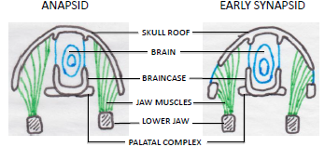
- Intermediate stage
  - Early synapsids (pelycosaurs
    - Brain bit bigger
    - Development of temporal fenestra, heavy connective tissue covers it
  - Therapsids
    - Enlargment of fenestra
    - Downgrowth of dermal bones + upgrowth of epipterygoid (later alisphenoid) begin to enclose brain

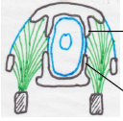
- Mammalian skull
  - Quadratojugal lost
  - Squamosal differentiates and becomes zygomatic arch, the rest helps form the braincase
  - Prefrontal,postfrontal, postorbital lost
  - Brain bigger and enclosed in bone
Net effect of changes:
- Muscles that were inside the skull are now outside
- Little of original skull bones left, many of same bones visible but not same surfaces as in earlier forms
- Development of a second palate (forms the dorsal roof of mouth) by
  - Downturning and medial expansion of premaxilla and maxilla
  - Palate used to be shared by both respiratory and digestive system; problem sometimes –when processing food, animal stops breathing-
    - Formation of a secondary palate to separate the systems. Passage is shorter and more efficient to move air into lungs and food into digestive system.
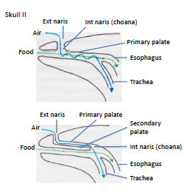
Temporal bones:
- Complex fusion of several elements; dermal and endochondral braincase
- 4 major bones and 3 ossicles involved
  - Squamosal: large, flat dermal bone on side of brain
  - Petrosal: braincase, fusion of prootic and opisthotic
  - Ectotmpanic: dermal bone, old lower jaw
  - Endotympanic: new development in mammals from braincase
  - Middle Ear Ossicles:
    - Malleus: articular, dermal bone of old lower jaw
    - Incus: quadrate, endochondral, palatal complex
    - Stapes: hyomandibular, so visceral endochondral
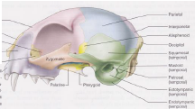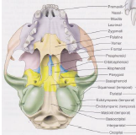

Sphenoid region:
Embryologically complex region where many cranial nerves emerge; many different kinds of bone present
Anterior portion:
- Begin as 3 embryologically separate elements in mammals that then fuse together
  - Presphenoid
  - orbitosphenoid ( includes optic foramen, orbital fissure)
Posterior portion:
- Similar to anterior
  - Basiphenoid
  - Alisphenoid ( includes foramen rotundum foramen ovale)

Lecture 12: Muscles

Various muscle categories (excluding those of head)
- Histological: striated vs smooth
- Physiological: voluntary vs involuntary
- Organizational: somatic vs visceral
Not always a strict distinction between categories

Somatic:
- Derived from myotomes of somites
- Always striated, mostly voluntary
- Innervated by somatic motor fibres

Visceral:
- Derived mainly from mesenchyme, comes from lateral plate
- Smooth or striated, mostly involuntary
- Innervated by visceral motor fibres

Somatic | Visceral
Derived from  - myotomes of somites  Always striated, mostly voluntary  Innervated by  - somatic motor fibres  Forms  - appendages, outer part of body wall  - Axial  - Appendicular | Derived mainly from  - mesenchyme, comes from lateral plate  Smooth or striated, mostly involuntary  Innervated by  - visceral motor fibres  Forms  - mostly muscles in wall of gut  -Branchiomeric  -Smooth (gut)

Actions of Muscles
- Flexor – closes a hinge joint
- Extensor – opens a hinge joints
- Adductor – towards ventral midline
- Abductor – away from ventral midline
  - In jaw, adductor closes, depressor opens

Axial Musculature
Epaxial and Hypaxial:
- in all jawed verts, division occurs along horizontal skeletogenous septum

In fish, axial musculature composes most of body’s bulk
- Consists of a series of myomeres, derived from myotomes (segmentally arranged)
- Start out as simple transverse bands, develop into complex zigzag pattern, especially internally to facilitate smooth curving action of body – important in locomotion

Epaxial Muscles
- Fish: basically single block, segmented (dorsalis trunci)
- Tetrapods: greatly reduced in volume (appendages take over). Epaxial restricted to between neural and transverse processes
- Amphibians: still dorsalis trunci; segmented, but little differentiation and subdivision
- Reptiles: still mostly segmented but longitudinally subdivided into 3
  - Iliocostalis – lateral part attaching to ribs
  - Longissimus dorsi –largest, dorsal to transverse processes
  - Transversospinalis –between longissimus and neural spines
- Mammals: same 3 parts but lose segmentation

Hypaxial Muscles:
- Fish: smaller than epaxial, also basically single unit
- Tetrapods: considerably reduced, form thin muscular sheets around flanks and belly
  - New function: support abdominal cavity and viscera

Hypaxial muscles become connected to ribs in very complex attachments and subdivisions: 3 groups, arranged dorsoventrally:
- Subvertebral Series:
  - Dorsally and medially, underneath transverse processes of vertebrae
- Lateral (Flank) Series:
  - Between transverse process and rectus abdominis
  - Primitively segmented, becomes 3 unbroken perpendicular sheets of muscle
    - External oblique
    - Internal oblique
    - Transversus abdominis
  - Insert by aponeuroses (sheet-like tendon)
- Ventral (Belly) Series:
  - Midventral muscle, rectus abdominis, between sternum and pelvis

Lecture 13: Cranial muscles
Musles sorted out by innervation

Somatic components :
- Axial musculature ( in embryo ; moytomes,epimeres): 3 groups
  - Extrinsic muscles of the eye
    - Essentially same in all vertebrate across evolution
    - Formed from 3 pre-otic myotomes
      - 1st myotome: forms ventral oblique & medial, dorsal and ventral rectus. Innervated by the occulomotor nerve
      - 2nd moytome: forms dorsal oblique. Innervated by trochlear nerve
      - 3rd myotome: forms posterior rectus. Innervated by abducens nerve
  - Epibranchial
    - Epaxial musculature in trunk, gills lie in between
    - Helps in the control and movement of neck and head
  - Hypobranchial
    - Hypaxial musculature in trunk, gills lie in between
    - Main part extends between shoulder girdle and jaw
    - In tetrapods: same position but modified due to tongue and 7 throat muscles:
      - Genioglossus, geniohyoid, styloglossus, hyoglossus, thyrohyoid (thyroid + cartilages), sternohyoid (sternum), sternothyroid.
Visceral components :
- Branchiomeric (in embryo ; neural crest).
  - Mesenchyme, visceral, striated
  - Associated with visceral arches
    - In higher vertebrates; loss of gills, become muscles of jaw, face, shoulder. Operculum present
    - In tetrapods:
      - Trapezius & dorsal shoulder muscles replace cucullaris
      - Sternocleidomastoid from ventral shoulder to back of skull
      - Almost all muscles supporting gill arches lost, a few remain as larynx muscles
Muscles of the hyoid arch
In fishes:
- Innervated by facial nerve (VII)
- Most muscles lost because hyoid arch acts as jaw support
- Superficial constrictor and levator remain with operculum
In tetrapods:
- Operculum lost, constrictor as a sheet around neck; sphincter colli
In mammals:
- Depressor mandibulae lost, sphincter colli retained
- Highly modified facial muscles (for expression), only mammals have them
  - Prominent muscle: buccinator (cheek muscles)
    - Only mammals have cheeks, important in chewing
- Jaw-opening muscles in mammals
  - Digastric, posterior part of it formed from sphincter colli

Muscles of mandibular arch
Highly modified jaws and muscles

Dogfish: 3 mandibular muscles
- Adductor mandibulae (closes mouth)
- Levator palatoquadrati
- Ventral muscles- intermandibularis

Tetrapods:
- Adductor more complex, but remains underneath skull roof to lower jaw
- Upper jaw fuses with braincase levators lost

Mammals:
3 main muscles close mouth
- Temporalis: largest, from temporal fossa to lower jaw
- Masseter: zygomatic arch to lower jaw; very large in some mammals
- Pterygoid muscles: internal/external, deep division of adductor mass, from pterygoid region of skull to lower jaw
Depressor mandibulae disappears
- Replaced by digastric –jaw opener
  - Partly mandibular muscle, partly hyoid muscle
  - Anterior half formed from mylohyoid
Lecture 14 : Respiratory system
System that obtains oxygen from environment & into blood stream

Gills- typical respiratory organs in fish
- On walls of pharyngeal slits
  - Develop between pharynx and outside. Occurs by pocketing of endoderm and ectoderm until they meet and form passage
  - Almost all jawed fishes have 5 slits and an optional spiracle
    - Cyclostomes:
      - Basic condition; spherical pouches with circular external opening
      - Each pouch open individually to outside, but exits join into common external opening
      - Also developed horizontal separation of pharynx and ventral respiratory tube; velum isolates respiratory tube
        - Velum closes when fastened to prey, isolating respiratory tube; blood passes through “oesophagus”. Gas exchange continues
  - Sharks:
    - interbranchial septa, brachial adductors, separate opening for each arch
  - Teleosts:
    - Operculum present (single opening)
      - No septa permits different arrangement of lamellae. Interweaving, more closely packed together more efficient at extracting oxygen from water as it passes over gill lamellae
    - Swimbladder – organ resembling lungs, but dorsal in position (contrast with lateral lungs)
      - Connection to digestive tract, used for buoyancy and respiration
      - Advanced teleosts lose connection between pharynx and swimbladder (only used for buoyancy then)
        - Likely that lungs are ancestral and swimbladder a specialization of lungs in advanced teleosts

Lungs:
- Sacs from ventral side of pharynx, not very efficient as air goes in and out from same tube (always some unexpelled deoxygenated)
- Gas exchange at alveolus: small, terminal pouches of bronchioles, tubes branching from bronchi, tubes branching from trachea

Tetrapods:
- Loss of gills and associated structures, respiration usually by lungs
- pharynx smaller and less important, but still is entrance to lungs through glottis
- Embryologically, lungs form ventrally from pharynx

Birds (reptiles):
- Very complex and efficient respiratory system (required for flight due to high altitude)

- Bird lungs rather compact , also have air sacs (continuation of respiratory system)
  - Distributed throughout trunk, some bony
  - No alveoli, parabronchi (tiny tubes for air exchange)
  - Air constantly movie unidirectionally; allows for nearly complete ventilation
  - 2 cycle system
    - Cycle 1:
      - 1st inhalation, air goes to posterior air sacs
      - 1st exhalation, air moves to lungs (through parabronchi)
    - Cycle 2:
      - 2nd inhalation, air moves from lungs to anterior air sacs
      - 2nd exhalation, air moves from anterior sacs to trachea and out

Cutaneous respiration:
Many vertebrates have capacity for gas exchange through skin or internal surfaces
- Limited, so usually accessory function
- Can perform majority (most amphibians) and in some cases all of gas exchange (lungless salamanders)

Lecture 15 : Digestive system
System involved in obtaining nutrients

Functions:
- Transport- takes food from where it is obtained, to where it is treated and absorbed
- Mechanical digestion-
  - Action of visceral muscles surrounding gut
  - Peristalsis- wave like contractions
  - Reduces food for chemical digestion
- Chemical digestion- breakdown into molecule components for absorbtion
- Absorption- passage of substances through gut wall into cardiovascular or lymphatic cells

Gut
- Divided into:
  - Esophagus, stomach, small intestine (duodenum, jejunum, ileum), large intestine (ascending, transverse, descending, sigmoid colon), rectum
- Recognize two parts in all vertebrates: foregut and hindgut
  - Foregut:
    - Pharynx, esophagus, stomach
      - In higher vertebrates sphincter present
      - Stomach arises in jawed vertebrates; start of being a carnivore
    - Pipe taking food to where treated. Little chemical digestion.
      - Amphioxus & cyclostomes have no stomach, small stomach and short esophagus in other fish.
      - Tetrapods have prominent esophagus, but still simple tube for transport
      - Birds have a crop (sac for temporary food storage)
      - Ruminants
  - Hindgut:
    - Small: duodenum, jejunum, ileum,
    - Large: ascending, transverse, descending & sigmoid colon. Rectum (exit for digestive system only) or cloaca (includes exists of other systems) may be present at the end
  - Ceca (outpocketings) are usually found between large and small interstine
Stomach:
- Orginally to dump food, peristaltic contractions help reduce food size
- Has glands that produce enzymes (gastric juices) used for chemical digestion
- Birds: 2-part stomach
  - Proventriculus: glandular part of stomach, secretes gastric juices
  - Gizzard: thicker, muscular portion. Contains grit (even pebbles purposely ingested) that helps grind food
    - Needed as birds lack teeth
- Ruminants: 4-chambered stomach (actually part esophagus, part stomach)
  - Rumen & reticulum (esophagus) manufacture of amino acids, proteins, vitamins), but work mainly as fermentation chambers; breakdown of cellulose –transformed into cud then regurgitated and chewed again. It is swallowed again and into omasum (esophagus) and abomasum (stomach)
  - The different chambers support microorganisms that carry out digestion of tough cell wall of plants, and the wall of chambers can absorb nutrients

Intestines:
Most of chemical digestion and absorption in small intestine, the large intestine is used for storage, water resorption.
Intestines increase area size by:
- Lengthen
  - Mainly teleosts & tetrapods. Longer tube, more S/A
- Spiral valve
  - Typical of primitive jawed fish. Lengthens and slows passage
- Cecum
  - Outgrowths along intestine, variable and common
- Rough internal surface
  - Finger-like projection of internal lining of intestine; villi. Projections on individual cells; microvilli

Lecture 16 : Mouth & pharynx
Mouth:
- In embryo as inpocketing of ectoderm; stomodeum (boundary between ecto and endoderm breaks down)
- Tongue:
  - true mobile tongue in terrestrial vertebrates; from hypobranchial musculature and its base hyoid apparatus
  - Primary tongue of fishes & rasping tongue of cyclostomes not same
  - Used to manipulate food, intraoral transport, swallowing
    - Other uses can occur: to obtain food ( elongated in frogs, lizards, some mammals & birds to capture food)
  - May develop taste buds- sensory organs responsive to chemicals
  - In most vertebrates; vomeronasal organ implicated in pheromone and/or prey detection (in some verts. like lizards and snakes, tongue flicking also participates)
- Oral glands:
  - Most fish lack oral glands
  - Lampreys- pair of large glands secrete anticoagulant
  - Terrestrial vertebrates commonly have salivary glands: lubricate food, facilitate manipulation & swallowing.
  - May also function in digestion- mammals and some amphibians produce digestive enzyme amylase to split starch
    - Once enzymes developed, some produce toxins in poison glands
Glands also develop in pharynx:
- Thyroid:
  - Several hormones important in metabolism, growth, reproduction, development of nervous system
  - Begins as a mid-ventral outgrowth of pharynx but connection then lost. Formed of follicles
  - Tunicates and amphioxus produce similar substance in endostyle (homologue of thyroid)
- Thymus:
  - Located at base of the neck, develops from some pharyngeal pouches in all vertebrates
  - Invaded by stem cells that differentiate into particular lymphocytes that then circulate in blood and enter lymph nodes and other lymphoid organs. Helps immune system attacking various kinds of microbes
  - More prominent in young, thymus tends to become reduced in older individuals

Teeth
Lampreys and hagfishes:
- Tooth-like denticles
- Associated with mouth and rasping tongue
- Keratinized, cone-like structures used to cling to prey and rasp flesh
Gnathostomes:
- True teeth present
- Secondarily lost in some –birds, turles, some mammals (anteaters)
- Generally viewed as a marginal series, but can be scattered as well as restricted to jaw margin
  - Many fishes, amphibians, reptiles also have teeth on palatal bones (inner surface of lower jaw)
  - In many teleosts on visceral arches – pharyngeal teeth

Epidermal and dermal origin
- Tend to be simple and conical in fishes and reptiles- hormodont
- Mammalian teeth more complex, especially in cheek region, and differentiated –heterodont

Attachment to jaw bones:
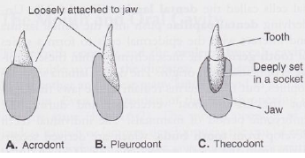
- Acrodont: teleosts
- Pleurodont: many lizards
- Thecodont: mammals, archosaurian reptiles

Tooth composed of 3 parts
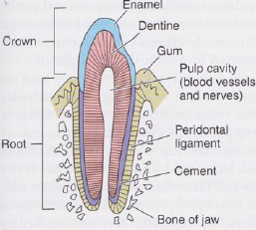
- Crown
- Base/root: in socket or alveolus
- Pulp cavity: blood vessels, nerves

Three substances: enamel, dentine, cementum

Tooth replacement:
- Polyphyodonty –teeth continuously replaced (most lower vertebrates)
  - Not random, complex, successive waves of replacement
  - Adjacent teeth out of phase with each other ( so no area is missing many teeth)
- Diphyodonty –two sets of teeth (most mammals)
  - Mammals:
    - milk (deciduous, juvenile) and adult (permanent)
    - incisors; premaxilla –canines; 1st tooth in maxilla (sometimes become incisform) –premolars; cheek teeth following canines (sometimes molarized) –molars; cheek teeth following premolars
      - Premolars have juvenile precursors (act as molars and may be called deciduous molars), molars are not replacement teeth.
- Monophyodonty –one set (toothed whales, sloths
Lecture 17 : Miscellaneous viscera
Coelom: space containing various organs and structures
Embryologically:
- Begins as 2 spaces that partially merge later
- Gut forms during gastrulation from endoderm
- Coelom:
Mesodermal, from hypomere. Hypomere splits internally to form pouches that expand to form 2 large bilateral spaces
  - Mesodermal portions will form: connective tissue, muscles, and peritoneum ( mesodermal epithelium of pleuroperitoneal cavity)
    - Lateral hypomere layer: parietal peritoneum (lining of outer tube- somatopleure from somatic mesoderm + ectoderm)
    - Medial hypomere layer: visceral (splanchnic) peritoneum (covering of inner tube –splanchnopleure from splanchnic mesoderm + endoderm)
  - Left & right coelomic cavities initially separated by 2 layers of visceral/splanchnic peritoneum (dorsal and ventral mesenteries)
    - Simple in embryo, become complex in adults: twisting of gut, division of coelom in compartments
    - Dorsal mesentery persists in adults (passage of vessels & nerves to gut)
    - Ventral mesentery less important; most disappears so L&R coelomic cavities merge into single cavity
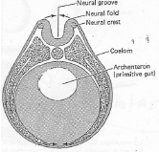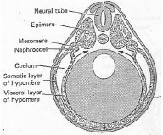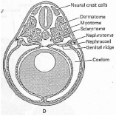

- Anteroventral region of coelom becomes pericardial cavity, in which heart develops
  - Cavity initally open but transverse septum develops from mesenchyme.
    - Separates pericardial cavity from rest of pleuroperitoneal cavity
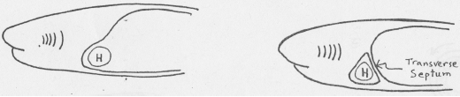

- In tetrapods:
  - development of neck -cavity pushed back
  - Extension of transverse septum develops into pleuropericardinal membrane which covers the cavity dorsally
  - Loss of pharyngeal slits, lungs develop in pleurperitoneal cavity
    - In mammals, turles, some lizards, crocodiles & birds: membrane forms to separate lungs from coelom, forming pleural cavities and and peritoneal cavities
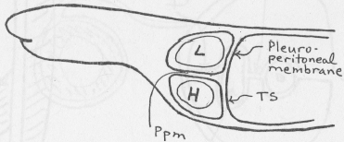

- In mammals:
  - Pleuroperitoneal membrane becomes diaphragm and transverse septum becomes central tendon

Mesenteries: two apposed sheets of splanchnic hypomere
- Functions:
  - Secures integrity of cavities
  - Defines spaces for activity of organs
  - Isolate organs from each other

Ventral mesentery:
- The liver (ventral outgrowth of gut) expands in the ventral mesentery and is attached to
  - Lesser omentum (gastrosplenic ligament) between gut and liver
  - Falciform ligament, between liver and ventral body wall
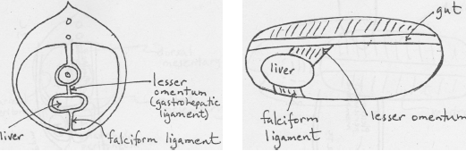

Dorsal mesentery:
- More prominent, becomes complex
- Mesentery in strict sense = sheet supporting small intestine
  - Mesocolon: supports large intestine
  - Mesorectum: supports rectum
  - Mesogaster: greater omentum (large), supports stomach
    - Expands during development to form omental bursa; bursa drapes ventrally over viscera. Contains space lesser peritoneal cavity, entrance is gastoepiploic foramen.

Glands of the gut: Glandular tissue present throughout gut
- Liver: largest of these glands, divided into lobes
  - Must be attached to cardiovascular system –supplied by hepatic artery; receives blood from viscera and spleen via hepatic portal vein, drained by hepatic veins
  - Takes shape of what packs nicely into cavity
  - Develops as ventral outgrowth of anterior part of intestine (endodermal in origin)
  - Expands within transverse septum, which form serosa of liver and coronary ligament
  - Retains connection to gut via hepatic duct (leads bile to gut)
    - Hepatic duct joins cystic duct (gall bladder duct) to form common bile duct, leading to small intestine
- Functions of liver:
  - Mainly storage, manufacture of carbs, proteins, fats of body (liver receives most absorbed material from intestine and converts it into things needed by body)
  - Production of RBC in early fetal stages
  - Destruction of old blood cells
  - Detoxification & removal of toxic substances from blood
  - Glandular function –to produce bile
    - Minor function but highly important
    - Also include bile salts which acts as emulsifiers –critical for lipid digestion and absorption
- Pancreas:
  - Common to all vertebrates but not always as discrete gland
  - Within dorsal mesentery, dorsal to stomach
  - Begins as 2 separate outgrowths of intestine (dorsal & ventral)
  - One or more pancreatic ducts lead to duodenum –produces “pancreatic juice”; mix of various enzymes/proenzymes, alkaline
  - Also an endocrine gland –islets of Langerhans (small patches of cells) produce insulin and glucagon; hormones important in control of glucose blood levels.
Spleen:
- Not a gland, not part of digestive system
- Little to do with gut except that it is in the same area and is embryologically derived from gut endoderm
- Functions as major blood forming organ in almost all vertebrates (at least in embryo)
  - Persists except in mammals, where bone marrow takes over formation of most blood cells
- Also functions in defense, storage & destruction of blood
- Not all vertebrates have a discrete spleen –those that don’t (cyclostomes, lungfishes) also lack a discrete pancreas

Lecture 18: veins
Cardiovascular system:
- Heart
- Arteries (bring blood away from heart, away from the capillaries)
- Veins ( bring blood toward heart, away from the capillaries)
  - Portal veins do not lead blood to the heart, but collect blood from one capillary and send it to another.
- Capillaries (tiny vessels connecting arteries and veins)
Functions of Cardiovascular system (CS):
- Transportation of material to & from cells (supply of O₂, glucose, removal of CO₂, nitrogenous wastes, excess water
- Communication through the circulation of hormones from endocrine glands
- Ensures uniform composition of the interstitial fluid and uniform internal temperature
- Immune system
- Repair of injured tissue
VEINS:
Divided into 4 systems:
- Sub-intestinal system:
  - First one to arise in the embryo, initially paired but soon coalesce to form a single sub-intestinal vein
    - Anterior part: gives rise to heart and ventral aorta
      - In most fishes; hepatic vein passes here from the liver to the heart
      - In tetrapods and lungfish, part of the HV is incorporated in the posterior vena cava.
    - Posterior part: extends from gut to heart
      - the hepatic portal vein passes here from the gut to the liver
- Dorsal (cardinal) veins and Venae Cavae (replaces DCV in higher forms)
  - Consists of paired anterior and posterior parts in every vertebrate embryo
  - All collect into the common cardinal vein, which continues to sinus venosus
  - Anterior dorsal C veins:
    - In all tetrapods except mammals, the main stem of each AC is the Lateral Head Vein
      - Begins within orbit and extends to the lateral surface of the braincase and otic region.
      - Further change in mammals results in a loss of LHV, replaced by inter-communicating sinuses in cranial cavity. Blood from head leaves posteriorly through internal jugular vein which is then joined by external jugular vein, and by subclavian vein
    - In tetrapods and lungfish; because the subclavian goes into CC, the Common cardinal becomes continuous with the AC so it begins to look like Anterior Venae Cavae.
  - Posterior dorsal C veins:
    - Primitively a pair of simple vessels entering CC
    - In mammals, region is drained by a single, complex Posterior Venae Cavae
    - In agnathans, PC receives blood from the Caudal Vein, kidneys and gut
    - In lungfish; branch of HV grows upwards past the liver and taps into the posterior cardinal vein; it becomes the Posterior Vena Cavae
      - Blood from posterolateral parts of body has now numerous paths to the heart
    - In lower tetrapods; loss of parts of PC
- Abdominal veins:
  - Important in embryos of all vertebrates (in mammals for umbilical vein formation), also important in adult primitive vertebrates
  - Primitively paired, extends along ventrolateral body wall
  - Chondrichthyeans; AbV receives subclavian and iliac veins
  - Actinopterygians lack abV
  - In amphibian and reptiles, abV a single median vessel that goes to liver (and not heart) so essential to hepatic portal system
  - In mammals, no abV or RPV, so iliac goes to PVC
- Pulmonary veins:
  - Absent in most living fishes
    - Some have a functional lung and PmV empties a mix of oxygenated and deoxygenated blood into HV and thence to heart.
  - In lungfish, PmV bypasses sinus venosus and enters heart through the left side of the atrium
    - This separate entrance is present in all higher vertebrates, allowing further divisions of the heart.
Lecture 19: heart and lymphatics
- Primitively, heart is basically a tube with 4 chambers, arranged in sequential order
  - Valves between chambers
  - Heart tends to fold up on itself into an S-shaped structure (eg; in dogfish)
- In Lungfish and all higher vertebrates; pulmonary vein enters left side of A instead of entering SV like other body veins

Tetrapods:
- Also 4-chambered
- Sinus Venosus and Conus Arteriosus often incorporated into other structures of the heart, arteries and veins tend to become divided so H becomes a double-pump
  - Double pump needed because the heart now receives Blood low in O2 and high in CO2 from the rest of the body, and in reverse from the lungs
- Heart not completely separated into barrels yet, but manage to keep blood separate to a large degree

Buiding a double-barreled heart:
- 1st step is to separate entrance into hear for blood coming from lungs
  - Pulmonary vein does not enter sinus venosus, but enters directly through the left side of atrium.
- 2nd step is transforming single atrium into:
  - Right atrium; receiving only venous blood
  - Left atrium, receiving only oxygenated blood
    - Still problem as both open into single ventricle division required

Modern amphibians:
- Ventricle undivided, but much of O2 exchange occurs through skin, and blood returns to right atrium. Pulmonary vein returns blood from lungs to left atrium.

Turtles, snakes, lizards:
- 1 or 2 partial septa present in ventricle, but a gap still exists so there is still potential mixing
  - Ventricle in reptiles very complex; partially subdivided into dorsal and ventral parts
  - Dorsal further subdivided, but only partially
- Both oxygenated and unoxygenated blood enters part of dorsal part of V.
  - Left and Right systemic artery receives mostly oxygenated blood from left atrium
  - Pulmonary artery receives unoxygenated blood from right atrium
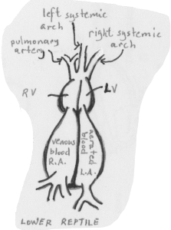

Birds and mammals:
- Completely separated ventricles:
  - Only oxygenated blood enters left ventricle, and goes to body and head
  - Venous blood enters right ventricle and goes to lungs
  - Only one systemic arch
    - Right systemic arch in birds
    - Left systemic arch in mammals
Conus arteriosus:
- Primitively a single tube, but separation is required when atriums and ventricles are divided

Lungfish & amphibians:
- Structure of conus arteriosus altered; originally containing series of valves but development of a spiral valve divides CA into 2 channels

Amniotes:
- CA considerably reduced; usually incorporated into ventricle or arches that leave the heart
  - Basically 3 aortic arches in reptiles, 2 in mammals and birds

LYMPHATICS
Secondary system of vessels supplementing veins, in returning fluids from tissues to heart
- Fluid exits from capillaries into tissues via arterial pressure, but fluid doesn’t entirely get back into veins (osmotic pressure lower than blood pressure)
  - “Surplus” of fluid into tissues lymph vessels developed to deal with the surplus
- Lymphatic system vessels distinguished in lacking direct connection to arterial system
- Lymph vessels arise from their own capillaries, which as blind-ended. They carry fluid back into veins
  - Pressure in lymph vessels extremely low; fluid enters easily and moves mainly by muscular action
  - Sometimes “lymph hearts” present; contractile structures along lymph vessels which pump the fluid back into veins
  - Lymphocytes (WBC) can enter lymph vessels
In mammals:
- Lymphatic system associated with production of lymphocytes by being connection to lymph nodes (main site of lymphocyte formation)
  - Lymph nodes very rare in non-mammals
- Lymph vessels important in gut, where they absorb many fats (fatty lymph called chyle)

Lecture 20: Aortic arches
Aortic arches arise from the heart
- In pairs from ventral aorta, pass through gill bars and into dorsal aorta, then to the rest of the body
- In adults, each aortic artery breaks up into capillary system within gill bars for gas exchange

Gnathostomes:
- Usually only 5 slits & a spiracle 6 pairs of AA’s
- AA passes anterior to slit, breaks up into capillary system and recollects into the dorsal aorta
  - In embryo, each arch is a continuous tube witihin gill bars. As gills develop, the arch is interrupted by a capillary system and ventral and dorsal portions
    - Afferent branchial arteries: blood from ventral aorta to capillary system
    - Efferent branchial arteries: blood from capillary system to dorsal aorta
- AA I: mandibular arch, between mouth and spiracle
- AA II: hyoid arch, between spiracle and 1st normal slit

In all amniotes, AAs never split into afferent and efferent portions (remain as continuous tubes).

Tetrapods:
- Gill set-up lost

FUCK THIS LECTURE

Lecture 21: Kidneys and urogenital system
Urogenital system includes organs of excretion & reproduction
- Kidneys and gonads develop next to each other in embryo, and some accessory organs are tangled

Kidney: major excretory organs of vertebrates
- Rids body of nitrogenous wastes
- Major role in water balance
- Embryology:
  - Segmentally arranged somites –epimere (dorsally), hypomere (ventrally) and mesomere (middle)
    - Develop from front to back

Lecture 22: Nervous system
Develops very early in embryo:
- Central nervous system (CNS) forms from ectoderm
  - Neural tube makes the brain & spinal cord
- Peripheral nervous system (PNS) nerves stem from CNS
  - Motor (efferent) neurons from CNS
  - Sensory (afferent) neurons from neural crest (lie outside spinal cord)
    - Peripheral nerves made up of axons
    - Ganglia; part of PNS, contains clusters of cell bodies

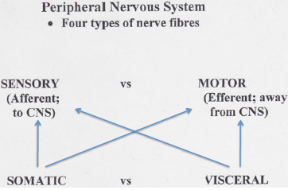
Somatic sensory: from skin and sense organs of muscles, tendons
Somatic motor: to somatic musculature
Visceral sensory: from gut
Visceral motor: to gut muscles, blood vessels, glands
- Autonomic: parasympathetic, sympathetic
- Special branchial (head and visceral arches)

Spinal nerves:
- Usually paired, present in every body segment
- Each nerve formed from dorsal and ventral root
- In most vertebrates; dorsal and ventral roots unite to form main trunk of spinal nerve within vertebral canal
  - Dorsal root: sensory fibres (somatic & visceral)
  - Ventral root: motor fibres (somatic & visceral)
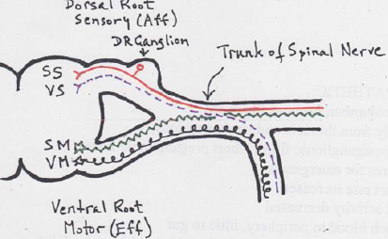IN HIGHER VERT. 2:2 ratio
SM and SS join in trunk of spinal nerve, VS and VM join each other as well

Many lower amniotes, amphibians & fishes have visceral motor both dorsally and ventrally 3:2 ratio

In amphioxus:
- Alternate arrangement ; not above one another
- Dorsal root is intersegmental, carries 3 types of fibers
- Ventral root carries only somatic motor
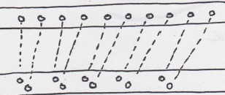

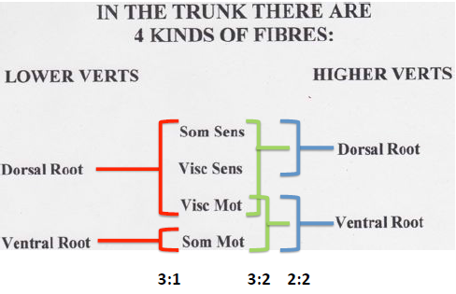

Lecture 23: Brain
Central nervous system: brain & spinal cord
- Forms early by rolling of tissue along middorsal line
- Neurectoderm forms neural tube

Vertebrates characterized by tripartite brain –three primary parts
- During development, 2 flexures define the 3 sections
  - 1st flexure folds downwards to define primitive forebrain: prosencephalon
  - A later dorsal flexure defines the remaining 2 parts; midbrain mesencephalon and hindbrain rhombencephalon
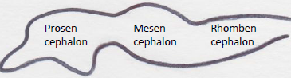
These 3 form the brain stem
- Phylogenetically oldest part of the brain, controls numerous vital functions
- Other parts of the brain are dorsal outgrowth of these 3
- Each originally associated with particular sensory function of sense organs
  - Prosencephalon: nose
  - Mesencephalon: eyes
  - Rhombencephalon: ear and lateral line

Further development into 5 regions:
- Prosencephalon:
  - Anteriorly gives rise to paired cerebral hemisphere and olfactory bulbs: telencephalon
  - Rest forms unpaired diencephalon
    - Thalamus (paired), epithalamus, hypothalamus
- Mesencephalon:
  - Roof (tectum) enlarges to form optic lobes
- Rhombencephalon:
  - Anteriorly forms the cerebellum ( and pons in mammals): metencephalon
  - Rest forms the myelencephalon; mainly medulla oblongata
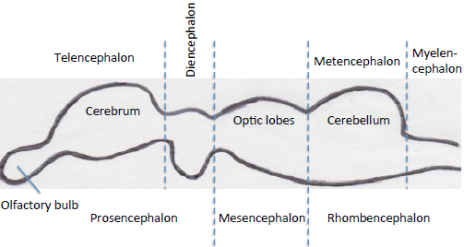
Set up largerly retained, except in higher vertebrates, mammals & birds sight switches to cerebrum of telencephalon
In vertebrates, each “portion” of brain associated with a ventricle:
- Telencephalon –lateral ventricle (one on each cerebral hemisphere)
- Diencephalon –third ventricle
- Mesencephalon –optic ventricle
- Metencephalon –cerebellar ventricle
- Myelencephalon –fourth ventricle

Lecture 24: Cranial nerves

7 kinds of nerves in cranial region:
- SOMATIC:
  - Somatic sensory
  - Somatic motor
- VISCERAL:
  - Visceral sensory
  - Visceral motor
- SPECIAL SENSORY:
  - Special Branchial (visceral) motor
    - Specialized striated musculature of visceral skeleton
  - Special Visceral sensory
    - Nerves of taste organs
  - Special Somatic sensory
    - Somatic sensory structures; nose, eyes, ears/lateral line
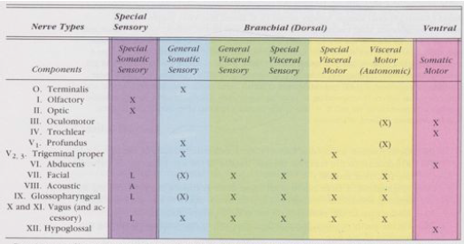

Ventral root nerves (somatic motor)

- Occulomotor (III)
- Trochlear (IV)
- Abducens (VI)
- Hypoglossal (XII)

Special somatic sensory
- Olfactory (I)
- Optic (II)
- Auditory (VIII)
  - Statoacoustical
  - Vestibulocochlear

