October 11th/2012
Goals include understanding:
Sensation, perception, bottom-up, top-down processing.
Absolute & difference thresholds, signal detection theory, adaptation, constancy.
Structures, processes associated with seeing.
Colour, motion, depth.
Gestalt psychology.
Aspects of visual impairment.
Sensation  Are not exerting a lot of cognitive energy in order to sense things  Minute processes that detect energy from our environment and somehow get them through our nervous systems to our brains | Perception  -Typically requires more energy from a  cognitive perspective; the process by  which of most of what we take in, is  organized; active because we are  actually acting on the information that we are tal  taking in.
Passive process | Active process
Detect physical energy from environment | Sensation actively organized
Transmitted to brain | Interpreted by brain
Bottom-up | Top-down

Bottom up processing:
Automatic, parallel, sensation
Components of stimulus detected by sensory receptors.
Bits of information transmitted to brain, combined and assembled.
*** Goes on in primarily parallel processing detected by sensory systems then turned into signals that our brain can interpret.
-Is automatic and happens in parallel ex: when psychologist talk about things going on in parallel, it means that multiple things have been processed by our brains at the same time.
ex: when you become an expert at driving, your taking in a whole bunch of different things at once, listening to music, checking your text messages, looking at the road in front of you, checking your mirrors (typically processing all of this in parallel)
Top down processing
Non-automatic, serial, perception
Influenced by past experience and knowledge
Find meaningful links between individual elements taken in by sensory receptors
*** Non automatic, meaning we have to exert some cognitive energy in order to make it happen and is often serial (a process where we have to do one thing at a time not two or more).
-It is very much influenced by our pass experience and knowledge and helps us to find meaningful links between the various things we (hearing, smell)
what demands more cognitive processing? Seeing an apple or reaching for that apple? Knowing that you are alive or determining (as a doctor) that a patient is alive?
***knowing that you’re alive (or determining as a doctor) that a patient is alive?

Absolute Threshold:
Difference between not perceiving and just being able to perceive a stimulus. (define it as that level of stimulation that is necessary for us to perceive something 50% of the time).
Minimum sensory stimulation that can be detected 50% of time.
Candle flame 50 km away (dark night, after being adapted, has to be pitch dark no light).
Watch ticking 6 meters away
1 tsp of sugar dissolved in 7.6 litres of water
1 drop of perfume in a 3-room house
Fly’s wing falling 1 cm on your cheek
*** we define it as that level of stimulation that is necessary for us to see something 50 percent of the time; when we use that definition we discover that we human beings are incredible as seeing, hearing, touching, tasting we can under ideal conditions see a single candle flame, on a dark night, once we have been adapted were able to see the candle flame 50 km away.
Difference Threshold:
Smallest increase or decrease in a stimulus required for “just noticeable difference” (JND) detectable 50% of time. (Smallest increase or decrease that we can detect).
JND a percentage of total value of stimulus. E.g. JND for weight will be larger when compared to a 10 kg object vs a 10 gram object
***Small increase or decrease that we can detect
-Ex; carrying 10 pound bag of potatoes, you drop one, can you take one more? Cannot tell the difference between 10 pound bag and one more potato; with money more likely to detect it.
-Define the difference Threshold, as something we can detect 50 percent of the time
Signal detection theory:
Detection of stimulus depends on more than just physical intensity of stimulus and the sensory abilities of observer. - Fatigue, expectancy, and urgency affect detection.
Decision making about stimulus in presence of uncertainty depends on criterion.
Noticing something versus “noise”
Decision process, e.g. radiology
***We develop some type of mental threshold or decision level that we can adjust
ex: trying to determine if there is a tumor present in someone’s brain mammogram. (If it was your mothers or sister would look at it differently). We would adjust our criterion depending upon how important in this case, the judgement was.
-If expecting something, your brain can trick you ex: expecting an important text (waiting around, any little sound, run to your phone oh it’s not there oh oh).
-We have a cognitive decision to make that is captured by a two by two matrix: is or is not there
(reality says yes there is or isn’t a tumor but on the other hand there is the decision we have to make).
-Noticing something versus “noise.”
-Decision process ex: radiology
Transduction:
Sensory receptors detect and respond to various stimuli
Transduction is process in which sensory receptors convert stimulation into neural impulses
***conversion process by which light, sound, and smell are turned into a form that is readable and understandable by our brains.
-Sensory receptors pick up light that is reflected from objects around us but transduction is when that light is converted into some kind of signal that is then sent on to the appropriate parts of our brain. (is the process in which light, sound, smells, taste are turned into a form that is readable and understandable by our brains).
Sensory Adaption:
We become less sensitive to stimuli over time
Adaptation process of becoming less sensitive to an unchanging sensory stimulus
Examples? Cold, heat, loud music
We become much less sensitive to something over time
ex: road trip, 4-5 hours, turn up the tunes, get to destination, park, go n chill....next morning music blasted (became adapted to certain volume but nxt morning whole lot louder).
Cornea:
*** If you were to take a pen or pencil and poke self in the eye, the first thing you would poke is Cornea
-Outer most layer of your eye, clear, and protects Past Cornea is the...
Lens: Clear, flexible part of your eye that changes shape whether or not it is clear or further away but first before light hits our lens, it goes through a hole called the pupil (it is just a hole) but around that whole is the iris.... lens then vitreous humor then retina?
Iris: Part of our eye that we refer to when we say what colour our eyes are brain, blue, hazel etc..
Once light goes through the cornea, pupil and the lens, it then goes through a very clear jelly like substance called
Vitreous humour: Jelly like substance would come out if popped out someone’s eye; when light goes through the vitreous humour, it is focused on the back of our eyes called the retina; when we focus on something directly in front of our eyes that thing is focused on dead center of the back of our eyes and that place is called the fovea
optic nerves: feed their signals out through a set of cables that all go through out one spot called set of nerves (rods and cones feed their signals through set of cables aka optic nerve and one spot in our vision where we cannot see a thing).
ex: Stare straight ahead and move finger further and further out, finger will disappear (when the nerves leave our eyes) and reappear

How Eye Works
Light reflects off objects. Reflected light passes thru cornea, pupil, & lens and focus on back of our eye the retina.
Ciliary muscles alter shape of lens depending on whether it is close up or further away.
Receptors (rods & cones) in Retina, convert light into neural signals.
Cones (6 million) provide colour & detail.
Rods (120 million) better in dim light, provide night vision and movement.
Detail vision best at fovea, where cones most common
*** rods and cones convert light into neuro signals (come from the retina)
cones: colour and visual fine detail
Rods: specialized to help us see in low light conditions and help us see night vision
Rods and Cones (REMEMBER RODS AND CONES!!!!!!!!!!!!!!!) Light goes through rods and cones before they hit the back of the retina, info is taking out through same direction and is collected through the optic nerve.
A lot more rods than there are cones
rods long and skinny, cones shaped like a cone
rods optimized and scattered around the periphery of the retina
cones are concentrated around the fovea
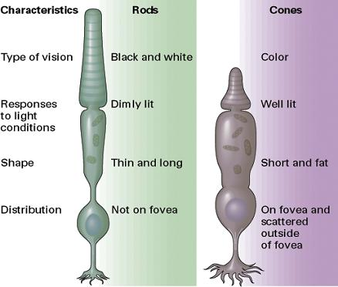
Binocular Vision:
Each hemisphere sees one half of visual field.
Information from each eye crosses over at optic chiasm.
Different views from each allow help us to see in depth
*** allows us to develop two different views of the world we see around us
- Because we c something different between both eyes we can see whether something is further away or closer (process that allows us to see in depth).

What and where are the pathways for vision:
*** prosopagnosia: people can see the faces perfectly well but they are unable to recognize them (makes us believe this part of our brain helps us to recognize faces).
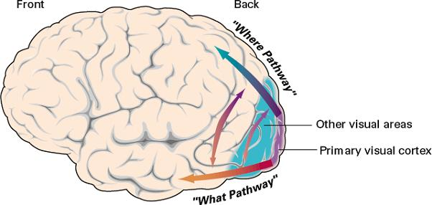
MOST SIGNALS GO TO THE BACK OF THE BRAIN!
When we see something there are portions of our visual cortex that seem to be specialized to help in identifying what that thing is that we are looking at, whether it is a chair, computer or face
Another part of our visual cortex that is specialized to figure out where that thing is, in front of us, behind us, to the side
Because we have two different ways of processing information, there are in some cases very specialized brain damage

Visual processing in the brain:
Ventral pathway (WHAT INFORMATION)- Processes “what” information about an object (e.g., colour, form, texture)
Dorsal pathway (WHERE INFORMATION)- Processes “where” information about an object (e.g., location, movement, depth)
Blindsight - After brain damage, can’t “see” something but know it is vertical or horizontal
***Can occur through brain injuries where they claim they cannot see something at all
Theories of colour vision:
Three dimensions of colour vision
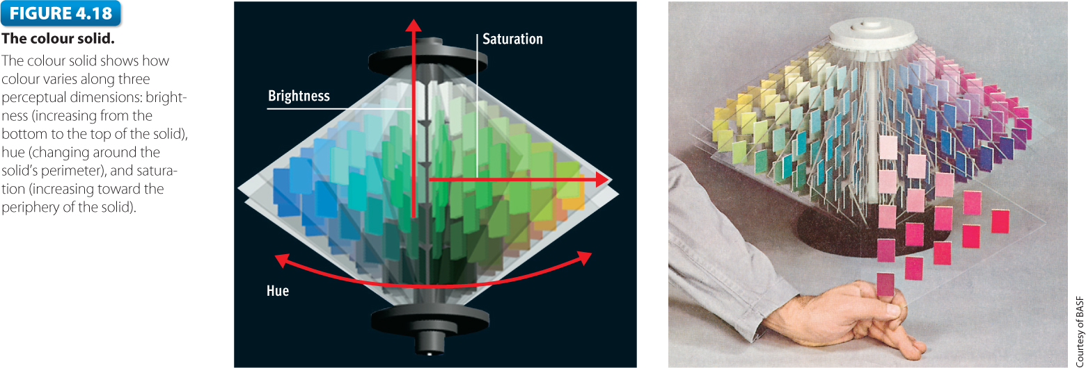Hue: colour perceived
Saturation: purity perceived – has to do with how far out a color is located (ex: non saturated green vs saturated green).
Brightness: intensity perceived having to do with the intensity with whatever color is perceived
Light waves are varying amplitude:
Light ways: small portion of overall magnetic spectrum
Wave length: peaks and valleys, amplitudes (how high the peaks and valleys are)
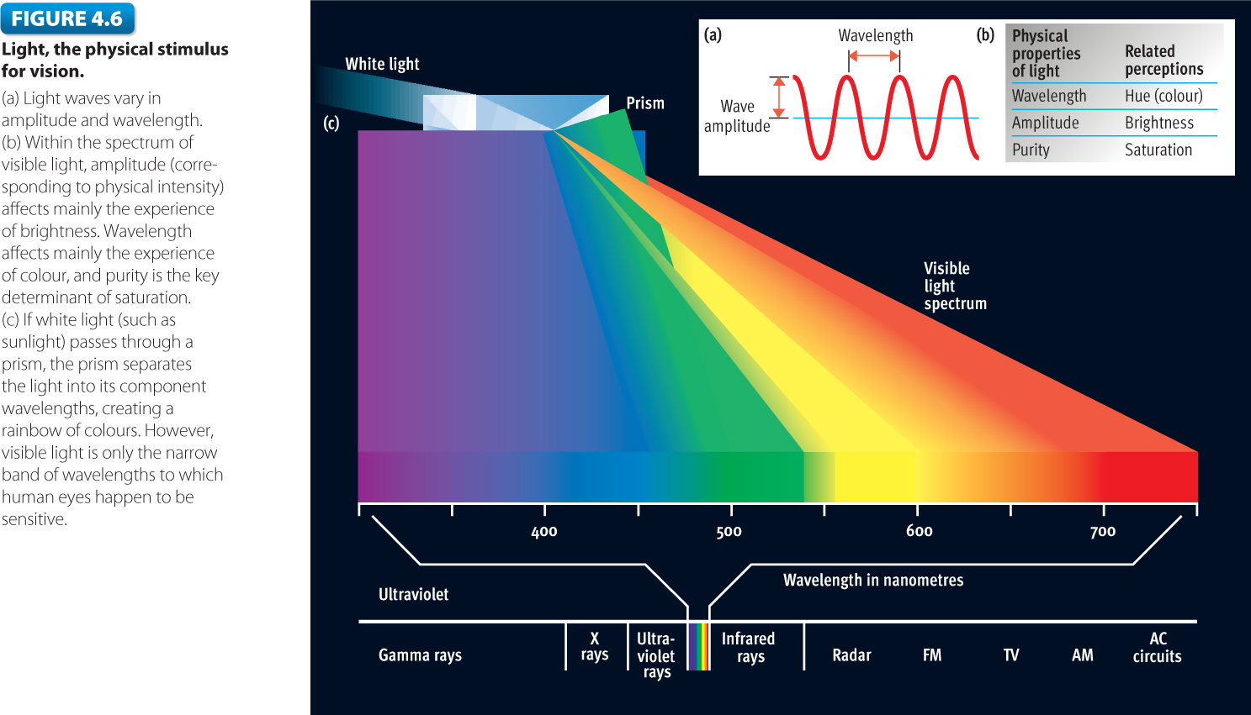

Trichomatric Theory:
Colour perception based on 3 types of cones. - Young (1802) and Helmholtz (1852)
Supporting evidence
-Create any colour by mixing 3 wavelengths
-trichromats, dichromats, monochromats (colour blindness number of colours that the individual can see)
*** We can create colors by three basic colors
-Suggest there might be specializes systems just like we have specialized cones
Opponent process theory:
Cells in visual system respond to complementary colours (red-green and blue-yellow) (Hering, 1878)
Supporting evidence - Negative afterimages
***Colors that are in our visible spectrum all have compliments
Yellow compliment of blue; red compliment of green; black compliments white
Trichromatic & Opponent-Process Theories
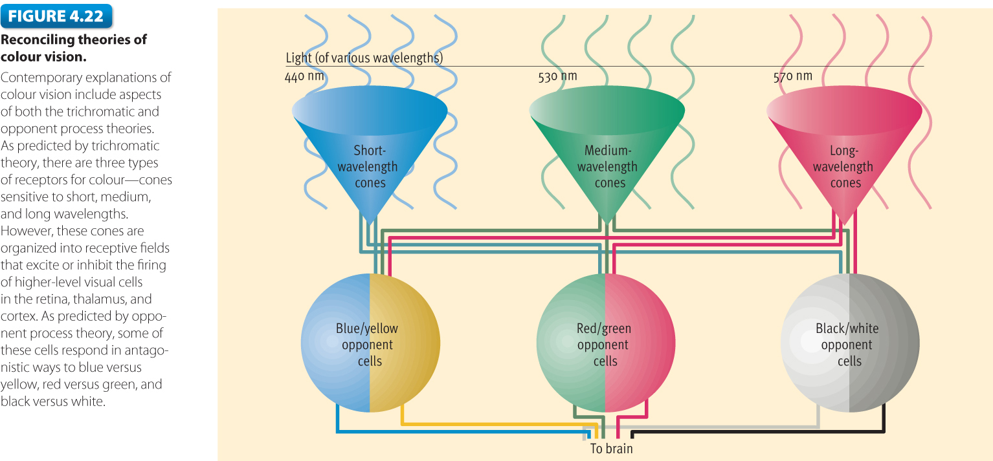
Both theories are correct - trichomatic account explains operation of cones.
*** Both theories equally correct
Opponent process theory applies to ganglion cells
Stroop Effect: difficult to name colours of words when words name different colours
-failure of selective attention
-Bottom up processing

Perceptual Set:
-Predisposition to perceive something in a particular way
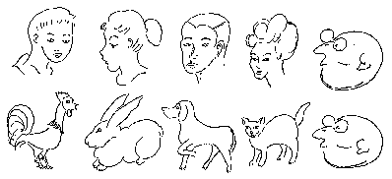
Gestalt psychology:
Whole is more than sum of parts…
People naturally organize their perceptions according to certain patterns. - Gestalt is a German word for “form” or configuration.
***ex: three red circles make a triangle (make it into a whole object).
Proximity: 4 vertical columns rather than rows
Similarity: Group things that are alike
Figure Ground: Can only make one picture out of what we see
Depth Perception:
Binocular depth cues – visual depth cues that depend on both eyes working together. *** when our two eyes are working together and we see two different views of our visual world; were able to understand that something’s are further away or closer together
-Convergence -Binocular disparity (stereopsis) further together or closer apart
Monocular depth cues – visual depth cues perceived by one eye alone.
Monocular cues are depth cues from an image in one eye.
Familiar size
height in field of view
linear perspective
overlap
shading
texture gradient
Motion Perception:
In humans movement is detected in the brain, not the retina.
Apparent movement is the perception that a stationary object is moving.
Stroboscopic motion
movement aftereffects
***Most of the movement we see is not detected from the eyes but visual cortex
Perceptual Constancies:
Objects perceived as constant even though sensory input about the objects change.
1.Size constancy - Non-literal interpretation of size
2.Shape constancy - Perspective does not change shape
3.Brightness constancy - brightness vs darkness
4.Colour constancy - brightness vs darkness
Visual Illusions:
A discrepancy between reality and the perceptual representation of reality
Illusions provide insight into how perceptual processes work.
Muller- Lyer Illusion
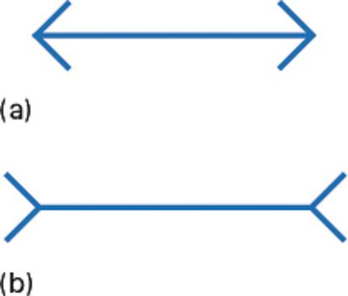
They are the exactly the same length if you take off the angels from the ends;
What would you do without vision?
C. Knauer, N. Pfeiffer, University of Mainz
People with 20/200–20/400 acuity would give up 48% of their lifetime
Blind people would give up 60% of their lifetime to regain vision.
Compare:
-AIDS (21%);
-stroke patients unable to walk, wash (46%);
-bedridden, incontinent patients following a stroke (66%).
Visual Impairment:
-8-14 million N Americans visually impaired (StatsCan, 2001; US Census Bureau, 2001)
-<10% totally blind|
-Legally blind: 20/200 or visual field <20°
-Cataracts: 42% of those 52-64
-Glaucoma: 1/200 < 50
-Macular degeneration: 10% of 66 -74
-Diabetic retinopathy: >20 million Americans
Correlated with age, obesity
Retinopathy of Prematurity (ROP)
Colour Blindness:
-7% of males, <1% of females
-Most commonly red/green
Key Facts:
Correctable:
-Myopia (nearsightedness) glasses to drive
-Hyperopia (farsightedness) see just fine to drive but glasses to read
-Presbyopia (failure to accommodate to near objects) a gradual inability of the eyes to change its focus (lens not able to focus as much on close up or further away).
Only 3% of blind can read Braille
Theories of hearing:
Place theory - each frequency produces vibrations at a particular spot on the basilar membrane
perception of high frequency sound
Frequency theory - perception of a sound’s frequency is due to how often the auditory nerve fires
perception of low frequency sound - volley principle
a cluster of nerve cells fire in rapid succession
***Hearing loss: when were exposed to loud noises (most common) but also due to old age
Decibels:
-Every increase of 6 decibels doubles a sound’s intensity.
-Sound 80 decibels or higher, if heard for prolonged periods of time, can cause permanent hearing loss.
Olfaction (Sense of smell):
Ability to evoke memories
Olfactory epithelium contains 10 million olfactory neurons
Pheromones undetectable but may change our behaviour
-Menstrual synchrony
-Pheromones in female vaginal secretions caused men to prefer those at peak fertility
*** Can’t smell pheromones but they affect our behavior
ex: woman are in residence (if together for more than couple months) their menstrual cycles synchronize
Pain:
Placebo effect – discovered with soldiers in world war 1 (thinking their getting their drug when they are getting something else, making them think their pain was gone).
Acupuncture -
Phantom limb pain -
Cultural differences -
Gate Control Theory of Pain
Spinal column contains a neural gate that can be open or closed.
Developed by Ronald Melzack (McGill) and Patrick Wall (1965)
-explains effects of acupuncture
-does not explain phantom limb pain
Endorphins probably turn pain signals on or off.
Sense of taste:
Sweet -
Sour -
Salty -
Bitter -
Umami -
Taste buds between papillae -

