CPCS181 MIDTERM NOTES

THE UNIVERSE
- Is comprehensible, we CAN study it.
- The Scientific Method can be used to form a hypothesis about the universe.
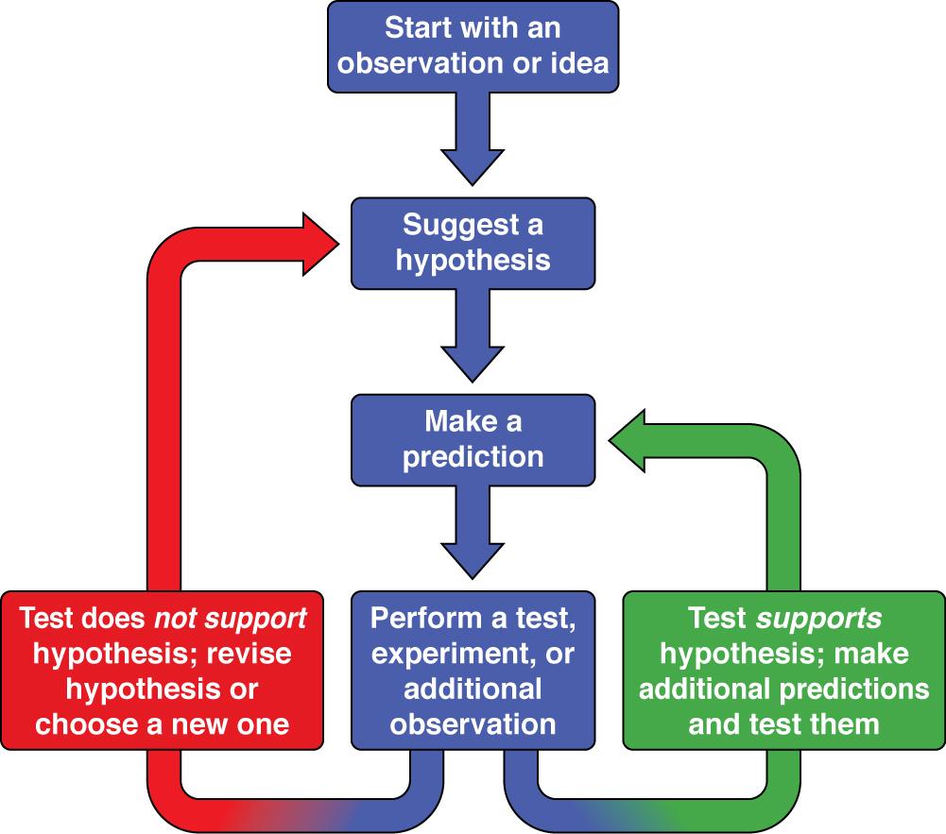

STAR: Large ball of gas.
PLANET: Object that orbits a star.
MOON/SATELLITE: Object that orbits a planet.
ASTEROID: A smaller object that orbits a star.
COMET: A small icy object that orbits a star.
GALAXY: A group of stars held together by gravity.
SUPERCLUSTERS: Thousands of galaxies held together by gravity.
GROUPS OF GALAXIES: Small amounts of galaxies held together by gravity.
SOLAR SYSTEM: Everything orbiting around a star.

SCIENTIFIC NOTATION:
- 10^0 = 1
- 10^1 = 10
- 8.9x10^4 = 89,000
- 10^-1 = 0.1
- 10^-2 = 0.01
- 2.1x10^-2 = 0.021

EARTH: Local Supercluster Local Cluster Milky Way Galaxy Solar System 3RD Planet from the Sun

TIME 0
- Everything confined to a single point, the point exploded into a universe.
- AKA The Big Bang
TIME 1 millionth of a second (10^-6)
- Plasma was created (resembles gas and liquid).
TIME 1 thousandth of a second (10^-3)
- Plasma expanded and cooled to form neutrons and protons.
TIME 30,000 YEARS (3x10^5)
- Universe cooled and created hydrogen and helium.
TIME 400 MILLION YEARS (4x10^8)
- First stars began to form.
TIME 800 MILLION YEARS (8x10^8)
- Galaxies formed because of gravity.
TIME 2 BILLION YEARS (2x10^9)
- Stars we see today organized themselves into galaxies.
TIME 9 BILLION YEARS (2x10^9)
- Solar systems formed (including Earth).
TIME 13.7 BILLION YEARS (1.37x10^10)
- Present day.
- Universe still expanding.
- 100 billion galaxies with 100 billion stars (approx.)

LIGHT YEARS (LY):
- The distance light travels in one year.
- 9.4x10^12 km (9.5 trillion kilometers)
- 4 LY to travel to Alpha Centauri.
- Andromeda is 10,000,000,000 LY away. (10^9)
ASTRONOMICAL UNITS (AU):
- The average distance between the Sun and Earth.
- 150,000,000 km (1.5x10^8)
- Speed of light is 300,000 km/second.
- Light has a finite spead can be measured.

WAVES: Something that vibrates and transfers information at the same time. Particles don’t shift left and right, information does.
WAVELENGTH: Distance from one peak to the other.
AMPLITUDE: Height of waves.
FREQUENCY: How often a trough (wave) occurs.

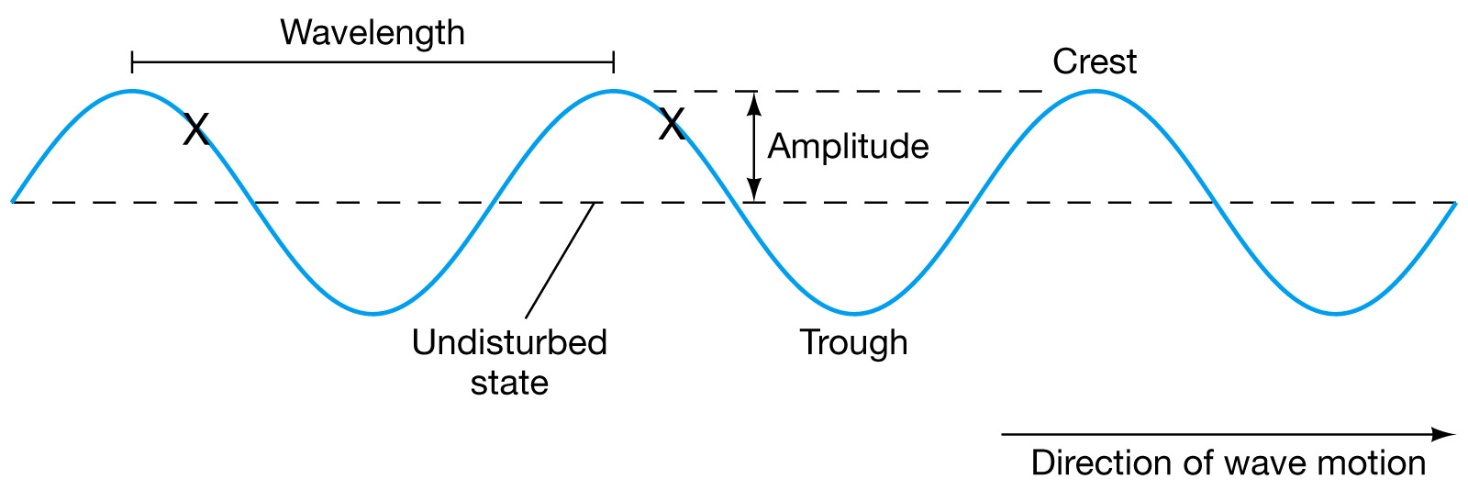

SPEED OF WAVE (m/s) = FREQUENCY (hertz) x WAVELENGTH (meters)

C 
LIGHT (RADIATION):
- Can only see light in its “visible form” (ROY G. BIV).
- Is a wave because the photon vibrates and moves at the same time.
- Colour is different wavelengths of light.
- All Electromagnetic Radiation travels at the same speed.
- The HIGHER the frequency of light, the MORE ENERGY it has.
- Any object that has a temperature that is above absolute zero emits light. Type of light depends on the temperature that the object has.
- Light particles are called photons.

BLACKBODY SPECTRUM:
- Graph showing the amount of light emitted by an object at each wavelength.
- There is always a peak (means they emit the MOST light at this wavelength).
- Emits the same amount of light it absorbs.
- Glows by itself, does not reflect light.
- Hotter the object, higher the peak.
- The hotter the object, light emitted shifts to the left (shorter wavelength).
- Hotter = Brighter
- WIEN’S LAW: Peak wavelength is related to temperature.
HIGHER TEMP SMALLER WAVELENGTH
COOLER TEMP LARGER WAVELENGTH
- Sun emits blue-green wavelengths but appears white.
- BLACKBODY CURVE: Graph of an objects energy output vs. wavelength.

max = 0.0029 / T
(METERS) (Kelvins)

ATOMS:
- Has a nucleus surrounded by electrons (-).
- Nucleus contains protons (+) and neutrons (no charge).
- PHOTON CREATION (EMISSION): When electrons jump down from a higher shell to a lower shell. Electrons don’t need energy so they release light.
- PHOTON DESTRUCTION (ABSORPTION): When photons are destroyed when electrons jump from a lower shell to a higher shell. This is how electrons get energy.

SPECTRA LIGHT:
- CONTINUOUS
- Blackbodies emit continuous spectrum light.
- EM radiation that is uninterrupted over a range of wavelengths.
- ABSORPTION
- Continuous radiation passes through a cooler medium before it reaches us.
- Cooler medium will absorb the light energy which creates absorption lines in the spectrum.
- EMISSION
- Each element produces a pattern of emission lines when heated.

DOPPLER EFFECT:
- Change in wavelength of radiation (light) due to relative motion between source and observer along line of sight.
- Used to learn about radial motion of stars/other objects.
- LIGHT MOVING AWAY EMITTED LIGHT INCREASES (REDSHIFT)
- LIGHT MOVING TOWARDS EMITTED LIGHT DECREASES (BLUESHIFT)
- Does not occur if object is moving side to side or up and down.

STARLIGHT TEACHES US:
- A star’s temperature = peak wavelength.
- A star’s chemical composition = dips in curve lines.
- A star’s motion = Doppler shift.

THE UNIVERSE:
- Cosmology = study of structure of the universe.
- COSMOLOGICAL PRINCIPLE (1): Universe is isotropic (same in every direction)
- COSMOLOGICAL PRINCIPLE (2): Universe is homogeneous (same as far as one can travel).
- The universe can have no center (violates isotropy).
- The universe can have no edge (violates homogeneity).
- CMB (Cosmic Microwave Background): Glow between stars. CMB is the same everywhere we look therefore universe is isotropic.

EDWIN HUBBLE:
- Showed existence of other galaxies.
- Found that galaxies were red shifted.
- RED SHIFTED: Galaxies are moving away. Farther they are = faster they are moving.
- BLUE SHIFTED: Galaxies moving towards us.
- HUBBLE’S LAW: V = H^0 x D
- V = VELOCITY D = DISTANCE OF OBJECT H^0 = SLOPE OF LINEAR RELATIONSHIP
- Only intergalactic space expands.
- As light travels through space the wavelength is expanded b/c the universe is expanding.
- Highest Redshift: IOK-1
- TEMPERATURE SCALE: Absolute zero = temperature at which atoms stop moving.
- TIME SCALE: Absolute zero = instant at which expansion began.

UNIVERSE GEOMETRY:
- FLAT: Universe is 2-D. Has zero curvature. No edges. Extends forever (open or closed).
- HYPERBOLIC: Saddle shape. Negative curvature. Extends forever (open or closed).
- SPHERICAL: Sphere. Positive curvature. Extends forever (closed).

GALAXIES:
- More than 100 billion observable ones.
- SPIRAL: Have arms emerging from a nucleus. Classified as to how close the arms are. Brightness related to closeness.
- BARRED SPIRAL: Bars across nucleus where spirals form. Rotate so that spirals trail behind.
- ELLIPTICAL: Lack spiral arms and dust. Smooth light. Contain older stars.
- IRREGULAR: No regular shape. DWARF: Low mass with young stars. MERGING IRREGULARS: Galaxies interacting.
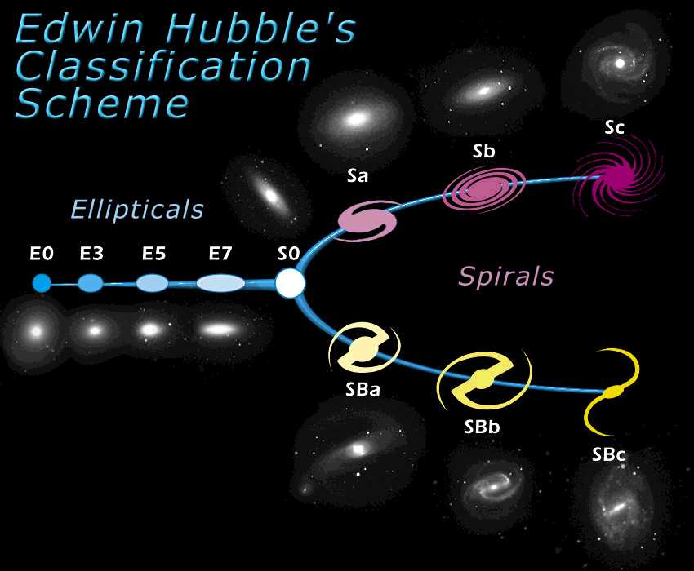
- Centre of Milky Way is near Sagittarius constellation.
- Milky way has a bulge, disk, and halo.
- 200 billion stars.
- GLOBULAR CLUSTERS: 1000S of stars born in the same cloud at the same time. In the center.
- 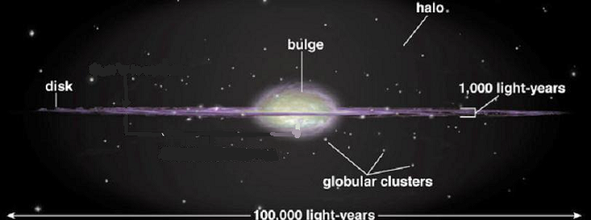
- 28,000 years to get to edge.
- 10,000 years to get to center.
- DISK STARS: Travel in same direction.
- BULGE STARS: Travel in a halo.
- Sun orbits center every 230 million years.
- Galaxies rotate at same speed.
- Orbital Speed vs. Radius = Radial Velocity
- DARK MATTER: Missing mass is dark matter. Do not see 90% of it. Is dark energy.
- ACTIVE GALAXIES: Light from galaxies is the light from each star. Sometimes bright cores outshine the galaxies. All contain a black hole.
- RADIO JETS: Minerals spewing from center of galaxies.
- QUASARS: Radio source with bright emission lines that are red shifted UV lines that formed when universe was 1/3 it’s age. Look like stars but have more energy. Get energy from supermassive black hole.

