Chapter 12

Information system
Software that helps the user organize and analyze data
Electronic spreadsheets and database management systems
Software tools that allow the user to organize, manage, and analyze data in various ways
Spreadsheet
A software application that allows the user to organize and analyze data using a grid of labeled Cells
- A cell can contain data or a formula that is used to calculate a value
- Data stored in a cell can be text, numbers, or “special” data such as dates
- Spreadsheet cells are referenced by their row and column designation
- The power of spreadsheets comes from the formulas that we can create and store in cells
- When a formula is stored in a cell, the result of the formula is displayed in the cell
- If we’ve set up the spreadsheet correctly, we could:
- Add or remove tutors.
- Add additional weeks of data.
- Change any of the data we have already stored and the corresponding calculations would automatically be updated.
- - Formulas make use of basic arithmetic operations using the standard symbols (+, -, 2, *, and /)
Spreadsheet functions
- Computations provided by the spreadsheet software that can be incorporated into formulas:
- - Range
- - A set of contiguous cells specified by the endpoints
Circular reference
A set of formulas that ultimately rely on each other

Spreadsheet Functions
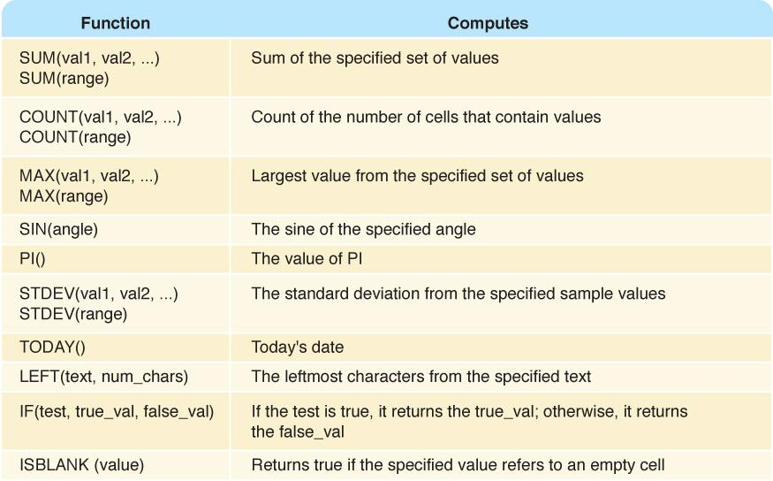
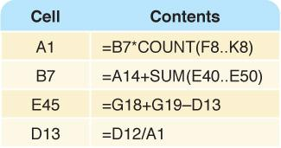
Possible tasks a spreadsheet could perform:
- Track sales
- Analyze sport statistics
- Maintain student grades
- Keep a car maintenance log
- Record and summarize travel expenses
- Track project activities and schedules
- Plan stock purchases
- Spreadsheets are also useful because of their dynamic nature, which provides the powerful ability to do what-if analysis
- Database
- A structured set of data
- Database management system (DBMS)
- A combination of software and data, made up of a physical database, a database engine, and a database schema
- Physical database
- A collection of files that contain the data
- Database engine
- Software that supports access to and modification of the database contents
- Database schema
- A specification of the logical structure of the data stored in the database
- Database query
- A request to retrieve data from a database

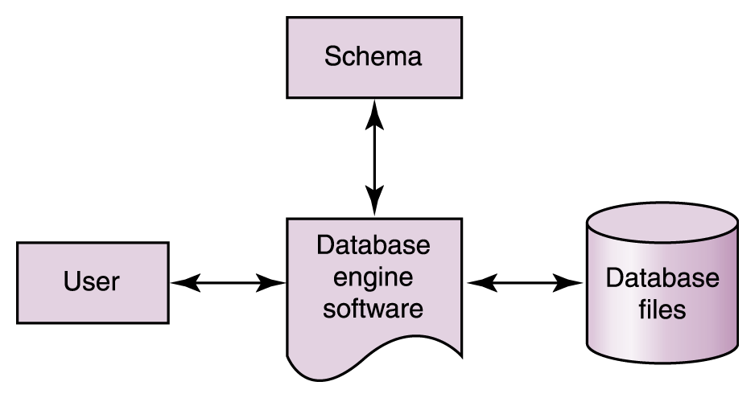
Relational DBMS
A DBMS in which the data items and the relationships among them are organized into tables
Tables
A collection of records
Records (object, entity)
A collection of related fields that make up a single database entry

Fields (attributes)
A single value in a database record
Key
One or more fields of a database record that uniquely identifies it among all other records in the table We can express the schema for this part of the database as follows: Movie (MovieId:key, Title, Genre, Rating)
Structured Query Language (SQL)
A comprehensive relational database language for data manipulation and queries
Entity-relationship (ER) modeling
A popular technique for designing relational databases
ER Diagram A graphical representation of an ER model
Cardinality constraint
The number of relationships that may exist at one time among entities in an ER diagram Electronic commerce
The process of buying and selling products and services using the Web

Chapter 16
The Web
An infrastructure of information combined and the network software used to access it
Web page
A document that contains or references various kinds of data
Links
A connection between one web page and another
table-list where condition name of table value restriction
Movie where Rating = 'PG'
Website
A collection of related web pages
Web browser
A software tool that retrieves and displays eb pages
Web server
A computer set up to respond to requests for web pages
Uniform Resource Locator (URL)
A standard way of specifying the location of a Web page, containing the hostname, "/", and a file
Instant messaging (IM)
An application that allows people to send and receive messages in real time
- – Both sender and receiver must have an IM running
- – Most IM applications use a proprietary protocol that dictates the precise format and structure of the messages sent
- – Instant messages are not secure Blog or Weblog
- An online journal or newsletter that is frequently updated and intended for public consumption

Cookie
A small text file that a web server stores on your local computer’s hard disk
- A cookie contains information about your visit to the site
- Cookies can be used
- to determine number of unique visitors to the site
- to customize the site for future visits
- to implement shopping carts that can be maintained from visit to visit
- Cookies are not dangerous
- Hypertext Markup Language (HTML)
- The language used to create or build a Web page
- Markup language
- A language that uses tags to annotate the information in a document
- Tags
- The syntactic element in a markup language that indicates how information should be displayed
- Tags are enclosed in angle brackets (<. . . >)
- Words such as HEAD, TITLE, and BODY are called elements and specify the type of the tag
- Tags are often used in pairs, with a start tag such as <BODY> and a corresponding end tag with a / before the element name, such as </BODY>
- The browser determines how the page should be displayed based on the tags
The browser
- Takes into account the width and height of the browser window
- Reformats the contents to fit your browser window Attribute
- Part of a tag that provides additional information about the element
- Attribute-name = value
- <IMG SRC = "myPicture.gif">
- Inserts the image stored in file "myPicture.gif" Java applet
- JSP Scriptlet
- A portion of code embedded in an HTML document designed to dynamically contribute to the content of the web page
- Java Server Page
- A web page that has a JSP scriptlet interwoven among the HTML content
- Extensible Markup Language (XML)
- A language that allows the user to describe the content of a document
- HTML describes how a document should look
- XML describes a document's meaning
- Metalanguage
- A language for talking about, or defining, other languages XML is a metalanguage XML represents a standard format for organizing data without tying it to any particular type of output Extensible Stylesheet Language (or XSL)
- A language for defining transformations from XML documents to other output formats Chapter 2

- Natural Numbers
- Zero and any number obtained by repeatedly adding one to it. Examples: 100, 0, 45645, 32 Negative Numbers
- A value less than 0, with a – sign Examples: -24, -1, -45645, -32
- Integers
- A natural number, a negative number, zero Examples: 249, 0, - 45645, - 32
- Rational Numbers
- An integer or the quotient of two integers Examples: -249, -1, 0, 3/7, -2/5
- The base of a number determines the number of digits and the value of digit positions
- How many ones are there in 642? 642 is 600+40+2 in BASE10
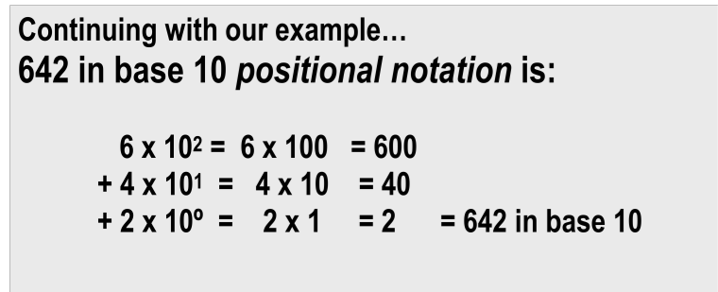

What if 642 has the base of 13?
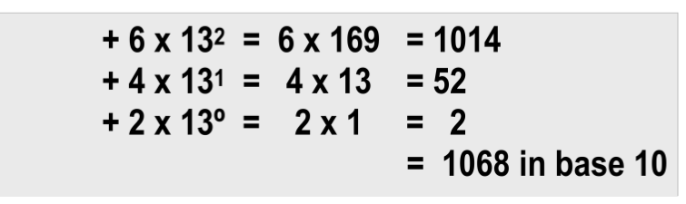
642 in base 13 is equivalent to 1068 in base 10

Decimal
A base 10 and has 10 digits: 0,1,2,3,4,5,6,7,8,9 Binary is base 2 and has 2 digits: 0,1

With distinct symbols for 10 and above. Base 16 has 16 digits:
0,1,2,3,4,5,6,7,8,9,A,B,C,D,E, and F

What is the decimal equivalent of the hexadecimal number DEF?
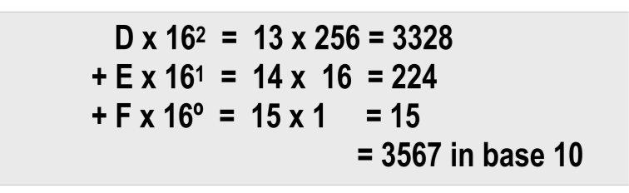
What is the decimal equivalent of the octal number 6?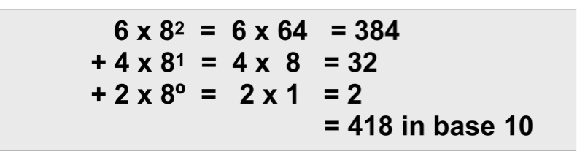

What is the decimal equivalent of the binary number 1101110?
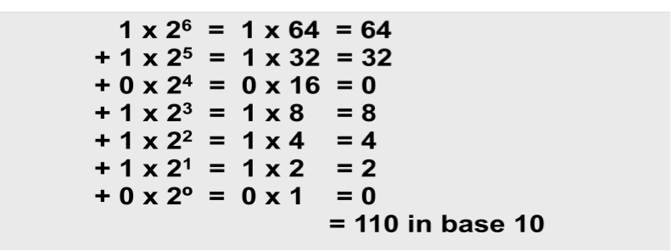

Converting Binary to Octal
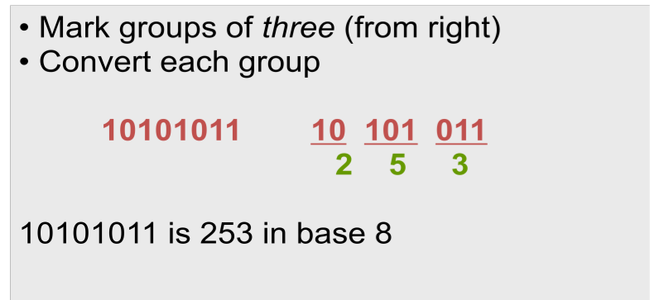

Converting Binary to Hexadecimal
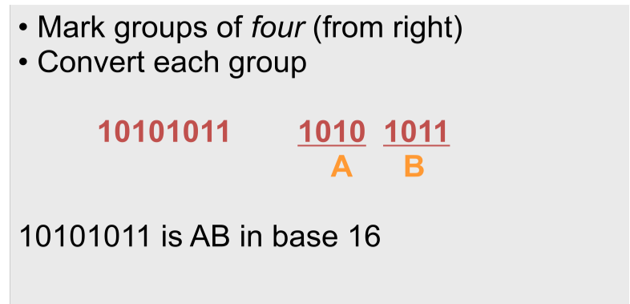

Converting Decimal to Octal
What is 1988 (base 10) in base 8?
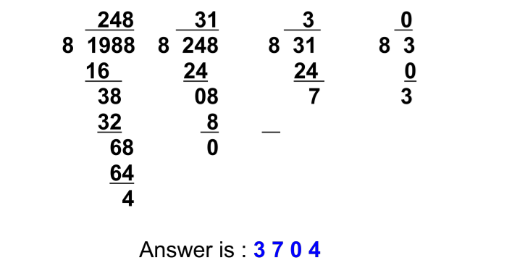

Converting Decimal to Hexadecimal
What is 3567 (base 10) in base 16?
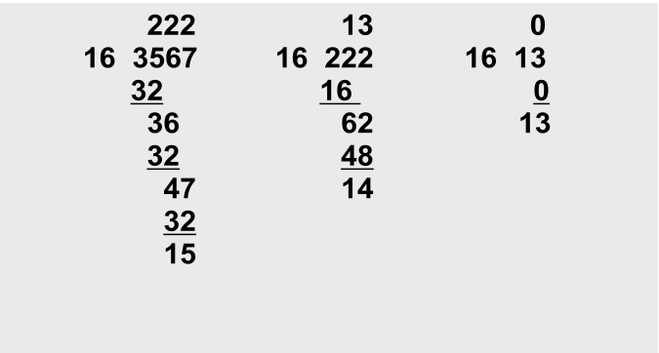

Chapter 3
Computers are multimedia devices, dealing with a vast array of information categories Computers store, present, and help us modify
- Numbers
- Text
- Audio
- Images and graphics
- Video
Data compression
Reduction in the amount of space needed to store a piece of data
Compression ratio
The size of the compressed data divided by the size of the original data A data compression technique can be lossless, which means the data can be retrieved without any loss of the original information loss, which means some information may be lost in the process of compaction Information can be represented in one of two ways: analog or digital
Analog data
A continuous representation, analogous to the actual information it represents
Digital data
A discrete representation, breaking the information up into separate elements
Computers cannot work well with analog data, so we digitize the data
Digitize
Breaking data into pieces and representing those pieces separately
Why do we use binary to represent digitized data?

Important facts about electronic signals
- An analog signal continually fluctuates in voltage up and down
- A digital signal has only a high or low state, corresponding to the two binary digits
- All electronic signals (both analog and digital) degrade as they move down a line
- The voltage of the signal fluctuates due to environmental effects
Signed-magnitude number representation
The sign represents the ordering, and the digits represent the magnitude of the number
ASCII Stands for American Standard Code for Information Interchange
- ASCII originally used seven bits to represent each character, allowing for 128 unique characters
- Later extended ASCII evolved so that all eight bits were used
- The first 32 characters in the ASCII character chart do not have a simple character representation to print to the screen
The Unicode Character Set
Extended ASCII is not enough for international use One Unicode mapping uses 16 bits per character How many characters can this mapping represent?
Unicode
A superset of ASCII The first 256 characters correspond exactly to the extended ASCII character set
Audio Formats
Audio Formats
- WAV, AU, AIFF, VQF, and MP3
- MP3 (MPEG-2, audio layer 3 file) is dominant
- Analyzes the frequency spread and discards information that can’t be heard by humans
- Bit stream is compressed using a form of Huffman encoding to achieve additional compression
- Color
- Perception of the frequencies of light that reach the retinas of our eyes
- Retinas have three types of color photoreceptor cone cells that correspond to the colors of red, green, and blue
- Vector Graphic
- A format that describes an image in terms of lines and geometric shapes
- A vector graphic is a series of commands that describe a line’s direction, thickness, and color
- The file sizes tend to be smaller because not every pixel is described
Representing Video
Video codec COmpressor/DECompressor Methods used to shrink the size of a movie to allow it to be played on a computer or over a network
Temporal compression
A technique based on differences between consecutive frames: If most of an image in two frames hasn’t changed, why should we waste space to duplicate all of the similar information?
Spatial compression
A technique based on removing redundant information within a frame: This problem is essentially the same as that faced when compressing still images

Chapter 4
Computers and Electricity Gate
A device that performs a basic operation on electrical signals
Circuits
Gates combined to perform more complicated tasks Boolean expressions
Uses Boolean algebra, a mathematical notation for expressing two-valued logic
Logic diagrams
A graphical representation of a circuit; each gate has its own symbol
Truth tables
A table showing all possible input values and the associated output values
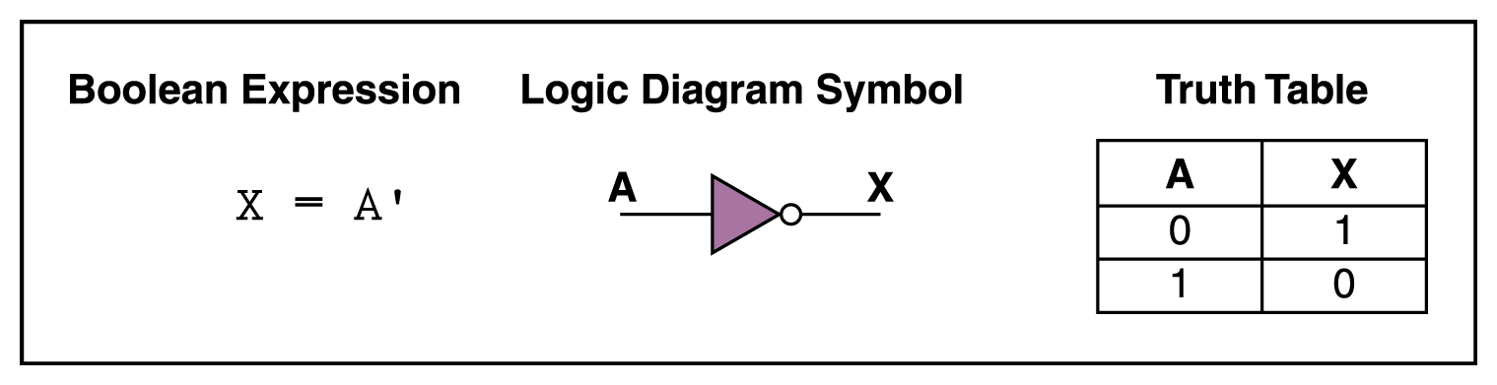 NOT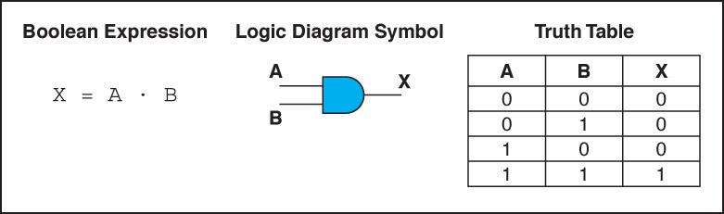 AND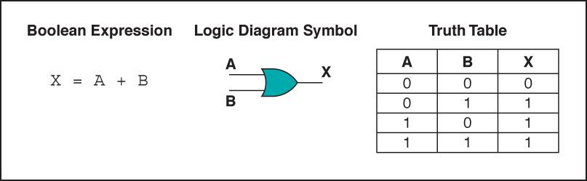 OR
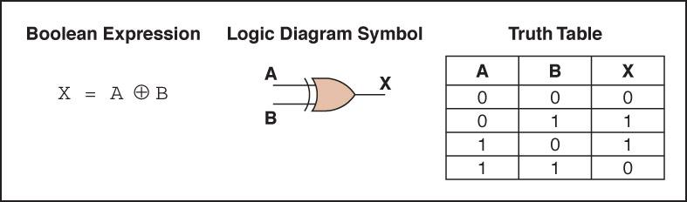 XNOR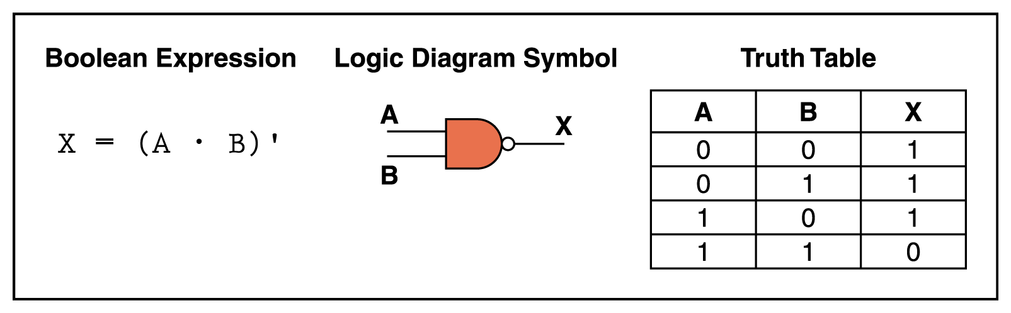 NAND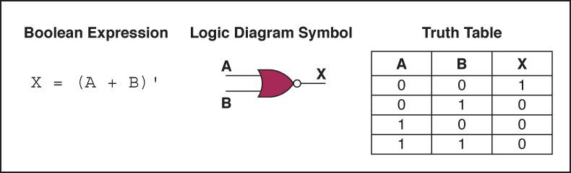NOR

Constructing Gates
Transistor
A device that acts either as a wire that conducts electricity or as a resistor that blocks the flow of electricity, depending on the voltage level of an input signal
- A transistor has no moving parts, yet acts like a switch It is made of a semiconductor material, which is neither a particularly good conductor of electricity nor a good insulator
Half adder
A circuit that computes the sum of two bits and produces the appropriate carry bit
Full adder
A circuit that computes the sum of two bits, taking an input carry bit into account

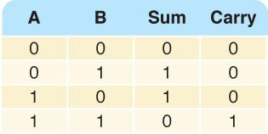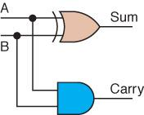
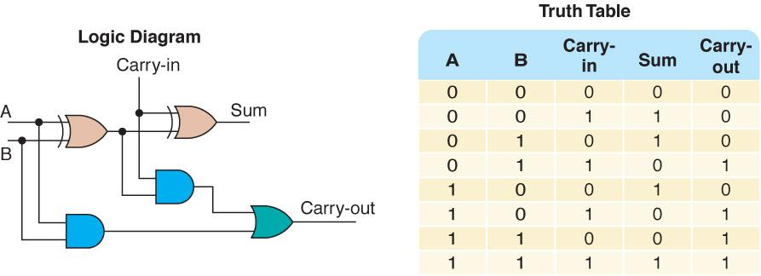
Multiplexer
A circuit that uses a few input control signals to determine which of several output data lines is routed to its output

Chapter 7
Problem solving
The act of finding a solution to a perplexing, distressing, vexing, or unsettled question
How do you solve problems?
- Understand the problem
- Devise a plan
- Carry out the plan
- Look back
Ask questions! Ask questions! Never reinvent the wheel! Divide and Conquer!
Algorithms Algorithm
A set of unambiguous instructions for solving a problem or subproblem in a finite amount of time using a finite amount of data Abstract Step
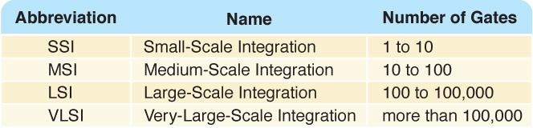

Abstract Step
An algorithmic step containing unspecified details
Concrete Step
An algorithm step in which all details are specified
Two methodologies used to develop computer solutions to a problem
Top-down design focuses on the tasks to be done
Object-oriented design focuses on the data involved in the solution (We will discuss this design in Ch. 9)
Summary of Methodology Analyze the Problem
Understand the problem!! Develop a plan of attack
List the Main Tasks (becomes Main Module)
Restate problem as a list of tasks (modules)
Give each task a name
Write the Remaining Modules
Restate each abstract module as a list of tasks
Give each task a name
Re-sequence and Revise as Necessary
Process ends when all steps (modules) are concrete
Control structure
An instruction that determines the order in which other instructions in a program are executed Can you name the ones we defined in the functionality of pseudocode?
Arrays
As data is being read into an array, a counter is updated so that we always know how many data items were stored
Sorted Arrays
The values stored in an array have unique keys of a type for which the relational operators are defined Sorting rearranges the elements into either ascending or descending order within the array
A sorted array is one in which the elements are in order
Sorting
Arranging items in a collection so that there is an ordering on one (or more) of the fields in the items
Sort Key
The field (or fields) on which the ordering is based
Sorting algorithms
Algorithms that order the items in the collection based on the sort key
Selection Sort
A slight adjustment to this manual approach does away with the need to duplicate space
- As you cross a name off the original list, a free space opens up
- Instead of writing the value found on a second list, exchange it with the value currently in the position where the crossed-off item should go
Bubble Sort
Bubble Sort uses the same strategy: Find the next item
- Put it into its proper place But uses a different scheme for finding the next item
- Starting with the last list element, compare successive pairs of elements, swapping whenever the bottom element of the pair is smaller than the one above it Bubble sort is very slow!

Insertion Sort
- If you have only one item in the array, it is already sorted
- If you have two items, you can compare and swap them if necessary, sorting the first two with respect to themselves.
- Take the third item and put it into its place relative to the first two
- Now the first three items are sorted with respect to one another
Subprogram Statements
We can give a section of code a name and use that name as a statement in another part of the program
- When the name is encountered, the processing in the other part of the program halts while the named code is executed
- What if the subprogram needs data from the calling unit?
Parameters
Identifiers listed in parentheses beside the subprogram declaration; sometimes called formal parameters
Arguments
Identifiers listed in parentheses on the subprogram call; sometimes called actual parameters
Recursion
The ability of a subprogram to call itself
Base case
The case to which we have an answer
General case
The case that expresses the solution in terms of a call to itself with a smaller version of the problem
Important Threads Information Hiding
The practice of hiding the details of a module with the goal of controlling access to it Abstraction
A model of a complex system that includes only the details essential to the viewer
Information Hiding and Abstraction are two sides of the same coin
Data abstraction
Separation of the logical view of data from their implementation
Procedural abstraction
Separation of the logical view of actions from their implementation
Control abstraction
Separation of the logical view of a control structure from its implementation
Identifiers
Names given to data and actions, by which – we access the data and
Read firstName, Set count to count + 1
– execute the actions Split(splitVal)
Giving names to data and actions is a form of abstraction Chapter 9
Object-oriented Design
A problem-solving methodology that produces a solution to a problem in terms of self-contained entities called objects
Object
A thing or entity that makes sense within the context of the problem
For example, a student, a car, time, date
World View of OOD
- Problems are solved by
- Isolating the objects in a problem,
- Determining their properties and actions (responsibilities), and
- Letting the objects collaborate to solve a problem
Class (or object class)
A description of a group of similar objects
Object (instance of a class)
A concrete example of the class
Classes
Contain fields that represent the properties (name, eye color) and behaviors (responsibilities) (shop, cook) of the class
Method
A named algorithm that defines behavior (shop, cook) Top-Down Design decomposes problems into tasks Object-Oriented Design decomposes problems into collaborating objects
Steps
- Isolate the real-world objects in the problem
- Abstract the objects with like properties into groups (classes)
- Determine the responsibilities of the group in interacting with other groups
Object-Oriented Design Methodology
- Four stages to the decomposition process
- Brainstorming to locate possible classes
- Filtering the classes to find duplicates or remove unnecessary ones
- Scenarios are tried to be sure we understand collaborations
- Responsibility algorithms are designed for all actions that classes must exhibit
- Brainstorming
- A group problem-solving technique that involves the spontaneous contribution of ideas from all members of the group
- All ideas are potential good ideas
- Think fast and furiously first, and ponder later
- A little humor can be a powerful force Brainstorming is designed to produce a list of candidate classes
- Filtering
- Determine which are the core classes in the problem solution
- There may be two classes in the list that have many common attributes and behaviors
- There may be classes that really don’t belong in the problem solution
- Scenarios
- Assign responsibilities to each class There are two types of responsibilities
- What a class must know about itself (knowledge responsibilities)
- What a class must be able to do (behavior responsibilities)
Encapsulation
- Bundling of data and actions in such a way that the logical properties of the data and actions are separated from the implementation details
- Each class encapsulates its data but shares their values through knowledge responsibilities
Responsibility Algorithms
The algorithms must be written for the responsibilities
- Knowledge responsibilities usually just return the contents of one of an object’s variables
- Action responsibilities are a little more complicated, often involving calculations
Translation Process
A program written in a high-level language must be translated into machine codes
Compilers High-level language
A language that provides a richer (more English-like) set of instructions
Compiler
A program that translates a high-level language program into machine code
Interpreter
A translating program that translates and executes the statements in sequence
- Assembler or compiler produce machine code as output, which is then executed in a separate step
- An interpreter translates a statement and then immediately executes the statement
Portability
The ability of a program to be run on different machines
Compiler portability
A program in a standardized language can be compiled and run on any machine that has the appropriate compiler
Bytecode portability
A program translated into Bytecode can be run on any machine that has a JVM
Programming Language Paradigms
Imperative Paradigm Program describes the processing Declarative Paradigm Program describes the results
- Each of these major paradigms have distinct subparadigms Imperative
- Procedural Characterized by sequential instructions
  - A program in which statements are grouped into a hierarchy of subprograms
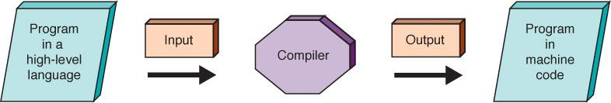

• Fortran, C, C++ – Object-oriented model
- Program consists of a set of objects and the interactions among the objects
- Python, Java, Smalltalk, Simula
- Functionality of Imperative Languages Sequence
- Executing statements in sequence until an instruction is encountered that changes this sequencing
- Selection
- Deciding which action to take
- Iteration (looping)
- Repeating an action
- Strong Typing Data type
- A description of the set of values and the basic set of operations that can be applied to values of the type
- Strong typing
- The requirement that only a value of the proper type can be stored into a variable
- Integer numbers Real numbers Characters Boolean values Strings
- Declarations Declaration
- A statement that associates an identifier with a variable, an action, or some other entity within the language that can be given a name; the programmer can refer to that item by name
- Reserved word
- A word in a language that has special meaning
- Case-sensitive Uppercase and lowercase letters are considered the same
- Assignment statement
- An action statement (not a declaration) that says to evaluate the expression on the right-hand side of the symbol and store that value into the place named on the left-hand side
- Named constant
- A location in memory, referenced by an identifier, that contains a data value that cannot be changed
- Input/Output Structures
Pseudocode algorithms used the expressions Read or Get and Write or Print High-level languages view input data as a stream of characters divided into lines Key to the processing
- The data type determines how characters are to be converted to a bit pattern (input) and how a bit pattern is to be converted to characters (output)
- name is a string; age is an integer; hourlyWage is a real
- The data must be a string, an integer, and a real in that order.
Control structures
An instruction that determines the order in which other instructions in a program are executed
Subprogram Statements
We can give a section of code a name and use that name as a statement in another part of the program
- When the name is encountered, the processing in the other part of the program halts while the named code is executed
Asynchronous processing
- Not synchronized with the program's action
- Clicking has become a major form of input to the computer
- Mouse clicking is not within the sequence of the program
- A user can click a mouse at any time during the execution of a program
- Functionality of OOPs Encapsulation
- A language feature that enforces information hiding
- Classes Inheritance
- A property that allows a class to inherit the data and actions of another class
- Polymorphism
- An ability to handle the ambiguity of duplicate names
- Object class (problem-solving phase)
- An entity or thing that is relevant in the context of a problem
- Object class (class) (problem-solving phase)
- A description of a group of objects with similar properties and behaviors
- Class (implementation phase)
- A pattern for an object
- Object ( implementation phase)
- An instance of a class
Different meanings in different places (See next slide)
Class Definition
Class encapsulates both data and actions
Inheritance and Polymorphism Inheritance
A construct that fosters reuse by allowing an application to take an already-tested class and derive a class from it that inherits the properties the application needs
Polymorphism
The ability of a language to have duplicate method names in an inheritance hierarchy and to apply the method that is appropriate for the object to which the method is applied
Inheritance and polymorphism work together
How?
They combine to allow the programmer to build useful hierarchies of classes that can be put into a library to be reused in different applications
Top-Down vs OO Designs Top-down Solution
Data structures needed in solution are determined Subprograms are written to manipulate the data structures
- Main program declares data structure
- Main program calls to the subprograms, passing data structures as parameters
Object-oriented Solution
ADTs needed in solution are determined ADTs are written only if not in library Data structure is encapsulated within the class that implements the ADT Main program is instructions to ADTs to perform the necessary tasks

Chapter 14
What Is Simulation?
A model of a complex system and the experimental manipulation of the model to observe the results
- Systems that are best suited to being simulated are dynamic, interactive, and complicated Model
An abstraction of a real system
- It is a representation of the objects within the system and the rules that govern the interactions of the objects
Continuous simulation
- Treats time as continuous
- Expresses changes in terms of a set of differential equations that reflect the relationships among the set of characteristics
- Meteorological models fall into this category
- Queuing system
- A discrete-event model that uses random numbers to represent the arrival and duration of events The system is made up of
- Servers
- Queues of objects to be served
To construct a queuing model, we must know
- The number of events and how they affect the system in order to determine the rules of entity interaction
- The number of servers
- The distribution of arrival times in order to determine if an entity enters the system
- The expected service time in order to determine the duration of an event
- Meteorological models
- Models based on the time-dependent partial differential equations of fluid mechanics and thermodynamics Initial values for the variables are entered from observation, and the equations are solved to define the values of the variables at some later time
- Computer models are designed to aid the weathercaster, not replace him or her
- The outputs from the computer models are predictions of the values of variables in the future
- It is up to the weathercaster to determine what the values mean
- Relocatable models
- Models applied to a moving target
- Computational Biology
- An interdisciplinary field that applies techniques of computer science, applied mathematics, and statistics to problems in biology
- Encompasses bioinformatics, computational biomodeling, computational genomics, molecular modeling, and protein structure prediction
- Graphics
- Originally the language of communications for engineers, designers, and architects
- Computer-aided design (CAD)
- A system that uses computers with advanced graphics hardware and software to create precision drawings or technical illustrations
Shape and surface influence an object’s appearance
- Equations used to describe planes, spheres, and cylinders
- Real world surfaces are rough, which scatter light differently, requiring texture mapping techniques
Illumination model
Simulation of light interaction at one point on an object
Shading model (shading)
Process of using an illumination model to determine the appearance of an entire object
Rendering
The process of creating an entire image
Computer Gaming Computer gaming is a simulation of a virtual world
Game designers must have knowledge of the following to make people, objects, and environments behave realistically in a virtual world:
- Computer graphics
- Artificial intelligence
- Human-computer interactions and simulation
- Software engineering
- Computer security
- Fundamentals of mathematics
- Laws of physics relating to gravity, elasticity, light, and sound
Gameplay
The type of interactions and experiences a player has during the game
Game genres, based on gameplay, include:
- Action games
- Shooter games
- Action-adventure games
- Life-simulation games
- Role-playing games
- Strategy games
Game engine
A software system within which games can be created Following functionality provided by tools of a game engine:
- A rendering engine for graphics
- A physics engine to provide a collision detection system and dynamics simulation
- A sound-generating component Additional functionality resulting from tools of a game engine:
- A scripting language apart from the code driving the game
- Animation
- Artificial intelligence algorithms (e.g., path-finding algorithms)
- A scene graph that holds the spatial representation in a graphical sense
Soft Skills
High Quality Game Design and Development Requires Effective Use of “Soft Skills”:
- Effective collaboration with designers, programmers, and artists on various technical ideas throughout the entire game design and development process
Game Programming
After all the design decisions have been finalized, programmers produce the code to create the virtual world of the game
- Popular languages include: C++, Java, and C Some well-established game engineers have created custom languages based on their games, e.g., Epic Game’s UnrealScript for the Unreal Game
- A variety of application programming interfaces (APIs) and libraries are available to help developers with key programming tasks
- The choice of API determines which vocabulary and calling conventions the programmer should employ to use the services
- The target game platform determines which service the programmer will use; some libraries permit efficient cross-platform development Coding process begins with the creation of “the game loop”
- Game loop is responsible for managing the game world, regardless of any input from the user
- For example, the game loop might update enemy movement in the game or check for victory/loss conditions
- Basically, the game loop manages the simulation Large design teams have different programmers focus on different aspects of the game
Thus, you might find yourself working as:
- A Junior Engine programmer writing and maintaining code for the game loop
- A 3D Software Programmer designing and implementing the 3D graphics component
- A User-Interface Programmer working on the APIs in the game engine
Collaborateing effectively is essential to creating a streamlined, “killer” computer game
- Collaboration and cooperation will be necessary because, despite beta testing and demoing, invariably bugs may begin to adversely effect the operation of the game
- If it is an online game you helped develop, you will be able to perform any fixes without having to interrupt the ongoing action or force the company to order a costly recall of the game

