Lec5
Chapter 6: Employee Selection

Importance of personnel selection

Productivity differences
- Productivity follows the Pareto distribution: 20% of the employees do 80% of the work
- As the number of employees increases, the level of productivity reduces
Price’s Law:
- Half of the work done in a creative domain is done by the square root of the number of people within it
- Out of 1000 scientists, the top 10 produce the same amount as the remaining 90
  - 10% of employees do 50% of the work
  - Scales with size: Out of 10,000, top 100 as productive as remaining 9,900!

*view slides 6-9
-Statistics – normal distribution
- 1 s.d. above the mean is the 84th percentile, 1 standard deviation below the mean is the 16th percentile.

Statistics – normal distribution
- 1 standard deviation ABOVE the mean is the 84th percentile: your score is higher than 84% of the pool
- For different types of work, they have different productivity differences even with 1 standard deviation. Ex. for unskilled/semi-skill labour, 1 s.d. above the mean is 19% productivity different from the mean, skilled work – 32%, managerial and professional: 48% productivity difference.
- Smaller % because for ex. unskilled work, doing routine task, not a lot of room for ability
- But as you have more complex position, there is a huge difference more $
- 1 standard deviation BELOW the mean is the 16th percentile.
- Unskilled & semi-skilled: 38%; Skilled work: 64%; Managerial & Professional: 96%
- For 1 worker that is 1 s.d. above the mean, equivalent to 2 workers’ productivity below 1 s.d. of the mean
- Financial gain to associate with productivity benefits, to hire someone at the 84th percentile has a higher financial gain for the company ($19,000/yr; $32,000/yr)
- Financial return accumulate quickly, employee selection makes a huge difference, because there is a huge productivity difference

Mistakes are expensive
- 40% of managers fail in the first 18 month
- Recruiting cost vary from 5-20% of yearly salary (when hire the wrong person, it can be difficult to fire them because of union legislation, or you have to recruit again, the entire selection, training process, cost time & $)
- Poor employees actually lower moral
- Training costs can be substantial

Selection Ratios
- The ratio of available positions to applicants
- Greater selectivity= greater benefit
- Most companies hire between 30-70% of applicants (a very low ratio)
- High unemployment= more applicants
- Great need for effective selection mechanisms

Evaluating Selection Methods
- Utility: the cost of a method should be less than the benefits of selecting a desirable employee
- Fairness: freedom from bias
  - Doesn’t discriminate against protected groups
  - “high stakes testing” debate in USA – many organization use the intelligence test
- Reliability: consistency in measurement across times and raters
- Validity: relation of measured attribute to desired outcome
  - You can have a very accurate result, unrelated to what you want to
  - Assess through correlation scatterplots
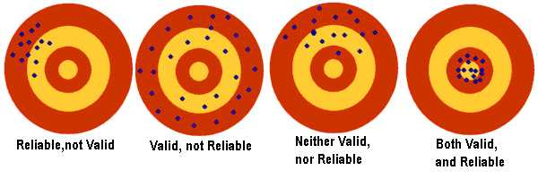
- Correlation: Coefficient between 0-1: 1 is high, 0 is none

Selection Methods
- Graphology: analysis of handwriting to infer personal characteristics
  - Developed in France, where it is used by 50% of all companies, and 80% of all organizational consultants
  - Cost up to 235 Euros per analysis ($350canadian)
  - Has 0 validity

- Canada: Unstructured interviews
  - Despite being the single most common employee selection technique, unstructured job interviews have very low reliability and validity
  - It can be very subjective, there is no actual relation to the job

Common Interviewer Errors
- Stereotyping and prejudice: disproportionately biased to the protected groups
  - Interviewer biases can have a profound effect on rating
- Overemphasis on Social fluency
  - Favours extraverts and narcissists
  - Introvert may not do well in the job interview, but can be potentially perform better than the extrovert
- Recency/Primacy error
  - Focusing too much on the applicant’s initial or most recent behaviour
- Similar-to-me error
  - Evaluation inflated because the candidate is similar to me
- Contrast error
  - Rating are biased by comparison with recent candidates
- Halo error: evaluations in one domain are automatically transferred to other domains

Why are interviews so popular?
- Allows for “personal touch”
- Interviewers overestimate themselves
- Lack of knowledge about empirical validity

Comparison of selection mechanisms
- 0 - no relation, 1 most related
- Low at the scale, they don’t predict very well about your job performance
- Personality!
- Highest to lowest: Cognitive ability, job tryout, biographical inventory, personality, ref check, experience, interview, training/experience ratings, academic achievement, interest, education

Best selection mechanism
- Cognitive ability – SATs, GREs, Ability/reasoning Test, IQ test
  - Ability to plan, reason, process information, and control behaviour
  - Cognitive ability is largely genetic (80%), but is influenced by environmental circumstances
  - *Single best predictor of workplace performance across all job categories
    - Predicts both performance and training ability
    - Supported by thousands of studies and 100+ years of research
    - The most robust study
  - Flynn effect? Every generation has an increase of about 50 IQ points on average because we’re exposed to rich environment, more access to technology and info

- Personality
  - Reflects stable individual differences in emotion, behaviour, and cognitive style
  - What make each of us a unique person is the personality
  - Motivational factors, integrity, task-focus
  - 2 people with the same level of intelligence doing the same task might have different results because of differences in personality
- Cognitive ability + Personality= Most powerful and efficient combination

Big Fiver Personality Traits
- 4,500 trait-descriptive adjectives in the English language
- Statistical analyses reveal 5 underlying factors that capture the overlap among these terms
- Factor structure has been replicated cross-culturally
- Extraversion
  - Sociable, gregarious, talkative
- Agreeableness (how friendly you are)
  - Cooperative, good-natured, softhearted, tolerant, trusting, nice people
  - Low agreeableness: selfish
- Conscientiousness
  - Achievement-oriented, hardworking, self-disciplined, careful, planning, organized, responsible
  - Low: lazy, spontaneous
- Openness to experience
  - Flexible in thought, open to new ideas, broad-minded, curious, original
  - Low: more concrete, down-to-earth
- Emotional stability
  - Stable: less stress, more secure
  - Unstable: depressed, angry, worried, neurosis, insecure

Why does personality matter?
- Job performance, job satisfaction, relationship status, economic well-being, political preferences, decision-making, physical health, social attitudes, sleeping habits, choice of words, body posture, emotional experiences, personal values, vocational interests, academic performance, creativity, belief in free will, Facebook activity

Personality and “fit”
- Every personality trait is associated with pros and cons
  - Strategic trade-offs are made at each level
- There is no such thing as a “bad” personality – only one that is not adapted to your current environment
- Person-Job “fit” reflects the selection of the right personality characteristics for the job at hand

Personality and performance
- Openness
  - Creativity and innovation
  - Investigative and artistic professions
- Conscientiousness
  - General workplace performance
- Extraversion
  - Sales and leadership ability
  - Social and enterprising professions
- Agreeableness
  - Team performance and customer service
  - Caring/helping professions
- Emotional Stability (inverse of neuroticism)
  - Stressful position

Personality Change
- Personality differences are relatively stable across the lifespan
- Self-transformation still happens, especially in response to major life events or transitions
- Similar patterns of personality change also occur across the lifespan
- According to the trend, after you are 20 your personality change is consistent

“Fake-proof” personality testing
- Choice between two desirable options:
  - Are you a hard worker or a compassionate person?
  - Are you a creative thinker or do you handle stress well?
  - Are you a fast learner or a good leader?
- Y-axis, correlation coefficient
*every rater has a unique bias
Classification Accuracy
- We never be certain about one way, but they are mostly accurate

Effective Size Comparison
- Combining personality and cognitive ability across job categories leads to an average validity coefficient of r = .65
- This is stronger than the vast majority of effects in the behavioural and medical sciences!
Relationship | Correlation
Smoking & lung cancer within 25 years | .08
Antihistamines and reduced congestion | .11
Ibuprofen and pain relief | .14
Unstructured interviews and job performance | .15
Personality + Cognitive Ability and job performance | .65
Financial Impact Example
- In a company of 100 employees with $50,000 average salary, financial impact of adopting valid selection tools:
- Improvements in validity (0.50) * productivity gain at 1SD (.48)
* Salary ($50,000) * number of employees (100)
= Yearly gain of $1,200,000!

- TELUS Example: 41,100 employees, average 16% productivity gain: $328,800,000
- 27.4% of net income

Summary:
- There are massive individual differences in performance and ability
- Valid selection mechanisms help to ensure that the best candidates are chosen

Lec6
Ch 7: Training and Development

- Economic growth is being driven by IT and human capital investment (education)
- Global cost of IT project failure: 6.2 Trillion every year
- Number one cause of IT project failure:
- Insufficient training

- Training: improving job-related competencies need to make sure ppl are flexible enough to adapt to new environments
- Development: preparing for future job responsibilities
- Training is short-term, development is long-term

Why train?
-Training is critical for long-range strategy
- Global competition and flatter organizational structures require multi- skilled employees
- Focus on lifelong learning: average employee works 4 different careers
- Diverse employees with varying cultural values
- people to interact with different culture, appropriate strategy, laws Relate to global training issues (last class)!

When should you train?
High Job Knowledge | Low motivation  -Examine the reward system | Systemic Problem  -Broader issues at play
Low Job Knowledge | Bad fit  -Consider moving employee from the position | Lack of knowledge  -Training!
 | Poor Employee Attitude | Good Employee Attitude

Training Failures
- 5$ billion in Canada
- 50$ billion in USA
- Almost half of this money is squandered on poor administration of training programs
- Systematic training, structured approaches are needed to ensure effectiveness
Systems approach to training:
- Universally-adopted training for developing and analyzing programs to ensure that they are effective
Phase 1. Needs assessment:
- Organization analysis: determine appropriateness of training by evaluating the characteristics of the organization, considers the org’s strategy, resources and management support
- Person analysis: process for determining individuals’ needs and readiness for training:
.Do performance deficiencies result from a competency gap?
.Who needs training?
.Are they ready for the training?
- Task analysis: identifies skills that training should emphasize, informed by job analysis and skill inventories

Phase 2: Designing the Program
Instructional Objectives: Clear Goals
- Elements of effectives instructional objectives
.Desired behavior/goal
.Standard
.Conditions
- Example: The trainee will splice six sets of wires -> need standard and condition
Standard: The trainee will splice, according to code, 6 sets of wires in 10 mins
Condition: while at the top of a telephone pole wearing a standard safety wire
- Readiness for Training
- Employee readiness characteristics
.Highly motivated to learn
.Can see potential benefits
.Have the necessary skillset
- Work Environment
- Situational Constraints:
.Ex: limits arising from lack of resources/time
- Social support
.Ex: Encouragement such as management and peer support
Principles of Learning
- Present information in memorable ways
- Break into chunks
- Include visual images

- Link content to trainees’ jobs
- Use familiar concepts, terms and examples
- Mirror the work environment as closely as possible- include physical and emotional elements
- Chance to practice and receive feedback
*NOTE: Issues related to workplace literacy

Kolb’s Experiential Learning Cycle
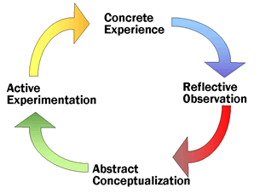
- The factory models school of education does not work. Students just accumulate knowledge.
- That is not the way how to mind works, not the way we process information bored
- ** We learn best when we are doing things, we are actively engage/participate (Concrete Experience) when you are participating you are engaging multiple level of your brains, then you will think about it
- Concrete Experience Reflective observation Abstract conceptualization Active experimentation

Characteristics of Successful Trainers
- Observant and listened to students
- Offer new and relevant information: delivering new information
- Charisma
- Enthusiast
- Encourage trainees: independent learning
- Sincerity
- Sense of humour
- Interest
- Clear instruction
- Individual assistance

Phase 3: Implementation
Choosing the instructional method
Classroom instruction: -most widely used training method
-Instructor leading a group
-Distance learning

Audiovisual learning: -Trainees work independently
-Uses videos, podcasts, workbooks
Computer-based training: -Likely to be interactive
-Electronic
-E-learning
- On-The-Job Training (OJT): -Apprenticeship, internship, cooperative education
- Simulations: Represents real-life situations, virtual reality
- Business games and case study; Help develop management skills, case studies, business games
- Behaviour modeling: demonstration of desired behaviour, opportunities to practice, learn by watching others
- Team training and Learning –Experiential program, adventure learning, cross-training, coordination training, action-learning, learn by doing work collaboratively

Phase 4: Evaluation
Criterion 1: Reactions
- Ask about Participant reactions
- The simplest and most common approach to training evaluation is assessing trainee’s reactions
- The potential questions might include the following
- What are your learning goals
- Did you achieve them?
- Suggestions to improve
- Should the organization continue to offer it?

Criterion 2: Learning
- Checking to see whether they actually learned anything
- Knowledge test before and after
- Testing knowledge and skills before beginning a training program gives abaseline standard on trainees that can be measured again after training to determine improvement.

Criterion 3: Behaviour
- Transfer of training
- Effective application of principles learned to what is required on the job
- Transfer training problem: people have the knowledge, but they are not transferring to their work performance
- Maximizing the ToT
- Feature identical elements
- Focus on general principles
- Establish a climate for transfer
- Give employees transfer strategies

Criterion 4: Results ROI (Return on Investment)
- Utility of Training Programs
- Calculating the benefits derived from training
- How much did quality improve
- How much has it contributed to profits
- What reduction in turnover and wasted materials did the company get after training
- How much has productivity increased, and by how much has cost reduced?

ROI: Rotman Commerce
- High school diploma: 28,502
- Undergrad degree: 66,605
- Yearly ROI: 38,103
- Total (35 year career): 1,333,605
- Rotman Commerce Tuition: 40,000
- Rotman commerce class time: 960 hours
- Every 1 dollar invested in tuition= 33.3 ROI
- Every 1 hour in the classroom: 1389 ROI
- For every 1$ invested in tuition, the government pays 2$

Costs and Benefits to training
Costs | Benefits
-Trainer’s salary + time  -Trainee’s salary + time  -Materials for training  -Expenses for trainers/trainees  -Costs of facilities/equipment  -Lost productivity (opportunity cost) | -Increases in production  -Reduction in errors/accidents  -Reduction in turnover  -Less supervision necessary  -Attitude changes  -Ability to use new capabilities
-Must balance them in your organizational strategy
-When and what is a good training idea

Training Evaluation: experiment Design Issues
- Hawthorne Effect: attitude changes when you know you are being watched
- Pygmalion effect: form of self-fulfilling prophecy, behavioural confirmation (the greater the expectation placed on people, the better they will perform)
- Placebo effect: just believing that something will happen increases the likelihood of it happening

Summary:
- Proper training ensures efficient use of employee abilities.
- Develop your employees to increase their potential for future value.

Lec6:
Chapter 8: Managing Performance

Ensure that employees’ activities and outputs match the organization’s goals
Requires effective performance appraisal

Administrative Functions | Developmental Functions
-Document personnel decisions  -Determine promotions candidates  -Determine Transfers & assignments  -Identify Poor performance  -Decide Retention or termination  -Decide layoffs  -Validate selection criteria  -Evaluate training programs/progress  -Meet legal requirements  -Personnel planning  -Make reward/compensation decisions | -Provide performance feedback  -Identify individual strengths/weaknesses  -Recognize individual performance  -Assist in goal identification  -Evaluate goal achievement  -Identify individual training needs  -Determine organizational training needs  -Reinforce authority structure  -Allow employees to discuss concerns  -Improve communication  -Provide a forum for leaders to help
Performance Appraisal and other HRM Functions
-Recruitment: Reveals effectiveness of recruitment efforts
-Selection: validates selection function
-Training and Development: determines training needs
-Compensation Management: factor in determining pay
-Labour Relations: justifies personnel actions

What is job performance?
-Task performance
:Output, efficiency, and productivity
-Citizenship performance
:Compliance, loyalty, altruism, peer-support, courtesy

Counterproductive performance:
:Theft, absence, lateness, loafting, bullying, sabotage

Importance of Measurement:
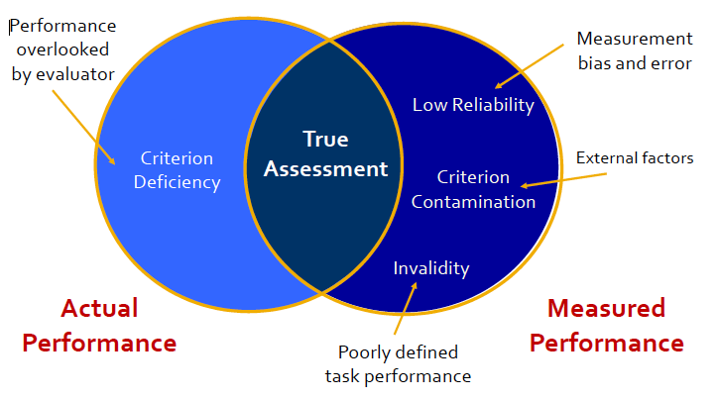

Common Rater Errors
Rater Error | Practical Impact
-Varying Standards  -Recency and Primacy Effects  -Central tendency, leniency and strictness errors  -Rater bias  -Halo and Horns effect  -Contrast error  -Similar to me/different than me error  -Sampling errors | -Similar performances are rated differently  -Timing of information affects the rating  -Everyone is rated the same  -Rater values or prejudices affect ratings  -Generalizations made from one trait  -Comparisons made to other ppl, not to performance standards  -Rater compares employees to self  -Available information is insufficient or inaccurate

Who should appraise?
-Manager/supervisor appraisals
-Self-appraisals
-Peer appraisals
-Subordinate appraisals
-Customer appraisals
-Superiors
-Suppliers
-Team members
-Subordinates
-Vendors
*360 degree assessment

Types of Assessment
1-Trait-based:
.Attitudes
.Initiative
.Creativity
2-Behaviour-based
.Verbal persuasion
.Timeliness of response
.Decision-making
3-Results-based
.Sales-made
.Customer satisfaction
.Cost reduction

Less useful More useful
Graphic Rating Scale:
1-Unsatisfactory: performance is well below standard. Whether the person can meet the minimum standards is questionable
2-Below expectation: performance is somewhat below min standards. Potential to improve within a reasonable time frame is evident
3-Meets expectations: performance is at or above min. Expected performance from experienced, competent employees
4-Exceeds expectations: performance is better than average for the unit, given the common standards and unit results
5-Outstanding: the person is so successful at this job criterion that special note should be made, and performance ranks the top 10%

Mixed Standards Scale
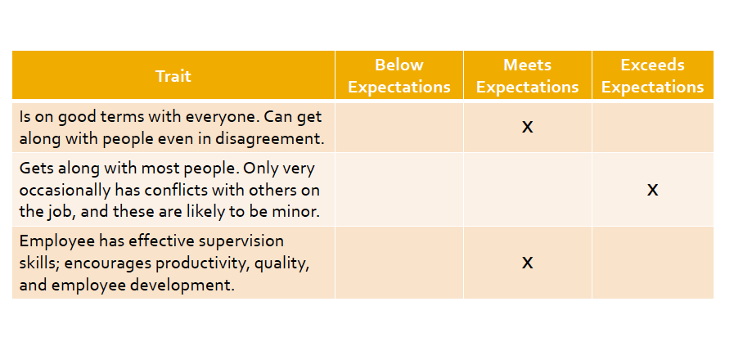

Paired Comparison Method:
-Each employee and job are compared to others

Employee ranking:
-Ranking employees from best to worse

Forced distribution:
-Requires managers to categorize individuals into categories with a fixed number of spots in each category
-Creates competition
-May not reflect true performance

Assessment: Trait Methods
-Advantages
.Inexpensive to develop
.Easy to use
-Disadvantages:
.High potential for rating errors and bias
.Not useful for employee feedback
.Not useful for allocating rewards/promotions

BARS: Behaviourally Anchored Rating Scale
-By anchoring a quantified scale with specific narrative examples of good, moderate, and poor performance.^{[1]}
-1: Unsatisfactory, 3: Satisfactory, 5: Outstanding

Behavioural Observation Scale
-Never Always

Critical Incident Method
-Managers maintain record for all incidents in which the employee excelled or failed to meet expectations

Electronic Monitoring:
-Internet use, computer use, email use, cellphones, telephones, instant messaging, cameras
-Supreme Court of Canada (2012) ruled that employees have “reasonable expectation of privacy” on their work computers
-Employers can face up to $20,000 in damages for mooting email or Internet use
-Only allowed when proved as “necessary precaution” with no alternatives

Assessment: Behavioural Methods
-Advantages
.Uses specific performance dimensions
.Are useful for providing concrete feedback
.Are fair for reward and promotion decisions
-Disadvantages:
.Can be time-consuming to develop/use
.May not capture full range of relevant activities
.Have some potential for rating error
.Require extensive supervision

Measuring results
-Quantitative measures of desired results
.Sales, productivity, costs, etc.
.May suffer from criterion contamination
.Danger of overemphasizing short-term results

No child left behind
-Passed into law by George Bush in 2001
-Schools and teachers are meant to be held more accountable for the performance of their students on standardized tests
-Results:
.Teaching to the test
.Widespread cheating by teachers

Management by Objectives
-Goals are set by employees and managers
-Performance assessment is focused on the extent to which the employee achieved these goals
-“What gets measured gets done”
-Goals should be
.Specific
.Measurable
.Achievable
.Timed
.Relevant

Balanced Scorecard:
- Performance measurement framework that added strategic non-financial performance measures to traditional financial metrics to give managers and executives a more 'balanced' view of organizational performance.
-David Norton & Robert Kaplan

Assessment: Results Methods
-Advantages:
.Have less subjectivity bias
.Are acceptable to employees and superiors
.Link individual to organizational performance
.Encourage mutual goal setting
.Are good for reward and promotion decisions

-Disadvantages:
.Are time-consuming to develop/use
.May encourage short-term perspective
.May use contaminated or deficient criteria

Sources of Performance
-Ability:
.Technical skills
.Interpersonal skills
.Problem-solving skills
.Analytical skills
.Communication skills
.Physical limitations
-Motivation:
.Career ambition
.Employee conflict
.Frustration
.Fairness/satisfaction
.Goals/expectations
-Environment:
.Equipment/materials
.Job design
.Economic conditions
.Unions
.Rules & policies
.Management support
.Laws and regulations

Improving Performance:
-Ability, motivation, environment vs Competency, behaviour, results
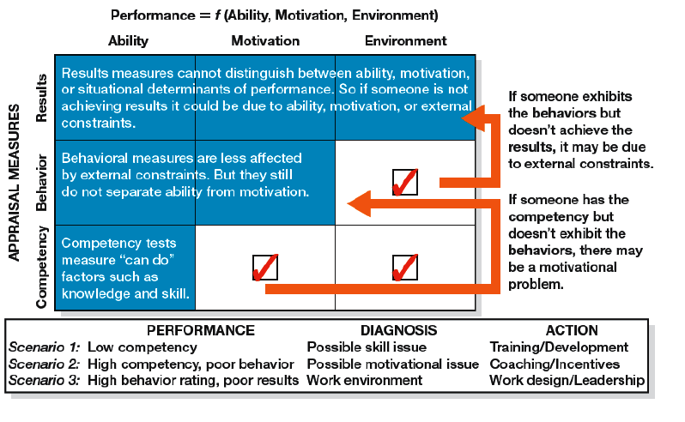
Appraisal Interviews

Do’s | Don’ts
-Prepare in advance  -Focus on performance and development  -Be specific about reasons for ratings  -Decide on specific steps to be taken for improvement  -Consider supervisor’s role in employee’s performance  -Reinforce desired behaviours  -Focus on future performance | -Do all the talking  -Lecture the employee  -Mix performance appraisal and salary or promotion issues  -Concentrate only on the negative  -Be overly critical or “harp” on a failing  -Get personal  -Compare with other employees
Legal Concerns
-Illegal discrimination
.Claims often allege discrimination on the basis of one of the protected grounds
-Unjust dismissal
.Claims that the person was dismissed for reasons besides those stated by the employer
-Psychological harassment
.Performance feedback goes beyond “Reasonable criticism”

Legally Defensible Performance Assessment System
-Objective performance appraisal criteria based on job analysis
-Absence of indirect discrimination and evidence of validity
-Formal evaluation criteria that limit managerial discretion
-A rating instrument linked to job duties and responsibilities
-Documentation of the appraisal activities
-Personal knowledge of and contact with the appraised individual
-Training of supervisors in conducting appraisals
-Review process to address disagreements and issues
-Counseling to help poor performance improve
Summary:
-Performance appraisal must be matched to the goals of an organization
-Accurate measurement and appropriate feedback are keys to success

Lec7: Chapter 9 & 10: Compensation + Rewards

Pay: is a quantitative statement of an employee’s worth by an employer
-Affects the perceived value of work to employees

Strategic Compensation Goals
-Reward past performance
-Remain competitive in the labour market
-Maintain salary equity among employees
-Align employees’ performance with organizational goals
-Attract new employees
-Reduce unnecessary turnover

Total Compensation=
Direct Compensation | Indirect Compensation
-Wages/salaries  -Commissions  -Bonuses  -Gainsharing: an incentive plan in which employees or customers receive benefits directly as a result of cost-saving measures that they initiate or participate in.  "the company's gainsharing program ties bonuses directly to team performance" | -Time not worked: Vacation, breaks, holidays  -Insurance plans: medical, dental, life  -Security plans: pensions  -Employee services: educational assistance, recreational programs
Compensation Costs
- Base pay 62%
- Benefits 20%
- Incentive plans 8%
- Pension & stock purchase plans 6%
- Learning & development 2%
- Restructuring and other initiatives 2%

Job Evaluation
-What is the value of a job to an organization?
-Job ranking
-Job classification
-Wage surveys
-Points system

Points Method
-Attempts to quantify the difficulty and value of a given position on multiple dimensions
-Ex: Job, Skill, Effort, Responsibility, Conditions, Total.
Wage Curve
-Points value on X axis, Wage rates on Y axis
-Wage increases with points
-People who are over the line they are over compensated
-People are below the line are under compensated: based on their point values, they should be right on the line and have higher compensation
-Dots not on the line: they are not compensated appropriately base on their performance

Pay Grades: simplified version of the wage curve
-Staircase-like graph (stepwise function)
-Grades min start at 150 points, 50 points is the range for each grade
-For each grade, the wage rate is the same, but after you pass the threshold, you will receive a higher compensation.
-Fixed framework of salary ranges
-Limitations:
.Within a given job, everyone is going to have the same point value, but what happens if one person is more experienced? Or performs better? Pay Ranges
-Pay Ranges allow vertical mobility within the given wage rate. There is an increase within the category.
-Once you hit the ceiling that will be your highest salary rate, include external factors. You will only get a higher salary if you are promoted or get higher points.

Equity Pay fairness
-Equity: pay seems fair - my outcomes/inputs = your outcomes/inputs
-Inequity: pay seems unfair – My outcomes/inputs > your outcomes/inputs
-But you can get negative consequences when you are over compensated, you might start to feel guilty
-Imposter syndrome: sinking feeling you get when you are not convinced that you deserve this much pay for what you are doing, or more than someone else in the same role

Small Group Discussion - Case: Awarding Salary Increases
-Very different compensation structure across different groups. This is what happens in reality that you are facing a lot of things strictly not based on performance based, you have the performance based information, citizenship information, extenuating circumstances, initial salary discrepancy.
-There is no perfect solution to apply for the situation.
-Fairness is subjective not objective so managers can be sued for discrimination

Economic Influences on Pay
-Benchmarking and wage surveys: “external pay equity”
-Pressure to reduce wages: global competition
-Pressure to increase wages: attractive better human resources

Government Regulation
-Canadian Labour Code:
.Minimum labour standards for all employees falling within federal jurisdiction
-Ontario Employment Standards Act:
.Child labour (14); maximum work week (48 hours), overtime rate= 1.5x normal (over 44 hours)
-Pay Equity:
.Fair employment practices applied to members of designated groups, regulated provincially.

Incentive Rewards
-Performance-based pay
Expectancy Theory:
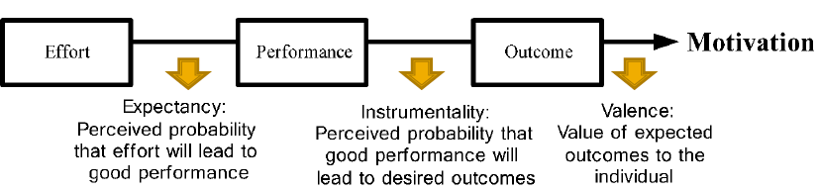
Variable Pay Programs:
-Cash bonus/incentive
-Profit-sharing
-Gainsharing
-Team-based incentive
-Other

Incentive for Individual Performance
-Piecework rates: worker is paid a fixed piece rate for each unit produced or action performed regardless of time
-Standard hour plans
-Merit pays: gets to compound every year with % increase
-Performance bonuses: one time lump sum
-Sales commissions

Incentive Pay for Group Performance:
-Gainsharing plans:
.Scanlon Plan: program in which employees share in pre-established cost savings, based upon employee effort.
.Improshare: Group incentive plan aimed at reducing the cost of production. Workers share a fixed percentage of the savings resulting from production costs coming lower than a pre-established standard cost.
-Team bonuses & rewards

Incentive Pay for Organizational Performance
-Profit sharing:
.Distributing extra profits with employees
.Ex: Alberta “prosperity bonus” of $400 in 2006
-Stock ownership
.Employee stock ownership plan (ESOP)
.Stock options

Executive Compensation
-Canada’s top 100 companies (2010)
-Average CEO Base Salary:
.$938,995
-Average CEO total pay:
.$6,000,000

CEO To Worker Compensation
CEO To Performance-Based Pay:
-Graph basically shows no correlation between company performance and CEO compensation
-Incentive base pay does not exist for the executives, because they get millions of dollar from the stocks.

CEO Fraud:
-Do stock options incentivize risk-taking and accounting fraud?

Rewards and Intrinsic Motivation:
-Excessive monetizing of performance may actually undermine intrinsic motivation
-Intrinsic motivation: doing something you enjoy
- Extrinsic motivation: only does it because someone is providing you external reason
- The literature suggest that if you initially going into something because you really love your job, then when you are tied into incentive-based pay, you will lose some of your passion.
.Ex. You love to play piano, play it for free, then one day someone approach, you get pay to do what you love, continuously. You have the connection that you are doing it for the money over- justification: when you passion is associated with money, that can override your intuitive desire.
- *Be careful not to demotivate people, unintentionally by getting them too hooked on money. Focusing too much on money makes employee less happy, less effective.

Employee Recognition Programs
-You want to incentivize your employees, but you don’t want them to be thinking about money all the time employee recognition program other ways of giving compensation
1. Certificate/plaques
2. Cash
3. Company logo merchandise
4. Gift certificates for products/items
5. Jewelry
6. Office accessories
7. Household items
8. Recreational item/sporting goods
9. Electronics
10. Gift certificate for personal services
11. Travel
12. Timepieces

Summary:
- Compensation is a key source of rewards and motivation for employees.
- Compensation should be tied to desired outcomes and organizational strategy.

Lec8: Chapter 14: Collective Bargaining + Labour Relations

York University Strike:
-CUPE 3903: contract professors, TAs and graduate assistants
-Key issue: job security
-Strike began Nov 6, 2008
-Disruption for 50,000 students
-Provincial government mandated back to work legislation on Jan 24, 2009

City of Toronto Strike
-24,000 employees strike on June 22, 2009, following six months of negotiations
-Key Issues: Job security, banking of sick days
-Disruptions of garbage collection, health inspections, parks and recreation
-Agreement reached 39 days later
-Toronto saved $33.2 million

Role of Unions and Labour Relations
-Unions are organizations formed for the purpose of representing their members’ interests in dealing with employers
-Labour relations is the field that emphasizes skills managers and union leaders can use to minimize costly forms of conflict and seek win-win solutions to disagreements

Why Unionize?
-Job dissatisfaction
-Lack of job security
-Unfair administration of policies
-Perceived inequities in pay
-Lack of opportunity for advancement
-Lack of influence on work-related decisions
-Dissatisfaction with pay, working conditions

Types of Unions
-Craft unions:
.Members all have a particular skill or occupation
.e.g. electricians, plumbers
-Industrial unions:
.Members are linked by their work in a particular industry
.Eg: Canadian Auto Workers
-Local Unions:
.Where most day-to-day interaction between labour and management occurs
-National/International unions:
. Association that seeks to advance the shared interests of members
.e.g. CLC, AFL-CIO

Largest Unions in Canada: view slides

Union Membership Across Sectors:
1. Education
2. Public Admin
3. Utilities
4. Health & Welfare
5. Transportation
6. Forestry/Logging
7. Construction
8. Manufacturing
9. Mineral, Oil & Gas Extraction
10. Fishing, Hunting & Trapping
11. Financial, Insurance, Real Estate
12. Agriculture

Union Density by Province
1. Alberta
2. Ontario
3. P.E.I.
4. New Brunswick
5. Nova Scotia
6. Saskatchewan
7. B.C.
8. Manitoba
9. Newfoundland
10. Quebec

Union Membership by Country
1. Sweden  2= Denmark  2= Finland  4. Norway  5. Belgium  6. Ireland  7. Austria  8. Italy | 9. Canada  10. UK  11. Germany  12=Australia  12= Netherlands  14= Switzerland  14= New Zealand  17. US  18. France
History and Trends
-Industrial revolution and mistreatment of workers
-Labour unions in Canada since 1812
-Toronto Typographical Strike in 1872 for 9-hour workday
-Winnipeg General Strike in May 1919 – 30,000 workers
-Collective bargaining recognized in 1937
.Enshrined as human right by Supreme Court in 2007
-Erosion of union power throughout the ‘80s
.Reagan, Thatcher, Mulroney
-Globalization, demographics, and attacks on unions
Canadian Labour Laws: Key Mandates
-The right of employees to form, join, and participate in a union
-“Bargaining in good faith” by both union and management
-Requires collective agreements be in force for at least one year
-Prohibition of strikes or lockouts during collective agreement
-Mandatory conciliation process before a strike or lockout
-Disputes over matters arising from interpretation of the collective agreement be settled by final and binding arbitration
-Prohibition of certain specified “unfair practices”

Unfair Labour Practices:
Management | Unions
-Interfering in the formation of a union or contributing financially  -Discriminating based on union membership because employee exercises rights  -Intimidating or coercing an employee into joining/not joining | -Trying to bargain when the union is not the certified agent  -Persuading employees during working hours or at the workplace  -Illegal strikes  -Failing to represent employees fairly

Impact on Company Performance
-Decrease productivity?
.Due to work rules and limits on workloads set by union contracts
.Production lost to union actions, e.g., strikes
.Higher wages, benefits
.Increase productivity?
.Reduced turnover
.Seniority-based pay systems encourage cooperation
.Forces employer to improve management practices and listen to employees’ ideas

Collective bargaining:
-is the negotiation between union and management representatives to arrive at an agreement defining conditions of employment

Union Power in Collective Bargaining
-Striking: work stoppage caused by the mass refusal of employees to work
-Boycotting: withdraw from commercial or social relations with (a country, organization, or person) as a punishment or protest.
-Picketing: Picketing is a form of protest in which people (called picketers) congregate outside a place of work or location where an event is taking place. Often, this is done in an attempt to dissuade others from going in ("crossing the picket line"), but it can also be done to draw public attention to a cause

Employer Power in Collective Bargaining
-Management methods for applying economic pressure during bargaining
Operating during strike
Locking out workers
Hiring replacement workers where allowed
Stock piling goods

Trends in Strikes & Lockouts
-Graph shows decreasing trend in number of hours lost due to labour disputes in Canada 1976-2010

Resolving Conflicts
-Mediation:
.Least formal
.Facilitate the negotiation
.No formal authority for resolution
-Conciliation:
.Report views of both sides
.May recommend settlement but parties may decline
-Arbitration:
.Most formal intervention
.Determines a binding settlement

Typical Provisions of Collective Agreements
- Union recognition  - Management rights  - No strike/lockout  - Unions security  - Union representation  - Grievance procedure  - Discharge and discipline  - Term of agreement  - Arbitration  - Seniority  - Probationary period | - Layoff  - Hours of work and overtime  - Restrictions contracting out  - Technological change  - Discrimination  - Severance pay  - Successor rights  - Salary  - Benefits  - Holidays

Union Avoidance Strategies:
-Union Suppression
.Fighting union representation
.Ex: Employer intimidates workers, threatens to close operations
-Union Substitution
.Examines what unions bring to the employment relationship and tries to introduce these features
.Advocated by many HR practitioners, consultants, and labour lawyers

Labour-Management Cooperation
-Wider acceptance that greater cooperation (rather than adversarial approach) is beneficial
-Employee involvement in decision-making
-Effective day-to-day relationship
-Self-managing employee teams
-Joint labour-management committees
-Treat employees with respect & fairness

Summary:
-Collective bargaining allows workers to gain more power over their working conditions.
-Collaborative approaches to employee well-being and organizational goals can reduce conflict

Lec10: Chapter 15: Managing Human Resources Globally
Culture:
-The set of shared attitudes, values, goals and practices that characterizes a social group
Any different way of perceiving/interpreting the environment
-Allows us to generate new ideas
-Multicultural individuals: more creative, multiple perspectives simultaneously

Quantifying Culture;
-Geert Hofstede: 5 cultural dimensions
1. Individual vs Collectivism
2. High power distance vs lower power distance
3. High uncertainty avoidance vs low uncertainty avoidance
4. Masculinity vs feminity
5. Long-term orientation vs short-term orientation
Hofstede’s Framework
Power Distance
-The extent to which a society accepts that power in institutions and organizations is distributed unequally
-Low distance:
- Relatively equal power between those with status/wealth an dhtose without
Ex: Ireland
-High distance:
- extremely unequal power distribution between those with status/wealth and those without
Ex: Russia

Individualism:
-the individual is emphasized as the focus of society/the root of all action
Ex: USA
Collectivism:
-A tight social framework that emphasizes interdependence between people
Ex: china

Masculinity:
-the extent to which a society reinforces traditional differentiation between male/female gender roles
-Masculinity
.High levels of gender differentiation. Males tend to dominate the power structure
.Ex: Japan
-Femininity
.Greater gender equality
.Ex: Norway
Uncertainty Avoidance:
-The extent to which a society feels threatened by uncertain and ambiguous situations and tries to avoid them
-High uncertainty avoidance:
.Rule-oriented society that is focused on well-defined laws, regulations and controls
.Ex: Greece
-Low uncertainty avoidance
.More open to social change, experimentation, and risk-taking
.Ex: Sweden
Time Orientation
-Long-term orientation:
.A national culture that emphasizes thrift, persistence, and the future
.Ex: South Korea
-Short-Term Orientation: A national culture that emphasizes the here and now
.Ex: UK
view chart
Recruitment and Selection
-Expatriates or Home-country nationals
. Employees from the home country who are on international assignment
+most familiar with ur company culture/practices
-Least familiar with what is going on in that new cultural environment

-Host-country nationals
-employees who are natives of the host country
+familiar with home country, knowing appropriate decisions there
-less familiar with your corporate culture

Third-country nationals: Employees who are natives of a country other than the home country or the host country
*Must have effective training: culture, language, framework
Training and Development
-Language and cultural training is critical
.Prepare for assignment and avoid misunderstandings
.Repatriation training is also essential
.Unwritten rules are the most important
-Organizational values need to be explicit

Performance management
-What should be measured?
:Different standards of behavior
Ex: Russian McDonald’s : based on how much they smiled
-Who should rate employees?
:HQ vs Host ratings
:Alignment with power distance
-Individual vs Group Level Appraisals

Compensation Stats
Labour Relations:
-International Differences in Unions:
-The level at which bargaining takes place
.National, industry or workplace
-The degree to which gov’t intervenes
-The degree of employee representation
International Trade Unions
-International Confederation of Free Trade Unions
.125 million members across 145 countries
.International Labour Organization (U.N. Agency)

Why do international assignments fail?
-Culture shock: frustration and poor cooperation abroad
-Family problems: poor adjustment or lack of family contract
-Career blockage: the home office has forgotten about me (disadvantage: out of sight out of mind)
-Overemphasis on the technical qualifications

Qualities associated with success in foreign assignments
-Competency in area of expertise
-Ability to communicate
-Flexibility and tolerance for ambiguity
-Sensitivity to cultural differences
-Motivation to succeed
-Enjoyment of challenges
-Willingness to learn
-Support from family members
Summary:
-Globalization introduces unique challenges for HR professionals.
- Cultural knowledge and sensitivity is critical for
effective cross-border personnel management.

