GMS Midterm#1 Notes
Chapter #1
Why Study Operation Management?
- Large percentage of a company’s expenses occurs in the operations area, such as purchasing materials and workforce salaries, more efficient operations.
- Large number of management jobs are in operations management- areas such as purchasing, quality, assurance, production planning and control, scheduling, logistics and many more
- Activities in all of the other areas of business organizations such as finance, accounting, human resources, management information systems and marketing are all interrelated with operations management.
Three Basic Functions Within Organization
- A typical organization has three basic functions: operations, finance, and marketing.
- These three functions and other supporting functions perform different but related activities necessary for the operation of the organization.
- Interaction between functions is key in achieving goals
- Finance provides the needed funds to operations and marketing provides the products to produce and the amount to produce based on demand.
- Operations
- This function performs all the activities directly related to producing goods or providing services.
- This function is responsible for the creation of an organization’s good and/or services.
- Inputs are used to obtain the finished goods, transformation/conversion processes (is the process in which value is added ex. transporting, storing and cutting), then comes the Output
- Feedback is taken at various points to be compared to previously established standards to ensure everything is running smoothly
- Finance
- Provision of Funds: the necessary funding of operations and the amount and timing of funding can be important and even critical when funds are tight.
- Economic analysis of investment proposals: Evaluation of alternative investments in plant and equipment requires inputs from both operations and finance people.
- Budgeting: plan financial requirements, including adjustments and evaluations.
- Marketing
- Is responsible for assessing customer wants and needs, and for communicating those needs and feedback to operations people and to product design people.
- Marketing, design and production must work closely together to successfully implement design changes and to develop and produce new products.
- Marketing needs to know the lead time (the time between ordering a good or service and receiving it) so that it can give the customers a realistic time for when it can fill its orders.
Other Functions
- These are supporting functions
- Accounting: supplies info to management on costs of labor, materials and etc. as well as creates financial statements.
- MIS: providing management with the info it needs to effectively manage.
- Purchasing: close contact with operations is necessary to ensure correct quantities and timing of purchase.
- Personnel or human resource: concerned with employees
- Manufacturing engineering: design/purchase of machines
- Maintenance: general upkeep and repair of equipment, buildings and etc.
- Product design: engineers who design products
- Logistics: transportation of raw materials, finished products and etc.
The Scope of Operations Management
- Primary function of operations management is to guide the system by decision-making. Thus, OM is….
- OM: The Management of processes or systems that create goods and/or provide services.
- Decisions affect two areas of Operations which are the Design and the others are operational
- Design decisions: strategic and long term (1-5 years ahead).
- Operational decisions: short term (1-12 weeks ahead)
- System design: involves decisions that relate to product and service design, such as geographic location of facilities, arrangement of departments and etc.
- Operational Activities: involve management of personnel, inventory planning and control, production planning, scheduling, project management and quality assurance.
The Operations Manager’s Job
- He or she has the ultimate responsibility for the creation of goods or performance of services.
- The kind of jobs that an operations manager oversee vary tremendously from organization to organization largely because of the different products or services involved. ( look at slide 27)
- The chief role of an operations manager is that of a decision maker.
- Operation manager exerts considerable influence over the degree to which the goals and objectives of the organization are realized.
Operations Managers and decision-making
- Models: is an abstraction of reality, a simplified representation of something. Models ignore the unimportant details much of which is irrelevant for any particular problem.
- Quantitative Approaches: to obtain optimum solutions to the mathematical models of managerial problems. Ex. Linear programming, queuing techniques, project scheduling techniques and etc.
- Analysis of Trade Offs: heuristic approach in which managers list the pros and cons of each action and choose the one that is the best.
- Systems Approach: emphasizes interrelationships among parts . hence from a systems viewpoint, the output and objectives of the organization as a whole take precedence over those of any one part.
- Establishing Priorities: in every situation certain elements are important than others. Recognizing this fact of life enables the managers to direct their efforts to where they will do the most good and to avoid wasting time and energy
- Ethics: managers have responsibility to make ethical decisions such as worker safety , product safety , the environment, closing facilities.
This Historical Evolution of Management
- Earliest Days
- Goods were produced using craft productions( system in which highly skilled workers use simple, flexible tools to produce small quantity of customized goods)
- Craft production was slow and costly, no economies of scale
- Mercantilism occurred in Canada where raw materials were extracted from here and sent to Europe to be manufactured.
- Industrial Revolution
- The steam engine and power to operate machines in factory the advancements of machines from wood to iron allowed for large-scale production.
- Division of labour: Breaking up a production process into small task so that each worker performs a small portion of the overall job.
- Interchangeable parts: Parts of a product made to such precision that they do not have to be custom fitted.
- Scientific Management: this ear brought widespread changes to the management of factories. This method emphasized maximum output management team was only responsible for planning, training and workers were responsible for actually doing the work.
- Mass Production: Introduced by For was a system in which lower skilled workers use specialized machinery to produce high volumes of standardized goods.
- The human Relation
- The previous scientific method made workers work like robots this new human relations movement emphasized the importance of human element in job design.
- Motivational theories started arising by ( Abraham Maslow)
- Giving special attention to workers increased productivity
- Decision Models and Computer
- The development of several quantitative techniques
- The excess pressure placed on refining quantitative tools resulted in decision models for forecasting, production planning, project management and other areas of management.
- 1980s network computing began to increase with the applications such as electronic data interchange
- more and more business are using enterprise resources planning
- The Influence of Japanese manufacturers
- Ways of the Japanese adapted by others was total quality management and lean production.
- Total Quality Management: involving every employee in a continual effort to improve quality and satisfy the customer
- Lean production: System that uses minimal amounts of resources to produce a high volume of high quality goods with some variety
Major Trends
- Internet and ecommerce: offers great potential for organizations and in many cases it has alter the way companies compete in marketplace. Ecommerce: use of the Internet and other electronic networks to buy and sell goods and services.
- Technology: have led to a vast array of new products and processes. The computer will have the biggest impact on organizations. Technology places burden on management as it is always changing and management team will keep on changing its computers which can be costly
- Globalization: global competition. Global markets, global supply chains and global operations are having a growing impact on the strategies and operations of organizations around the world
- Supply Chains: a sequence of activities and organizations involved in producing and delivering a good or service.

Chapter#2

- This chapter discusses competitiveness, strategic planning, and productivity: three related topics that are vitally important to organizations
- Competitiveness: ability and performance of an organization in the marketplace compared to other organizations that offer similar goods or services.
- Strategy: the long-term plans that determine the direction an organization takes to become (or remain) competitive.
- Strategic planning: the managerial process that determines a strategy for the organization
Competitiveness
- Competotovemes depends on the capabilities and performance of the company in its marketplace.
- An organization’s performance in the marketplace depends on the expectation of its customers for purchase of goods or services, mainly price, quality, variety, and timeliness( known as key purchasing criteria.
- Most customers tend to trade off price against the other purchasing criteria and choose the “best buy” or “best value” : value= w1*quality+ w2*timeliness +w3*Flexibility/price
- In complex purchases customers may use two categories of purchasing criteria: order qualifiers and order winners:
- Order qualifiers: are those purchasing criteria that customer perceive as minimum standards of acceptability for purchase.
- Order Winners: are those purchasing criteria that cause the organization to be perceived as better than the competition
- Organizations compete by emphasizing one or more of the key purchasing criteria in their goods or services ( these are called competitive priorities.) Which include :
- Cost: organizations that compete based on cost emphasize lowering operating costs.
- Quality: organization’s perspective means of determine customer’s quality requirements , translating these into specifications for goods or services, and performing their services or goods to these specifications
- Flexibility: customizing or modifying goods or services to meet the requirements of individual customers. May also refer to easily increasing or decreasing quantity produced.
- Delivery: being able to consistently meet promised due dates by producing goods or performing services on time or quickly.

Strategic Planning
- Strategic planning starts with top management soliciting the performance of current strategy from department managers, and commissioning a market research study of the industry and where it is headed in the next 1-5 years.
- The chosen strategy is implemented by determining a set of action plans at the operating department level.
- A well known decision aid is the SWOT Analysis (Strength, Weakness, Opportunity, Threat)
Mission , Vision and Values
- Mission: where the organization is going now , its products and its marketplace.
- Vision: where the organization desires to be in the future.
- Values: shared beliefs of organization’s stakeholders ( mainly shareholders/owners, customers)
- Goals and Objectives: Mission/vision provides a general direction for an organization and should lead to organizational goals, which provide substance to the overall mission /vision. An objective is a specific goal containing numerical values.
- Strategies, Tactics, and Action Plans: A strategy is the long term plans that will determine the direction an organization will take to become ( or remain) competitive. Three types of strategies:
- Functional strategy: long term functional plans.
- Tactics: medium term plans used as components of a strategy.
- Action Plan: a medium or short-term project to accomplish a specific objective, assigned to an individual.
Operations Strategy
- The approach that is used to guide the operations function.
- In other words operations management is a set of well co-ordinated policies, objectives and action plans, directly affecting the operations function, which is aimed at securing a long term sustainable advantage over the competition.
- The creation of operations strategy occurs both at the company level and functional level.
- The operations policies, objectives and actions plans are classified into nine strategic decision categories.
- Facility: a major decision for multi-facility organizations is how to specialize or focus each facility: by market, product group or etc.( usually depends on the economics of production.
- Capacity: long term capacity decisions relate to size of plants and major equipment.
- Vertical Integration: this is the ownership of a major part or the whole of the supply chain, cost, coordination and control are the important factors.
- Vendor Relations: two extremes are using competitive arm’s length or cooperative close relationships. This decision also determines how the quality of purchased goods will be assured
- Product Mix and New Products: calling of operations management increases as the variety of products and the rate of new product introduction increases
- Process Types and Technology: Four generic process types: job shop, batch, assembly line, and continuous flow.
- Human Resources: with cooperation of the personnel department workers/staff are appraised, developed, motivated and etc. to works as a team to achieve company goals.
- Quality: product quality is determined during the design and production. Conformance to specification during production requires quality assurance, control, and improvement.
- Operations Infrastructure and Systems: decisions include choosing a computerized planning and control system( include forecasting, material requirements planning, and scheduling) whether to use just in time production, operation policies and the type of production /delivery system used.
Formulation of an Operations Strategy
- link the organization goals to the operations strategy
- Categorize the customers into types and for each type determine which of the four competitive priorities (cost, quality, delivery and flexibility) should be emphasized
- Group product lines into types
- Conduct an operations audit to determine the strengths/weaknesses of the current operations strategy in each of the nine strategic decision categories
- Assess the degree of focus at each plant: note that a focused plant is more efficient.
- Develop an operations strategy and re allocate product lines to plants if necessary. For each of the nine strategic decision categories, state the objectives, policies and action plan.

Generic Operation Strategies
- Are theme based operations improvement programs and plans such as just in time production and total quality management /continuous improvement. These are generic because they are used irrespective of the market conditions and competitive situation.
- Used by Japanese manufacturers after world war II were these 4 generic operations strategies:
- Low labour cost strategy: exploiting inexpensive labour pool
- Scale based strategy:used capital intensive method to achieve high labour productivity and lower unit costs
- Focused factories strategy: use small factories that focuses on narrow product lines.
- Flexible Factories Strategy: reduced time needed to add new product and process design. Used flexible equipment that allowed volume and design changes.
- Continous improvement strategy: introduce new product features and continuous improvement of both products and processes.
- Two Recent popular generic operation strategies are:
- Time based competition: focuses on reduction of time needed to accomplish tasks
- Outsourcing: buying a part of a good or service or a segment of production service process from an outside supplier.
Productivity
- Measure of productive use of resources usually expressed as the ratio of output to input.
- P=ouput/input
- Productivity growth: increase in the productivity from previous period to the current period relative to the productivity in the previous period.
- PG= current period productivity- previous period productivity/previous year productivity
- Measuring Productivity: productivity measures can be based on a single input , multi inputs , or total input.
- Choice of productivity matters solo on the purchase of the measurement.
- There is labour productivity, machine productivity, material productivity, energy productivity
- Productivity used to track performance over time, determine areas for improvement, compare competitiveness.
- Total productivity and profit of a company are directly related.
Productivity Measurement of Services
- Service productivity measurement is more problematic than manufacturing.
- This occurs because services are intangible making it hard to find or measure output
- Involve intellectual activities
- Have output with a high degree of variability
- Sometimes measures of output used in services could result in misleading conclusions and productivity growth.
Factors that Affect Productivity
- Methods of management , equipment and technology, and labour
- Other productivity improvements might be achieved through improving organization and preparation for the actual typing. (methods and management)
- Many productivity gains in the past have come from equipment and technological improvements.

Chapter#4
- Product Design: involves the determination of the form and function of the product.
- In most cases, products are redesigned to invigorate their demand and to take advantage of new technology.
Product Design Process
- Successful organizations use four elements to rapidly create new goods and services and bring them to consumers. These four elements are the following:
- Product Approval Committee: consists of top management and oversees and directs the design/development activities. It is responsible for authorizing new products, reviewing their progress at phase review points, allocating resources across different projects, and ensuring consistency between company strategy and design/development projects.
- Core teams: cross functional teams emowered t plan and lead the design/development projects from idea to commercialization, This involves resolving issues, making trade off decisions and etc.
- Phase Reviews: are milestones during a new product design/development project when the progress of the core team is reviewed by the product approval committee. Phase Reviews results in recognizing the problems and making necessary changes earlier.
- Structured Development Process: breaking each phase into steps and each step into activities determining their precedence relationships, scheduling, and execution and control. The core team manages this process. Activities must be broken down into day-to-day tasks.
Product design Process: phases
- Idea generation and preliminary assessment: ideas come from research development, customer feedbacks and etc. Preliminary assessment involves market, technical, and financial evaluation.
- Building a business case: determine what customers want as well as determine the nature of the product and assess its technical feasibility, establish product goals and objectives. Evaluate the market and competitor analysis.
- Development of Product and Process: translate the “ voice of the customer: into technical product specifications, such as product size, features and so on. At this stage sketches of the product are drawn and the best sketch is actually built and designed. Prototyping occurs at this stage.
- Testing and validation: perform external testing, finalize the product and process specifications, and buy machines and equipment and start trial runs.
- Launch.
- A core team usually consists of a product manager, product designers, and manufacturing/operations representatives.
- Concurrent engineering: team based approach of simultaneously designing the product and process.
Stage Gate Model
Gate#1: Idea Screen
Stage#1: Scoping
Gate#2: Second Screen
Stage#2: Build Business Case
Gate#3: Go to Development
Stage#3: Development
Gate#4:Go to Testing
Stage#4:Testing and Validation
Gate#5: Go to Launch
Stage #5: Launch
(look at slide #9)
Sources of Ideas for new or redesigned products
- Ideas for new or improved goods and services can come from a wide range of sources internal and external.
- Product failures and warrant claims indicate where improvements are needed.
- Reverse engineering: dismantling a competitors product to discover what it is composed of and how the components work, searching for own product improvements.
- Research and development: lab scientists and engineers involved in creative work on a systematic basis to increase knowledge directed toward product and process innovation.
Key Issues in Product Design
- Designers must take into account issues such as plc,standardization, customization product realability, robust design,legal andethical issues, design for environment Life Cycles, Concurrent Engineering, Computer-Aided Design (CAD),Design for Manufacturing and Assembly,Component Commonality.
- PLC
- Incubation: item is introduced treated with curiosity.
- Growth: passage of time design improvements usually create a more reliable and less costly product. Demand grows.
- Maturity: few if any design changes demand levels off.
- Saturation: competition exists, competitors make superior product and market declines.
- Decline: companies attempt to prolong the useful life of a product by improving its reliability, reducing costs of producing, redesigning it or introducing substitutes.
Standardization
- Extent to which there is an absence of variety in a product, service or process.
- Advantages: Economies of scale reduce costs in production and purchasing, Design time spent on improvements, Reduced training costs and time.
- Disadvantages: Limits range of consumer appeal, Designs frozen prematurely resist modifications.
Design for Mass Customization
- A strategy of producing standardized goods or services, but incorporating some degree of customization.
- Two Tactics
- Delayed differentiation: producing but not quite completing a product until customer preferences are known.
- Modular Design: Parts are grouped into modules that are easily replaced or interchanged. The product is composed of a number of modules or components instead of a collection of individual parts.
- Advantages include: easier diagnosis and remedy of failures, easier repair and replacement, simplification of manufacturing.
Reliability
- Is a measure of the ability of a product, a part or an entire system to perform its intended function under normal conditions.
- Failure: situation in which a product, part, or system does not perform as intended.
- New products are tested to find their breaking point
Robust design
- Design that can function over a broad range of conditions.
- Taguchi’s Approach: it is often easier to design a product that is insensitive to environmental factors, either in manufacturing or in use, than to control the environmental factors. Center of his approach is parameter design: involves determining the specification settings for the product that will result in robust design in terms of manufacturing variations , product deteriorations.
Legal and Ethical Issues
- Legal
  - FDA, EPA, HPA
    - Change in standards or bans = change in design
  - Patent/trademark/copyright violations
  - Product liability
    - for injury/damage caused by faulty workmanship or design
- Ethical
  - Releasing products with defects
  - Environmental issues

Design for Environment
- Includes the three Rs
- Most Common DFE Practices:
- energy efficiency of product
- energy efficiency used in manufacturing
- hazardous material minimization
- emissions and wastes in manufacturing
- bio-degradable disposal, packaging
- re-use, including packaging
- disassembly and remanufacture
- recycling, including packaging
- Remanufacturing: refurbishing used products by replacing worn out or defective components
- Design for Disassembly: design so that used products can be easily taken apart
- Recycling: recovering materials for future use.
Concurrent Engineering
- Bringing engineering design, manufacturing engineers, and staff from marketing, manufacturing, and purchasing together early in the design phase.
Computer Aided Design:
  - Product design using computer graphics
  - Increases productivity of designers 3 to 10 times
  - Creates database for manufacturing info on product specifications
Design for manufacturing:
  - Designers take into account the organization’s manufacturing capabilities when designing a product
Design for assembly:
  - Design focus on reducing the number of parts in a product and on assembly methods and sequence
Component commonality:
  - Use the same internal component for a variety of products
  - Multiple products or product families that have a high degree of similarity can share components.
Key Differences Between Goods and Services
- Services are intangible
  - ambiance, convenience, image
- Services created and delivered at same time
  - cannot be inventoried or “fixed” beforehand
  - training, process design, customer relations important
- Services are customized, vary in length
- Services have low barriers to entry and exit
- Location important to service design
Service Design Guidelines
- Have a single unifying theme, such as convenience or speed
- Make sure system has capability to handle variability in service requirements
- Include design features and checks for reliable and consistent quality
- Design the system to be user friendly
Quality Function Deployment
- An approach that integrates the “voice of the customer” into product design.
- Translate customer requirements to measurable technical specifications
- Set of matrices house of quality.
- Look at slide 37

Chapter #6
- Process design and facility layout (arrangement of the workplace) are closely tied.
- Process design: determining the form and function of how goods or services are produced.
- Process design has major implications for layout of facilities, equipment and design of work systems.
- First step in process design is to consider whether to make or buy some or all of a product or a segment of the production process. ( this decision is often strategic) Based on:
- Available Capacity : does the firm have the available equipment, skills, time
- Expertise: firm lacks the necessary expertise, it may make sense to buy
- Quality Consideration: who can do the best job quality wise
- The Nature of Demand
- Technology Secrecy
- Cost
- Four basic types of processes:
1) Job Shop:
- A process type used when a low quantity of high variety customized goods or services is needed.
- Work shifts from one small job to the next each with somewhat different requirements.
- High flexibility of equipment and skilled workers are important characteristics of a job shop.
2) Batch Process
- A type of process used when a moderate volume and variety of goods or services is desired.
- The equipment need not be as flexible as in a job shop, but process is still intermittent
- Skill level does not need to be as high as job shop
- Example: Airlines, movie theatres and etc.
3) Repetitive Process
- A type of process used when higher quantities of more standardized goods or services are needed.
- Assembly line: a sequence of machines/workstations that perform operations on a part/ product.
- The line can be either machine paced(same speed) or worker paced( variable speed)
- Example automobiles, television sets
4) Continuous Process
- Used when a high volume of highly standardized output is required.
- Almost no variety in output and, hence, no need for equipment flexibility and assembly lines, workers are generally low skilled.
- Example. steel, paper , sugar and etc.
Hybrid Processes
- Some processes have elements of other process types
- “focused factory” = specialized in a high quantity, standardized product
- Mass customization = producing high quantity and high variety efficiently
  - e.g. McDonald’s “made for you”
Automation
- using machinery/equipment with sensing and control devices that enable it to operate automatically.
- Advantages include:
- Better than human labor as it has a low variability whereas it is difficult for a human to perform a task in exactly the same way and rapidly.
- Automation is frequently touted as a strategy necessary for competitiveness.
- Disadvantages include:
- It is costly as the technology is expensive
- requires high set of volume to offset initial costs
- much less flexible than human labor
- workers fear automation because they may lose their jobs.
- Three types of automation:
1) Fixed Automation: it uses high cost, specialized equipment for a fixed sequence of operations.
- Low unit cost and high volume are its primary advantages.
- Disadvantages: high cost to make major changes in either product or process
2) Programmable Automation: using high cost, general purpose equipment controlled by a computer program that provides both the sequence of operations and specific details about each operation.
Numerically controlled machines: Machines that perform operations by following mathematical processing instructions. that tell the machine the details of the operations to be performed.

N/C machines are best used in cases where parts are processed frequently and in small batches, where part geometry is complex, close tolerances are required, mistakes are costly, and there is the possibility of frequent changes in the design.

The main limitations of N/C machines are the higher skill levels needed to program the machines and their high cost.
Robot: machine consisting of a mechanical arm, a power supply, and a controller.
Robots can be powered pneumatically (by air), hydraulically (by fluids), or electrica

- Flexible:
Flexible automation evolved from programmable automation. It uses equipment that is more customized than that of programmable automation

A key difference between the two is that flexible automation requires significantly less changeover time. This permits almost continuous operation of equipment and product variety without the need to produce in batches.

flexible manufacturing system (FMS) is a group of machining centres, controlled by a computer, with automatic material handling and robots or other automated equipment.

-They can produce a variety of similar products

An FMS offers reduced labour costs and more consistent quality compared with more traditional manufacturing methods, lower capital investment and higher flexibility than “hard” automation, and relatively quick changeover time.

An FMS appeals to managers who hope to achieve both the flexibility of job shop and the productivity of repetitive process.

limitations.

this type of system can handle a relatively narrow range of part variety, so it must be used for a family of similar parts requiring similar machining.

an FMS requires longer planning and development times than more conventional processing equipment because of its increased complexity and cost.

- companies sometimes prefer a gradual approach to automation, but FMS represents a sizable chunk of technology.
Computer-integrated manufacturing (CIM) is a system that uses an integrating computer system to link a broad range of manufacturing and other activities, including engineering design and production planning and control.
In effect, a CIM system integrates information from other areas of an organization with manufacturing. The overall goal of using CIM is to link various parts of an organization to achieve rapid response to customer orders and/or product changes, to allow rapid production, and to reduce indirect labour costs.

Process Design
Process Design determines the form and function of how production of goods or services is to occur. It involves identifying the activities and their sequence, resources, and controls directly needed in the production of goods or rendering of services.
Methodology for Production Process Design
- Define the production process (called Operations Assessment in Stage 2 of Stage-gate model for product design)
  - Determine how completed the input materials should be. These are make-or-buy decisions.
  - Set production process objectives:
    - Capacity (or production speed), flexibility
    - Type of process (job shop, batch, assembly, continuous)
    - Cost (fixed, variable), process quality capability
    - Technology/extent of automation, production start date
.
- Production process development (in Stage 3 of Stage-gate model)
2.1 Conceptualize the design
This answers the question: How do you get from inputs (materials) to output? That is, what is the sequence of major operations (activities) needed?
  - Develop a few alternative process concepts (sketches). Two approaches can be used:
    - Incremental: do one step at a time from start to end.
    - Hierarchical (top down): break the whole job into two operations, then divide each into sub-operations, etc., until the desired level of detail is reached.
  - Usually a process flow diagram is used to show the operations and the movement of materials through the operations.
  - Evaluate each alternative process concept.
2.2 Make an embodiment of the design
  - Choose one process concept and complete the design.
  - Build a prototype process (can use computer modelling) and test it.
    - Determine the resources (machines, equipment, and labour) needed, in general.
    - Estimate the costs, quality, etc., and compare with the objectives.
  - Refine the process and re-evaluate it.

2.3 Create a detailed design
  - Finalize the process specifications
    - Determine the specific machines, equipment (their capacities and make), and labour.
    - Design the plant layout.
    - Design the work centres.

- Buy the machines and equipment, recruit workers, and start trial runs (in Stage 4 of Stage-gate model)
Drawing a process flow diagram (Diagram of steps in a process)

starts with identifying the boundaries of the process (inputs and outputs) and the level of detail required

The incremental approach involves following the flow of materials (or customers, in services) through the transformation process, and identifying the activities and resources (machines, labour, and their capabilities) required and their sequence. Experience with a similar process is useful. For technical products, expertise of process/manufacturing engineers is required.

As an example, the process flow diagram for making a cheeseburger in McDonald's is as follows:

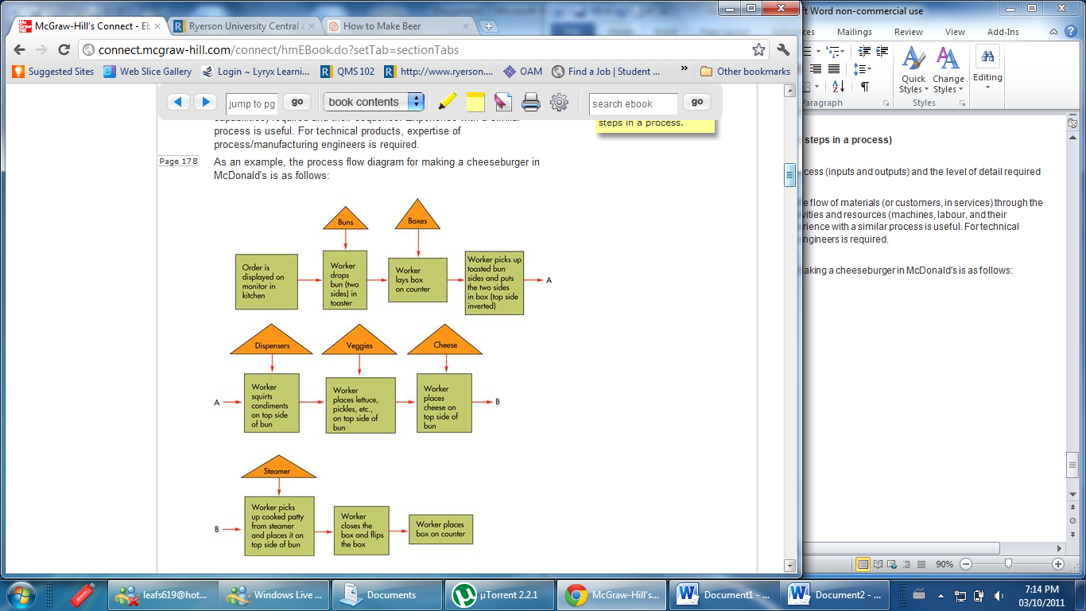

Customer Perception in Service Process Design
Some suggestions to improve customer perception in services are:
- Do not raise customer expectations too high in the beginning. This is because customers compare their expectation and the actual service they receive in order to judge the quality of service.
- End the service positively because customers remember the end more.
- If the service is pleasurable, divide it into segments. For example, two short rides in an amusement park may be better than one long ride.
Page 182
- If the service is painful, combine the segments. For example, cleaning teeth in a one-hour session may be better than two half-hour sessions.
- Let customers control part or all of the process. For example, self-services such as ATMs are preferred by most people. In this case, it is important to make the process user-friendly.
- Communicate the evidence of quality to customers.
TYPES OF LAYOUT
Layout refers to the location of departments, work centres, or equipment in the facility/plant. A good layout facilitates flow of work, whereas a bad one results in congestion.
Generally there are 2 types of layouts:
Product line layout: Arranges production resources linearly according to the progressive steps by which a product is made.
used to achieve a smooth and rapid flow of large quantities of goods or customers through a system.
s made possible by highly standardized goods or services that allow highly standardized, continual production
For instance, if a portion of a manufacturing operation required the sequence of cutting, sanding, and painting, the appropriate pieces of equipment would be arranged in that sequence

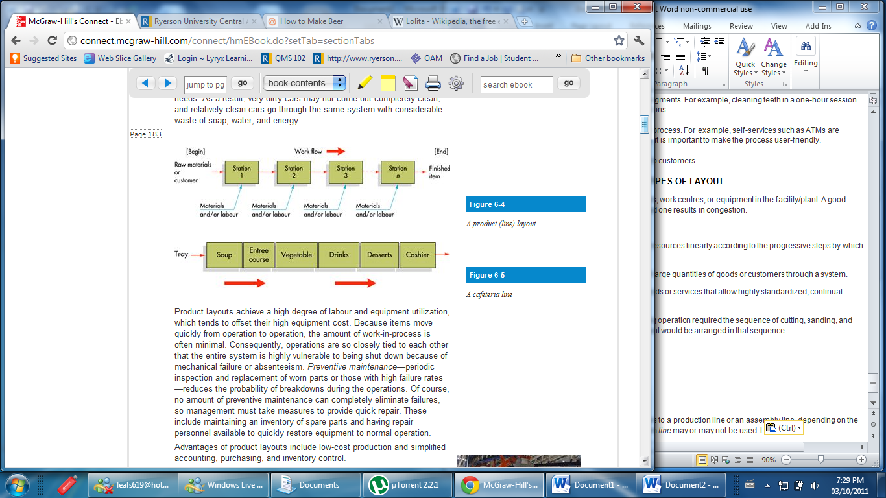

In manufacturing environments, a line refers to a production line or an assembly line, depending on the type of activity involved. In services, the term line may or may not be used. I
Product layouts achieve a high degree of labour and equipment utilization, which tends to offset their high equipment cost. Because items move quickly from operation to operation, the amount of work-in-process is often minimal.
Preventive maintenance—periodic inspection and replacement of worn parts or those with high failure rates—reduces the probability of breakdowns during the operations.
Process (functional) layouts
Process Layouts Arranges production resources together according to similarity of function.
This causes a discontinuous work flow, which is referred to asintermittent processing.
manufacturing example of a process layout is a machine shop, which has separate departments for milling, grinding, drilling, and so on
service examples: emergency department of a hospital, a grocery store and an auto repair shop. For instance, an emergency department may have areas consisting of emergency rooms, X-ray rooms, surgery rooms, etc.
Because equipment in a process layout is arranged by type rather than by production sequence, the system is much less vulnerable to shutdown caused by mechanical failure or absenteeism.
Maintenance costs tend to be lower because the equipment is less specialized than that of product layouts, and the grouping of machinery permits repair personnel to become skilled in handling that type of equipment
Reduces investment in spare parts

Process design diagram
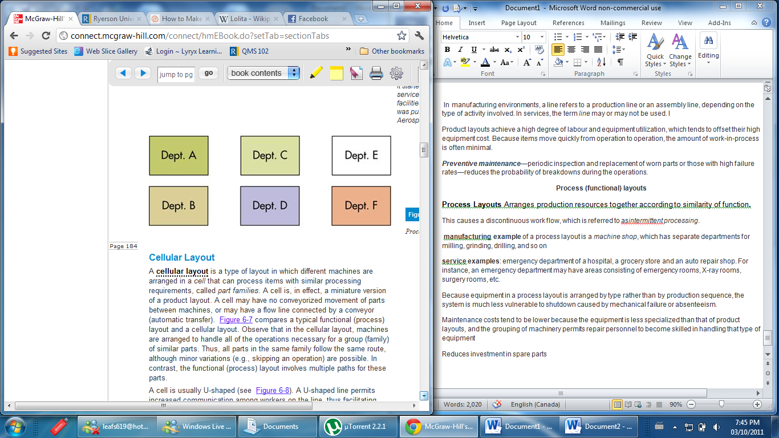

Cellular Layout

Cellular layout : Layout in which different machines are arranged in a cell that can process items that have similar processing requirements called part families
Observe that in the cellular layout, machines are arranged to handle all of the operations necessary for a group (family) of similar parts.
A cell is usually U-shaped (see Figure 6-8). A U-shaped line permits increased communication among workers on the line, thus facilitating teamwork. Flexibility in work assignments is increased because workers can handle not only adjacent stations but also stations on opposite sides of the line.

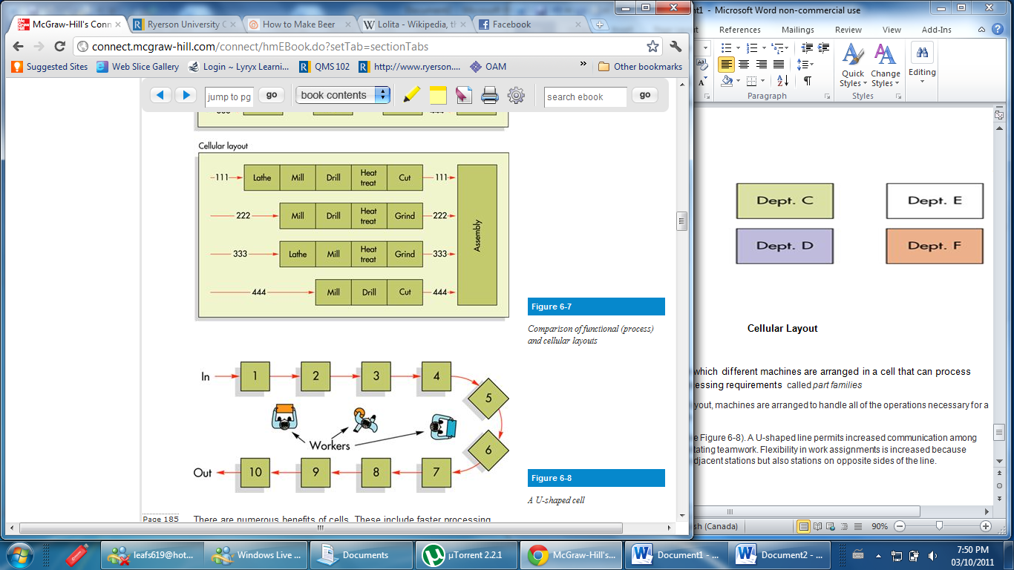

As opposed to functional where
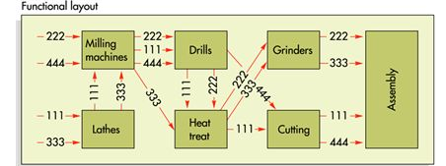
Benefits: These include faster processing time,
increased capacity,
less material handling,
less work-in-process inventory
and reduced setup times.

Group technology: Grouping items with similar design or manufacturing characteristics into part families.

Warehouse Layout
the design of a warehouse is based on a different set of factors than the design of factories.
Items requiring cold storage are stored together in freezers and coolers.
Frequency and size of orders is an important consideration; items that are ordered frequently and in large amounts should be placed near the entrance to the warehouse (or receiving/shipping area),
those ordered infrequently or in small amounts should be placed toward the rear of the warehouse.
Any correlation between items is also significant (e.g., item A is usually ordered with item B), suggesting that placing those two items close together would reduce

