Assignment II
- Name of protein: CDC34
- Chosen process that the protein is involved in: Ubiquitin-protein ligase activity
- 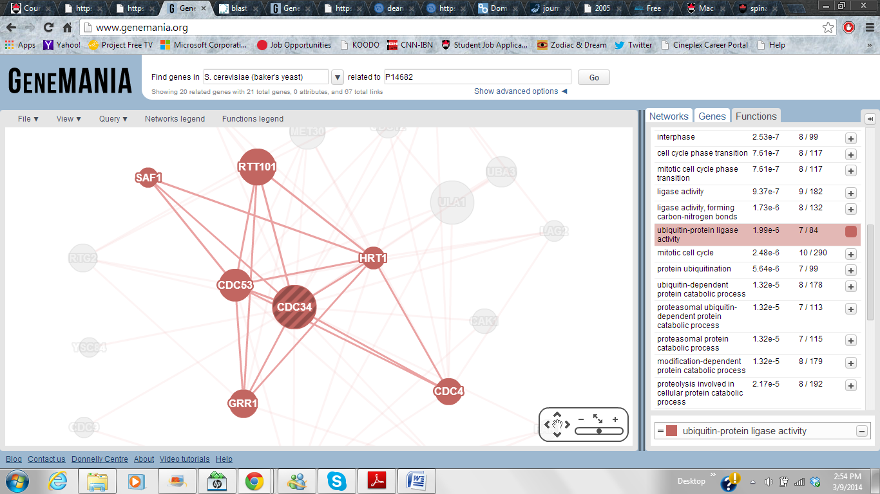
Figure 1. The functional network involving CDC34 (S.cereviseae) and related members for Ubiquitin-protein ligase complex
- Yes, the protein chosen is a part of this complex. The other members are: CDC4, GRR1, CDC53, HRT1, RTT101, SAF1
- The human homolog of this protein found through BLAST: UBE2G2_HUMAN (P60604 = entry number) with a percent identity of 45%
- 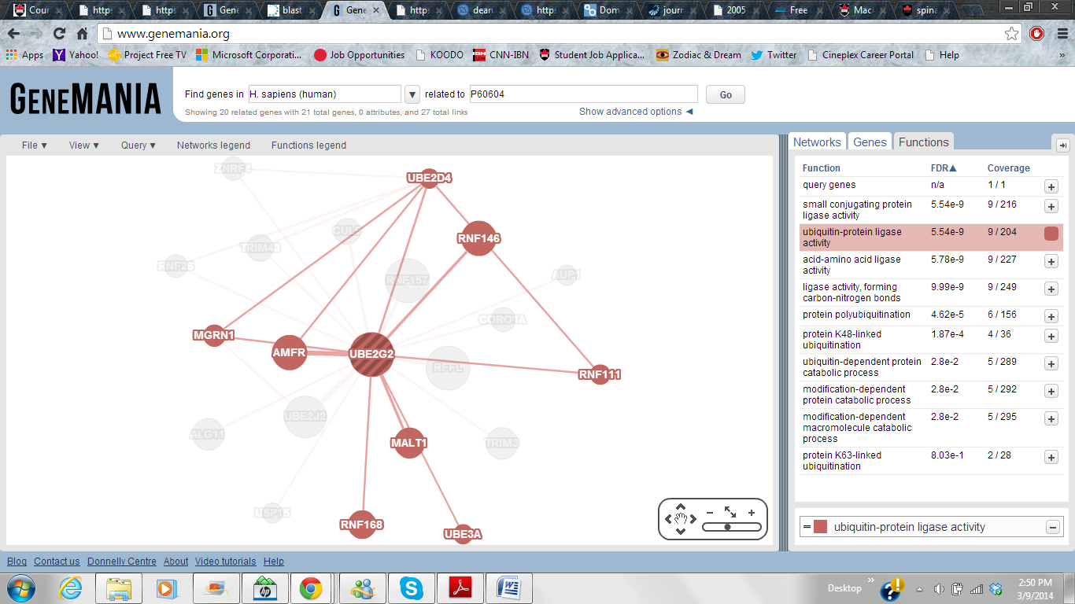
Figure 2. The interaction network for human homolog UBE2G2 for the Ubiquitin-protein ligase complex
The other members involved in this process are: UBE2D4, RNF146, RNF111, MALT1, RNF168, UBE3A, AMFR, MGRN1
- In the case of both yeast and human, both the proteins (CDC34 & UBE2G2) are seen to have 20 related proteins in the total interactome network provided by Genemania. Whereas in the case of the chosen process that these proteins are present in, CDC34 is functionally related to 6 other proteins whilst UBE2G2 is related to 8 other proteins.
It is also seen that CDC34 (yeast) is involved in a lot more functions for instance SCF ubiquitin ligase complex, G1/S transition of mitotic cell cycle, proteolysis, regulation of cell cycle, protein catabolic process etc and UBE2G2 (human) is not involved as many functions. Some of the functions that UBE2G2 are involved acid Amino acid ligase activity, protein polyubiquination, protein modification by small protein conjugation.
- Based on the functions described performed by CDC34 and the multi-protein complexes it is a part of, I predict that it is also involved in regulation of DNA replication along with initiation because it is seen that CDC34 is present in complexes involving the mitotic cell cycle whether it is to mediate the phase transition between G2/M or G1/S or interphase.

References:
www.genemenia.org to get the functional interactome for Yeast & Human
www.uniprot.com For BLAST sequence

