Experiment 1: Flow through a Venturi Meter

Summary
The pressure changes along a linearly deformed throat were measured as a function of the change of height in an array of monometers. Performing the experiment at two arbitrary speeds showed the pressure change was directly related to the cross sectional area of the Venturi Meter, the data points forming the same curve, offset only by the relative vacuum powers the experiment was performed at. Two Venturi Coefficients were calculated, at 0.96 and 0.97 respectively. Using the corrected flow rates the static pressure in the Venturi tube was plotted and compared with the initial calculated static pressure (without a corrected flow rate) and found to be most accurate at either end of the throat, differing by a larger amount near the throat of the Venturi Meter. Thus it can be assumed that the no-slip condition of fluid flow has a greater effect within the smaller area presented by the Venturi Meter’s throat.

Nomenclature
P_{atm} = Atmospheric Pressure, usually in Pascals : 101325 Pa [Supplied in Lab]
P_{static} = Static Pressure, in Pascals
P_{dyn} = Dynamic Pressure, in Pascals
ρ_{air} = Density of Air in kg/m³ : 1.225kg/m³ [1]
ρ_{water} = Density of Water in kg/m³ : 1000 kg/m³ [2]
V_{c}= Venturi Coefficient, Found by comparing the ideal and actual volume flow rates
Q_{ideal} = Ideal Volume Flow Rate, in m³/s
Q_{actual} = Actual Volume Flow Rate in m³/s
h_{atm} = Height of fluid in monometer tube open to atmosphere, in metres
h_{static} = Height of fluid in monometer tube at point the tap is connected along Venturi, in metres

Flow Analysis
This Lab consisted of Re-arranging Bernoulli’s equation within a Venturi Meter, and thus the initial equation that we started with is Bernoulli’s base equation (eq 1):
$$P_{1}+\frac{1}{2}ρV_{1}^{2}+ρgz_{1}=P_{2}\frac{1}{2}{ρV}_{2}^{2}+{ρgz}_{2}$$
Bernoulli’s equation can only be applied when fluid flow is assumed to be incompressible, inviscid, frictionless and along a streamline. Knowing this, and assuming point 2 is far enough away from the bell mouthed Venturi as to have no velocity, and be at standard air pressure, Bernoulli’s equation can be re-arranged to find the velocity of air in the Venturi Meter:

(eq 2)
$$V_{1}=\sqrt{\frac{2(P_{atm}-P_{static})}{ρ_{air}}}$$
However, before calculating V₁ the value of the unkown P_{static} must be determined. This is where the readings on the monometers connected to the venturi allow us to calculate the static pressure at the tap position’s, by measuring the difference in level from a manometer tube open to the atmosphere and one being affected by the Venturi we can come up with equation 3:
(eq 3)
$$P_{static}=P_{atm}+ρ_{water}g(h_{atm}{-h}_{static})$$
Now with P_{static} The velocity of the air at the tap position in the Venturi can be Calculated. The velocity is important as it provides us with one half of the next equation, the volume flow rate:
(eq 4)
$$\dot{Q}=V*A$$
The other half of the equation, A must be calculated with the two given diameters of the Venturi tube, and the similar triangle relationship:
(eq 5)
$$A= {(d/2)}^{2}π$$
Where d is calculated via two equations depending on the taps position compared to the neck of the venturi:
(eq 6.1 before neck)
$$d=2*tan(θ)*(133- d_{tap})+17.957mm$$
(eq 6.2 after neck)
$$d=2*tan(θ)*(d_{tap}-133)+17.957mm$$

Theta is found by assuming the Venturi throat is linear, and halving the inlet diameter to create a triangle:
(eq 7)
$$θ=\tan^{-1}(\frac{4.293mm}{133})$$
In this case theta turned out to be 1.8487 degrees.
Now that the flow rate can be calculated, the flow rate at the first tap, and at the throat are considered the actual and ideal flow rates respectively. Using these two values, the Venturi Coefficient can be calculated:
(eq 8)
$$C_{v}=\frac{{\dot{Q}}_{actual}}{{\dot{Q}}_{ideal}}$$
This coefficient allows us to calculate the corrected flow rate, the flow rate due to the no slip condition along the sides of the venturi. Rearranging it also allows us to calculate the corrected velocity. (Obviously area cannot be corrected as it isn’t affected by the no-slip condition):
(eq 9)
$${\dot{Q}}_{corrected}= C_{v}*A*V$$
(eq 10)
$$V_{corrected}=\frac{{\dot{Q}}_{corrected}}{C_{v}*A}$$
The corrected velocity value can then be used to rearrange equation 2 combined with equation 4 to find the corrected static pressure at the tap position:
(eq 11)
$$P_{static}= P_{atm} - \left(\frac{{\left(\frac{Q}{C*A}\right)}^{2}ρ_{air}}{2}\right)$$

With the data and calculated values present, it is also possible to calculate the dynamic pressure at the tap position, and thus the stagnation pressure at the same position:
(eq 12 – dynamic pressure)
$$P_{dyn }=\frac{1}{2}{ρV}^{2}$$
(eq 13 – Stagnation pressure)
$$P_{stagnation}=P_{static}+P_{dynamic}$$

Experimental Setup and Procedure
The experiment outlined in the lab manual was followed directly, following is a detailed and labelled diagram of the equipment setup.

Results and Discussion
With the data gathered and the equations as they were laid out in the flow analysis it was possible to gather a variety of results from the experiment. The analysis of this lab required several steps of calculations to reach a final conclusion. Firstly, Q_{actual} was calculated for both flow rates, and was found to be 0.0194 m³/s in experiment 1 and 0.0172 m³/s for experiment 2. [Table 2, Row 1, Columns 7 and 8] Q_{actual} was calculated using the mouth of the Venturi tube as a base point. Next, using the throat of the venturi meter, Q_{ideal} found to be 0.02022 m³/s and 0.017613 m³/s for experiment 1 and two respectively.[Table 2, Row 9, Columns 7 and 8] Both Q_{actual} and Q_{ideal} were calculated using equation 4, which was provided by the Lab TA. Next the ratio between both flow rate values were found for each experiment, giving two separate venturi coefficients, 0.961 and 0.974. [Table 2, Row 1, Columns 1 and 2] These two values are well within an experimentally acceptable approximation of standard venturi coefficients and are consistent, differing by only 1.8%. Using the data gathered and calculated, it was then possible for us to discover the static, dynamic, and thus stagnation pressures at the Venturi’s throat. In experiment one the static pressure was calculated as 97421 Pa, the dynamic pressure as 3904.38 Pa and the stagnation pressure as 101325 Pa.[Table 2 Row 9 Columns 3,11 and 12] For the second experiment static pressure was calculated as 98362 Pa dynamic as 2962.62 Pa and stagnation as 101325 Pa.[Table 2 Row 9 Columns 4,12 and 14].
As can be seen in the plot below, the static pressure in both experiments varied similarly, with two nearly identical traces. In both cases the corrected static pressure was lower than the initial value. It is interesting to note that at the points with the smallest area, the original and corrected value differed the most, suggesting a correlation between decreased area and the difference between ideal and corrected values. This correlation is likely due to an increased velocity as the area of the tube decreases, as can be seen in table 2, rows 5 and 6.
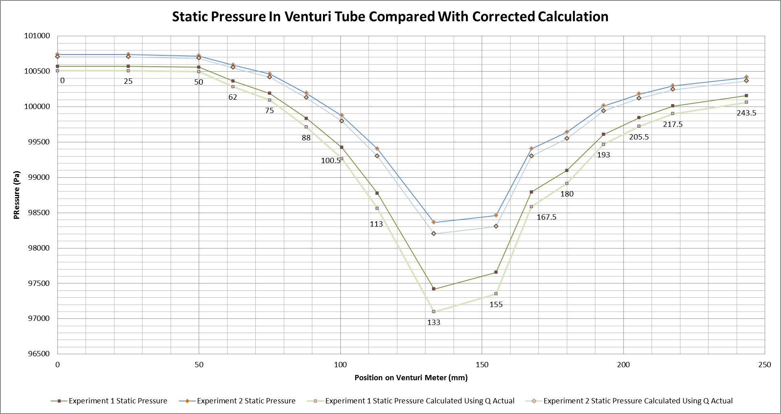

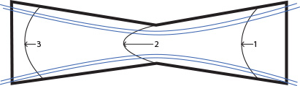
As can be seen in the sketch, the velocity profiles are shown at points 1, the Venturi inlet, point 2, the Venturi’s throat, and point 3, the downstream end of the Venturi. The arrow at point 2 is considerably longer than those at points 1 and 3, showing the increased velocity as a result of decreased diameter. the severity of the arc also shows how with the increased velocity and decreased area, there is greater friction along the edges of the Venturi due to the no slip condition. The Velocity profiles at points 1 and 3 are very similar, as the air passes through the throat it continues to travel along the slipstreams, slowing down as the cross sectional area increases.
Throughout this experiment there exist a variety of places for air, reading error in the monometer tubes as the scale was only for 2mm, similarly the ruler used to measure the tap distances could be replaced by a vernier caliper for more accurate results.

Conclusions
The results of this experiment can result in the following conclusions: As the cross sectional area of a Venturi meter (or any pipe) decreases, the air flowing through it will increase its velocity; this increased velocity will cause a considerable velocity profile at the narrowest points. This velocity profile is thus the reason we must calculate the Venturi Coefficient and calibrate our results, in ideal flow, which is required for the application of Bernoulli’s principles and formulas the no slip condition is disregarded in favour of a simplified model.

References
[1] “US Standard Atmosphere 1976” Published by NOAA NASA and USAF. http://scipp.ucsc.edu/outreach/balloon/atmos/1976%20Standard%20Atmosphere.htm Accessed February 25th 2014
[2] “What is the Density of Water” Anne Marie Helmenstine, PhD. http://chemistry.about.com/od/waterchemistry/f/What-Is-The-Density-Of-Water.htm Accessed February 25th 2014

Appendices

Table 1 – Experimental Data Table 3 – Venturi Coefficients
Table 2 – Calculated Data

Notes:
- Diameters with a green background were calculated using equation 6.1, Diameters with a purple background were calculated using equation 6.2
- The throat tap has a background of blue

Sample Calculations
eq 1 - Theoretical
eq 2.
$$V_{1}=\sqrt{\frac{2(101325 Pa-100569.63 Pa)}{1.225 kg/m^{3}}}$$
$$V_{1}= 35.11776 m/s$$
eq 3.
$$P_{static}=101325 Pa+1000 kg/m^{3}9.81 m/s^{2}(0.09m-0.150m)$$
$$P_{static}= 100736.4 Pa$$
eq 4.
$$\dot{Q}=35.11776 m/s*0.000553 m^{2}$$
$$\dot{Q}= 0.019432 m^{3}/s$$
eq 5 – Trivial (Area of a Circle)
eq 6 $$d=2*tan(1.8487)*(133- 25)+17.957mm$$
$$d=24.9289$$

eq 7
$$θ=\tan^{-1}(\frac{4.293mm}{133})$$
$$θ=1.8487°$$

eq 8
$$C_{v}=\frac{0.019432{ m}^{3}/s}{0.02022 m^{3}/s}$$
$$C_{v}=0.9610$$

eq 9 – Trivial (Multiplication of Q by Venturi Coefficient)
eq 10 – Trivial (Finding Corrected Value of Velocity)
eq 11 –
$$P_{static}= 101325 Pa- \left(\frac{{\left(\frac{0.019432 { m}^{3}/s}{0.9610*0.000553 m^{2}}\right)}^{2}1.225kg/m^{3}}{2}\right)$$
$$P_{static}= 100507.1245 Pa$$
eq 12 –$$P_{dyn }=\frac{1}{2}1.225kg/m^{3}{(79.840m/s)}^{2}$$
$$P_{dyn }=3904.38$$
eq 13 – Trivial (addition of static and dynamic pressures)

