Chapter 9: Intelligence and Sociological Testing
Mental Ability Tests: have right and wrong answers
- Intelligence tests: measure general mental ability
- Aptitude tests: assess specific types of mental abilities
- Achievement tests: gauge a person's mastery or knowledge of various subjects
Personality Tests: measure various aspects of personality, including motives, interests, values, and attitudes. have only right answers
Standardization: refers to uniform procedures used in the administration and scoring of a test
Test norms: provide information about where a score on a psychological test ranks in relation to other scores on that test
Reliability: measurement consistency of a test
Correlation coefficient: numerical index of the degree of relationship between 2 variables
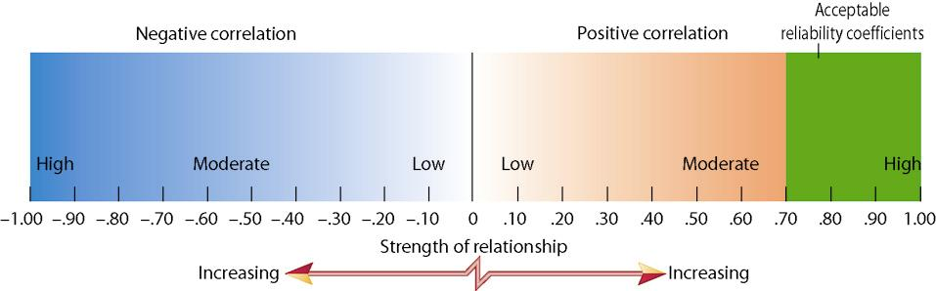
Validity: ability of a test to measure what it was designed to measure
Content validity: degree the content of a test is representative of the domain it's supposed to cover
Criterion-related validity: estimated by correlating subjects scores on a test with their scores on another measure of the trait assessed by the test
Construct validity: The extent to which there is evidence that a test measures a particular hypothetical construct.
Hypothetical construct: abstract personal qualities such as creativity, intelligence, extraversion, independence
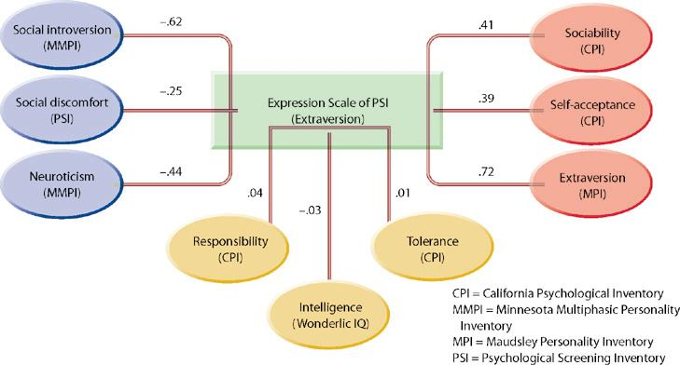

Sir Francis Galton: hereditary genius, concluded that success runs in families because it is passed down from generation to generation
Alfred Binet & Theodore simon: IQ= Mental Age/Chronological age x 100
David Wechsler: Wechsler adult intelligence scale
Fluid intelligence: reasoning ability, memorycapacity, and speed of information processing
Crystallized intelligence: ability to apply acquired knowledge and skills in problem solving
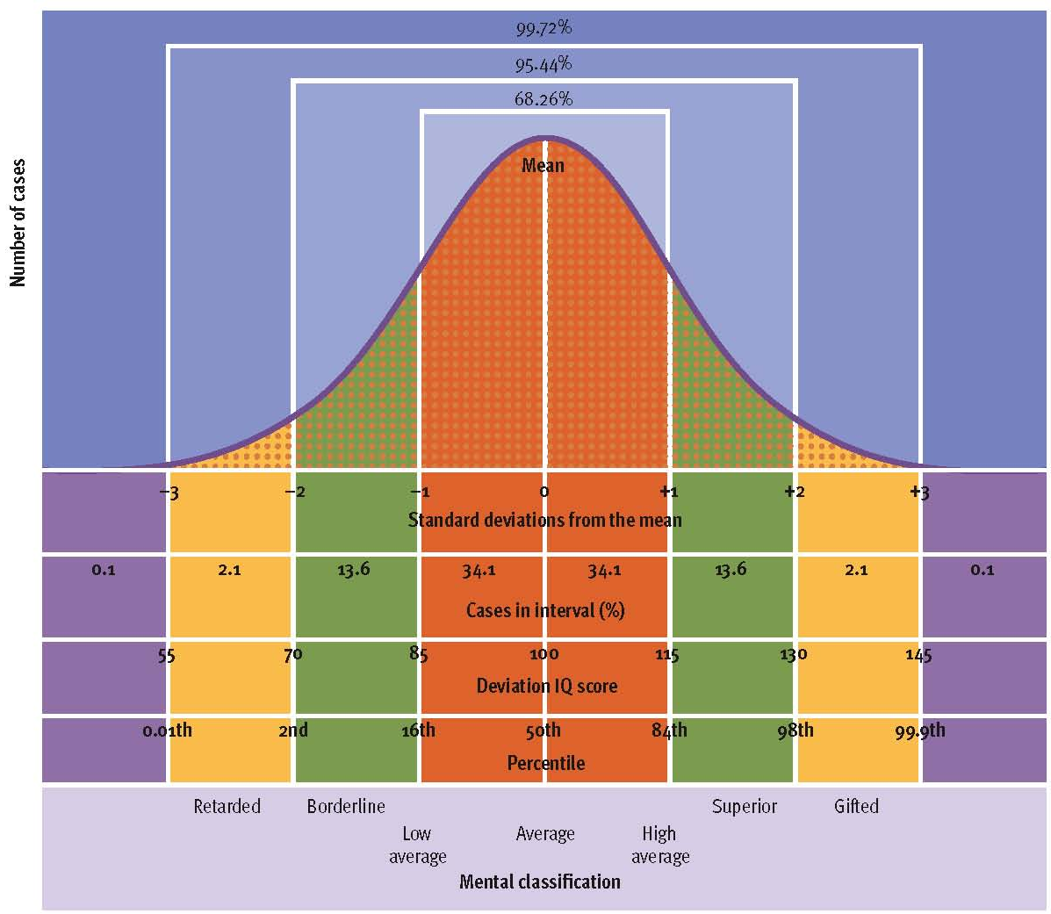

Verbal intelligence: speaks clearly, verbally fluent, knowledgeable about field, reads with high comprehension
Practical Intelligence: Sees all aspects of problem, sizes up situations well, makes good decisions
Social Intelligence: Accepts others for what they are, Social conscience, thinks before speaking
IQ tests focus on academic/verbal intelligence
Stability and Culture
- Stability not seen in infancy/preschool ages
- Scores are stable around ages 7 yrs +
- Changes can occur (e.g. Headstart Programs)
- Used in Western Cultures and not in non-Western Cultures
  - Cross-cultural issues
Extremes of Intelligence: Mental Retardation
- Diagnosis based on IQ and adaptive testing
  - IQ 2 or more SD below mean
  - Adaptive skill deficits
  - Origination before age 18
- 4 levels: mild, moderate, severe, profound
  - Mild most common by far
- Causes:
  - Environmental vs. Biological
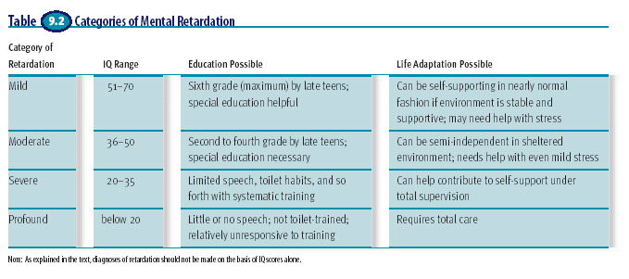
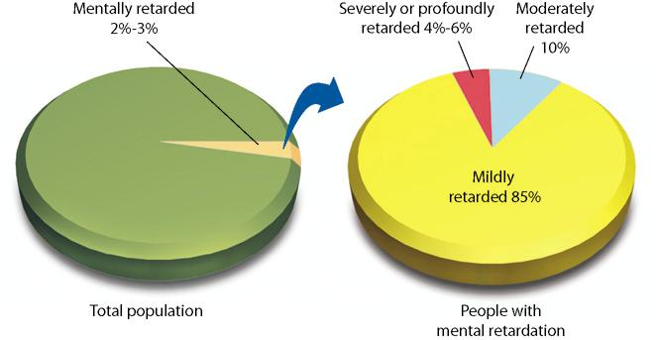
Moderately gifted are much different than profoundly gifted children.
- introverted and socially isolated
- interpersonal and emotional problems are twice as high
Stereotypes – weak, socially inept, emotionally troubled
IQ is hereditary
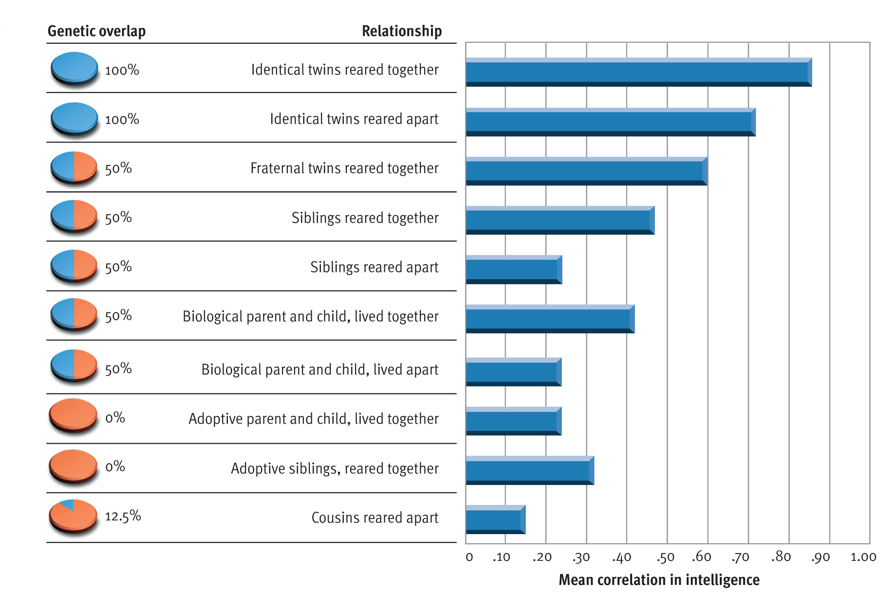

Upbringing affects mental ability
Adopted kids show resemblance to their adoptive parents due to the adoptive parents shaping their environment
The Flynn Effect: IQ performance has been steadily rising since the 1930's. Unexplained.
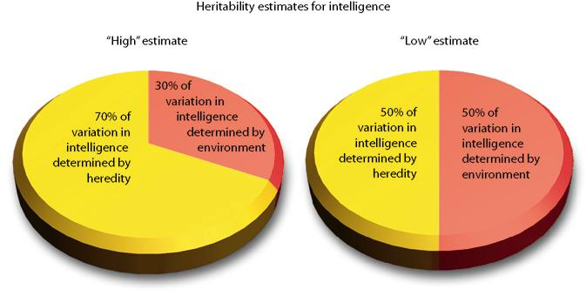

Fig 9.14 – The concept of heritability. A heritability ratio is an estimate of the portion of variation in a trait determined by heredity—with the remainder presumably determined by environment—as these pie charts illustrate. Typical heritability estimates for intelligence range between a high of 70% and a low of 50%, although some estimates have fallen outside this range. Bear in mind that heritability ratios are estimates and have certain limitations that are discussed in the text.
Reaction range: children raised in high quality environments can near the top of their potential IQ, while children raised in low quality environments will not
Arthur Jensen: argued cultural differences in IQ are mainly due to heredity
- 1. intelligence is largely genetic in origin
- 2. genetic factors are therefore strongly implicated as the cause of ethnic differences in intelligence
Fig 9.17 – Genetics and between-group differences on a trait. Kamin’s analogy (see text) shows how between-group differences on a trait (the height of corn plants) could be due to environment, even if the trait is largely inherited. The same reasoning presumably applies to ethnic group differences in the trait of human intelligence.
Chapter 10: Motivation and Emotion
Motives – needs, wants, desires leading to goal-directed behaviour
Drive theories – seeking homeostasis
Incentive theories – regulation by external stimuli to motivate behaviour
Evolutionary theories – maximizing reproductive success
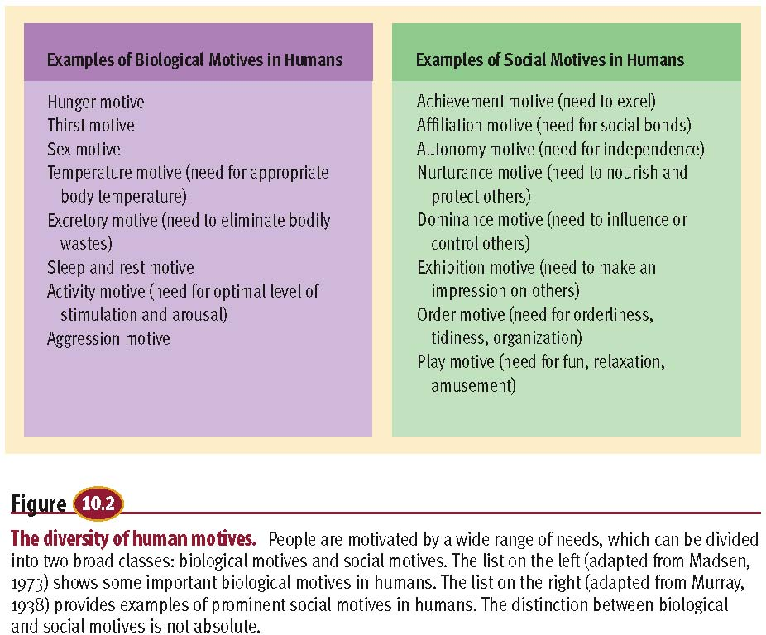

Hunger is controlled by the brain, not the stomach. Hypothalamus.
Lateral and ventromedial hypothalamus are brains on off switches for hunger
Arcuate nucleus and paraventricular nucleus contain a group of neurons that are sensitive to incoming hunger signals.
Insulin: hormone secreted by the pancreas. Must be present for cells to extract glucose from blood
Leptin: Produced by fat cells. circulates through blood. Provides hypothalmus information about body fat cell stores.
Glucoastic theory: fluctuations in blood glucose level are monitored in the brain where they influence the experience of hunger.

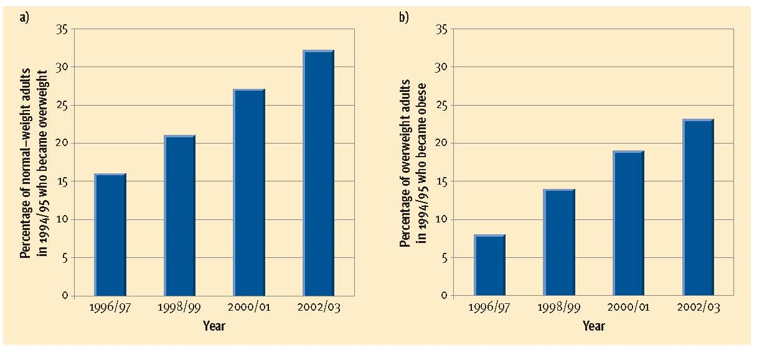

Set point theory: the body monitors fat cell levels to keep them and weight fairly stable
Settling point theory: Weight tends to drift around the level at which the constellation of factors that determine food consumption and energy expenditure reach an equilibrium
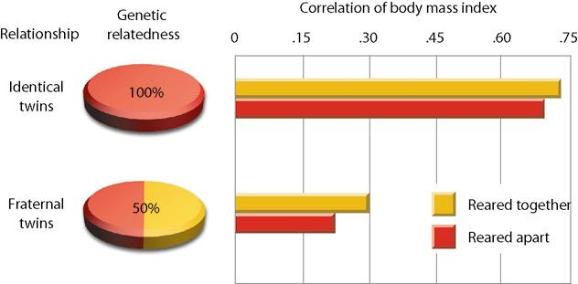

Human Sexual Response
- Excitement Phase
- Plateau Phase
- Orgasm Phase
- Resolution Phase
Parental investment theory: A species mating patterns depend on what each sex has to invest, time, energy, and survival risk
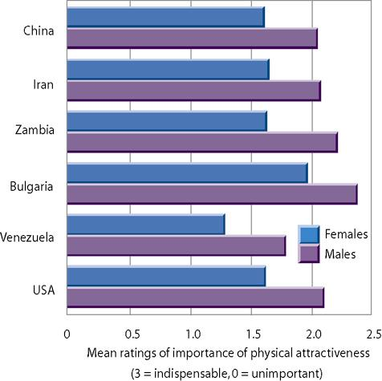
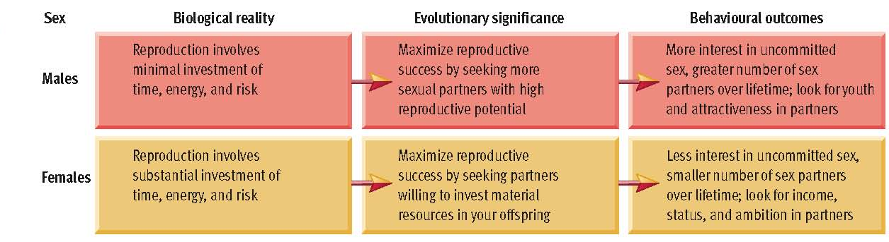
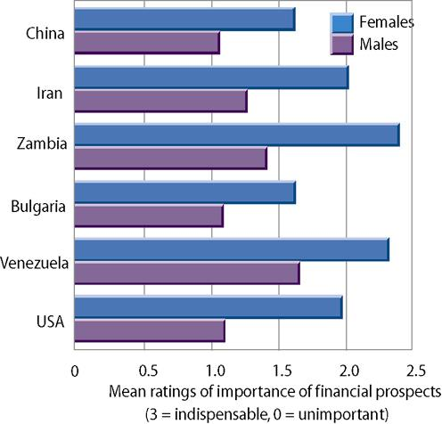

Heterosexual – Bisexual – Homosexual
  - A continuum
Theories explaining homosexuality
  - Environmental
  - Biological
  - Interactionist
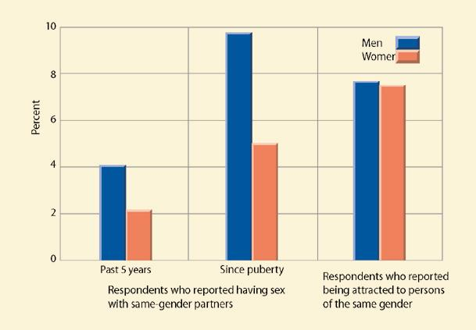
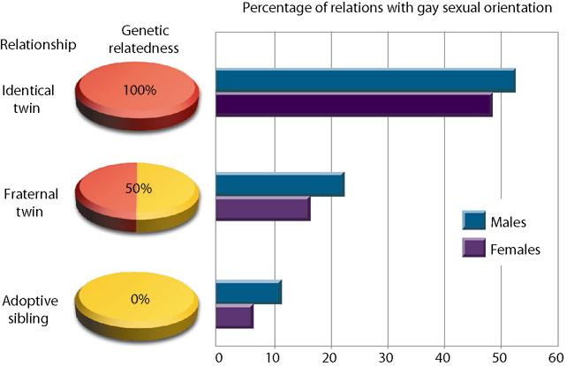
Fig 10.17 – Genetics and sexual orientation. A concordance rate indicates the percentage of twin pairs or other pairs of relatives who exhibit the same characteristic. If relatives who share more genetic relatedness show higher concordance rates than relatives who share less genetic overlap, this evidence suggests a genetic predisposition to the characteristic. Recent studies of both gay men and lesbian women have found higher concordance rates among identical twins than fraternal twins, who, in turn, exhibit more concordance than adoptive siblings. These findings are consistent with the hypothesis that genetic factors influence sexual orientation. (Data from Bailey & Pillard,
1991; Bailey et al., 1993)
- Affiliation motive = need for social bonds
  - Devote more time to interpersonal activities
  - Worry more about acceptance
- Achievement motive = need to excel
  - Work harder and more persistently
  - Delay gratification
  - Pursue competitive careers
  - Situational influences on achievement motives
  - Thematic Apperception Test (TAT)
The Elements of Emotional Experience
- Cognitive component
  - Subjective conscious experience
  - Positive psychology
- Physiological component
  - Bodily (autonomic) arousal
  - Affective Neuroscience
- Behavioural component
  - Characteristic overt expressions
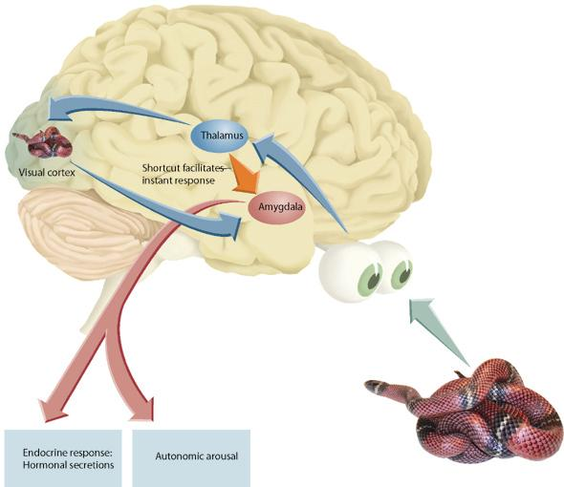
Fig 10.22 – The amygdala and fear. Emotions are controlled by a constellation of interacting brain systems, but the amygdala appears to play a particularly crucial role. According to LeDoux (1996), sensory inputs that can trigger fear arrive in the thalamus and then are routed along a fast pathway (shown in red) directly to the amygdala, and along a slow pathway (shown in green) that allows the cortex time to think about the situation. Activity in the fast pathway allows for rapid responses to threats, which has probably had
adaptive significance for humans. Activity in this pathway also quickly elicits the autonomic
arousal and hormonal responses that are part of the physiological component of emotion.
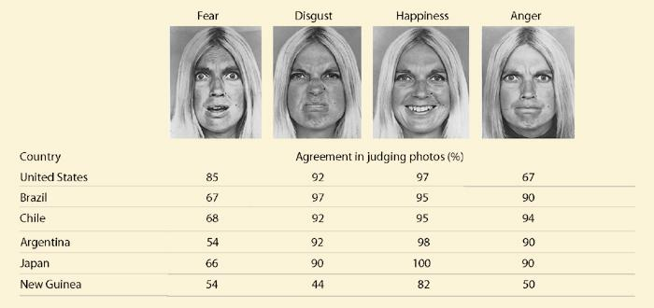
Cross-cultural comparisons of people’s ability to recognize emotions from facial expressions. Ekman and Friesen (1975) found that people in highly disparate cultures showed fair agreement on the emotions portrayed in these photos. This consensus across cultures suggests that facial expressions of emotions may have a biological basis.
- James-Lange
  - Feel afraid because pulse is racing
- Cannon-Bard
  - Thalamus sends signals simultaneously to the cortex and the autonomic nervous system
- Schacter’s Two-Factor Theory
  - Look to external cues to decide what to feel
- Evolutionary Theories
  - Innate reactions with little cognitive interpretation
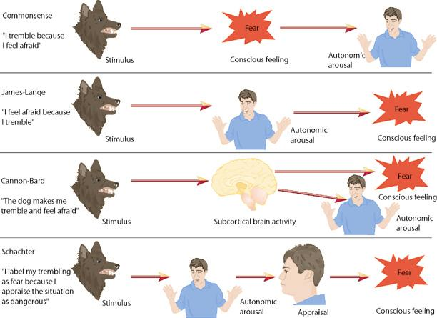
Happiness
- Common sense notions incorrect
  - Income, age, parenthood, intelligence, and attractiveness largely uncorrelated
  - Physical health, good social relationships, religious faith, and culture modestly correlated
  - Love, marriage, work satisfaction, and personality strongly correlated
- Subjective rather than objective reality important

Chapter 11: Human development across the lifespan
Prenatal development:
- Germinal stage: first 2 weeks, conception, implantation, formation of placenta
- Embryonic stage: 2 weeks-2 months, formation of vital organs and systems
- Fetal stage: 2 months-birth, bodily growth continues, movement begins, brain cells multiply, age of viability
The placenta is a structure that allows oxygen and nutrients to pass into the fetus from the mother’s bloodstream and bodily wastes to pass out to the mother.
Somewhere between 22 and 26 weeks, the age of viability is reached…when the baby could survive if born prematurely. At 22 or 23 weeks, chances for survival are slim, but by 26-28 weeks chances improve to a survival rate of about 85%.
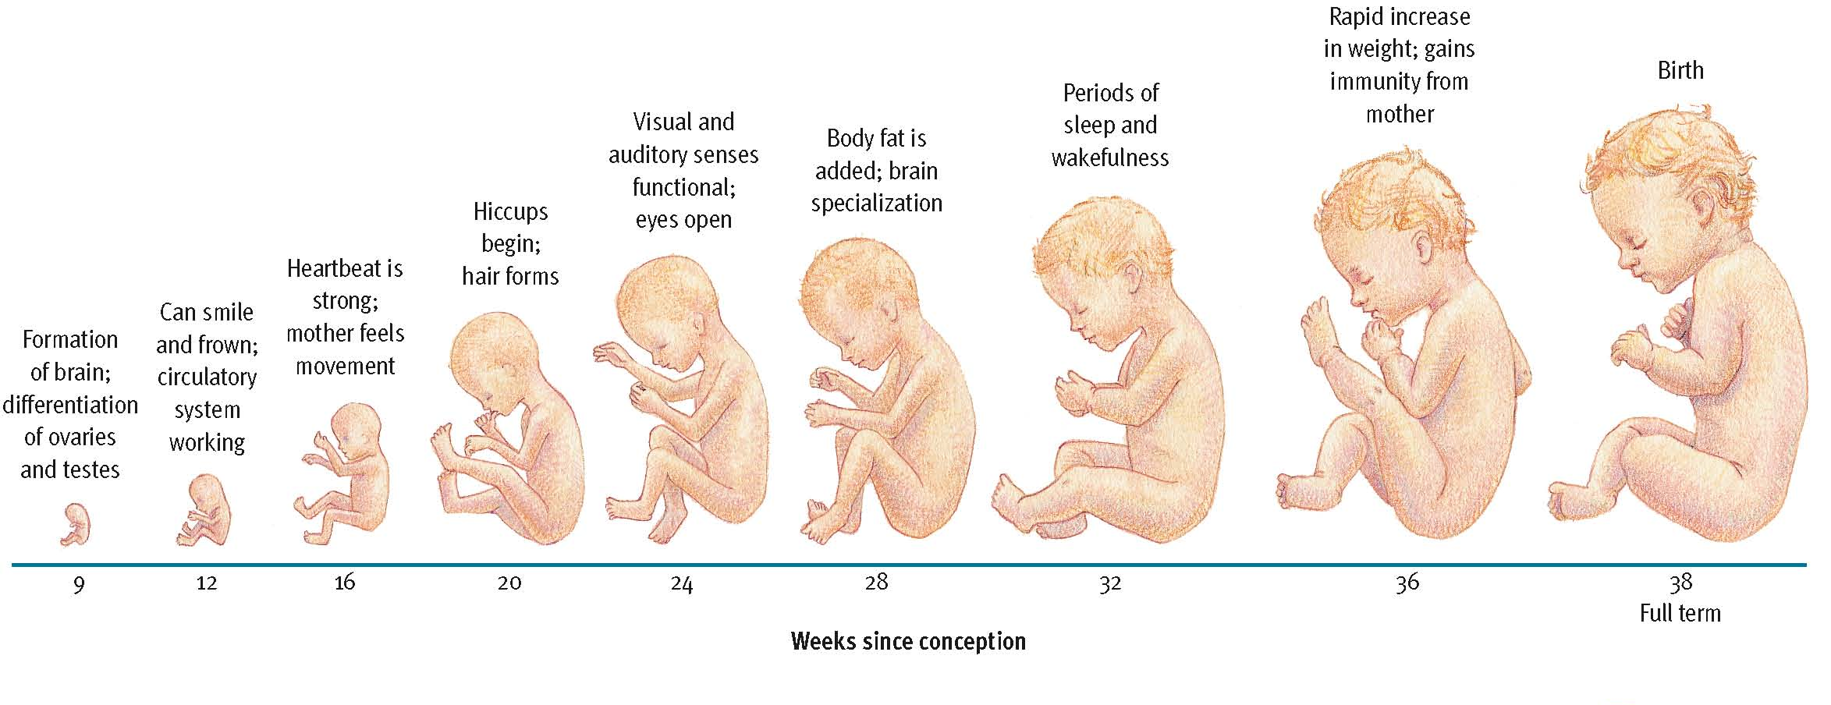

Environmental Factors and Prenatal Development
- Maternal nutrition
  - Malnutrition linked to increased risk of birth complications, neurological problems, and psychopathology
  - vulnerability, schizophrenia, and other psychiatric disorders in adolescence and early adulthood.
- Maternal drug use
  - Tobacco, alcohol, prescription, and recreational drugs (marijuana)
  - Fetal alcohol syndrome -one of the leading causes of mental retardation, is a collection of congenital (inborn) problems associated with excessive alcohol use during pregnancy. Problems include microcephaly, heart defects, irritability, hyperactivity, and delayed mental and motor development. FAS is also related to increased incidence of depression, suicide, and criminal behaviour in adulthood.
- Maternal illness
  - Rubella, syphilis, mumps, genital herpes, AIDS, severe influenza
  - Prenatal health care
  - Prevention through guidance
Prenatal care is associated with higher survival rates and reduced prematurity, but many women, because of poverty and other problems, do not receive prenatal care.
Teratogens are any external agents that can harm an embryo or fetus
The Childhood Years: Motor Development
- Basic Principles
  - Cephalocaudal trend – head to foot direction of motor development
  - Proximodistal trend – centre-outward direction of motor development
- Maturation – gradual unfolding of genetic blueprint and infant’s ongoing exploration of the world.
- Developmental norms – median age at which individuals display various behaviours and abilities…useful benchmarks only.
  - Cultural variations indicate the importance of experience on the development of motor skills. Nevertheless, the similarities across cultures outweigh the differences, illustrating the importance of maturation.
Easy and Difficult Babies: Differences in Temperament
Temperament: characteristic mood, activity level, and emotional reactivity
- Longitudinal design: observe one group of participants repeatedly over time.
- cross-sectional designs: compare groups of participants of differing age at a single point in time
- Cross-sectional studies are easier, quicker, and cheaper; longitudinal designs are more sensitive to developmental influences, however.
Thomas, Chess, and Birch (1970) - first to begin a longitudinal study of temperament, an individual’s characteristic mood, activity level, and emotional reactivity.
  - 3 basic temperamental styles
    - easy – 40% - happy, regular in sleep and eating, adaptable, and not readily upset
    - slow-to-warm-up – 15% - less cheery, less regular in sleep and eating, and slow adapting to change, with moderate reactivity
    - difficult – 10% - difficult children were glum, erratic in sleep and eating, resistant to change, and relatively irritable. developed more emotional problems than other children, and temperament was generally stable over time.
    - mixed – 35%
      - stable over time
- Kagan & Snidman (1991)
  - Inhibited vs. uninhibited temperament
    - inhibited – 15 - 20% - inhibited children exhibiting shyness, timidity, and wariness of the unfamiliar
    - uninhibited – 25 - 30% - uninhibited children exhibiting less restraint with regard to the unfamiliar and little trepidation
- stable over time, genetically based
Cohort effects: when differences between age groups are due to the groups growing up in different time periods

Early Emotional Development: Attachment

- Separation anxiety: emotional distress seen in many infants when they are separated from people with whom they have formed an attachment.
  - Ainsworth (1979)- developed a research paradigm to study attachment using separation anxiety as a measure. She found that most infants have a secure attachment, playing and exploring comfortably when mom is present, becoming visibly upset when she leaves, and calming quickly upon her return.
  - The strange situation and patterns of attachment
Strange situation procedure: infants are exposed to a series of eight seperation and reunion episodes to assess quality of attachment

Patterns of attachement:
    - Secure- 67%- playing and exploring comfortably when mom is present, becoming visibly upset when she leaves, and calming quickly upon her return. tend to become resilient, competent toddlers, with high self esteem.
    - Anxious-ambivalent- 12%- anxiety even when mom is near and protest excessively when she leaves, but are not particularly comforted when she returns
    - Avoidant- 21%- sought little contact with their mothers and were not distressed when she left, a pattern Ainsworth labeled avoidant attachment.
- Developing secure attachment
  - Bonding at birth- Bonding during the first few hours after birth does not appear to be crucial to secure attachment.
  - Daycare- day care is not harmful to children’s attachment relationships, and there is evidence that there may be beneficial effects of day care on social development in children from deprived backgrounds.
  - Cultural factors- cultural variations in childrearing practices can impact the patterns of attachment seen in a society.
- Evolutionary perspectives on attachment
- John Bowlby: originated the concept of attachment in the late 60s, assumed attachment to be a function of natural selection, with infants programmed to emit behaviours that trigger affectionate, protective responses in adults.
- Jay Belsky (1999) asserts that children have been programmed by evolution to respond to sensitive or insensitive care with different attachment patterns.

Stage Theories: developmental period where characteristic patterns of behavior are exhibited and certain capacities become established
- progress through stages in order as each stage builds on next
- progress through stages related to age
- development marked by major discontinuities that usher dramatic transitions in behaviour
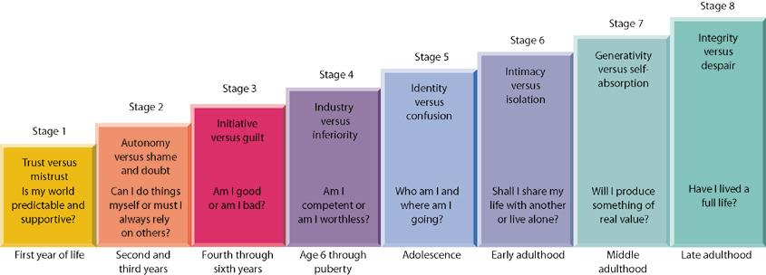
Erikson’s stage theory. Erikson’s theory of personality development posits that people evolve through eight stages over the life span. Each stage is marked by a psychosocial crisis that involves confronting a fundamental question, such as “Who am I and where am I going?” The stages are described in terms of alternative traits that are potential outcomes from the crises. Development is enhanced when a crisis is resolved in favor of the healthier alternative (which is listed first for each stage).
Stage Theories: Cognitive Development
Cognitive development: transitions in youngsters patterns of thinking
- Jean Piaget (1920s-1980s): asserted that interaction with the environment and maturation gradually alter the way children think.
  - Assimilation: interpreting new experiences in terms of existing mental structures without changing them
  - Accommodation: changing existing mental structures to explain new experiences).
  - Piaget proposed that children’s thought processes go through a series of four major stages.
  - 4 stages and major milestones
    - Sensorimotor
      - Object permanence: the recognition that objects continue to exist even when they are no longer visible.
    - Preoperational
children engage in symbolic thought, with characteristic flaws in their reasoning
      - Centration- the tendency to focus on just one feature of a problem
      - Egocentrism- the limited ability to share another’s viewpoint
      - animism, the belief that all things are living, just like oneself.
    - Concrete Operational
ability to perform operations with symbolic thought such as reversing or mentally undoing an action
      - Decentration: able to focus on more than one feature of a problem simultaneously
      - Reversibility: Permits a child to mentally undo a situation
      - Conservation: recognizing that amount of a substance does not change just because appearance is changed
    - Formal Operational
      - begin to apply operations to abstract concepts in addition to concrete objects.
      - Abstraction: abstract concepts such as justice, love, and free will
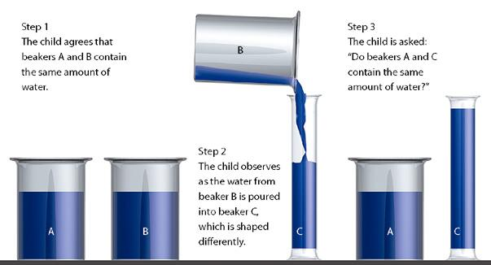
Fig 11.11 – Piaget’s conservation task. After watching the transformation shown, a preoperational child will usually answer that the taller beaker contains more water. In contrast, the child in the concrete operations period tends to respond correctly, recognizing that the amount of water in beaker C remains the same as the amount in beaker A.

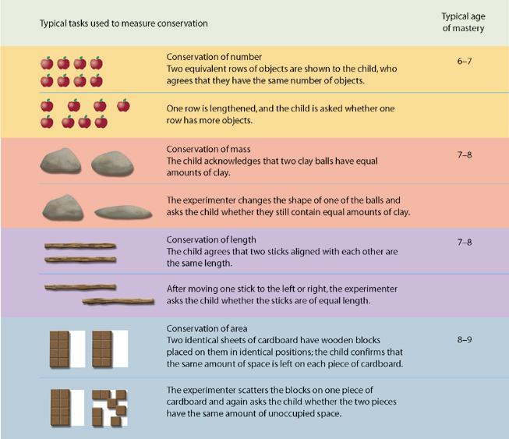
Fig 11.12 – The gradual mastery of conservation. Children master Piaget’s conservation problem during the concrete operations period, but their mastery is gradual. As outlined here, children usually master the conservation of numbers at age 6 or 7, but they may not understand the conservation of
area until age 8 or 9.

Lev Vygotsky:
Sociocultural theory: Social, cultural, and social interaction greatly affects the cognitive development in children
Zone of proximal development: gap between what a learner can accomplish alone and what they can achieve with guidance from more skilled partners
Scaffolding: assistance provided is adjusted as learning progresses.
Innate cognitive abilities:
- Habituation: gradual reduction in the strength of a response when a stimulus event is presented repeatedly
- Dishabituation: new stimulus creates an increase in the strength of a habituated response
Critical period in development: age ranges or time periods that are optimal or essential for development of certain abilities or characteristics
Theory of mind: development of children's understanding about the mind and mental states and how they conceive another person's thought processes, knowledge, feelings, and beliefs
The Development of Moral Reasoning
- Kohlberg (1976)
  - Theory focuses on moral reasoning as opposed to behaviour
    - Moral dilemmas
      - Measured nature and progression of moral reasoning
  - Individuals progress through 3 levels, each with 2 sublevels
    - Preconventional: Acts are wrong because they are punished or right because they lead to positive consequences. Young children.
    - Conventional: Rules necessary for maintaining social order. Older children internalize rules to be virtuous and win approval from others
    - Postconventional: Working out a personal code of ethics. Adolescence
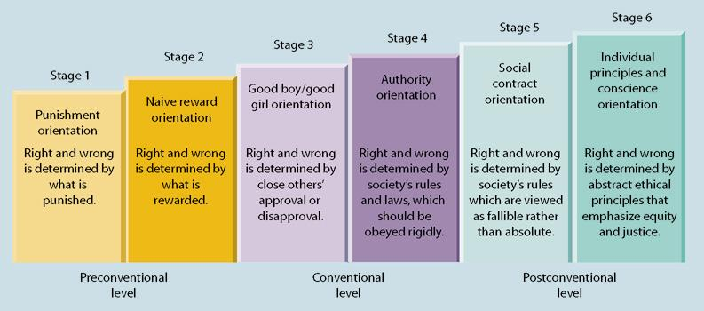
Kohlberg’s stage theory. Kohlberg’s model posits three levels of moral reasoning, each of which can be divided into two stages. This chart summarizes some of the key facets in how individuals think about right and wrong at each stage.

Adolescence: Puberty and the Growth Spurt
Pubescence: two-year span preceding puberty during which the changes leading to physical and sexual maturity take place. Grow taller, heavier, and develop secondary sex characteristics; physical features that distinguish one sex from the other but that are not essential for reproduction.
Puberty: stage during which sexual functions reach maturity, marking the beginning of adolescence. It is during puberty that the primary sex characteristics, the structures necessary for reproduction, develop fully.
- Females: puberty signaled by menarche - the first occurrence of menstruation
- Males: Puberty signaled by sperm production
- Occurring at younger ages due to improved nutrition and medical care
- Belsky hypothesizes that quality of person's early family relationships influences earlier onset
- 10-15 for girls, 11-16 for boys
- early vs. late maturation: early maturing girls and late maturing boys having greater risk for psychological problems and social difficulties.
The Teen Brain: Prefrontal cortex (executive control center) is last area to mature, and may not mature until mid 20's. Explains why risky behaviour peaks during adolescence.
Turmoil:
- Self image/self esteem especially high during teen years due to erratic physical changes and confusion about self image.
- Suicide: Third leading cause of death among adolescents. Second cause of death among Canadians between 10-24. Increased alarmingly over past few decades. Suicide 800 times higher within first nations canadians.
- Crime and bullying: More teenage girls charged with violent crimes than ever before. Most at risk for continued bullying are those that have troubled relationships with friends and parents.
Adolescence is somewhat more stressful than other developmental periods
The search for identity:
- Erik Erikson (1968)
  - Key challenge - forming a sense of identity
- James Marcia (1988): the presence or absence of crisis and commitment during the identity formation stage can combine in various ways to produce four different identity statuses.
  - 4 identity statuses
    - Foreclosure: premature commitment to a role prescribed by one’s parents.
    - Moratorium: delaying commitment and engaging in experimentation with different roles.
    - Identity Diffusion: a state of lack of direction and apathy, where a person does not confront the challenge and commit to an ideology.
    - Identity Achievement: arriving at a sense of self and direction after some consideration of alternative possibilities.
The Expanse of Adulthood:
- Adults who move successfully through Erikson’s stages develop intimacy, generativity, and integrity.
- Family life cycle: sequence of stages that families tend to progress through
- Transitions in family life
  - Marriage- Studies of marriage and marital satisfaction indicate that when spouses have differing role expectations, adjustment to marriage is more difficult. Research also shows highest rates of marital satisfaction at the beginning and end of the family cycle.
  - Parenthood-proceeds more smoothly if unrealistic expectations are not held. Research on later parent/child relations suggests that parent-adolescent relations and the adjustment difficulties that parents may have when children leave home (empty nest syndrome) may not be as stressful as once believed.
  - Empty Nest- Most parents adjust effectively to empty nest transition. empty nest increased marital satisfaction. More time with husbands. Problems arise if children return to empty nest.
- Physiological development: Hair grays, recedes. Proportion of body fat increases, amount of muscle decreases. Gradual decline through mid 50's. Menopause.
- Neural development: Brain tissue and brain weight decline after age 60. Normal part of aging process. Dementia: multiple cognitive deficits that include memory impairment. Seen in 15-20% of people over 75.
- Cognitive changes: general mental ability remains fairly stable, with small declines in IQ after age 60. Fluid intelligence is more likely to decline with age, while crystallized intelligence remains stable or increases.
- Mental speed declines in late adulthood, and memory losses have been reported in many studies. These are moderate and variable.

