- Lecture 2

- Technical Core People who do the basic work of the organization
  - Who produces the output

- Breakdown of University..
  - Technical Core Professors
  - Middle Management Dean
  - Top Management President, VP, Finance

- Primary Level of analysis in org theory
  - Departmental
  - Organizational

Organization
  - Noun (entity)
  - Verb (process)

- Organizations are a groups – we look at…
  - Social groups
  - Achieve goals, create value
  - Deliberately Structured and coordinated
  - Linked to external Environment

- Organizations are Ubiquitous (Ubiquitous = everywhere)

- Organizations..
- Plus side:
  - Exist to do complex tasks efficiently
  - Utilize Available resources
  - Relative Permanence
  - Are accountable
  - Provide Livelihood

- Down side:
  - Short term goals
    - make it appealing on stock market at current time
  - Unethical Activities of Many

- Division of Labour
  - Roles
  - Specialization
  - Authority
  - Differentiation
  - Integration

- 5 Basic Parts of an Organization
  - Top Management
  - Middle Management
  - Technical Core (operators)
  - Technical Support Staff
  - Administrative Support Staff
    - Managers’ roles cover all but technical core (operatorS)

Managers at different levels (bottom to top)
  - Tech Core
  - Junior Managers: Accounts Payable
  - Mid-Level Managers: Director of …
  - Senior Managers: COO, CIO, CFO, VP, etc..
  - CEO/President
  - Board of Directors
  - Shareholders

  - Managers roles are to…
    - Design to improve an organization
    - Organize for effectiveness and efficiency

  - Their Choices involve…
    - Goals
    - Strategy
    - Environment
    - Technology
    - Size
    - Structure
    - Culture
    - Processes

- Systems Systems ‘do something’ Input, Transformation, Output
  - Made up of interdependent interacting systems
  - Environment interacts through the inputs and outputs
    - Goes into inputs and outputs go into environment

- Closed System Does not interact with environment (E.g. Production Line)
  - Promoting from within
  - Sticking to the old ways of doing something

Organizations Goal’s
  - Mission, Vision
  - Official
    - Publicly Stated; some include Mission
  - Operative Broken down, derived, de facto

- Goals Provide
  - Legitimacy Especially at official level
  - Guidance
  - Motivation
  - Measures Higher the level the more difficult it becomes

Strategy An approach to business for the foreseeable future
  - Different for every organization
    - Sustainable competencies are almost always people based

- SBU Level Strategy
  - Low Cost
  - Product/Service Differentiation
  - Focus Narrow the target market

- 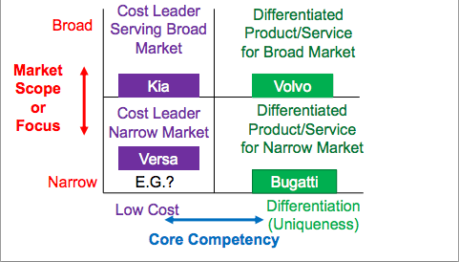

Ways to asses effectiveness
  - Input securing resources
  - Transformation Internal systems and technical approach
  - Output Goal approach

Stakeholders
  - Shaerholders
  - Suppliers
  - Employees
  - Community
  - Government
  - Managers
  - Customers
    - Think about effectiveness in eye of each stakeholder

- Another view of effectiveness

- 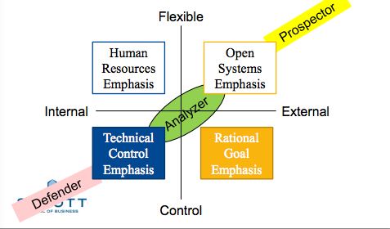

Analyzers Game

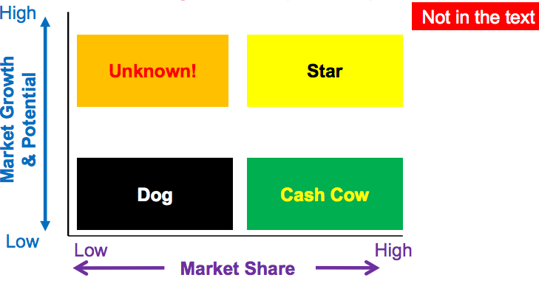

Size of Span of Control
  - Depends on required interactions
    - Skill of Manager
    - Skill of subordinates
    - Technology used for doing work
    - Complexity of structure
      - Higher level in hierarchy results in greater span of control

Problems with tall hierarchies
  - Communication Created primarily from chain of command/unity of command rules superimposed on hierarchy
    - Time
    - Distortion
    - Filtration
  - Motivation of people lower
  - Cost

Problems with flatter hierarchies
  - Authority Veto power, Scope of decisions
  - Responsibility who is accountable for what
  - Specialization(vertical) expertise/Skill

- Horizontal Differentiation People may be at the same level but are differentiated by:
  - Expertise/specialization
  - Education level
  - Orientations Details, opportunity to meet people outside
  - Professional (external/internal Memebership/Loyalty
  - Goals
  - Time Horizons
    - More differentiation creates more need for integration/coordination
  - Typical Horizontal Differentiation
- 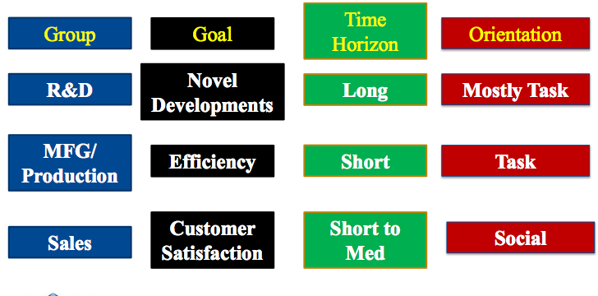

- Two dimensions created by differentiation
  - Hierarchy Vertical
  - Specialization Primarily horizontal

Mechananisms for Integration, Coordination (& Control)
  - Formalization written rules, manuals, forms, etc..
  - Standardization processes
  - Socialization
  - Supervision Sometimes supervision is tighter than socialization
  - Mutual Adjustment
    - Top of list is tighter, bottom of list is looser

  - To sum, differents ways of structuring leads to different dimensions of organizations

- Other structural and tangible/visable integrating mechanisms
  - Integrating Departments
  - Integrating Manager
  - Liaison
  - Comittees
  - Task Force
  - Meetings
    - Top of list is tighter, bottom of list is looser

- Simple Dichotomy
- 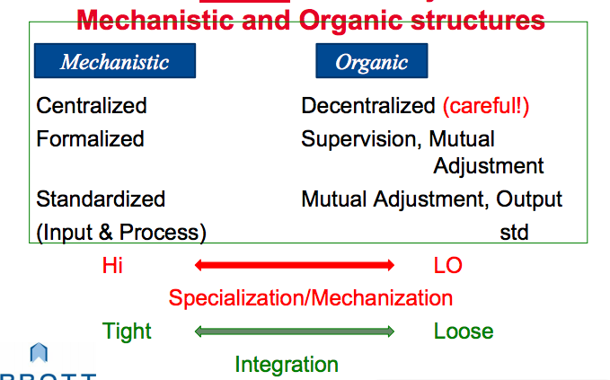

- Structures of Organizations (Oldest/most common to newest)
  - Functional Grouping
    - Pros
      - Develops deep and narrow expertise Can lead to core competency
      - Easy communication with a group
        - Share basic knowledge, terms, etc..
      - Efficient
      - Low Cost
      - Measurement of performance easier within group
    - Cons
      - Goals of organization may get lost focus on fuctional goals
      - Integration with other groups is difficult
        - Communication outside group is hard
        - Too many problems rise up for resolution
      - Measurement of overall performance of the group is difficult
  - Divisional Grouping Product/market/geographic
    - Pros
      - Develop from perspectives of all functions
        - Leads to development of GM’s
      - Communication within group is easy
      - Measurement of performance within group is easy
      - Easy to add/eliminate a group
      - Can grown almost indefinitely
    - Cons
      - Duplication of resources Costly
      - Communication between groups is difficult
      - Transfer pricing problems
      - HQ seen as controllers instead of integrators
      - Less in depth learning on the job than functional structures
  - Matrix
    - Shares different levels of advantages and disadvantages of functional and divisional pros and cons
  - Hybrid (Is this hybrid and matrix the same? confused by his slides)
    - Functional at upper level, Divisional at lower level
    - Cross functional teams, cross divisional managers, etc..
  - Horizontal
    - Rooted in Socio-technical system
    - Offshoot of trend in:
      - Decentralization
      - Empowerment
      - Rising education standards at all levels
    - Team is empowered to make decisions
  - Network Virtual/boundryless
    - Pros
      - Flexible
      - Low overhead
      - Great for projects/products with unknown potential
    - Cons
      - Security
      - Commitment

  - New concept due to modern world
    - Result of increasing competition and globalization
    - Possible by telecommunication technologies and globalization

- Centralization of Decision Making
  - Differences in Expertise and authority (vertical vs. Horizontal)
  - Is a way of differentiating and integrating

Stakeholders
  - Shareholders
    - Agency Theory
  - Suppliers
    - What a company does affects what/how the supplier produces
  - Employees
  - Community
  - Government
  - Customers
  - Managers

Agency Theory
  - Board of Director is empowered by the shareholders (Principals) to govern the management (Agents) to make sure the agents act in the best interest of the principals (which is the best interest of the company)

Comparison of Mechanisms for Integration, Coordination (& Control)
  - Formalization Measures by noting written rules
  - Standardization Standard process of doing something
  - Socialization Norms and Values
    - Bringing someone outside of the organization into it)
    - Propagates culture of an organization
  - Supervision coordination of employees and timing of task

completion
  - Mutual Adjustment between two departments, employees, etc..
    - Takes supervisor out of the game

    - Scale from tight to loose from formalization to Mutual adjustment
      - As you get to mutual adjustment things become more flexible

- Tangible/Visible integrating mechanisms
  - Integrating department Scheduling department
  - Full time integrator Product Manager
  - Direct Contacts
    - Liaison
    - Committee people from different areas of the organization who come together regularly (standing committee)
  - Task Force people from different areas of the organization who come together to achieve a task and then disband
  - Meeting

- A simple Dichotomy
  - Mechanistic
    - Centralized
    - Formalized
    - Standardized
  - Organic
    - Decentralized
    - Supervision, Mutual adjustment
    - Mutual Adjustment, Standard Output

Structures of Organizations – Grouping of Roles
  - Functional Grouping (U-form)
    - Based on skills and expertise
      - Pros
        - Development of narrow and deep expertise
          - Often leads to core competency
        - Communication within group is easy
        - Efficiency
        - Low Cost
        - Easier to measure performance within group
      - Cons
        - Development of functional dub goals
          - Organizational goals may get lost
        - Integration with other groups may be difficult
        - Too many problems rise up for reolution
        - Measurement of overall group performance is difficult
  - Divisional Grouping (M-form)
    - Product
    - Client/Customer
    - Market
    - Geography
      - Pros
        - Development of perspectives of all functions
        - Communication within group is easy
        - Performance is easier to measure per group
        - Easy to add/eliminate a group
        - Can grow almost indefinitely (such was old belief)
      - Cons
        - Duplication of resources
        - Communications and cooperation is difficult in group
        - Transfer pricing problems
        - Head quarters seen as controllers apposed to integrators
        - On job learning is not as in depth as functional structure

  - Matrix Hybrid between Functional and Divisional
    - Takes on both pros and cons of functional and divisional
      - Communication
      - Measurement of performance
      - Ease of addition/elimination of groups
      - What about learning and growing on job
    - Cons
      - Duality of command (what manager has more authority)
      - Conflict over resources
  - Horizontal (Team grouping)
    - Offshoot in trend
      - Decentralization
      - Empowerment
      - Rising education standards at all levels
        - Team is empowered to make decisions
  - Network, Virtual & Boundary-less
    - Internal
    - Dynamic - external
    - Stable
      - Pros
        - Flexible
        - Low overhead (when outsourced)
        - Market price & evidence of competency
        - Great for projects/products of unknown potential
      - Cons
        - Security
        - Commitment

- 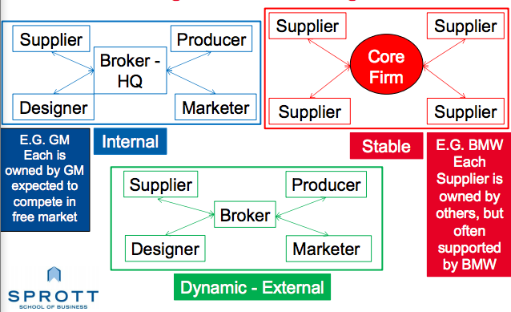

- Organizational Environment All element that exist outside the boundary of the organization that have the potential to affect all or part of the organization
  - Types of Environment
    - Internal Internal to the organization
    - External
      - General environment stability of economy
      - Specific/Task Environment Competitors

- Who in organizations deal with the environment
  - Boundary spanners
    - Those in the company who interact with the environment
      - Marketing, HR, etc..
  - Boundary scanners
    - Used only by our lord & savior, smartest man alive ghandi-pal
      - Look at environment to predict changes
        - Could be a CEO, or shit like that

- Information is the lens used to discuss relationship between the environment and the organization
  - Info used to deal with uncertainty
  - Managers pursue predictability
    - Higher complexity = more uncertainty

Complexity is a function of _____ of elements
  - Number
  - Disparity
  - Strength
    - Knowledge to understand the elements
  - Interaction

2nd Dimension of the environment is Dynamism
  - Dynamism Speed of changes: Stable to unstable ot static to dynamic dimension
    - faster that things change = greater uncertainty

  - Dynamism leads to more
    - Mutual Adjustment
    - Power Differential
    - Lack of Formalization
    - Verbal Communication
      - Impromptu meeting

- Contingency Theory

- 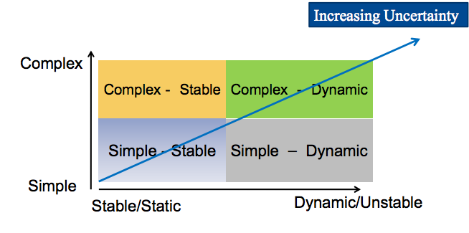

- Simple-Stable Coke
- Simple-Dynamic Fashion, Toys
- Complex-Stable University
- Complex-Dynamic Mobile Phone

  - Different Structures are effective in different environments
- 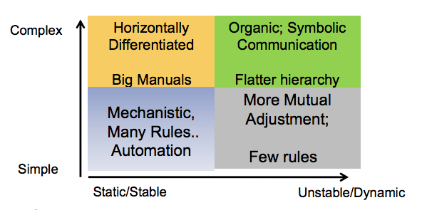

- 3rd Dimension - Richness (Rich-Poor dimension)
  - How bountiful is the environment
    - Customers, raw material, HR, capital, etc..

- - For all Dimensions, the poorer the environment, the greater the competition leading to attempts to influence the environment

- Strategies for controlling the external environment
  - Establish formal relationship
    - Acquire ownership stake
    - Joint ventures and partnerships
    - Lock in key players
    - Recruit executives
  - Influencing the environment
    - Change where you do business
    - Political activity to influence regulations
    - Join or form trade associations
    - Illegitimate activities

- Paradoxical Twins Acme and Omega

No idea whats good in the slides about this glennard, sorry bawd

Inter-organizational interdependanceis

Resource dependency Theory

Organizations seek..
  - Minimize dependence on other organizations
    - Supply/access to scarce resources in the environment
  - Find ways to influence environment
    - Make resources available
  - Respond to need of other orgs
    - Make other orgs depend on them
      - As much as possible (hard to do)

- Two kinds of Inter-dependencies
  - Symbiotic
  - Competitive
  - Resource based arguments lead to various
    - Resource strategies
    - Power strategies

- Strategies for Symbiotic relations
  - Develop good reputation
  - Co-optation
  - Interlocking directorate
  - Strategic Alliances
    - Long term contracts, minority ownerships, joint ventures
  - Mergers, Takeovers, Joint Ventures

    - Top of list is most informal, bottom of list is most formal

Strategies used in competitive relations
  - Collusion Always illegal
  - Cartel Often illegal
  - Third party linkage
  - Strategic alliances Networks, Joint ventures, etc..
  - Mergers and takeovers
    - Top of list is most informal, bottom of list is most formal

Institutionalism why so some structures/behaviors get institutionalized/adopted

- Population Ecology Framework that looks at organizations from a macro view
  - Considers a set of organizations and studies them
    - As done in biology, apparently. Shut up shibu…

- Organization Ecology Model
- 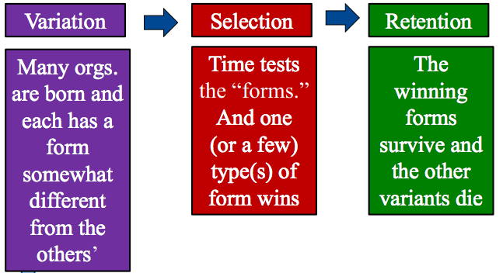

3 ways for organizational convergence
  - Mimetic
  - Coercive
  - Normative

- 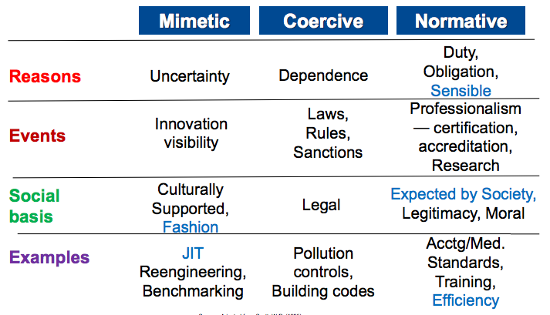

Transaction Costs
  - Another way to measure inter and intra organizational relations and behaviors

  - Transactions are
    - Buying
    - Selling
    - Collaborating Alliances, joint ventures, etc..
    - Group decision making lobbying
  - Transaction costs are defined by
    - Time
    - Money
    - Frustration
    - Acrimony
  - Sources of Transaction Costs
    - Nature of people
      - Cheating
      - Distrusting
      - Forgetting
      - Bounded Rationality
  - Ways to reduce transaction costs
    - Locate source of TC
      - Does it affect exchange relationship
      - How high are the TC’s going to be
    - Estimate TC savings by using different linkages
    - Estimate administrative costs of operating linkages
    - Choose the linkage that gives the most TC savings and the lowest bureaucratic cost

Changing characteristics of Collaborative Networks

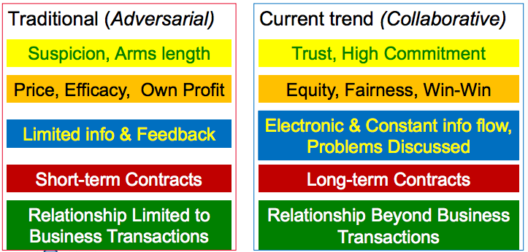

Sources of problems for principals
  - Asymmetry of information
  - Differences in goals/interests
    - Problems and solutions are the focus of agency theory

- 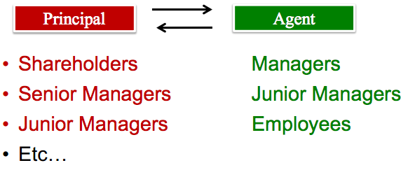

  - Solution to above is governance/control mechanisms
    - BOD, Inventory controls, cameras, etc..

- Agency theory
- 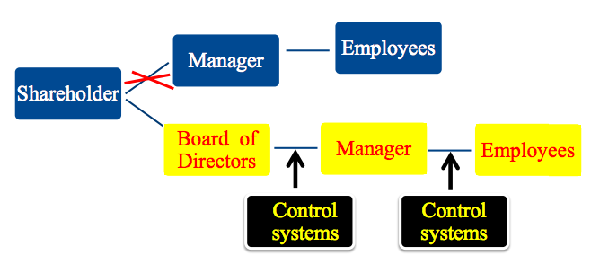

- Why go International
  - Economies of Scale
    - Economy of scope: Input transformation Output

  - Problems
- 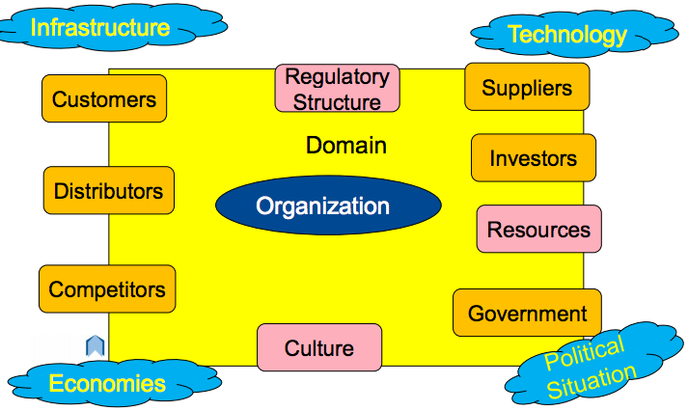

- Root of Complexity & Differentiation
  - Culture
    - Power Distance
    - Individualism
    - Uncertainty Avoidance

- Building Global Capabilities
  - Global Organizational Challenges
    - Increased complexity and differentiation
    - Need for Integration
    - Knowledge Transfer
  - Global Coordination Mechanisms
    - Global teams & networking
    - Headquarters planning
    - Expanded coordination roles
  - Designing Structure to fit global strategy
    - Balancing the needs for..
      - Differentiation
      - Integration
      - Knowledge Transfer
    - International Division
      - Global Product Structure
      - Global Geographic Structure
      - Global Matrix Structure

- Approaches to Globalization
  - Strategy Based on Differentiation (Multi-Domestic)
    - No formula Each countries operation is independent based on reality of that country
  - Strategy Based on Standardization
    - Product design, manufacturing and marketing standardized worldwide

- Different Structures provide different advantages
- 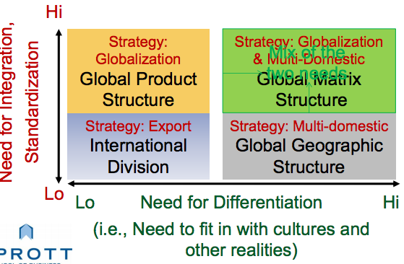

- Transnational Structure
- Giant MNC’s looking for
  - Global Efficiency
  - Global Organizational Learning
  - National Responsiveness

- Stages of Globalization
- 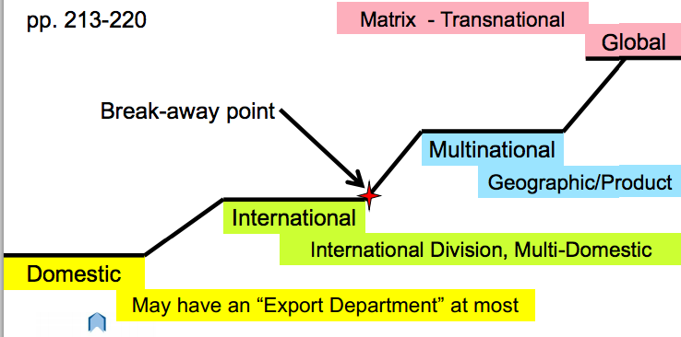

- Two ways to look at Globalization
  - Stages of Evolution
    - Domestic
    - International Dep’t./div.: Multi-Domestic
    - Multi National
    - Global
  - Levels of Strategies
    - Functional
    - Business (Also known as SBU)
    - Corporate
    - Global
      - These lists do not correspond 1 to 1

- Corporate level of Strategy: Diversification
  - Vertical Integration
- 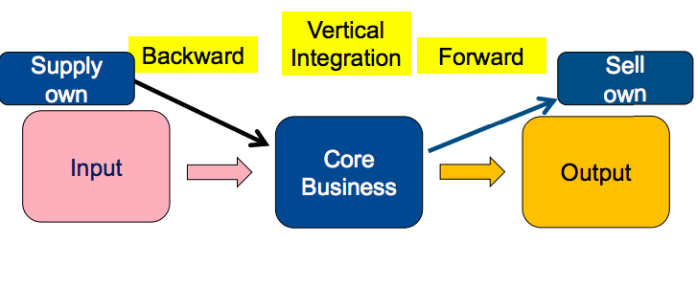
  - Horizontal Integration
- 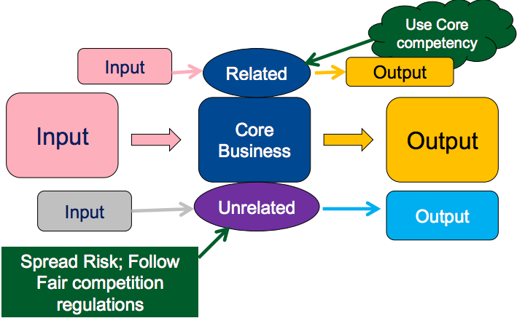

  - Vertical and Horizontal Integration’s extensions: Internationalization

- Leveraging Core Competencies for Strategy Works in a loop kind of
  - Ability to obtain scarce resources
    - Helps Develop Competencies
      - Core competencies provide competitive advantages

This helps ability to obtain scarce resources
        - Core competencies and competitive advantages help the organization grow

Leveraging Core competencies another loop, kind of
  - Transfer Core competencies abroad
    - Establish International Network
      - Access International Talents and resources
        - Leverage learning to gain more competencies

Transfer knowledge and begin process again

  - Leads to transfer of core competencies multi-nationally/globally

- Progression of Strategies (especially in developing Countries)
- 

