- The Ten Principles of Economics:

1. People face tradeoffs:
- -Individuals face tradeoffs everyday
- -Society faces tradeoffs as well:
- -Efficiency versus equity
- -National defense versus consumer goods
- -Current versus future consumption

- 2 The cost of something is what you give up to get it:
- -Making decisions requires comparing the costs and benefits of alternative choices.

- 3 Rational people think at the Margin:
- Rational people:
- -Systematically and purposefully do the best they can to achieve their objectives.
- -Make decisions by evaluating costs and benefits of marginal changes – incremental adjustments to an existing plan.
- -Look forward, not backwards.

- 4 People respond to incentives:
- Incentive: something that induces a person to act, i.e. the prospect of a reward or punishment.

- 5 Trade can make everyone better off:
- -Rather than being self-sufficient, people can specialize in producing one good or service and exchange it for other goods.
- -Countries also benefit from trade and specialization.

- 6 Markets are usually a good way to organize economic activity:
- -Market: a group of buyers and sellers (need not be in a single location.)
- - A market economy allocates resources through the decentralized decisions of many households and firms as they interact in markets.
- -Famous insight by Adam Smith in The wealth of Nations (1776) “Each of these households and firms acts as if led by an invisible hand.”

- 7 Governments can sometimes improve market outcomes:
- -Government enforces property rights.
- -Public policy may promote efficiency.

- 8 A country’s standard of living depends on its ability to produce goods and services.
- The most important determinant of living standards productivity, the amount of goods and services produced from each hour of a workers time.

- 9 Prices rise when the government prints too much money.
- Inflation: increases in the general level of prices.

- 10 Society faces a short-run tradeoff between inflation and unemployment.
- This simply means that, over a period of a year or two, many economic policies
- The fundamental lessons about individual decision making are:
- That people face tradeoffs among alternative goals
- The cost of any action is measured in terms of forgone opportunities
- That rational people make decisions by comparing marginal costs and marginal benefits
- People change their behavior in response to the incentives they face
- The fundamental lessons about interactions among people are:
- Trade can be mutually beneficial
- Markets are usually a good way of coordinating trade among people
- The government can potentially improve market outcomes if there is some market failure or if the market outcome is inequitable.
- The fundamental lessons about the economy as a whole are:
- Productivity is the ultimate source of living standards
- Money growth is the ultimate source of inflation
- Society faces a short-run tradeoff between inflation and unemployment

- The First Model: The Circular-Flow Diagram.
- A visual model of the economy shows how dollars flow through the economic system.

- The Second Model: Production Possibilities Frontier.
- Model explains scarcity, choice/tradeoffs, and efficiency.
- Outside of line means impossible i.e. do not have resources.
- Below the line is inefficient.
- Technological change in one product can affect both products.
- PPF is bow-shaped because workers have different abilities and skills.

- Assumptions and Models:
- Assumptions simplify the complex world make it easier to understand.
- Unrealistic, but simple to learn and gives useful insights about the real world.

- Opportunity Cost:
- Opportunity cost = slope of PPF. Change in Y/ Change in X = Opportunity Cost.

- Difference between Micro and Macroeconomics:
- Microeconomics is the study of how households and firms make decisions and how they interact in markets.
- Macroeconomics is the study of economics-wide phenomena, including inflation, unemployment and economic growth.

- Positive and normative statements:
- Positive: a statement based on fact and can be refuted.
- Normative: a statement on how the world should be.

- Disagreements:
- Economists who advise policymakers offer conflicting advice either because of differences in scientific judgments or because of differences in values.

- Example of the benefits of trade:

- Two Countries: Canada & Japan
- Two Goods: computers & wheat
- One Resource: Labor, measured in hours.

- Canada has 50,000 hours of labor available for production per month.
- Producing one computer requires 100 hours of labor. Producing one ton of wheat requires 10 hours of labor.
- Japan has 30,000 hours of labor available per month.
- 125 hours to produce 1 computer, 25 hours to produce 1-ton wheat.

- Absolute advantage: the ability to produce a good using fewer inputs than another producer. Canada has an absolute advantage in wheat: producing a ton of wheat uses 10 labor hours in Canada vs. 25 in Japan. (The amount of labor)

- The opportunity cost of a computer in our example is the amount of wheat that could be produced using the labor needed to produce one computer.

- Comparative Advantage: the ability to produce a good at a lower opportunity cost than another producer.

- Trade makes everyone better off because it allows people to specialize in those activities in which they have a comparative advantage.

- Demand:
- The law of demand states that as the price of a good falls, the quantity demanded rises.
- The demand curve shows how price affects quantity demanded, other things being equal.
- These “other things” are determinants of demand other than the good’s price. Examples:
- Income (normal and inferior goods),
- Prices of related goods (complements & substitutes),
- Tastes,
- Expectations,
- Number of buyers.
- Changes in all of these shift the demand curve.
- Supply:
- The supply curve shows how price affects quantity supplied, other things being equal.
- These “other things” are determinants of supply other than the goods price. Examples:
- Technology,
- Input prices (wages, prices of raw materials),
- Expectations,
- Number of sellers.
- Changes in all of these shift the supply curve.

- Surplus: When quantity supplied is greater than quantity demanded.
- Shortage: When quantity demanded is greater than quantity supplied.

- Three steps to analyzing changes in equilibrium:
- Decide whether event shifts S curve, D curve, or both.
- Decide in which direction curve shifts.
- Use supply-demand diagram to see how the shift changes equilibrium price (P) and quantity (Q) .
- Change in supply = shift.
- Change in the quantity supplied = movement along curve.
- Change in demand = shift.
- Change in the quantity demanded = movement along the curve.

- Example:
- Demand for Hybrid Cars:
- Event to be analyzed: Increase in price of gas.
- Step 1: D curve shifts.
- Step 2: D shifts right because high gas prices decrease the demand for normal cars- a substitute of hybrid cars.
- Step 3: Equilibrium Price goes up, Equilibrium Quantity goes up.

- Ultimately, in market economies prices are the signals that guide economic decisions and thereby allocate scarce resources. For every good in the economy, the price ensures that supply and demand are in balance. The equilibrium price then determines how much of the good buyers choose to purchase and how much sellers choose to produce.
- Summary of Elasticities:

- Price Elasticity:

- Demand Elasticity: %∆ Q demanded ∕ %∆Price
- Even though we know it is always negative, the convention is to drop the minus sign
- Measures responsiveness of quantity demanded to price change
- Determines degree of steepness in demand curve
- The slope of a linear demand curve is constant, but its elasticity is not.
- The determinants of price elasticity of demand:
- 1. The extent to which close substitutes are available.
- 2. Whether the good is a necessity or luxury
- 3. How broadly or narrowly the good is defined. Example: food is inelastic, but chocolate ice cream is elastic.
- 4. The time horizon – elasticity is higher in the long run than the short run. Short run = inelastic, Long run = elastic.

- Supply Elasticity: %∆ Q supplied ∕ %∆ Price
- Sign is positive, reflecting positive relation between price and quantity supplied
- Measures responsiveness of quantity supplied to price change
- Determines degree of steepness in the supply
- The determinants of price elasticity of supply:
- Generally, elasticity is larger in longer term than in short-term

- If zero, then perfectly inelastic – An increase in price, leaves the quantity supplied unchanged.
- If between zero and 1, then inelastic – For example: A 22% increase in price, leads to a 10% increase in quantity supplied.
- If 1, then unit elastic – For example: A 22% increase in price leads to a 22% increase in quantity supplied.
- If greater than 1, then elastic – For example: A 22% increase in price leads to a 67% increase in quantity supplied.

- Income Elasticity: %∆ Q demanded ∕ %∆ in Income
- If less than zero, then an inferior good
- If greater than zero, then normal good
- If greater than 1, then luxury good

- Cross-price Elasticity: % ∆ in Q demanded of one good ∕ % ∆ in price of another good
- If negative, then two goods are complementary
- If positive, then two goods are substitutes

- Relation of Demand Elasticity to Total Revenue/Total Expenditure:
- If less than 1 (inelastic), price increases/decreases lead to an increase/decrease in total revenue/expenditure
- If greater than 1 (elastic), then price and total revenue/expenditure move in opposite directions
- If equal to 1, then price changes do not change total revenue/expenditure

- Example:
- 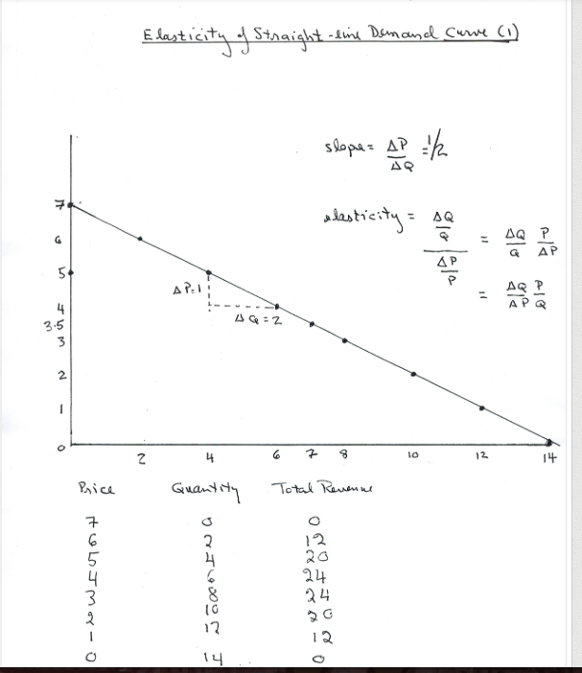
- Example:
- 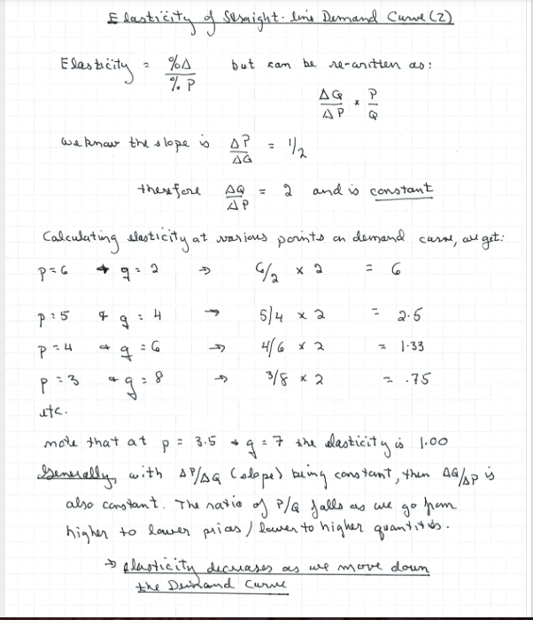
- Example of Mid-point method:
- 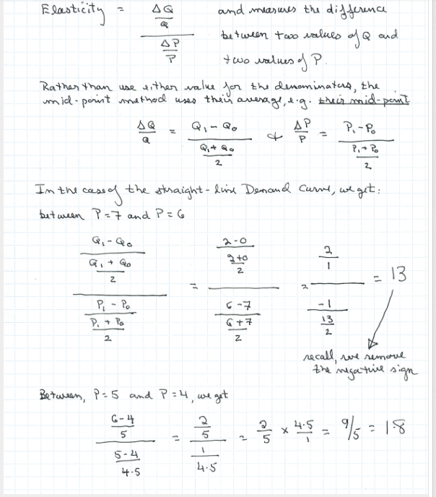
- Price Ceiling: A legal maximum on the price at which a good can be sold.
- Price Floor: A legal minimum on the price at which a good can be sold.
- How Ceilings Affect Market Outcomes:
- If the equilibrium price is below the ceiling, the ceiling is “not binding.” The ceiling has no effect on the market.
- If the equilibrium price is above the ceiling, the ceiling is a “binding constraint.” The market price becomes the price ceiling; this can create a shortage if the Quantity demanded exceeds the Quantity supplied.
- Examples on page 121.
- How Price Floors Affect Market Outcomes:
- If the equilibrium price is above the floor, the floor is not binding. The floor has no effect on the market.
- If the equilibrium price is below the floor, the floor is a binding constraint. The market price becomes the price floor; this can create a surplus, if the quantity supplied exceeds the quantity demanded.
- Tax Incidence: The manner in which the burden of a tax is shared among participants in a market.
- Taxes on Buyers, Market Outcomes:
- The demand curve shifts as buyers must now pay a tax as well as the regular price; the supply curve stays the same as the incentives for sellers haven’t changed.
- The demand curve shifts left (down) as buyers demand a smaller quantity of ice cream at every price (as they are now paying the effective price, i.e. market price + tax.)
- Buyers buy less; sellers sell less: therefore the tax reduced the market for that particular good.
- Because the market price fails: sellers receive less for every good sold, while buyers will pay more.
- Taxes discourage market activity, reduces the quantity of goods sold.
- Examples on page 132.
- Taxes on Sellers, Market Outcomes:
- The supply curve shifts as with the added tax. With the tax, the good is no longer as profitable per sale. The demand curve stays the same as the quantity demanded at any price is not affected.
- The tax on sellers increases production costs of the good, reducing quantity supplied at any price, the supply curve sifts left(up).
- Implications: If you tax the buyer or the seller both will pay, no matter who the tax is implemented on.
- Elasticity and Tax Incidence:
- If the supply curve is elastic and the demand curve inelastic, then the price received by sellers falls slightly and the price buyers pay rises substantially (buyers bear most of the tax burden.)
- If the supply curve is inelastic and the demand curve elastic, then the price received by sellers falls substantially and the price paid by buyers rises slightly (sellers bear most of the tax burden.)
- If supply is more inelastic, sellers pay more of the tax. If demand is more inelastic, buyers pay more the tax.
- Examples on page 137.
- Willingness to Pay: The maximum amount that a buyer will pay for a good.
- Consumer Surplus: Buyer’s willingness to pay minus what they actually pay.
- Marginal Buyer: Buyer who would leave the market first if the price rises.
- Using the Demand Curve to Measure Consumer Surplus: The area below the demand curve, above the price measures Consumer Surplus. (a lower price increases consumer surplus.)
- Producer Surplus: Amount a seller is paid minus the seller’s cost (benefit to sellers.)
- Cost: Value of everything a seller must give up to produce a good.
- Using the Supply Curve to Measure Producer Surplus: The area below price, above the supply curve measures producer surplus (a higher price raises producer surplus.)
- Marginal Seller: Seller who would leave the market first if price falls.
- Market Efficiency:
- Consumer surplus and Producer surplus are tools to measure the welfare of buyers and sellers.
- Total Surplus equals (Buyers Willingness To Pay) – (Cost To Sellers.)
- Efficiency: is when resource allocation is maximizing the total surplus received by all members of society.
- Equity: the fairness of the distribution of well-being among he members of society.
- Evaluating Market Equilibrium:
- 1. Free markets allocate the supply of goods to the buyers who value them most highly (measured by their willingness to pay.)
- 2. Free markets allocate the demand for goods to the sellers who can produce them at least cost.
- 3. Free markets produce the quantity of goods that maximize the sum of consumer surplus and producer surplus i.e. total surplus.
- Deadweight Loss: The fall in total surplus that results from market distortion, such as taxes. Taxes prevent buyers and sellers from realizing some of the gains from trade.
- Determinants of Deadweight Loss: They are based on the price elasticities of supply and demand.
- Examples:
- Inelastic Supply: Deadweight loss is small
- Elastic Supply: Deadweight loss is large
- Inelastic Demand: Deadweight loss is small
- Elastic Demand: Deadweight loss is large
- The greater the elasticities of supply and demand, the greater the deadweight loss will be.
- Deadweight Loss and Tax Revenue:
- Tax Revenue:

- Externality: The uncompensated impact of one person’s actions on the well-being of a bystander.
- *** Externalities cause markets to allocate resources inefficiently. ***
- Negative Externality: Has adverse effect on bystander.
- Positive Externality: Has positive effect on bystander.
- How the government improves market allocation? They are able to do this because some decision maker fails to take account of the external effects of his or her behavior. The government responds by trying to influence this behavior to protect the interests of the bystanders.
- How does a negative externality affect the efficiency of the market outcome? Because the cost to society is larger than the cost to produce the item. This “social cost” includes the private costs of the producers plus the costs to the bystanders who were adversely affected.
- What quantity should be produced? When the social cost curve and the demand curves intersect, this reaches the “optimal point.”
- Internalizing the externality: alter incentives such as taxes (negative) or subsidies (positive) so that people take account of the external effects of their actions.
- To summarize: Negative externalities lead markets to produce a larger quantity than is socially desirable. Positive externalities lead markets to produce a smaller quantity than is socially desirable. To remedy the problem, the government can internalize the externality by taxing goods that have negative externalities and subsidizing goods that have positive externalities.
- There are two ways a government can respond to externalities:
- 1. Command and Control Policies: This method regulates behavior directly. They do this by making certain behaviors required or forbidden. For example, it is a crime to dump poisonous chemicals into the water supply. In this case, the external costs to society far exceed the benefits to the polluter.
- 2. Market-Based Policies: provide incentives so that private decision makers will chose to solve the problem on their own.
- The Coase Theorem: the proposition that if private parties can bargain without cost over the allocation of resource, they can solve the problem of externalities on their own. Ultimately, The Coase Theorem says that private economic actors can solve the problem of externalities among themselves. Whatever the initial distribution of rights, the interested parties can always reach a bargain in which everyone is better off and the outcome is efficient.

- Excludability: The property of a good whereby a person can be prevented from using it. “Can people be prevented from using the good?”
- Rival in Consumption: The property of a good whereby one person’s use diminishes other peoples use. “Does one person’s use of the good diminish another persons ability to use it.”
- Four types of goods:
- 1. Private Goods: Goods that are both excludable and rival in consumption. Examples include: Ice-cream cones, clothing and congested toll roads. Most goods are private goods.
- 2. Public Goods: Goods that are neither excludable or rival in consumption. Examples include: Tornado siren, national defense, and uncongested non toll roads.
- 3. Common Resources: Goods that are rival but not excludable. Examples: Fish in the ocean, the environment, and congested non toll roads.
- 4. Natural Monopolies: When a good is excludable but not rival. Example: Cable TV, and Fire protection.
- The study of common and public goods is closely related to externalities. This is because externalities arise because something of value has no price attached to it. For example, if one person provides a public good, other people would be better off, thus causing a positive externality. Another example is if somebody uses a common resource such as fish in the ocean, other people are now worse off because they have less fish to catch, creating a negative externality.
- Free Rider: a person who receives the benefit of a good but avoids paying for it.
- If there is an incentive to be a free rider rather than a buyer, the market will fail.
- The 3 Most Important Public Goods: 1.National Defense. 2. Basic Research. 3. Fighting Poverty.
- In deciding whether something is a public good, one must determine the number of beneficiaries and whether these beneficiaries can be excluded from using the good. A free rider problem arises when the number of beneficiaries is large and exclusion of any one of them is impossible. For example, if a lighthouse benefits many ship captains, it is a public good. Yet if it primarily benefits a single port owner, it is more like a private good.
- Cost-Benefit analysis: A study that compares the costs and benefits to society of providing a public good.
- Tragedy of the Commons: A parable that illustrates why common resources get used more than is desirable from the standpoint of the society as a whole.
- The Tragedy of the Commons is a story with a general lesson: When one person uses a common resource, that person diminishes other peoples enjoyment of it. Because of this negative externality, common resources tend to be used excessively. The government can solve the problem by reducing use of the common resource through regulation or taxes. Alternatively, the government can sometimes turn the common resource into a private good.
- Three Important Common Resources: 1. Clean air and water. 2. Congested Roads. 3. Fish, Whales and other Wildlife.

- Budget Deficit: An excess of government spending over government receipts.
- Budget Surplus: An excess of government receipts over government spending.
- An efficient tax system is one that imposes small deadweight losses and small administrative burdens.
- If total surplus has fallen by more than the tax revenue, the tax has a deadweight loss.
- Tax Efficiency:
- Average Tax Rate: Total taxes paid divided by total income.
- Marginal Tax Rate: The extra taxes paid on an additional dollar of income.
- If we are trying to gauge the sacrifice made by a taxpayer, the average tax rate is more appropriate because it measures the fraction of income paid in taxes.
- Although if we are trying to gauge how much the tax system distorts incentives, the marginal tax system is better.
- The marginal tax rate determines the deadweight loss of an income tax.
- Lump-sum Tax: a tax that is the same amount for every person.
- Lump-sum taxes are the most efficient because there is no administrative burdens and no deadweight losses. The reason it is not in place is many places is because although it is very efficient, it is not equitable.
- Tax Equity:
- Benefits Principle: The idea that people should pay taxes based on the benefits hey receive from government services.
- Ability-to-pay principle: the idea that taxes should be levied on a person according to how well that person shoulder the burden.
- Vertical Equity: the idea that taxpayers with a greater ability to pay taxes should pay larger amounts.
- Horizontal Equity: the idea that taxpayers with similar abilities to pay taxes should pay the same amount.
- Proportional Tax: a tax for which high-income and low income taxpayers pay the same fraction of income.
- Regressive Tax: a tax for which high-income taxpayers pay a smaller fraction of their income than do low-income taxpayers.
- Progressive Tax: a tax for which high-income taxpayers pay a larger fraction of their income than do low-income taxpayers.
- Flypaper Theory: the burden of a tax, like a fly on flypaper, sticks wherever it first lands. Rarely valid.

