Wednesday, October 23rd, 2013
Communicating and Finding Research
Communication facilitates:
- Information growth
- Application of ideas
- Assessments of quality
Research is reported in a variety of formats in a variety of contexts:
- Talks at conferences
- Posters
- Research reports psychology journals

APA FORMAT
- The APA format is the style that psychologists use to communicate their results
- APA= American Psychological Association
Why have a set format for communicating research results?
- With format held constant, people can focus on the ideas and results
- To better communicate results in a clear, efficient, and unbiased fashion
- APA style is formal, the language should be unbiased and clear and the published work should be cited

WHAT DOES AN ARTICLE LOOK LIKE?
- Includes a title, author’s name & affiliation, summary paragraph, the paper
- Summary paragraph= abstract (150-200 words)
- Introduction: situate research question in larger literature (background literature)—cite work in the area
  - Provides rationale and purpose for research study (why is this research article important; how it will help advance knowledge)
  - List the hypotheses
- Sources:
  - Secondary sources: description or summary of someone’s work
Ex. media report of a study; introduction in journal that refers to another researcher’s research
  - Primary sources: first hand reports of results or observations
Ex. journal article or book
- Method: provides a detailed description of what was done; the recipe for the study.
  - Participant’s characteristics (number, mean age, reported cultural background etc.)
  - Material/apparatuses used (questionnaires, heart rate monitors, hot sauce, Wii game etc.)
  - Procedure, describes the set-up
- Results: summary of the data and data analysis techniques
Ex. means, median, mode, correlations, standard deviation, alpha level, t test, F tests, chi-square tests
- Discussion: summarizes the results and discuss the implications and limitations of the findings
- References: all references cited in research report; listed alphabetically, by the last name of the first author
Ex. Paraphrasing an article: However, in recent years, scholars have suggested that dissatisfaction can result not only from the presence of negativity in a relationship, but also from the loss of positivity (Gable & Reis, 2001).
Ex. Quoting an article: Indeed, Aron and Aron (1986) have claimed that “boredom is the major underrated, under-treated obstacle to lasting love” (p. 91).

FINDING RESEARCH CLAIMS
- You just don’t want to take any research claim that you read or hear as truth. You want to be able to assess the quality of the claim
- As a general rule, it is best to look for the primary sources of the research claims
HOW DO YOU FIND PRIMARY SOURCES IN SYCHOLOGY?
- Google scholar
- Using psychInfo database to find a primary source in:
  - Journal/articles
  - Books/edited chapters
  - Theses
Monday, November 4th, 2013
Tools for Evaluating Causal Claims
- When a researcher makes causal claims, there are word’s used such as:
  - Causes
  - Affects
  - Makes
  - Influences
Ex. Messy desks make you more creative
- Experiments allow researchers to assess causal claims

FEATURES OF AN EXPERIMENT
Independent variable (IV): at least one variable is manipulated or varied by the experimenter; hypothesized cause (what comes first)
- Situational: different features of the environment
Ex. lighting, gender of experimenter, clothing of the experimenter, ink colour, objects present in a room, desk environment etc.
- Task: asked to do different tasks
Ex, play different videogames, recollect memories of being excluded
- Instructional: asked different groups of participants to perform the same task in different ways
Ex. asked to focus on facts vs. asked to imagine how it feels in that situation
- In a typical psychology experiment, there are at least two levels of an independent variable (at least one comparison group)
Ex. IV- lighting in a room 2 levels of lightness: dark and normally lit;
- There does not just have to be two levels; there can be 3, 4, 5, 6 and so on
Ex. Tactile temperatures 3 levels (hold hot cup of coffee, hold lukewarm cup of coffee, hold iced cup of coffee)
Ink colour ink colour (red, green, black)
- A researcher has to be mindful not to have too many levels or otherwise, it becomes unmanageable to analyze and conduct the study.
- It also becomes more likely to confuse levels of the independent variables with the independent variable itself
Ex. in Elliot study, the IV was pen colour and there were three conditions (red, green and black ink)
Dependent variable (DV): measured variable; hypothesized effect (comes after the independent variable)
- Any variable that differs in quantity or quality and can be measured
Ex. how many times does a person stutter during speech, heart rate, attitudes about racism, creativity with ping pong ball use, activity level, productivity, persistence
Extraneous variables (EV): all other variables are controlled (it is one method of the key features of the scientific method)
Ex. Bushman catharsis study was an experimental claim and I used it to explain a feature of the scientific method in an earlier lecture, namely control. Everyone was made angry in the same way for the same amount of time, by the same person. All groups did their respective task for two minutes. All played the same quiz game, all had the same number of times to aggress against Steve.
Placebo effect: is a simulated or otherwise medically ineffectual treatment for a disease or other medical condition intended to deceive the recipient (sugar pill)

What controls would you implement?
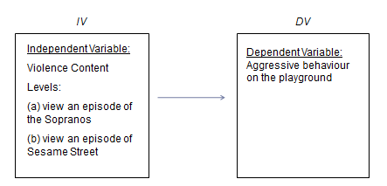
Premeasuring levels of aggression
Finding two episodes that are the most different:
Manipulating the episodes: a regular version of sesame street vs. sesame street acting out like the sopranos.
Keep the length of the shows the same

Wednesday, November 6th, 2013
Basic Experimental Design: Between and Within
There are generally two designs that a researcher can choose from when using the experimental strategy:
- Between-Subjects: examines if differences in the dependent variable exist between two or more levels of the independent variable
- Different groups of people associates with each level of the independent variable
- Two different groups of people
- Advantages of Between Subjects: each individual score is independent of other scores (each participant enters the study fresh and naïve with respect to the procedures being tested
- Disadvantages of Between Subjects: require relatively large number of participants; pre-existing individual differences (characteristics that differ between participants at the beginning of the experiment (extraneous variable)
- Within-Subjects: examine if differences in the dependent variable exist between two or more levels of the independent variable
- Same group of participants in all the levels of the independent variable (exposure time to objects and recognition ability)
- One group experiencing two levels
- Advantages of Within Subjects: need fewer participants; eliminates problems of individual differences (problem in between-subject designs); no differences between groups in terms of individual differences because only one group of participants
- Disadvantages of Within Subjects: series of treatment conditions administered at different times; order-related factors may influence score (practise, fatigue, aftertaste) ex. caffeine study

BETWEEN-SUBJECTS DESIGN VS. WITHIN-SUBJECTS DESIGN
Ex. between-subject design
- Does sugar lead to greater activity levels in children?
- Design experiment
- Independent variable- sugar given to participants, 3-levels: artificial sweetener, 10 g, 40 g
- Dependent variable- activity level during dance video game

EXTERNAL VALIDITY
- Generalizability of the results
- Degree to which obtained results hold true outside the constraints of the study
- Populations, environments, measurements, and times
- External validity is based on how participants are recruited and tested rather than how many of them were recruited
- Threat to external validity- any factor that limits the generalizability of research results
Examples include:
- Generalizing across participants or subjects: do the findings generalize to the population of interest
- Several issues when considering whether research claims generalize to the population of interest
  - Convenience samples: sampling procedures favour selection of some individuals over others; one popular form of selection bias is the use of university/ college students—easily available, characteristics limit generalizability to other adults- highly select group (age, education, socioeconomic status)
  - Volunteers: individuals who choose to volunteer may be systematically different than those who didn’t volunteer (ex. more educated, higher social class, more intelligent, more sociable.
  - Cultural differences: research conducted with North Americans might not necessarily apply to people living in Japan
  - Species differences: research conducted on non-humans does not necessarily apply to humans; need to consider similarities and differences between species.
- Generalizing to the real world: ecological validity- extent to which a study mimics the real world
- Generalizing across features of the study
- Generalizability across response measure
  - Variables can be defined and measures in different ways
  - Limited by specific measurement
  - May not generalize to other definitions or measures
- Time of measurement
- Measurement at a specific time after (during) treatment
- Actual effect of treatment may decrease or increase with time
- Results may differ depending on the time of measurement
Ex. extent of generalizability might only be a few seconds, minutes, a day, a week
- Experimenter characteristics
- To what extent can the results of the study be generalized to other experimenters
- Results of study can be specific to an experimenter with certain set of characteristics
- Demographics- age, race, gender
- Personality- degree of friendliness, prestige, anxiety, hostility
Mon Nov 11th& Wed Nov 13th, 2013
Internal Validity
Internal validity is the control of extraneous variables.
Internal validity is also a specific issue for experiments (causal claims)
Examples of extraneous variables are:
- Individual differences in mood, personality, culture, age, gender and so on
- Time of day and date when experiment takes place
- Environment where the experiment takes place
- Experimenters
- Materials used in study (e.g., type of video, type of questionnaire)
One variable can potentially be a problem for both external and internal validity (type of expiraments)
Types of extraneous variables: unsystematic vs. systematic
Unsystematic variables
(“Regular bad kind”)
Extraneous variables
(“unwanted variability”; anything besides the independent variable and the dependent variable)
Systematic variables
(“Really bad kind”)
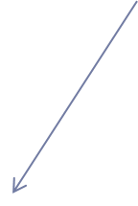

Unsystematic Variability: the extraneous variables are spread relatively evenly across all levels of the independent variable. (There are no patterns in the way they are distributed
Ex, Assessing the violence content of video games and how they affect aggression levels
IV- content of video games
DV- aggression
EV- Time of day: Playing a violent video game at different times of days (morning, evening, night)
….some of the participants play both non-violent and violent video games in the morning, some in the afternoon and some at night.
THE EXTRANEOUS VARIABLES ARE SPREAD OUT EVENLY.
Systematic Variability (confounds): extra variable systematically—piggy-backing—on levels of the independent variable and influencing the dependent variable.
Ex. Caffeine and attention span study (the environment)
IV caffeine levels (caffeinated vs. decaffeinated)
DV attention span
EV- the environment
….all the caffeinated students go to Starbucks and the decaffeinated students go to the library and then see who got the most work done. THE EXTRANEOUS VARIABLE IS NOT SPREAD OUT EVENLY.
Provides an alternative explanation for the results and threaten the quality of your claim
- Unsystematic variability can hinder the results but, for the most part, this is acceptable variability (i.e., will still get published).
- Systematic variability in a true experiment provides a strong reason not to publish the research (i.e., the cause in the claim is in question).
- Issues of internal validity (i.e., controlling for confounds) apply to both between-subjects and within-subjects experimental designs
- There are some confounds that apply to both between-subjects and within-subjects designs--environmental variables.
- There are other confounds that are unique to each design
- Between-subjects design- individual differences
- Within-Subjects design-- order effects
ENVIRONMENTAL VARIABLES AS CONFOUNDS
- This is where some aspect of the environment, that is not the independent variable, is systematically different for each level of the independent variable
Ex. effects of caffeine on attention span study where the researcher mistakenly has everyone in the caffeine condition complete task in
noisy coffee shop and everyone in the no caffeine condition complete in quiet library.
- Noisy environment as an environmental confound
Is a concern for a between-subjects design AND a within-subjects design
Ex. Researcher wants to examine the effects of happy mood on helping strangers with a sample of 100 people recruited through SONA.
IV- Mood (2 levels: happy vs. sad)
DV- Helping strangers
….People listening to the sad song about helping are helping people more than the happy song about gummy bears. It may not be the beat but rather the lyrical content

WHAT DO YOU THINK AN ALTERNATIVE EXPLANATION FOR THE RESULTS CAN BE
- Internal validity concerns also differ based on the type of experimental design (confounds come in different forms)
  - Some confounds are unique to between-subjects and others are unique to within-subjects design
- Between-subject designs have a different group of people representing each level of the independent variable.

THREATS TO INTERNAL VALIDITY FOR BETWEEN-SUBJECT DESIGNS
- 2 major sources of confounding for between-subject designs
- Environmental variables
- Characteristics of the environment that may change from one treatment condition/level to another
- Pre-existing individual differences
- Selection effects
- Selection effects: Occur when certain types of people with particular traits are systematically associated with levels of the independent variable.
Ways to increase chances of selection effects:
- Have participants choose what level of the independent variable they want to be in
- Have experimenter interview potential participant first and then decide what level of the independent variable that person should be in
…these are things researchers do not want to do (to avoid biases from researchers
Selection effects can be minimized through random assignment and matched-groups
RANDOM ASSIGNMENT: use of a random process to assign participants to treatment conditions help to avoid selection effects
- Random assignment helps to increase chances that participant characteristics are distributed evenly across levels of the independent variable
- Advantage: Controls many variables simultaneously; Does not require special attention to each extraneous variable
- Disadvantage: Does not guarantee extraneous variables are controlled (uses chance); Need large sample
…Note. Although random sampling is relatively rare in psychological studies, random assignment to conditions is commonly used
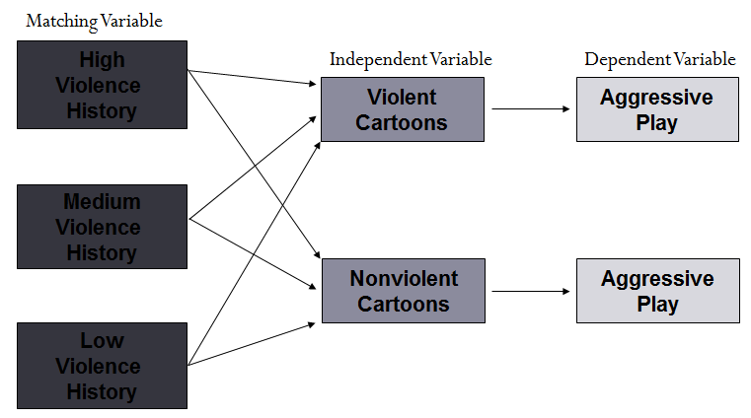
MATCHING ACROSS TREATMENT CONDITIONS: Matching levels of the variable across treatment conditions is another way to address selection effects
- Advantage: Useful for studies with small sample sizes; guarantees that things will be spread out
Disadvantage: Extra work to pre-measure and ensure equal amounts between different levels of the independent variable

To deal with threats to internal validity for between-subjects designs
1. Make the environment as similar as possible for all levels of the independent variable (of course the independent variable manipulation will differ across the levels)
2. To deal with selection effects use random assignment and/or matching

THREATS TO INTERNAL VALIDITY FOR WITHIN-SUBJECT DESIGNS
- Within-subjects designs have one group of people experiencing all levels of the independent variable
- 2 major sources of confounding for within-subjects designs
- Environmental variables: Characteristics of the environment that may change from one treatment condition/level to another
- Order effects: Carry-over and progressive factors; Time-related factors (maturation, history, instrumentation)
Order-related effects are only confounds if a researcher uses the same order of levels of the independent variable for every participant
- Carry-over effects: Earlier treatment (or rather level of the independent variable) is still in your system or still remembered and used in later levels of the independent variable (Ex caffeine still in system)
- Progressive order effects (Testing Effects); Earlier exposure to set-up of study or dependent variable changes scores
- Practice effects: Progressive improvement in performance as participant gains experience
Ex. math test scores; memory game; performance on Wii game
- Fatigue: Progressive decline in performance as participant gains experience
- Time-related order effects:
  - Maturation: change in behaviour—physical, emotional, moral—that happens naturally over time (Ex, effects of age on memory, reaction time, perspective taking)
- Maturation is an alternative explanation if you always have one level of the independent variable go first.
- E.g., testing memory ability in sample of 90 year olds using two techniques (one technique in November 2012; second technique in November 2013)
  - History: A historical or external event that varies systematically with one level of the independent variable (Ex, Effects of coping techniques, meditation vs. running, on reducing stress over two semesters (in one of the semesters there is a fire in the dorm))
  - Instrumentation: Changes in measurement over time (Ex. for Observational measures- Research assistants get better with practice, change of standards on which observations based (i.e., changes to the coding book), observers fatigued)

WHAT MAKES INSTRUMENTATION DIFFERENT FROM PROGRESSIVE ORDER EFFECTS
- To reduce order-effects as being confounds:
- Vary the order (i.e., counterbalance)
- If you always have one condition come first then this can be an order effect which is considered a confound
- One way to deal with this type of confound is by counterbalancing
- With two levels, things are easy
- With more than two levels, get more complex
- 2 levels= 2 possible orders
- 3 levels= 6 possible orders
- 4 levels= 24 possible orders
- Partial counterbalancing can help
- Increase the time between levels of the independent variable (controlling time)
- One way to deal with carryover effects is to increase the time between treatments
- There is a tradeoff though and time affects different issues
- If you increase the time between treatments, you bring on the risk of decreased carryover and progressive effects as well as increased time-related effects
- If you decrease the time between treatments, you bring on the risk of increased carryover and progressive effects as well as decreased time-related effects
- Have a comparison group
- If expected carryover and progressive effects are strong and obvious, a researcher may simply use a between subjects design
Eliminates threat of confounding from carryover and progressive error
- Carryover effect relates to the independent variable
- Progressive effect relates to the dependent variable
- If expected carryover and progressive effects are strong and obvious, a researcher may simply use a between subjects design
- Eliminates threat of confounding from carryover and progressive error

Ex. Assessing which study techniques that will improve people’s performance
IV- study technique ( 2 levels visualize vs. rhyming)
DV- recall
…. One group of participants (50 ten-year olds) will experience two rounds of this study
Round 1 (practise visualize technique in September in old classroom then recall objects one month later)
Round 2 (practise rhyming technique in October in new classroom then recall objects one month later)
To keep the internal validity, control as many of the extraneous variables as possible
Modify the environment (same classroom and same teacher)
Modify the order (time 1- group A 25 students learn visualization/ memory and group B 25 learn rhyming/ memory + time 2- group B 25 students learn visualization/ memory and group A 25 learn rhyming/ memory)

Questions that may arise:
Aren’t there two IV in the previous slide (memory technique and order)?
May be good practice
Or yes, if the researcher is interested in order effects
- Counterbalancing and having comparison groups doesn’t actually remove them (just like random assignment and matching doesn’t actually remove individual differences).
- Instead, the priority is to make things as equal as possible for the levels of the independent variable (i.e., no systematic variability).
Why isn’t this a problem( having a carryover effects and maturation effects in the mean score)?
Most researchers are interested in knowing if one level of the independent variable is relatively higher than the other level (visualization and rhyming), therefore this is not an issue

- To control for threats to internal validity in within-subjects designs…
- Make sure the environment is the same as much as possible in the different levels (just like between-subjects design)
- To reduce order and other effects as being confounds:
- Vary the order (i.e., counterbalance)
- Increase the time between levels of the independent variable
- Have a comparison group
Mon, Nov 18th & Wed, Nov 20th, 2013
Statistical Validity: Inferential Statistics
Research hypothesis applies to target population. The ultimate goal is to generalize findings from samples to the population
There is one main quality that relates to sampling and that is sampling error.
- Sampling Error: Samples do not provide a perfectly accurate picture of population; keep in mind that many different samples can be drawn from a population. Each time a sample is drawn some differences are expected.
If you choose a random sample from 1000 college students, you may receive a sample that is not representative of your population
Why is it important to know?
- It is important to know because researchers have to keep this in mind when assessing effects and relationships
Ex. researchers must distinguish between real differences ad sampling error differences (which challenges the quality of a claim)
Ex. Between-Subject Designs
Population of preschool children in Canada
Create a sample and randomly assign one treatment to half the sample and another treatment to another sample.
Treatment A (non-violent TV) has a mean of 3.64 for aggression
Treatment B (violent TV) has a mean of 7.60 for aggression
Inferential statistics are one way to assess the quality of the claim (recall the others are construct validity, internal validity and external validity) Ex. are the differences between the two group means meaningful or are they just due to sampling error
… it is up to the researcher to design their studies to account for other threats to quality (confounds, generalizability, reliabity and validity of the measure). Inferential statistics just address the sampling error as a threat to the quality.

HYPOTHESIS TESTING
- The main type of inferential statistic is the hypothesis test
- Hypothesis test: a way of thinking through a logical set of steps; the goal is to rule out the chance (sampling error) as a plausible explanation for the results
- Hypothesis testing underlies all research claims whether we are talking about frequency, association or causal claims
- There are some specific rules and logic for hypothesis testing:
  - Assume there is no effect
    - The logic of testing is that the researchers take a conservative view that nothing exists until there is evidence to back it up.
    - Null Hypothesis (NH): statement about the populations having no effect, no relationship, no change
Ex. violent TV has no effect on aggression
    - Alternative Hypothesis (AH): usually is the research hypothesis; existence of a relationship or treatment effect
Ex. violent TV causes increased aggression
…. Two outcomes include: Reject null hypothesis (support in favour of the AH) retain the null hypothesis (the NH is still in favour)
  - The data from the sample is collected
    - Ex. means in attention span for the caffeinated and decaffeinated conditions in an experiment
    - Ex. each individual’s mean self-reported aggression and mean number of hours spent watching violent media per week
  - Calculate test statistics with the data collected
- Ex. chi-squares, correlations, t-tests, z-tests, F-tests
  - Decide whether to reject or retain the null hypothesis
- Not based on the ‘gut feeling’ or after ‘eyeballing’ the scatterplot or means.
- Instead it is based on the calculation of test statistics (ex. z, t, r tests)
- With every test statistic calculated, an associated p value is calculated

P-VALUE
- P value= probability value
- Refers to the level of probability that the findings are due to sampling error ( also referred to as type 1 error)
- Also referred to as the alpha level
- As a convention, psychology researchers feel comfortable making claims with a 5% chance or less that the results are due to sampling error
- If p < .05, the convention is to reject the null hypothesis
- If p > .05, the convention is to retain the null hypothesis
- If a researcher rejects the null hypothesis (this means the same as being statistically significant), she or he is essentially saying that
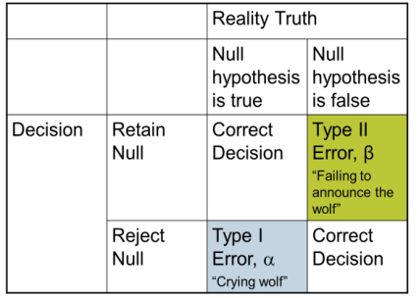
- Data like these could have come by chance
- BUT, data like these happen very rarely by chance
- THEREFORE, we are pretty sure the data were not the result of chance
- If the researcher retains the null hypothesis (i.e., fails to reject it which means not statistically significant) they are essentially saying
- Data like these could have happened by chance
- In fact, data like these are likely to happen by chance X% of the time (i.e., not rarely)
- Therefore, we conclude we are not confident based on these data, to reject the null hypothesis
- There are common errors that occur when making inferential judgements.
- Type 1 error (false positive, “crying wolf”)
- Type 2 error (a miss, “wolf there but no warning cries”)
- When calculating error we don’t know exactly if we have made an error BUT we can calculate the probability of doing so
- Once again, psychology researchers have a comfort level with the amount of possible error
- Recall, it is 5% for a type 1 error
- For type 2 error, or power, a set of factors determines it including: alpha level, sample size, effect size and unsystematic variability, and statistical choices
…Note. The lower the alpha (or type 1 error) the higher the possibility of a type 2 error (i.e., a less stringent alpha gives researcher more power)
- Hypothesis testing criticism
  - Misconception that a significant effect is also a substantial effect
  - Statistical significance (alpha): Does not provide any information about the magnitude of the treatment effect
  - Practical or clinical significance: Whether the treatment effect is large enough to have practical or clinical application
- Purpose: to provide info about the absolute size of the treatment effect that is not influence by outside factors like sample size
- Whenever find a statistically significant result, recommended to report the effect size
E.g., Cohen’s d

Null Effects
- A null effect in an experiment implies that there are no differences between the levels of the independent variable
- Null effects are not often reported in psychology journals but this is not to imply they don’t exist.
- They exist, but are just not reported
- Publication bias exists
- When a researcher is faced with a null hypothesis (e.g., no difference between violent and non-violent group), they will review their study design
What should the researcher look out for?
- There are two kinds of variability: good & bad
- Good variability: Systematic differences due to independent variable (i.e., between the levels)
- Bad variability: Differences due to unsystematic variability (i.e., differences within the levels)
- Although we are not actually learning to calculate inferential statistics, the basic idea is this:
Researchers want a greater ratio of good variability to bad variability (Good > Bad)
Not enough variability between levels (i.e., not enough of the “good” variability)
- Weak manipulations: A researcher might figure out that the intended manipulation of the independent variable was not strong enough
Ex. number of violent acts in study
Ex. money study (e.g., .25, .50, 1.00)
- Insensitive measures: If measure is too crude, researcher will not be able to find differences
Ex. divorce as a measure of relationship satisfaction
Ex. assessing reaction time in seconds when the effect occurs in milliseconds
Ex. smell test for extent of food decay
… There are special cases of weak manipulations and insensitive measures and they’re called ceiling and floor effects
Ceiling effects: A special case of an insensitive measure or weak manipulation; participants score the same; at the top end of the scale.
- the manipulation of the IV (i.e., weak manipulation) * weak in the sense that it is not high quality; not that it is not doing anything, in fact, all levels are doing the same thing at a very high level*
Ex. if manipulating levels of anxiety by telling people that they will receive a shock (10, 50, or 100 volts), it is possible that all people will score at the top end of the anxiety scale.
- or the measurement of the DV (i.e., insensitive measure)
Ex. Easy math test
Floor effects: A special case of an insensitive measure or weak manipulation; participants score the same; at the bottom end of the scale
- The manipulation of the IV (i.e., weak manipulation) * Note. In this case, it is a weak manipulation in multiple senses (i.e., quality and effect on dependent variable).
Ex. Give children .1 mg, .5 mg. or .8 mg of sugar (all participants are likely to show no difference in energy because the sugar level is too weak; all will score at the bottom end)
- or the measurement of the DV (i.e., insensitive measure)
Ex. Difficult math test
How does a researcher deal with weak manipulations, ceilings, and floors? Manipulation check

Too much variability within levels (i.e., too much of the “bad” variability)
Unsystematic variability: Systematic variability outside of the manipulation of the independent variability (i.e., confounds) are certainly a problem. In addition, unsystematic variability is an issue.; Unsystematic variability is also known as error variance. It gets in the way of detecting effects.
- Measurement error: Any factor that inflates or deflates a person’s true score
Ex. a person’s GRE score is a function of their true score and random error of measurement
Common Sources of Measurement Error
- Observer error (i.e., research assistants coding behaviors): what the coders are observing, might not always see the same thing
- Environmental change: room temperature, lighting, crowding
- Participant changes: transient mood, health, fatigue-level, motivation
Solutions for Measurement error
      - Reliable, precise measurements
      - Measure more instances
- Individual differences: A particular problem in between-groups designs
Solutions for individual differences
  - Change the design (i.e., make it a within-subjects design)
  - Add more participants- the more people you measure, the less likely an extreme person will skew the results
- Situation variability: Factors that relate to the environment
Ex. noisy coffee shop
ANOTHER REASON FOR THE NULL EFFECTS THAT HAS NOTHING TO DO WITH VARIABILITY
‘Nothing going on’
This is a real possibility
After exploring other issues, a researcher just might have to accept that there is no support for the hypothesis
Mon, Nov 25th & Wed, Nov 27th, 2013
Experiments with More Than One Independent Variable
- FACTORIAL DESIGN: Manipulation of 2 or more independent variables (or factors)
- Factor: An independent variable (when two or more independent variables are examined in one study)
- The most common type of factorial design is a two-factor design Implies there are two independent variables
- Two-factor designs come in many forms but the one thing two-factor designs have in common is that there are two factors (i.e., two independent variables)
- E.g., 2X2; 3X5; 4X7; 2X5; 5X9; 6X10; 10X12
4 X 8 (four levels of factor 1 and 8 levels of factor 2)
- The most common form of a two-factor design and the simplest factorial that exists is a 2 X 2 design
- Structure of a Two-Factor Design:
  - Can be represented by a matrix (generically denoted with letters A and B)
  - Levels of one factor form columns
  - Levels of other factor form rows
 |  | FACTOR B
 |  | Level B1 | Level B2
FACTOR A | Level A1 | Condition A1B1 | Condition A1B2
FACTOR A | Level A2 | Condition A2B1 | condition A2B2
Ex. Cell phone + music in a car while driving
- A two factor design example (2 X 2) where the researchers examined the effects of cell phone use and music in car on driving ability in a simulated driving situation
- Driving ability was operationally defined in terms of reaction time to stop during a driving simulation task
- Independent variable #1 (or Factor A) cell phone condition
- 2 levels:
- Driver on cell phone
- Driver not on cell phone
- Independent variable #2 (or Factor B) Music
- 2 levels:
- Music
- No music
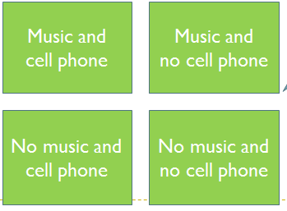
- To create a factorial design, researchers merge levels of the independent variables together during the design phase(i.e., merging two separate single experiments together)
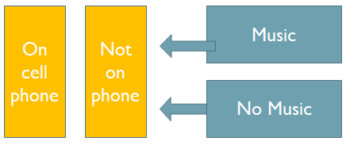

- Thus, every level of the independent variables is crossed together (i.e., crossed-factorial design)
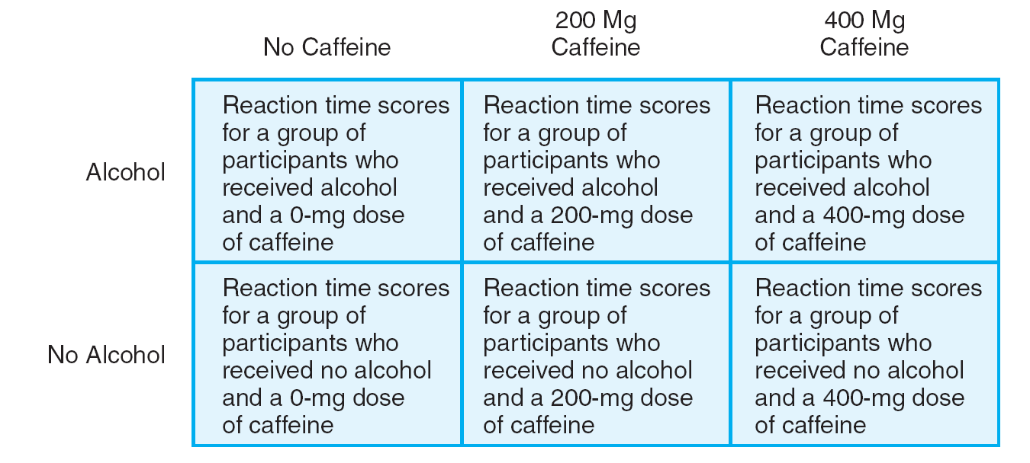
Ex. Alcohol and caffeine and driving ability
2 x 3 factorial design
How do you know which is factor A and which is factor B?
Alcohol/400mg Caffeine
Alcohol/200mg Caffeine
Alcohol/No Caffeine
In a research paper, you don’t call them factor A and factor B; instead you refer to them by name
Ex, We examined a Cell phone condition (cell phone vs. no cell phone) X Music (music vs. no music) factorial design.
No Alcohol/No Caffeine
No Alcohol/200 mg Caffeine
No Alcohol/400 mg Caffeine
- What happens when I analyze the results of a factorial design?
- A researcher who analyses a factorial design is interested in main effects and interaction effects.
- Main effect: Mean differences among the levels of one factor (e.g., music vs. no music; cell phone vs. no cell phone)
- Not as simple as comparing music vs. no music or cell phone vs. no cell phone because there are cells representing each level
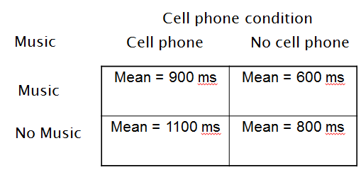
- Researchers create averages for each level, otherwise known as marginal means
- Marginal means can be thought of as a “mean of means”
- Main effect of cell phone condition
900 (music) + 1100 (no music) = 2000/2 = 1000 ms cell phone (marginal mean)
600 (music) + 800 (no music) = 1400/2 = 700 ms no cell phone (marginal mean)
300 millisecond difference (main effect of cell phone condition)
Main effect of music
900 + 600 = 1500/2= 750 ms music (marginal mean)
1100 + 800 = 1900/2= 950 ms no music (marginal mean)
200 millisecond difference (main effect of music)
- Main effect for cell phone condition
- Is one marginal mean (or “mean of means”) larger than the other marginal mean?
- Yes, 1000 ms – 700 ms = 300 ms
- Main effect for music
- Is one marginal mean (or “mean of means”) larger than the other marginal mean?
- Yes, 950 ms-750 ms = 200 ms
- In other words, hypothesis testing needs to be done (i.e., assess statistical significance).
- For the purposes of this class, you can make judgments based solely on differences (i.e., is the difference greater than zero).

- The most important reason why researchers assess factorial designs is because they want to assess interactions
- Interaction effects are defined as “the effects of a factor vary depending on levels of the other factor”
- Ex. Does the effect of cell phone use on driving ability vary depending on music?
- Ex. Does the effectiveness of commands to dogs to sit vary depending on the presence of treats?
- Ex. Do the effects of exposure to violence on aggression vary depending on the type of violence?
- Interaction effects allow researchers to examine the interplay of independent variables on the dependent variables
Ex, intuitive Interaction Example: examining the effectiveness of treats and commands on getting a dog to sit

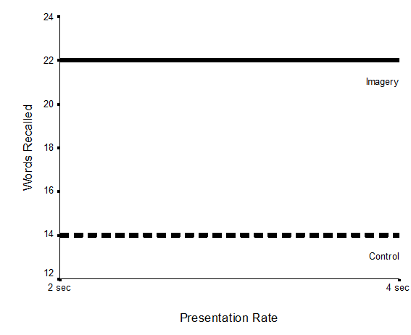
DETECTING MAIN EFFECTS AND INTERACTION EFFECTS IN GRAPHS
A researcher can take the matrix of raw means and graph them…
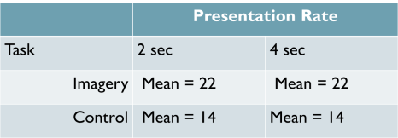
Main effect for type of training only, no main effect for presentation rate, no interaction

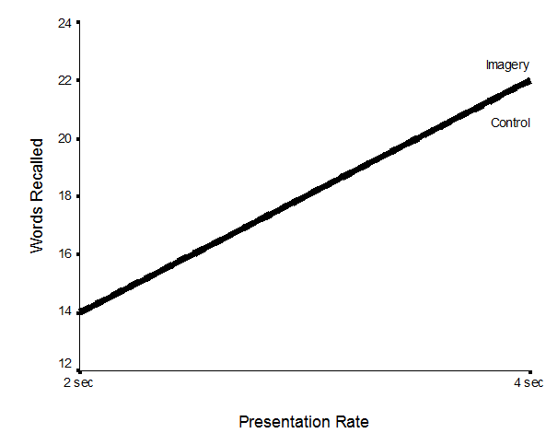
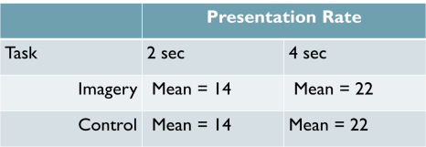
Main effect for presentation rate, no main effect for type of training, and no interaction

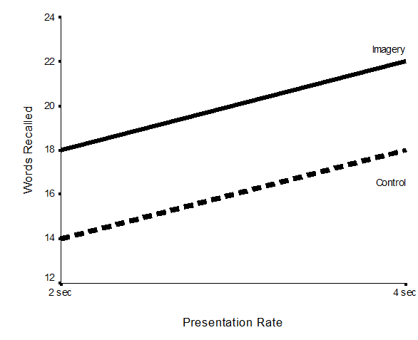
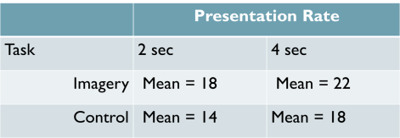

Main effect for type of training and presentation rate, no interaction

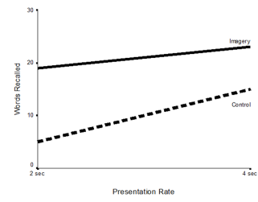
- When there are interactions, the lines are no longer parallel
- this means the main effect for one variable is not constant across the other variable
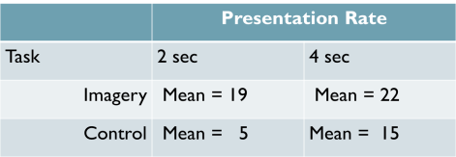
2 main effects and an interaction
Imagery increases recall, presentation rate increases recall (i.e., main effects), but there is a greater type of training effect for the 2 second group than for the 4 second group

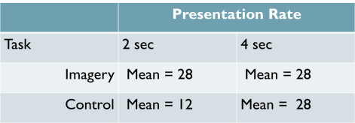
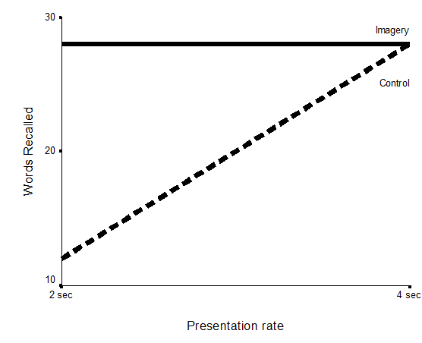
Type of training affects recall, as does presentation rate (main effects) but it can also be seen that the effects of presentation rate depend on the levels of type of training (i.e., presentation rate has no effect for imagery but presentation has a large effect for the control group).

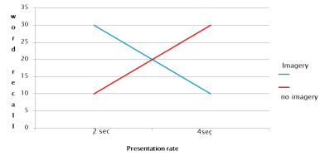
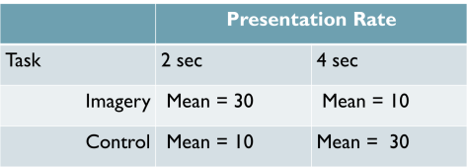
No consistent pattern for either independent variable (no main effects). The effects of one independent variable is completely dependent on the level of the other independent variable (interaction effects).

- Independence of main effects and interactions
Can have any possible combination of significant main effects and interaction
POSSIBLE RESULTS FOR 2 FACTOR DESIGNS
Main effect for factor A only
Main effect for factor B only
Main effects for factor A and B only
Main effect for factor A and an interaction
Main effect for factor B and an interaction
Main effect for both A and B plus an interaction
An interaction only (criss cross)
No main effects and no interaction (straight lines)
- Interpreting Main Effects and Interaction effects
Researchers don’t just “eyeball” graphs and tables of means, instead they engage in hypothesis testing to determine if main effects
and interactions are significant
- Different types of factorial designs
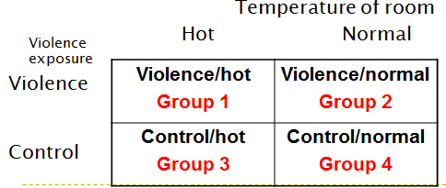
- Between-subjects
Separate group of participants in each treatment combination (cell)
Ex. Factor A = Violence exposure (violent vs. control)
Factor B = temperature of room (hot vs. normal)
Dependent variable: Aggression

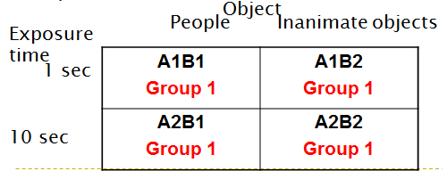
- Within-subjects
Same participants in all treatment conditions (cells) (only one group of participants)
Ex. Factor A = Exposure time (1 sec vs. 10 second)
Factor B = Object (people vs. inanimate objects)
Dependent variable: Recall

- Mixed: Combines within-subjects and between-subjects factors
Participants respond to all levels of the within-subject factor but only one level of the between-subjects factor
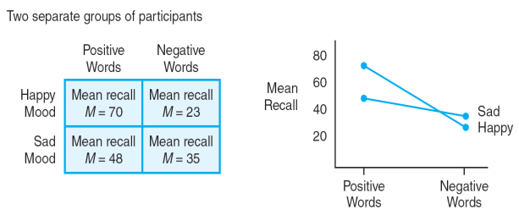

Therefore:
- Creates a more ‘realistic’ situation (than single-factor studies)
- Opportunity to examine
- How the factors influence behavior (Main effects)
- How the factors influence or interact with each other (Interaction effects)

Mood = Between-Subjects factor
Type of Word = Within-Subjects factor
Mon, Dec 2nd & Wed, Dec 4th, 2013
Quasi Experiment, Small N Designs, Longitudinal Research

The structure of quasi-experiments looks the same as a true experiment.
- “independent variable”*, of sorts, and measures the effect on a dependent variable
- Less control of extraneous variables in quasi-experiments

Why do quasi-experiments have less control of extraneous variables?
- Quasi-experiments have less control because groups are not created by manipulation of the independent variable.
- Instead...
- Different levels of the “independent variable” are defined in terms of
pre-existing participant variables
OR
in terms of time
Why would a researcher not manipulate an independent variable?
- It is unethical or too costly or impossible to manipulate certain variables
Ex, gender, cigarette use, onset of depression, age, university experience

****In quasi-experiments, the “independent variable”* is referred to as a quasi-independent variable*****
- Recall that for experiments, there are two general types of experimental designs:
Between-subjects design & Within-subjects design
- Quasi-experiments can be classified in a similar way
Non-equivalent control group design & Time series designs

NON-EQUIVALENT CONTROL GROUP DESIGNS
(Between-subjects type)
- For variables that are difficult/impossible/too costly to manipulate (e.g., gender, smoking), look for existing groups in the population that have various levels of the variable in question
- Compare groups based on pre-existing characteristics
- Not randomly assigning people to different groups
Ex. Group 1 X O
Group 2 O Rudimentary control group
x = treatment (quasi-independent variable, IV)
o = outcome (dependent variable, DV)
- One group gets the treatment and is compared to another group that does not get the treatment
X O
Just like a regular experiment, there will be a mean score for the HS program level…
…And a mean score for no HS program Level

Group 1
Head Start (HS) program Intelligence Test
Group 2
No Head Start program Intelligence Test
Not randomly assigned to either the Head Start program or the No Head Start program; don’t know how similar participants were to begin with
Mean score for ‘StayWell’ level
Mean score for No ‘StayWell’ level
Ex Group 1 O X O
Group 2 O O rudimentary control group

Where x = treatment ( Quasi IV) and o = outcome (DV)
o = healthy behaviours (measured at the same times for both groups)
x= StayWell program
Again, no random assignment
- In the example on the previous page, why is the researcher measuring the dependent variable twice?
- Allows researcher to assess whether the 2 groups are similar to begin with
- More importantly, why is one of the dependent variables coming before the quasi-independent variable?
- Researchers just interested in “Change” score (i.e., one mean score per level). The focus is just on what happens AFTER the quasi-independent variable above and beyond the pre-measure score
… Thus, the main disadvantage of non-equivalent control group designs is Assignment Bias (also called Selection effects).
- Assignment bias (selection effect): Occurs when assignment procedure produces groups that have different participant characteristics Ex. smokers vs. non-smokers
- Participant characteristic variables could be confounding variables and hence could explain observed difference between groups
- Threat to internal validity!, a potential confound built into the quasi-experimental study design
TIME SERIES DESIGN
(Within-Subjects or repeated measures type)
- One group observed
- measured before and after treatment/event
- Researchers take advantage of naturally occurring policy, regulation, event
- Goal To evaluate the influence of the intervening treatment/event by comparing the observations made before event with the observations made after event
- Time-Series Designs
- Rather than just one observation before and after the treatment, there are multiple observations before and after
O O O X O O O
- Allows researcher to look for existing trends before the treatment was introduced
- Can look at post-treatment trends
Threats to Internal Validity
- Time-related factors threaten internal validity
- History, instrumentation, maturation
- Cannot counterbalance order of treatments thus, there can be testing/order effects
- Always have control group first, then the treatment group

DEVELOPMENTAL RESEARCH DESIGNS
A type of research design that relates to age (not an experiment, not a quasi-experiment, instead it is viewed as a correlational design)
- Study changes in behavior that relate to age (natural maturation process)
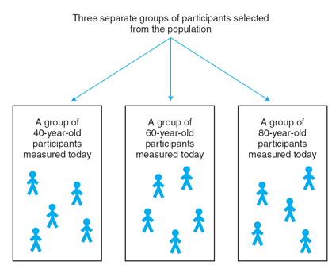
- Purpose: To describe relationship between age and other variables
- Two types:
- Cross-sectional design
- Separate groups of participants for each of the ages being compared
- Groups compared on dependent variable to determine whether there are age differences
- Like a between-subjects set-up in that different groups of people are being compared
- A snap-shot in time
Advantages:
- Can examine the effects of aging in short period of time (quick data collection)
- Does not require long-term co-operation between researcher and participant
- Time and expenses tracking people
Disadvantages:
- Need more participants
- Cannot determine how individual develops over time
- Factors other than age may differentiate the groups
- Cohort effects or generation effects
- Environmental factors that differentiate one age group from another
- More problematic the more years between groups
- Threat to internal validity

- Longitudinal design
- Measuring dependent variable in individuals over a period of time – multiple measurements (repeated measures)
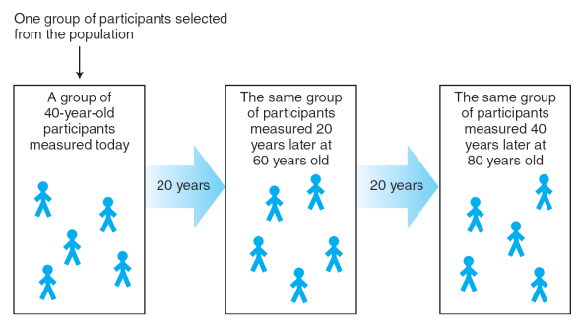
- No manipulation of an independent variable
- Investigate relationship between age and variable of interest
- Like a within-subjects, repeated measures design
- No treatment administered (treatment = age)
Advantages:
- Need fewer participants
- Absence of cohort effects
- Able to determine how individual’s behavior changes with age (maturation/growth)
Disadvantages:
- Time consuming
- Requires long-term commitments from researcher and participants
- Expensive
- Subject to high drop-out rates
- Potential practice effects

- Can researchers use quasi-independent variables in factorial designs?
Yes; remember nothing is being manipulated in terms of quasi-independent variables. By convention, they are still called factors.
Combined Designs
- At least one Quasi-independent variable and at least one manipulated independent variable
- Very common
Ex. examine the effects of presentation rate AND Gender on recall ability
- The researcher can use causal language for the manipulated factor and association language for the quasi-independent variable
- Both variables can be quasi variables as well
Ex. examine the relation between gender and the types of exercise habits people engage in on health
SMALL N DESIGNS
- Up until this point, the focus of research claims has been on groups of people (large-N designs)
- Researchers also use small-n designs under certain circumstances.
- Small-n design: shift focus from gathering information from large groups of people to gathering large amounts of information from one or a few individuals
- Each participant is treated as a separate study
- Individual data are presented
- To assess whether a finding is replicable, the researcher repeats the study with a new participant.
- Large-N design: Participants are grouped and data are represented as group averages. Researchers decide whether a result is replicable by doing hypothesis testing
FAMOUS SMALL-n DESIGN STUDIES (LONGITUDINAL)
Piaget (1923)
- Studied cognitive development of his 3 children
- Longitudinal- age is variable of interest
Ebbinghaus (1913)
- Used himself as a participant
- documented the “forgetting curve”.
- Longitudinal- time is variable of interest
TED TALKS: DEB ROY
- Even though the focus is on one individual, the amount of data is extremely large!
- Even though only one person is the focal point, the value of this study is high for understanding language development in children.
- The sophistication of the observation and analysis of data was very high

- Small-n designs have the potential to be just as valuable and just as sophisticated as large-N designs.
- Where the small-n design falls short on the number of participants, it more than makes up on the amount of data gathered by the individual.
Ex. a quasi-experimental small-n design (that is, small-n designs don’t all have to be longitudinal)
TED TALKS: CHARLES LIMB
- Even though the focus is on a small group of individuals, there is a large amount of data to examine
- Even though only a few people are focused on, the value of these studies is high for understanding brain activity during instances of improvisation and creativity
- The sophistication of the observation and control of observations was very high

THREE SMALL-n DESIGNS
- Stable-baseline design: Obtain baseline of a behaviour for a client (e.g., memory), then introduce treatment and observe changes in behaviour
- Multiple-baseline design: Same idea as the stable-baseline except that the researcher is staggering the introduction of a treatment.
- Reversal designs: Similar to the stable-baseline design or the multiple baseline design except that after introducing a treatment the researcher removes it at some point to observe whether the behaviour changes back to baseline levels and then reintroduces it.
Advantages of small-n designs:
- Assess special cases
- Assess a breadth of information from a few participants
- Able to demonstrate exceptions to the rule
Disadvantages of small-n designs:
- Representativeness of the sample
ASSESSING QUALITY OF SMALL-N DESIGNS
Construct Validity:
- Are the researchers measuring what they are supposed to measure or manipulating what they are supposed to manipulate?
Internal Validity:
- Are the researchers controlling for extraneous variables to rule out alternative explanations?
Yes, a small-n design does not mean that the researcher uses less overall control
Statistical Validity:
- For very small n (e.g., single person), researchers look to see whether finding generalizes to another person; they will not be concerned with hypothesis testing in this situation.
- Other times, hypothesis testing is used for small groups. Given that the sample is small, researchers focus their attention on effect size.
External Validity:
- A definite concern for small-n designs is the generalizability
- Each time the study is replicated with a new participant, a researcher can gain further confidence in the generalizability.

