Chapter one : how value is created
Chapter 2 : macro, micro , developing plans, swot, situational
Chapter 3 : macro and micro,
Chapter 4 : market research process steps, primary vs secondary data, ways to collect data
Chapter 5: steps in consumer buying process, types of buying situation complex, ambidual etc. post purchase decision behaviors. Post- purchase – dissonance
Chapter 6: b2b marketing b2c markets, buying center, organizational culture, buying situation effect buying situation

Segmentation – customer needs, find target market, GDBP

KEY CHARACTISITICS OF TARGET MARKET, CUSOMER NEED, P.O.D
(point of differentiation) - how products are different from competitors

Product adoption Curve ----
Consumer Adoption Cycle
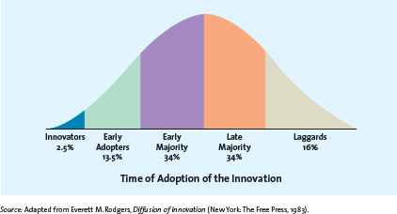
Product Life cycle <- (beginning middle end)

Don’t spend time on packaging

Intensive distribution – get products into as many outlets as possible (Walmart, Shoppers, Loblaws, Zellers)
Selective distribution – uses a few customers (Sears, Bay)
Exclusive distribution – granting rights to one or very few customers so no other can sell the particular brand (Cartier, Tiffany & Co.)
Supply chain management
Don’t read logistics
No chapter 13
Chapter 14; communications process, intergrated marketing communications, tools

Chapter 15: ADA models, advertising objectives, no legal and unethical issues, sales promotion, personal selling,

Chapter 17: ethical deicison makin
Utility principle

