MKT 100 – CHAPTER 2

Levels of Strategic Planning:
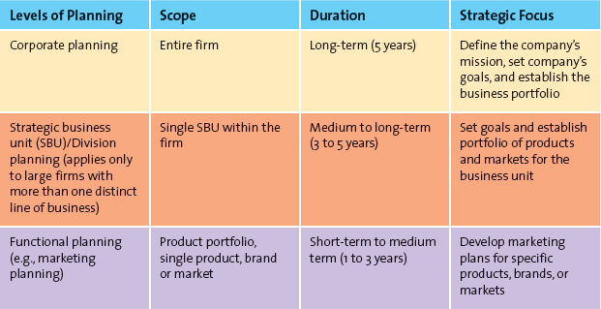
(lower it is, the less time it takes to plan)
These plans are used to react to changes in environment, the competition, and their customers

Successful strategies:
- Portfolio analysis – dogs and stars
- Growth strategies
- Sustainable competitive advantages

MARKETING OBJECTIVES – everything involved
Marketing planning process: ( 3 phases of strategic planning)
- Planning phase – when marketing executives and top managers define the mission/objective of the business
- SWOT – strengths, weaknesses, opportunities, threats
- Identifying opportunities – segmentation (dividing the market into groups) , targeting positioning
- Implementation phase – marketing managers identify and evaluate different opportunities by engaging in a process known as segmentation, targeting, and positioning. (Implementing the mix by using the four Ps)
- Control phase – evaluating the performance of the market strategy by using market metrics and taking any necessary actions to for correction.
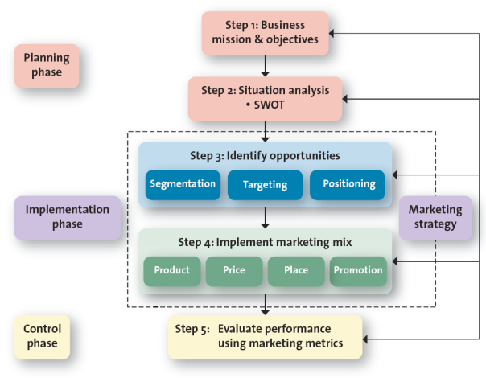
Relative market share - measures the strength of a particular market . (Sales of the focal market divided by the largest firm in the industry; horizontal axis)

Market Growth rate – annual growth rate. (Vertical axis)

Stars (high)-> Cash cows (high growth; low shares) -> Question marks (high shares; low growth) -> Dogs (low)

Growth Strategies:
- Market penetration strategy – using marketing mix and focuses the firms efforts on existing customers (More advertising, promotion, additional sales)

- Market development strategy – employs the existing marketing offering to reach new market segments, domestic or international or segments not currently served by the firm. (expansion of tim hortins out of canada to the states)

- Product development strategy – New product ; current customer
  - offers new product to existing customer (Developing new products ex. Apple iphone 5c,5s,ios 7)

- Diversification – new product; new customer
  - and new market segment that were not served. (kids clothing store decides to make teenage clothes too) (Apple developing their first ipad doesn’t count because they’re still marketing the same customers)

- Downsizing – reducing product portfolios. May either exit markets or abandoning products. (Entering new markets with no expierence and products/services doesn’t fit in)

Marketing Strategy identifies:
- Firms target market
- Related marketing mix (four Ps)
- Bases upon which the firm plans to build a sustainable competitive advantage.

Sustainable competitive advantage – advantage over the competition that is not easily copied and can be maintained over a long period of time. (Mcdonalds). ESTABLISHING LONG TERM BENEFITS
- A broad description of the firms objectives and scope of its activities.
- Tool used to evaluate marketing performance.
- Something the firm can consistently do better than its competitors.
- Written document that discusses competitor strengths and weaknesses, and the firms advantages over them.

Market segmentation – businesses making products that SATISY customer wants by using social-cultural factors

Target Market – evaluating segments and seeing which one to pursue and to tackle on. (choosing the final product to sell to younger students)

Market Positioning – costumers can define that the companys product is distinctive to other competitive products

Developing customer value:
- Customer excellence: Focuses on retaining loyal customers and excellent customer service. (Apple)
- Operational excellence: Achieved through efficient operations and excellent supply chain and human resource management. (Walmart)
- Product excellence: Having products with high-perceived value and effective branding and positioning. (abrecombrie and finch)
- Locational excellence: Having a good physical location and Internet presence. (J. Crew)

Stars – high market share – high growth rate
Cash cows – high market share low growth rate
question marks
Dog – low in everything

Portfolio Analysis – overall performance of a company/product

Company capabilities, resources, processes:

Competitors – direct competitors > indirect competitors . important to look at market shares.
STP: positioning, sementation

Analyzing competition:

- Share of Market – company sales as a % of total industry sales. Top 4 vs. H index.
- Share of Mind – % of customer who names your brand when asked to name the first brand that comes in mind. (more customers thinking about you first)
- Share of Voice – % spend on media in total industry spend. (Telling people about company)
- Share of R&D (research and development) - % spend R&D in total industry spend. (More competition, better innovation and products)

Competition analysis:

1. top 3 or 4 mkt share:
Add up the market share of the top 3 or 4 firms in the industry;
> 67% highly concentrated and uncompetitive industry
< 67% less concentrated and more competitive industry

2. herfindahl index (H index)
Square the market share of all competitors industry and add up the total. (if %, make it a decimal)
> .18 highly conentraded and uncompetitive industry
< .18 less concentrated and competitive industry.

Analyzing competition:

Share of Market – company sales as a % of total industry sales. Top 4 vs. H index.

Share of Mind – % of customer who names your brand when asked to name the first
brand that comes in mind. (more customers thinking about you first)

Share of Voice – % spend on media in total industry spend. (Telling people about company)

Share of R&D (research and development) - % spend R&D in total industry spend. (More competition, better innovation and products)

