Kyle Battersby
Human Development
Cognitive Development
Jean Piaget
- Sensorimotor Period (0-2 years old)
- Learns by sensory experience and motor activities
- Pre-operational (2-7)
- Language development and animistic thinking
- Lack of conversation
- Concrete Operation (7-11)
- Grounded in concrete thinking
- Conversation
- Mental operations
- Increase in spatial activities
- Understanding of identity (who siblings, parents are, sex)
- Difficulty with hypothetical thinking
- Formal Operation (11+)
- Sophisticated thinking
- Logical thinking
- Idealism and criticism (towards caregivers)

Moral Development
Kohlberg
- Pre-conventional (early childhood)
- Child’s behaviour seen by caregiver
- Consequences given based on behaviour (skinner’s approach_
- Conventional (late childhood)
- Relationships (friends, teachers)
- More authorities (but listens to people with most value and consequence)
- Wants approval (to be ‘good’)
- Post-conventional (late adolescence?)
- Personal code of ethics
- Concern for others’ welfare
- Wrong versus Right
- Not everyone will reach this
Identity Status (4)
James Marcia
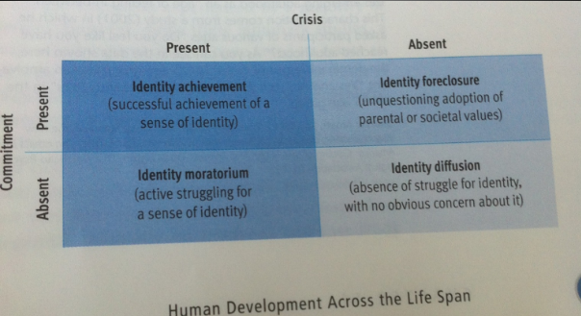
Psychosocial Development
Erik H. Erikson
Childhood consists of 4 stages:
- Trust vs Mistrust (0-1.5 years old) (to caregivers)
- Autonomy vs Self-doubt (1.5-3) (belief in ones self)
- Initiative vs Guilt (3-5)
- Competence (industry) vs Inferiority (6-10)
Adolescence consists of 1 stage:
- Identity vs Role confusion (10-20)
Adulthood consists of 3 stages:
- Intimacy vs Isolation (20-40)
- Meaningful relationships (ex. Marriage vs Single)
- Generativity vs Stagnation (40-60)
- Opportunity to give back to next generation vs what’s in it for me
- Integrity vs Despair (over 60)
- Integrity –god life, Despair – regret
- Reflecting on life

Emotional Development
Harry Harlow (“Two surrogates” comfort vs nourishment)
Attachment
Mary Ainsworth (Bond b/w mother and child)
Stranger situation paradigm
- Secure
- Insecure
  - Avoidant
    - Mom leaves and returns, child shows no interest
    - This means the mother is impatient with child and doesn’t know what is expected of parenting
  - Anxious ambivalent
    - When mom returns child wants to punish mom and also unsure to connect
    - This means the parenting is inconsistent (caring/uncaring/caring)
  - Disorganized/disoriented
    - When mom returns child is fearful and unsure how to respond
    - Sign of abuse, inconsistent caring, intrusive
- The infant contributes to the relationship
- This effects the relationship throughout life
- Daycare
  - You want to know everything about it-ratio b/w kids and caregivers, age group...

Parental Behaviour - Diana Baumrind
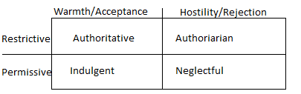
- Authoritative
  - Demanding but caring
  - Good child-parent communication
- Authoritarian
  - Parental power
  - Without warmth
- Indulgent
  - Warmth
  - Lacks in setting limit
  - Wants to be child’s friend
- Neglectful
  - Indifferent
  - Uninvolved with child
  - Difficulty with communication

Gender Development
- Gender schema (Bem)
- Gender type:
  - Masculine
  - Feminine
  - Anthrogyny (scoring high in both fem and masc)
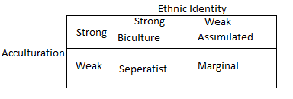

Emerging childhood (EA)
- Role transitions less important
- Cognitive, emotional and behaviour transitions occur more gradually over time
- Creating extended period of time before people consider themselves as adults
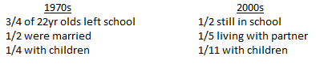
Features of EA
- Identity explorations
  - Trying different ways to live/see yourself
    - Relationships, jobs, what you like
  - Instability
  - Being self-focused
    - If something happens, change the ‘plan’
  - Feeling in-between childhood and adulthood
  - Time of possibilities

Psychology of Dying – Rubler-Ross (died 2004)
Stages of Dying (grief):
- Denial: Saying nothing has changed. The refusal to accept.
- Anger: Direct anger at the lost one or at self (regret).
- Bargaining: Negotiating the situation with a greater power.
- Depression: Change in sleeping/change in self/change in eating/ or less active.
- Acceptance: Acknowledgement that life has to go on/at peace.
Psychology of Personality (PYSC 2600)
- Your unique, relatively consistent pattern of thought, feelings and behaviour
- In psych we want to:
  - Explain our uniqueness
  - Predict out behaviour
Trait Theories:
- Personal characteristics
- Allport’s Disposition Theory
  - 18,000 words for personality
  - Narrowed to 200 clusters
- Cattell’s Trait Theory
  - 16 source traits
  - Each varies along a continuum
    - Ex-Relaxed vs Tense, Intelligent vs Less intelligent
- Hans Eysenck (bit his teacher)
  - Three Factor Model
    - Stability-Instability (low anxiety vs high)
    - Introversion-Extraversoin (shy vs social)
    - Psychoticism-Self Control (wreckless vs concern for rules)
- McCrae and Costa
  - Five Factor Model
    - Openness
    - Conscientiousness (higher-organized, reliable, safe)
    - Extraversion (higher-socially comfortable, lower-shy)
    - Agreeableness
    - Neuroticism (Stability vs instability (anxiety))
      - OCEAN
Psychoanalysis
- Freud
- Conversion hysteria
- Charcot and hypnotic suggestion
- Breuer and Anna O.
- Anxiety and Catharsis
- Theory of personality and a therapy
- Instincts
  - Sexual (Eros)
  - Aggression (Thanatos)
- Libido (Instinctual energy)
- Topographical Model
  - Conscious
    - What you`re thinking of
  - Preconscious
    - Information which we are unaware of but easily accessible (what did you eat for lunch?)
  - Unconscious
    - Information that is a powerful influence on personality but externally aware
Structural Model for the Unconscious
- Id (id) (the “it”)
  - The pleasure principle (sexual)
  - Highly motivated to achieve pleasure, directly or indirectly
- Ego (the “I”)
  - Reality principle
  - Dialog with id to control (self preservation)
- Superego ( the “over I”)
  - Conscience and ego-ideal
    - What is right and wrong (conscience)
    - What we want to be (ego-ideal)
    - Balancing act of ego
      - Wrong-ego-right

Defence Mechanisms
- Repression:
  - Repressing a memory or part of one’s self
- Reaction Formation:
  - Opposite belief becomes emphasized
- Projection:
  - Attributing an unacceptable impulse to someone else
- Displacement:
  - Channel unacceptable impulse to acceptable/less threatening item/person
- Sublimation:
  - Divert unacceptable impulse to socially acceptable activity (sports)
- Rationalization:
  - Socially acceptable reason for unacceptable action (I did it ‘cause I had to)
- Denial:
  - Refusal to accept reality
- Intellectualization:
  - Emotion repressed and used reason (break up, rationalize without emotion)
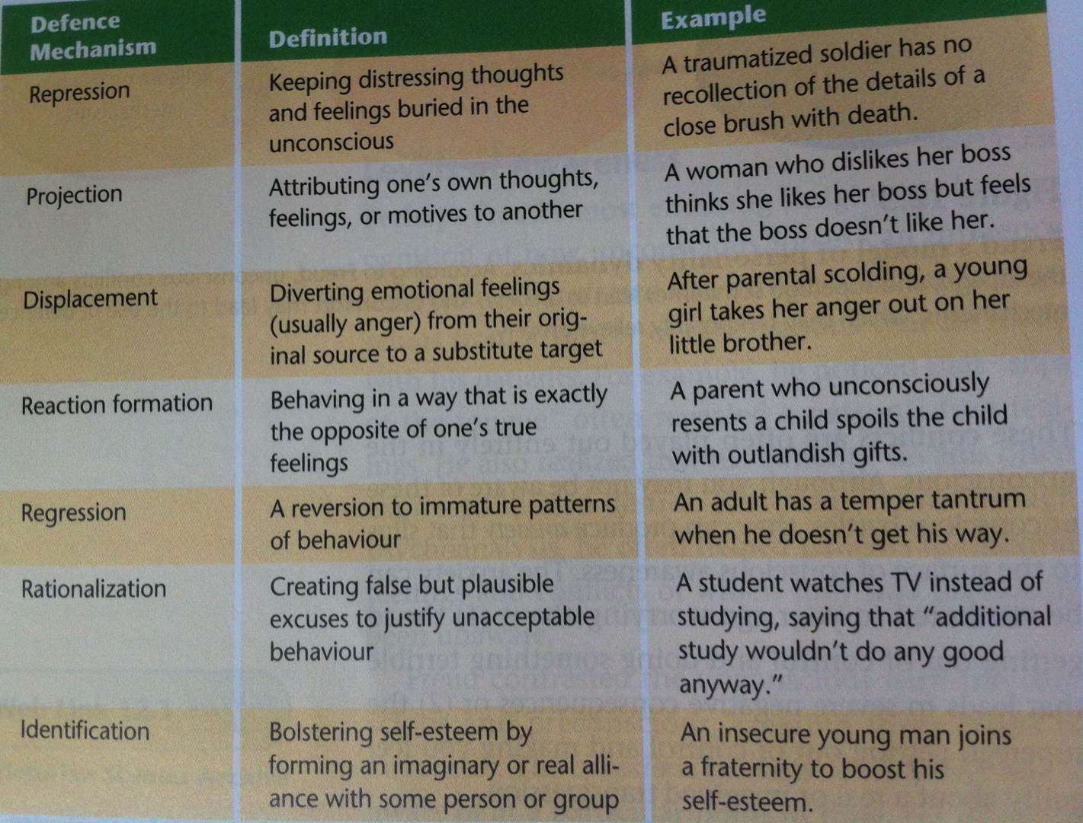
Analytic Psychology
Carl Gustav Jung
Personal and collective unconscious (two sections or the mind)
- Believes we share an unconscious mind with the rest of human kind
  - That we interpret the world with others, helping to process the world
  - Archetypes
    - Hero
    - Wise old man (Gandalf, Dumbledore, Yoda)
    - Shadow (evil)
    - Anima (Female) (Jung suggests that men are influenced by females)
    - Animus (Male) (Jung suggests that females are influenced by males)
    - Mother (Nature)
    - God
    - Etc.
  - Extraversion, Introversion

Individual Psychology
- Alfred Adler
- Social interest: kinship with society (need for other people)
- Striving for superiority (striving to matter-social interest)
- Inferiority complex (exaggerated feeling of weakness)
- Style of life (goals, methods to achieve those goals)
- Importance of birth order (youngest child/only child)

Humanistic Psychology
- AKA Human Potential Movement or Third Force
- We are good, capable, trust worthy; and they help people realize this
- More interested in conscious world, free will (subjective viewpoint)

Abraham Maslow
  - Hierarchy of needs
    - A systematic arrangement of need, according to priority, in which basic needs must be met before less basic needs are aroused

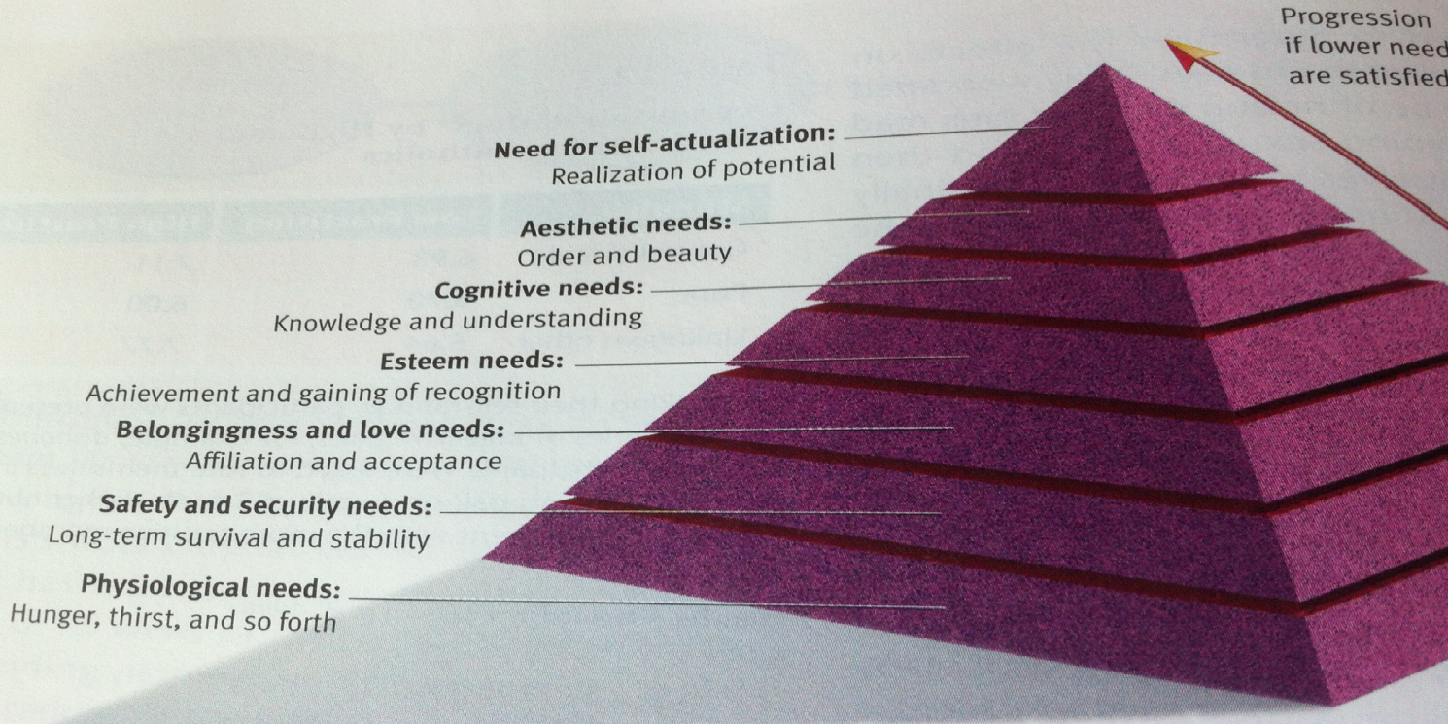

Carl Rogers
  - Person-centered approach
  - Self-theory
  - Positive regard (preferably unconditional)
  - Conditions of worth
  - Deny aspects of yourself=anxiety
  - Ideal self=who you eventually want to be
  - Fully-functioning people

Social Cognitive Approaches
- Albert Bandura
  - Behaviour & cognitive (expectations about consequences)
  - Reciprocal determinism
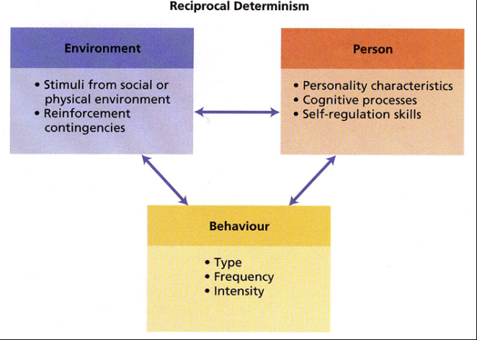
-Environment
-Person
-Behaviour

  - Self-efficacy
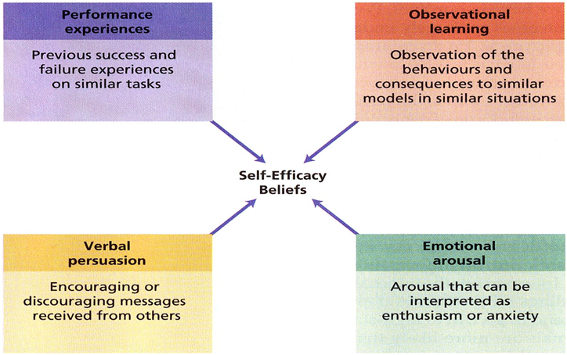
-Performance experiences
-Observational learning
-Verbal persuasion
-Emotional arousal

- Julian Rotter (sounds like roter)
  - We always ask ourselves “Why?”
  - Locus of control
    - Internal – I am personally responsible for my outcomes (ability)
    - External – Not personally responsible (luck or b/c of someone else)
  - Positive and negative events

Personality Assessment
- Objective tests (closed questioned)
  - MMPI
  - 16PF
  - NEO-PI-R
  - MBTI
- Projective tests (presented stimuli (picture) and asked to interpret)
  - TAT
  - Rorsehach Inkblot

- Minnesota Multiphasic Personality Inventory (MMPI)
- Objective test
- Most widely used
- Assess psychological disturbance
- 567 “I” statements
- Ten clinical scales:
Scale Interpretation of high score on scale
Hypochondrias: -------------------- Over concerned with physical health, symptoms
Depression: --------------------------Despondent, distressed, feeling of hopelessness
Hysteria: ------------------------------Frequent symptoms with no organic cause
Psychopathic Deviancy: -----------Adventurous, disregard for social or moral standards, shallow emotion
Masculinity-Femininity: -----------Provide indication of “traditional” gender interests
Paranoia: -----------------------------Guarded, Suspicious, feel persecuted
Psychasthenia: ----------------------Anxious, rigid, tense, worrying, obsessive, compulsive
Schizophrenia: ----------------------Social Alienation, bizarre thoughts, hallucinations
Hypomania: -------------------------Easily excitable, recklessly, impulsive, hyperactive
Social Introversion: --------------Shy, withdrawn, uninvolved in uninvolved in social relationships
- MMPI validity scales
  - K scale (defensiveness scale)
  - L scale (Lie scale)
  - F scale (frequency scale)
  - “Cannot say” scale

- 16 Personality Factor (16 PF)
  - Personality not psychopathology
  - 187 multiple choice questions
  - Used extensively by marriage and vocational councillors
  - Developed profiles for successful people in various occupations

- NEO-PI-R (Neuroticism Extraversion Openness Personality Revised)
  - Agree/disagree/strongly disagree (format)

- Myers-Briggs Type Indicator (MBTI)
  - Disposition test based on analytic psychology
  - 4 personality dimensions yielding 16 types
    - Extraversion vs Introversion (external energy source(other ppl) vs internal)
    - Sensing-Intuition (how you perceive info in the world) (facts from senses vs abstract)
    - Thinking-feeling (objective analysis vs values, principles)
    - Judging-Perceiving (closure/certainty vs spontaneous/experience/flexible)
      - Orientation to outside world

- Thematic Apperception Test (TAT)
  - Projective test
  - Reveals our needs
  - 20 B&W cards with pictures of people in ambiguous situations
    - Usually only 8-12 are used in the interest of time

Stress Coping and Health
- Health, body, and mind
- Historical dominance of medical model
- Health was defined as an absence of disease; illness due to biological factors
- Increasing influence of biopsychosocial model: health & illness affected by a combo of biological, psychological, & social factors
Medical VS Biopsychosocial
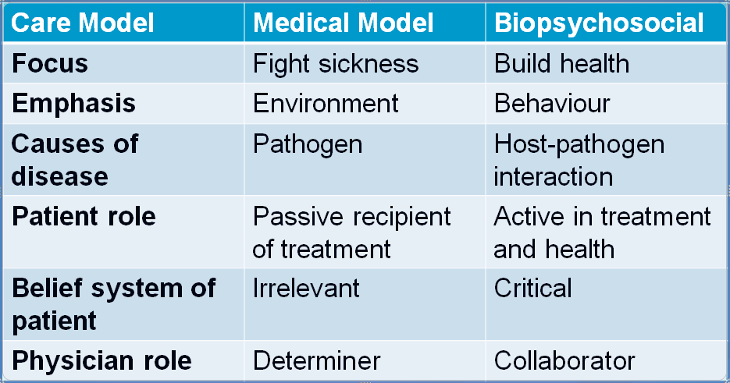

Health Psychology
- Stress: any circumstance that threaten or are perceived to threaten one’s well-being and thereby tax one’s ability to cope

Elements of stress:
- Frustration:
  - Prevention from achieving your goals
- Pressure:
  - Involve expectations for certain behaviours or results
- Change (challenge):
  - Circumstances are altered in a way that requires action or effort
- Conflict:
  - Have to make a difficult decision b/w two or more competing motives or behavioural impulses (Lewin)
    - Approach-Approach (least stressful)
      - Both good outcomes
      - Cannot loose
    - Avoidance-Avoidance (most stressful)
      - Cannot win
      - Decide on less evil
    - Approach-Avoidance
      - Both have attractive and repellent attributes
      - Example-on diet but you want to eat chocolate
Stress Response
- Characteristic physiology reaction to stress
- Hans style
- General adaptation Syndrome
- Responses to adversity
  - Why does one survive under, even thrive under the same circumstances that lead another person to break down, give up, or burn out?
Stress-Moderator Variables
- Vulnerability or protection (resiliency)***********************************************
- Variables that change the effects of a stressor on any given type of stress reaction:
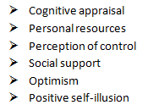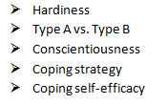

Cognitive Appraisal
- How people interpret situations (appraisals) is important in determining an event’s stressfulness
Two steps to the appraisal process
- Primary appraisal: significance of an event for psychological well-being
  - Do I perceive event as
    - A) Harmful (already occurred)
    - B) Threat (future danger)
    - C) Challenge (to be overcome)?
- Secondary appraisal:
  - Evaluations of personal and social resources available to cope with the event
- Negative appraisals lead to increased levels of perceived stress

Personal Resources and Control
- Personal Resources
  - Money
  - Time
  - Social skills
  - Knowledge
  - Health
- Perception of control
  - Internal locus of control
  - Opposite of learned helplessness
Social Support
- Three types of benefits:
  - Tangible Assistance (providable service)
  - Information (advice)
  - Emotional support
- Some relationships add to stress
- Includes obligations to provide support
Optimum
- General Expectation that things will go well in spite of occasional set backs
- Problems=difficult to overcome
- Benefits. Benefits, benefits
- Self-fulfilling prophecy
Pessimism
- Opposite of optimum
- Also self-fulfilling prophecy
- More risky behaviours (unsafe sex, smoking, etc)
From Cognitive Therapy...
- Cognitive reconstucturing:
  - modifying the thoughts, ideas and beliefs that maintain an individual’s problems which can be used to get people to think more positively and optimistically
- Positive ‘Self-talk”

Positive Self-illusion
- Some positive illusions about one’s self and the world can be wealthy
- Happy people often:
  - Have falsely high opinions of themselves
  - Use self-serving explanations
  - Exaggerate ability to control events
Levels: Grandiose Self-illusion
Median Mildly positive self-illusion
Median Reality
Negative self-illusion
Hardiness
- Kobasa’s “Three C’s”
- Commitment:
  - to work, family, other involvements; believe what they are doing is important
- Control:
  - View themselves as having control over outcomes
- Challenge:
  - Appraise demands of situations as challenges or opportunities rather than a threat

Personality Type:
- Cardiologists Friedman & Rosenman
- Worn out waiting room (front of chairs, carpet in front of chair)
- 2 types of personalities:
  - Type A (Exaggerated time pressure)
  - Type B (Relaxed, agreeable, lower level of heart diseases)
Coping
- Process of dealing with demands that are perceived as straining or exceeding an individual’s resources
- Emotion-focused:
  - managing the feelings that accompany stress and trying to find ways to feel better
- Problem-focused:
  - confronting the problem and dealing directly with the stressor via overt action or realistic problem solving
- Issue of controllability vs uncontrollability
- Best if you have a variety of possible strategies and can tailor your response to the demand of the situation
- Proactive coping:
  - Anticipatory form of coping
- Coping self-efficacy
Health Promotion
- Process of preventing, reducing, eliminating behaviours that pose risks to health and of increasing healthy behaviour patterns
- Conduct and apply research on cognitive factors associated with health related behaviours
- Goals:
  - better understand thought processes leading to health-endangering behaviours and to tailor interventions that keep these processes in mind
Health Beliefs and Behaviours
- How can we help people to choose more healthy behaviours?
- Most influential health belief model offered by Irwin Rosenstock
- Assumed people’s decisions about health-related behaviours guided by four main factors
Health Belief Model
- Perceiving a personal threat of developing a specific health problem
- Perceiving the seriousness of the illness and the consequences of having it
- Belief that a particular behaviour change will reduce the threat
- Comparison of perceived costs of enacting health-related behaviour change and benefits expected from that change
Transtheoretical Model
- Prochaska and DiClemente
- Changing behaviours depends not only on health beliefs but also person’s readiness to change
- Six stages:
  - Precomtemplation
    - Problem unrecognized or unacknowledged
  - Contemplation
    - Recognition of problem, contemplating change
  - Preparation:
    - Preparing to try to change behaviour
  - Action:
    - Implementing change strategies
    - Must last 6 months
  - Maintenance:
    - Behaviour change is being maintained
  - Termination:
    - Permanent change; no maintenance efforts required
    - Complete control, feels natural
- Relapse represents movement from action or maintenance to earlier stage
- Apply Stage-matched interventions designed to move person along

MIDTERM

FINAL EXAM NOTES:
Psychological Disorders
Schizophrenia
- Group of psychological disorders involving distortions of thought. Perception, emotion, speech, bizarre behaviour; social withdrawal
- Prevalence (% of population which exhibits a disorder during a specified time period)
- Effects
- Eugen Bleuler:
  - “Split mind” from reality
  - Created term schizophrenia
- 1/4 attempt suicide, 1/10 succeed
Positive Symptoms (Distortion/Excess to normal functioning)
- Delusions:
  - Faulty beliefs that cannot be shaken despite evidence to the contrary
    - Of Reference (thinks the media is directly speaking about you, or lyrics)
    - Of Persecution (others are plotting against you) (paranoid)
    - Of Control (thought insertion/broadcasting controlled by others/external force)
    - Of Grandeur (belief of yourself as a VIP with special powers)
- Hallucinations:
  - Perceptions occurring in absence of real, external stimuli or are pronounced distortions of perceptual input
    - Auditory (60%) (nasty voice saying terrible things to do/about yourself)
    - Tactile (touch)(trying to wipe bugs from body)and olfactory (rotten flesh)
    - Visual (seeing distortion of reality or things which aren’t there)
    - “If you can’t trust your senses, who do you trust?”
- Disorganised Speech
  - Shifts (abruptly in sentences, difficult to communicate)
  - Poverty of content (lack of meaning)
  - Persevation (repetition of words)
  - Clanging (words have no relation but rhyme)
  - “Word Salad” (seeming random words together, yet grammatically correct)
- Disorganized and Bizarre Behaviour
  - Catatonic excitement (random motor activity)
  - Catatonic rigidity (can remain motionless in strange posture for long period of time)
  - Waxy flexibility
  - Disregard social conventions (inappropriate nudity, giggling, grooming(+40,wint jacket))
  - Inappropriate affect (inappropriate emotions)
Negative Symptoms (Decrease/loss of normal functioning)
- Anhedonia (inability of feeling pleasure from normally pleasurable events)
- Loss of energy, motivation
- Flat affect (emotion)
- Poverty of speech (slow with speech)
- Hard to treat
Subtypes (of schizophrenia)
- Paranoid: Delusions/Hallucinations
- Catatonic: Excited/rigity/waxy
- Disorganized (hebephrenic): incoherence, speech, behaviour, affect
- Undifferentiated (residual or simple): dif. Symptoms from each group into a new cluster

Causation
- Strong evidence of organic causes
  - Cross-culture consistency
  - Dopamine hypothesis (over activity of dopamine)(receptors)
  - Brain degeneration (cell loss in cerebrum accelerated)
- Hereditary Predisposition
- Environment Factors
  - Diathesis-stress
  - Role of the family
- Socio-cultural Factors
  - Social-causation
  - Social Drift
- Prognosis (likely outcomes)
  - Side effects less challenging
  - 28% of those diagnosed live independently

Mood Disorders
- Depression
  - Dysthymia
  - Major Depression Disorder
- Bipolar Disorders
  - I and II
  - Cyclothymia

Depression
- Emotional Symptoms
  - Sadness
  - Hopelessness
  - Anxiety
  - Misery
  - Inability to enjoy

- Cognitive Symptoms
  - Negative cognitions about self, world and future
- Motivational Symptoms
  - Loss of interest
  - Loss of drive
  - Difficulty starting anything
- Somatic Symptoms (body)
  - Loss of appetite
  - Lack of energy
  - Sleep difficulties
  - Weight gain/loss

- Dysthymia: Chronic state of sadness/dissatisfaction (for a minimum of 2 years)
- Major Depression: Intensification of symptoms, thoughts of suicide (episodes are by-weekly minimum, it is a recurrent experience, 10% will not recover)

Causes of depression
- Heredity (inheriting, but a situation in the environment will activate)
- Neurotransmitter imbalances
- Biological rhythms (ex. SAD (Seasonal Affective Disorder)
  - Possibly the amount of sunlight intake
- Rogers: Discrepancies in self
  - Who you want to be versus who you are – too great of a discrepancy may cause depression
Cognitive Causes of Depression
- Beck and the cognitive triad: depressed people apply negative attitude towards self, situation and future
- Attributional Style
  - Internal vs. External; Stable vs. Unstable; Global vs. Specific
- Learned helplessness
  - You feel like there’s nothing you can do, and there’s no way out.
Bipolar
- Depression and Mania
- Mania
  - Elated, euphoric, very sociable, talkative, impatient, does not get tired, delusions of grandeur, increased sex drive, fluctuating appetite, hyperactive.

- Bipolar I and II
  - Bipolar I: Alternating between depression and mania
  - Bipolar II: Depression and hypomania (not as intense as mania)

- Cyclothymia
  - More chronic, less incapacitating
  - Mild depression, less mania (lower range)
Causes of Bipolar
- Genetics (strong evidence)
- Neurotransmitter imbalances: high mental state (mania) or low (depression)
- Possibly extreme stress

Anxiety Disorders
Emotional symptoms
- Feelings of tension
- Apprehension

Physiological Symptoms
- Increased heart rate
- Muscle tension
- Other autonomic arousal symptoms

Cognitive symptoms
- Worry
- Thoughts about inability to cope

Behavioural Symptoms
- Avoidance of feared situations
- Decreased task performance
- Increased startle response
Generalized Anxiety Disorder
- Consistent state of anxiety
- “free-floating” (not attaching to stimuli)

Panic Disorder
- Sudden and overwhelming
- Panic attacks
- Not uncommon for victim to think they are having heart attack

Phobic Disorders
- Intense and persistent fear of something though there is no threat and they know this
- Something happened to cause phobia
- Avoidance of phobic stimuli
- Simple of specific phobias
- Social Phobia (Social Anxiety Disorder)
- Agoraphobia: afraid that escape or help will be difficult if a situation occurred. Happens when is public place (like a mall or marketplace)

Post-traumatic Stress Disorder (PTSD)
- Anxiety, arousal, distress that weren’t present before
- Flashbacks
- Becomes numb to the world; avoids stimuli that serves as reminders of trauma (such as war movies towards veterans)
- “Survivor’s Guilt” – Why me?

Obsessive-Compulsive Disorder (OCD)
- Cognitive and behaviour
- Compulsive ‘hoarding’ may represent a form of OCD
- O: unwanted image in conscience which will not go away
- C: overwhelming desire to engage in a specific behaviour, which is repetitive

Somatoform Disorders
Somatization disorder (reoccurring physical complaints, but no organic cause)
- AKA Briquet’s Syndrome (will ‘doctor shop’, an attention seeker, manipulative)

Hypochondriasis:
- Persistent belief that something is wrong, but is not medically proven
- Any change to self is major (ex-headache must be a brain tumour)
Body Dysmorphic Disorder
- Imagined defect, or unwanted aspect of appearance
- Stand in front of mirror for hours analyzing imagined defect
  - Most commonly the face
- Sometimes tries to fix the defect, medically or by themselves

Pain Disorder
- Pain which a person experiences and tends to be disproportionally intense and last long
- Everything hurts, all the time, at the maximum pain level
- Just wants to talk about the pain, not the cause

Conversion Disorder
- Lost part of all disproportional functioning
- Glove anaesthesia
  - Lost sensation in hands, but arm is normal
  - (area of hang as if wearing a glove, highly unusual)
- La Belle indifference
  - Can’t see but doesn’t bother the person
  - Something is wrong but all the person wants to do is talk about the symptoms rather than how to get better

Disorders of Childhood
Externalising disorders
- Attention deficit hyperactivity disorder (ADHD)
  - Cannot sit still or remain attentive

- Oppositional Defiant Disorder
  - Hostile towards other
  - Likes to annoy others
  - Angry
  - Easily annoyed themselves
  - Common to have separated parents
  - Or a socially isolated parent
  - 10-12 relatively balanced gender

- Conduct Disorder
  - Pleasure from harming others or animals
  - Bullies, people frequently absent from school, peers label as cruel, lower academics
  - Not unusual to become a psychopath
    - A psychopath is manipulative, has a shallow emotion, hard to show affection
    - Psyc 2600 (Forensics)

Dissociative Disorders
- Formally known as psychogenic disorders
- Dissociative amnesia
  - Memory loss
  - Partial/total forgetting of something (people, events, places)
    - Anxiety
- Dissociative fugue
  - Amestic state?
  - Walk out door and establish a new identity
  - Wake up one day and do not know who you are-loss of identity
  - Incredibly rare
- Dissociative Identity Disorder
  - Formerly “Multiple Personality Disorder”
  - Trauma-dissociative theory
  - Different pattern of awareness
  - In some cases the ‘host’ knows of the alternates, either some of them or one.
  - Trauma-dissociative theory
    - Experienced significant trauma, typically young sexual assault
    - Personality fractured like a piece of glass that dropped
  - This disorder can be therapy-induced
    - Suggestions say that people can develop this after being hypnotized
- Psyc 3604 (abnormal disorders)

THERAPY
Psychodynamic Approaches (Freud)

Psychoanalysis
- Provides insight into unconscious (ex: Super-ego)
- “The Couch” (make the person Comfortable)
- Free Association (say whatever you want and just keep taking)
  - Leads to unconscious mind, leading to the problem
- Resistances
  - Client’s behaviours which interfere with the therapeutic process
  - Such as bringing up something powerful at the end of a session, cancelling, being late
- Transference
  - Acting towards therapist as important person in life (ex: Family)
- Counter-Transference
  - Therapist acting towards client as an important person in life (ex: Family)
Humanistic Approach
- Conscience control and taking responsibility (you can heal yourself)
- Inner-resources for healing and growth
- Create the environment for self-exploration and removal of road blocks to growth
- Person-centred therapy (Carl Rogers
  - Unconditional positive regard
    - Non-judgemental and non-directive
  - Active listening
    - Paraphrasing and reflecting(emotions – “you sound angry, sad, frustrated”)
  - Empathy
    - You have a sense of what it is like in their shoes
  - Genuineness
    - You have to believe in what you do
    - Being consistent
- Gestalt Therapy
  - Living “inauthentic lives” ability
  - Achieve wholeness...in here and now
  - Increase emotional expressiveness
  - Take responsibility for your actions
  - Challenge maladaptive thoughts and behaviours
  - Observe for dishonesty
  - Open-chair technique
    - Ex- “If your dad was sitting in this chair what would he say to you?”

Cognitive Approaches
- Events do not cause maladaptive emotions and behaviours – our interpretations of events do
- Focus on self-defeating thoughts
- Changes in thinking can produce changes in behaviours and emotions
- Rational-emotion behaviour therapy (REBT) (Albert Ellis)
  - A-B-C-D theory of emotions
    - A= Activating event (reaction)
    - B= Irrational belief (how did that make you feel)
    - C= Emotional and behaviour consequences
    - D= Disputing and changing of ‘B’
  - “A does not cause C”
  - Identify irrational beliefs
  - Challenge client for evidence; dispute evidence
    - Example:
    - A = Don’t get an “A+” on your midterm
    - C = You’re upset
    - B = You have to be perfect
    - D = What’s going to happen if you’re not perfect?

    - Common irrational beliefs
    - Homework
      - Paradoxical intention
        - Behavioural homework(ex: go to a party, then explain in therapy)
Behavioural Approaches
- Change maladaptive behaviours & learning
- Systematic desensitization
  - Anxiety hierarchy
  - Progressive relaxation
  - Pairing
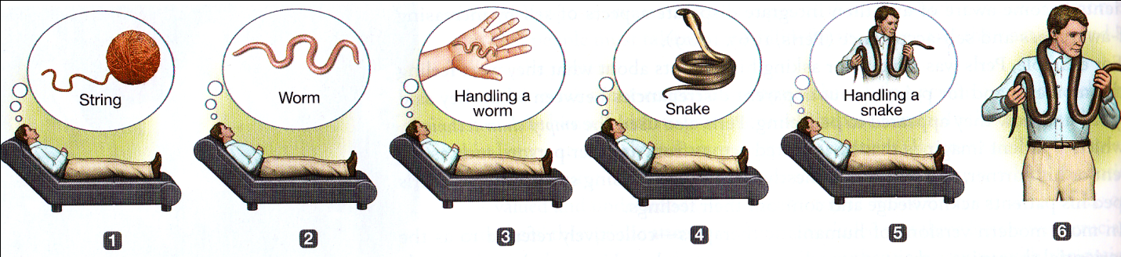

- Flooding:
  - Exposing client to high intensity stimuli that creates anxiety
- Aversion therapy:
  - Trying to make a maladaptive behaviour unpleasurable
- Behaviour modification
  - Reinforcement (Trying to make an increase of behaviour occurring)
  - Punishment (Trying to make a decrease of the behaviour occurring)
- Social skills training
  - Observational learning
  - Client observes someone who is socially acceptable
  - Client imitates the role model
  - Perhaps by simply asking how people are

Drug Therapy (Pharmacotherapy)
- Placebo effect – a pill of injection that has no effect but the patients believe there is and feel better

Schizophrenia:
- Antipsychotics –reduces dopamine
- Older antipsychotics can cause:
- Tardive dyskinesia (involuntary movement of the tongue/face
  - Primary side-effect is weight gain, diabetes
- Whereas recent antipsychotics have more success with negative symptoms

Depression – 40 million prescriptions
- Tricyclics: Increase amount of NE
  - Can be toxic with other medications
  - Used only for extreme cases when other medications/therapies do not work
- Monoamine oxidase inhibitors (MAOIs)
  - Cleans
  - Side effects: sudden spike in blood pressure
- Selective Serotonin reuptake inhibitors (SSRIs)
  - Blocks reuptake of serotonin
  - Prozac
- Serotonin norepinephrine reuptake inhibitors (SNRIs)

Bipolar
- Lithium carbonate
- Valproate (valproic acid)
Anxiety
- Tranquilizers: Benzodiazepines
Issue with relying on medication is that they do not allow the clients to use their skills

Electroconvulsive Therapy (ECT)
- Side effects: Cognitive problems such as memory loss
Psychosurgery (Prefrontal Lobotomy)
- Go past eye and disconnect part of frontal lobe where the ‘personality’ is located
- Causes a permanent disruption in personality and the clients cognitive use
- Almost possible death
Trephining
- 14th -15th Century
- Cut hole in skull and let spirits leave
- Not all patients die
18th – 19th Century Approaches
- Circulating Swing
  - Spin the client quickly, and this changes self
- Tranquilizing Chair
  - Client has head in box
  - Lowers anxiety
- The “Crib”
  - For the client to achieve a sedative experience
18th – 19th Century Institutionalization
London’s Bethlehem Hospital
- Mental patients chained outside for entertainment
Reform
- LaBicetre in Paris
  - Jean-Baptiste Pussin’s new rules
    - Unchained the males
    - Listened to the patients
  - Philippe Pinel’s innovations
    - Unchained the females
    - Keep records of conversations, early classification
- England
  - William Tuke and moral therapy
    - Allowed the patients to walk outside freely with nature, and prey
    - The patients then became manageable
- United States
  - Benjamin Rush
    - Liberal views, and for doctors to treat patients kindly
  - Dorothea Dix
    - Worked with prison population
    - Wanted more psychiatric institutions, was responsible for 32 being created

Social Psychology (Psyc 2100)
- How thoughts, feelings and attitudes are influenced by others
- The power of situations
- Construal of the situation
- Fritz Heider “naïve psychology”
Folk wisdoms:
- “Birds of a feather flock together”
- “Opposites attract”
  - These contradict each other
- “Absence makes the heart grow fonder”
- “Out of sight, out of mind”
  - These contradict each other
- “Many hands make light the work”
- “Too many cooks spoil the broth”
  - These contradict each other
Forming an Impression
- Definition: Collections of perceptions about others that we maintain and use to interpret their behaviours.
- What type of information do we use to help us form an impression?
- “Don’t judge a book by its cover.”
  - But a cover can tell you a lot about a book
Biases in Impressions
- Primacy effect (Asch)
  - Rate hypothetical people as if a first impression
  - Intelligent, attractive, critical, stubborn
  - Stubborn, critical, attractive, intelligent
    - The first characteristics are more powerful
    - It should not matter but it does
- Recency effect
  - Recent info is more important (due to the gap from the first impression to the recent info)
- Positivity bias (“Pollyanna Effect”)
  - Hope something is good
  - “Hope this person is nice” (and not the opposite belief)
- Power of negative information
  - Holds a lot of influence
  - If you do not like someone, you do NOT like them
  - “I still don’t like them” (doesn’t matter what other people may say)

Interpersonal Attraction
- Relationships key to happiness
- Their absence can lead to “symptoms”
- We are selective…and that’s adaptive
- Study of why one person will like and positively evaluate another person
- Is there such a thing as love at first sight?

- We like people that we encounter often
  - Increases opportunities for interaction
  - Mere exposure effect
- We like people who are similar to us
  - “Birds of a feather flock together”
  - Provides social validation
  - What about “complementarity?”
- We like people who like us
  - Reciprocal-liking
  - Elements of a self-fulfilling prophecy
    - Believe person likes you
    - You behave nicely towards them
    - They respond positively
    - You believe that you were right

- What we look for in a person:
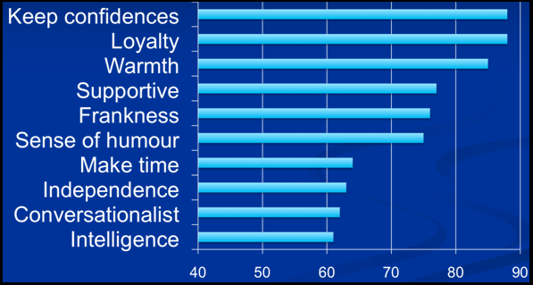

- We like people who are physically attractive
  - More powerful than personality information
  - Aesthetic appeal leads to positive emotions
  - People hold “what is beautiful is good” stereotype
  - Influence of social skills
  - Association for social profit
  - Matching hypothesis
  - External conditions
- Matching Hypothesis
  - Romantic partners tend to be similar in physical attractiveness
- External conditions (Pennebaker et al.)
  - (such as alcohol)
  - This observation was experimented in a bar
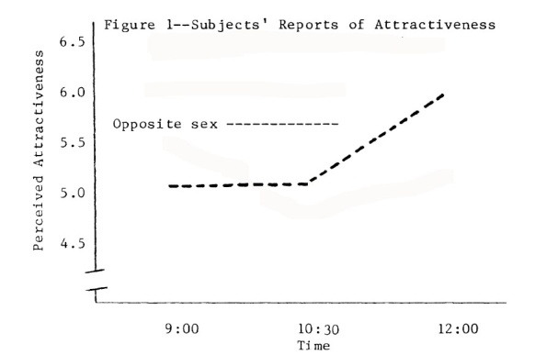
- Social exchange theory (Thibault & Kelley)
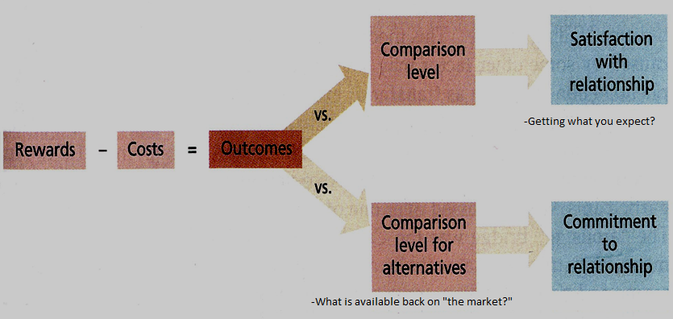

Social Comparison
- Leon Festinger
  - Upward and downward comparisons
    - Upward: Comparison to someone “better” than you
    - Downward: Comparison to someone “less” than you
- Which approach might you use for:
  - Self-improvement? - Upward
  - Self-enhancement? - Downward
  - Self-assessment? – Looking for people similar to you

Attributions of Causality
- Explain our behaviour/their behaviour
- External Attributions
  - Situational factors
- Internal Attributions
  - Personal factors
Attributional Biases
- Fundamental attribution error
  - Overestimate person factors, underestimating external factors
- Actor-observer bias
  - Actor: happening to you (ex: if you slip on ice, it is because of the ice)
  - Observer: Happens to someone else (slips on ice because they are a clutz)
- Self-serving bias
  - Offering different attribution pattern for success than failure
    - Do well – because of yourself, do bad – someone else’s fault
    - Protects self-esteem
- Defensive attributions
  - Blaming the victim
    - “She was asking for it”
  - Just-world (Lerner)
    - “Good things happen to good people while bad things to bad people
Group Processes
- Prevalence of groups
- What about performance?
- Social facilitation
- Ringelmann Effect
  - Coordination loss?
  - Loss of effort?
  - Ringelmann Effect (visual):

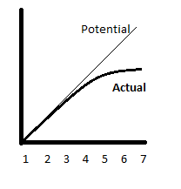
- Social loafing
  - You don’t feel as though your efforts matter

Intergroup Relations
- Bombarded with perceptual stimuli
- Cognitive misers (Fiske & Taylor)
- Social schemas
  - Mental structures to organize knowledge about social world
  - Establish expectations
- Social identity theory (Tajfel)
- Stereotypes, prejudice, discrimination, ethnocentrism

Attitudes
- Evaluation of a person, object, or idea
- ABC tripartite model
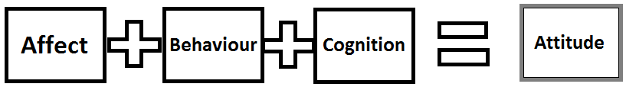

Cognitive Dissonance
- Leon Festinger
- Feeling of discomfort when:
  - Our behaviour is inconsistent with our attitudes
  - We hold two conflicting attitudes
- Motivated to reduce the tension

Eliminating Dissonance
- Change our cognitions (maybe trivialize)
- Add a consonant cognition
- Change our behaviour

