Flow Through a Sluice Gate and Hydraulic Jump
Author:
October 21, 2013

Lab Partners: Neal Traynor, Garrett Lihou, Alex Bouchie
Group Number: L2I

Summary:
The behaviour of fluid in a hydraulic jump was analysed for two separate flows. The velocity of each supercritical flow was found to be 1.82m/s and 1.29m/s. Head of each flow within the reservoir, supercritical flow and subcritical flow and was used to show that Mechanical energy through a hydraulic jump is not conserved. In addition an equation to calculate height of a hydraulic jump was derived using conservation of momentum and flow rate equations.

Nomenclature/List of Symbols:
Variable/symbol | Name | Units
Q | flow rate | m³/sec
y | depth | inches
P | Static pressure | Mpa
ρ | density | kg/m³
g | Gravitational constant | N/kg or m/s²
z | elevation | metres
V | Velocity | m/s
w | width | metres
h | height | metres
H | head | metres

Flow Analysis:

Velocity of Supercritical flow (using Bernoulli's equation):
Using Bernoulli's equation across the sluice gate, velocity of the supercritical flow downstream of the sluice gate can be determined. Point 1 is taken to be top of the reservoir and point 2 is the top of the flow downstream of the sluice gate:
$P_{1}+\frac{1}{2}ρV_{1}^{2}+ρgy_{1}=P_{2}+\frac{1}{2}ρV_{2}^{2}+ρgy_{2}$ (1)
Assuming P₁ and P₂ are equal to P_{atm} and ρ to be constant Bernoulli's equation can be rearranged to give
$V_{2}=\sqrt{2g(y_{1}-y_{2})}$ (2)

Velocity of Supercritical flow (using flow rate equation)
Using the flow rate equation gives another way to solve for V:
$Q=VA=Vwh=>V=\frac{Q}{wh}$ (3)
From the v-notch in the hydraulic jump lab Q(flow rate) can be found using:
$Q=1.38H^{2.5}$(4)
Knowing Q and the flow rate, both equations can be combined and rearranged to give an equation that solves for V:
$$V=\frac{1.38H^{2.5}}{wh}$$

Head upstream and downstream of sluice gate
Head is calculated using the equation:
$H_{1}=\frac{P}{ρg}+\frac{V^{2}}{2g}+z$ (5)

Head upstream of sluice gate
Assuming P to be gauge pressure (calculated using ρg$∆$y),z is zero as it is at datum level and velocity within the reservoir to be 0, the experimental values can be input to find H_{tot} of the first flow within the reservoir:
$H_{1}=\frac{P}{ρg}$ => $H_{1}=\frac{ρg∆y}{ρg}+z$

Head downstream of sluice gate
The H₂ of the flow beyond the sluice gate is calculated using the head equation, where z is zero as the point lies on the datum and velocity of the flow was calculated with Bernoulli's equation in the previous section:
$H_{2}=\frac{P}{ρg}+\frac{V^{2}}{2g}+z=>$ $H_{2}=\frac{ρg∆y}{ρg}+\frac{V^{2}}{2g}+z$ => $H_{2}=∆y+\frac{V^{2}}{2g}+z$

Calculating depth of flow after hydraulic jump
The momentum equation is used to solve for depth of flow after the hydraulic jump:
${-(ρVQ)}_{1}+{(ρVQ)}_{2}=F={(PA)}_{1}-{(PA)}_{2}$(6)
V can also be expressed as V=Q/w
$${-(\frac{ρQ^{2}}{wy})}_{1}+{(\frac{ρQ^{2}}{wy})}_{2}=F={(Pwy)}_{1}-{(Pwy)}_{2}$$
w is constant throughout the flow ρ, Q are assumed to be constant. The equation can be rearranged to give:
$$0=-\left(P_{2}y_{1}\right){y_{2}}^{2}+[\left(P_{1}y_{1}^{2}\right)+\left(\frac{ρQ^{2}}{w^{2}}\right){]y}_{2}-y_{1}\left(\frac{ρQ^{2}}{w^{2}}\right)$$
P can be expressed as ρg$∆$y giving:
$$0=\left(ρgy_{1}\right){y_{2}}^{3}+[-\left(ρgy_{1}^{3}\right)+\left(\frac{ρQ^{2}}{w^{2}}\right){]y}_{2}-y_{1}\left(\frac{ρQ^{2}}{w^{2}}\right)$$
As ρ is a common term amongst all terms of the equation it too can be factored giving a final equation of
$0=\left(gy_{1}\right){y_{2}}^{3}+[-\left(gy_{1}^{3}\right)+\left(\frac{Q^{2}}{w^{2}}\right){]y}_{2}-y_{1}\left(\frac{Q^{2}}{w^{2}}\right)$(7)
At this point the equation can be solved using numerical methods. This form of cubic function can give only one positive zero for the equation. This zero is the value of $y_{2}$.

Total Head Change
Total head change is the difference in head before and after the hydraulic jump:
$H_{tot}=H_{2}-H_{1}=\frac{P_{1}}{ρg}+\frac{{V_{1} }^{2}}{2g}+z_{1}-\frac{P_{2}}{ρg}+\frac{{V_{2} }^{2}}{2g}+z_{2}$
$H_{tot}= \frac{ρg∆y_{1}}{ρg}+\frac{{V_{1} }^{2}}{2g}+z_{1}-\frac{ρg∆y_{2}}{ρg}+\frac{{V_{2} }^{2}}{2g}+z_{2}$
z is 0 as the flow is still at the datum:
$H_{tot}= \frac{ρg∆y_{1}}{ρg}+\frac{{V_{1} }^{2}}{2g}-\left[\frac{ρg∆y_{2}}{ρg}+\frac{{V_{2} }^{2}}{2g}\right]$ (8)
V₂ is found using the flow rate equation where Q is found using the calibration equation of the v-notch weir downstream of the jump:
$$Q=1.38H^{2.5}$$
Q can then be written as an equation of V:
$Q=VA=Vwh=>V=\frac{Q}{wh}$
Knowing Q and the flow rate, both equations can be combined and rearranged to give an equation that solves for V:
$$V=\frac{1.38H^{2.5}}{wh}$$
Combining this equation with the head equation gives:
$H_{tot}= \frac{ρg∆y_{1}}{ρg}+\frac{{(\frac{1.38H^{2.5}}{wh})}^{2}}{2g}-\left[\frac{ρg∆y_{2}}{ρg}+\frac{{(\frac{1.38H^{2.5}}{wh})}^{2}}{2g}\right]$ (9)

Experimental Setup and Procedure:
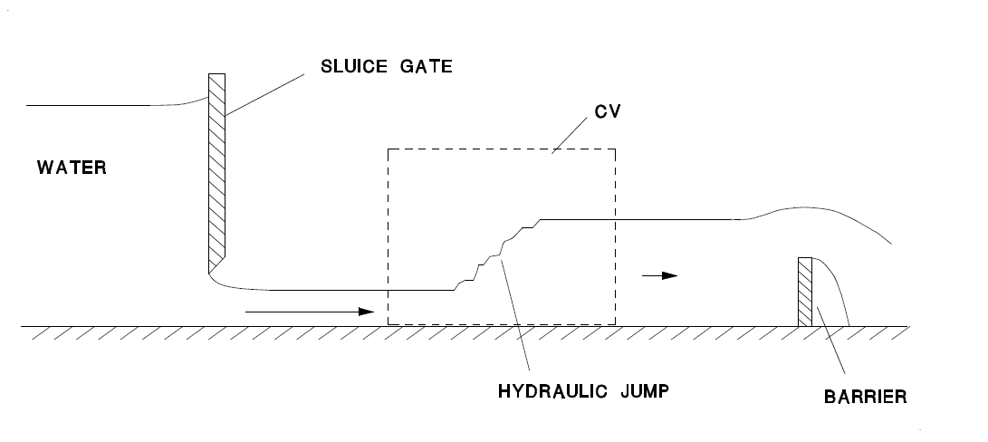

(1) (2) (3)
Figure 1: Setup of Hydraulic Jump
Refer to pages 9 and 10 of the Fluid Mechanics I (MAAE 2300) course manual for instructions on how to conduct this experiment properly.

Results and Discussion:
Results | Flow 1 | Flow 2
Velocity of Supercritical flow (using Bernoulli's equation): | V₂=2.80m/s | V₂=2.89m/s
Velocity of Supercritical flow (using flow rate equation) | $V=$1.82m/s | $$V=1.29m/s$$
Head upstream of sluice gate | $H_{1}=$0.409m | $$H_{1}= .4349m$$
Head downstream of sluice gate | $H_{2}=$ .408m | $$H_{2}=.4337m$$
Calculating depth of flow after hydraulic jump | 0.022m or 2.2cm | 0.060m or 6.0cm
Total Head Change from Hydraulic Jump | $$H_{tot}=-.282m$$ | $$H_{tot}= -0.308m$$
Table 1: Results

Velocity of Supercritical flow (using Bernoulli's equation):
For this part of the experiment Bernoulli's equation(eq. 1) was used to solve for the velocity of the supercritical flow, downstream of the sluice gate.
1 is taken to be the top of the reservoir while 2 is taken to be the top of the flow downstream of the sluice gate. P₁ and P₂ are assumed to equal to P_{atm} . V₁ is also taken to be zero at the surface of the reservoir. This results in an equation that can be used to solve for velocity of the supercritical flow(eq. 2).
However, as shown in the results of this experiment Bernoulli's equation is limited to specific circumstances. Bernoulli's equation can only be applied :
- along a single streamline
- in a frictionless, uncompressible flow
- between two points where no work or heat transfer is undergone
When Bernoulli's equation was used in this experiment it was assumed that Bernoulli's equation was applied under these circumstances. In reality, it is known that no flow is truly frictionless or incompressible. This leads to a source of error as Bernoulli's equation can only be applied when all of these conditions are met.

Flow across sluice gate using flow rate equation:
For this part of the experiment the flow rate equation(eq. 3) was used to solve for the velocity of the supercritical flow, downstream of the sluice gate.
Q was found using the recorded height of the V-trough, w was measured as width of the flow and h as the measured height of the flow. From this velocity of the supercritical flow can be calculated for.
The advantage of this method over Bernoulli's equation is that no simplifying assumptions other than a consistent flow rate throughout were made in order to solve for the velocity of the supercritical flow. A consistent flow rate was a valid assumption as no part of the apparatus was storing water after the reservoir and before the barrier. This means that the results of this equation should be more accurate than the results calculated using Bernoulli's equation.

Head upstream and downstream of sluice gate:
Head represents mechanical energy in a flow or the combination of potential energy, pressure energy and kinetic energy. The resulting head is the height to which the energy can move the respective fluid. Head is calculated using a formula derived by rearranging Bernoulli's equation(eq. 5). All four heads calculated using this equation were found to be very similar to the measurements taken off of the pitot tubes. This makes sense as a pitot tube converts all of the energy in a flow to gravitational potential energy stored by raising a fluid up the length of the pitot tube.

Head upstream of sluice gate:
In order to calculate Head upstream of the sluice gate(within the reservoir) some assumptions are made. P is assumed to be gauge pressure (calculated using ρg$∆$y) and velocity within the reservoir is assumed to be 0. z is taken to be zero as it is at datum level.

Head downstream of sluice gate:
The H₂ of the flow beyond the sluice gate is calculated using the head equation(eq. 5). Like the head within the reservoir, P is taken to be gauge pressure (calculated using ρg$∆$y), and z is zero as the point lies on the datum and velocity of the flow was calculated with Bernoulli's equation in the previous section:
Unlike the head within the reservoir velocity was not assumed to be zero. Velocity was calculated using Bernoulli's equation(eq. 1) as shown above. In retrospect this may not have been the best decision as the velocity calculated using the flow rate equation(eq. 3) appears to be a more accurate equations as no un supported assumptions were made when using this equation.

Calculating depth of flow after hydraulic jump:
In order to calculate depth of flow after the hydraulic the conservation of momentum equation(eq. 6) was used. As shown above this equation was rearranged to give a cubic function with respect to y₂(eq.7) Solving for the zeroes of this equation should theoretically have given a single value which would have been the height of the flow after the jump. As the results from this equation were off by a magnitude of order, it is evident there is error within this equation. At this time no possible sources of error have been identified.

Total Head Change:
Total head change is the difference in head before and after the hydraulic jump(eq. 8). In this circumstance z was taken to be zero as the base flow was unchanged and at the datum. V₂ was found using the flow rate equation (eq. 3) where Q was found using the calibration equation of the v-notch weir downstream of the jump (eq.4). This combined with the flow rate equation solves for the velocity. Replacing V₂ in equation 8 with equations 3 and 4 gives a final equation that can be used to solve for Total Head Change (eq.9)
The results given from equation 9 are reasonable as the negative sign of the Total Head Change alludes to the fact that the energy of a fluid is dissipated when a fluid undergoes a hydraulic jump. This is reasonable as energy is dissipated when the fluid rebounding of the barrier collides with supercritical flow.

Assumptions
There were a number of assumptions made during this experiment. These assumptions were:
- Both flows were one dimensional
- water is uncompressible
- no water stored in the flow
It is known that both flows were not one dimensional due to the no-slip condition learnt about in class. It was assumed that the entire cross-section of the flow had a uniform velocity when in reality the it would be a parabolic relationship with the edges having a velocity of zero and max velocity somewhere in the middle of the flow. This assumption is valid because the effects of the no-slip condition should be minimal in these flows due to the small ratio between width and length of the apparatus.
Water is treated as uncompressible because it was in a liquid state. While water can be compressed, it is difficult to compress water compared to the compressibility of a fluid like air. As taught in Fluid Mechanics, it is safe to assume that a liquid is uncompressible.
Finally it was assumed that no water was stored in the flow because of the operation of the apparatus. The apparatus appeared to be a closed loop system where the output lead to the input of the hydraulic jump. This closed loop makes it safe to assume that no water is stored in the hydraulic jump.

Conclusions:
The velocities of both supercritical components of flows one and two using Bernoulli's equation were found to be V₂=2.80m/s, and V₂=2.89m/s respectively. Using the flow rate equation these velocities were found to be $V=$1.82m/s and $V=1.29m/s$. The velocities found using the flow rate equation were determined to be more accurate because fewer assumptions were made when using the flow rate equation. Furthermore Head before and after the sluice gate were found to be very similar (within 0.001m) demonstration conservation of energy in the flow. On the contrary Total Head was found to decrease after the hydraulic jump demonstrating that energy was dissipated due to the hydraulic jump.

Appendices:

Lab Results
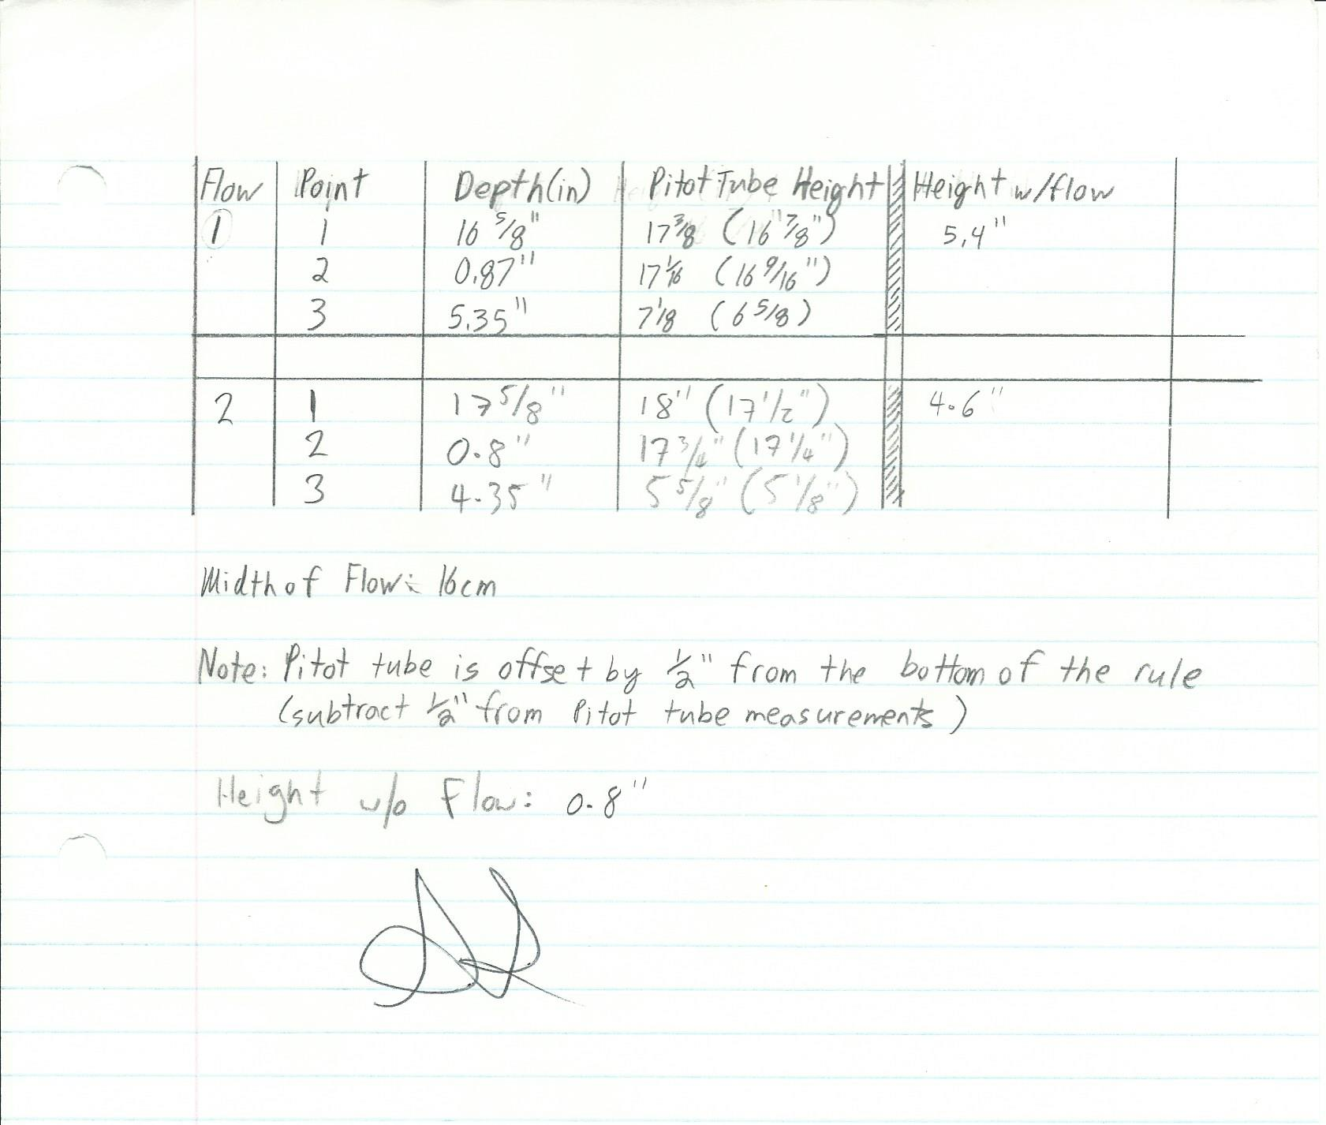

Sample Calculations:

Conversion from imperial to metric:

$$D=15\frac{5}{8}inches×0.0254\frac{metres}{inch}=.396metres$$

Velocity of Supercritical flow (using Bernoulli's equation):
By applying Bernoulli's equation at the sluice gate, the velocity of the first flow downstream of the sluice gate can be calculated. 1 is taken to be the top of the reservoir while 2 is taken to be the top of the flow downstream of the sluice gate.
$P_{1}+\frac{1}{2}ρV_{1}^{2}+ρgy_{1}=P_{2}+\frac{1}{2}ρV_{2}^{2}+ρgy_{2}$
P₁ and P₂ are equal to P_{atm}
$$\frac{1}{2}ρV_{1}^{2}+ρgy_{1}=\frac{1}{2}ρV_{2}^{2}+ρgy_{2}$$
Likewise ρ can be factored out of this equation by assuming water is an uncompressible flow giving:
$ρ(\frac{1}{2}V_{1}^{2}+gy_{1})=ρ(\frac{1}{2}V_{2}^{2}+gy_{2})$ => $\frac{1}{2}V_{1}^{2}+gy_{1}=\frac{1}{2}V_{2}^{2}+gy_{2}$
V₁ is also taken to be zero at the surface of the reservoir. We can then rearrange the equation and plug in the known values(metric units) to solve for V₂.
$\sqrt{2g(y_{1}-y_{2})}=V_{2}$ = $\sqrt{2(9.81\frac{m}{s^{2}})(0.4223m-0.02223m)}$
V₂=2.80m/s
Using this same process for the second flow the velocity of the flow downstream is found to be:
V₂=2.89m/s

Velocity of Supercritical flow (using flow rate equation)
From v-notch in the hydraulic jump lab Q(flow rate) can be found using:
$$Q=1.38H^{2.5}$$
Plugging in H, q is found to be:
$$Q=1.38{(0.117{ m}^{3}/s)}^{2.5}$$
$$Q=6.46×{10}^{-3}{ m}^{3}/s$$
Rearranging the flow rate equation:
$$Q=VA$$
$V=\frac{Q}{A}=>V=\frac{Q}{hw}=>V=(6.46×{10}^{-3}{ m}^{3}/s)/(0.02223m×.16m)$
$V=$1.82m/s
Using this same equation the velocity of the second flow is found to be:
$$V=1.29m/s$$

Head upstream and downstream of sluice gate
Head is calculated using the equation:
$H_{1}=\frac{P}{ρg}+\frac{V^{2}}{2g}+z$ (1)
Assuming P to be gauge pressure (calculated using ρg$∆$y),z is zero as it is at datum level and velocity within the reservoir to be 0, the experimental values can be input to find H_{tot} of the first flow within the reservoir:
$H_{1}=\frac{P}{ρg}$ => $H_{1}=\frac{ρg∆y}{ρg}+z=> H_{1}=.409m+0m$
$H_{1} =$0.409m
The H₂ of the flow beyond the sluice gate is calculated using equation (1), the velocity of the flow calculated with Bernoulli's equation in the previous section:
$H_{2}=\frac{P}{ρg}+\frac{V^{2}}{2g}+z=>$ $H_{2}=\frac{ρg∆y}{ρg}+\frac{V^{2}}{2g}+z$ => $H_{2}=∆y+\frac{V^{2}}{2g}+z$
Plug in for known values(z is still datum as base of flow has not changed) and constants and H is found to be:
$$H_{2}=∆y+\frac{V^{2}}{2g}+z$$
$H_{2}=\left(.009m\right)+\frac{{\left(\frac{2.80m}{s}\right)}^{2}}{2\left(9.81\frac{m}{s^{2}}\right)}+0m$
$H_{2}=$ .408m
For the second flow H₁ and H₂ are found to be:
$$H_{1}=.4349m+0m$$
$$H_{1}= .4349m$$
$$H_{2}=\left(.008m\right)+\frac{{\left(\frac{2.89m}{s}\right)}^{2}}{2\left(9.81\frac{m}{s^{2}}\right)}+0m$$
$$H_{2}=.4337m$$

Calculating depth of flow after hydraulic jump
Use momentum equation for this scenario
$${-(ρVQ)}_{1}+{(ρVQ)}_{2}=F={(PA)}_{1}-{(PA)}_{2}$$
V can be expressed as an equation of $V=\frac{Q}{wy}$. Plugging into the equation above:
$${-(\frac{ρQ^{2}}{wy})}_{1}+{(\frac{ρQ^{2}}{wy})}_{2}=F={(Pwy)}_{1}-{(Pwy)}_{2}$$
ρ, Q and w are constant throughout the flow and can be factored giving:
$$\left(\frac{ρQ^{2}}{w}\right)(\frac{1}{y_{2}}-\frac{1}{y_{1}})={w[(Py)}_{1}-{\left(Py\right)}_{2}]$$
Divide both sides of the equation by $(\frac{1}{y_{2}}-\frac{1}{y_{1}})$ and bring w to the left hand side
$\left(\frac{ρQ^{2}}{w^{2}}\right)={[(Py)}_{1}-{(Py)}_{2}]÷(\frac{1}{y_{2}}-\frac{1}{y_{1}})$ =>$\left(\frac{ρQ^{2}}{w^{2}}\right)={[(Py)}_{1}-{(Py)}_{2}]÷(\frac{y_{1}-y_{2}}{y_{2}y_{1}})$
$$\left(\frac{ρQ^{2}}{w^{2}}\right)={[(Py)}_{1}-{(Py)}_{2}]×(\frac{{ y}_{2}y_{1}}{y_{1}-y_{2}})$$
$$\left(\frac{ρQ^{2}}{w^{2}}\right)=[(P_{1}y_{1})-(P_{2}y_{2})]×(\frac{{ y}_{2}y_{1}}{y_{1}-y_{2}})$$
$$\left(\frac{ρQ^{2}}{w^{2}}\right)=(P_{1}y_{1}^{2}y_{2})-(P_{2}y_{1}{y^{2}}_{2}) (\frac{1}{y_{1}-y_{2}})$$
Bring $(\frac{1}{y_{1}-y_{2}})$ to the left hand side and rearrange for y₂
$$\left(\frac{ρQ^{2}}{w^{2}}\right){(y}_{1}-y_{2})=(P_{1}y_{1}^{2}y_{2})-(P_{2}y_{1}{y^{2}}_{2})$$
$$\left(\frac{ρQ^{2}}{w^{2}}\right){(y}_{1}-y_{2})=(P_{1}w_{1}y_{1}^{2}y_{2})-(P_{2}w_{2}y_{1}{y^{2}}_{2})$$
$$y_{1}\left(\frac{ρQ^{2}}{w^{2}}\right)-y_{2}\left(\frac{ρQ^{2}}{w^{2}}\right)=(P_{1}y_{1}^{2}y_{2})-(P_{2}y_{1}{y^{2}}_{2})$$

Rearrange the equation to create a quadratic equation
$$0=-\left(P_{2}y_{1}\right){y_{2}}^{2}+[\left(P_{1}y_{1}^{2}\right)+\left(\frac{ρQ^{2}}{w^{2}}\right){]y}_{2}-y_{1}\left(\frac{ρQ^{2}}{w^{2}}\right)$$
Replacing P with ρg$∆$y
$$0=-\left(ρg{(-y}_{2})y_{1}\right){y_{2}}^{2}+[\left(ρg(-y_{1}{)y}_{1}^{2}\right)+\left(\frac{ρQ^{2}}{w^{2}}\right){]y}_{2}-y_{1}\left(\frac{ρQ^{2}}{w^{2}}\right)$$
$$0=\left(ρgy_{1}\right){y_{2}}^{3}+[-\left(ρgy_{1}^{3}\right)+\left(\frac{ρQ^{2}}{w^{2}}\right){]y}_{2}-y_{1}\left(\frac{ρQ^{2}}{w^{2}}\right)$$
Factor out ρ
$$0=ρ[\left(gy_{1}\right){y_{2}}^{3}+[-\left(gy_{1}^{3}\right)+\left(\frac{Q^{2}}{w^{2}}\right){]y}_{2}-y_{1}\left(\frac{Q^{2}}{w^{2}}\right)]$$
$$0=\left(gy_{1}\right){y_{2}}^{3}+[-\left(gy_{1}^{3}\right)+\left(\frac{Q^{2}}{w^{2}}\right){]y}_{2}-y_{1}\left(\frac{Q^{2}}{w^{2}}\right)$$
At this point the equation can be solved using numerical methods. This form of cubic function can give only one positive zero for the equation. This zero is the value of $y_{2}$.
The predicted depth downstream of the hydraulic jumps created in this experiment are calculated using:
$$0=\left(gy_{1}\right){y_{2}}^{3}+[-\left(gy_{1}^{3}\right)+\left(\frac{Q^{2}}{w^{2}}\right){]y}_{2}-y_{1}\left(\frac{Q^{2}}{w^{2}}\right)$$
Plug in known values.
$$0=\left(9.81\frac{m}{s^{2}})(.022m\right){y_{2}}^{3}+[-\left(9.81\frac{m}{s^{2}} )(.022m^{3}\right)+\left(\frac{Q^{2}}{{.16m}^{2}}\right){]y}_{2}-.022m\left(\frac{Q^{2}}{{.16}^{2}}\right)$$
Q is found using$Q=1.38H^{2.5}$:
$$Q=1.38H^{2.5}=> Q=1.38{(0.117m)}^{2.5}=> Q=6.46×{10}^{-3}{ m}^{3}/s$$
$$0=\left((9.81\frac{m}{s^{2}})(.022m\right){y_{2}}^{3}+[-\left(9.81\frac{m}{s^{2}} ){\left(.022m\right)}^{3}\right)+\left(\frac{{{(6.46×{10}^{-3}{ m}^{3}/s}^{2})}^{2} }{{.16m}^{2}}\right){]y}_{2}-.022m\left(\frac{{{(6.46×{10}^{-3}{ m}^{3}/s}^{2})}^{2} }{{.16m}^{2}}\right)$$
$0=0.21582{y_{2}}^{3}+0.001526y_{2}-3.5863×{10}^{-5}$
Using numerical methods y₂ or height of the flow after the hydraulic jump is found to be 0.022m or 2.2cm.
y₂ or height after the hydraulic jump of the second flow can be found using the same method as above:
$$0=\left(gy_{1}\right){y_{2}}^{3}+[-\left(gy_{1}^{3}\right)+\left(\frac{Q^{2}}{w^{2}}\right){]y}_{2}-y_{1}\left(\frac{Q^{2}}{w^{2}}\right)$$
$$0=\left((9.81\frac{m}{s^{2}})(.0206)m\right){y_{2}}^{3}+[-\left((9.81\frac{m}{s^{2}} ){\left(.0206\right)}^{3}\right)+\left(\frac{Q^{2}}{{.16m}^{2}}\right){]y}_{2}-.0206m\left(\frac{Q^{2}}{{.16}^{2}}\right)$$
Find Q:
$$Q=1.38H^{2.5}=> Q=1.38{(0.096)}^{2.5}=> Q=3.94×{10}^{-3}{ m}^{3}/s$$
$$0=\left(9.81\frac{m}{s^{2}})(.0206m\right){y_{2}}^{3}+[-\left(9.81\frac{m}{s^{2}} ){\left(.0206\right)}^{3}\right)+\left(\frac{{(3.94×{10}^{-3}{ m}^{3}/s)}^{2}}{{.16m}^{2}}\right){]y}_{2}-.0206m\left(\frac{{(3.94×{10}^{-3}{ m}^{3}/s)}^{2} }{{.16}^{2}}\right)$$
$$0={{0.2021y}_{2}}^{3}-{0.00052y}_{2}-1.2492×{10}^{-5}$$
Using numerical methods y₂ or height of the flow after the hydraulic jump is found to be 0.060m or 6.0cm .

Total Head Change
Total head change is the difference in head before and after the hydraulic jump:
$H_{tot}=H_{2}-H_{1}=\frac{P_{1}}{ρg}+\frac{{V_{1} }^{2}}{2g}+z_{1}-\frac{P_{2}}{ρg}+\frac{{V_{2} }^{2}}{2g}+z_{2}$
$H_{tot}= \frac{ρg∆y_{1}}{ρg}+\frac{{V_{1} }^{2}}{2g}+z_{1}-\frac{ρg∆y_{2}}{ρg}+\frac{{V_{2} }^{2}}{2g}+z_{2}$
z is 0 as the flow is still at the datum:
$H_{tot}= \frac{ρg∆y_{1}}{ρg}+\frac{{V_{1} }^{2}}{2g}-\left[\frac{ρg∆y_{2}}{ρg}+\frac{{V_{2} }^{2}}{2g}\right]$
V₂ is found using the flow rate equation where Q is found using the calibration equation of the v-notch weir downstream of the jump:
$$Q=1.38H^{2.5}$$
Plugging in H, q is found to be:
$$Q=1.38{(0.117{ m}^{3}/s)}^{2.5}$$
$$Q=6.46×{10}^{-3}\frac{{ m}^{3}}{s} = VA$$
$$V=\frac{6.46×{10}^{-3}\frac{{ m}^{3}}{s}}{A}=>V=\frac{6.46×{10}^{-3}\frac{{ m}^{3}}{s}}{hw}$$
$$V=\frac{6.46×{10}^{-3}\frac{{ m}^{3}}{s}}{.135m.16m}= .300m/s$$
Now plugging in known values H_{tot} is found. y₂ will be experimental measurements rather than theoretical values as error of theoretical values is very high.

$$H_{tot}= \left[\left(.122m\right)+\frac{({.300m/s) }^{2}}{2×9.81} \right]-\left[ \left(.009m\right)+\frac{{\left(\frac{2.80m}{s}\right)}^{2}}{2\left(9.81\frac{m}{s^{2}}\right)}\right]$$
$$H_{tot}=-.282m$$
Using the same process for flow two head can be found:
$$H_{tot}= \frac{ρg∆y_{1}}{ρg}+\frac{{V_{1} }^{2}}{2g}-\left[\frac{ρg∆y_{2}}{ρg}+\frac{{V_{2} }^{2}}{2g}\right]$$
V₂ is found using the flow rate equation where Q is found using the calibration equation of the v-notch weir downstream of the jump:
$$Q=1.38H^{2.5}$$
Plugging in H, q is found to be:
$$Q=1.38{(0.096{ m}^{3}/s)}^{2.5}$$
$$Q=3.94×{10}^{-3}\frac{{ m}^{3}}{s} = VA$$
$$V=\frac{3.94×{10}^{-3}\frac{{ m}^{3}}{s}}{A}=>V=\frac{3.94×{10}^{-3}\frac{{ m}^{3}}{s}}{hw}$$
$$V=\frac{3.94×{10}^{-3}\frac{{ m}^{3}}{s}}{.110m.16m}= .223m/s$$
Now plugging in known values H_{tot} is found. y₂ will be experimental measurements rather than theoretical values as error of theoretical values is very high.
$$H_{tot}= \left[\left(.097m\right)+\frac{({.223m/s) }^{2}}{2×9.81} \right]-\left[ \left(.008m\right)+\frac{{\left(\frac{2.89m}{s}\right)}^{2}}{2\left(9.81\frac{m}{s^{2}}\right)}\right]$$
$$H_{tot}= -0.308m$$

