Flow Through a Venturi Meter
Author:
November 25, 2013

Lab Partners: Neal Traynor, Garrett Lihou, Alex Bouchie
Group Number: L1I

Summary:

Nomenclature/List of Symbols:
Variable/symbol | Name | Units
Q | flow rate | m³/sec
y | depth | inches
P | Static pressure | Mpa
ρ | density | kg/m³
g | Gravitational constant | N/kg or m/s²
z | elevation | metres
V | Velocity | m/s
w | width | metres
h | height | metres
$$\dot{m}$$ | Mass flow rate | Kg/s

Flow Analysis:

Static Pressure as Found by the Static Taps
Using the hydrostatic pressure equation the static pressure of a flow can be found using the measurements recorded from the manometer bank.
$P=ρ_{water}gy+P_{atm}$ [1]
y is taken to be the change in elevation of the fluid within the manometer between the taps open to atmosphere and the tap in question.
True Volume Flow Rate for Venturi meter
True Volume Flow Rate at Venturi meter is calculated using Bernoulli equations. Bernoulli's equation is applied between two points of the same elevation, one point a distance from the inlet in the room and a point at the mouth of the inlet.
$$P_{room}+\frac{1}{2}ρ_{air}V_{room}^{2}+ρgy_{room}=P_{2}+\frac{1}{2}ρ_{air}V_{2}^{2}+ρgy_{2}$$
Rearranging Bernoulli's equation for V₂, velocity at the inlet can be found. Static pressure at point 2 can be found by using the reading of the manometer (y) and the hydrostatic pressure equation[1].
$$P_{room}+\frac{1}{2}ρ_{air}V_{room}^{2}=(P_{room}+ρ_{water}gy)+\frac{1}{2}ρ_{air}V_{2}^{2}$$

Taking V_{room} to be zero as it is assumed to be so small that it can be considered negligible and rearranging this equation V₂ can be found.
$V_{2}=\sqrt{\frac{{2ρ}_{water}gy}{ρ_{air}}}$ [2]
It is important to remark that Bernoulli's equation has conditions that restrict the application of this equation. The streamline that is analysed must be part of a 1-d flow, that has not lost or gained energy between the two points over which Bernoulli's equation is applied. In this situation these criteria are met as no device is present to give energy to the flow, friction is assumed to be zero between the flow and the apparatus, and the bellmouth inlet of the apparatus creates a 1-d flow within the apparatus.
Ideal Volume Flow Rate at Venturi meter
The ideal volume flow rate of the Venturi meter is found by applying both the continuity and Bernoulli's equation between the inlet and throat of the Venturi meter. For both equations point 1 is taken to be the centre of the cross-sectional area of the mouth of the inlet while point 2 is taken to be the centre of the cross-sectional area of the throat of the Venturi outlet. Starting with Bernoulli's equation and rearranging for V₂,
$$P_{1}+\frac{1}{2}ρ_{air}V_{1}^{2}+ρgy_{1}=P_{2}+\frac{1}{2}ρ_{air}V_{2}^{2}+ρgy_{2}$$
Applying the continuity equation and rearranging for at the throat an equation can be found to substitute velocity at the throat in Bernoulli's equation,
$${\dot{m}}_{1}={\dot{m}}_{2}=>A_{1}V_{1}=A_{2}V_{2}=> V_{2}=\frac{A_{1}V_{1}}{A_{2}}$$
Plugging the above equation into the Bernoulli's equation developed for this scenario and rearranging to solve for velocity at the inlet of the Venturi
$$P_{1}+\frac{1}{2}ρ_{air}V_{1}^{2}=P_{2}+\frac{1}{2}ρ_{air}{\left(\frac{A_{1}V_{1}}{A_{2}}\right)}^{2} => \frac{1}{2}ρ_{air}V_{1}^{2}-\frac{1}{2}ρ_{air}{\left(\frac{A_{1}V_{1}}{A_{2}}\right)}^{2} =P_{2}-P_{1}$$
$$\frac{1}{2}ρ_{air}V_{1}^{2}\left(1-{\left(\frac{A_{1}}{A_{2}}\right)}^{2}\right)=P_{2}-P_{1}$$
Finally rearranging for velocity at the inlet of the Venturi meter
$$V_{1}=\sqrt{\frac{\frac{2\left(P_{2}-P_{1}\right)}{ρ_{air}}}{1-{\left(\frac{A_{1}}{A_{2}}\right)}^{2}}}$$
Static pressure at points 1 and 2 can be found by using the reading of the manometer (y) and the hydrostatic pressure equation[1].
$V_{1}=\sqrt{\frac{\frac{2\left(ρ_{water}gy_{1}-ρ_{water}gy_{2}\right)}{ρ_{air}}}{1-{\left(\frac{A_{1}}{A_{2}}\right)}^{2}}}$

$V_{1}=\sqrt{\frac{\frac{2ρ_{water}g\left(y_{2}-y_{1}\right)}{ρ_{air}}}{1-{\left(\frac{A_{1}}{A_{2}}\right)}^{2}}}$ [3]
Velocity of a flow to Volume flow rate
Velocity of a flow can be converted to a volume flow rate by multiplying the velocity of the flow by the cross-sectional area the flow is moving through
Calculating the Venturi coefficient
The Venturi coefficient is calculated using the following equation
$$C_{V}=\frac{Q_{actual}}{Q_{ideal}}$$
Q_{actual} and Q_{ideal} can be found from the actual velocities and ideal velocities calculated using equations [2] and [3] and the cross-sectional area of the Venturi meter at its inlet.
$$C_{V}=\frac{V_{actual}A_{inlet}}{V_{ideal}A_{inlet}}$$
$C_{V}=\frac{V_{actual}}{V_{ideal}}$ [4]
Cross-sectional area throughout the Venturi Meter
Area of the cross-sectional area at any point throughout the Venturi meter can be found using the basic area of a circle formula
$$A=πr^{2}$$
where r is the radius of the cross-sectional circle in metres. Radius of the Venturi Meter is assumed to vary linearly with the distance of the cross-sectional area from the intake of the Venturi. With this and known radii at the throat and intake in mind a linear equation between radius and distance from the inlet can be derived. The slope of the equation is given by the rise over run between the inlet and throat
$m=\frac{rise}{run}=\frac{{y_{2}-y}_{1}}{x_{2}-x_{1}}=\frac{\frac{1.6256}{2}cm_{r}-\frac{2.5908}{2}cm_{r}}{22.5cm_{d}-10.7cm_{d}}=-0.04089\frac{cm_{r}}{cm_{d}}$
By using the calculated slope knowing that the intercept of the slope is 1.2985 cm(no translation from x-axis) the equation of the slope of the radius can be found. Therefore the equation for the radius of the Venturi meter at a distance(x) from the inlet is:
$r=-0.04089*x+1.2985$ [5]
Theoretical Pressure along the Venturi Meter
The theoretical pressure of the Venturi tube can be Calculated using Bernoulli's equation between points 1 and 2 where 1 is a point a distance from the inlet in the room(P_{atm}), and point 2 is the middle of the cross-sectional area within the Venturi meter. Point 1 is assumed to have no velocity as it is a large distance from the inlet of the meter.
$$P_{1}+\frac{1}{2}ρ_{air}V_{1}^{2}+ρgy_{1}=P_{2}+\frac{1}{2}ρ_{air}V_{2}^{2}+ρgy_{2}$$
${P_{2}=P}_{1}-\frac{1}{2}ρ_{air}V_{2}^{2}$ [6]
Ideal Velocity along the Venturi meter
Using the continuity equation and the ideal velocity calculated at the mouth of the inlet, the ideal velocity of the Venturi meter can be calculated at any point within the Venturi meter
$$A_{1}V_{1}=A_{2}V_{2}$$
$V_{2}=\frac{A_{1}V_{1}}{A_{2}}$ [7]
Stagnation Pressure of the flow at the Venturi Throat
Stagnation Pressure of the flow at the throat of the Venturi meter throat can be calculated with the following equation
$P_{stag}=P_{static}+\frac{1}{2}ρ_{air}V^{2}$ [8]

Experimental Setup and Procedure:
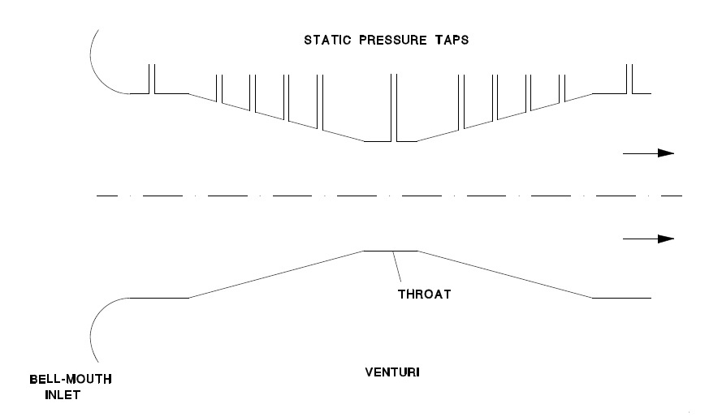
Figure 1: Setup of Venturi Meter
Refer to pages 5 of the Fluid Mechanics I (MAAE 2300) course manual for instructions on how to conduct this experiment properly.

Results and Discussion:

Results
 | Fast flow | Slow Flow
Theoretical Flow Rate (m³/s) | 0.017433 | 0.014564
Actual Flow Rate (m³/s) | 0.015929 | 0.013835
Venturi Coefficient | 0.9137 | 0.949
Stagnation Pressure at Throat(Pa) | 101325 | 101325
Table 1: Results of Venturi Meter Experiment
Discussion
A Venturi coefficient is used to differentiate between the theoretical flow rate and actual flow rate of a flow that travels through a Venturi Meter. That is to say that a Venturi coefficient of 1 means that the actual flow through the Venturi is perfectly identical to the theoretical flow moving through the Venturi meter. A Venturi coefficient is simply a numerical way to correct for real world losses, otherwise not considered in theoretical fluid dynamics.
Possible sources of the losses in the real world flow can be found in the assumptions made when applying different equations to the Venturi meter. One such equation is Bernoulli`s equation as it requires a flow that has no energy loss or gain, is uncompressible, and1-d. energy loss and the 1-d flow can be considered not met as the no-slip condition will cause the flow to begin to vary along the cross-sectional area of the as a boundary layer is generated between the wall and the flow. This boundary layer and friction will cause some of the energy of the flow to be transfer to thermal energy that isn`t considered when measuring the potential energy of the flow stored in the static and dynamic pressures of the flow. In addition, in calculating the true velocity, the velocity of air was taken to be zero within the room. This assumption can be considered valid as the air would move so little in such a large reservoir as to be considered non-moving. Furthermore, the compressibility of air makes Bernoulli`s equation more inapplicable in this situation.
However, in order to minimize the differences caused by these assumptions, measures were taken to minimize the impacts of the assumptions. First a Bell-mouth inlet was used to provide a flow that is 1-d upon entering the Venturi meter, and the Venturi is kept short in order to minimize the size of the boundary layer generated along the length of the Venturi tube.

Figure 2: Static Pressure of the Fast Flow

Figure 3: Static Pressure of the Slow Flow
As can be seen above both flow are very similar in their differences between their experimental and theoretical pressures. Both Flows show the experimental pressure as higher than the theoretical pressure before the throat of the Venturi(lowest pressure) and lower than the theoretical pressure after the throat. The initially higher pressure can be attributed by friction and part of the flow hitting the wall of the Venturi meter as the radius of the meter shrinks. This could reduce the speed of the flow reducing dynamic pressure and increasing static pressure as energy is transferred.
The lower experimental pressure after the throat is cause to believe that the flow after throat is flowing faster than theoretical values anticipate. This could be due to turbulence caused by the flow rushing out of the throat and trying to rapidly fill the expanding cross-section. This turbulence would leave swiftly moving low pressure zones along the wall of the Venturi meter after the throat of the Venturi, explaining the lower than expected pressures after the Venturi throat.
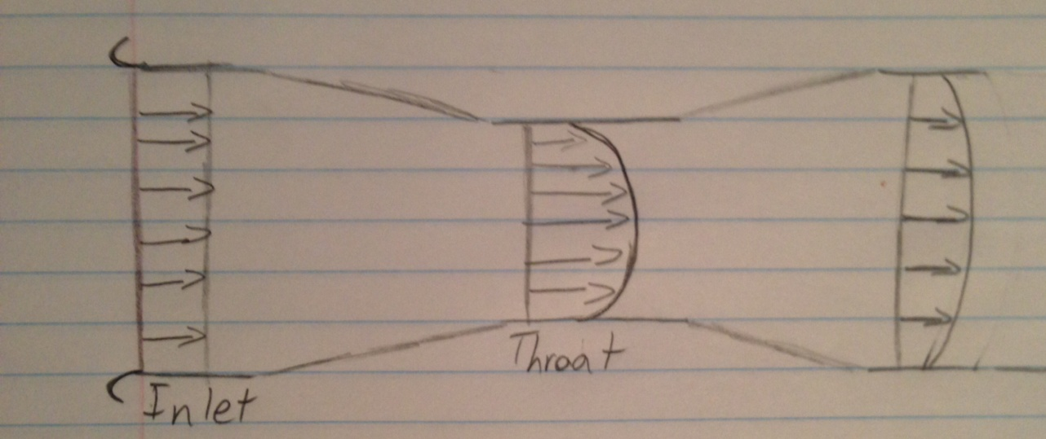
Figure 4: Approximate Velocities along the Venturi meter

Appendices:

Lab Results
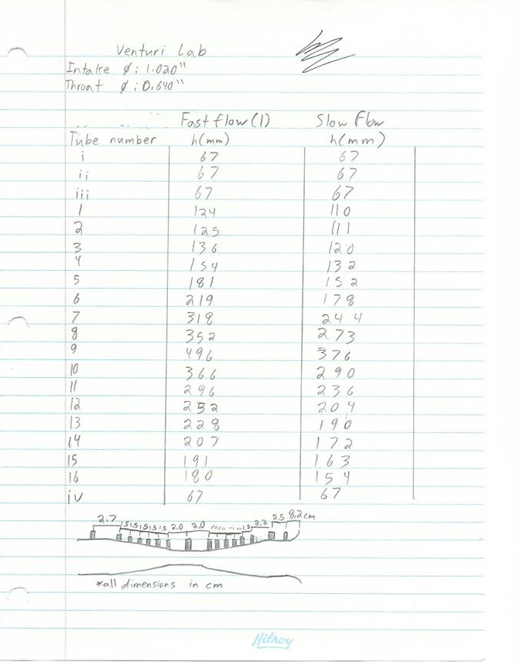

Sample Calculations:
Converting Imperial Units to Metric
$$0.0254inch= xmetres$$
$$0.0254inch*1.02= xmetres=0.025908metres$$
Static Pressure as Found by the Static Taps
$P=ρ_{water}gy+P_{atm}$ [1]
$$P=1000kg/m^{3}*9.81*\left(.124-.067\right)+101325=100765.83Pa$$
True Volume Flow Rate for Venturi meter
$V_{2}=\sqrt{\frac{{2ρ}_{water}gy}{ρ_{air}}}$ [2]
$$V_{2}=\sqrt{\frac{2*(1000\frac{kg}{m^{3}}*9.81\frac{m}{s^{2}}*\left(.124m-.067m\right))}{1.2250kg/m^{3}}}=30.21\frac{m}{s}$$
Ideal Volume Flow Rate at Venturi meter
$V_{1}=\sqrt{\frac{\frac{2\left(P_{2}-P_{1}\right)}{ρ_{air}}}{1-{\left(\frac{A_{1}}{A_{2}}\right)}^{2}}}$ [3]

$$V_{1}=\sqrt{\frac{\frac{2*1000\frac{kg}{m^{3}}*9.81\frac{m}{s^{2}}\left(.057m-.429m\right)}{1.2250kg/m^{3}}}{1-{\left(\frac{0.000527 m^{2}}{0.000207 m^{2}}\right)}^{2}}}=33.067\frac{m}{s}$$
Velocity of a flow to Volume flow rate
$Q=V*A=33.067\frac{m}{s}*0.000527m^{2}=0.017433\frac{m^{3}}{s}$
Calculating the Venturi coefficient
$C_{V}=\frac{V_{actual}}{V_{ideal}}$ [4]
$$C_{V}=\frac{30.21\frac{m}{s}}{33.067\frac{m}{s}}=0.9137$$
Cross-sectional radii throughout the Venturi Meter
$r=-0.04089*x+1.2985$ [5]
$$r=-0.04089*\left(13cm-10.7cm\right)+1.2985=1.201cm$$
Theoretical Pressure along the Venturi Meter
${P_{2}=P}_{1}-\frac{1}{2}ρ_{air}V_{2}^{2}$ [6]
$$P_{2}=101325-\frac{1}{2}1.225*{33.068}^{2}\frac{m}{s}=100665Pa$$

Ideal Velocity along the Venturi meter
$V_{2}=\frac{A_{1}V_{1}}{A_{2}}$ [7]
$$V_{2}=\frac{0.000527m^{2}*33.068\frac{m}{s}}{0.000287 m^{2}}=60.713\frac{m}{s}$$
Stagnation Pressure of the flow at the Venturi Throat
$P_{stag}=P_{static}+\frac{1}{2}ρ_{air}V^{2}$ [8]
$P_{stag}=97116.51Pa+\frac{1}{2}1.225\frac{kg}{m^{3}}*82.89\frac{m}{s}=101325Pa$

