Flow Through a Sluice Gate and Hydraulic Jump
Author:
November 11, 1013

Lab Partners: Neal Traynor, Garrett Lihou, Alex Bouchie
Group Number: L1I

Summary:
The performance of a Jet Pump was tested, by measuring and analysing two trials. In each of these trials a high velocity flow was used to entrain and "pump" a non-moving volume of air. This resulted in a mixed flow being generated near the end of the jet pumps mixing tube.
In both flows theoretical and experimental values at the outlets of the mixing tube were compared. The static pressure of flows 1 and 2 at the outlet were found to be 101.707KPa and 101521KPa respectively, compared with theoretical values of 102.138 KPa and 101.766 KPa.
The velocities of both flows at the outlet were also analysed and found to vary from theoretical values and the not be one dimensional in nature. The average outlet velocity of flows 1 and 2 at the outlet were found to be 28.4 m/s and 22.94m/s respectively, compared with theoretical values of 18.6835m/s and 12.591m/s.
V₁ | 105.88m/s | 61.9916 m/s
V₂ | 10.58 m/s | 8.00 m/s
V₃ | 18.6835 m/s | 12.591 m/s
P₁ | 101442.72Pa | 101383.86 Pa
P₂ | 101256.33 Pa | 101285.76 Pa
P₃ | 102138 Pa | 101766 Pa

Nomenclature/List of Symbols:
Variable/symbol | Name | Units
Q | flow rate | m³/sec
y | depth | inches
P | Static pressure | Mpa
ρ | density | kg/m³
g | Gravitational constant | N/kg or m/s²
z | elevation | metres
V | Velocity | m/s
w | width | metres
h | height | metres
$$\dot{m}$$ | Mass flow rate | Kg/s

Flow Analysis:
In this experiment Point 1 is on the primary flow at the mouth of the high velocity jet pump, point 2 is a point along the secondary flow adjacent to the mouth of the high velocity jet pump and point 3 is point along the mixed flow just before the pitot tube rake.
Static Pressure as Found by the Static Taps
Using the hydrostatic pressure equation the static pressure of a flow can be found using the measurements recorded from the manometer bank.
$P=ρ_{water}gy+P_{atm}$ [1]
y is taken to be the elevation of the fluid within the manometer
Velocity at of Primary Flow at the Mouth of Jet Pump
Using equations found on pages 6 and 7 of Fluid Mechanics I (MAAE 2300) course manual velocity of the primary stream can be solved with respect to the measurements given by the stand alone manometer (P_{c1}) and the first manometer(P_{c2}) in the manometer bank.
$$Q=C_{q}\left(P_{c1}-P_{c2}\right)=\frac{1}{2}ρ_{air}V_{1}^{2}=>V_{1}=\sqrt{\frac{2C_{q}\left(P_{c1}-P_{c2}\right)}{ρ_{air}}}$$
P_{c1} and P_{c2} are given by the readings taken from the manometers used in the lab. Plugging in the hydrostatic equation [1] for P_{c1} and P_{c2} gives the final equation that can be used to solve for V₁.
${V_{1}=\sqrt{\frac{2C_{q}\left(ρ_{water}gy_{1}+P_{atm})-(ρ_{water}gy_{2}+P_{atm}\right)}{ρ_{air}}}=> V}_{1}=\sqrt{\frac{2C_{q}{(ρ}_{water})g\left(y_{1}-y_{2}\right)]}{ρ_{air}}}$ [2]
Velocity and Pressure of the Secondary flow at Intake(Point 2)
Velocity of the secondary flow at point 2 can be found using Bernoulli's equation while a reading from the manometer bank can be used to determine static pressure. Static pressure is determined using equation[1].
In order to find velocity of the flow at point 2, Bernoulli's equation is applied between point 2 and a point a distance away from the inlet of the jet pump. The height of both points are taken to be equal and the pressure of the room is taken to be atmospheric.
$$P_{room}+\frac{1}{2}ρ_{air}V_{room}^{2}+ρgy_{room}=P_{2}+\frac{1}{2}ρ_{air}V_{2}^{2}+ρgy_{2}$$
Static pressure at point 2 can be found by using the reading of the manometer (y) and the hydrostatic pressure equation[1].
$$P_{room}+\frac{1}{2}ρ_{air}V_{room}^{2}=(P_{room}+ρ_{water}gy)+\frac{1}{2}ρ_{air}V_{2}^{2}$$
Taking V_{room} to be zero as it assume to be so small that it can be considered negligible and rearranging this equation V₂ can be found.
$V_{2}=\sqrt{\frac{{2ρ}_{water}gy}{ρ_{air}}}$ [3]
Theoretical Velocity and Pressure at Jet Pump Outlet (Point 3)
In this experiment, equations were developed in order to solve for static pressure and momentum of the mixed flow in the jet pump just before it reaches the pitot tube rake. These equations used both the momentum and continuity equations learnt in class.
Continuity equation
${\dot{m}}_{in}={\dot{m}}_{out}=>A_{1}V_{1}+A_{2}V_{2}=A_{3}V_{3}=> V_{3}= \frac{{(A}_{1}V_{1}+A_{2}V_{2})}{A_{3}}$ [4]
Momentum equation
$$\sum{F=0 }=F_{pressure}+F_{velocity}={(P}_{1}A_{1}+P_{2}A_{2}-P_{3}A_{3})+{(\dot{m}v)}_{in}-{(\dot{m}v)}_{out}$$
$0={(P}_{1}A_{1}+P_{2}A_{2}{-P}_{3}A_{3})+ ρ_{air}A_{1}{V_{1}}^{2}+{ρ_{air}A}_{2}{V_{2}}^{2}-ρ_{air}A_{3}{V_{3}}^{2}$
$P_{3}=\frac{{(P}_{1}A_{1}+P_{2}A_{2})+ρ_{air}(A_{1}{V_{1}}^{2}+A_{2}{V_{2}}^{2}-A_{3}{V_{3}}^{2})}{A_{3}}$ [5]
Velocities at the jet pump Outlet (Point 3) as Given by the Pitot Tubes
Pitot tubes have been used in this experiment in to observe the change in velocity along the outlet plane with respect to radius. Velocity can be calculated from a pitot tube using stagnation pressure.
$$P_{stag}=P_{pitot}+\frac{1}{2}ρ_{air}V_{flow}^{2}=>V_{flow}= \sqrt{\frac{{2(P}_{stag}-P_{pitot})}{ρ_{air}}}$$
Static pressure at the pitot tube P_{pitot} can be found by applying the hydrostatic pressure equation[1] to the reading of the static level with the pitot tube while P_{stag} can be found by applying the hydrostatic pressure equation[1] to the reading of the pitot tube bank.
$V_{flow}= \sqrt{\frac{{2(P}_{stag}-P_{pitot})}{ρ_{air}}}$
P_{stag} - P_{pitot} can be determined using the hydrostatic pressure equation[1] and calculating the change in pressure with respect to change in height of the pitot tube meter.
$V_{flow}= \sqrt{\frac{2ρ_{water}g(H_{pitot}-H_{stag})}{ρ_{air}}}$ [6]

Experimental Setup and Procedure:
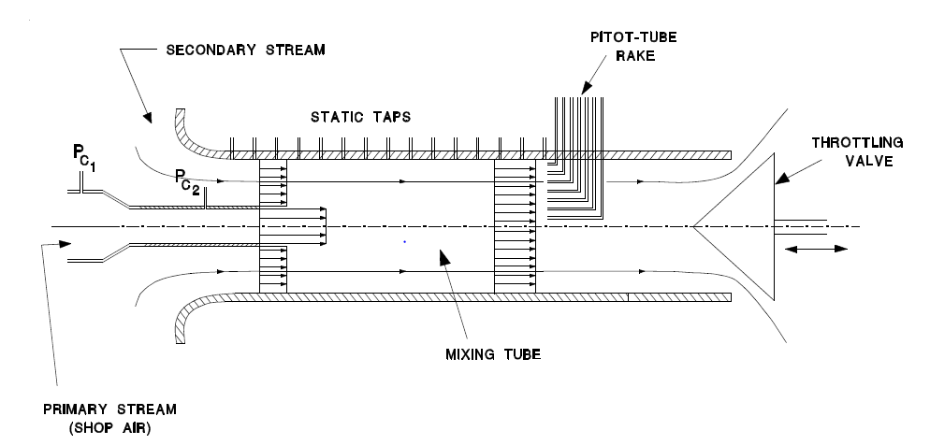
Figure 1: Setup of Jet Pump
Refer to pages 6 and 7 of the Fluid Mechanics I (MAAE 2300) course manual for instructions on how to conduct this experiment properly.

Results and Discussion:
Table 1
Result | Flow 1 | Flow 2
V₁ | 105.88m/s | 61.9916 m/s
V₂ | 10.58 m/s | 8.00 m/s
V₃ | 18.6835 m/s | 12.591 m/s
P₁ | 101442.72Pa | 101383.86 Pa
P₂ | 101256.33 Pa | 101285.76 Pa
P₃ | 102138 Pa | 101766 Pa

Table 2: Pressures in First Flow
Tube | manometer(mm) | change in height(mm) | Static pressure(Pa) | distance from end of bellmouth(inches)
1 | 107 | 12 | 101442.72 | N/A recording primary flow
2 | 126 | -7 | 101256.33 | 2
3 | 124 | -5 | 101275.95 | 9
4 | 123 | -4 | 101285.76 | 11
5 | 122 | -3 | 101295.57 | 13
6 | 115 | 4 | 101364.24 | 15
7 | 102 | 17 | 101491.77 | 17
8 | 92 | 27 | 101589.87 | 19
9 | 86 | 33 | 101648.73 | 21
10 | 82 | 37 | 101687.97 | 23
11 | 80 | 39 | 101707.59 | 25
12 | 80 | 39 | 101707.59 | 27
13 | 80 | 39 | 101707.59 | 29
14 | 80 | 39 | 101707.59 | 31
15 | 80 | 39 | 101707.59 | 33
16 | 80 | 39 | 101707.59 | 35
17 | 80 | 39 | 101707.59 | 37
18 | 119 | 0 | 101325 | N/A
19 | 119 | 0 | 101325 | N/A
20 | 119 | 0 | 101325 | N/A

Table 3: Pressures of second flow
Tube | manometer(mm) | change in height(mm) | Static pressure(Pa) | distance from end of bellmouth(inches)
1 | 112 | 6 | 101383.86 | N/A recording primary flow
2 | 122 | -4 | 101285.76 | 2
3 | 122 | -4 | 101285.76 | 9
4 | 122 | -4 | 101285.76 | 11
5 | 120 | -2 | 101305.38 | 13
6 | 120 | -2 | 101305.38 | 15
7 | 116 | 2 | 101344.62 | 17
8 | 113 | 5 | 101374.05 | 19
9 | 100 | 18 | 101501.58 | 21
10 | 98 | 20 | 101521.2 | 23
11 | 98 | 20 | 101521.2 | 25
12 | 98 | 20 | 101521.2 | 27
13 | 98 | 20 | 101521.2 | 29
14 | 98 | 20 | 101521.2 | 31
15 | 98 | 20 | 101521.2 | 33
16 | 98 | 20 | 101521.2 | 35
17 | 98 | 20 | 101521.2 | 37
18 | 118 | 0 | 101325 | N/A
19 | 118 | 0 | 101325 | N/A
20 | 118 | 0 | 101325 | N/A

1)
Using the continuity and momentum equations learnt in class the pressure and velocity of the flow at the outlet can be predicted. For the first flow pressure and velocity were found to be 18.6835 m/s and 102138 Pa respectively. For the second flow these values were found to be 12.591 m/s and 101766 Pa respectively. In order to calculate both of these values, some simplifying assumptions were made. It was assumed that the flow at all times was one dimensional, uncompressible, frictionless. It was also assumed that no energy was transferred into or out of the flow in the jet pump. Furthermore the air at a large distance from the inlet was assumed to be unmoving. This was done to apply Bernoulli's equation between this point and a point just inside of the inlet in order to calculate the velocity of the secondary flow at the inlet.

In order to produce the most one dimensional flow a bell mouth inlet was used allowing a fundamentally one-dimensional and non-turbulent flow to be present at the intake of the control volume.

These assumptions lead to error which can be seen by the difference between the expiriemental and theroetical values as shown in the graph below.The error in flow one was found to be 51%(guage pressures) while error in flow two was found to be 55%(guage pressure). This shows that error in calculate pressure does not vary much with respect to the mass flow rate of the flow.
These errors can be attributed to the errors caused by the assumptions made during this expiriment. For example, pressure loss at the outlet of the jet pump could be attributed to friction and subsequent loss of energy. Pressure of a fluid can be related to the energy in the fluid. If the pressure in the fluid decreases the energy in the fluid decreases as well. Therefore, if energy is taken from the airflow in the form of frictional loss, it can be expected that the pressure of the fluid decreases as well.
Graph 1:

With regards to mixing, it can be seen above that the length of the mixing tube for both flows was sufficient to mix the flows. This is shown by the plateau created at the end of both flows. This plateau indicates that the pressure in the flow is constant, meaning that the flow has been mixed. Furthermore it can be seen that a lower velocity flow results in a shorter mixing distance. The fast flow(flow one) mixed in 25in while the slower flow mixed in 23inches. That is distance 8% shorter for a flow 41% faster than the slower flow.

Friction in the jet pump will also be a growing source of error with respect to velocity of the flow as friction generated by the no-slip condition is directly related to the velocity of the flow. This means as velocity increases so too do the frictional forces applied by the mixing tube on the flow.

Table 4: Velocities of First Flow
Tube | Pitot Tube (mm) | change in height(mm) | Velocity of Pitot tube(m/s) | Distance from centreline(mm)
1 | 78 | 46 | 27.14315789 | 0.035
2 | 76 | 48 | 27.72694851 | 0.032
3 | 75 | 49 | 28.01428207 | 0.028
4 | 74 | 50 | 28.29869832 | 0.025
5 | 74 | 50 | 28.29869832 | 0.022
6 | 73 | 51 | 28.58028434 | 0.019
7 | 73 | 51 | 28.58028434 | 0.015
8 | 73 | 51 | 28.58028434 | 0.012
9 | 73 | 51 | 28.58028434 | 0.009
10 | 73 | 51 | 28.58028434 | 0.006
11 | 73 | 51 | 28.58028434 | 0.002
12 | 73 | 51 | 28.58028434 | -0.001
13 | 73 | 51 | 28.58028434 | -0.004
14 | 73 | 51 | 28.58028434 | -0.007
15 | 73 | 51 | 28.58028434 | -0.011
16 | 73 | 51 | 28.58028434 | -0.014
17 | 73 | 51 | 28.58028434 | -0.017
18 | 73 | 51 | 28.58028434 | -0.020
19 | 73 | 51 | 28.58028434 | -0.024
20 | 124 | 0 | 0 | 0.000

Table 3: Velocities of Second flow
Tube | Pitot Tube (mm) | change in height(mm) | Velocity of Pitot tube(m/s) | Distance from centreline(mm)
1 | 96 | 30 | 21.92007746 | 0.035
2 | 95 | 31 | 22.28241734 | 0.032
3 | 94 | 32 | 22.63895865 | 0.028
4 | 94 | 32 | 22.63895865 | 0.025
5 | 94 | 32 | 22.63895865 | 0.022
6 | 94 | 32 | 22.63895865 | 0.019
7 | 94 | 32 | 22.63895865 | 0.015
8 | 94 | 32 | 22.63895865 | 0.012
9 | 94 | 32 | 22.63895865 | 0.009
10 | 92 | 34 | 23.33570445 | 0.006
11 | 92 | 34 | 23.33570445 | 0.002
12 | 92 | 34 | 23.33570445 | -0.001
13 | 92 | 34 | 23.33570445 | -0.004
14 | 92 | 34 | 23.33570445 | -0.007
15 | 92 | 34 | 23.33570445 | -0.011
16 | 92 | 34 | 23.33570445 | -0.014
17 | 92 | 34 | 23.33570445 | -0.017
18 | 92 | 34 | 23.33570445 | -0.020
19 | 92 | 34 | 23.33570445 | -0.024
20 | 126 | 0 | 0 | 0.000

Graph 2

As seen above, there was some discrepancy between theoretical and experimental values of the velocities at the outlet of the jet pump. Experimental values were found to be higher that theoretical values. It has been shown in the graph above that both flows in the jet pump are not 1-d, This can be seen by the fact that the experimental velocities vary due with respect to location across the cross-section of the jet pump.
The total error between the theoretical flows and the average of the experimental flow are 34% for flow 1 and 45% for flow 2.
Through an understanding of Fluid Dynamics it is expected that the experimental velocities would be less than the theoretical velocities. This difference in velocities would be attributed to a loss of kinetic energy in the jet pump due to frictional forces.

Conclusion:
It has been shown that the assumptions that a flow in a jet pump is 1-d, non-compressible, frictionless are not always considered valid as they have led to a large error ranging up to 45%. Furthermore, the assumption that the flows are 1-d and frictionless have been shown wrong by graph 2 which details the velocity of the flow varying with respect to radius due to friction along the surface of the jet pump. However, it has been shown that the mixing tubes were of sufficient length, resulting in a flow with consistent pressure after mixing.

Appendices:

Lab Results
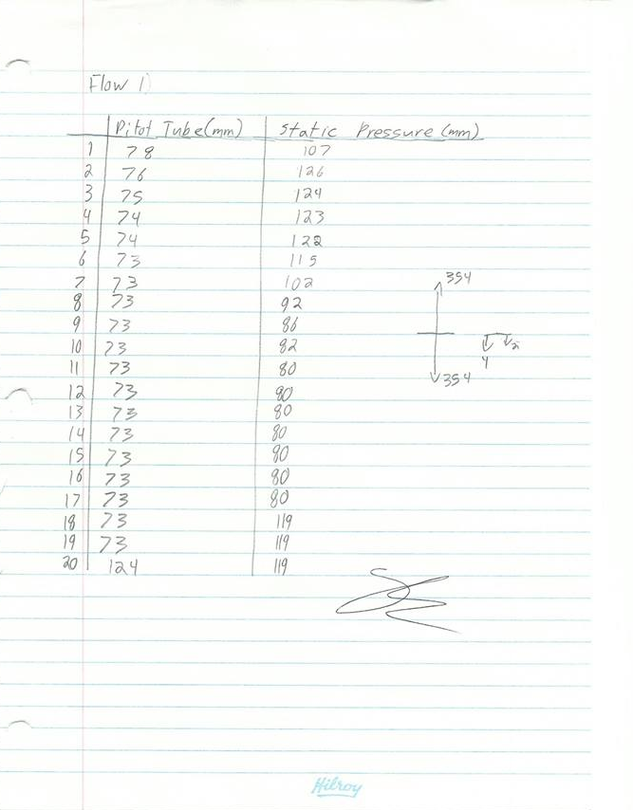
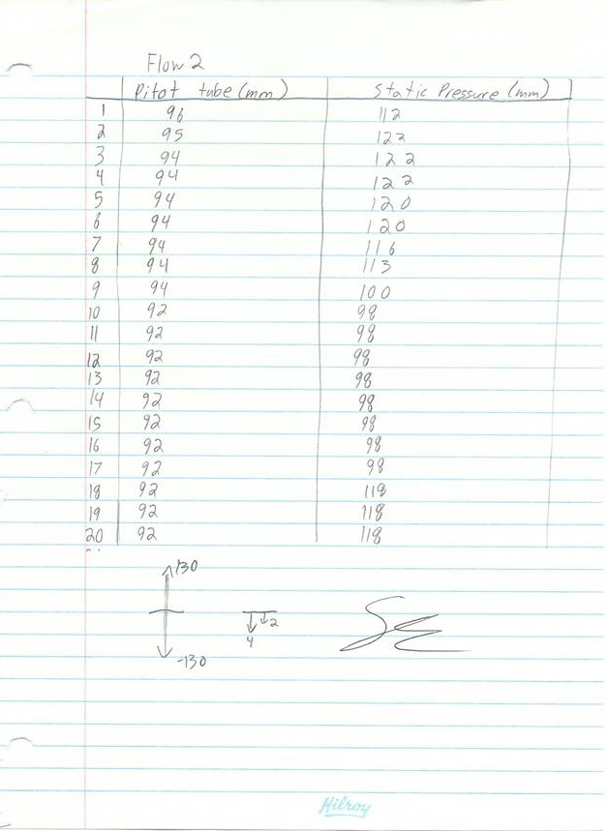

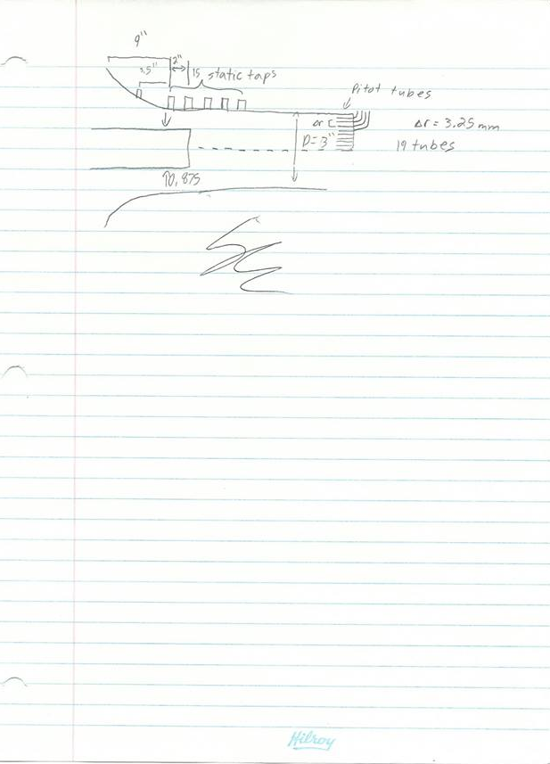

Sample Calculations:
Error/percent difference
$$\%error=\frac{Value_{exp}-Value_{theor}}{Value_{exp}}×100\%= \frac{105.88-61.9916}{105.88}×100\%=41.4\%$$
Converting Imperial Units to Metric
$$0.0254inch= xmetres$$
$$\left(0.875inches\right)(0.0254)=x metres=0.022m$$
Static Pressure as Found by the Static Taps(used to find P at the mouth of the inlet)
$P=ρ_{water}gy+P_{atm}=\left(1000\frac{kg}{m^{3}}\right)\left(9.81\frac{N}{kg}\right)\left(-.07m\right)+101325Pa=$101256.33
Velocity at of Primary Flow at the Mouth of Jet Pump
${ V}_{1}=\sqrt{\frac{2C_{q}{(ρ}_{water})g\left(y_{1}-y_{2}\right)}{ρ_{air}}}$ =$\sqrt{\frac{2(0.93\left(1000\frac{kg}{m^{3}}\right)(9.81\frac{m}{s^{2}})\left((.712m)-(.012m)\right)}{1.2250\frac{kg}{m^{3}}}}=105.884\frac{m}{s}$
Velocity and Pressure of the Secondary flow at Intake(Point 2)
$V_{2}=\sqrt{\frac{{2ρ}_{water}gy}{ρ_{air}}}=\sqrt{\frac{2\left(1000\frac{kg}{m^{3}}\right)(9.81\frac{m}{s^{2}}).007m}{1.2250\frac{kg}{m^{3}}}}=10.58\frac{m}{s}$
Theoretical Velocity and Pressure at Jet Pump Outlet (Point 3)
Continuity equation
$V_{3}= \frac{{(A}_{1}V_{1}+A_{2}V_{2})}{A_{3}}$
$V_{3}= \frac{π{\left(0.01111m\right)}^{2}\left(105.884\frac{m}{s}\right)+π(({0.0381m}^{2}-{\left(0.01111m\right)}^{2})(10.58\frac{m}{s})}{(π{0.0381m}^{2})}=18.68\frac{m}{s}$
Momentum equation
$P_{3}=\frac{{(P}_{1}A_{1}+P_{2}A_{2})+ρ_{air}(A_{1}{V_{1}}^{2}+A_{2}{V_{2}}^{2}-A_{3}{V_{3}}^{2})}{A_{3}}$
$P_{3}=\frac{(101442.72Pa 0.000388m^{2}+101256.33Pa 0.004172m^{2})+1.2250\frac{kg}{m^{3}}(0.000388m^{2}{\left(105.884\frac{m}{s}\right)}^{2}+0.004172m^{2}{\left(10.58\frac{m}{s}\right)}^{2}-0.00456m^{2}({18.68\frac{m}{s})}^{2})}{0.00456m^{2}}$
$$P_{3}=102138Pa$$
Velocities at the jet pump Outlet (Point 3) as Given by the Pitot Tubes
$V_{flow}= \sqrt{\frac{2ρ_{water}g(H_{pitot}-H_{stag})}{ρ_{air}}}$
$V_{flow}= \sqrt{\frac{2(\left(1000\frac{kg}{m^{3}}\right)(9.81\frac{m}{s^{2}})(0.127m-0.078m)}{1.2250\frac{kg}{m^{3}}}}=27.14m/s$

