1) Who is Richard Branson? What does he tell us about the Adversity Quotient?
- Founder the Virgin Group of Companies
- Overcame cash flow issues, dropping out of school, and attacks by other airlines, yet get fighting
- The Adversity Quotient measures how well someone responds to difficulty

2) What is Scalability? What does it meant to scale a Business? Give examples
- Scalability refers to a venture’s ability to grow revenues exponentially while keeping costs stable
- Occurs most often when a venture’s costs are mainly fixed, since there are low variable costs, you make additional units without incurring significant costs
- Software is very scalable since once you have a product you can reproduce it for almost 0 cots
- Consulting is not scalable since to make more money you need to hire more people

3) Define entrepreneurship – according to 2 French and German men
- Jean-Baptist: An entrepreneur is one who shifts economics resources out of an area of lower and into an area of higher productivity
- Joseph Schumpeter: An entrepreneur is an “agent of change” who exploits opportunity

4) What is the Suboptimal Equilibrium view of Entrepreneurship?
What does it have to do with Creative Destruction?
- Balanced feedback loop
- Entrepreneur see unmet need as opportunity and wants to shift the suboptimal equilibrium
- Test it: eBay, Facebook, email
- So an entrepreneur is one who sees the original state, sees the “happiness deficient” and moves to change it – which leads to CREATIVE DISTRUCTION

5) According to Roger Martin, what are the 3 elements of Entrepreneurship?
- Suboptimal Solution exists
- Person brings: Inspiration, creativity, direct action, courage, fortitude
- Results in a 10X shift in equilibrium shifting the entire market

6) What is the 10X Rule? Why is it so important to entrepreneurs
- A little better is not enough
- The 10x rule means that in order to gain market traction a product must be exponentially better. ie 10 x faster, 10x smaller, 10x cheaper, 10x more profitable
- Airplanes (10x faster than ships), email (10x faster than snail mail)

7) How does itunes illustrate both the 10x Rule & Creative Destruction?
- Our parents used to buy her BeeGees music at Sam the Record Man, now uses iTunes
- ITunes has destroyed the need for a music store because you:
  - More than 10x the choice
  - It is 10x faster to shop online
  - Digital music is 10x easier to handle, move, etc.

8) Every great opportunity has 4 essential qualities. Name and define them
- Attractive – generate high ROI (return on investment)
- Durable – will last long enough to get ROI
- Timely – market is ready to buy
- Creates/adds value for buyer/user – focus on end user pain point

9) What are the 7Ps? Name and Explain each. Why do they matter?
- People – who is behind the venture
- Pain – bigger the pain, the better
- Product – it is 10x
- industry Placement – CAGR > 25%
- go to market Plan – reasonable not right
- Proposal – reward worth the risk

10) What is CAGR? And why must CAGR > 25%?
- Cumulative Annual Growth Rate
- The year-over-year growth rate of an investment over a specified period of time

11) What are the key elements of an Elevator Pitch? What 4 criteria need it meet to be great?
- The 2 minute conveyance of what you do and why I should care
- Made up of 2 parts
  - Pain Statement
  - Value Proposition

12) Writing a Good Elevator Pitch
- Must be 4 things:
  - Irrefutable (i.e not subjective)
  - Easily understandable (i.e anyone could get it)
  - Greed inducing (i.e will make big $$$)
  - Succinct (under 1 minute)

13) What is BoND?
- Aka Infographic or xplane diagram
- Very Canadian
- Used to convey your entire venture in 1 image
- Shows all moving parts without underlying tech
- Focus on customers + adds value

14) According to former CEO of HP, why is change so hard?
- Fear
  - Everyone is afraid courage is not the absence of fear – courage is the action in the face of fear
- Momentum
  - Those in power like the status quo
  - People in power invest to keep that power

15) According to Carly Fiorina what 3Cs are key for 21st Century Leaders?
- Capability
  - Asks questions – hear answers
  - Lifelong learning
  - Be adaptive to change
- Collaboration
  - World is flat
  - Good decisions come from diversity
- Character
  - Judgement
  - Perspective
  - Ethics

14) What is the Talent Triangle? Describe 3 corners – what happens if you miss a corner? BODCAT (consultation, authority, trust)
- Business Acumen
  - Often responsible for ensuring that the venture focuses on only core competencies that add direct value to their startup
- Domain Knowledge
  - Must have years of hands on experience
  - Job is to ensure that the startup’s product and value proposition meet + exceed the needs of the end user
- Operational Experience
  - Make decisions that relate to the venture’s implementation and execution of the business plan
  - If one of the corners is missing, might create a monumental void while not necessarily causing failure to the startup – can still hinder company’s ability to raise venture capital

15) What does ‘Been there, done that’ mean to investors?
- ‘I have taken a start-up to greatness’
- ‘I had success in the industry’

16) Why do most founders feel Startup Hiring is a Catch 22?
- To get $ we need a team
- To get a team we need $

17) What is Jack Welch’s 6 or 9 Theory?
- Jack Welch created the 6 or 9 theory
- The CEO of GE had all units rank their team members as either 6/10 or 9/10
- Fired all the 6s and gave their resources to all the 9s
  - Have to pull the weeds to let the flowers bloom
  - The lion eats the slow gazelle and the herd is better for it

18) Difference between PRE and POST valuation? How do you calculate one using the other?
- Pre-money valuation: refers to the valuation of a company or asset prior to an investment or financing
- Post-money valuation: the value of the company after the investment has been made. This value is equal to the sum of the pre-money valuation and the amount of new equity
- If a company is worth $100 million (pre-money valuation) and an investor makes an investment of $25 million, the new post-money valuation of the company will be $125 million – investor now owns 20% of the company

19) What do investors like startups with sales?
- Helps them figure out what they’re getting themselves into
- If they have decent sales, they know they don’t have to worry about being paid back
- Feel more comfortable with a business that has experience

20) What is the Spectrum of Financing?
- Key is to match the SOURCE with the STAGE
- Links reward to risk, helps identify where/when to get funding
- Risk is based on stage, early stage = more risk
- 3 types of risks:
  - Magic risk – can this be made (is it 10X)
  - Market risk – will anyone buy it
  - Management risk – can these founders execute
- Ex: Sally has nothing but an idea and a dream, where must she go for startup capital? – Because Sally idea is brand new, she has a high level of investment risk assumed by an investor. This means her best bet would be to ask a family member to invest in her idea
- Jill has $5M in sales in Canada but now wants to expand, where should she go to fun this? – Because Jill has $5M in sales, she could ask for assistance from a VC
- What investors want?
  - ROI (Return on Investment): performance measure used to evaluate the efficiency of an investment or to compare the efficiency of a number of different investments
  - ROI = gain from investment/cost of investment

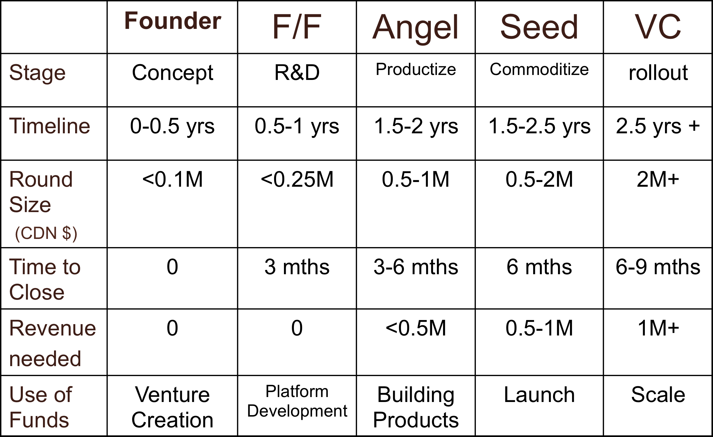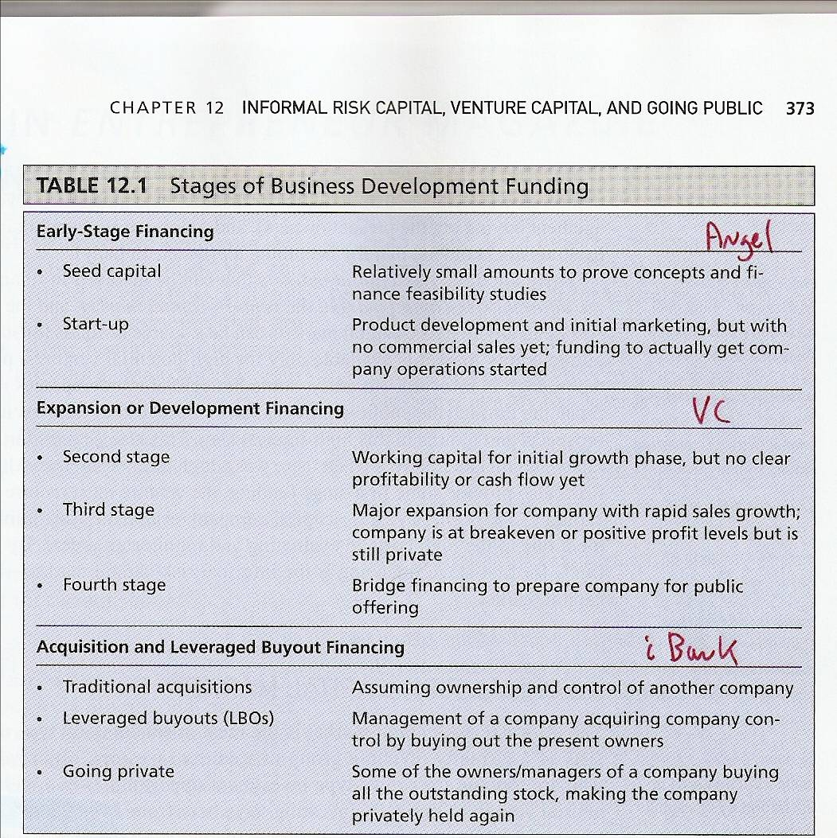

21) What is the Risk Reward Ratio?
- The more risk you take, the greater the potential reward you must take
- That is why angels need high ROI than VCs, and VCs high than the banks

22) What investors want?
- Friends and family – same as founders
- Angels – 10-20x
- VCs
  - Seed – 10-15x
  - Early – 10x
  - Late – 5x
- Venture Debt – 2x

23) 3 differences between VCs and Angel Investors? (Angel to VC – heaven to hell)
- More 000’s
- VCs require traction
- 6-12 referencable clients
- More governance
- Tricker terms
- Professional investors
- More math/less passion

24) 3 T’s that attract investors?
- Team, tech, traction

25) All investors have to mitigate (make less sever) 3 types of risk, what are they?
- Management: been there, done that
- Market: if we build it, will they buy it?
- Magic: will it work?

26) What is the ‘First Who: Then What’ theory? (By: Jim Collins) What is it more often called?
- Often called Good-to-great. These leaders began the transformation by first getting the right people on the bus (and the wrong people off the bus)
- ‘Who’ question comes BEFORE the ‘What’ decisions (i.e. before vision, stratefy, organization structure, and tactics)
- ex: Gillette, Circuit City, Google
- What did GOOD-TO-GREAT companies share in common:
  - Level 5 leadership
  - Stokedale Paradox
  - The Hedgehog concept
  - Technology Acceleration
  - A Culture of dicipline

27) The Right People…
- Can adapt easier to a changing world and appreciate being on the bus with the other right people
- Are self-motivated to be part of something great
- Are not the wrong people (if you have the wrong people, it dones’t matter if you discover the right direction)
- Tie this in with the Talent Triangle and the 6 or 9 theory

28) Why does it cost more to hire 9s? Why is it worth it? Does it really cost more?
- 9s are self motivated evangelists, what you pay extra in salary you will gain back threshold, since 9s work harder, work smarter and need little suppervsion
- You can hire 6s for cheaper, but in the long run it won’t be

29) Hiring from within the company is the best move, why?
- The employee is already up to speed on the company and it’s culture – less training costs
- Inspires others to work hard
- Less costly than hiring a headhunter
- Less risk of getting ga person who can’t do the job
- Keeps Tacit knowledge form leaving the company

30) The Hedgehog Concept uging Prof Wise as an ex. – create the Hedgehog
- Are you a fox or a hedgehog?
  - The Fox knows many things, the hedgehog knows one big things
  - Take a complex world and simplify it
- The 3 circles:
  - What are you best at?
  - What can make you money?
  - What are you passionate about?

31) What is Level V Leadership?
- Channel their ego needs away from themselves and into the larger goal of building a great economy
- Incredibly ambitious – their ambition is for the institution, not themselves
- Have personal Will
  - Results oriented
  - Set standards for building a great company
  - Driven
  - Personal Humility
    - Modesty
    - Quiet calm determination
    - Plow horse vs. show horse

32) Managers vs. Leaders?
- Managers
  - Oversees the current process
  - Must achieve balance
  - Thinks execution
  - Comfortable with control
  - Problems are just that, and need resolution ASAP
  - Procedure is King
  - Instructs as to technique and process
  - Impersonal, remote
- Leader
  - Wants to create the future
  - Needs to make change
  - Thinks ideas
  - Welcomes risks
  - Sees problems as opportunities and is patient
  - Substance trumps the King
  - Your best college professor
  - High emotional intelligence

33) 3 Key Theories of how leaders are formed (Theoretical example)
- Trait Theory
  - People are born with leadership traits
- Great Events Theory
  - Crisis brings out leadership qualities in an ordinary person (Batman)
- Transformational Leadership Theory
  - You can choose to become a leader
  - It is the most widely accepted theory

34) What is Blue Ocean Strategy?
- Creating uncontested market space making the competitoon irrelevant
- BOS is the result of a decade long study of 150 strategic moves spening more than 30 industries over 100 years old (1880-2000)
- BOS is the simultaneous pursuit of differentiation and low cost
- The aim: not to put perform the competition in the existing industry – but to create a new market space or a blue ocean, making the competition more irrelevant

35) Pros and Cons of following a BOS?
- PROS:
- Increase size of the pie by increasing customer base
- New customers often mean new price points
- Lets you focus on big wins
- CONS:
  - Have to educate customers – can be expensive
  - Competitors can follow you into your blue ocean – not sustainable advantage
  - Big risk

36) Blue Ocean Strategy in comparison to the Red Ocean Strategy?
  - Blue Ocean
    - Create uncontested market space
    - Make the competition irrelevant
    - Create and capture new demand
    - Break the value-cost trade-off
    - Align the whole system of a firm’s activities in pursuit of differentiation and low cost
  - The aim of BOS is not to out-perform the competition in the existing industry, but to create new market space or a blue ocean, thereby making the competition irrelevant.
  - Red Ocean
    - Compete in existing market space
    - Beat the competition
    - Exploit existing demand
    - Make the value-cost trade-off
    - Align the whole system of a firm’s activities with it’s strategic choice of differentiation or low cost

37) Sean Wise’s hedgehog?
  - Entrepreneurship, Public speaking, teaching
- 38) How does crowd sourcing move an elephant with a mouse?
  - Turned the industry on its head by giving away his key asset….proprietary geo data
  - Launched the GoldCorp challenge
  - Crowdsourcing the finding of gold
  - Now the lowest cost and highest profit gold miners in the world
- 39) Why are customers King?
  - Customer’s always right
  - No matter what you’re selling, future of the company relies on the customers – the people who will spend money on your company
  - "Customer-centricity" is the path to growth because it drives customer loyalty, helping make a company mission-driven as well as profit-driven
  - loyal customers come back more often, buy additional products and services, refer their friends, provide valuable feedback, cost less to serve and are less price sensitive
- 40) According to Steve Blank, what is a startup?
  - “An organization formed to seach for a repeatable and scalable business model”
- 41) Describe 3 ways that entrepreneurs are different in the 21st century
  - Business Canvas not business plan
  - Open not NDA (share idea not hide idea)
  - Customers before Investors
  - Agile Development not Waterfall Developement
  - Get out of Building
  - Build – Meausure – Learn
- 42) What are the 9 parts of a Business Model?
  - Problem – top 3
  - Customer segment – who is your potential customer?
  - Unique Value Proposition – how does it add value
  - Solution – top 3
  - Channel – how you reach your potential customers
  - Revenue Streams – revenue model, life time value of customer profits
  - Cost Structure – costs to build/sustain the business
  - Key metrics – activities that drive customer retention
- 43) What is Pivot?
  - A pivot is a “structured course correction designed to test a new fundamental hypothesis about the product, strategy, and engine of growth.”
  - A notable example of a company employing the pivot is Groupon; when the company first started, it was an online activism platform called The Point
- 44) What is an MVP?
  - A minimum viable product (MVP)
  - You don’t want to waste your time and money building a product no one will want to use or pay for – GET out of the building + talk to customers
  - That product which has just those features and no more that allows you to ship a product that early adopters see and, at least some of whom resonate with, pay you money for, and start to give you feedback on goal of a MVP is to test fundamental business hypotheses (or leap-of-faith assumptions) and to help entrepreneurs begin the learning process as quickly as possible.
  - But why minimal? Because your time and money are severely limited. You want the biggest “bang for your buck”: maximum learning with minimal effort.
  - Exs: A landing page – web page where visitors “land” after clicking a link from an ad, e-mail or another type of a campaign.
  - Another example of a MVP - Explainer video: a short video that explains what your product does and why people should buy it

45) What are the three keys to the Lean Startup Process
  - Learn faster – customer interviews, customer development
  - Measure faster – clear product owner, search engine marketing
  - Code faster – usability tests, continuous integration, just-in-time scalability
- 46) All Social Entrepreneurs are first and foremost Entrepreneurs. Agree or Disagree?
  - Agree to a certain extent
  - Social entrepreneurs are first and foremost, a business
  - That means it is an organization engaged in the trade of goods, services, or both to consumers – but it trades primarily to support a social purpose (not profits for shareholders!).
  - To assist with making the work a better place
  - ”Lasting transformational benefit to society” - Martin & Osberg
  - Critical distinction lies in the value proposition.
  - Entrepreneurs: Value is primarily to create financial profit.
  - Social Entrepreneur: Value is a transformational benefit to a significant segment of society or the ‘primacy of social benefit’; targeting an underserved, neglected or highly disadvantaged population or a ‘mission-related impact’. (eg Grameen Bank and Muhammad Yunus)
- 47) Why must SMEs (small/medium sized enterprises) leverage bank financing, while Startups turn to Angel Investors?
  - Angel investors are a group of individuals who provide capital to start ups, in exchange for convertible debt or ownership equity
  - Unlike VCs who manage pooled money of others in a professionally-managed fund
  - Angels typically invest their own money
- 48) What Attracts Investors?
  - Proof of concept/3rd party validation
  - Solid management team
  - Solid lead product with strong spin-off related products in the pipeline
  - Well-protected IP
  - Traction (milestones, strategic alliances, IP)
  - Past start-up & seed now pushing for launch and operational excellence
  - A high potential ROI to reward their risk
  - Specifically look for (The 4 Ps):
    - People: the management team
    - Product: and the pain it adresses
    - Placement: industry size, status and saturation
    - Plan: go to market stratefy
  - They want to learn all this from you Business Plan
- 49) What is the Stockdale Paradox and how does it related to Entrepreneurs starting a business?
  - The Stockdale Paradox is named after admiral Jim Stockdale, who was a United States military officer held captive for eight years during the Vietnam War – had faith he would get out
  - “You must never confuse faith that you will prevail in the end – which you can never afford to lose – with the discipline to confront the most brutal facts of your current reality, whatever they might be.”
  - When starting a company you have to believe that your vision will come to pass. You’ve got to do everything you can to make it happen. But, you can never let your belief and faith cloud your confrontation with reality.
- 50) Jack Welch’s 6 or 9 Theory reappeared throughout the course. Name two other leaders that seemed to follow his advice in their cases?
  - PAUL TELLIER – made major workforce cuts in the Bombardier business to help refocus the company

- 51) There is no difference between Social Entrepreneurship and Corporate Social Responsibility? Argue against this.
  - Corporate Social responsibility
    - Charitable foundations; self-regulation (Tim Hortons)
  - Social Entrepreneurship
    - Businesses designed around social challenges in order to drive social change
- 52) Can corporate culture really save you money? Prove it?

- 53) The Home Depot boys set up a home hardware empire, using three concepts from class give some examples of why they were successful (3 marks)
  - Bernie Marcus and Arthur Blank founded the company in 1978
  - the founders’ vision of one-stop shopping for the do-it-yourselfer came to fruition when they opened the first two Home Depot stores Atlanta, Georgia.
  - Empty boxes piled high on the shelves gave the illusion of even more product.
  - From the start, associates were able to offer the best customer service in the industry
  - The Home Depot revolutionized the home improvement industry by bringing the know-how and the tools to the consumer and by saving them money. (10x)
  - Their philosophy of customer service – “whatever it takes” – means cultivating a relationship with customers rather than merely completing a transaction. (customers king)
  - High perservearance

- 54) What is the need for pain? (1 mark)
  - The dire need for something – must have and will
- 55) Using the company you based your executive summary on, or the entrepreneur from your entrepreneur’s biography write an elevator pitch for their business.
  - Ever want to go out and realize all you have in your closet are outfits that have been worn before? Want to spruce up your closet while getting rid of unwanted item? Don’t feel like traveling to the malls and wasting big bucks? No problem! 99Dresses is here to help you get rid of your unwanted lightly warn garnments, while trading them in for a brand new outfit.
- 56) What is guerilla marketing? How did Terry McBride use this technique in his industry?
  - An advertising strategy that focuses on low-cost unconventional marketing tactics that yield maximum results
  - Unconventional, unorthodox approach to marketing
  - Response based marketing – pull from consumers

- 57) How does Prof Wise use double dipping in his career?
  - Writes a book about entrepreneurship, goes on tour to talk about his book, teaches at ryerson university – taking 1 thing, and making money out of it in multiple ways

- 58) How does building a cult like culture save you money?

- 59) Define value innovation. Considering the world is in a state of recession which portions value innovations should the product be focused on when selling it? (2 marks)
  - Value Innovation: is the simultaneous pursuit of differentiation and low cost. focuses on making the competition irrelevant by creating a leap of value for buyers and for the company, thereby opening up new and uncontested market space.
  - Product should be focused on feeding that pain of recession – or making it easier for the consumer/end user
- 60) What did GoldCorp do to leverage their company and became the lowest cost, highest profit company in the world? (2 marks)

- 61) What is SWIPE, give and example?

- 62) Doubble Dipping?
  - Build once, sell twice, make money three times
- 63) Entrepreneurship Defined – positives and negatives
  - Positive side:
    - connotes a special innate ability to sense and act on opportunity, combining out-of-the-box thinking with a unique brand of determination to create or bring about something new to the world.
  - Negative side:
    - It is an ex post term – you need a passage of time before impact is known.
  - According to Prof Martin: “You can claim to be an entrepreneur, but you should have at least one success!”
- 64) Top down vs. Bottom up Hiring?
  - Bottom Up
    - Leads to getting people on the team who are generalists vs. someone who's the right fit for a single job.
    - Hiring from the bottom up means filling specific roles with specific skill sets
    - gives people an opportunity to add value and expand their roles
    - ultimately helps grow the company
  - Top Down
    - Hiring from the Top Down means hiring senior staff (e.g. VP Sales) from outside of the company
    - Allows you to steal senior / key employees from competitors
    - Brings fresh ideas and fresh eyes to problems
- 65) The Halo Effect

- 66) Entrepreneurial Characteristics
  - Inspiration
  - Creativity
  - Direct Action
  - Courage
  - Fortitude – adversity, setbacks, barriers, challenges
- 67) Perfect Storm Metaphor
  - Several environmental factors can converge into a trobled chalenge for a company needing extraordinary leadership
  - Paul Tellier becomes the first non-family CEO of Bombardier amid a profound crisis
    - Sept 11, 2011 causes reduction in demand for flight
    - 2004, Canadian dollar spikes and fuel prises rise dramatically
  - Leaders embrace challenge – Paul detailed a 3 year recontructing plan and changed Bombardier approach to financials by making them more informative
  - Tellier made several major cuts in the workforce and attempted to adjust and refocus the company on its core business activities.
- 68) Jim Collins
  - Author of ‘Good to Great’
  - Good is the enemy of great
  - How can good companies become great companies?
  - His research team used tough benchmarks to identify a set of elite companies that made the leap from good to great.
- 69) Serial Entrepreneur
  - entrepreneur who continuously comes up with new ideas and starts new businesses. As opposed to a typical entrepreneur, who will often come up with an idea, start the company, and then see it through and play an important role in the day to day functioning of the new company
  - serial entrepreneur will often come up with the idea and get things started, but then give responsibility to someone else and move on to a new idea
- 70) Personal vs. Positional Power
  - Personal: people that follow you because of your character
  - Positional: people that follow you because of your title

