Chapter 1 Information Systems & Business Strategy
- Instant messaging and WiMax allow people across an organization to communicate
- Info system creates efficiencies & effectiveness across the organization
- Business operates by function interdependent areas (function silos)
- Info enables departments to more efficiently perform system operations
Information Systems (IS) – any computer-based tool that people use to work with information and that supports the information and information-processing needs of an organization
- An information system can be an important enabler of business success and innovation
Information technology (IT)- acquisition, processing, storage, and dissemination of vocal, pictorial, textual, and numerical information by a microelectronics- based combination of computing and telecommunications
Management Information System (MIS)-function that plans for, develops, implement, & maintains IT hardware, software, & applications that people use to support goals of organization
Data, Information, Knowledge
Data- raw facts that describe characteristics of object/ event
- Date, item #, item description, qty ordered
Information- data meaning & useful context
- Best selling item, worst selling item, best customer
Knowledge- when info can be acted upon “actionable info”
- Turn data into info and generates knowledge
IS can increase efficiency in manufacturing, retain key customer, seek out new supply, intro effective financial management
Four common information sharing culture:
- Information functional- employees trust each other to use info to improve
- Information-sharing – employees use info as mean of power & influence
- Info inquiring- employees across departments search for info to better understand future
- Info discovery- employees are open to new insights about crisis & seek ways to create competitive advantage

Chapter 1 Page Summary

Roles & Responsibilities in IS
Chief Information Officers (CIO)- executive level position; involves high level strategic planning and mgmt of IS
- Responsible for overseeing all uses of IS (IS related)
- Communicate how IS can be used to benefit enterprise
- Manager- Is project on time within budget (delivery)
- Leader- Is is inline with strategic vision
- Communicator- communicate Is strategy by building & maintaining exec relationship

Chief Technology Officer (CTO)- responsible for ensuring throughput, accuracy, reliability of IT. Knowledge on IT (hardware, software, telecommunications)
- Reports to (CIOs) CIO makes additional responsibility
Chief Security Officer (CSO)- ensuring security for IS. Develop strategies &tech safeguards against hackers & viruses
Chief Privacy Officer (CPO)- ensure ethical & legal use of info within organization (someone may be CPO and CSO)
Chief Knowledge Officer (CKO)- collect, maintain, distribute organization’s knowledge
Competitive Advantages
- Product/service that organization’s customer place a greater value on that similar offerings from competitors
First mover advantage- first to market with a competitive advantage and impacting its market share
Environmental Scanning- acquisition & analysis of events & trends in the environment external to an organization
Common tools use to analyze & develop competitive advantage
- 5 Forecast Model 2) 3 Generic Strategies 3) Value Chain Analysis
Five Forces Model determine relative attractiveness of an industry

- Buying power
- Supplies power
- Threat of substitute products/services
- Threat of new entrants
- Rivalry among existing competitor
Buying power- FFM high buyer have many choice; loyalty programs to reduce buying power
Supplier Power- FFM high high when buyers have few choices and low when have many. Organization wants suppliers to be high, suppliers vice versa
- B2B marketplace internet- based service with buyers & sellers
- Reverse auction- bids get lower, lowest bids win suppliers drop out
- Private exchange- bidding through reverse auction
Threat of Substitute- FFM high when there are many alternative- vice versa
- Switching cost- cost that can make customer reluctant to switch to another product
- Ex. Amazon has past purchases on profile not other place. Or losing phone #
Threat of New Entrance – high when its easy for a new competitor to enter market
Rivalry among Existing Competitor- FFM high when competition are fierce & low when more complacent
- Product differentiation – Occurs when a company develops unique differences in its products or services
with the intent to influence demand
Three Generic Strategies Creating A Business Focus
- Broadcast leadership- target large market
- Broad differentiation – large market
- Focused Strategy – target niche market; concentrate on cost leadership or differentiation
Hyundai – broadcast leadership strategy
- lower cost vehicles in each particular model stratification- appeal to large audience
Audi - broad differentiation
- several price point
- differentiation is safety, price
- large stratified audience
KIA - cost leadership strategy (focused) low cost vehicles lower level model stratification
Tesla - focused differentiation
Value Chain Analysis – Targeting Business Processes
Value Creation
Business process- standardized set of activities that accomplish a specific task – processing customer’s order
Value Chain –views an organization as a series of processes, each of which adds value to the product or service for each customer
- Added value is created through lower cost or superior benefits to customers (differentiation)
- Value Chain Groups – Within a company separate the company’s activities into two categories: 1) primary value activities- (top) acquire raw materials, deliver, market, sell, & provide after sale services
2) support value activities- (btm of chain) firm infrastructure, hr mgtm, tech development, procruement
- To create a competitive advantage, the value chain must enable the organization to provide unique value to its customers
- Examining the organization as a value chain determines which activities add value for customers
- The organization can then focus specifically on those activities
Business Driven System
- enhance poor-performing value activities or strengthen important value change
- Information Systems collect the data from the business process activities and provide analysis to give organizations insight into ways to behave more competitively.
- Information system are not used on their own. They are driven by the need of business for fast, accurate and insightful information
Chapter 1 Summary:
FFM, 3 generic strategy and value change are methods to access competitive advantage
Order of Priority for key resource : People, processes, IS

Chapter 2 Decision Making and Business Processes
2.1 Decision Making and Info System
Decision Making
Decision making a problem solving occur at each level of organization
Strategic decision making– Managers develop overall strategies, goals, and objectives
monitor overall direction in political, economic & competitive business environment
Strategic
Managerial
Operational
Unstructured decisions – Occurs in situations in which no procedures or rules exist to guide decision makers toward the correct choice. Infrequent extremely important related to long term business strategies. Eg. Decision to enter new market/industry

Employee Type: Senior management, presidents
Focus: external, industry, cross company
Time Frame: Long term, yearly, multi-year
Decision Types: Unstructured, nonrecurring, one time
MIS Type: Knowledge
Metrics: CSFs focusing on effectiveness

Managerial Decision-Making- Employees evaluate company operations to identify, adapt to, and leverage change. Cover short & medium range plans, sched, budget, policies, bus objective, monitor divisions. (producing new prod)
- Semi-structured decisions – Occur in situations in which a few established processes help to evaluate potential solutions, but not enough to lead to a definite recommended decision
Employee Type: Middle mgmt., managers, directors
Focus: Internal, cross-functional
Time Frame: Short term, daily, monthly, yearly
Decision Types: Semistructured, adhoc, reporting
MIS Type: Business Intelligence
Metrics: KPIs focusing on efficiency, and CSFs focusing on effectiveness

Operational decision making - Employees develop, control, and maintain core business activities required to run the day-to-day operations. Made frequently; almost repetitive; affect short term bus. Strategy, weekly production schedule
- Structured decisions - Situations where established processes offer potential solutions

Employee Type: lower management, analysts, staff
Focus: Internal, functional
Time Frame: Short term, day-to-day operations
Decision Types: Structured, recurring, repetitive
MIS Type: Information (summarized from raw data)
Metrics: Key performance indicators focus on efficiency

Chapter Two Page Summary
Higher position level means less boundaries and less structured decision. Heals with more important longer term decisions. External needs a higher position to deal with.

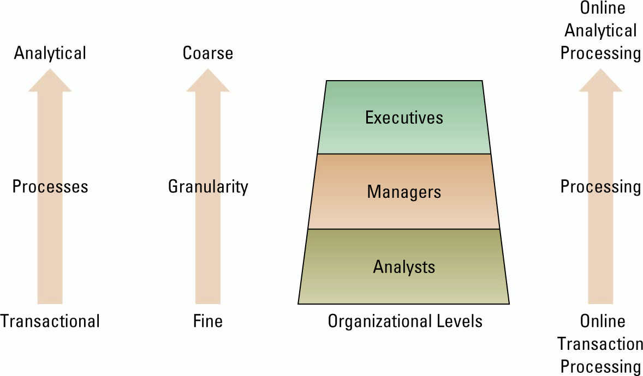
Transactional Data & Analytical Information
- Moving up through the organizational pyramid, users move from requiring transactional information to analytical information
Transactional data- encompass all raw facts contained within a single business process or unit of work.
-purpose: to support performing daily operational tasks (ex. Purchasing stock (stock price), airline decision (reservation number), withdrawal (bank balance)
Analytical Information- all summarized translated data. Purpose: support performing analysis task.
- includes external info examples : trends, aggregated sales amount by region, product statistics
Two types of processing occur with respect of trans. data and analytical info:
Online Transaction Processing (OLTP)- (performed at operational level) capturing of transaction and event data using IS to
- Process data according to define roles
- Store data
- Update existing data to reflective new data entered
* organization must capture every detail of transaction
Online Analytical Processing (OLAP)- ( managerial and strategic level) analysis of summarized or aggregated info sourced from transaction processing system data ; make analytical and strategic (non-operational) decision
- Consolidation: aggregation of info & features simple roll-ups to complex groupings of interrelated info (some organizations track financial info at regional level and consolidate it on global level)
- Drill down- enables users to view details of info
- Slice & Dice- ability to look at info from different perspectives
Business intelligence broad, general term to describe info people use to support analytical & strategic decision making efforts

Chapter 2 Page Summary

Measuring Decision Success
Metrics – Measurements that evaluate results to determine whether a project is meeting its goals
Common Types -
  - KPIs – Key Performance Indicators
  - Efficiency and Effectiveness

- Key performance indicators (KPIs) – The quantifiable metrics a company uses to evaluate progress toward critical success factors

  - Turnover rates of employees
  - Number of product returns
  - Number of new customers
  - Average customer spending

- Efficiency metrics – Measure the performance of IS itself, such as throughput, transaction speed, and system availability
- Effectiveness metrics – Measures the impact IS has on business processes and activities, including customer satisfaction and customer conversation rates
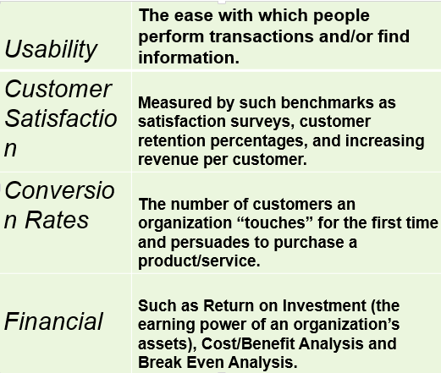
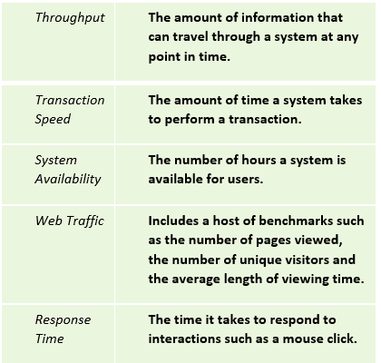

Benchmark – Baseline values the system seeks to attain
- Benchmarking – A process of continuously measuring system results, comparing those results to optimal system performance (benchmark values), and identifying steps and procedures to improve system performance
TPS, DSS, and EIS Decision making support system TPS, DSS, EIS, [OLTP, OLAP, source document]
- Transaction processing system (TPS) – Basic business system that serves the operational level and assists in making structured decisions. Use OLTP. Accounting system (payroll system) is TPS (used by clerks, analysts)
- Decision support system (DSS) – Models information to support managers and business professionals during the decision-making process; analytical purposes(used by business professional, managers)
-used for either transactional data or analytical info depending on level
Three quantitative models used by DSS include
  - What-if analysis – the study of the impact of a change in an assumption on the proposed solution
  - Sensitivity analysis – the study of the impact that changes in one (or more) parts of the model have on other parts of the model
  - Goal-seeking analysis – finds the inputs necessary to achieve a goal such as a desired level of output
Interaction between TPS and DDS:
- The TPS supplies transaction-based data to the DSS
- The DSS summarizes and aggregates the information from the many different TPS systems, which assists managers in making informed decisions.
- Canadian Pacific Railway (CPR) uses a DSS to analyze the movement of all its railcars and to track shipments against delivery commitments.
  - Similar to the logistics and scheduling challenges faced by Grocery Gateway, CPR would have a difficult task of integrating and analyzing this transaction-based data without this tool.

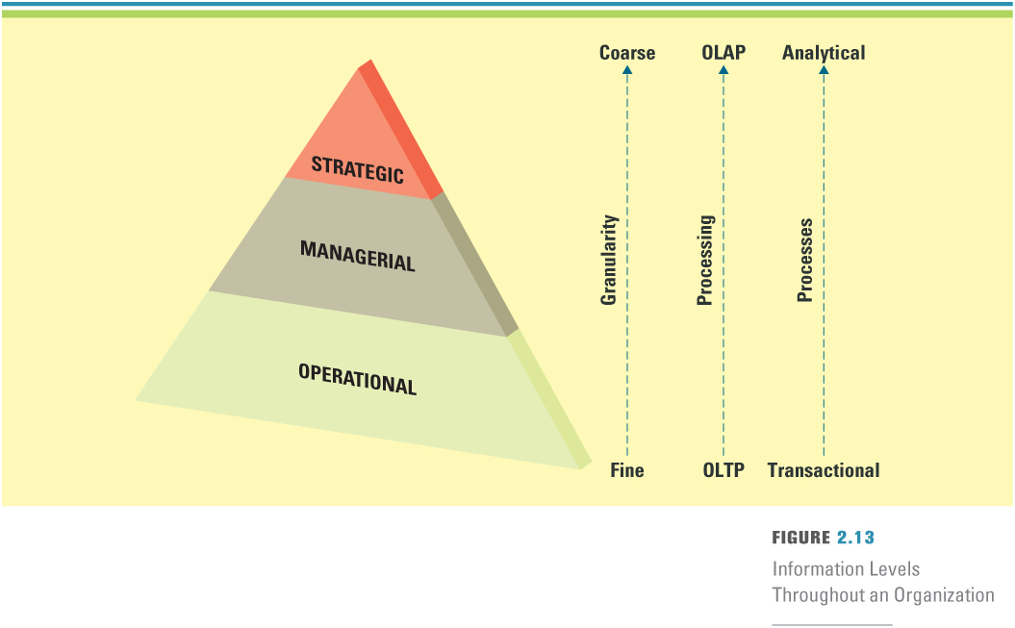
- Executive Information Systems (often for strategic purposes)
Specialized DSS supporting executive decision-making.
- Differs from DSS; EIS contains info from external sources & info from internal data
- Contains very coarse (not so fine, rough) info
Why would you need interaction between a TPS and EIS?
-The EIS needs information from the TPS to help executives make decisions
-Without knowing order information, inventory information, and shipping information from the TPSs, it would be very difficult for the CEO to make strategic decisions for the organization
- The structure of a typical organization is similar to a pyramid
- Organizational activities occur at different levels of the pyramid
- People in the organization have unique information needs and thus require various sets of IT tools (see Figure)
- At the lower levels of the pyramid, people perform daily tasks such as processing transactions
- Moving up through the organizational pyramid, people (typically managers) deal less with the details (“finer” information) and more with meaningful aggregations of information (“coarser” information) that help them make broader decisions for the organization
- Granularity refers to the extent of detail in the information (means fine and detailed or “coarse” and abstract information)

Digital Dashboard- (feature of IS) integrate info from multiple component & tail it to individual preference
- Includes measures that call into:
- Market pulse, customer service (prob solved on first call), cost driver (repair trucks in field)

Chapter 2 Page Summary

Artificial Intelligence
Artificial Intelligence (AI) Simulate human intelligence such as the ability to reason and learn
- Robots mimic human actions
Intelligence System- Various commercial applications of artificial intelligence
Neural network/ Artificial Neural Network
- A category of AI
- Attempts to emulate the way the human brain works
- Analyze large quantity of info to establish patterns & characteristics in situation where rules are unknown
- Features include
  - Adjusting to new circumstances of their own
  - Functioning without complete info
  - Analyzing non-linear relationship
- Biggest problem is learning how neurons are interacting & how its learning
Fuzzy Logic
Mathematical logic of handling subjective information Ex. Washing machine washes until water is clean
Genetic algorithm- artificial intelligence system that mimics the evolutionary to generate better solution to a problem
Intelligent Agent- special purpose knowledge- based info system that accomplishes specific task on behalf of its users; shopping bot
Virtual Reality- computer generated environment that can be simulated world or imaginary world
2.2 Business Process: Understanding the Importance of Business Process
Business process- standardized set of activities that accomplish a specific task, such as processing a cust. order
Customer facing processes – result in a product or service that is received by an organization’s external customer
  - Marketing campaign, Sales initiative such as a discount, customer service, New service, order shipping
Business facing processes- are invisible to the external customer but are essential to the effective management of the business
  - Goal setting, day to day planning, reward, strategic planning, budget forecasting, training
The Order-to-deliver Business Process Business Process improvement
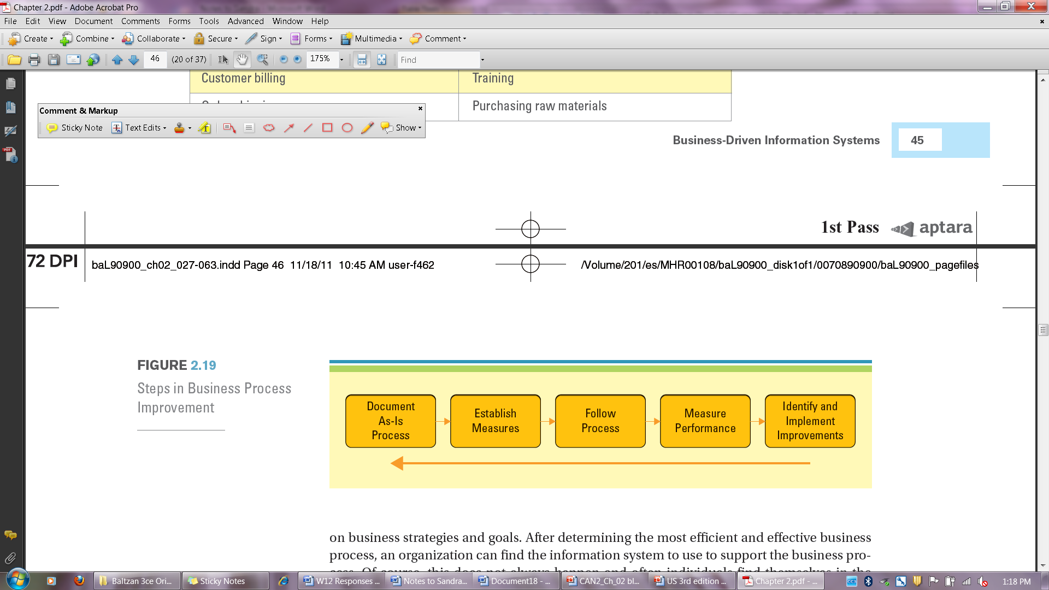
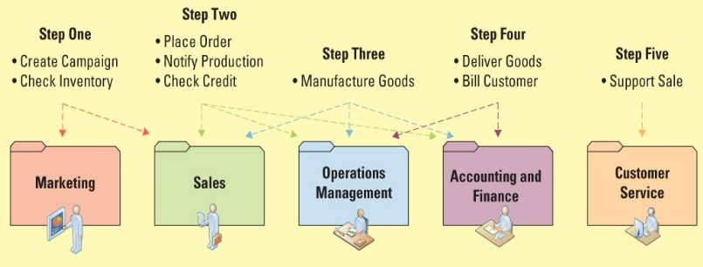
Business process improvement
Attempts to understand and measure current processes and upgrade them to improve
  - BPI, a cyclical activity. Metrics at the end are feedback for a new round of improvements
Business process re-engineering (BPR)
The analysis and redesign of workflow within and between enterprises
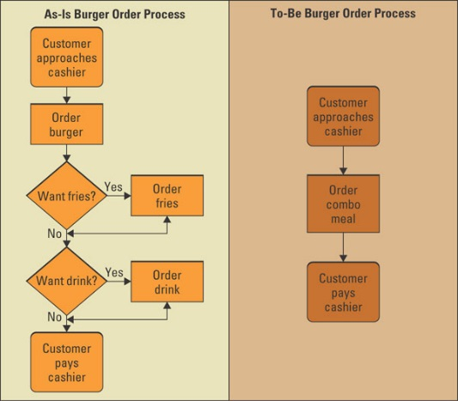
Business Process Modeling (mapping)
Why is it important to diagram the As-Is process prior to diagramming the To-Be process? It is important to understand the entire process from end-to-end before determining how to fix the process
What is the difference between the As-Is and To-Be process
- As-Is process model - represents the current state of the operation that has been mapped, without any specific improvements or changes to existing processes
- To-Be process model - shows the results of applying change improvement opportunities to the current (As-Is) process model

Business Process Management
Integrates all organization business processes to make individual processes more efficient
- Tracks and orchestrate BP
- Provides tools to measure performance and identify opportunities for improvement

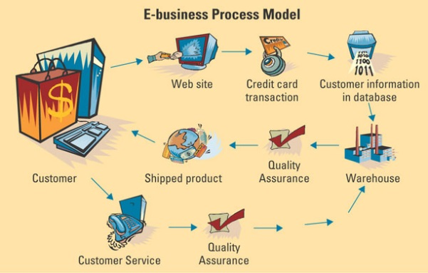
E-business Process Model

Chapter Two Page Summary

Chapter Two Summary
Market basket analysis provides information beyond about what is just being sold; it identifies opportunities for things like cross-selling.
What does RivalWatch employ when it offers its strategic business information services that enables its customers to track the product offerings, pricing policies, and promotions of online competitors?
- Artificial intelligence- artificial intelligence, which offers the opportunity for RivalWatch to give its customers the reporting needed for them to make decisions about their online activities.

Chapter 3 The Internet and E-Business

SECTION 3.1 - BUSINESS AND THE INTERNET
Disruptive Technology
Evolution of the Internet
Web 2.0
The Future – Web 3.0
Accessing Internet Information
Providing Internet Information
Chapter Three Overview
SECTION 3.2 - E-BUSINESS
E-Business Basics
Advantages of E-Business
E-Business Models
Organizational Strategies for E-Business
E-Business Benefits and Challenges
New Trends in E-Business: E-Government and M-Commerce

Learning Outcomes
- Explain how the Internet and the World Wide Web have evolved over the years and distrupted traditional ways of doing business.
- Describe the different methods an organization can use to access Internet information and the different types of service providers that supply organizations with access to the Internet.
- Compare the four types of e-business models.
- Describe how an organization’s various departments can use e-business to increase revenues or reduce costs, and how organizations can measure e-business success.
- Describe the benefits and challenges of e-business, and the new trends happening in e-business today.
3.1 Business and the Internet
Disruptive Technology
Digital Darwinism – implies that organizations which cannot adapt to the new demands placed on them for surviving in the information age are doomed to extinction.
Disruptive vs. Sustaining Technology
  - Disruptive technology – a new way of doing things that opens new markets and destroys old ones.
  - Sustaining technology – Produces improvements to products that customers are eager to buy.
The Internet- Disruptive Business Technology
- Internet, one of biggest forces changing business
- Organizations must be able to transform as markets, economic environments, & technologies change
- Focusing on the unexpected allows an organization to capitalize on the opportunity for new business growth from a disruptive technology
Impact on industry:
- Auto- use of marketplace listing millions of cars from private owners to dealers
- Publishing- anyone can be a published author. Self-publishing & print-on-demand
- Financial Services- e-finance business makes money. On-line mortgage application processing is cheaper
- Retail- online retail sales

Chapter 3 Page Summary

Evolution of Internet
- The Internet began as an emergency military communications system operated by the U.S. Department of Defense.
- Internet moved from a military pipeline to a communication tool for scientists to businesses.
  - Internet – computer networks that pass information from one to another using common computer protocols.
  - Protocol – standards that specify the format of data as well as the rules to be followed during transmission.
- World Wide Web (WWW) – a global hypertext system that uses the Internet as its transport mechanism
* Internet and WWW is not synonymous: The Internet is a global public network of computer networks that pass information from one to another using common computer protocols
- Hypertext transport protocol (HTTP) – the Internet standard that supports the exchange of information on the WWW
What are the two primary reasons for growth of the WWW?
Two events changed the history of the Internet: On August 6, 1991 Tim Berners-Lee built the first Web site &
Marc Andreesen built and distributed Mosaic
The Internet’s impact on information:

-Easy to compile - Increased richness - Increased reach - Improved content

Digital divide – when those with access to technology have great advantages over those without access to technology.
Web 2.0 is a set of economic, social, and technology trends that collectively form the basis for the next generation of the Internet.
Mashup – Website or Web application that uses content from more than one source to create a completely new product or service
  - Application programming interface
  - Mashup editor
Web 3.0 – Based on “intelligent” Web applications using natural language processing, machine-based learning and reasoning, and intelligence applications
Semantic Web – Structuring data so web pages describe things in a way that computers can “understand” and, thus, find, share and integrate ideas more effectively for people.
Accessing Internet Information
Four tools for accessing Internet information
  - Intranet – internalized portion of the Internet, protected from outside access, for employees
  - Extranet – an intranet that is available to strategic allies
  - Portal – Web site that offers a broad array of resources and services
  - Kiosk – publicly accessible computer system that allows interactive information browsing
Providing Internet Information
- Three common forms of service providers
  - Internet service provider (ISP) –provides individuals and other companies access to the Internet
  - Online service provider (OSP) – offers an extensive array of unique Web services
  - Application service provider (ASP) – offers access over the Internet to systems and related services that would otherwise have to be located in organizational computers
- Common ISP services include:
  - Web hosting
  - Hard-disk storage space
  - Availability
  - Support
- ISPs, OSPs, and ASPs use service level agreements (SLA) which define the specific responsibilities of the service provider and set the customer expectations
Chapter 3 Page Summary

Chapter 3.2: E- Business
E-Business Basics
How do e-commerce and e-business differ?
  - E-commerce – the buying and selling of goods and services over the Internet
  - E-business – the conducting of business on the Internet including not only buying and selling, but also serving customers and collaborating with business partners
Industries Using E-Business
    - Manufacturing and Retail: RFID, online payments and orders, sales via the Internet, customer service via the Internet
    - Financial: online banking, online mortgages, online loans
    - Telecommunications: Voice over the Internet (VoIP)
    - Healthcare: digital hospitals, pharmacy orders via the Internet
    - Travel: online reservations, Travelocity, Expedia
Advantages of E-business
Expanding Global Reach
Easy access to real-time info as primary benefits
Information richness- depth of details contained in textual, graph, audio, video info
Information reach- measures # of people a firm can communicate with all over the world

Opening New Markets
Mass customization – The ability of an organization to tailor its products or services to the customers’ specifications Mini Cooper, Nike shoes, M&Ms
Personalization – Occurs when a company knows enough about a customer’s likes and dislikes that it can fashion offers more likely to appeal to that person Amazon, Netflix
The Long Tail – Refers to the tail of a typically sales curve
Intermediary – Agents, software, or businesses that provide a trading infrastructure to bring buyers and sellers together
Disintermediation – Occurs when a business sells directly to the customer online and cuts out the intermediary. Buying a computer from Dell’s website cuts out the electronics retailer.
Reintermediation – Steps are added to the value chain as new players find ways to add value to the business process. www.biddingo.com is a Canadian online marketplace for government procurement. Co-0perative websites that provide a virtual space to facilitate worldwide house exchanges are an example. www.homeexchange.com
Cybermediation – Refers to the creation of new kinds of intermediaries that simply could not have existed before the advent of ebusiness. Netflix is an example
Reducing Costs—Business processes that take less time and human effort.
Improving Operations—Communications customized to meet consumer needs and available 24/7.
Improving Effectiveness—Web sites must increase revenue and new customers and reduce service calls
- Interactivity metrics measure E-business success: number of repeat visits, times spent on site and number of pages viewed among other activities.
* click stream data can be used to observe exact patterns of consumer navigation
Improving Effectiveness through E-business marketing
Cross-marketing efforts lever the loyalty of customers from one business for another:
- Associate(Affiliate) programs allows a business to generate commissions or referral fees when a customer visiting its site clicks on to another merchant’s Web site.
- A Banner Add is a box running across a Web site that advertises the products and services of another business.
Browser/buyer behaviour is added by:
- Tracking click-throughs which count the no. of people who visit a site.
- A Cookie is a small file deposited on a hard drive by a Web site to collect information about a customer and their browsing habits.
Some marketing activities are unique to the Web:
- A Pop-up ad is a small Web page containing an advertisement that appears outside of the current Web site.
- Viral Marketing takes “word-of-mouth” advertising to a vastly wider leverl. Web site or web users pass on marketing messages to other Web sites or users. Imagine the word-of-mouth impact of a rock star putting a product message on Facebook. Even ordinary individuals reach many family members and friends who have similar buying profiles.
Chapter 3 Page Summary

Measuring Website Success

Stickiness—visit duration time.
Raw Visit Depth—total Web page exposures per session.
Unidentified visitor—no information about visitor is available.
Unique visitor—recognized and counted once in a period of time.
Identified visitor—can be tracked across multiple web visits.
Hits—A single request made by a visitor to view a web page
E Business Model
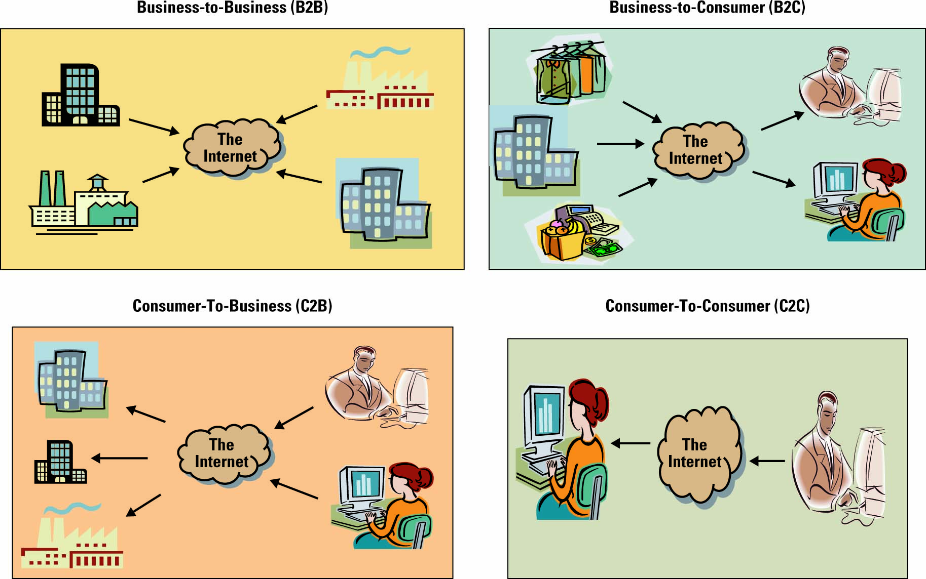
B2B: Applies to businesses buying from and selling to each other over the Internet.
B2C: Applies to any business that sells its products or services to consumers over the Internet.
C2B:Applies to any consumer that sells a product or service to a business over the Internet…examples: eBay, Kijiji
-will increase because of demand for lower prices from consumers
C2C: applies to any consumer that sells a product or service to other consumers, eBay, Kijiji
  - One of the most successful C2C business model is C2C Communities which are sometimes used for consumer to consumer financial transactions.
  - Communities of interest - People interact with each other on specific topics, such as golfing and stamp collecting
  - Communities of relations - People come together to share certain life experiences, such as cancer patients, senior citizens, and car enthusiasts
  - Communities of fantasy - People participate in imaginary environments, such as fantasy football teams and playing one-on-one with Michael Jordan

Business Types:
  - Brick-and-mortar business - operates in a physical store without an Internet presence.(local book store)
  - Pure-play (virtual) business - a business that operates on the Internet only without a physical store. Examples include Amazon.com and Expedia.com.
  - Click-and-mortar business – a business that operates in a physical store and on the Internet. Examples include Sears and Indigo Books & Music, Mountain Equip
E-auctions are a successful E-business model.
  - Forward Auction—Seller offers to many buyers who bid and the highest bid wins.
  - Reverse Auction—Buyer specifies product or service and lowest seller bid wins contract.
Chapter 3 Page Summary

Business to Business (B2B)
Electronic marketplace (e-marketplace) – interactive business communities providing a central market where multiple buyers and sellers can engage in e-business activities
- Primary goal is to increase market efficiency by tightening and automating the relationship between buyers and sellers
- Existing e-marketplaces allow access to various mechanisms in which to buy and sell almost anything, from services to direct material
Business-to-Consumer (B2C)
- Common B2C e-business models include:
  - e-shop – a version of a retail store where customers can shop any time without leaving their home
    - Also called e-store or e-tailing
  - e-mall – consists of a number of e-shops; it serves as a gateway through which a visitor can access other e-shops
Organizational Strategies for E-Business
Marketing
- E-business’ success in direct selling is evidenced by growth of the Internet sales of Dell Inc., eBay, Indigo and Travelocity.
- Innovative approaches are changing the face of retailing:
  - For Example: Sears installed Skype-enabled screens into 10 of its fashion outlets so that buyers could remotely show their friends potential clothing choices.
Financial Services
Online Consumer Payments:
  - Financial cybermediary - an Internet-based company that facilitates cybermediary payments over the Internet. PayPal is the best-known example of a financial cybermediary.
  - Electronic cheque - a mechanism for sending a payment from a chequing or savings account. There are many implementations of electronic cheques, with the most prominent being online banking.
  - Electronic bill presentment and payment (EBPP) - a system that sends presentment and bills over the Internet and provides an easy-to-use mechanism (such as payment (EBPP) -- clicking on a button) to pay the bill. EBPP systems are available through local banks or online services such as Checkfree and Quicken.
  - Digital wallet - both software and information—the software provides security for the transaction and the information includes payment and delivery information (for example, the credit card number and expiration date).
Chapter 3 Page Summary

Online Business Payments
  - Electronic data interchange (EDI) - a standard format for exchanging business data. One way an organization can use EDI is through a value-added network.
  - Value-added network (VAN) - a private network, provided by a third party, for exchanging information through a high-capacity connection. VANs support electronic catalogues (from which orders are placed), EDI-based transactions (the actual orders), security measures such as encryption, and EDI mailboxes.
  - Financial EDI (financial electronic data interchange) is a standard electronic process for B2B market purchase payments. National Cash Management System is an automated clearinghouse that supports the reconciliation of the payments.
Procurement
Maintenance, repair, and operations (MRO) materials (also called indirect materials) – materials necessary for running an organization but do not relate to the company’s primary business activities (equipment, supplies)
  - E-procurement - the B2B purchase and sale of supplies and services over the Internet
  - Electronic catalogue - presents customers with information about goods and services offered for sale, bid, or auction on the Internet
Customer Service
- Customer service is the business process where the most human contact occurs between a buyer and a seller
- E-business strategists are finding that customer service via the Web is one of the most challenging and potentially lucrative areas of e-business
- The primary issue facing customer service departments using e-business is consumer protection
Security
  - Encryption - scrambles information into an alternative form that requires a key or password to decrypt. Encryption is achieved by scrambling letters, replacing letters, replacing letters with numbers, and other ways.
  - Secure socket layer (SSL) - (1) creates a secure and private connection between a client and server computer, (2) encrypts the information, and (3) sends the information over the Internet. SSL is identified by a Web site address that includes an “s” at the end—https.
  - Secure electronic transaction (SET) - a transmission security method that ensures transactions are secure and legitimate. Similar to SSL, SET encrypts information before sending it over the Internet. However, SET also enables customer authentication for credit card transaction. SETs are endorsed by major e-commerce players including MasterCard, American Express, Visa, Netscape, and Microsoft.

Chapter 3 Page Summary

E-business Benefits and Challenges
E-Business Benefits
  - Highly Accessible - Businesses can operate 24 hours a day, 7 days a week, 365 days a year
  - Increased Customer Loyalty - Additional channels to contact, respond to, and access customers helps contribute to customer loyalty
  - Improved Information Content- In the past, customers had to order catalogues or travel to a physical facility before they could compare price and product attributes. Electronic catalogues and Web pages present customers with updated information in real-time about goods, services, and prices
  - Increased Convenience - E-business automates and improves many of the activities that make up a buying experience
  - Increased Global Reach - Businesses, both small and large, can reach new markets
  - Decreased Cost - The cost of conducting business on the Internet is substantially smaller than traditional forms of business communication
E-Business Challenges
- Protecting consumers—Against unsolicited, illegal or harmful goods, invasion of privacy, cyber fraud
- Leveraging existing systems—Effectively integrating innovative systems with existing systems.
- Increasing liability--Identity theft, privacy, and the Internet’s global reach means dealing with laws of many countries.
- Providing security—Protection of consumer and business information and data assets
- Taxation Rules- Adhering to often new rules
New Trends In E-Business: E-Government & M-Commerce
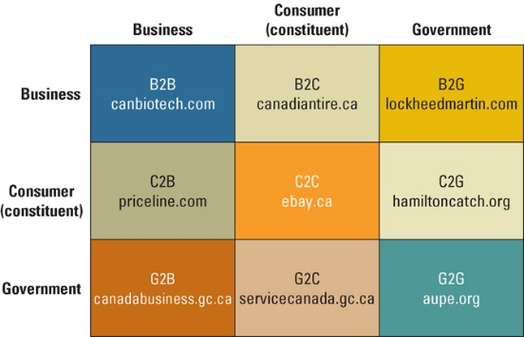
E-government - involves the use of strategies and technologies improve the delivery of services and enhance the quality of interaction between the citizen-consumer within all branches of government.
-Federal government portal, www.canada.gc.ca, connects citizens, immigrants, visitors and others to all government public communication.
Mobile commerce - the ability to purchase goods and services through a wireless Internet-enabled device Business
Social Media & Business
- Companies advertise on Facebook, with their own pages on Facebook, active on Twitter.
- Companies are advised to integrate social media in business communications, use social customer support, provide leadership and expertise through social media, and that social media can drive reputation.

Chapter 3 Page Summary

Chapter 3 Summary

Chapter 4 Enterprise Computing Challenges and Enterprise Resource Planning
Learning Outcomes
4.1 Explain what enterprise computing challenges are happening in organizations today (e.g., innovation, going green, social networks, and virtual worlds)
4.2 Describe enterprise resource planning as a management approach and how information systems can help promote ERP.
4.3 Describe the components of ERP systems and the differences between them.
4.4 Explain the business value of integrating supply chain management, customer relationship management, and enterprise resource planning system together.
4.1 Enterprise Computing Challenges
Primary changes and challenges organizations are focusing on in the 21st century:

Innovation: Finding new Virtual worlds: It’s a whole new world
Social entrepreneurship: Going green Social network: Who’s who

Innovation: Finding New
Innovation is the introduction of new equipment methods.
Current Impetus (motivation) for innovation comes from the need to cut cost, while creating competitive advantage
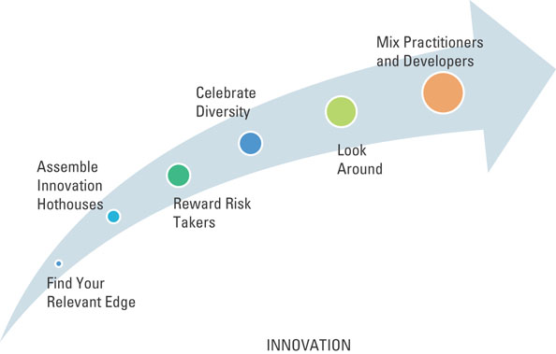
Six Best Practices of Innovation
Find Your Relevant Edge: Example, companies making diesel engines and power generators should find ways to more effectively serve lower income customers. Find relevant edge that will test and push current performance.
Assemble Innovation Hothouses: Attract Motivated groups to these edges to work together on challenging performance issues.

Reward Risk Takers: Recognize people who are likely to be attracted to the edge.
Celebrity Diversity: Recognize that the edge fosters not just risk taking, but different cultures that are also edgy. Look Around: Find ways to appropriate insights from adjacent disciplines and even more remote areas of activity.
Mix Practitioners and Developers: Bring users and developers of technology together

Chapter 4 Page Summary

Social Entrepreneurship: Going Green
Social Responsibility implies that an entity (government, corporation, organization, individual) has a responsibility to society.
Corporate Policy is a dimension of social responsibility that refers to the position a firm takes on social and political issues.
Corporate Responsibility is a dimension of social responsibility that includes everything from hiring minority workers to make safe products.
Sustainable (green) IT describe the management, use, and disposal of IT in a way that minimizes damage to the environment.
Energy Consumption
In ’92, HP launched its Design for Environment program with goals of energy efficiency, materials innovation, and recycling
Ways tech companies, utilities, and builders are responding:
Sun Microsystems: Through Computing: Multi-core chip has several processors on a single silver silicon, each of them running cooler and sucking less energy and getting work done; designed by Marc Tremblay.
Virtualization: a framework of dividing the resources of a computer into multiple execution environments. Software allows IT managers to easily load multiple programs on a single machine and move programs from one computer to another. Reduces energy use to up to 80% because fewer users are needed.
Energy Rebate Programs: The province of Ontario offers businesses a number of incentive programs aimed at reducing energy consumption. Programs range from lighting upgrades for small businesses, to incentive for businesses to upgrade systems to hold onto energy saving, and to high performance new construction.
Small Cooling: Thousands of head sensors monitor temperatures, and software directs the air-conditioning systems created by HP (Dynamic Smart Cooling technology)
Alternative Energy Sources: Wind and solar power used by Google
Biology Meets Chips: IBM design devices that cool chips using liquid delivered through capillary-like circulation systems. A metal cap fits over a processor and sprays jets of water out of 50,000 nozzles into microscopic channels etched in the metal and cuts the energy required to pump the water.
Government Involvement: EU has imposed limits on carbon emissions.
Recycled IT Equipment
Sustainable IT disposal refers to the safe disposal of IT assets. Ensures that ewaste or cold computer equipment, does not end up in landfill. (ewaste: discarded, obsolete or broken electronic devices)
Electronic Product Stewardship Canada (EPSC) an industry association that educates and encourages ewaste control
Chapter 4 Page Summary

Greener IT
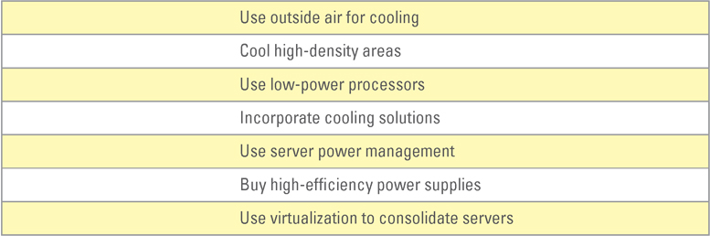
Ways to Save Energy in Data Centre

Social Networks: Who’s Who
Passive Research- finding new people for new jobs who are happy and productive working for other companies through business networking website.
Boomerangs- former employees returning to old jobs. Cost less to train than new hires.
Marketing Networks- using business network for marketing and events
Virtual Worlds: It’s a whole new world
Virtual Workforce- working from home or anywhere via the internet. Can keep cars off the road, foster employee retention and boost workers’ productivity.
Tools for Virtual Workforce:
- Mobile Commerce (m-commerce): ability to purchase goods/services through wireless Internet-enabled devices
- Telematics: blending of computers and wireless telecommunication technologies with the goal for efficiently electronic communication to improve operations
- Electronic Tagging: technique for identifying and tracking assets and individuals via technologies such as radio frequency identification (RFID) and smart cards
Virtual Worlds- Second life- an internet resource which presents a 3D virtual community
4.2 Enterprise Resource Planning
Enterprise resource planning (ERP) integrates all departments and functions throughout an organization into a single information system so employees can make decisions by viewing enterprise-wide data on all business operation
Everyone involved in sourcing, producing, and delivering the company’s product works with the same data. Reduces redundancies, wasted time, and removes inconsistencies in data.
- is a logical solution the mess of incompatible applications
- addresses the need for global information sharing and reporting
- is used to avoid the pain and expense of fixing legacy system
Legacy Systems and ERP are older computer and technology still in use
Chapter 4 Page Summary

Functional systems are information systems that serve a single business such as accounting
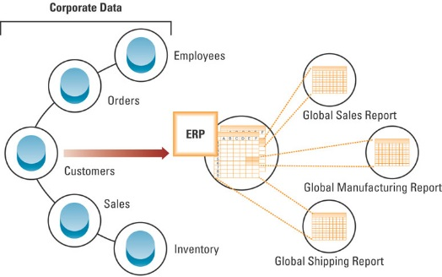
Enterprise Resource Planning System ERP Process Flow
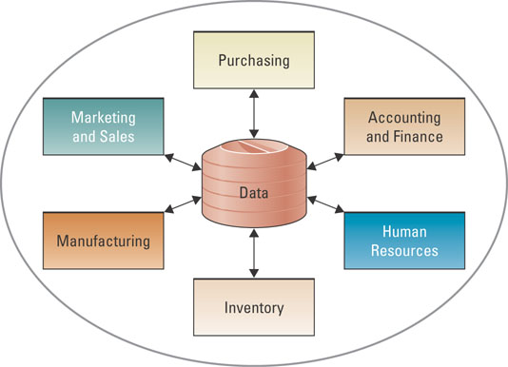

Two components to ERP: The Heart of ERP and The Evolution of ERP
The Heart of ERP- central database that collects data and feeds data into all ERP system’s individual application component (called module) and automatically updates data throughout entire system when data is updated in one module.
Evolution of ERP
ERP (1990)-Materials planning, order entry, distribution, general ledger, accounting, shop floor control
Extended ERP (2000)-Scheduling, forecasting, capacity planning, e-commerce, warehousing, logistics
ERP II (present)-Project management, knowledge management, workflow management, customer relationship management, HR management, portal capability, integrated financials
Extended ERP component extra components that meet the organizational needs not covered by the core components and primarily focus on external operations
Four most common extended ERP components: BI, CRM, SCM, E-Business
Business Intelligence describes information that people use to support their decision making efforts.
- Collect data and turn it into information & apply analytical tools to assist managers and analysts with decisions.
Customer Relationship management (CRM) managing aspects of customer’s relationship with organization to increase customer loyalty and retention, and profitability.
- Includes contact centres, sale force automation, marketing function.
Supply Chain Management (SCM) managing data flows between and among stages in a supply chain to maximize total supply chain effectiveness and profitability
- Acquisition from raw materials to the receipt of finished goods by customers.
E-business means conducting business on the Internet. E-logistics manages the transportation and storage of goods. E-procurement is the B2B purchase and sale of supplies and service over the internet.
Chapter 4 Page Summary

Integrating SCM, CRM, and ERP
SCM, CRM, and ERP are the backbone of e-business.
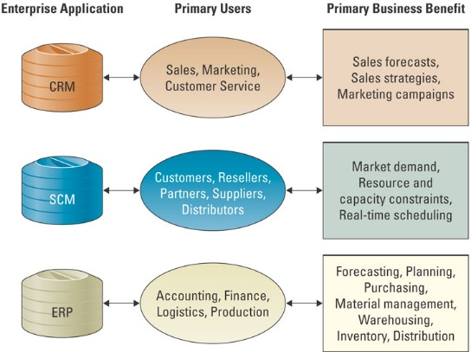
Integration Tools: Integration are achieved using middleware (several different types of software that sit in the middle of and provide connectivity between two or more software applications) which translate data between disparate systems.
Enterprise Application Integration (EAI) middleware represents a new approach middleware by packaging together commonly used functionality, such as providing pre-built links to popular enterprise applications.

Core ERP component traditional components included in most ERP systems and they primarily focus on internal operations
Three most common core ERP components focusing on internal operations:
Accounting and finance, production and materials management, Human Resource
Accounting and Finance ERP Components manage accounting data and financial processes within the enterprise with functions such as general ledger, a/p, a/r, budgeting, and asset management. Most useful feature is credit-management feature.
Production and Materials Management ERP Components handle various aspects of production planning and execution such as demand forecasting, production scheduling, job cost accounting, and quality control.
Human Resources ERP Components track employee data, including payroll, benefits, compensation, and performance assessment with legal requirements of multiple jurisdictions and tax authorities.
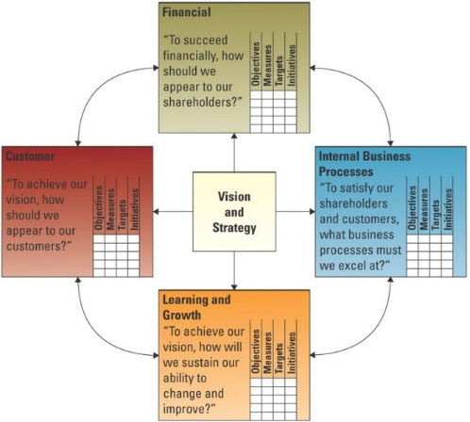
Measuring ERP Success
Balanced Scorecard management system, in addition to a measurement system that enables organizations to clarify their vision and strategy and translate them into action.
- Provides feedback for both internal business process and external outcome
- Views organization from 4 perspective: the learning and growth perspective, the internal business process perspective, customer perspective, financial perspective.
ERP and SME Markets
Large-scale ERP vendors are attempting to enter small to medium enterprise (SME).
- SMEs demand affordability and ease of use more than large organizations
- Large Scale ERP are relatively unknown to most SME organization
- In Canada, several large-scale ERP vendors have missed the mark when attempting to market their ERP solutions to SME companies. Priced towards American mid-sized company which is Canada’s large-sized company
- SME market space demands using partners (resellers) to sell software solutions.
Chapter 4 Page Summary and Chapter Summary

Chapter 5 Operations Management and Supply Chain Management
Learning Outcomes
5.1 Explain the fundamentals of operations management and its role in business.
5.2 Describe how information systems can support the operations management function.
5.3 Explain supply chain management and its role in business.
5.4 Describe the relationship between information systems and the supply chain.
5.5 Summarize the best practise for implementing a successful supply chain management system.
Production - creation of goods and services using the factors of production: land, labour, capital, entrepreneurship, and knowledge.
  - Operation Management
Operation Management Fundamentals
Production management describes all the activities managers perform to help companies create goods
Operation management (OM) management of systems or processes that convert or transform resources (including hr) into goods or services. Responsible for managing the core processes used to manufacture goods and product services.
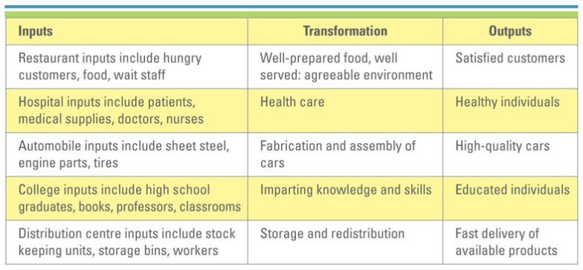
Transformation process often referred as technical core in manufacturing organizations. Actual conversion of inputs and outputs.
Example of inputs, transformation processes, and outputs
Value added term used to describe the difference between the cost of inputs and price of outputs.
In non for profit organization value of outputs is their value to society. For profit organization value output is measured by the prices that customers are willing to pay for the goods/services.
OM in Businesses
Typical OM activities:
Forecasting: Estimating demand for a product/service
Capacity Planning: Determining the amount of space, equipment and throughput is needed to achieve the production targets.
Scheduling: Determining when the production will occur.
Managing inventory: Ensuring raw materials will be available on time and in place and that work in progress and finished goods have storage.
Assuring quality: Ensuring standards are met through sampling inputs, in process work and outputs.
Motivating and training employees: Appropriate pay, benefits, scheduling, and direction, supervision and instructions.
Locating Facilities: Determining where to put production facilities and the cost effectiveness of near major markets or away from markets and close to transportation routes.
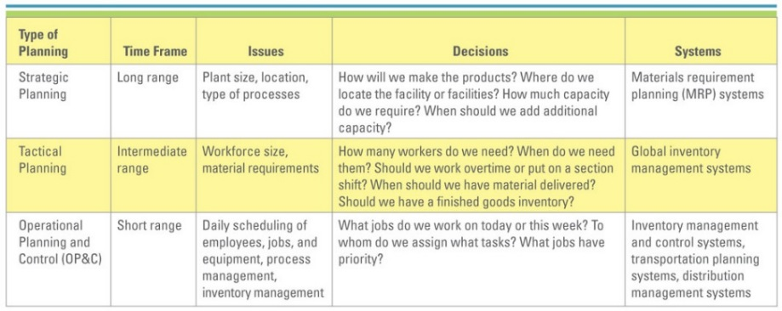
Information System’s Role in OM
OM Strategic Business Systems
Factors to be considered in developing an operations strategy: a) Level of technology available b) required skill levels of working and c) degree of vertical integration in terms of the extent to which suppliers are used.
Strategic Business Units (SBUs) several stand-alone businesses; larger conglomerates (companies) operates in terms of this. Decisions focus on being effective.
Strategic Planning (long rang effective decisions; doing the right thing) focuses on long-range planning such as plant size, location, and type of process to be used.
Material requirement planning (MRP) systems (primary system used for strategic planning) use sales forecast to make sure that needed parts and materials are available at the right time and place.
Tactical planning (Intermediate-range efficient decisions; focus on doing things right) focuses on producing goods/services as efficiently as possible.
Global Inventory Management System (GIMS) (primary system used in tactical planning) provide the ability to locate, track, and predict the movement of every component or material anywhere upstream or downstream in the business process.
Operational Planning and Control (OP&C) (short range decision) deals with the day to day procedures for performing work. Includes scheduling inventory, and process management
Inventory Management and Control System provide control and visibility to the status of individual items maintained in inventory. Maintain inventory record accuracy, generates material requirements for all purchased items, and analyzes inventory performance.
Software organizes: current inventory & order status, cost accounting, sale forecasts and customer orders, manufacturing capacity, new-product introductions
Transportation planning system track and analyze the movement of materials and products to ensure delivery of materials at right time, right place and lowest cost.
Distribution Management System coordinates the process of transporting materials from a manufacturer to distribution centres to the final customers.
Competitive OM Strategy
5 key competitive priority that can add value its OM decision: Cost, Quality, Delivery, Flexibility, Service
Chapter 5 Page Summary

OM and the Supply Chain
Supply chain consists of all parties involved directly or indirectly in obtaining a product or raw material.
Supply chain management (SCM) involves managing information flows between and among stages in a supply chain to maximize total effectiveness and profitability.
Four basic components of SCM:
- Supply Chain Strategy - A company must have a plan for managing all the resources that go toward meeting customer demand for products or services.
- Supply Chain Partners - Companies chosen to deliver finished products, raw materials and services.
- Supply Chain Operations - Scheduling production activities, including testing, packaging, and preparing for delivery.
- Supply Chain Logistics - Product delivery process and elements including orders, warehouses, carriers, defective product returns and invoicing.
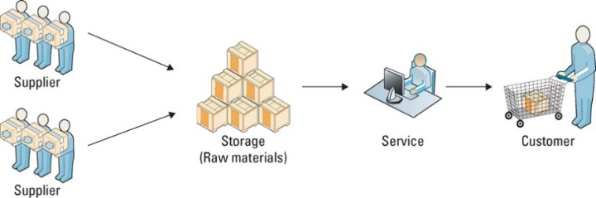
Typical Manufacturing Supply Chain Typical Service Supply Chain
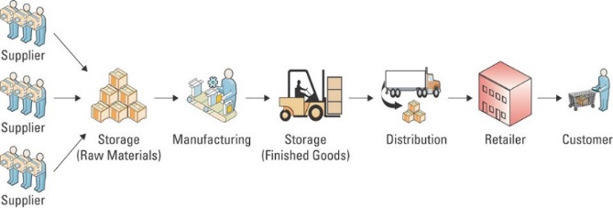
Effective and efficient SCM systems can enable an organization to
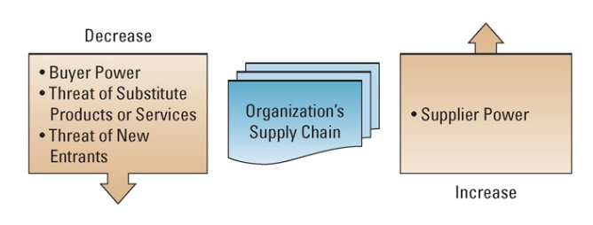
- Decrease the power of its buyers
- Increase its own supplier power
- Increase switching costs to reduce the threat of substitute products or services
- Create entry barriers thereby reducing the threat of new entrants
- Increase efficiencies while seeking a competitive advantage through cost leadership
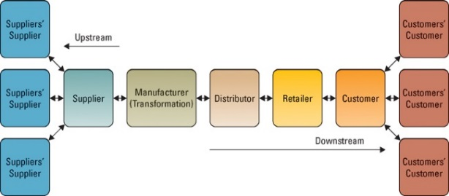
5.2 Supply Chain Fundamentals Supply chain has three main links:
- Materials flow from suppliers and their upstream suppliers at all levels
- Transforming materials into semi-finished and finished products- the organization’s own production processes
- Distributing products to customers and their downstream customers at all levels. A typical supply chain for a manufacturer
Chapter 5 Page Summary

5 basic components of supply chain management
- Plan – strategic portion of supply chain management. Develop a set of metrics to monitor the supply chain so that it is efficient, costs less, and delivers high quality and value to customers.
- Source –Develop a set of pricing, delivery, and payment processes with suppliers and create metrics for monitoring and improving the relationships.
- Make – Companies manufacture their products or services. Scheduling the activities necessary for production, testing, packaging, and preparing for delivery. Most metric-intensive portion of the supply chain, measuring quality levels, production output, and worker productivity.
- Deliver (logistics) – Receive orders from customers, fulfill the orders via a network of warehouses, pick transportation companies to deliver the products, and implement a billing and invoicing system to facilitate payments.
- Return – Most problematic step in the supply chain. Create a network for receiving defective and excess products and support customers who have problems with delivered products.
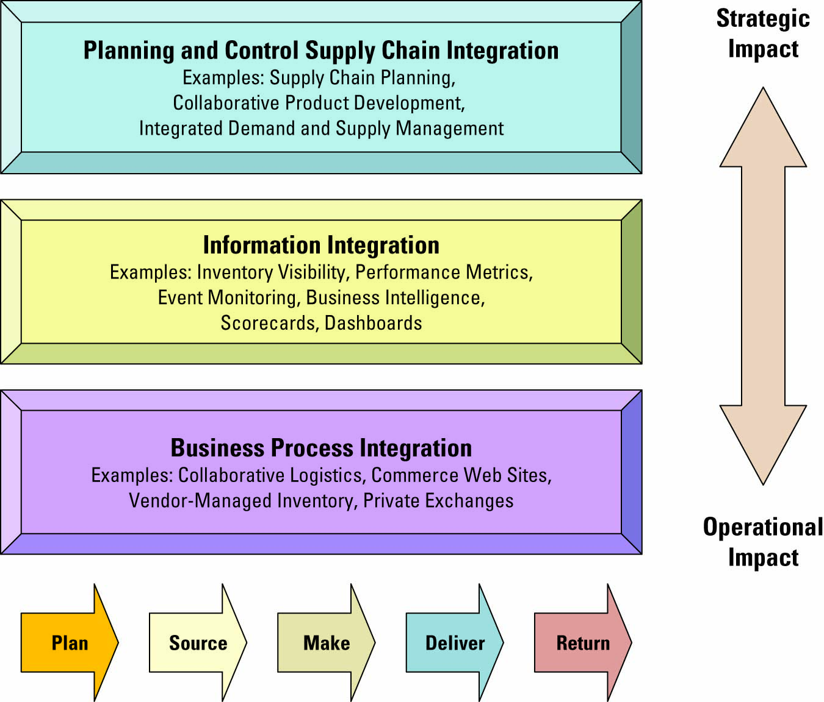
Information Systems’ Role in the Supply Chain
Information systems’ primary role in SCM
- Integrating the information links between functions within a firm such as marketing, sales, finance, manufacturing and distribution—and between firms to allow the smooth synchronized flow of both information and products between customers, suppliers and transportation providers across the supply chain.
Integrated Supply Chain

Factors Driving Supply Chain
Visibility – The ability to view all areas up and down the supply chain. The bullwhip effect (disruptions upstream at supply source increase in impact as they move downstream to the consumer) For example: A strike at a supplier making one critical computer component means stock-outs on the shelves of the computer retailer. Organizations need to know what is happening above and below them to be able to manage effectively.
Consumer Behaviour – Demand Planning systems create forecasts using statistical tools and techniques so that customers can respond faster to consumer demands, reducing inventory and improving delivery time.
Competition – To provide a competitive edge, Supply Chain Planning Systems (SCP), process correct and timely information with Mathematical algorithms to improve the flow of input materials and final product outputs through the supply chain. Supply Chain Execution (SCE) automates steps in the supply chain such as order, shipment and payment. A blanket PO (purchase order) sits in the suppliers’ computers and the use of the purchasers’ products are tracked. When the purchasers’ inventory falls to a specified level an automatic shipment is triggered and payment is done through automatic bank withdrawal. The most common system is EDI (Electronic Data Interchange).
Speed – As EDI and other Supply Chain Execution applications remove the need for paper flow and allow for continuous materials and product flow, speed is increased. Increasing speed and capacity of servers and telecommunications has improved supply chain speed dramatically.

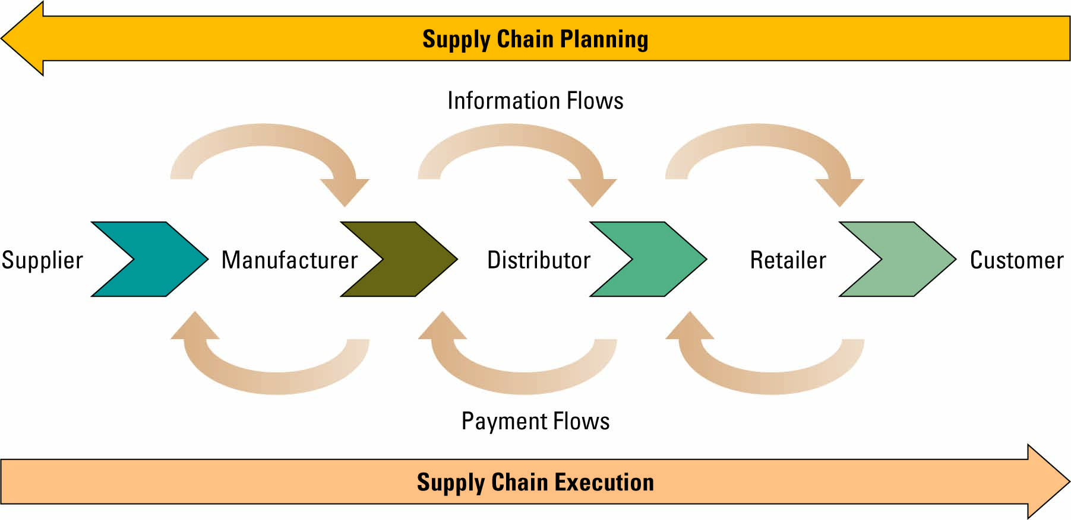
Three Factors Fostering Speed
- Pleasing customers has become something of a corporate obsession. Information about
issues such as order status, product availability, delivery schedule, and invoices gas become necessary part of total customer service experience.
- Info is crucial to manager’s ability to reduce inventory and HR requirements to a competitive level
- Info flows are essential to strategic planning for and deploying resources
Supply Chain Management Success Factors
SCM Success Metrics can help an organization understand how it’s operating over a given time period. Supply chain metrics includes:
Back order: an unfilled customer order. Customer demand against an order that is out of stock.
Customer order promised cycle time: anticipated or agreed upon cycle time of a purchase order. Gap between purchase order date and requested delivery date.
Customer order actual cycle time: Average time it takes to actually fill a customer’s purchase order.
Inventory Replenishment cycle time: Measure of the manufacturing cycle time plus the time included to deploy the product to the appropriate distribution center.
Inventory turns (inventory turnover)- number of times that a company’s inventory cycles or turns over per year. One of the most commonly used supply chain.
7 Principles of Supply Chain Management
- Segment Customers by service needs, regardless of industry, and tailor service to those segments.
- Customize the logistics network and focus intensively on the service requirements and on profitability of the pre-identified customer segments.
- Listen to signals of market demand and plan accordingly. Planning must span the entire chain to detect signals of changing demand.
- Differentiate products closer to the customer, since companies can no longer afford to hold inventory to compensate for poor demand forecasting.
- Strategically manage sources of supply, by working with key suppliers to reduce overall costs of owning materials and services.
- Develop a supply chain information technology strategy that supports different levels of decision making and provides a clear view (visibility) of the flow of products, services and information.
- Adopt performance evaluation measures that apply to every link in the supply chain and measure true profitability at every stage.
Future Supply Chain Trends
- Instrumentation—Data will be increasingly machine-generated. GIS and RFID-enabled devices, meters and actuators.
- Interconnectedness—Every component from customer back to materials source and every element in between such as vehicles, containers and products will be identified and can be tracked.
- Intelligence—Data received from the smart objects in the supply chain will be processed with smart analytics which will create better models to support improved decisions in an increasingly complex world.
Chapter 5 Summary
SCM systems focus on extending beyond company’s four walls to influence
suppliers, suppliers’ suppliers, customers’ customers

Chapter 6 Customer Relationship Management
6.1 Explain the difference between customer relationship management and customer relationship management systems
6.2 Describe the business benefits of customer relationship management and how customer relationship management systems can help achieve those benefits
6.3 Explain the differences between: operational and analytical customer relationship management; the operational customer relationship management systems used by marketing departments, sales department, and customer service department; and the various analytical customer relationship management systems used by organizations
6.4 Identify and explain best practices in implementing CRM in organizations, including the tracking of common customer relationship management metrics by organizations
6.5 Describe the benefits of expanding customer relationship management to include suppliers, partners, and employees, as well as other future trends in CRM
6.1 CRM Fundamentals
Customer relationship management (CRM) involves managing all aspects of a customer’s relationship with an organization to increase customer loyalty and retention, and organization profitability.
CRM allow insights into customer’s shopping & buying behaviours
Tracks every communication between customer and organization & provides access to CRM data across different system, accounting to other stuff
Many organizations, such as Charles Schwab and Kaiser Permanente, have obtained great success through the implementation of CRM systems

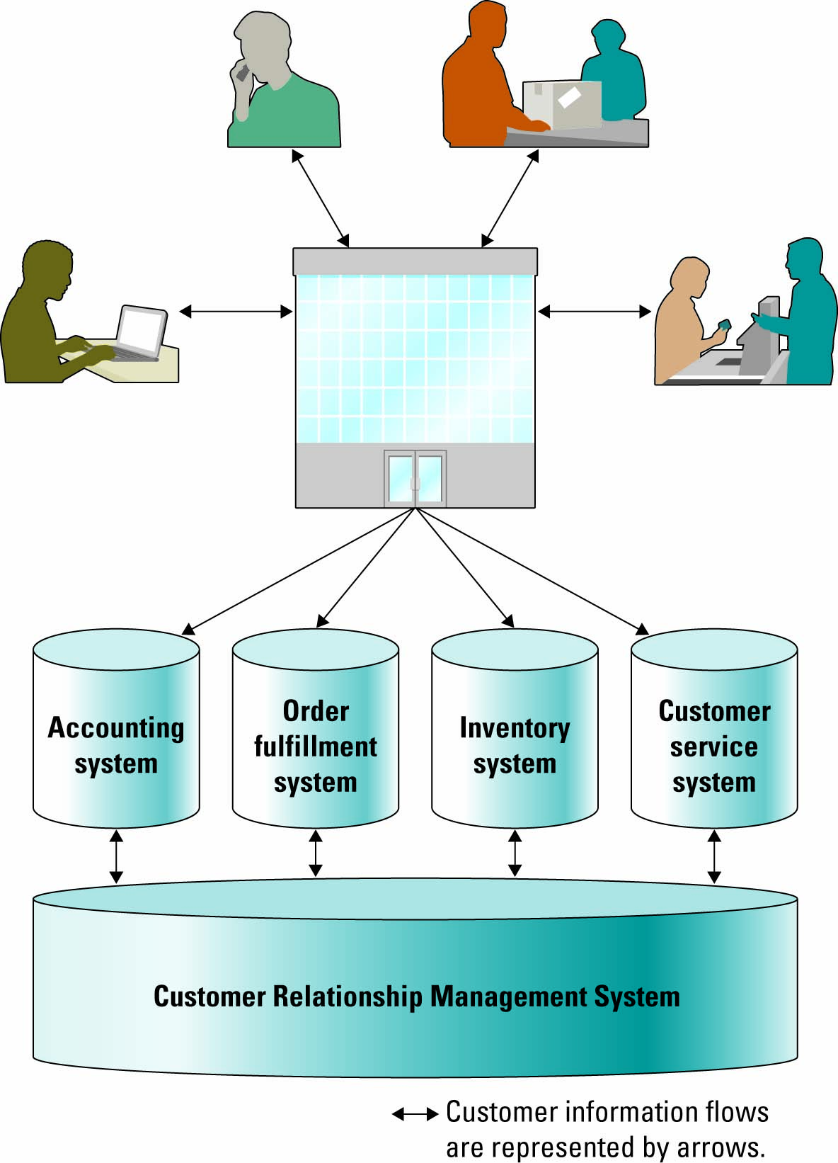
Fundamentals of CRM:
- CRM as a business strategy
- Business benefits of CRM
- The evolution of CRM
- The evolution of CRM
- Operational and analytical CRM
CRM as a Business Strategy
- Helps an organization identify customers and design specific marketing campaigns
- Increase customer spending
- Insight on consumers preferences & behaviours
Business Benefits of CRM
CRM enables an organization to:
  - Provide better customer service
  - Make call centres more efficient
  - Cross-sell products more effectively
  - Help sales staff close deals faster
  - Simplify marketing and sales processes
  - Discover new customers
  - Increase customer revenu
Organizations can find their most valuable customers through “RFM” - Recency, Frequency, and Monetary value
  - How recently a customer purchased items
  - How frequently a customer purchased items
  - The monetary value of each customer purchase
Evolution of CRM
Three phases in evolution:
1) Reporting (identification)-help organizations identify customers across other applications. What happened?
2) Analyzing (segmentation)- help organization segment customers into categories: best and worst customers. Why it happened?
3) Predicting (prediction)- help organizations make predictions regarding customers behaviour: risk of leaving. What will happen?
* Two primary components: Operational and analytical CRM assist in customer reporting
Operational CRM supports traditional transactional processing for day to day front office operations or systems that deal directly with customers
Analytical CRM supports back-office operations and strategic analysis (includes all systems that do not deal directly. Used by banks
Chapter 6 Page Summary

Using Info Systems to Drive Operational CRM
Marketing and Operational CRM
Three primary operational CRM systems Marketing can use to increase customer satisfaction:
- List Generators (sale- sales management/service- contact centre)—compile customer data from a variety of sources and segment the data for different marketing campaigns. (website visits, questionnaires, surveys, flyers, toll free #)
- Campaign Management Systems (sales-contact management/service- web based self service)—guide campaign planners through key tasks, can calculate campaign ROI and track results for future fine tuning. (planning, scheduling, segmentation and success metrics by having them enter forecasted attendance, costs)
- Cross-selling and Up-selling Strategies (sales-opportunity management/ service- call scripting)—identify customers that would have interest in (cross selling) additional, related products or (upselling) might respond to increasing the value of their purchase.
Sales and Operational CRM
First to use CRM systems were sales departments using Sales for automation (SFA) a system that automatically tracks al of the steps in sales process
-sales reps were struggling to maintain customers’ data
- companies were lacking vital data of customers since it was with the sales rep
3 primary operational CRM technologies sales department can implement to increase cus.satisfaction:
- Sales Management CRM system features include calendars to help plan customer meetings, alarm reminders signaling important tasks, customizable multimedia presentations and document generation. Metrics include the ability to analyze how each individual sales representative is performing through the sales cycle.
- Contact Management CRM system features include maintaining organizational charts, detailed customer notes, and supplemental sales information to allow the sales representative to personalize communication with customers and customize promotions and offerings.
- Opportunity Management CRM system determine potential customers and competitors and define selling efforts including budgets and schedules. Opportunity Management CRM systems and Contact Management CRM are similar but Opportunity Management CRM considers new customers and Contact Management CRM deals with established customers.

Chapter 6 Page Summary

Pointers for gaining prospective customers
1. Get their attention If you have a good prospect, chances are that he or she receives dozens of offers from similar companies. Be sure your first contact is professional and gets your customer’s attention.
2. Value their time When you ask for a meeting, you are asking for the most valuable thing a busy person has— time. Many companies have had great success by offering high-value gifts in exchange for a meeting with a representative. Just be careful because some organizations frown on expensive gifts. Instead, offer these prospective customers a report that can help them perform their jobs more effectively.
3. Overdeliver If your letter offered a free DVD in exchange for a meeting, bring a box of microwave popcorn along with the movie. Little gestures like these tell customers that you not only keep your word, but also can be counted on to overdeliver.
4. Contact frequently Find new and creative ways to contact your prospective customers frequently. Starting a newsletter and sending out a series of industry updates are excellent ways to keep in contact and provide value.
5. Generate a trustworthy mailing list If you are buying a mailing list from a third party be sure that the contacts are genuine prospects, especially if you are offering an expensive gift. Be sure that the people you are meeting have the power to authorize a sale.
6. Follow up One of the most powerful prospecting tools is a simple thank-you note. Letting people know that their time was appreciated may even lead to additional referrals.
Customer Service and Operational CRM
Three primary operational CRM systems to increase customer satisfaction
- Contact centre (call centre) – where CSRs answer customer inquiries and respond to problems through different touchpoints
- Web-based self-service system – allow customers to use the Web to find answers to their questions or solutions to their problems
    - Click-to-talk –customers click on a button and talk with a CSR via the Internet
- Call scripting system – access organizational databases that track similar issues or questions and automatically generate the details to the CSR who can then relay them to the customer

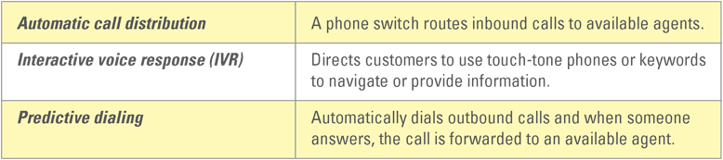
Common features included in contact centres

Chapter 6 Page Summary

Using Info System to Drive Analytical CRM
Analytical CRM—Digs deep into the company’s historical customer data to expose patterns of customer behaviour on which a company can capitalize.
-Information produced helps companies make decision about how to handle customers based on value.
-Reveal info on which customers are worth investing in
-Relies heavily on warehousing systems and business intelligence
Analytical CRM info Examples
1. Give customers more of what they want Analytical CRM can help an organization go beyond the typical “Dear Mr. Smith” salutation. An organization can use its analytical CRM information to make its communications more personable. For example, if it knows a customer’s shoe size and preferred brand it can notify the customer that there is a pair of size 12 shoes set aside to try on the next time the customer visits the store.
2. Find new customers similar to the best customers Analytical CRM might determine that an organization does a lot of business with women 35 to 45 years old who drive SUVs and live within 30 miles of a certain location. The company can then find a mailing list that highlights this type of customer for potential new sales.
3. Find out what the organization does best Analytical CRM can determine what an organization does better than its competitors. For example, if a restaurant caters more breakfasts to midsized companies than its competition does, it can purchase a specialized mailing list of midsized companies in the area and send them a mailing that features the breakfast catering specials.
4. Beat competitors to the punch Analytical CRM can determine sales trends allowing an organization to offer the best customers deals before the competition has a chance to. For example, a clothing store might determine its best customers for outdoor apparel and send them an offer to attend a private sale right before the competition runs its outdoor apparel sale.
5. Reactivate inactive customers Analytical CRM can highlight customers who have not done any business with the organization in a while. The organization can then send them a personalized letter along with a discount coupon. It will remind them of the company and may help spark a renewed relationship.
6. Let customers know they matter Analytical CRM can determine what customers want and need, so an organization can contact them with this information. Anything from a private sale to a reminder that the car is due for a tuneup is excellent customer service.

Personalization – when a Web site knows enough about a person’s likes and dislikes that it can fashion offers that are more likely to appeal to that person

Chapter 6 Page Summary

6.2 CRM Best Practices and Trends
Implementing CRM
CRM 5 industry best practices:
Clearly communicate the CRM strategy – ensuring that all departments and employees understand exactly what CRM means and how it will add value to the organization is critical to the success of the implementation
Define data needs and flows – the organization must understand all of the different ways that data flows into and out of the organization to implement a successful CRM system. If the organization misses one of the data flows, such as a customer service Web site, then none of that data from that Web site will be integrated into the CRM system and the company will not have a complete view of its customers
Build an integrated view of the customer – the CRM system must support the organization's strategies and goals
Implement in iterations – avoid the big-bang approach and implement in small, manageable, pieces
Scalability for organizational growth – ensure the system can support the organization's future growth

Building blocks (8) are meant to help organization see the big picture of CRM
  - Creating a CRM vision that provides a “big picture” of what the customer-centric organization should look like.
  - Defining and weaving a CRM strategy that aligns with broader marketing and sales strategies, and informs operational and production strategies.
  - Understanding and engaging the customer.
  - Ensuring organizational collaboration between internal groups and external business partners.
  - Focusing on improving customer processes.
  - Achieving data integrity across the enterprise
  - Leveraging information systems to implement CRM.
  - Defining, collecting, and analyzing CRM metrics.
CRM manager ensures that somebody in the company is held accountable for the continued successful rollout of CRM. Includes functional management, operational management, change management, and strategic partnership with key CRM stakeholders.
CRM Metrics
Analyze metrics on customers; experiences that span multiple customer interactions over different communication channel.

CRM Sales Metrics
- Number of prospective customers
- Number of new customers
- Number of retained customers
- Number of sales calls

CRM Customer Service Metrics
- Cases closed the same
- day
- Number of cases handled by an agent
- Number of service calls
- Average number of service requests by type

CRM Marketing Metrics
- Number of marketing campaigns
- New customer retention rates
- Number of responses by marketing campaign
- Revenue generated by marketing campaign

Supply Relationship Management (SRM) is not the same as SRM system. SRM is the management activity. Focuses on keeping suppliers satisfied by evaluating and categorizing suppliers for different projects.
SRM system can help an organization communicate with its suppliers by providing communication channels where data can be shared.
Good supplier relationships result into supply chain efficiency
Partner Relationship Management
Alliance Partners - competitor organizations who co-operate with one another to allow successful competition
Dealers – agents who sell products or services on behalf of a company/ organization (auto industry)
Retailers - stores or shops acquire goods form manufacturers and sell to consumers to profit
Resellers – companies/individuals who purchase goods in bulks with intention of reselling
Partners Relationship Management (PRM) – focuses on keeping vendors satisfied by managing alliance partner, dealer, retailer, and reseller relationship.
PRM system are IS applications that support the management activity of PRM
Employee Relationship Management (ERM) – management activity that focuses on managing an organization’s relationship with its employees
Future CRM Trends
  - CRM applications will continue to evolve and be used by a wide variety of partners
  - CRM will continue to be a major strategic focus for companies
  - CRM applications will continue to adapt wireless capabilities supporting mobile sales and mobile customers
  - CRM suites will incorporate SRM, PRM and ERM modules
Conclusion
- CRM involves managing all aspects of a customer’s interactions with an organization
- To increase customer loyalty and thus retention
- To increase profitability
- Enabling access to accurate, up-to-date information on the customer across the organization
Chapter 6 Page Summary

Chapter 6 Summary

Chapter 7 Database and Data Warehouses
  - Explain the defining value characteristics of both transactional data and analytical information, need for organizations to have data and info that are timely and of high quality
  - Describe relational database fundamentals and advantages
  - Explain how users interact with database management system, advantage of data-driven Web sites, primary methods of integrating data and information across multiple databases in organizations
  - Describe data warehouse fundamentals and advantages
  - Describe business intelligence, data mining, and explain the relationship between business intelligence and data warehousing
Netflix Case Study
- Fixed price for movies Cinematch defines clusters of movies, connects customer movie ranking to cluster and uses it to recommend movies.
- Cinematch considers Netflix’s inventory condition in its recommendation
- Database enables NetFlix to have its website adapt to personal taste of customers
7.1 Database
- Useful in telling organization how its current operations are performing and estimates & strategize how future operations might perform
- Data raw facts that describe characteristics of event. Characteristics of sales event may be date, item number, qty orders, cust. Name, shipping details
- Information data converted into meaningful and useful context. Info from sales events could be best-selling item, worst-selling, best customer, word customer
Organizational Data and Information
- Ford built Homologation Timing System (HTS), based on relational database
    - Help keep track and analyze standards
    - Reduce compliance risk
- Organizational data and info come at different levels, format, and granularities
    - Granularity; extent of details within the data and info (fine & detailed vs. Coarse & abstract), one end is coarse granularity (highly summarized data or info) another end is fine granularity (great amount of detail)
Levels, Formats, and Granularities of Organizational Data and Information
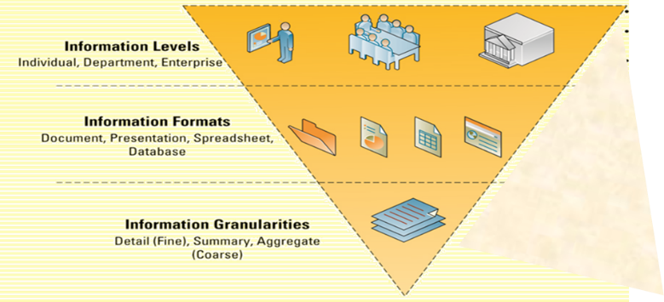

Value if Transactional Data and Analytical Information
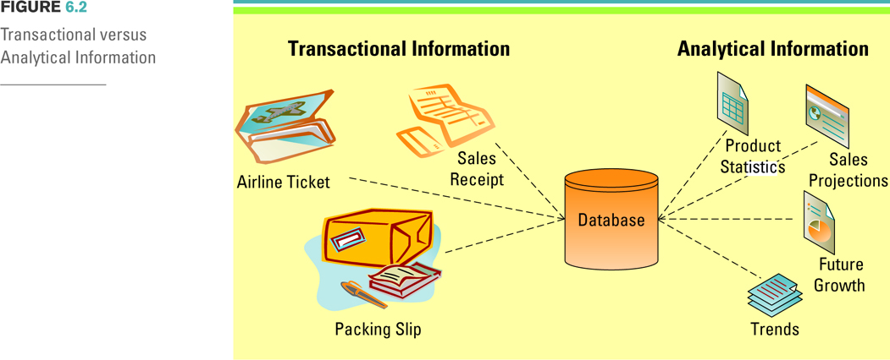
Transactional data encompasses all of the data contained within a single business process or unit of work; purpose to support performing daily operational tasks. Used when performing operational tasks and repetitive decisions such as analyzing daily sales figures, production schedule to determine amount of inventory to carry
Analytical information encompasses all organization information, purpose to support the of higher-analysis tasks. Analytical info is used when making important ad hoc decisions such as whether to build new man. Plant or hire additional sales personnel.

Value of Timely Data and Info
Timeliness is an aspect of data and information that depends on a situation.
Real time data – immediate, up to date data. Real time info – up to date immediate info
Real time system – provides real time transactional data and/or analytical info in response to query request
- Real time data and info helps make faster and more effective decisions, keep smaller inventories, operate more efficiently and track performance more carefully
Value of Quality Data and Information
Challenges include:
Tasks and timeliness were difficult to track
Looking for information was time-consuming
Reporting of SOX data visibility in the data was taking too long
Sharing information was challenging, especially with non-employees
Characteristics of High-Quality Data and Information
Accuracy- Are the values correct?
Completeness- Are any of the values missing?
Consistency- Does aggregate or summary information agree with detailed information?
Uniqueness- Is each transaction, entity, and event represented only once in the information
Timeliness- Is the information current with respect to business requirements?
The four primary sources of low-quality information include:
  - Online customers intentionally enter inaccurate information to protect their privacy
  - Data or information from different systems have different entry standards and formats
  - Call centre operators enter abbreviated or erroneous information by accident or to save time
  - Third party and external information contains inconsistencies, inaccuracies, and errors

Understanding Costs of Poor Data and Info
Bad Data or info can cause serious business ramification such as
- Inability to accurately track customers, affects strategic initiatives such as CRM and SCM
- Difficulty identifying organization’s most valuable customers
- Inability to identify selling opportunities and wasted revenue from marketing to non-existent customers and non-deliverable mail
- Difficult tracking revenue because of inaccurate invoices
- Inability to build strong relationships with customers, which increases their buyer power
Storing Transactional Data
CRM and SCM maintain transactional data stored in databases
Database management system (DBMS) computer program used to manage and query a database
- Properties and design of data bases are included in studies of info science, info system, and computer science
Schema description of type of raw facts held in database, describes objects represented and relationship among them
Most commonly used data model is Relational model
- represents all data in form of multiple related tables of rows and columns
- represents relationships using values common to more explicit representation of relationships
Relational Database Fundamentals
Database maintains data about various types of objects, events, people, and places
Hierarchical database model data are organized into tree-like structure that allows repeating data using parent/child relationships. Used in the first mainframe database management systems. Often cannot have be used to relate to structures that exist in real world.
Network database model flexible way of representing objects and their relationships; allows each record to have multiple parent and child records, forming lattice structure
Relational database model type of database that stores data in form of logically related 2-d tables. Text focuses on relational database model because it is most prevalent form of database structure used in business
Entities, Entity Classes, and Attributes
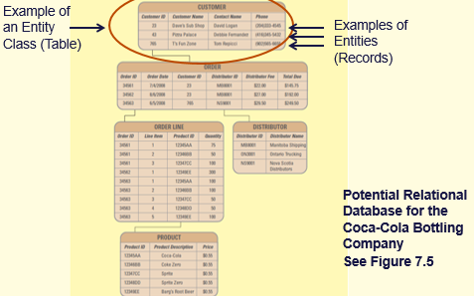
Entity is a category of a person, place, thing, transaction, event about which data are stored
Entity class (table) collection of similar entities (such as customer, order, online, product, distributer)
Attributes (field, column) characteristics or properties of an entity class (customer id, customer name, contact name, phone, product id, price)
* In a relational database each Table collects the data for an entity class. For example: One table is for Customers, another for Orders, another for Products.
*In each table (entity class) each row or Record, contains the data for each entity belonging to that class.

Keys and Relationship
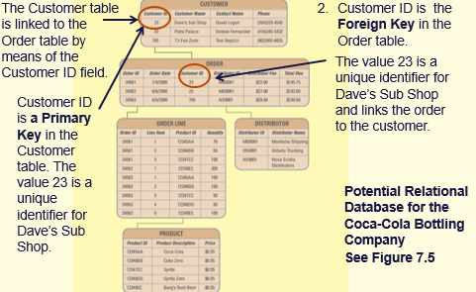
Primary key is a field (or groups of fields) that uniquely identifies given entity in a table such a customer id. Important because provide a way of distinguishing entity in a table.
Foreign key in a relational database mode is primary key of one table that appears as attribute in another and provide logical relationships between two tables. Distributor has distributor id for table which is a attribute under order table.
Relationships – The data from one table is linked to another when the computer finds a match between the values in a primary key to the values in the foreign key of another table.
Relational Database advantages from a business perspective include:
  - Increased flexibility.
  - Increased scalability and performance.
  - Reduced redundancy.
  - Increased integrity (quality).
  - Increased security.

Increased Flexibility: A well-designed database should:
  - Handle changes quickly and easily
  - Provide users with different views
  - Have only one physical view
    - Physical view – deals with the physical storage of information on a storage device
  - Have multiple logical views
    - Logical view – focuses on how users logically access information
Increased Scalability and Performance
A database must increase or decrease in size to meet increased demand, while maintaining acceptable performance levels.
  - Scalability – refers to how well a system can adapt its capacity to changing demands.
  - Performance – measures how quickly a system performs a certain process or transaction.
Reduced Data Redundancy
Data Redundancy – the duplication of information or storing the same information in multiple places, occurs when same data is in multiple location
Problems include:
Inconsistency of data describing the same thing.
Waste of space, waste of time to enter and update.
Difficulty securing data in many places.

Increased Integrity (Quality)
Data/ Information integrity – measures the quality of data/information.
Integrity constraint – rules that help ensure the quality of information; 2 types:
- Relational integrity constraint – rule that enforces basic and fundamental information-based constraints
Ex. A referential integrity constraint would not allow someone to create an order for a non-existent customer, provide mark-up percentage that was negative, or order zero pounds of raw materials from supplier
- Business-critical integrity constraint – rule that enforces business rules vital to an organization’s success and often requires more insight and knowledge than relational integrity constraints
Ex. Supplier might implement a business- critical integrity constraint stating no product returns are accepted after 15 days past delivery
Increased Security
Information is an organizational asset and must be protected. Databases offer several security features including:

Password – provides authentication of the user
Access level – determines who has access to the different types of information
Access control – determines types of user access, such as read-only access

Database Management Systems
Database management systems (DBMS) – software through which users and application programs interact with a database
Two primary ways that users can interact with DBMS
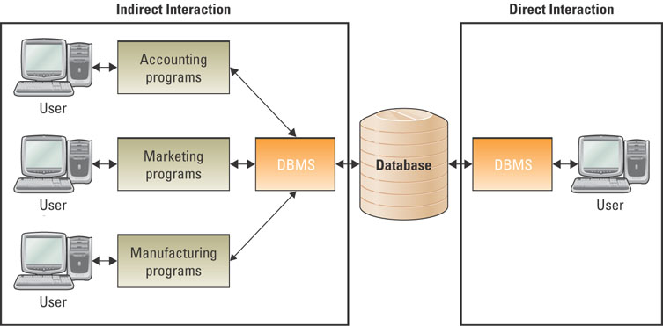
- Direct interaction –
  - The user interacts directly with the DBMS
  - The DBMS obtains the information from the database
- Indirect interaction
  - User interacts with an application (i.e., payroll application, manufacturing application, sales application)
  - The application interacts with the DBMS
  - The DBMS obtains the information from the database
Data Driven Web Sites
An interactive Web site which uses a database to keep it updated and relevant to the needs of its customers. Ex: Google
Data driven Website Advantages:
- Development: Changes can be made anytime without reliance on developers or HTML expertise.
- Content Management: No web programmer required and, therefore, reduced cost and administration.
- Future Expandability: Able to grow faster as it is already adaptable
- Human Error Minimized: Data-driven web site has “error trapping” mechanisms to ensure required information is correctly filled out by visitor and displayed in the correct format.
- Reduced Production and Update Costs: Reduced requirement for expertise reduces labour and training cost. Changes and updates take a fraction of the time than for a static site further reducing production costs.
- Increased Efficiency: Because the sites are computer driven, the automation manages huge volumes of information cheaply and effectively.
- Improved Stability: Data and designs reside in the database and not in a person whose talent and creativity may leave the organization at any time.
Data Integration
Integration – allows separate systems to communicate directly with each other.
Without integration organizations will 1) spend time entering same data into multiple system 2) suffer from low quality and inconsistency in redundant data
Two integration method:
  - Forward integration – takes information entered into a given system and sends it automatically to all downstream systems and processes.
  - Backward integration – takes information entered into a given system and sends it automatically to all upstream systems and processes.
What would happen if users could enter order data directly into the billing system?
  - The systems would quickly become out-of-sync. There might be bills for nonexistent orders, or orders that do not have any bills (if someone deleted a bill)
  - For this reason organizations typically place a business-critical integrity constraint on integrated systems: With a forward integration the information must be entered in the sales system; you could not enter information directly into the billing system
- Integrations are expensive to build and maintain; are difficult to implement
- For these reasons many organizations only build forward integrations and use business-critical integrity constraints to ensure all information is always entered only at the start of the integration (one source of record)
- Why would an organization want to build both forward and backward integrations?
  - This allows users to enter information at any point in the business process and the information is automatically sent upstream and downstream to all other systems
  - For example, if order fulfillment determined that they could not fulfill an order (the product had been discontinued), they could simply enter this information into the database and it would be sent automatically upstream to the sales representative who could contact the customer and downstream to billing to remove the item from the bill
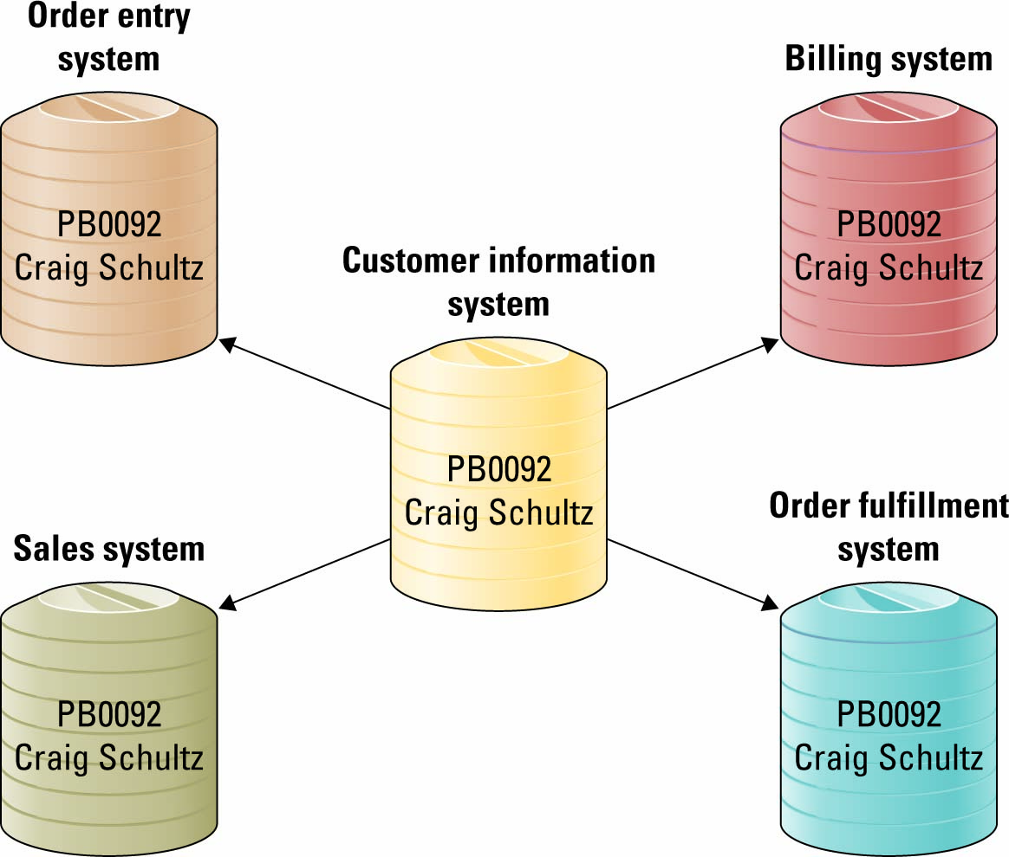
Forward and Backward Customer Data Integration Integrated Customer Data
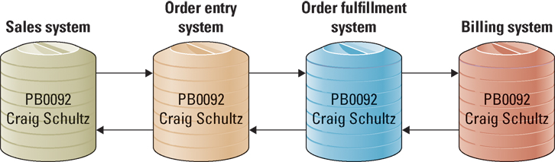
Users can create, read, update, and delete only in the main customer repository, and it is automatically sent to all of the other databases. Other systems have “read-only” access to data.

Section 7.2 Data Warehousing
History of Data Warehousing
- Data warehouses extend the transformation of data into information.
- Organizations need more timely info, OS were too focused on providing info efficiently and quickly
- In the 1990’s executives became less concerned with the day-to-day business operations and more concerned with overall business functions.
- The data warehouse provided the ability to support decision making without disrupting the day-to-day operations.

Data Warehouse Fundamentals
- Data warehouse – a logical collection of information – gathered from many different operational databases – that supports business analysis activities and decision-making tasks. “Subject-oriented, integrated, time variant, non volatile collection of info used to support organizational decision making”
- The primary purpose of a data warehouse is to aggregate information throughout an organization into a single repository for decision-making purposes.
***What is the primary difference between a database and data warehouse?
The primary difference between a database and a data warehouse is that a database stores information for a single application, whereas a data warehouse stores information from multiple databases, or multiple applications, and external information such as industry information
This enables cross-functional analysis, industry analysis, market analysis, etc., all from a single repository
Data warehouses support only analytical processing (OLAP)
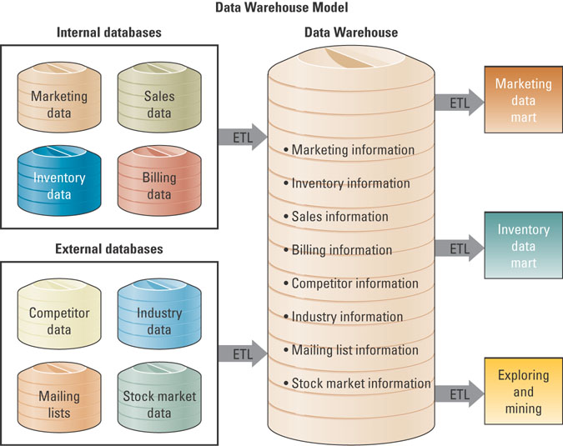
Extraction, transformation, and loading (ETL) – a process that extracts information from internal and external databases, transforms the information using a common set of enterprise definitions, and loads the information into a data warehouse.
- The ETL process gathers data from the internal and external databases and passes it to the data warehouse.
- The ETL process also gathers data from the data warehouse and passes it to the data marts.

Data mart – contains a subset of data warehouse information extracted to be analyzed for specific units or objectives.
**Difference between a data warehouse and a data mart?
  - A data warehouse has an enterprise-wide organizational focus, while a data mart focuses on a subset of information for a given business unit such as finance.

Multi-dimensional Analysis
- Relational Databases contain information in a series of two-dimensional tables.
- In a data warehouse and data mart, information is multi-dimensional. it contains layers of columns and rows
  - Dimension – a particular characteristic of the information; an attribute.
- Cube—common term for the representation of multi-dimensional information.

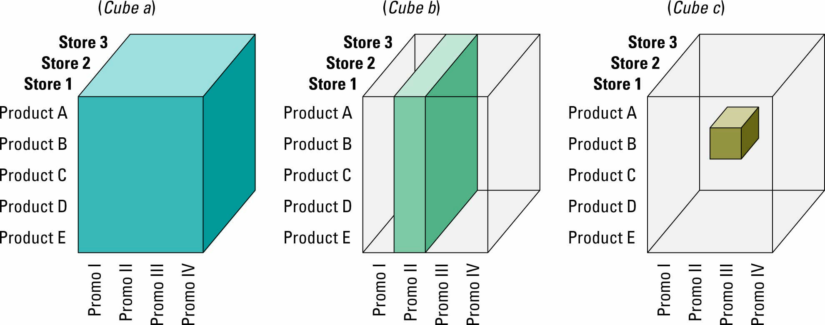
- Users can slice and dice the cube to drill down into the information.
- Cube A represents store information (the layers), product information (the rows), and promotion information (the columns).
- Cube B represents a slice of information displaying promotion II for all products at all stores
- Cube C represents a slice of information displaying promotion III for product B at store 2.

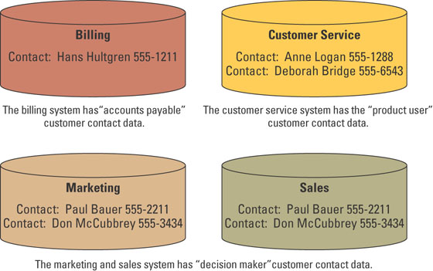
Information Cleansing or Scrubbing
- An organization must maintain high-quality data in the data warehouse.
- Information cleansing or scrubbing – a process that weeds out and fixes or discards inconsistent, incorrect, or incomplete information.
- Software tools use sophisticated algorithms to parse, standardize, correct, match and consolidate warehouse information.
Customer Contact Data in OS

Business Intelligence
BI- applications and technologies used to gather, provide access to, and analyze information to support decision-making.

The challenge is to make decisions in an environment that is data rich and information poor.
- It can also cause problems as it exceeds available storage space.
- The industry of delivering rich information from rich data is already estimated to be more than US$100 billion in 2010 and growing at 10% per year.
- Microsoft, IBM and SAP have spend more than US$15 billion buying firms that specialize in data management.

The Solution: Business Intelligence
- Businesses make hundreds of decisions a day based on facts but also on experience, accumulated knowledge and rules of thumb that take years to develop.
- Improving business decisions has a direct, positive effect on the bottom line.
- BI systems can assist in better decisions, a more agile, intelligent enterprise.
BI can help with better decisions including:
- Retail and Sales: Predicting sales, determining correct inventory levels
- Banking: Forecasting levels of bad loans and fraudulent credit card use.
- Operations management: Predicting machinery failure, optimizing manufacturing capacity.
- Brokerage and Securities: Predicting bond price changes, forecasting stock fluctuations, determining when to buy and sell securities
- Insurance: Forecasting claims amounts and medical coverage; classifying key factors affecting coverage
- Law enforcement: Tracking crime patterns, locations and criminal behaviours
- Government and defence, airlines, healthcare, broadcasting, marketing
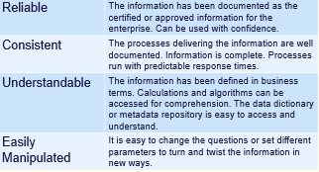
Characteristics of BI Systems

Finding the answers to tough business questions by using data that is reliable, consistent, understandable, and easily manipulated allows a business to gain valuable insight into such things as:
- Where the business has been. Historical perspective is always important in determining trends and patterns of behavior.
- Where it is now. Current situations are critical to either modify if not acceptable or encourage if they are trending in the right direction.
- And where it will be in the near future. Being able to predict with surety the direction of the company is critical to sound planning and to creating sound business strategies.

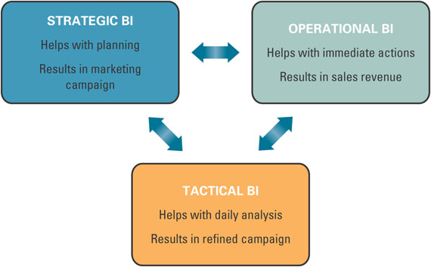
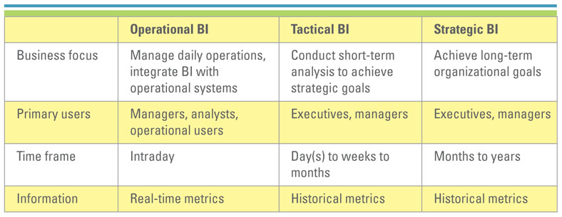Three Forms of BI Must Work Toward a Common Goal
- Strategic BI is used in the planning stages that are implemented with the help of Operational BI and refined with Tactical BI.
BI’s Operational Value
Latency Between a Business Event and an Action Taken
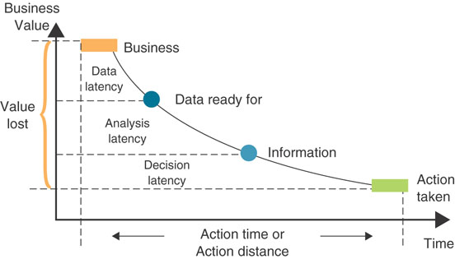
Walk students through the diagram which illustrates response time and business value.
The longer or farther it takes to implement a decision, the less business value there is as a result.
The horizontal axis is time or distance. The vertical axis is business value. The curve shows diminishing returns across the time/distance horizon.
The curve is segmented by the stages of getting the business, acquiring the data, transforming into information and finally taking action.
With Strategic, Operational and Tactical BI the lags diminish and business value is added.
Data latency is the time needed to make transactional data ready for analysis.
Analysis latency is the time from which data is made available and analysis of it is completed.
Decision latency is the time it takes a human to comprehend the analysis and take appropriate action.

Data Mining
Data mining – the process of analyzing data to extract information not offered by the raw data alone.
- Data mining can begin at a summary information level (coarse granularity) and progress through increasing levels of detail (drilling down), or the reverse (drilling up)
- Data-mining tools include query tools, reporting tools, multidimensional analysis tools, statistical tools, and intelligent agents

  - Drilling Down –increasing levels of detail.
  - Drilling Up—increasing summarization.
  - Data-mining tool – uses a variety of techniques to find patterns and relationships in large volumes of information and infers rules that predict future behaviour and guide decision making

Data Mining techniques/ analysis:
- Cluster analysis – A statistical technique used to divide an information set into mutually exclusive groups such that the members of each group are as close together as possible to one another and the different groups are as far apart as possible.
Some examples of cluster analysis include:
  - Consumer goods by content, brand loyalty or similarity
  - Product market typology for tailoring sales strategies
  - Retail store layouts and sales performances

  - Association detection – Reveals the relationship between variables along with the nature and frequency of the relationships
Market basket analysis analyzes such items as Web sites and checkout scanner information to detect customers’ buying behavior and predict future behavior by identifying affinities among customers’ choices of products and services
*Maytag uses association detection to ensure that each generation of appliances is better than the previous generation

- Statistical analysis – Performs such functions as information correlations, distributions, calculations, and variance analysis
Forecast – Predictions made on the basis of time-series information
Time-series information – Time-stamped information collected at a particular frequency
*Kraft uses statistical analysis to assure consistent flavor, color, aroma, texture, and appearance for all of its lines of foods

Business Benefits of BI
- Single Point of Access for all Users.
All authorized users can access the central depository of data and analysis to create reports relevant to their needs. BI provides an easy-to-understand, non-technical, graphical user interface.
- BI across Organizational Departments.
Can be used at every step in the value chain.
- Up-to-the-Minute Information for Everyone
Real time updates and scenario generation. Master Card Worldwide monitors day-to-day operations. It uses dynamically generated analysis to limit credit card fraud.
- Categories of BI benefits:
    - Direct quantifiable benefits. Benefits to which actual metrics such as amount of dollars saved, amount of response time reduced.
    - Indirect quantifiable benefits. A benefit such as improved response time that may be due to other factors that BI but initial impetus may have been because of a business intelligence consciousness or a benefit that is due to other factors as well as BI.
    - Unpredictable benefits. Pleasant surprises such as analysis revealing a new target market or a new use for an old product.
    - Intangible benefits. A general expectation that the change will positively impact the bottom line but cannot be immediately measured. Examples would include improved customer satisfaction and improved product quality ratings.
- Data Visualization (Information Aesthetics)
To be useful, data must be understandable. With data and information, as with other things, a picture may be worth a thousand words. Venn diagram and maps

CLOSING CASE ONE
WestJet Accepts Blame About Spying On Air Canada
Was WestJet’s access to Air Canada’s Web site information ethical? Legal? Explain
While WestJet’s access to Air Canada’s web site was clearly unethical, whether or not it was legal is not clear. The legality of the case would hinge on the confidentiality agreement that the employee signed, and what effect ending the employment contract would have. Students can create an argument about the legality of the situation based on their understanding of the legal practices of contracts.
To what extent do you think unauthorized access to private competitor information is commonplace in organizations?
Students may argue about how commonplace this practice is. It may be appropriate to discuss other issues such as hacking in this context.
Does Air Canada have any responsibility in WestJet’s ability to access Air Canada’s private information? Explain.
Reasonably, Air Canada should accept some responsibility in WestJet’s ability to use its resources, and students should be able to explain why Air Canada should have cheques in place to avoid these kinds of security leaks.
What people-measures could Air Canada implement to prevent further unauthorized access to private information?
People measures that could be implemented include terminating ex-employee’s access, and enforcing password changes. Students can discuss other kinds of policies and procedures which may be used to avoid problems such as these.
What technology-measures could Air Canada implement to prevent further unauthorized access to private information?
IT can be used for such things as monitoring access and enforcing password changes. Students can discuss other kinds of IT and policy changes which would avoid problems such as these.

OPENING CASE QUESTIONS
Embracing Privacy at the City of Hamilton
- Why is protecting information privacy in the best interests of both Hamiltonians and the City of Hamilton?
Protecting information privacy is in the best interest of Hamiltonians because it is their personal information which is at risk. Protecting information privacy is in the best interest of the City because as a municipal government, the City of Hamilton is subject to the Municipal Freedom of Information and Protection of Privacy Act (MFIPPA), and therefore has statutory obligations to safeguard personal information collected.
- What steps did the City of Hamilton take to address privacy concerns in the McMaster University research project?
Several steps were taken to address privacy concerns. First the staff removed the problem functionality, that is, it stopped access to the personal information. Then staff from the municipal Freedom of Information Office and the City’s Information Technology Services division worked with the Office of the Privacy Commissioner of Canada to make public the breach and to redesign and reinstate functionality with safeguards to prevent unauthorized access.
- What policies could the City of Hamilton implement internally to protect citizen information privacy?
Answers to this question will vary, but should be based on the guidelines provided. Students should also demonstrate their awareness of the legal requirements for Canada.
- What lessons can be learned from the opening case study that will help other organizations better protect the personal information they collect?
One of the lessons that the City of Hamilton learned was that technology is just a tool. When humans behaviour can subvert the process, all efforts must be taken to educate and make people aware of the risks associated with privacy threats and potential breaches.
- How does the recent trend of city governments allowing free public-access to municipal data raise awareness of the need for governments to embrace privacy planning as part of normal, everyday business practice?
There is a need to protect citizen’s private data while still allowing access to municipal data and abide privacy legislation and citizen’s expectations that their private data is protected. All of these factors are leading to the need for governments to embrace privacy planning.
- In the City of Hamilton example, how can the City’s embracement of privacy mitigate future information security problems?
The first line of defence in information security is people. Ensuring all people using or having access to organizational information are aware of the importance of privacy will help protect the company’s information.

- What is the biggest information security roadblock facing organizations, like the City of Hamilton, attempting to achieve compliance with privacy legislation?
The biggest information security roadblock facing organizations is the people who interact with the system. Although procedures and policies may be developed, and IT created which supports those procedures and policies, if people are not aware of what their responsibilities are, and the importance of being vigilant, efforts by the company to remain compliant with the existing legislation will not be successful.

- Can technology alone at the City of Hamilton guarantee information is kept secure? Why or why not?
No, technology alone cannot guarantee information is kept secure. The people involved with developing, implementing and using the information systems must be vigilant at all times, as conditions change and the safeguards developed today may not be effective in the future.

- Privacy and security breaches, like the City of Hamilton’s dog-license incident, are unfortunately a common occurrence in organizations today. What recent privacy and security breaches have been in the media lately? Do you think things will get worse before getting better? How can organizations better prepare themselves against future privacy and security breaches?
Students may or may not be aware of recent security breaches. This question may be answered in the form of a debate, where both side of the argument are presented.

