Topic 1: Skeletal System Part I- Bone Structure
Osteoporosis: This is defined as the loss of bone density and it affects about 1/5 in women, about 1/25 in men. It leads to increase risk of fractures and is believed to be related in a decrease in estrogen due to menopause which is ovarian function decreases, causing a decrease in estrogen. Hormone replacement is known to decrease the risk in fractures. Calcium is very important for structure and vesicle release. Estrogen is linked to reabsorption of calcium, which in turn is important for bones.
Bones are continually being broken down by a process called bone resorption, and constantly being built through bone formation. In this disease, there is an imbalance in these two processes where bone resorption is greater than bone formation.
Here you see a collaboration of the endocrine and skeletal system
Vitamin D in the liver, gets turned into Calcidiol which hits the kidneys and turns into calcitriol which works as a circulating hormone, actively promoting bone health and leads to the absorption through the gut of Ca⁺⁺ and Po⁻₄ through the digestive system. Vitamine D is absorbed by the skin i.e Produced in skin through UV light and you can therefore see the relationship between endocrine and integumentary system as well.

Second risk factor is the aging processes and it is all about the sedentary lifestyle of the elderly and this is linked to the muscular system. When muscles contract, they stress the bone and this makes the bone become stronger and thicker and activity promotes bone formation. Muscular system is also very important for the development and maintenance of the skeletal system
Rickett’s: Softening of the bones which cause femur to bend due to deficiency of vitamin D from children not being exposed to UV i.e insufficient amount of Vit D.
Endocrine—thyroid, estrogen
Integumentary—rickett’s, calcitrial (derivative of vitamin D through UV light)
Muscular—DMD, load and weight bearing (muscle is attatched to bones)
Digestive—Ca⁺⁺, PO⁻₄
Any injury in any of these systems and you have a problem.
Functions of the skeletal system
- Support: Need something where the bone can attach to
- Protection: Protects vital organs e.g rib cage, skull
- Movement: Bones constantly working with muscles to provide movement
- Mineral storage
  - Comes back to calcium in the body (need it in order for muscle contraction and for vesicles for neurons). 98% of calcium is stored in the bones (always a flux) and it is in response to whatever is happening in your body. Amount of calcium that is absorbed and reabsorbed is tightly regulated. Body is trying to absorb or release calcium, depending on body needs.
- Blood
  - All of formed elements (cells) are formed in bones and production of blood cells occur in the bones
  - Starts with HSC with reside in the bones
    - Differentiate into
      - lymphoid stem cell, which go on and form T+B lymphocytes
      - Myeliod stem cell, which go on and form RBC or WBC (monocytes and neutrophils)
  - Two different types of bone marrow and this is where the bones are formed
    - Red bone marrow: Soft fibrous tissue which sits in bones, containing of blood cells of all different developments. P.S At the beginning of development, all blood is red
    - Yellow bone marrows: Adipocytes, storing fat. When you are born, all of your marrow is yellow and as development progresses, red bone marrow converts into yellow. This is important cos in cases of extreme blood loss the yellow can convert to red and start to produce blood.
A tissue is a combination of cells, which particular functions and structures. Tissues are either muscular (smooth, cardiac or skeletal), neural (nervous tissue), epithelial, or connective. An organ is two or more tissue types.
Skeletal system is made up of connective tissues (bones ligaments, cartilages and joints).
Epithelial, muscular and nervous tissues are very regular, with the same morphology and arrangement is all the same. Connective tissues however do not have the same regular arrangement; they have a morphology that is called mesenchymal (irregular).
Connective Tissues
All share three basic components
  - Specialized cells
    - Greater variety of specialized cells, some of which are fixed in place
    - Some are wandering or mobile
  - Extracellular protein fibers
    - Multiple types of these fibers (collagen, elastin, fibrilin) and it is the combination of these fibers determine the tissue.
  - Fluid (ground substance):Mostly liquid, but still very thick and gives it a gel like appearance. Extracellular fibers and fluid make up extracellular matrix that surrounds cells i.e Connective tissues are surrounded by the matrix (fluid and all the fibers).
2 and 3 make up the extracellular matrix and works to protect and support connective tissues and movement of solutes.
They have fewer cells and more extracellular material compared to other types of tissue and they occur less in the body.
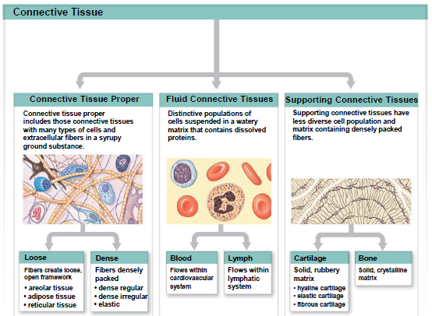
Types of Connective tissue
- Connective tissue proper
  - Loose tissue: fibers make more of a mesh work
    - Areolar tissue: contains every single cell and fiber type and also glycoproteins you’ll find in tissue. It is also used as packing material of the body i.e it fills sup space.
Static cells found in Areolar tissue
Contains every single cell, fiber and protein types, including: Melanocytes (carry pigment), Macrophages (for immune functioning), Mast cells (responsible for inflammatory response), Fibroblasts (responsible for generating the fibers), Adipocytes (lots of fat storage) and adipocytes are packed with triglycerades (fat) and so functions in energy storage.
Mobile cells (that come from the blood back to the tissue) found in areolar tissue: the common thing in their function is immunity. These are the Lymphocytes, Macrophages, Neutrophils and Plasma cells
Areolar also contains MSC cells and you can find it in every single organ you have and they participate in organ repair.
Types of fibers found in Areolar : a) Reticular Fiber-- made from collagen III fibers
Collagen fibers made from collagen I fibers and elastic fiber made from elastin and fibrillin.
Areolar tissue is also has group substance
    - Adipose: very similar to areolar tissue except that it is jampacked with adipocytes as compared to the amount found in areolar tissue and it has very few of the other cells.
    - Reticular: called this cos it made up of reticular fibers and forms a huge mesh work. It is found ONLY in the liver, kidney, spleen and in the bones cos bone marrow is a reticular tissue. It is also that it has the most unique combination of cells and depending on where you look, it will only have certain cells that you don’t find anywhere else e.g Reticular tissue in the bone contain hematopoietic cells and this is not found anywhere else.
  - Dense tissue
    - Dense regular: Full of fibroblasts, type 1 and 2 collagen fibers that have parallel arrangements of fibers and this reflects the direction of force exertion
    - Dense irregular: the fibers from an interwoven meshwork in “no consistent” pattern and this can be seen in dermis and can withstand a lot of force
    - Elastic: Full of elastin and little collagen and so it is springy and tough.
- Fluid connective tissue
  - Blood
  - Lymph
- Supporting connective tissue
  - Cartilage
  - Bone
Langer’s Lines
Punctured corps with spikes
The shape that it made would split into one particular direction
Went along the whole body to examine the direction of the muscle patterns
When you go along a Langer line, the scar is more pronounced
matrix has a gel like quality cos it is packed with proteoglycans.

In connective tissue proper, matrix is not syrup-ey, it has a gel like quality and this is cos it is packed full of proteoglycans. Proteoglycans is made from the coming together of polysaccharides and protein and the polysaccharide in this case is called chondroitin sulfate. This gets attached to proteins to form proteoglycans in cartilage and this makes the ground substance solid and gel like and this is what hold everything together.

Within the matrix of cartilage, you find only one type of cell called chondrocytes.
51:10.

Cartilage
Cartilage
What differentiates cartilage is the combination of fibers and proteoglycans
- When bones originally form, they form from cartilage
- tightly packed gel forming matrix
- chondroitin sulfate is an unbranched polysaccharide—packs in really tightly together to stick to proteins and create that matrix
- cell--chondrocytes
- Matrix is firm gel containing polysaccharide derivatives (chondroitin sulfates [chondros, cartilage])
  - Forms complexes with proteins producing proteoglycans (enormous unbranched polysaccharides)
- Cells (chondrocytes)
  - Only cells in cartilage matrix
  - Occupy small chambers (lacunae [lacus,lake])
- No blood supply, therefore it is fed by diffusion
- Hyaline Cartilage
  - Found anywhere in the body that experiences movement
- Elastic Cartilage
  - Greater percentages of collagen fibers
  - Devoid of blood supply
  - Very bendable and responsive
  - Found in the ear
- Fibrous Cartilage
  - Seen in intervertebral discs and puberous synthesis
  - Allows for some degree of compression but it is generally tough
  - Forms quicker but it is very tough, with not that much elasticity—when damaged, it will become very tough
  - Strongest out of the cartilages
- When you are developing, all of cartilage has an extra layer called perichondrium
  - Contains vesicles which supply nutrients
  - Surrounds cartilage
  - Series of dense, irregular tissue on the outside (relatively rough—therefore cannot provide sliding motion), and an inner cellular layer on the inside with cartilage precursor cells
  - In any cartilage where you get repair
  - Limited blood supply
  - During development , you begin with essentially a cartilage bone skeleton which gradually increases in size to eventually be overtaken by bones
- Fibro cartilage is the cartilage which is formed when there is a tare in the cartilage

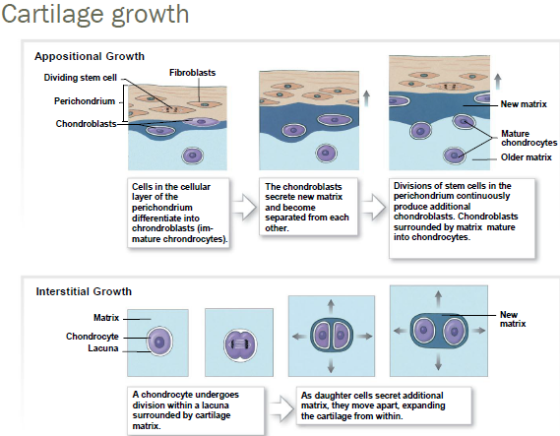
Appositional Growth
- stem cells divide, creating chondroblasts (immature chondrocytes) which start secreting matrix, gradually laying down matrix more and more
- stem cells continue to divide and the chondroblasts will start to differentiate to eventually become fully mature chondroblasts
- growth from the outside
Interstitial Growth
- mature chondrocyte sitting in a lacuna will be triggered to divide
- growth from the middle out
- as an adult there is no interstitial growth
Bone
Osseous Tissue
- (os, bone) structure
- Body matrix
  - Small volume of ground substance
  - 2/3 matrix is calcium salts (provide strength)
    - Mostly calcium phosphate
    - Some calcium carbonate
  - Many collagen fibers (provide flexibility)
    - Can, therefore, withstand a great amount of force while providing that flexibility
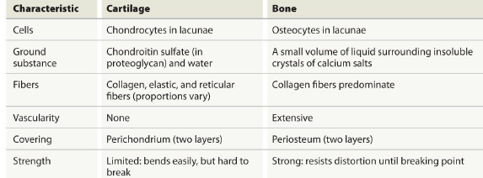
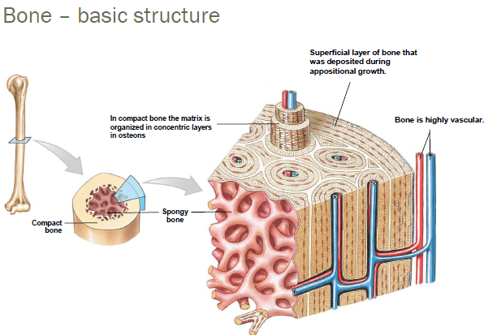
- Medullary cavity
  - hollowness in the bone
  - the inside is lined by spongy bone
- Spongy Bone
  - also called cancellous bone or trabecular bone
  - meshwork is call a trabecular network
- Cortical
  - compact bone A+K+A
- Matrix is arranged in concentric circles because the osteocyte cells are arranged in these circles, which are all arranged in the central canal (which is highly vascular, containing vesticles etc)
- Superficial layer is deposited during appositional growth
  - With bones, the only growth is appositional
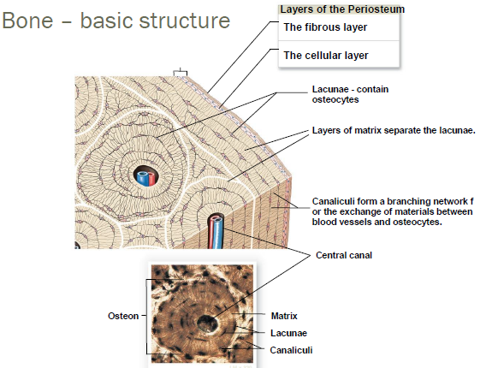
- Osteon
  - The functional unit of the bone (compact/cortical)
- The lacunas are connected by small canals called canalicuili, allowing for diffusion (of waste, oxygen, etc) to travel through the passageways
- Perisosteum
  - A two layered structure which sits on the outside of the bone
  - Similar to the pericardium
  - Fibrous irregular, dense tissue
  - Fibers from this layer penetrate into the inner cellular matrix
    - These fibers are called Sharpey’s Fibers
    - Forever stuck to the bone, and if they were to be removed, it would cause a tremendous amount of pain due to the fact that it is highly vascularized
  - Cellular layer is responsible for the remodeling of the bone
The bones of the skeletal system
Skeletal system components
- Bones (206 total)
  - Divisions:
Axial Skeleton (80 bones)
    - Bones of skull, thorax and vertebral column
    - Form longitudinal axis of body
Appendicular Skeleton (126 bones)
    - Bones of the limbs and girdles that attach them to the axial skeleton
- Cartilages
- Ligaments and other connective tissue
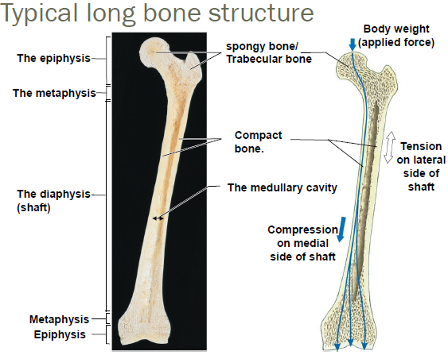
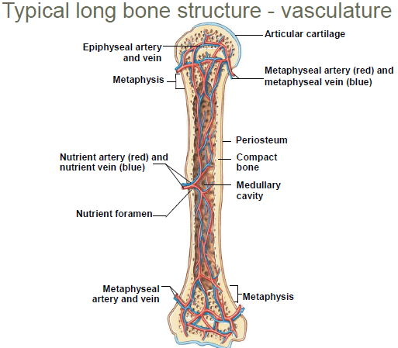
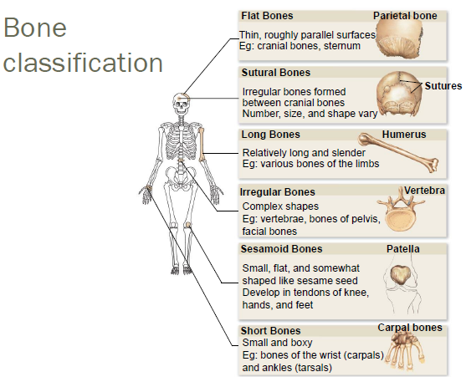
Sutural and sesamoid bones vary within everyone—some have a few, some have none
Sesamoid bones may form in unusual places
During development, there are many sesamoid bones and they either develop or don’t
Medullary cavity is full of yellow marrow (energy store of fat)
***Any space that contains marrow is a medullary cavity, although there are many long bones that do not produce marrow
In flat bone which is full of marrow, there is no defined medullary cavity
Long bones can take so much force because they contain spongy bone at the end of each tip
Nutrient foramen: vesicles move in and out
Arteries come in a branch immediately
All regions of the bone are fed by this supply, and that is why there is so much bleeding when there is damage to the bone

