PSYC 2800 Final Exam Mock Questions
- Describe the key work environment factors associated with the ‘vigilance decrement’.
Vigilance is sustained attention to low stimulus changing environments. So vigilance decrement is weakening in the ability to remain vigilant for critical signals with time, as indicated by a decline in the rate of the correct detection of signals. There are certain characteristics of the environment that lead to the loss of performance in detecting signals or events of relevance:
- Time – longer duration of vigilance, increases chance of misses
- Event salience – subtle events increase chances of error e.g., typesetting error
- Signal rate – when signal events occur at low rates, likelihood of detection will be reduced
- Arousal level – problems occur when there is little intrinsic task-related activity
- What are the three things one should remember when designing warning labels?
When designing a label, one should remember:
- Use descriptive word that conveys the seriousness of the hazard
- Describe the nature of the hazard
- Describe the consequences of the hazard
- Describe the action that is needed so that the hazard can be avoided
- “Human Factors expertise involves learning scientific research skills that provide a means of acquiring knowledge that can be applied to practical problems.” Describe the research skills referred to in this quote.
- List the characteristics of the social environment associated with workplace accidents and provide examples.
- “Corporate” climate
- Training availability and style
- Workplace social norms
- List properties of equipment and tools associated with workplace accidents and provide examples
- Working with equipment with high vibrations –
  - Example, jackhammer can cause internal bleeding or crack ribs if mishandle it.
- Working from heights
  - Example ladder, if leaning while working on ladder (ladder not properly placed) can cause a fall.
- Working with a leaky piece of equipment
  - Example if equipment is leaking oil, it can cause a trip slip or fall.
- Working in a vehicle with many blind spots
  - Example a work truck you can’t see far behind so when reversing without doing a circle check can cause someone or something to be run over.
- Working with hot tools
  - Example, a welder misused can cause burns or fires
- List personnel factors associated with workplace accidents.
- Age
- Gender
- Job experience
- Personality
- Stress, fatigue, drugs and alcohol
- What is a factorial experiment? Compare and contrast the advantages and disadvantages of using between---subjects variables, within---subjects variables and designs that use both (i.e., “mixed”).
A factorial design evaluates more than 1 independent variable (factor) in one single experiment. “Factorial” indicates that all possible combinations of the independent variable levels are combined and evaluated. This allows us to assess the effect of each independent variable by itself and how they interact with each other. A factorial design has 3 advantages:
- You can vary more features in an experiment (its efficient)
- It captures a greater part of the complexity found in the real world
- They allow you to see if there’s an interaction between the variables.
Between Subjects Design
- The different levels of the independent variable are assessed using separate groups of subject.
- Each combination of independent variables is administered to a different group of subjects
- Between subjects is used when having subjects perform more than one condition would be problematic, for example:
- Between-subjects design also eliminates any confounds that would be related to the order effects.

Within-Subjects Design
- The same subjects participate in all the experimental conditions
- It compares the performance of each person with him/herself across all the different conditions.
- Within-subjects design is more sensitive and easier to find statistically significant differences between conditions.
- It is also advantageous when your number of participants is limited

Mixed
- Both types are used in the same experiment (between and within)

- Define the terms “statistical significance” and “practical significance” and provide some real---world examples of where the two correspond and where 1 they do NOT correspond.
- Statistically significant means that p<0.05 and the difference between the groups was not because of chance.
- But, 2 groups can be statistically different without the difference being large. Ex. If one mean is 80 and one is 83. If there were a lot of participants and a powerful design, there may still be statistical significance.
- You also have to look at it in terms of practical significance. Is it worth it to change something if the means are only 3 different?
- Researchers tend to base decisions more on statistical significance than practical.
- An example of how the two correspond would be if you did a study and found that putting a streetlight at the corner of two streets would decrease the amount of accidents by 25%. Making that change would be both statistically and practically significant.
- An example in which the two do not correspond would be if there were two different textbooks for a class and the average while using one was a 75% and the average while using the other was 77%. There is a statistically significant difference, but the book that gives you a 2% difference is double the price and your school is already over their budget. In this case buying all new textbooks to increase the average by 2 percent might be statistically significant but it is not practically significant.
- Task analysis was presented in the context of the product/system life cycle. List the 8 stages associated with this life cycle and describe how human factors expertise can affect each.
- Concept
- Flow chart
- Preliminary Design
- Detailed Design
- Construction
- Commissioning
- Operating and Maintaining
- Decommissioning
- Norman provided guidelines for task design. Describe them.
- Simplify task structure
- Make critical information VISIBLE
- Make it easy to determine what actions are possible at any moment
- Make sure system status is readily available all the time
- Exploit the power of constraints
- Design for fast and easy error recovery
- Standardize to maximize positive transfer training
- Create a list (point form OK) showing the things that automated systems are better at than human operators.
- Smaller
- Faster
- More powerful
- Cheaper
- More “intelligent”
- These changes have been exponential rather than linear
- More precision in performance
- Operational flexibility
- Reduced operator mental and physical workload
- Enhanced safety
- Can do tasks humans can’t
- Increase productivity
- What is the Speech Transmission Index and how is it measured?
- Speech Transmission Index (STI) is a measure of the fidelity of speech transmission across a ‘channel’ (a telephone system, wireless radio, an auditorium, a lecture hall, a television, etc.
- It is calculated by measuring the signal across the receiver’s position for each of a series of narrow frequencies.
- RASTI (Rapid Speech Transmission Index)- is a portable measurement and computer-based calculation
- In common use in architectural standard for noise and acoustic properties of built spaces.
- Aircraft, vessel and vehicle operations
- Industrial noise abatement (mining, manufacturing, construction, etc.)
- Explain what is meant by “kinematic cueing” as applied in design and manufacture of simulation technology.
Kinematic cueing is the combination of visual and/or auditory stimulation with proprioception. It provides a ‘realistic’ sense of motion, which is useful in “level D” flight simulators and automotive simulators.
- Describe the general approaches for workplace design.
- Discuss the issues surrounding the concept of Automation Reliability.
Trust varies with automation reliability
- Calibrated trust: subjective trust matches objective automation reliability
- Over-trust: subject trusts greater than objective automation reliability.
- Under-trust: subject trusts lower than objective automation reliability.
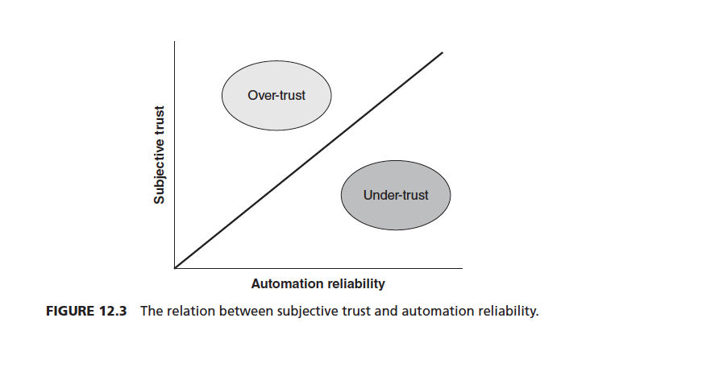
- Describe the major differences amongst training simulators.
- List the various factors associated with cognition in the workplace.
- ‘Executive’ control
- Decision making
- Reasoning
- Problem solving
- Task switching
- Response selection
- Planning
- Compare and contrast analytic and intuitive decision-making.
- Intuition
  - not necessarily externally driven
  - decision occurs quickly
  - example: like someone or you don’t
- Analytic
  - Rational (Normative) decision making
  - occurs more slowly
  - assumes an optimal decision
  - cost vs. benefits of different choices
- Our capacity for paying attention is limited to about one thing at a time. Provide an example of a successful method of presenting stimuli that optimizes the limits on attentional demands.
For example, if you practice the piano enough to get it into procedural memory you don’t have to pay as much attention to it and can shift more attentional resources to what you are multitasking with?
- Describe 5 methods for ensuring efficient use of items in Long Term Memory.
- Encourage regular use of information to increase both frequency and recency
- Standardize procedures, communications and tasks
- Leverage memory aids, such as guessing
- Leverage existing mental models and ‘population stereotypes’
- Design to support development of mental models
- Create a list (point form OK) showing the things that human operators are better at than automated systems.
- Automation have problems due to changes in feedback
- Automation does not define goals
- Humans can interpret the environment around them if the work needs to stop.
- Discuss the three ways to maximize concurrent task performance.
- Use different input modes and response devices.
- The more a given task can be automated, the easier it is to share that task with another task.
- Information should be available for the person to judge how to allocate resources between/among tasks.
- Explain how the TR/TA ratio is used to assess workload.
Timeline analysis computes the ratio of time required (TR) to the time available (TA) to complete a task. It is assumed that workload is proportional to the ratio of the time occupied performing tasks to time available: TR/TA. If a task requires 100% of the time available in a given time interval, workload is 100% for that interval (“red line”). Thus, workload is represented by lines with lengths proportional to their duration. Workload is the summed total length of the lines divided by the total time. Overload region is when the ratio (TR/TA) is more than 1 and reserve capacity region is where the TR/TA ratio is less than 1.
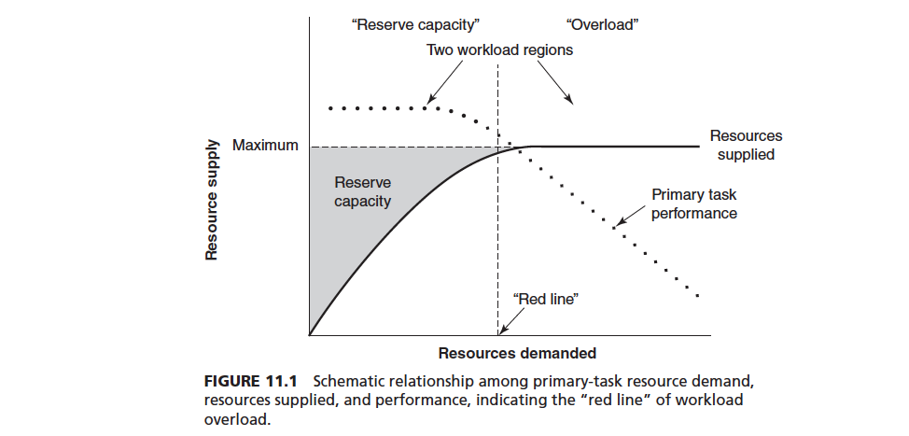
- The term ‘multiple resource time sharing’ refers to a characteristic of human information processing in which monitoring of events in the external world can be efficiently carried out. Three dichotomies were presented in lectures that refer to this concept. List them and provide a real world example for each.
- Early vs. late processing
- Visual vs. auditory
- Processing codes: spatial vs. verbal in early processing and manual vs. vocal in late processing
- List the cognitive processes associated with REAL WORLD decision-making.
- Ill-structured problems (lack of complete information basis, etc.)
- Uncertain and dynamic environments
- Information-rich environments with rapidly evolving situations
- Serial, iterative cognitive processing
- Time constraints and time stress
- Risk
- Many involved in the decision
- Describe and discuss the three implications of complacency in response to system automation.
- Over-trust associated with low monitoring of automation
- Follows from the generation effect: easier to remember actions chosen by oneself than those carried out by another agent
- Evidence for automation complacency:
  - Accident reports: Royal Majesty grounding
  - Poor detection of automation failures under multi-task conditions (Parasuraman et al., 1993)
- Both naïve and expert human operators can exhibit automation complacency
- First failure effect: failure to detect first occurrence of automation imperfection
- List the 5 most common causes of workplace injury and the 5 most common causes of workplace death.
Workplace Injury
- Overexertion
- Impact Accidents- being struck by or against an object
- Slips and falls
- Chemical burns and reactions
- Compression
Workplace Death

- Ground vehicular accidents
- Worker violence (including suicide)
- Falls
- Electrocution
- Drowning

- How are the characteristics of rational decision-making models different from “descriptive” decision-making models?
- Rational: Assumes optimal decisions can be found through reference to codified, rule-based procedures (logic) that use as input information regarding cost of difference choices and benefits of different choices.
- Descriptive: attempts to model he decision process that people actually use. (Not as much evaluating)
29. Describe, with a real-world example, the term “framing” in the context of decision-making.
Decisions are dependent upon the context in which the problem was presented. Decisions that depend upon the presentation form are subject to what is called the framing effect. Some decisions are apparently made without considering alternatives. For example, If you go in for a medical procedure and they give you a 10% chance of dying, or instead if they gave you a 90% chance of living. Both mean the same thing but the person would likely make the decision to go ahead with the surgery based on the 90% chance to live just because of how the information is presented.

- Describe the methods of improving human decision making for skill-based and-rule based task performance.
**Look up Rasmussen’s SRK Model in textbook *** Number 49 too, same guy.
- Describe ‘clumsy automation’ and provide an example of its consequence in a system designed to reduce workload.
- Clumsy automation is making easy tasks easier and hard tasks harder.
- Example: Flight management system tends to make the low-workload phases of flights (ex. straight level flying) easier but tends to make high work load phases (ex. Maneuvers in preparation for landing) more difficult. Pilots have to share their time between landing procedures, communication, and programming the flight management system.
- Discuss the role of feedback in the design of error-tolerant systems.
- Error tolerant systems minimize the effects of human error.
- The role of feedback would be to let a human of the system know when something is changing (example, pressure, temperature). For example keeping track of pressure in a pipe to make sure it doesn’t explode. I don’t really get the error-tolerant part? Maybe it’ll feedback and when the pressure gets too high an alarm goes off and if it keeps getting higher it’ll open a valve to let gas out to make sure it won’t explode.
- Explain how mental workload is measured.
Mental workload is measured by:
- Behavioral measures
- Secondary Tasks
- Probe reaction time
- Time estimation
- Mental arithmetic
- “Embedded” secondary tasks
- Subjective measures
- Modified Cooper-Harper Scale
- NASA Task Load Index (TLX)
- Describe the six procedural steps involved in systematically using anthropometric data in design.
- Characterize target population
- Define RELEVANT body dimensions
- Determine % of population to be accommodated
- Refer to anthropometric database to establish “envelopes” for relevant body dimensions and get % of the population
- Ensure all users can be accommodated (ex. Maintenance workers, repair people etc.)
- Use mock-ups and simulators where possible (cost effective)
- Describe the elements associated with the design and implementation of safety programs.
It is essential for safety programs to include the following:
- Management involvement
- Accident/incident investigation
- Recommendations for changes to equipment, job, environment
- Development of safety rules and procedures
- Personal protective equipment
- Employee training
- Safety promotion (safety culture)
- List the major goals of worker’s compensation programs.
- Provide sure, prompt and reasonable income and medical benefits to work-related accident victims or income benefits to their dependents regardless of fault.
- Provide a single remedy to reduce delays and costs for personal injury litigation
- Cover legal ancillary fee payment for appeals
- Encourage maximum employer interest in safety and rehabilitation
- Promote the study of causes of accidents
- List the characteristics of the physical environment associated with workplace accidents and provide examples
- Illumination
- Noise and vibration
- Temperature and humidity
- Fire hazards
- Radiation hazards
- Falls
- Exits and emergency evacuation
- In order to guarantee that it will be processed; presenting visual information within 15 degrees of the center of gaze is necessary but not sufficient. Explain.
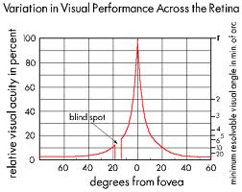
The most accurate vision is 0 degrees from the centre of gaze but anything away from it decreases accuracy.
- Draw a diagram showing the preferred position limits for vertical surface areas (in units of distance relative to the center of the seat reference point) for the following classes of control devices: Primary controls, Secondary controls not requiring precision adjustments, Secondary Controls requiring precision adjustments, Emergency Controls.
- Describe the principles associated with component arrangement in the design of a workspace and provide examples for each.
- Describe the main purpose of using‘ link analysis’ in workspace design
Link analysis is a quantitative and objective method for examining the relationship between components, which can be used as the database for optimizing component arrangements. A link between a pair of components represents a relationship between the two components. The strength of the relationship is reflected by link values. One goal of link analysis is to support a design that minimizes the total travel tie across all components; that is, to make the most traveled links the shortest.
- Define situational awareness and describe the three stages that lead to it.
Situational Awareness: perception of the elements in the environment within a volume of time and space, the comprehension of their meaning and the projection of their status in the near future
- 1. Use cue filtering and integration to reduce cognitive workload
- 2. Augment “normal” informational cues with more abstract “summative” cue
- 3. Employ spatial data organizing techniques
- 4. Provide ‘status’ updates via computer displays so the user can be warned of changes in the situation during their decision making progress.
- The following factors affect optimal use of timeline analysis methods when assessing task designs: Identification of task times, scheduling and prioritization, task resource demands and automaticity and the need for multiple resources. Discuss each briefly and explain how each affects the timeline analysis.
- Describe the pros and cons of three commonly used strategies intended to minimize the negative effects of shift work
- To assign workers permanently to different shifts, under the assumption that the circadian rhythms of the “night shift” worker will eventually adapt. The problem with this approach is that full adaptation never entirely takes place as long as the worker is exposed to some evidence of the Earth’s natural day-night cycle. The quality of daytime sleep will, as a result, continue to be less than adequate. Another problem with this strategy is the smaller pool of people who are willing to work the night shift because of personal preference and a need to retain an activity cycle more compatible with other family members.
- To maintain a fairly continuous rotation of shifts. Here, the problem is that desynchronization remains in a continuous state of flux. The circadian rhythms never have a chance to catch up to the levels of alertness that the person is trying to obtain via the scheduled shift. Hence, the workers arousal will never be optimal during work time.
- To alter the shift periods but to do so relatively infrequently. This strategy has the advantage of allowing the circadian rhythm to synchronize with (adapt to) the desired schedule, an adaptation which takes 4-5 days to occur and yet still allow workers all workers to share in the same inconveniences of night an early morning shifts.
- List job characteristics associated with workplace accidents and provide examples
- Equipment
- Controls and displays
- Electrical hazards
- Pressure and toxic substances hazards
- Explain the term “single-point failure” and describe how it differs from multiple cause failure. Describe the 8 levels of automation ranging from complete manual control to complete automatic control.
- If one part of the system fails the entire system will stop working
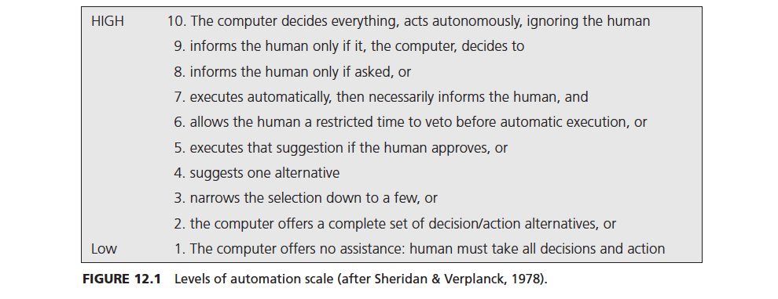
- Compare and contrast, with examples, errors of omission and errors of commission, slips, lapses, rule-based mistakes and knowledge-based mistakes.
- Omission vs. commission
- Slip vs. lapse: a slip is an action that is typically caused by confusing links between display and controls whereas lapses is when the operator did not intend to NOT to do the action. For example is a pilot presses one button instead of another would be a slip and if the pilot just forgot to press a button all together that would be a lapse.
- Rule-based vs. knowledge-based: A rule-based mistake happens when the person selects the wrong rule and a knowledge-based mistake is a perceptual, cognitive mistake.
- Describe the “Yerkes-Dodson Law” and draw a graph showing the major features of this law affecting performance (on the Y axis).
The Yerkes-Dodson Law postulates an inverted U-shaped function between stress and performance. It originally proposed in the context of studies where the learning performance of rats that were receiving electrical shocks of different intensity levels. At low arousal scale, increasing stress, but increasing arousal increases arousal. At high arousal scale, attentional problems lead to performance decrement. The inverted-U function shifts to the left for more complex tasks. The optimum level of arousal is lower for more complex tasks than for simpler tasks.
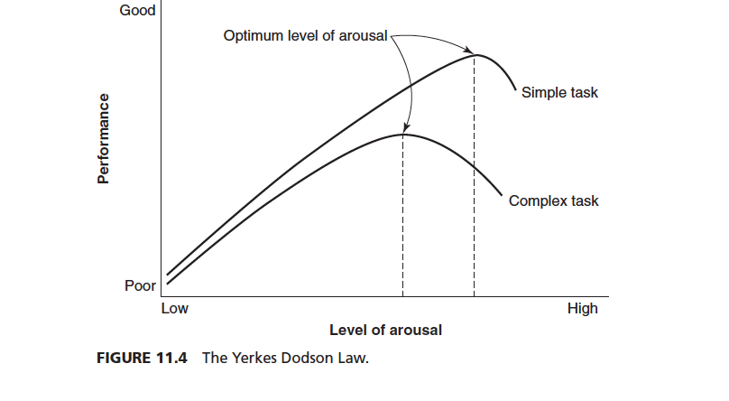
- Describe methods for improving decision making for knowledge---based performance.

