GMS401 – Chapter 1
1.1 Introduction
- Operations management – management of processes and the systems that create goods and or provide services
- Process – series of linked actions, changes, or functions brining about a result
  - core/operational processes – directly create goods/services
  - Support processes – support core processes
  - managerial processes – govern the system
Activities of operations management, eg. airline
- Forecasting – seats demand, growth in air travel
- Capacity planning – deciding no. of plane and where to use them
- scheduling – of plans for flights, pilots, attendants, ground crews, counter staff
- Assuring quality – emphasis is on safety, efficiency and courtesy
- Employee motivation and training
- Location of facilities – where to locate, the major and minor hubs
- Buying materials

- Efficiency – operating at mi. cost and time
- Effectiveness – achieving the intended goals (quality and responsiveness)
Why study operations management
- large % of company expenses occur in the operations area
- large no. of jobs are in operations management
- activities in all of the other areas of organizations are all interrelated with with operations management activities
1.2 Functions within organizations
Typical organizations
- Operations, finance, marketing
Operations functions
- performs all the activities directly related to producing g/s
  - Goods-oriented – fabrication/assembly operations
  - service-oriented – healthcare, transportation
- Inputs -> transformation/conversion processes -> outputs
- feedbacks are taken at various points then compare with control
- Value added – difference between the cost of inputs and the value or price of outputs
  - non-profit -> value added is their value to society
  - for profit -> measured by prices customer willing to pay
Finance
- securing resources at favourable prices and allocating those resources throughout org.
- Provision of funds – planning of necessary funding and amount and timing of funds
- Economics analysis of investment proposals – evaluation of alternative investments
Marketing
- Assessing customer wants and needs, communicating those feedbacks to operations ppl to product design ppl.
- lead time – time between ordering a good or services that receiving it
Other functions
- accounting, management information system, purchasing, personnel, human resources, manufacturing engineering, maintenance, product design, logistics
1.3 The scope of operations managements
- System design –decisions that relate to product and service design, system capacity, geo location, arrangement of departments, placement of equipment (essentially determines many of the parameters of operations.
- Operational activities – management of personnel, inventory planning and control, production planning, scheduling, project management, and quality assurance ( day-to –day operating decision)
1.4 Differentiation production of goods vs performance of services
- tangible output – anything we can see or touch
  - manufacturing is the largest sector
- Services – similar in terms of what is done but different in terms of how it is done
  - Customer contact, use of inventories, demand variability, uniformity of input, labour content of jobs, uniformity of output, measurement of productivity, quality assurance
1.5 The operations manager’s job
- ultimate responsibility for the creation of goods or performance of services , all managers are managerial, must coordinate the use of resources through the management activities of planning, organizing, directing, and controlling.
- job content and satisfaction – enjoy challenges, not happy with heavy hours of work, condition

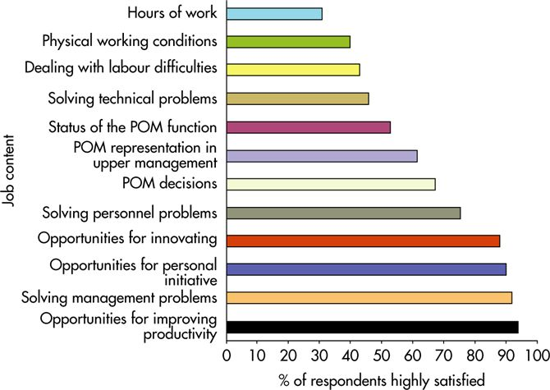
1.6 Operations managers and decision making
- model – abstraction of reality, a simplified rep. of something
  - ignore unimportant details, concentrated on important aspect of a situation
  - Physical, mathematical, schematic models.
  - each model have to learn...
- its purpose
- how it is used to generate results
- how these results are interpreted and used
- what assumptions and limitations apply
Quantitative approaches
- attempt to obtain optimum solutions to the mathematical models of managerial problems
- Linear programming – optimum allocation of scarce resources
- Queuing techniques- analyzing situations which waiting lines forms
- Inventory techniques – control inventories
- Project scheduling techniques (PERT) – planning, coordinating, controlling large-scale projects
- forecasting techniques – forecasting demand
- statistical techniques- quality control
- sometimes a heuristic approach is quick way to find good solution
Analysis of trade-offs
- listing the adv. and dis. of a course of action to understand consequences, add weights to items that reflect importance of various factors
The Systems Approach
- System – set of interrelated parts that must work together
- important to take into account the impact on all parts of the system
Establishing priorities
- Pareto Phenomenon – a few factors account for a high % of results achieved
- 80-20 rule – 20% factors will impact 80% of results achieved
Ethics
- Worker safety – providing training, maintaining equipments, safe working environment
- Product safety – product min. risk of injury to users or damage to property, enviro.
- The environment – not doing stuff harm the environment
- Closing facilities – impact on community, honouring commitments that have been made
1.7 The Historical evolution of operations management
Early days
- craft production – skilled workers using simple, flexible tools produced goods according to customer specification, one person responsible for making product
- production slow and costly, replacement have to be custom made
- No economic of scale – production costs did not decrease as volume increased
- canada limited to mercantilism – raw materials exported to Europe for further processing and manufacturing
The Industrial Revolution
- substituting machine power for human or animal power
- Division of labour – (Adam Smith) operation is divided up into a series of small tasks, no skills required
- Interchangeable parts – (Eli Whitney) standardize parts so any part in a batch of parts would fit
Scientific Management
- based on observation, measurement, analysis and improvement of work methods, and economic incentives, emphasized maximizing output
- Ford introduced moving assembly line
- Mass production – system of production in which large volumes of standardized goods are produced by low-skilled or semiskilled workers using highly specialized, costly equipments
The Human Relations Movement
- emphasized the importance of human element in job design rather than technical aspects of work design
Decision Models and Computers
- Mathematical models for inventory management
- Statistical procedure for sampling and quality control
- operations research – achieve advancements in military and manufacturing
- companies using enterprise resources planning software to coordinate sales, materials management, production planning, manufacturing, finance
Influence of Japanese Manufacturers
- total quality management – emphasized quality and continual improvement, worker teams, empowerment, achieving customer satisfaction, lead production system and just in time manufacturing
- Lead Production – fewer resources then mass production system to produce a comparable amount of output by using highly skilled workforce and flexible equipment
1.8 Major Trends
- The internet and e-commerce – use internet to sell/buy goods
- technology – technological innovations in both products and processes will continue to change the way organizations operate
- Globalization
- Supply chain – a sequences of activities and organizations involved in producing and delivering a g/s
  - Outsourcing – buying a part of g/s or a segment of production/ services process rather than producing or performing it within the org.
    - increased in importance of coordination and collaboration of members of each supply chain

Chapter 2 – Competitiveness, strategic planning, productivity
- Competiveness – ability and performance of an org. in the marketplace compared to other organizations that offer similar g/s
- Strategy – long-term plans that determine the direction an org. takes to become(remain) competitive
- Strategic planning – managerial process that determines a strategy for the organization,
- Productivity – measure of how efficiently the resources are being used
1.1 Competitiveness
- Key purchasing criteria – major elements influencing a purchase
  - Price – amount a customer pay for g/s
  - Quality – characteristics of g/s determined by its design, material, workmanship, performance, consistency
  - Variety – choices of models and options available to customers
  - Timeliness – availability of g/s when they are needed by the customer
Value = quality, timeliness, etc./ price
- Order qualifiers – purchasing criteria that customers perceive as min standards of acceptability for purchase
- Order winners – purchasing criteria that cause the org. to be perceived as better than the competition
- Competitive priorities – the importance given to operations characteristics
  - cost – unit production of g/s (low cost)
  - quality – determining customers quality requirement (high performance, consistent quality)
  - flexibility- able to produce a variety of g/s in same facility (variety, quantity flexibility)
  - delivery – consistently meet promised due dates (rapid/on-time delivery)
1.2 Strategic planning
- process of determining a strategy, long-term plans that will set a new direction for an org. implementing it through allocation of resources and action plans
- Getting started – scope of business, current strategy working?, issues/problems
- Analyze the industry/source of competitive advantage
- Analyze customers – market segment, key purchasing criteria
- Analyze competitors (rivals) – strategies and position, behave, strategy changed over time?
- Assess our relative position – product’s strength/weaknesses, profitability
- Assess the state of our business – major issues, goals?
- Develop and evaluate alternative strategies – investments? Actions? financial returns justify it?
- Choose and refine the recommended strategy – which one, actions/policies?, resources, timetable, expected results?
- Identify major actions and implement them – to coordinate the action and monitor overall progress
Mission, Vision, and Values
- mission – where the org. is going now, its products, and its markets
- vision – org. desires to be in the future
- Values – shared beliefs of the org. stakeholders which should drive everything else such as culture, mission/vision, and strategy
goals and objective- mission/vision provides a general direction for an org. and should lead to org. goals, provide substance to the overall mission/vision
Strategies, tactics, and action plans
- overall organizational strategy
- functional strategy – financial, marketing, operations strategy
- Tactics – medium-term plans sometimes used as components of a strategy
- Action plans – medium/short term project to accomplish a specific objective, assigned to an individual, with a deadline and the resources needed
Operations strategy
- deals with guiding the operations function of the org. but should answer org. goals
- should collectively monitor the external market
- trade-offs must be made among these priorities (cost, quality, delivery, flexability)
Nine strategic decision categories
- facility – by market, product group, or production process type
- capacity – size of plants and major equipment
- vertical integration – ownership of a major part or whole of supply chain (cost, coordination, control)
- vendor relations – competitive arm’s length or cooperative close relationships
- product mix and new product – variety of product and rate of new product intro increase
- process types/tech. – job shop, batch, assembly line, continuous flow
- Human resources – cooperation of the personnel department
- quality – determined during design and production
- operations infrastructure and system – choosing a computerized planning and control system
Formulation of an operations strategy
- link org. goals to operations strategy
- categorize the customers into types – major customer, others
- group product lines into types – low/high volume
- conduct an operations audit determine strengths/weaknesses of strategy into categories
- assess the degree of focus at each plant
- develop an operations strategy and re-allocate product lines to plants if necessary
Generic operations strategies
- time-based operations improvement programs and plans such as just-in- time production and total quality management/continuous improvement
- low labour cost, scale-based (high labour productivity/lower unit cost), focused factories strategy, flexible factories, continuous improvement
- Time-based competition – focuses on reducing time required to accomplish various activity
- Outsourcing – buying a part of g/s or segment of productive and service process from another company, a supplier
1.3 Productivity
- productivity – measures output(g/s) per unit input (machine, labour, materials, energy)
Productivity = output/input
- productivity growth- increase in productivity from previous period to current period relative to the productivity in the previous period
Productivity growth = (current period productivity – previous period productivity)/ previous period productivity
Measuring productivity
- partial productivity (single input)
- multifactor productivity (more than one input)
- total productivity (all input)
Efficiency –narrower concept that pertains to getting the most out of a fixed set of resources
- productivity is broader concept that pertains to better use of overall resources
- aggregate measures – productivity measure used to judge performance of an entire industry/ country
- business leaders are concerned with productivity as it relates to competitiveness
Productivity measurement of services
- In some services where there is also a large goods component, a measure of output is not hard to find
Factors that affect productivity
- methods, management, equipment, technology, labour
- management/methods results in better design, planning, operating decisions, standardizing, improving processes, improving quality, reducing waste, etc.
Chapter 4 – Product design
- Product design – involves the determination of the form and function of the product.
1.1 Product Design Process
- 4 elements to rapidly create new goods/ services and bring them to consumers

- Product approval committee – top management
  - authorizing new products, reviewing progress at phone, allocating resources across different projects, ensuring consistency between company strategy/ design projects
- Core Teams – cross functional team
  - plan/lead design/development products from idea to commercialization
  - consists of product manager, product designer, manufacturing/operations representatives – expanding during each phase of design
- Phase reviews
  - Milestones during a new product when progress of core team is reviewed by the product approval committee. decision approve, cancel, redirect the project
  - escalator effect – cost of changes tends to multiply with each phase
- Structured development process - use of project management techniques
  - breaking each phase into steps and steps to activities, determining their precedence relationships, scheduling and executing and control

- phases (stages) for product design

- idea generation and preliminary assessment (scoping)
- building a business case
- development of product and process
- testing and validation
- launch

- concurrent engineering – team-based approach of simultaneously designing the product and process, each functional area performed its part of design in isolation and throw work to next department in design
1.2 Sources of ideas for new or redesigned products
- front-line employees – make g/s to customer, seen products in manufacturing/assembly operations caused by faulty design of the parts and products. feedback could improve the redesigned products
- Reverse engineering – purchase a competitor’s product and dismantle it to discover what is it composed of and how the components work.
- Research/development (R/D) – lab scientists and engineers who are involved in creative work on a systematic basis in order to increase knowledge directed toward product or process innvation
Searching for new product ideas
- Listening to market complains
- Gaps in the market
- exploring niche market
- using new technology
- creating new market space
1.3 Key issues in product design
Life Cycle – incubation, growth, maturity, saturation, decline
- matter of the basic need of the item and the rate of technological change
Standardization
- Standardization – extent which there is absence of variety in a part or product
- same key components, reduce time/money for increasing quality/reliability, cost to train employees
- lack of variety and lock in obsolescence and resist modification
Design for mass customization
- mass customization – strategy of producing standardized g/s but incorporating some degree of customization in the final product
- Delayed differentiation – producing , but not quite completing a product until customer preferences are known
- Modular design – grouping parts into modules that are easily interchanged and replaced, composed of no. of modules/components instead of a collection of individual parts.
  - failures easier to diagnose and remedy b/c modules can be tested individually, simpler purchasing, inventory control, assembly operations
  - inability to disassemble to replace a faulty part.
Reliability
- reliability – measure of the ability of a product, part, entire system to perform its intended function under normal conditions
- Failure – situation which a product, part, system does not perform as intended
  - not operate at all – fail to respond
  - substandard performance – alarm too faint
  - unintended response – sound alarm but no smoke
Robust Design
- robust design – design that can function over a broad range of conditions
- Taguchi’s approach – based on robust design, premise is it’s easier to design product insensitive to environmental factors
  - parameter design – determining specification setting for product result in robust design in terms of manufacturing variation, product deterioration, conditions during use.
Legal and Ethical issues
- gov regulations
- Food/Drugs act, Canadian Environmental protection act, Motor vehicle safety act, hazardous product act.
- not infringe on patents, trademarks, copyright
- product liability – manufacturer is liable for any injuries or damages caused by a faulty product
Design for environment
- incorporate environmental concerns
- Remanufacturing –refurbishing used product by replacing worn-out or defective components, reselling the product
- design for disassembly – design so used products can be easily taken apart
- Recycling – recovering materials for future use
Concurrent Engineering
- concurrent engineering – bringing design and manufacturing engineers together early in the design phase to simultaneously develop the product and process for creating product
- manufacturing engineers and personnel can identify production capabilities
- major shortening of the product development process
Computer-Aided Design (CAD)
- computer-aid design (CAD) – uses computer graphics for product design, increased productivity of designers, database for manufacturing that can supply info on product
- determine weight and volume of part/stress analysis
Design for Manufacturing and Assembly
- design for manufacturing (DFM) – indicate designing of products that are compatible with manufacturing capabilities.
- design for assembly (DFA) – focuses on reducing the no. of parts in an assembly, on assembly methods and sequences that will be employed
Component Commonality
- component can be used in multiple products, saving in standard training and buying in bulk.
- decision making tool – make commonality trade-off decision, between annual holding cost saved by using commonality vs. extra cost of manufacturing to provide commonality
4.4 Differences in designing services
- tangible/intangible – service design includes secondary factors, hard to sketch a service, rely on faith of customer -> importance of image
- services are created and delivered, service redesign have to consider process of delivering services
- variability in length of service, involve some degree of customization (variety)
- lower barriers to entry and exit, company cannot easily measure the cost of introducing the services b/c of shared resources
- location important, convenience as a major factor
The Service Design Process in the Financial sector
- differences is better idea screening, preliminary market assessment, market research, service development, post-launch review
Service Design Guidelines
- have single, unifying theme, help personnel work together
- ensure service delivery system has the capability to handle any expected variability in service requirement
- ensure service reliable, provide consistently high quality
- design the service delivery system to be user-friendly
4.5 Quality Function deployment
- Quality function deployment (QFD) – a structured approach for integrating the “ voice of the customer” into product design
- structure of QFD based on a set of matrices – The house of quality
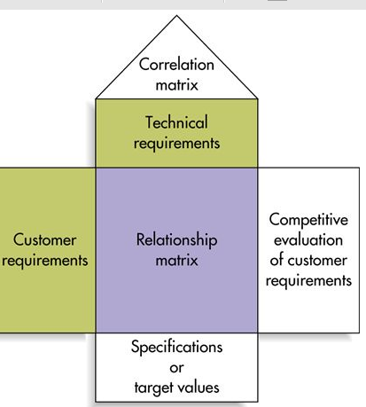
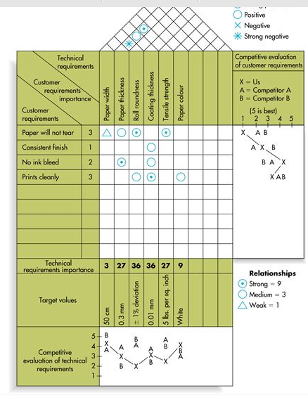
GMS401 – Chapter 4s
1.1 Introduction
- Reliability – a measure of the ability of a product or part to perform its intended function under a prescribed set of condition -> probability
- Reliability when activated -> focus on one point in time
- Reliability for a given length of time -> focus on the length of service
- reliability management – statistics and probability theory
1.2 Finding Probability of functioning when activated
- Determining probability when product consists of no. of independent components requires the use of rules of probability for independent event
- Rule 1 – If two or more events are independent and “success” is defined as the occurrence of all of the events, then the probability of success Ps is equal to the product of the probabilities of the events occurring ie . Ps = P1 x P2 x ....
- even if individual components of a series system might have high reliability, series system as a whole can have considerably less reliability b/c all its components must function
- No. of components in a series system increase, the system reliability decrease
- To increase overall reliability -> overdesign, enhance the design to avoid a particular type of failure
  - simplification – reduce the no. of components in the product
  - redundancy – providing backup components
- Rule 2- If two or more events are independent and “success” is defined as occurrence of at least one of the events, then the probability of success Ps is equal to 1- probability that none of the event will occur ie. 1- (1-p1)(1-p2)(1-p3)... Simplifying Ps= p1 + (1-p1)P2 + (1-P1)(1-p2)P3 +...
1.3 Finding probability of functioning for a given length of time
- Failure rate per hour is the no. of failure divided by total operating hours
- if failure rate is constant over time, time-quantity transposition is applicable -> reduce the test time but use more test items.
- failure rate is generally a function of time and follows the bathtub curve
- mean time to failure(MTTF) – inverse of failure rate per hour, the average length of time (in hours) before failure
- mean time between failures (MTBF) – the average time from the up time after the repair following a failure to the next failure
Reliability = P(no failure before T) = e^ - T/MTTF
e= 2.7183, T= length of service before failure, MTTF = mean time to failure
Probability that failure will occur before time T is 1- reliability
Normal distribution
- the table provides areas under a normal curve up to a specified point Z, where z is a standardized value calculated using the formula
z= T – mean wear-out time/ standard deviation of wear-out time
Availability
- availability – the fraction of time a piece of equipment or a repairable product is expected to be available for operation.
Availability = MTBF/ (MTBF + MTTR)
MTBF = mean time between failures, MTTR = mean time to repair
GMS401 – Chapter 6 Process Design and Facility Layout
6.1 Introduction and process types
- Process design – determines the forms and function of how production of g/s is to occur, implications for layout of facilities, equipment, design of work systems
- 1st step (make or buy) – decide whether to make a part or product in-house or to buy it or a segment of production process from another company
Job Shop
- a process type used when a low quantity of high-variety customized g/s is needed
- intermittent – work shifts from one small job to the next with different requirements
- characteristics are high flexibility of equipment and skilled workers
- managerial challenge is to schedule the jobs so due dates are met and resources are utilized as much as possible
Batch
- batch process – a moderate volume/quantity and variety of g/s is desired, not as flexible but still intermittent
- managerial challenge is scheduling batches in order to meet planned production and demand while utilizing the resources at a high level.
Repetitive
- repetitive process – higher quantities of more standardized g/s are need, slight flexibility, low skill workers
- production line – a sequence of machines/workstations that perform operations on a part/product
- assembly line – a production line where parts are added to a product sequentially
- either machine-paced (same speed) or worker-paced (variable speed)
- managerial challenge are capacity balance, tech management, materials management
Continuous
- continuous process – high volume of highly standardized output is desired
- almost no variety in output so no equipment flexibility, worker is low skilled
- managerial challenge is greater care is required for automated control of the flow, start/stop of production are more challenging
 | Job shop | Batch | Repetitive/assembly | Continuous
Product variety | Customized | Semi-standardized | Standardized | Highly standardize
Volume | low | Low-moderate | High | Very high
Equipment flexibility | Very high | Moderate | Low | Very low
Product-process matrix
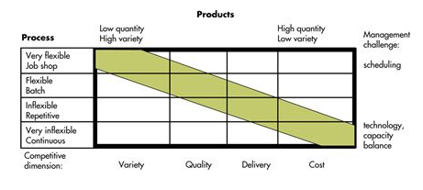
- the ideal is to have production process capability, equipment flexibility to match product requirements.
- product often go through a life cycle – begins with low quantity, increased when better known. managers need to know when to shift one type or production process to the next
- have hybrid processes – processes that have elements of other process types embedded in
- focus factory – process that produce high quantity of product specialized in these products
- within each production process, many individual operations are performed
6.2 Automation
- automation – using machinery/equipment with sensing and control devices that enable it to operate automatically
- Adv. - low variability, don’t get bored/distracted, injured
- Dis. – costly, high volume of output to offset high initial cost, less flexible than human labour, hard to change once been automated, adverse effect on morale/producitvity
- frequently touted as a strategy necessary for competitiveness
Fixed automation
- most rigid, high-cost, specialized equipment for a fixed sequence of operations. low unit cost and high volume, minimal variety/high cost of making major changes
Programmable automation
- high-cost, general-purpose equipment controlled by a computer program, provides sequence of operations and specific details. changing process is as changing the computer program. produce fairly wide variety of low volume products in small batches

Numerically controlled (N/C) machines (part of programmable automation)
- programmed to follow a sequence of processing instruction based on math relationships
- computerized numerical control (CNC) – individual machines have their own computer
- direct numerical control (DNC) – one computer control a no. of N/C machines
- used in parts are processed frequently and in small batches, part geometry is complex, mistakes are costly, frequent changes in design
- limitation is higher skill levels needed to program machines and high cost
- Robot – a mechanical arm, power supply, controller
  - robots follow fixed set of instruction
  - programmable robots – repeat set of movement after led through the sequence
  - robots follow instruction from a computer
  - robots that recognize object make simple decisions
- robots powered by pneumatically(air), hydraulically (fluids), electrically
- flexible automation – used equipment more customized than programmable automation, requires less changeover time.
- machining centre – machine capable of performing a variety of operations on parts (numerically controlled)
Flexible Manufacturing system (FMS)
- group of machining centres, controlled by a computer, automatic material handling and robots or other automated equipment.
- handle intermittent processing requirements with benefits of automation and individual machines (flexibility of job shop/productivity of repetitive process)
- reduce labour cost and more consistent quality, lower capital investment/higher flexibility than “hard” automation, relatively quick changeover time.
- only handle relatively narrow range of part variety, family of similar parts/machining
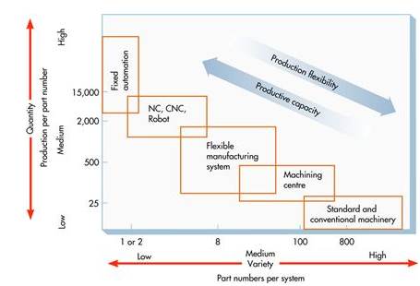
- longer planning/development time, represents a sizable chuck of tech.

Computer-integrated manufacturing (CIM)
- integrating computer system to link a broad range of manufacturing and other activities, integrates info from other areas of org. with manufacturing. achieve rapid response to customer orders/product changes, rapid production, reduce indirect labour cost.
1.3 Process design
- determines the form and function of how production of g/s is to occur
Methodology for production process design
- Define the production process (operations assessment in product design)
  - determine how completed the input materials should be, make/buy decisions
  - set production process objectives
    - capacity, flexibility, type of process, cost, process quality capability, technology/extent of automation, production start date
  - Determine the nature of process in general
- Production process developement
  - Conceptualized the design
    - how to get input to output, sequence of major operations
    - Incremental – one step at a time from start to end
    - Hierarchical – break job into two operations, divide into sub-operations
    - process flow diagram – show operations/movements of materials
    - evaluate each alternative process concept
  - Make an embodiment of the design
    - choose one process concept/complete the design/build prototype process, test
    - determine resources needed in general, refine and re-evaluate
  - Create a detailed design
    - finalize the process specification
    - determine specific machines, equipment, labour, plant layout, work centres
- Buy the machines and equipment, recruit workers, start trail runs (stage 4 of stage-gate model)

- process flow diagram – identifying boundaries of process/level of detail required, incremental approach follow flow of materials through transformation process, identify activities/resources required.
- Integrated definition (IDEF) – method is hierarchical top-down approach to process design, decomposes the name/function of process into its linked components until level of detail desired is reached
Services process fail-safeing
- service process design similar to manufacturing except instead of material, flow of the customer or something belonging to them should be follow
- vulnerable to quality/delivery problems, companies need identify potential failure points/incorporate features that minimize the chance of failure.
Customer perception in service process design
- services is usually varied and intangible, raises customer perception issue
- don’t raise customer expectation too high in the beginning
- end the service positively b/c customers remember the end more
- if service pleasurable, divide it into segments/ service painful, combine the segments
- let customers control part or all of the process, communicate evidence of quality to customer
6.4 Types of layout
- refers to the location of departments, work centres, equipment in the facility/plants
Product (line) layout
- product layout – arranges production resources linearly according to the progressive steps by which a product is made.
- smooth/rapid flow of large quantities of highly standardized goods/customers through a system
- can arrange layout to correspond to production requirements of the product
- high degree of labour/equipment utilization, offset high equipment costs, amount of work-in-process is minimal
- entire system is highly vulnerable to being shut down b/c of mechanical failure
- Preventive maintenance – periodic inspection nd replacement of worn parts/high failure reates
- take measures to provide quick repair, spare parts, repair personnel
- Adv – low-cost production, simplified accounting, purchasing, inventory control
- dis. – higher equipment cost, repetitive jobs, stress injuries, inflexibility in response to changes
Process (Functional) layout
- process layout – arranges production resources together according to similarity of function
- processes items have variety of production requirements, frequent adjustments
- intermittent processing – discontinuous work flow
- use of general-purpose equipment provides flexibility necessary to handle range of production requirement. E.g. Machine shop. workers operating equipment are usually skilled
- Adv. - less vulnerable to shutdown, idle equipment usually available to replace machines temp out of services. less interdependence between successive operations. maintenance cost lower
- Dis. – routing/scheduling done on continual basis to accommodate variety of production. material handling inefficient, unit handling costs are higher. large in-process inventories due to batch processing.
Cellular layout
- cellular layout – different machines are arranged in a cell that can process items with similar processing requirements (part families), mini product layout.
- no converorized movement of parts between machines, machines are arranged to handle all operations necessary for a group of similar parts. parts from same family follow route with minor variation. U shaped, increased communication among workers
- Adv. – faster processing time, increased capacity, less material handling, work-in-process inventory, reduce setup time.
- group technology – identifying items with similarities in design or manufacturing characteristics, group into part families.
- conversion is major undertaking -> visual inspection -> examination of design/production data -> production flow sequence/routing analysis
Warehouse layout
- based on different set of actors than design of factories
- cool storage (freezer), frequency, size of order (place near or rear of warehouse)
- correlation between items, place together reduce cost and time of retrieving items
Retail Layout
- objective pertain to cost minimization/product flow, take account of presence of customers/opportunity to influence sales.
Office layout
- flow of paperwork was replaced with electronic communication, less place need to place office workers
Layout design steps
- determine location of receiving and shipping
- “product layout” – fit process flow diagram onto sketch, determine location of each part process
- “process layout” – expected work flow between departments, place highest workflows closest
- continue until all departments are located
- keep special requirements of machines in mind
- allow space for machines, in-feeds, out-feeds, workers, carts/forklifts
- keep rearranging plan using feedback from workers
- on the factory floor, paint outline machines, in-feed, out-feed spaces
- walk through normal sequence of activities
- run the electricity and other lines, move machines in.

