PASS MOCK EXAM

Course: ECON1000 A Facilitator: Andrew Loebus
Date/Location of mock exam take-up: Dec 14, 7:00pm – 9:00pm, ME 4332
Dec 17, Noon – 2pm, CB 2202

IMPORTANT:

It is most beneficial to you to write this mock midterm UNDER EXAM CONDITIONS. This means:

- • Complete the midterm in 3 hours.
- • Work on your own.
- • Keep your notes and textbook closed.
- • Attempt every question.

After the time limit, go back over your work with a different colour or on a separate piece of paper and try to do the questions you are unsure of. Record your ideas in the margins to remind yourself of what you were thinking when you take it up at PASS.

The purpose of this mock exam is to give you practice answering questions in a timed setting and to help you to gauge which aspects of the course content you know well and which are in need of further development and review. Use this mock exam as a learning tool in preparing for the actual exam.

Please note:

- Come to the PASS session with your mock exam complete. There, you can work with other students to review your work.

- Often, there is not enough time to review the entire exam in the PASS session. Decide which questions you most want to review – the facilitator may ask students to vote on which questions they want to discuss.

- Facilitators do not bring copies of the mock exam to the session. Please print out and complete the exam before you attend.

- Facilitators do not produce or distribute an answer key for mock exams. Facilitators help students to work together to compare and assess the answers they have. If you are not able to attend the PASS session, you can work alone or with others in the class.

PART A
Multiple Choice
Answer ALL Questions, 2 marks each

1. Which of the following concepts is NOT illustrated by the production possibilities frontier?
a. | efficiency
b. | opportunity cost
c. | equity
d. | tradeoffs

Table 1

Labor Hours needed to make one unit of: |  |  | Amount produced in 160 hours:
 | Quilts | Dresses | Quilts | Dresses
Helen | 40 | 10 | 4 | 16
Carolyn | 80 | 16 | 2 | 10

2. Refer to Table 1. The opportunity cost of 1 quilt for Helen is
a. | 2 dresses.
b. | 3 dresses.
c. | 4 dresses.
d. | 5 dresses.

Figure 1
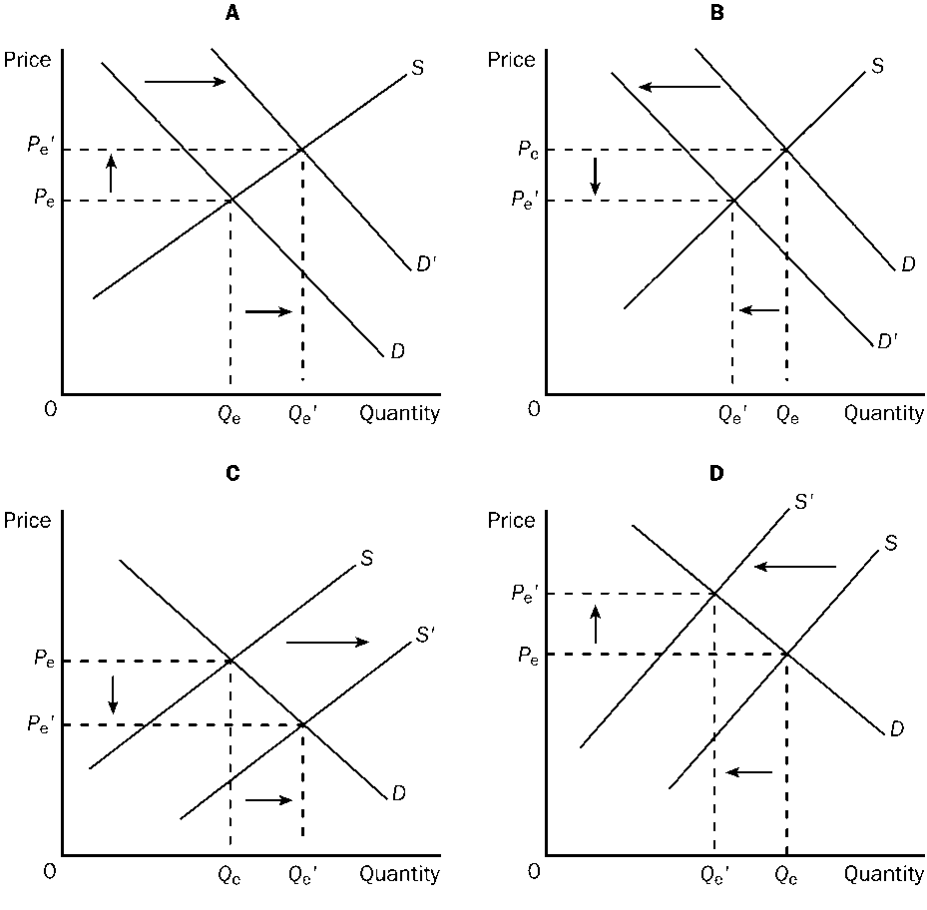

3. Refer to Figure 1. Which of the four graphs represents the market for peanut butter after a major hurricane hits the peanut-growing south?
a. | A
b. | B
c. | C
d. | D

4. Suppose the price elasticity of demand for basketballs is 1.20. A 15 percent increase in price will result in
a. | an 18 percent decrease in the quantity of basketballs demanded.
b. | a 15 percent decrease in the quantity of basketballs demanded.
c. | an 8 percent reduction in the number of basketballs demanded.
d. | a 12.5 percent reduction in the number of basketballs demanded.

5. When the price of bubble gum is $0.50, the quantity demanded is 400 packs per day. When the price falls to $0.40, the quantity demanded increases to 600. Given this information and using the midpoint method, you know that the demand for bubble gum is
a. | inelastic.
b. | elastic.
c. | unit elastic.
d. | perfectly inelastic.
e. | vertical.

Figure 2

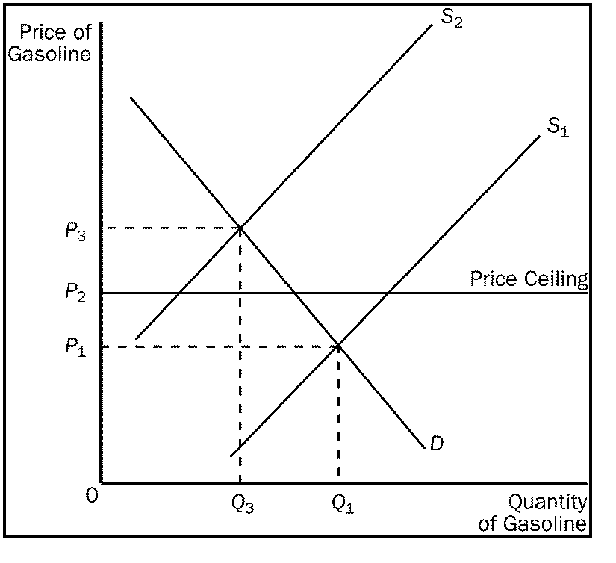

6. Refer to Figure 2. With a price ceiling present in this market, when the supply curve for gasoline shifts from S1 to S2
a. | the price will increase to P3.
b. | a surplus will occur at the new market price of P2.
c. | the market price will stay at P1 due to the price ceiling.
d. | a shortage will occur at the price ceiling of P2.

Figure 3

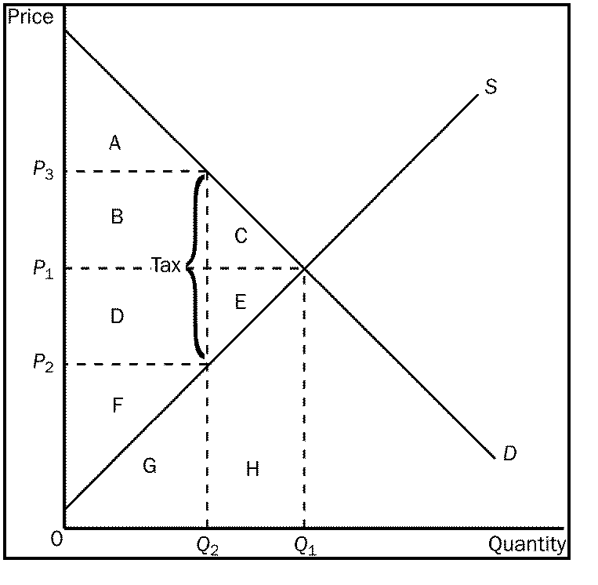

7. Refer to Figure 3. After the tax was levied, it caused a reduction in consumer surplus represented by area
a. | A
b. | B + C
c. | C + E
d. | D + E
e. | F

8. Refer to Figure 3. The loss in total welfare resulting from the tax is represented by area
a. | A + B + C
b. | D + E + F
c. | A + B + D + F
d. | C + E
e. | C + D + E

Figure 4
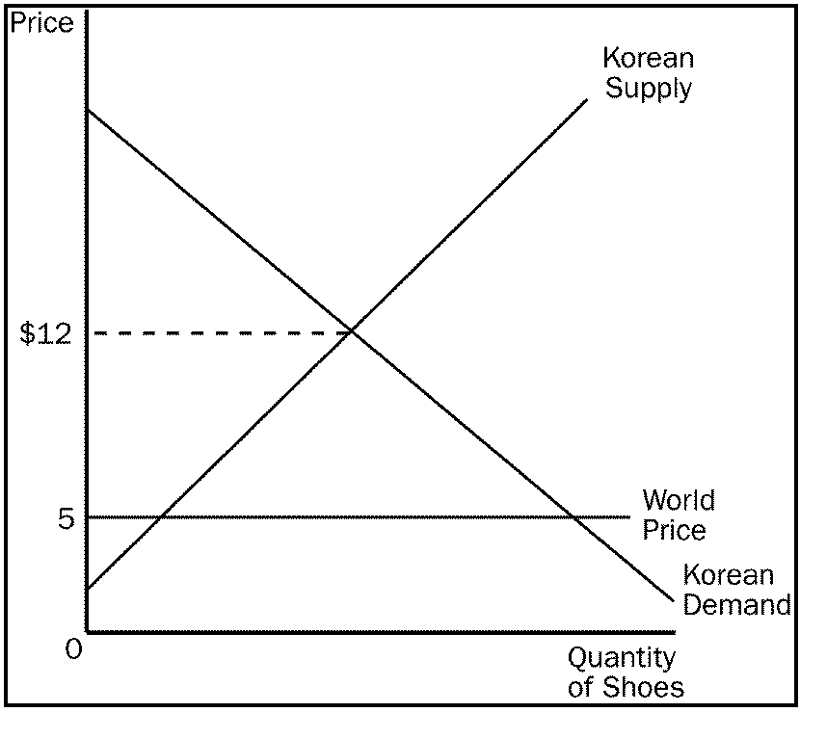
9. Refer to Figure 4. If trade in shoes is allowed, Korean shoe
a. | consumers and Korean shoe producers will gain.
b. | consumers and Korean shoe producers will lose.
c. | consumers will gain, and Korean shoe producers will lose.
d. | producers will gain, and Korean shoe consumers will lose.

Figure 5

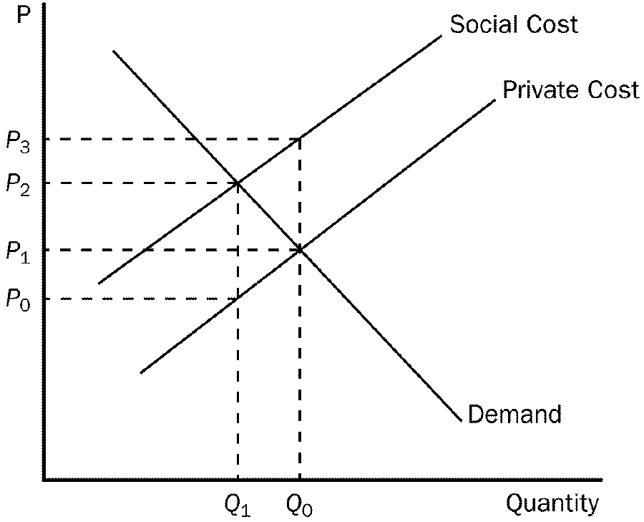

10. Refer to Figure 5. The marginal
a. | benefit of the positive externality is measured by P₃ - P₁.
b. | cost of the negative externality is measured by P₃ - P₂.
c. | cost of the negative externality is measured by P₃ - P₁.
d. | cost of the negative externality is measured by P₃ - P₀.

Figure 6

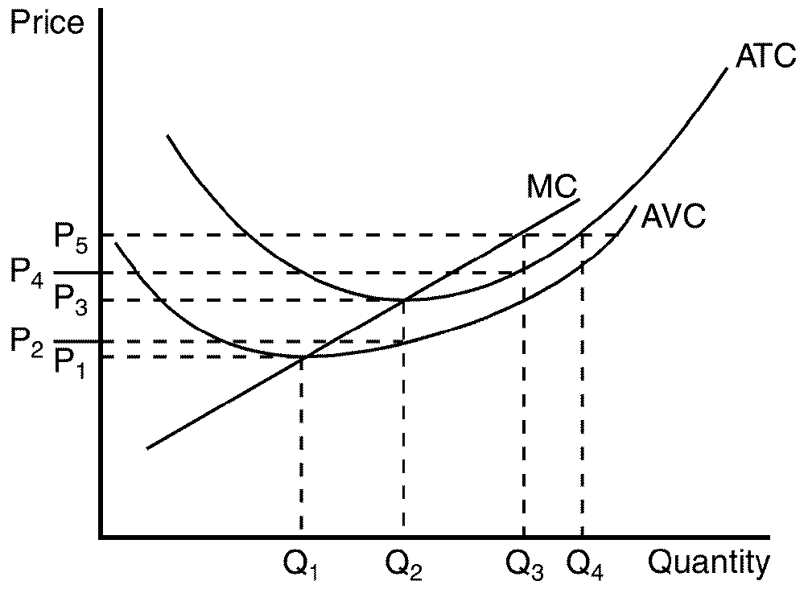

11. Refer to Figure 6. Firms would be encouraged to enter this market for all prices that exceed
a. | P₁.
b. | P₂.
c. | P₃.
d. | None of the above are correct.

Figure 7

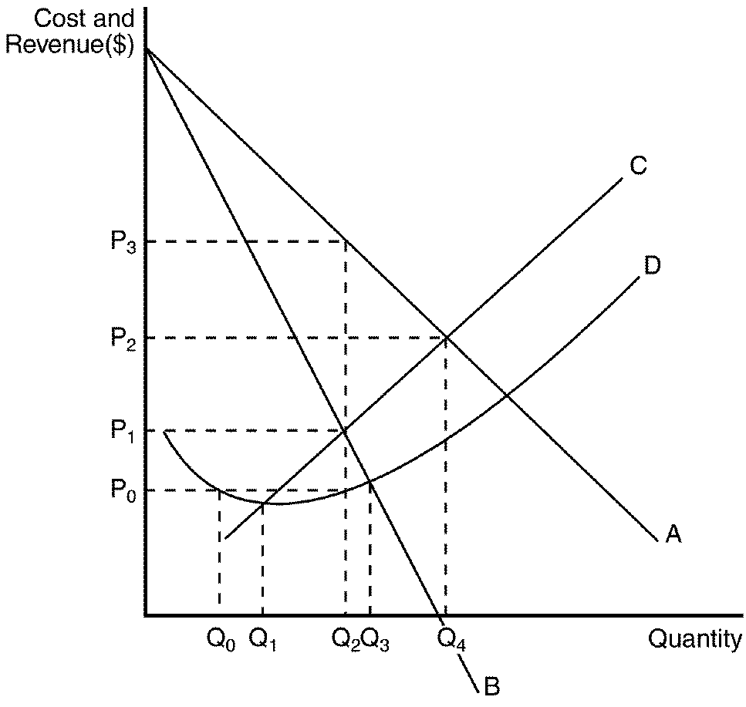
12. Refer to Figure 7. A profit-maximizing monopoly's profit is equal to
a. | P₃ ´ Q₂.
b. | P₂ ´ Q₄.
c. | (P₃ - P₀) ´ Q₂.
d. | (P₃ - P₀) ´ Q₄.

13. For a monopolist,
a. | average revenue is always greater than the price of the good.
b. | marginal revenue is always less than the price of the good.
c. | marginal cost is always greater than average total cost.
d. | All of the above are correct.

Figure 18. The decision/payoff box for two oligopolistic firms look like this:
Firm B
Low Price High Price
B gets $100

A gets $100
B, 0
A, $300
Low Price

Firm A
B, $200
A, $200
B, $300
A, 0

High Price

14. Refer to Figure 18. The Nash equilibrium has:
a. | Both firms charging high prices.
b. | Firm A charging high prices.
c. | Both firms charging low prices.

Figure 8

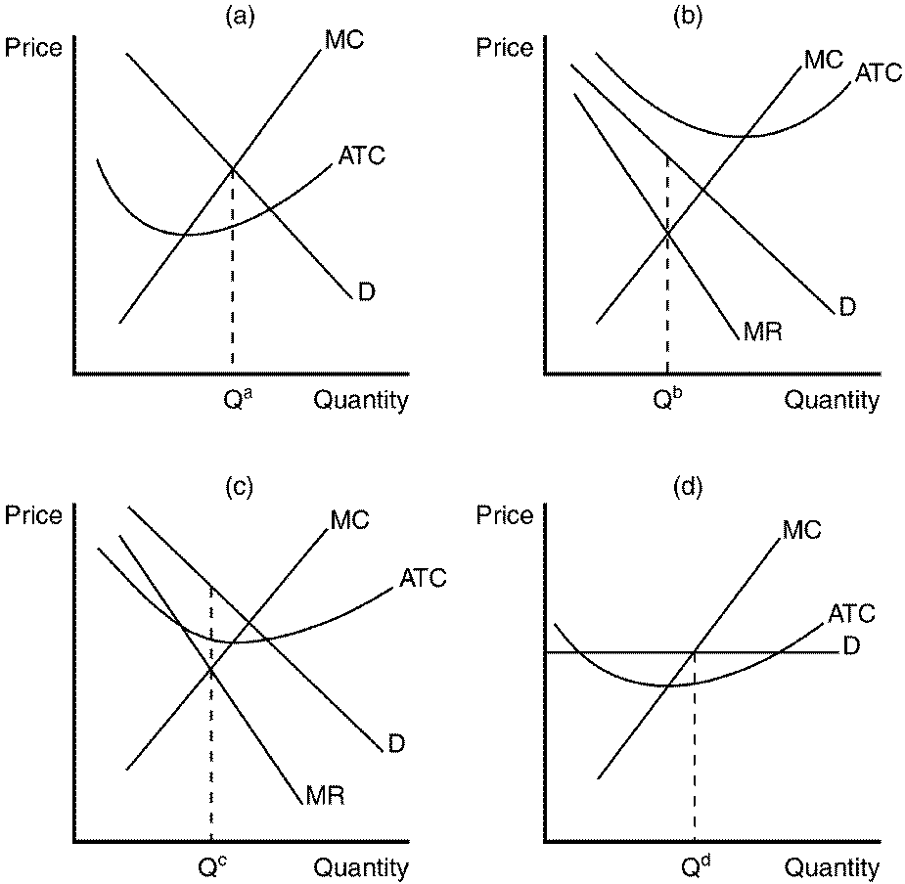

15. Refer to Figure 8. Which of the graphs shown would be consistent with a firm in a monopolistically competitive market that is earning a positive profit?
a. | panel a
b. | panel b
c. | panel c
d. | panel d

16. A unit tax imposed on a market with an inelastic demand and an elastic supply will cause
a. | sellers to pay the majority of the tax.
b. | buyers to pay the majority of the tax.
c. | the tax burden to be equally divided between buyers and sellers.
d. | the tax burden to be divided, but it cannot be determined how.

17. You are the mayor of a small town with 2,000 residents. The head of your economic development agency recently conducted a survey in which the 2,000 residents said that a public concert in the center of town would be worth $20 to each of them. Since the concert cost only $5,000 to hold, you organized and held the concert, which everyone in town enjoyed. But when you asked for donations to pay for the concert, you only collected $1000. You are convinced that
a. | the survey certainly overstated how much the concert was worth to each resident.
b. | from the standpoint of total costs and benefits, the cost of the concert certainly exceeded the benefit.
c. | the concert was an example of the tragedy of the commons.
d. | many residents of the town were probably free-riders.

18. On hot summer days, electric-generating capacity is sometimes stretched to the limit. At these times, electric companies sometimes ask people to voluntarily cut back on their use of electricity. An economist might say that
a. | every electric customer has an incentive to prevent the system from overloading, so this voluntary approach is the most efficient.
b. | it would be more efficient if the electric company raised its rates for electricity at peak times.
c. | it would be more efficient to have a lottery to decide who had to cut back their use of electricity at peak times.
d. | it would be more efficient to force everyone to cut their usage of electricity by the same amount.

19. Round-trip airline tickets are usually cheaper if you stay over a Saturday night before you fly back. What is the reason for this price discrepancy?
a. | Airlines are practicing imperfect price discrimination to raise their profits.
b. | Airlines charge a different rate based on the different nature of peoples' travel needs.
c. | Airlines are attempting to charge people based on their willingness to pay.
d. | All of the above are correct.

20. When advertising is used to strengthen brand loyalty,
a. | demand for the product becomes less elastic.
b. | demand for related products is typically unaffected.
c. | consumers become more sensitive to price differences among similar goods.
d. | firms should lower price to increase revenue.

Continued on next page

PART B
Short Answer Questions
Answer ALL FOUR Questions, 8 marks each

1. a) Describe what is meant by an “externality”.
b) Give an example of one positive and one negative externality, and explain why these are externalities.
c) In the case of a negative externality, use a diagram to illustrate how this externality affects the market equilibrium. Illustrate how the market equilibrium with the negative externality compares with the social optimum. How might the government help to eliminate this inefficiency?

2. a) If the government places a $3 unit tax on each hat sold, use a diagram to explain
how this will affect producer surplus, consumer surplus and total surplus.
b) What portion of the tax is borne by producers, and what portion is borne by consumers?
c) How would these burdens change if the relative elasticities of supply and demand changed? Explain using a diagram.

3. Using a diagram, explain how a profit-maximizing monopolist chooses its level of output and the price of its goods. Explain and graphically depict the deadweight loss caused by a monopoly. How is this similar to the deadweight loss from taxation?

4. The housing market is initially in a long-run equilibrium. In order to ensure that low-income families can afford their rent, the government imposes a binding price ceiling on the market. Demonstrate the effects using a clearly labeled diagram.

PART C

Long Answer Questions

Answer BOTH of the following questions, 20 marks.

1. Canada imports radios. Using diagrams, explain the effects of a tariff on imported radios, and the impact on:

- The price of radios in Canada and the quantity of imports.
- Consumer surplus, producer surplus, tax revenue, and changes in total surplus.
- Would it be a valid argument to say that the tariff makes Canadians better off? Explain.

2. Many small Canadian firms produce rice, all rice is the same, and there are no barriers to entry for firms producing rice. Explain the impact, both in the short run and in the long run, on the price of rice, the output of rice, and the profits of rice producers, if there is a sudden increase in Canada’s population. Use both firm and market diagrams to illustrate your answer.

