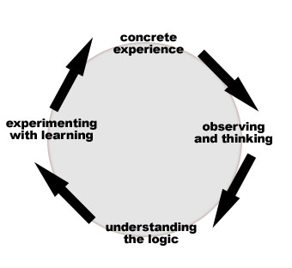
- Slide 2 Learning Styles
  - Activists: concrete experience. Involved vs listening.
  - Reflectors: time to think, observe, assimilate before acting. Decisions own time, no pressure.
  - Theorists: abstract models, explore problems methodically, step-by-step, analytical way.
  - Pragmatists: experiment, practical solutions, problems as a challenge

- Slide 3 What is a computer
  - A computer consists of a CPU, memory, hard disk, floppy disk, monitor, printer, and communication devices.
  - Hardware: you can physically touch
- 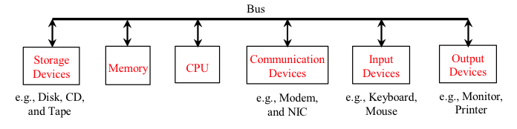
- Slide 4 CPU
  - The central processing unit (CPU) is the brain of a computer. It retrieves instructions from memory and executes them. The CPU speed is measured in megahertz (MHz), with 1 megahertz equaling 1 million pulses per second.
- 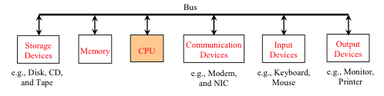
- Slide 5 Memory
  - Memory is to store data and program instructions for CPU to execute. A memory unit is an ordered sequence of bytes, each holds eight bits. A program and its data must be brought to memory before they can be executed. Fast but volatile
- 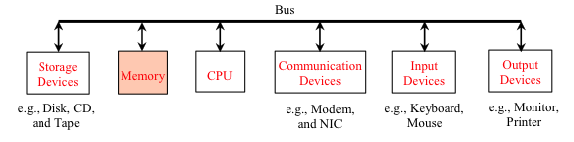
- Slide 6 How Data is Stored?
  - Numbers, characters, and strings, are encoded as a series of bits (zeros and ones).
  - Standards include ASCII & ANSI (PCs), EBCDIC (mainframe-COBOL), etc

- Slide 7 Storage Devices
  - Memory is volatile, because information is lost when the power is off. Programs and data are permanently stored on storage devices and are moved to memory when the computer actually uses them.
  - These are typically thousands of times slower than Memory on RAM chips
- 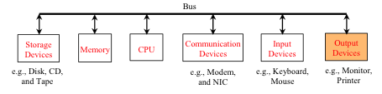

- Slide 8 Output Devices: Monitor/Printer
  - The monitor displays information (text and graphics). The resolution and dot pitch determine the quality of the display.

- Slide 9 Communication Devices
  - Regular modem (phone line) 56,000 bps (bits per second).
  - DSL (digital subscriber line – also phone line) 20 times faster.
  - Cable modem (TV cable line) as fast as a DSL.
  - Network interface card (NIC) device to connect a computer to a local area network (LAN). Common in business, universities, government.
  - NIC (10BaseT) transfer data at 10 mbps (million bits per second).
- 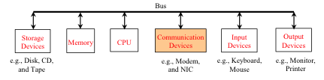

- Slide 10 Programs
  - Computer programs, known as software, are instructions to the computer.
  - Computers do not understand human languages, so you need to use computer languages to communicate with them.
  - Programs are written using programming languages.

Q. Is the Office 2007 CD hardware or software?

Q. Algorithim or flowchart on a paper napkin?

- Slide 11 Programming Languages
- Machine Language Assembly Language High-Level Language
  - Machine language
    - Primitive instructions
    - Binary code (ie 1101101010011010)
    - Programming is a tedious process.
    - Difficult to read and modify.
- Slide 12 Programming Languages
- Machine Language Assembly Language High-Level Language
  - Assembly languages
    - Developed to make programming easier.
    - Computer cannot understand assembly language
    - Assembler is used to convert assembly language into machine code.

- Slide 13 Programming Languages
- Machine Language Assembly Language High-Level Language
  - High-level languages
    - English-like and easy to learn and program.
    - Example, following is a high-level language statement that computes the area of a circle with radius 5:
      - area = 5 * 5 * 3.1415;

- Slide 14 Popular High-Level Languages
  - COBOL (COmmon Business Oriented Language)
  - FORTRAN (FORmula TRANslation)
  - BASIC (Beginner All-purpose Symbolic Instructional Code)
  - Pascal (named for Blaise Pascal)
  - Ada (named for Ada Lovelace)
  - C (whose developer designed B first)
  - Visual Basic (Basic-like visual language developed by Microsoft)
  - Delphi (Pascal-like visual language developed by Borland)
  - C++ (an object-oriented language, based on C)
  - C# (a Java-like language developed by Microsoft)
  - Java (We use it in the book)

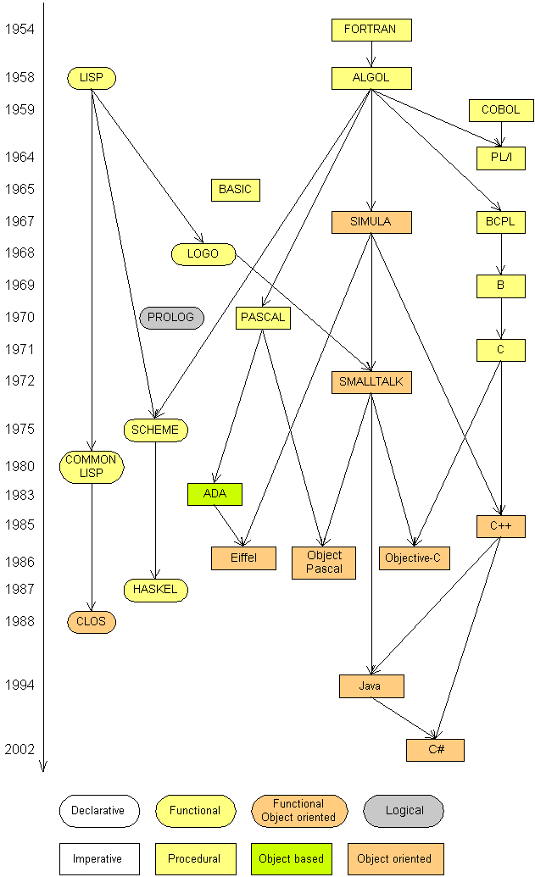
- Slide 15 Languages
- Some influential ones:
  - FORTRAN
    - science / engineering
  - COBOL
    - business data
  - LISP
    - logic and AI
  - BASIC
    - a simple language
  - JAVA
    - Internet programming
  - C#
    - Microsoft’s language

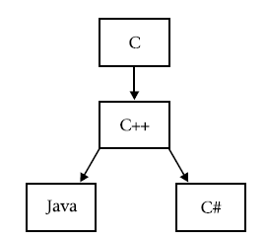
- Slide 16 C Family Tree

  - The grandfather of Java & C# is C.
  - From C, Java derives its syntax, many of its keywords, and operators.
  - Java builds upon and improves the object model defined by C++.
  - If you know C or C++, you will feel at home with Java or C#.

- Slide 17 C# versus Java
  - Java & C# both descended from C and C++.
  - Both shares the C/C++ syntax and object model.
  - Like Java, C# is designed to produce portable code, and C# programs execute in a secure controlled runtime environment.
  - However, C# is not descended from Java.
  - Instead, C# and Java are more like cousins, sharing a common ancestry, but differing in many important ways.
  - The good news is that if you know Java, many C# concepts will be familiar.

- Slide 18 Compiling source code
  - Program (high-level language) = source program.
  - Compiler translates to a machine language (object program.
  - Object program often linked with other supporting library code before the object can be executed.
- 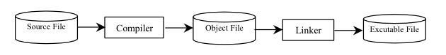
- Slide 19 Compiling Java Source Code
  - Java designed to run object programs on any platform.
  - You write the program once, and compile the source program into a special type of object code, known as bytecode.
  - Bytecode can then run on any computer with a Java Virtual Machine.
  - Java Virtual Machine is a software that interprets Java bytecode

Slide 20 Compiling/running a program
- Before you run your programs, you must compile them.
- Java Development Kit includes a Java compiler.
- byte code: The Java compiler converts your source code into a format named byte code that can be executed on many different kinds of computers.

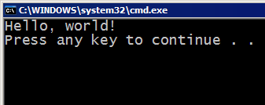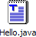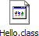

compile
execute
output
source code
Hello.java

Slide 21 Operating Systems
- Operating system (OS) program that manages and controls a computer’s activities.
- Windows is currently the most popular PC OS.
- Need to know if your using 32 or 64bit (Vista or 7)
- Application programs such as an Internet browser, word processor cannot run without an OS.

Slide 22 Number Systems
  - Computers use binary numbers internally
  - (store 0s and 1s).
  - Each 0 and 1 is called a bit, short for binary digit.
  - Not intuitive, since we use decimal numbers.
  - Internally, computer software converts decimal into binary , and vice versa.

- Slide 23 Number Systems
  - Binary: 0, 1
  - Octal: 0, 1, 2, 3, 4, 5, 6, 7
  - Decimal: 0, 1, 2, 3, 4, 5, 6, 7, 8, 9
  - Hexdecimal: 0, 1, 2, 3, 4, 5, 6, 7, 8, 9, A, B, C, D, E, F

- Slide 24 Why Java?
  - Deploy applications on the Internet for servers, desktop computers, and small hand-held devices.
  - Future of computing is being profoundly influenced by the Internet.
  - Java promises to remain a big part of that future. Java is the Internet programming language.
  - General purpose programming language.
  - Internet programming language.

- Slide 25 Java, Web, and Beyond
  - Java can be used to develop Web applications.
  - Java Applets
  - Java Web Applications
  - Develop applications for hand-held devices: smart phones, iPads, etc.

- Slide 26 Examples of Java’s Versatility (Applets
- 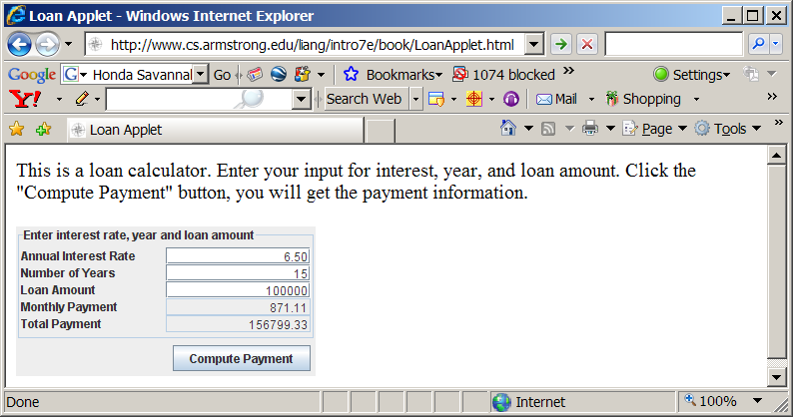

- Slide 28 Java’s History
  - James Gosling and Sun Microsystems
  - Oak
  - Java, May 20, 1995, Sun World
  - HotJava
  - The first Java-enabled Web browser

- Slide 29-40 Characteristics of Java
  - Java Is Simple
    - Java is partially modeled on C++, but greatly simplified and improved. Some people refer to Java as "C++--" because it is like C++ but with more functionality and fewer negative aspects.
  - Java Is Object-Oriented
    - Java is inherently object-oriented. Although many object-oriented languages began strictly as procedural languages, Java was designed from the start to be object-oriented. Object-oriented programming (OOP) is a popular programming approach that is replacing traditional procedural programming techniques.
    - One of the central issues in software development is how to reuse code. Object-oriented programming provides great flexibility, modularity, clarity, and reusability through encapsulation, inheritance, and polymorphism.
  - Java Is Distributed
    - Distributed computing involves several computers working together on a network. Java is designed to make distributed computing easy. Since networking capability is inherently integrated into Java, writing network programs is like sending and receiving data to and from a file.
  - Java Is Interpreted
    - You need an interpreter to run Java programs. The programs are compiled into the Java Virtual Machine code called bytecode. The bytecode is machine-independent and can run on any machine that has a Java interpreter, which is part of the Java Virtual Machine (JVM).
  - Java Is Robust
    - Java compilers can detect many problems that would first show up at execution time in other languages.
    - Java has eliminated certain types of error-prone programming constructs found in other languages.
    - Java has a runtime exception-handling feature to provide programming support for robustness.
  - Java Is Secure
    - Java implements several security mechanisms to protect your system against harm caused by stray programs
  - Java Is Architecture-Neutral
    - Write once, run anywhere
    - With a Java Virtual Machine (JVM), you can write one program that will run on any platform.
  - Java Is Portable
    - Because Java is architecture neutral, Java programs are portable. They can be run on any platform without being recompiled.
  - Java's Performance
    - Java’s performance Because Java is architecture neutral, Java programs are portable. They can be run on any platform without being recompiled.
  - Java Is Multithreaded
    - Multithread programming is smoothly integrated in Java, whereas in other languages you have to call procedures specific to the operating system to enable multithreading.
  - Java Is Dynamic
    - Java was designed to adapt to an evolving environment. New code can be loaded on the fly without recompilation. There is no need for developers to create, and for users to install, major new software versions. New features can be incorporated transparently as needed.

- Slide 41 JDK Versions
  - JDK 1.02 (1995)
  - JDK 1.1 (1996)
  - JDK 1.2 (1998)
  - JDK 1.3 (2000)
  - JDK 1.4 (2002)
  - JDK 1.5 (2004) a. k. a. JDK 5 or Java 5
  - JDK 1.6 (2006) a. k. a. JDK 6 or Java 6

- Slide 42 Popular Java IDE’s
  - NetBeans Open Source by Sun
  - Eclipse Open Source by IBM
  - Borland JBuilder 2007 (Based on Eclipse)
  - JCreator LE by Xinox (will be using in this course)

- Slide 43-46 A simple Java Program
  - Listing 1.1
- //This program prints Welcome to Java!
- public class Welcome {
- public static void main(String[] args) { enter main method
- System.out.println(“Welcome to Java!”); Execute statement

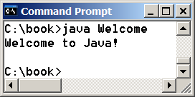
Yellow highlight prints a message to the console

- }
- }

- Slide 47 Comments
  - Line comment: A line comment is preceded by two slashes (//) in a line.
  - Paragraph comment: A paragraph comment is enclosed between /* and */ in one or multiple lines.

- Slide 48 Reserved Words
  - Keywords are words that have a specific meaning to the compiler and cannot be used for other purposes in the program.
  - Example: class, public, static, void. (use will be introduced later in the course).

- Slide 49 Blocks
  - A pair of braces in a program forms a block that groups components of a program.
- 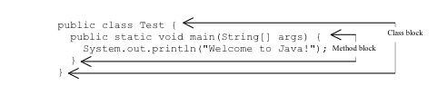
- Slide 50 Classes
  - Class = template or blueprint for objects.
  - Mystery of class will be unveiled throughout this course
  - For now, understand that a program is defined by using one or more classes.

- Slide 51 Methods

System.out.println("Welcome to Java!“);
    - Method: a collection of statements
    - Can be used even without fully understanding the details of how it works.

- Slide 52 main Method
  - The main method provides the control of program flow. The Java interpreter executes the application by invoking the main method.
  - The main method looks like this:

public static void main(String[] args) {

// Statements;

}

- Slide 53 The showMessageDialog Method

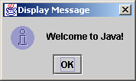
JOptionPane.showMessageDialog(null,

"Welcome to Java!",

"Display Message",

JOptionPane.INFORMATION _MESSAGE);

- Slide 54 The exit Method
  - Prior to JDK 1.5, you have to invoke System.exit() to terminate the program if the program uses JOptionPane dialog boxes. Since JDK 1.5, it is not necessary

- Slide 55 Program Execution Flow
- 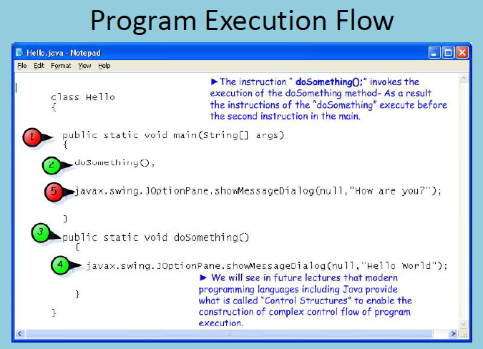

- Slide 2: Trace a Program Execution

public class ComputeArea {

/** Main method */

public static void main(String[] args) {

double radius; radius (no value) Allocates memory for radius

double area; are (no value) allocates memory for area

// Assign a radius

radius = 20; assign 20 to radius, area no value

// Compute area

area = radius * radius * 3.14159; radius=20, area 1256.636

// Display results

System.out.println("The area for the circle of radius " +

radius + " is " + area); prints message to the console
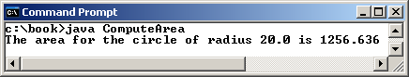

}

}

- Slide 7 Variables
  - A variable is a sequence of characters that consist of letters, digits, underscores (_), and dollar signs ($).
  - A variable must start with a letter, an underscore (_), or a dollar sign ($). It cannot start with a digit.
  - A variable cannot be a reserved word. Avoid reserve words by using dbl..ie: dblArea
  - A variable cannot be true, false, or
null.
  - A variable can be of any length.

- Slide 8 Variables

// Compute the first area

radius = 1.0;

area = radius * radius * 3.14159;

System.out.println("The area is “ + area + " for radius "+radius);

// Compute the second area

radius = 2.0;

area = radius * radius * 3.14159;

System.out.println("The area is “ + area + " for radius "+radius);

- Slide 9 Declaring Variables
  - int x; // Declare x to be an 2.1 billion

// integer variable;
  - double radius; // Declare radius to

// be a double variable;
  - char a; // Declare a to be a

// character variable;
- Diff between float and double
- Float can only do 7 decimal places with accuracy, double is more precise
- Slide 10 Assignment Statements
  - x = 1; // Assign 1 to x;
  - radius = 1.0; // Assign 1.0 to radius;
  - a = 'A'; // Assign 'A' to a;

Slide 11 Declaring and Initializing in one step
  - int x = 1;
  - double d = 1.4;

- Slide 12 Constants
  - final datatype CONSTANTNAME = VALUE;
  - final double PI = 3.14159;
  - final int SIZE = 3;
- final: cannot change it throughout the program. HST hardcoded to 13%. No one can override.

Slide 13 Numeric Data Types

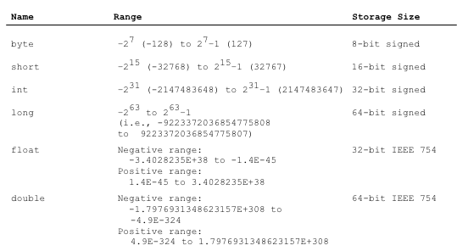

Slide 14 Numeric Operators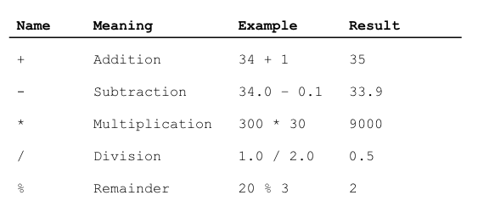

Division on the test

Slide 15 Integer Division
  - +, -, *, /, and %
  - 5 / 2 yields an integer 2. Drops everything after 2. Does not round
  - 5.0 / 2 yields a double value 2.5 comp sees . and translates to 2.5
  - 5 % 2 yields 1 (the remainder of the division)

- Slide 16 Remainder Operator
  - Remainder is very useful in programming.
  - An even number % 2 is always 0
  - An odd number % 2 is always 1.
  - Can use this to determine if number is even or odd.
  - Suppose today is Saturday and you and your friends are going to meet in 10 days. What day is in 10 days?

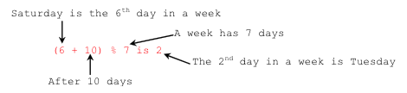

Saturday is 6th day of week, Sunday is 0 in programming. This is ON the MIDTERM

Slide 17 Note
  - Calculations involving floating-point (decimal) numbers are approximated
  - Not stored with complete accuracy.
  - System.out.println(1.0 - 0.1 - 0.1 - 0.1 - 0.1 - 0.1);

displays 0.5000000000000001, not 0.5,
  - System.out.println(1.0 - 0.9);

displays 0.09999999999999998, not 0.1.
  - Integers are stored precisely.

Slide 18 Number Literals
  - A literal is a constant value that appears directly in the program:

  - int i = 34;

long x = 1000000;

double d = 5.0;

- Slide 19 Arithmetic Expression
- 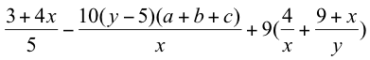
  - is translated to
    - (3+4*x)/5 – 10*(y-5)*(a+b+c)/x + 9*(4/x + (9+x)/y)

- Slide 20 How to evaluate an Expression
  - BEDMAS
    - Brackets
    - Exponents
    - Division
    - Multiplication
    - Addition
    - Subtraction

- Slide 21 Problem: Converting Temperatures
  - Write a program that converts a Fahrenheit degree to Celsius using the formula:
- 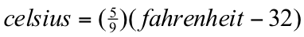

- Slide 22 Conversion of Celsius to Fahrenheit
- 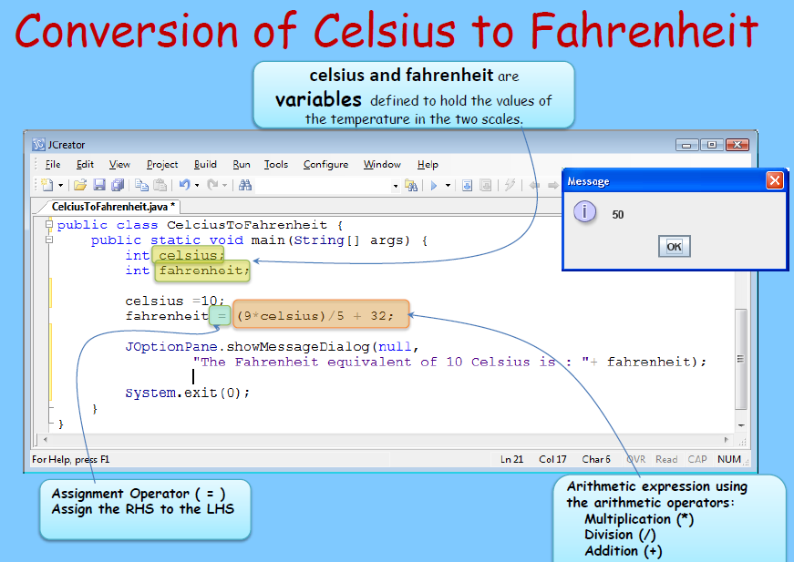

- slide 23 Shortcut Assignment Operators
- Operator Example Equivalent
- += i += 8 i = i + 8
- -= f -= 8.0 f = f - 8.0
- *= i *= 8 i = i * 8
- /= i /= 8 i = i / 8
- %= i %= 8 i = i % 8

- Slide 24 increment and Decrement Operators
- Operator Name Description
- ++var preincrement The expression (++var) increments var by 1 and evaluates to the new value in var after the increment.
- var++ postincrement The expression (var++) evaluates to the original value in var and increments var by 1.
- --var predecrement The expression (--var) decrements var by 1 and evaluates to the new value in var after the decrement.
- var-- postdecrement The expression (var--) evaluates to the original value in var and decrements var by 1.

- I= i+1= a loop, as an increment
- ++var: increments first then assign whatever you need

- 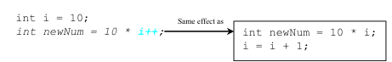

- in both answers 1 becomes 11. And in the first one only stores 100, 110 in the next one.

- Slide 26 Numeric Type Conversion

Consider the following statements:

byte i = 100;

long k = i * 3 + 4; //300+4=304

double d = i * 3.1 + k / 2;

//310.0+152=462.0

- Slide 27 Type Casting
  - Implicit casting

double d = 3; (type widening)
  - Explicit casting

int i = (int)3.0; (type narrowing)

int i = (int)3.9; (Fraction part is truncated) output is going to be 3

What is wrong? int x = 5 / 2.0; //possible loss of precision
- 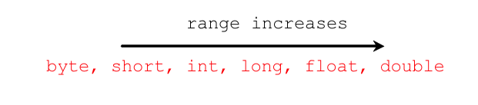

- Slide 28 Type Casting
  - type cast: A conversion from one type to another.
- Common uses:
  - To promote an int into a double to achieve exact division.
  - To truncate a double from a real number to an integer.
- Examples:
  - double result = (double) 19 / 5; // 3.8
  - int result2 = (int) result; // 3

- Slide 29 More about type casting
- Type casting: only casts the item immediately next to it.
  - double x = (double) 1 + 1 / 2; // 1.0
  - double y = 1 + (double) 1 / 2; // 1.5
- Can use parentheses to force evaluation order.
  - double average = (double) (a + b + c) / 3;
- A conversion to double can be achieved in other ways.
  - double average = 1.0 * (a + b + c) / 3;

- Slide 30 problem: Keeping two digits after decimal points
  - Write a program that displays the sales tax with two digits after the decimal point.
- 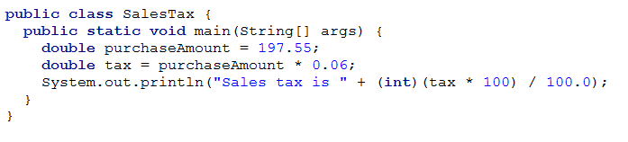
  - Better: round the numbers: Math.round(tax*100)/100.0

- This slide is on the midterm

- Slide 31 Escapes sequences for special characters
- Description Escape Sequence Unicode
- Backspace \b \u0008
- Tab \t \u0009
- Linefeed \n \u000A
- Carriage return \r \u000D
- Backslash \\ \u005C
- Single Quote \' \u0027
- Double Quote \" \u0022

- Slide 32 Appendix B: ASCII Character Set
- ASCII Character Set is a subset of the Unicode from \u0000 to \u007f

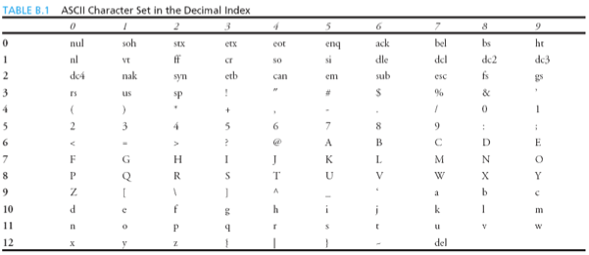

- Slide 33 Casting between char and numeric types
  - int i = 'a'; // Same as int i = (int)'a'; gonna give u 97
  - char c = 97; // Same as char c = (char)97; gonna give u a

- Slide 34
- 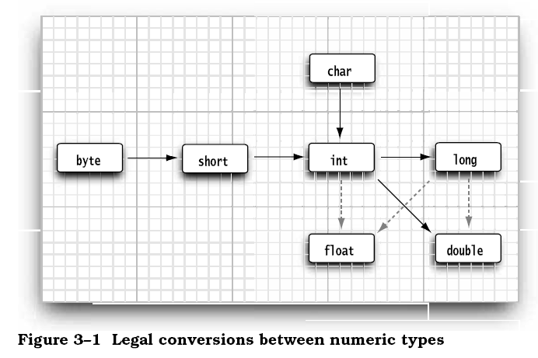

- - Solid arrows denotes conversions without information loss
- Dotted arrows may lose precision :
int n = 123456789; float f = n; // 1.23456792E8

- Slide 35 String Concatenation
- The String type is not a primitive type. It is known as a reference type.
- // Three strings are concatenated
- String message = "Welcome " + "to " + "Java";

- // String Chapter is concatenated with number 2
- String s = "Chapter" + 2; // s becomes Chapter2

- // String Supplement is concatenated with character B
- String s1 = "Supplement" + 'B'; // s becomes SupplementB

- Slide 36 Naming Conventions
- Choose meaningful and descriptive names.
- Variables and method names:
  - Use lowercase. For example:
  - Variables: radius,area
  - Method: computeArea()
- Good to use prefix to show data type:
  - Variables:
    - dblRadius,intCount,strName

- Slide 37 Naming Conventions
- Class names:
  - Capitalize first letter of each word.
  - example: ComputeArea.
- Constants:
  - Capitalize all letters
  - Use underscores
  - Examples: PI, MAX_VALUE

- Slide 38 Proper Indentation and Spacing
- Indentation
  - Indent two spaces.
- Spacing
  - Use blank line to separate segments of the code.

- Slide 39 Block Styles
  - Use end-of-line style for bracs
- 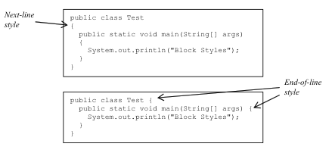

- Slide 40 Programming Errors
  - Syntax Errors typoo
    - Detected by the compiler
  - Runtime Errors needs to use operating system- reads file but files not there. Harder to program
    - Causes the program to abort
  - Logic Errors it will run but the math is wrong
    - Produces incorrect result

- Slide 41 Syntax errors

public class ShowSyntaxErrors {

public static void main(String[] args) {

i = 30;

System.out.println(i + 4);

}
- i is not declared

- Slide 42 Runtime Errors

public class ShowRuntimeErrors {

public static void main(String[] args) {

int i = 1 / 0;

}

}
- 1/0 is overload

- Slide 43 Logic Errors

public class ShowLogicErrors {

// Determine if a number is between 1 and 100 inclusively

public static void main(String[] args) {

// Prompt the user to enter a number

String input = JOptionPane.showInputDialog(null,

"Please enter an integer:",

"ShowLogicErrors", JOptionPane.QUESTION_MESSAGE);

int number = Integer.parseInt(input);

// Display the result

System.out.println("The number is between 1 and 100, " +

"inclusively? " + ((1 < number) && (number < 100)));

System.exit(0);

}

}

- Slide 44 Debugging
  - Logic errors are called bugs.
  - The process of finding and correcting errors is called debugging.
- Common approach (for simple programs)
  - Hand-trace (i.e., catch errors by reading the program)
  - Insert print statements in order to show the values of the variables or the execution flow of the program.

- Slide 45 Getting Input from Input Dialog Boxes
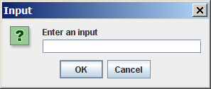
- String input = JOptionPane.showInputDialog(
- "Enter an input");

- Slide 46 Getting input from input dialog boxes

String string = JOptionPane.showInputDialog(

null, “Prompting Message”, “Dialog Title”,

JOptionPane.QUESTION_MESSAGE);

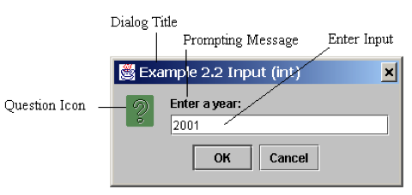

Slide 47 Converting strings to integers
- To convert a string into an int value, you can use the static parseInt method in the Integer class as follows:

- int intValue = Integer.parseInt(strString);
- getting the string converting to integer and translating a value
- where strString is a numeric string such as “123”.

Slide 48 Converting strings to doubles
- To convert a string into a double value, you can use the static parseDouble method in the Double class as follows:

- double dblValue =Double.parseDouble(strString);

where strString is a numeric string such as “123.45”

Slide 49 Temp example (copy to JCreator)

import javax.swing.JOptionPane;

public class Exercise3_1WithDialogBox {

// Main method

public static void main(String[] args) {

// Enter a temperature in Celsuis

String celsiusString = JOptionPane.showInputDialog(null,

"Enter a temperature in Celsius:",

"Exercise2_1 Input", JOptionPane.QUESTION_MESSAGE);

// Convert string to double

double celsius = Double.parseDouble(celsiusString);

// Convert it to Celsius

double fahrenheit = (9.0 / 5) * celsius + 32;

// Display the result

JOptionPane.showMessageDialog(null, celsuis + "Temperature " + Celsius + " Celsuis is " +

fahrenheit + " degrees in Fahrenheit");

}

}

Slide 50-51 Problem: Lab exercise Computing loan Payments
- This program lets the user enter the interest rate, number of years, and loan amount and computes monthly payment and total payment.

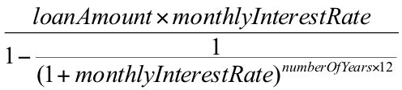

public class CH3Loan {

public static void main(String[] args) {

// Get info from user and convert to appropriate data type

// Enter yearly interest rate (ie 8%)

// Obtain monthly interest rate by dividing by 1200

// Enter number of years

// Enter loan amount

// Calculate payment

double monthlyPayment = loanAmount * monthlyInterestRate / (1

- 1 / Math.pow(1 + monthlyInterestRate, numberOfYears * 12));

double totalPayment = monthlyPayment * numberOfYears * 12;

// Format to keep two digits after the decimal point

monthlyPayment = Math.round(monthlyPayment * 100) / 100.0;

totalPayment = Math.round(totalPayment * 100) / 100.0;

// Display results

System.out.println("The monthly payment is " + monthlyPayment);

System.out.println("The total payment is " + totalPayment);

}

}

