Ch7.
- An industry where economies of scale are purely external will typically consist of many small firms and be perfectly competitive.
- Internal economies of scale result when large firms have a cost advantage over small firms, causing the industry to become imperfectly competitive.
The Theory of External Economies
- Specialized equipment or services may
be needed for the industry, but are only supplied by other firms if the industry is large and concentrated.
- Labor pooling: a large and concentrated industry may attract a pool of workers, reducing employee search and hiring costs for each firm.
- Knowledge spillovers: workers from different firms may more easily share ideas that benefit each firm when a large and concentrated industry exists.
- There is a forward-falling supply curve: the larger the industry’s output, the lower the price at which firms are willing to sell.
- One possibility is comparative advantage due to underlying differences in technology and resources.
- If external economies exist, however, the pattern of trade could be due to historical accidents:
- Countries that start as large producers in certain industries tend to remain large producers even if another country could potentially produce more cheaply.
- Assume that the Vietnamese cost curve lies below the Chinese curve beTrade based on external economies has an ambiguous effect on national welfare.
- There will be gains to the world economy by concentrating production of industries with
external economies.
- It’s possible that a country is worse off with trade than it would have been without trade: a country may be better off if it produces everything for its domestic market rather than pay for imports.
- cause Vietnamese wages are lower than Chinese wages.
- At any given level of production, Vietnam could manufacture buttons more cheaply than China.
- One might hope that this would always imply that Vietnam will in fact supply the world market.
- But this need not always be the case if China has enough of a head start.
- No guarantee that the right country will produce a good that is subject to external economies.
- Note that it’s still to the benefit of the world economy to take advantage of the gains from concentrating industries.
- Each country wanting to reap the benefits of housing an industry with economies of scale creates trade conflicts.
- Overall, it’s better for the world that each industry with external economies be concentrated somewhere.
- Dynamic increasing returns to scale exist if average costs fall as cumulative output over time rises.
Dynamic increasing returns to scale imply dynamic external economies of scale
- Dynamic increasing returns to scale could arise if the cost of production depends on the accumulation of knowledge and experience, which depend on the production process
over time.
- A graphical representation of dynamic increasing returns to scale is called a learning curve.
- Like external economies of scale at a point in time, dynamic increasing returns to scale can lock in an initial advantage or a head start in an industry.
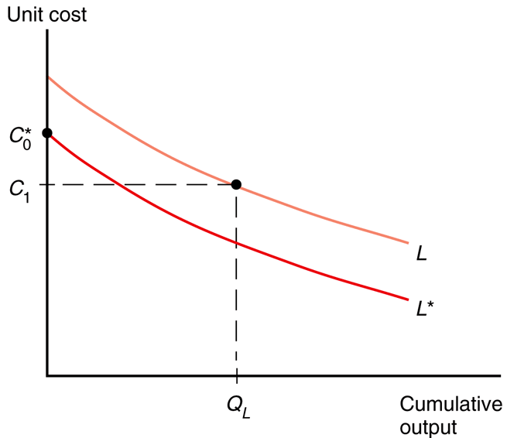
- Can also be used to justify protectionism.
- Temporary protection of industries enables them to gain experience: infant industry argument.
- But temporary is often for a long time, and it is hard to identify when external economies of scale really exist.
- External economies may also be important for interregional trade within a country.
- Trade need not be the result of comparative advantage. Instead, it can result from increasing returns or economies of scale, that is, from a tendency of unit costs to be lower with larger output.
- Economies of scale give countries an incentive to specialize and trade even in the absence of differences in resources or technology between countries.
- Economies of scale can be internal (depending on the size of the firm) or external (depending on the size of the industry).
- Economies of scale can lead to a breakdown of perfect competition, unless they take the form of external economies, which occur at the level of the industry instead of the firm.
- External economies give an important role to history and accident in determining the pattern of international trade.
  - When external economies are important, a country starting with a large advantage may retain that advantage even if another country could potentially produce the same goods more cheaply.
- When external economies are important, countries can conceivably lose from trade.
  - Also the free trade price can fall below the price before trade in both countries.
- Economic geography refers to how humans transact with each other across space, including through international trade and interregional trade.
- Trade based on external economies of scale may increase or decrease national welfare, and countries may benefit from temporary protectionism if their industries exhibit external economies of scale either at a point in time or over time.

Ch.9
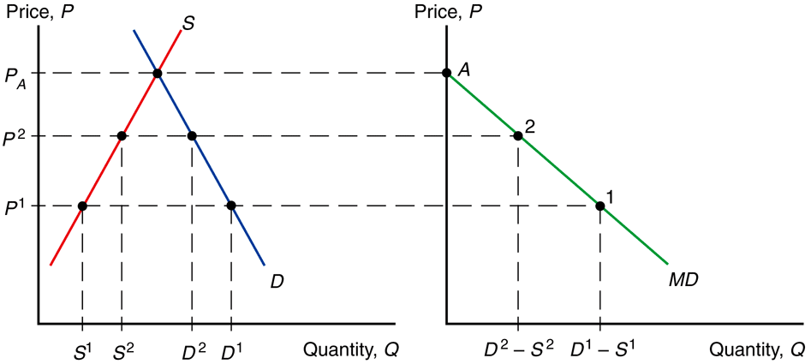
- A specific tariff is levied as a fixed charge for each unit of imported goods.
- An ad valorem tariff is levied as a fraction of the value of imported goods.
- An import demand curve is the difference between the quantity that Home consumers demand minus the quantity that Home producers supply, at each price.
- The Home import demand curve
MD = D – S
intercepts the price axis at P_{A} and is downward sloping:
  - As price increases, the quantity of imports demanded declines.
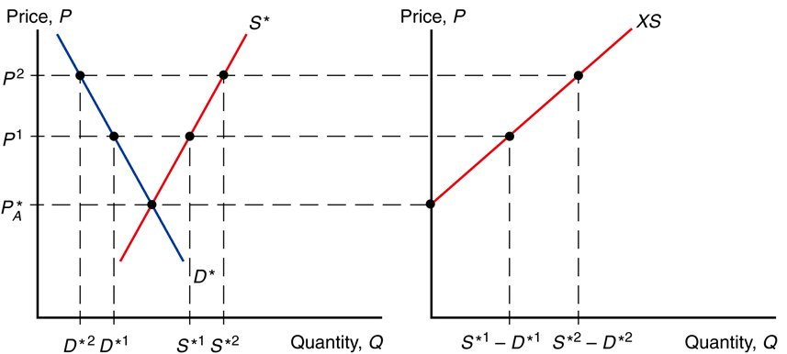
- An export supply curve is the difference between the quantity that Foreign producers supply minus the quantity that Foreign consumers demand, at each price.
- The Foreign export supply curve
XS* = S* – D*
intersects the price axis at P_{A}* and is upward sloping:
  - As price increases, the quantity of exports supplied rises.
In equilibrium,
  - import demand = export supply,
  - home demand – home supply = foreign supply – foreign demand,
  - home demand + foreign demand = home supply + foreign supply,
  - world demand = world supply.

- The quantity of Home imports demanded equals the quantity of Foreign exports supplied when
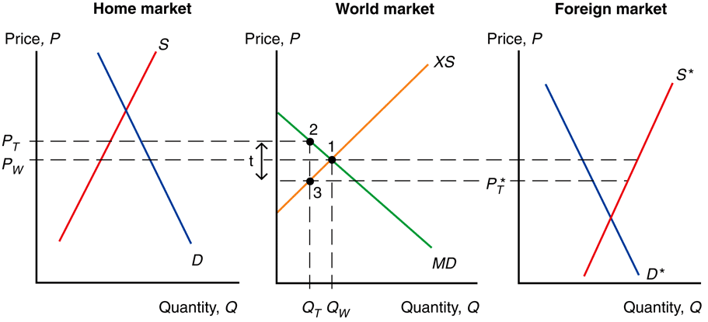
P_{T} – P*_{T} = t

- When a country is “small,” it has no effect on the foreign (world) price because its demand is an insignificant part of world demand for the good.
-The foreign price does not fall, but remains at P_{w} .
-The price in the home market rises by the full amount of the tariff, to P_{T} = P_{w} + t .
- A tariff raises the price of a good in the importing country, so it hurts consumers and benefits producers there.
- In addition, the government gains tariff revenue.
- Consumer surplus measures the amount that consumers gain from purchases by computing the difference in the price actually paid from the maximum price they would be willing to pay for each unit consumed.
  - When price increases, the quantity demanded decreases as well as the consumer surplus.
- Producer surplus measures the amount that producers gain from sales by computing the difference in the price received from the minimum price at which they would be willing to sell.
  - When price increases, the quantity supplied increases as well as the producer surplus.
- An export subsidy raises the price in the exporting country, decreasing its consumer surplus (consumers worse off) and increasing its producer surplus (producers better off).
- Also, government revenue falls due to paying
s X_{S}* for the export subsidy.
- An export subsidy lowers the price paid in importing countries P_{S}* = P_{S} – s.
- In contrast to a tariff, an export subsidy worsens the terms of trade by lowering the price of exports in world markets.
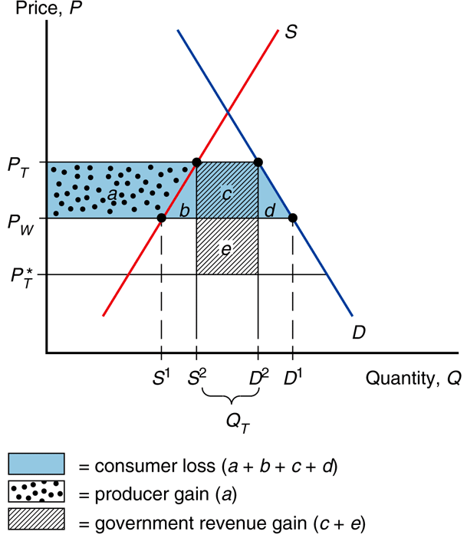
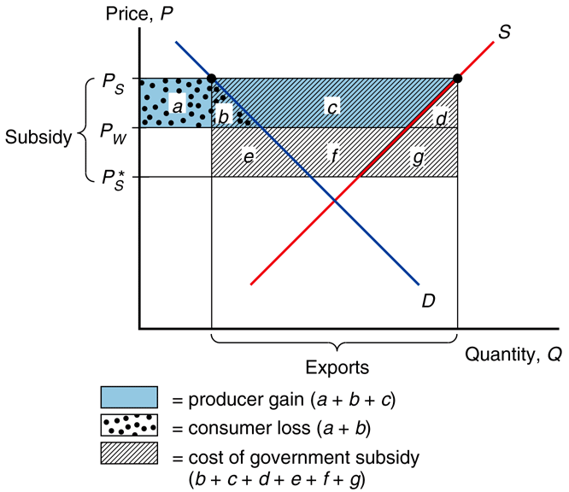

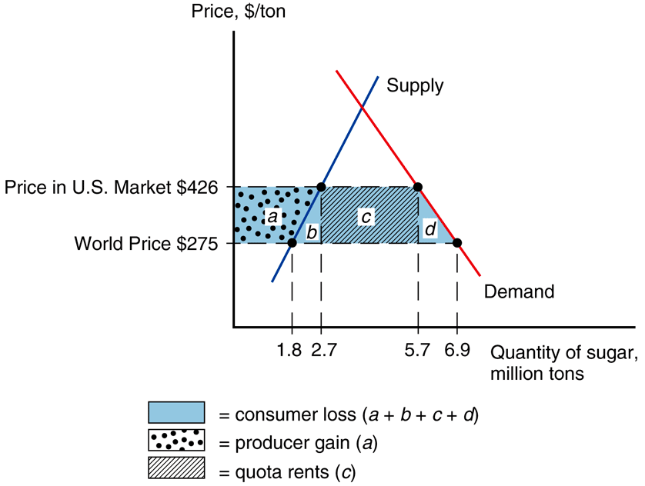
- An import quota is a restriction on the quantity of a good that may be imported.
- This restriction is usually enforced by issuing licenses or quota rights.
- A binding import quota will push up the price of the import because the quantity demanded will exceed the quantity supplied by Home producers and from imports.
- When a quota instead of a tariff is used to restrict imports, the government receives no revenue.
  - Instead, the revenue from selling imports at high prices goes to quota license holders.
  - These extra revenues are called quota rents.
- A voluntary export restraint works like an import quota, except that the quota is imposed by the exporting country rather than the importing country.
- These restraints are usually requested by the importing country.
- The profits or rents from this policy are earned by foreign governments or foreign producers.
  - Foreigners sell a restricted quantity at an increased price.
- A local content requirement is a regulation that requires a specified fraction of a final good to be produced domestically.
- For each trade policy, the price rises in the Home country adopting the policy.
  - Home producers supply more and gain.
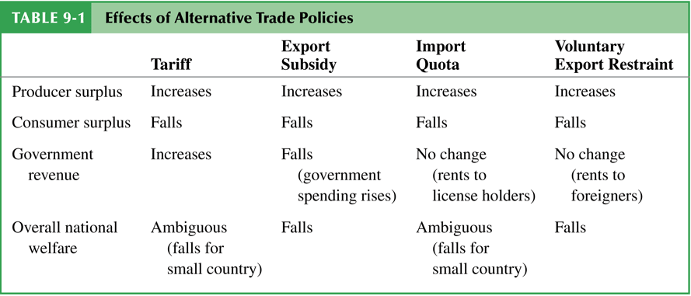
  - Home consumers demand less and lose.
- The world price falls when Home is a “large” country that affects world prices.
- Tariffs generate government revenue; export subsidies drain it; import quotas do not affect government revenue.
- All these trade policies create production and consumption distortions.
Summary
- A tariff increases the home price and the quantity supplied and reduces the quantity demanded and the quantity traded; also decreases the world price when the country is “large.”
- A quota does the same; an export subsidy does the same.
- Tariffs generate government revenue; export subsidies drain it; import quotas are revenue neutral.
- The welfare effect of a tariff, quota, or export subsidy can be measured by
  - efficiency loss from consumption and production distortions.
  - terms of trade gain or loss.
- With import quotas, voluntary export restraints, and local content requirements, the government of the importing country receives no revenue.
- With voluntary export restraints and occasionally import quotas, quota rents go to foreigners.

Ch.10
- The first case for free trade is the argument that producers and consumers allocate resources most efficiently when governments do not distort market prices through trade policy.
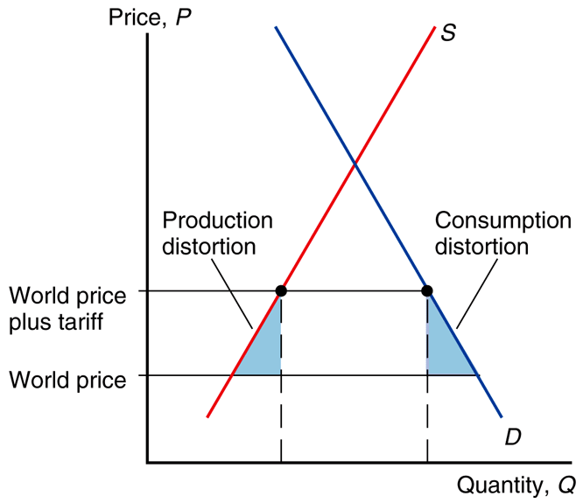
  - National welfare of a small country is highest with free trade.
  - With restricted trade, consumers pay higher prices and consume too little while firms produce too much.
- Free trade allows firms or industry to take advantage of economies of scale.
- Protected markets limit gains from external economies of scale by inhibiting the concentration of industries:
  - Too many firms to enter the protected industry.
  - The scale of production of each firm becomes inefficient.
- Free trade provides competition and opportunities for innovation (dynamic benefits).
- By providing entrepreneurs with an incentive to seek new ways to export or compete with imports, free trade offers more opportunities for learning and innovation.
- Free trade avoids the loss of resources through rent seeking.
  - Spend time and other resources seeking quota rights and the profit that they will earn.
- The political argument for free trade says that free trade is the best feasible political policy, even though there may be better policies in principle.
  - Any policy that deviates from free trade would be quickly manipulated by political groups, leading to decreased national welfare.
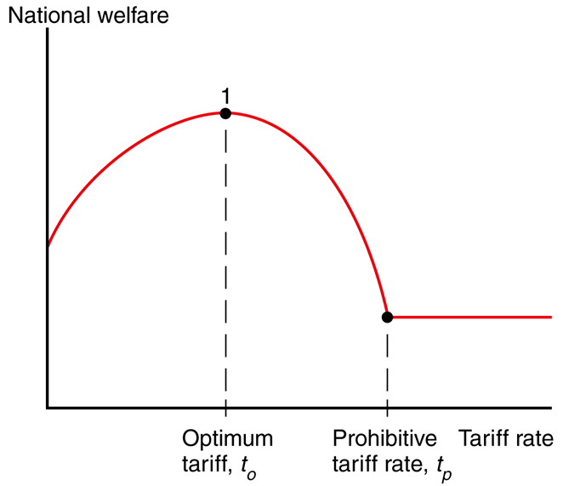
- For a “large” country, a tariff lowers the price of imports in world markets and generates a terms of trade gain.
  - This benefit may exceed the losses caused by distortions in production and consumption.
- A small tariff will lead to an increase in national welfare for a large country.
  - But at some tariff rate, the national welfare will begin to decrease as the economic efficiency loss exceeds the terms of trade gain.
- A tariff rate that completely prohibits imports leaves a country worse off, but tariff rate t_{O} may exist that maximizes national welfare: an optimum tariff.
- A second argument against free trade is that domestic market failures may exist that cause free trade to be a suboptimal policy.
The economic efficiency loss calculations using consumer and producer surplus assume that markets function well
- The domestic market failure argument against free trade is an example of a more general argument called the theory of the second best.
- Government intervention that distorts market incentives in one market may increase national welfare by offsetting the consequences of market failures elsewhere.
  - If the best policy, fixing the market failures, is not feasible, then government intervention in another market may be the “second-best” way of fixing the problem.
Economists supporting free trade counter-argue that domestic market failures should be corrected by a “first-best” policy: a domestic policy aimed directly at the source of the problem
This policy could avoid economic efficiency losses due to a tariff
- Government policies to address market failures are likely to be manipulated by politically powerful groups.
- Due to distorting the incentives of producers and consumers, trade policy may have unintended consequences that make a situation worse, not better.
Models of governments maximizing political success rather than national welfare:
- Median voter theorem
- Collective action
- A model that combines aspects of collective action and the median voter theorem
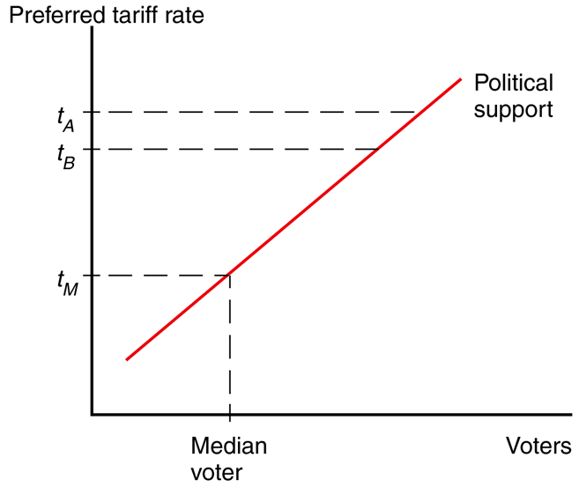
The median voter theorem predicts that democratic political parties pick their policies to court the voter in the middle of the ideological spectrum (i.e., the median voter).
- offer the same tariff policy to court the median voter (the voter in the middle of the spectrum) in order to capture the most votes.

- Political activity is often described as a collective action problem:
  - While consumers as a group have an incentive to advocate free trade, each individual consumer has no incentive because his benefit is not large compared to the cost and time required to advocate free trade.
  - Policies that impose large losses for society as a whole but small losses on each individual may therefore not face strong opposition.
- However, for groups who suffer large losses from free trade (for example, unemployment), each individual in that group has a strong incentive to advocate the policy he desires.
  - In this case, the cost and time required to advocate restricted trade is small compared to the cost of unemployment.
- Models of trade restrictions try to measure the trade-off between the reduction in welfare of constituents as a whole and the increase in campaign contributions from special interests.
- Multilateral negotiations mobilize exporters to support free trade if they believe export markets will expand.
This support would be lacking in a unilateral push for free trade. The multilateral approach counteracts the support for restricted trade by import-competing groups.
- WTO negotiations address trade restrictions in at least 3 ways:
- Reducing tariff rates through multilateral negotiations.
- Binding tariff rates: a tariff is “bound” by having the imposing country agree not to raise it in the future.
- Eliminating nontariff barriers: quotas and export subsidies are changed to tariffs because the costs of tariff protection are more apparent and easier to negotiate.
  - Subsidies for agricultural exports are an exception.
  - Exceptions are also allowed for “market disruptions” caused by a surge in imports.
Preferential trading agreements are trade agreements between countries in which they lower tariffs for each other but not for the rest of the world.
Under the WTO, such discriminatory trade policies are generally not allowed:
- Each country in the WTO promises that all countries will pay tariffs no higher than the nation that pays the lowest: called the “most favored nation” (MFN) principle.
- An exception is allowed only if the lowest tariff rate is set at zero.

There are two types of preferential trading agreements in which tariff rates are set at or near zero:
A free trade area: an agreement that allows free trade among members, but each member can have its own trade policy towards non-member countries. (NAFTA).
A customs union: an agreement that allows free trade among members and requires a common external trade policy towards non-member countries. (European Union.)
- it is possible that national welfare decreases under a preferential trading agreement.
- How? Rather than gaining tariff revenue from inexpensive imports from world markets, a country may import expensive products from member countries but not gain any tariff revenue.
- Preferential trading agreements increase national welfare when new trade is created, but not when existing trade from the outside world is diverted to trade with member countries.
Trade creation -> occurs when high-cost domestic production is replaced by low-cost imports from other members.
Trade diversion -> occurs when low-cost imports from nonmembers are diverted to high-cost imports from member nations.
Summary
- The cases for free trade are that freer trade
  - allows consumers and producers to allocate their resources freely and efficiently, without
price distortions.
  - may allow for economies of scale.
  - increases competition and innovation.
- The cases against free trade are that trade restrictions may allow
  - terms of trade gains.
  - a government to address a market failure when better policies are not feasible.
- Models of trade policy choice consider the incentives politicians face given their desire to be reelected, and the tendency for groups that gain from protection to be better organized than consumers who lose.
- Agricultural and clothing industries are the most protected industries in many countries.
- Multilateral negotiations of free trade may mobilize domestic political support for free trade, as well as make countries agree not to engage in a trade war.
- The WTO and its predecessor have reduced tariffs substantially in the last 50 years, and the WTO has a dispute settlement procedure for trade disputes.
- A preferential trading agreement is beneficial for a country if it creates new trade but is harmful if it diverts existing trade to higher-cost alternatives.

